How to Create a Fallout 4 Quest: Part 12— Scripting Artifact Retrieval
Nick V. Flor (nickflor@unm.edu)

Start up your Mod in the GECK  Open up your Quest  Bring up the Cell View windows  Note: This is only if the GECK isn’t running, and yes I skipped a lot of steps because we’re far into these tutorials!  Having accepted the quest, we also need to add a scene to handle the dialog where the player finds the object and has to return it to the NPC.  But we’ll introduce a new concept: scripting for objects | 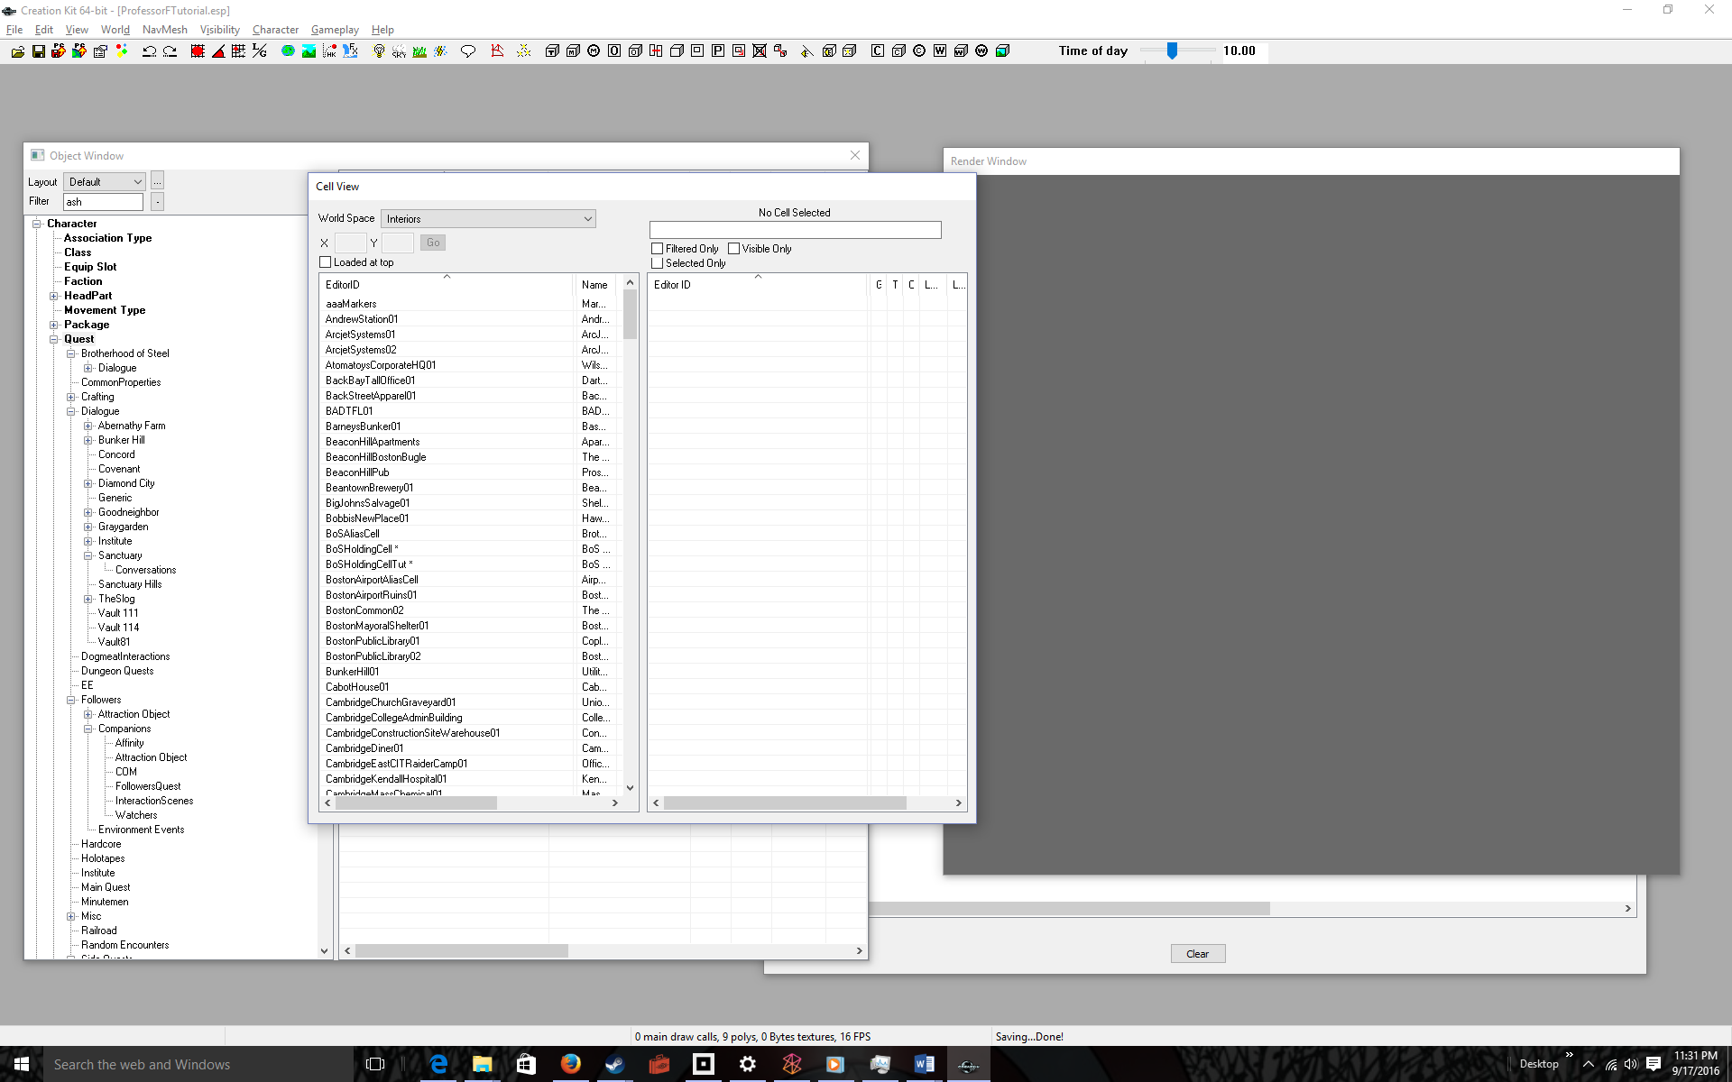
START: PROCEDURE ADDING CODE TO AN OBJECT  Double-click the cell containing the object to be retrieved  In our case the object is the TeddyBear and it’s in BoSHoldingCellTut.  I adjusted the windows and zoomed up so you could see the Teddy Bear (loser left) and Ash Skow (upper right)  We need to add code to the teddy bear so when the player picks it up we update the Quest Stage # to the retrieved index (30) | 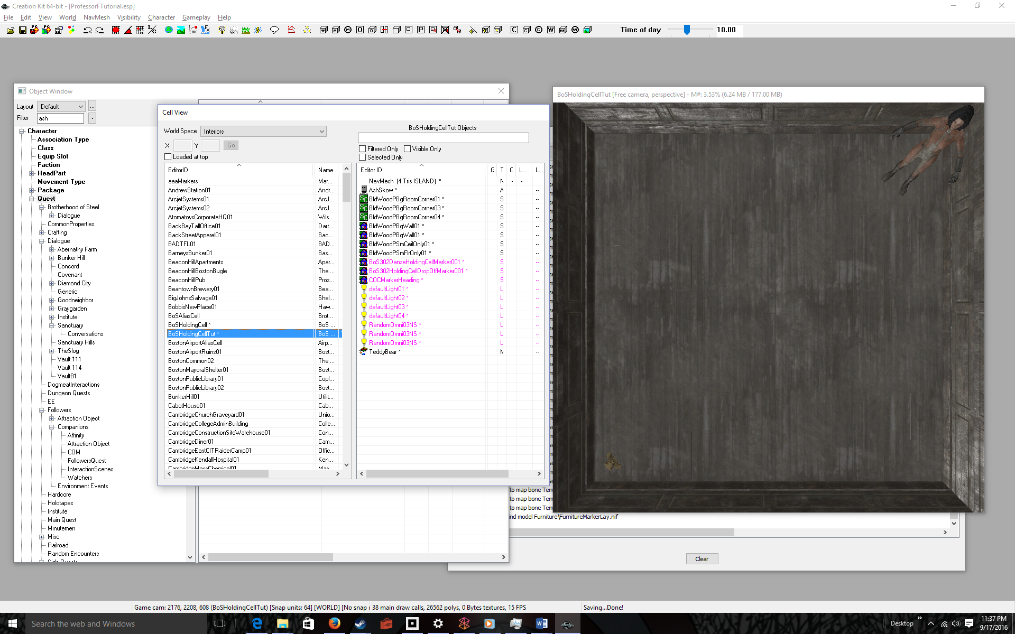
Right-click over the Teddy Bear | 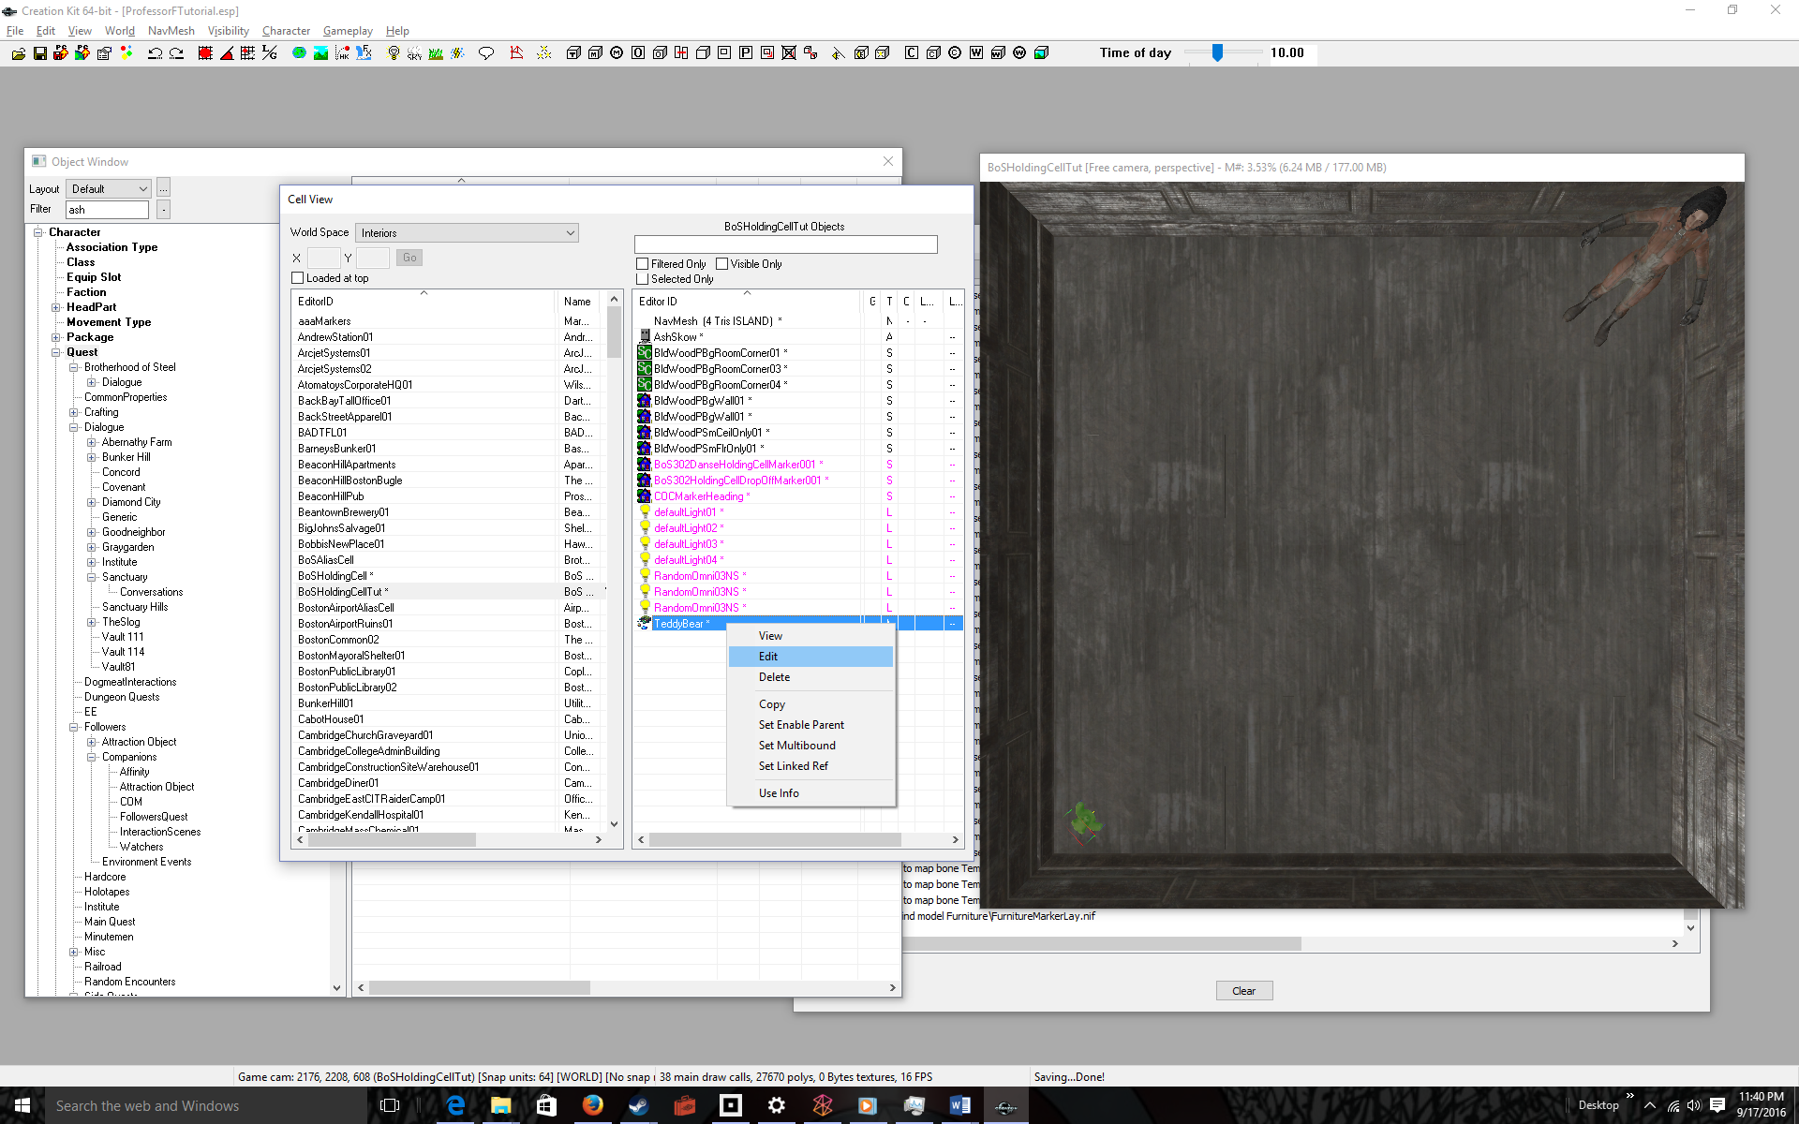
Select Edit in the Pop-Up | 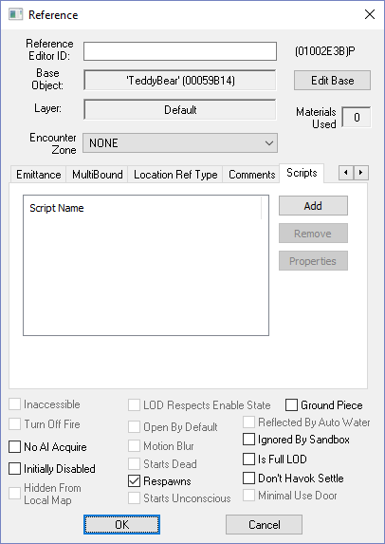
Click Scripts (tab) > Add (button) | 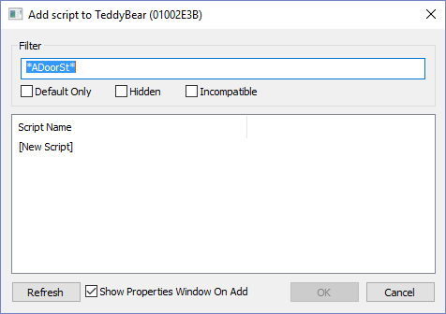
Click [New Script] | 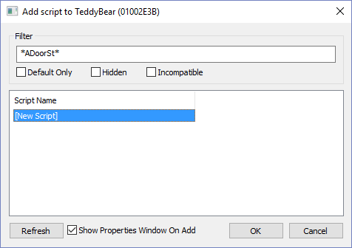
Click OK | 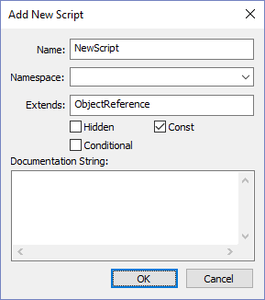
Enter a Name: for the script  I used AshSkowTeddyBear | 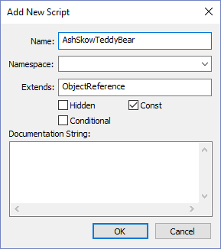
Click OK  Recall I said when the player retrieves the TeddyBear, it updates the Quest Stage # to retrieved (30). But the Teddy Bear needs access to the AshSkow Quest Object, and we give it access via a property | 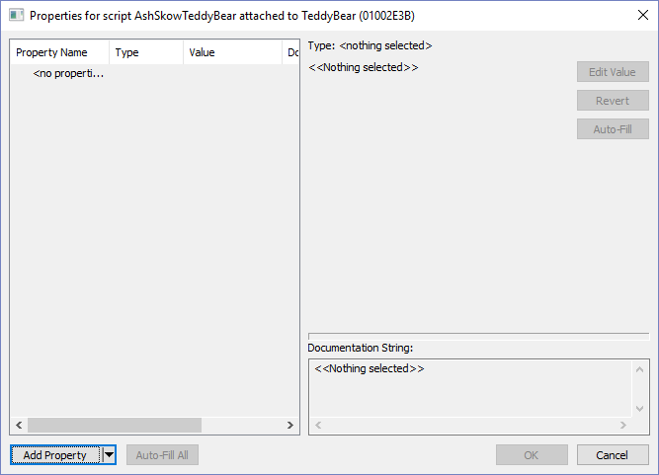
Click the Add Property Button | 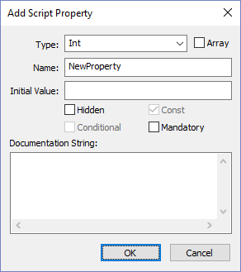
Select Quest as the Type: and enter a Name:  I used pQuest, for property Quest. The name is arbitrary, subject to typical programming variable name conventions. | 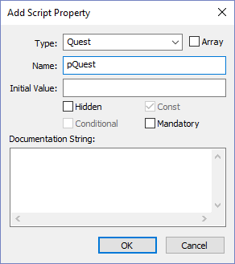
Click OK | 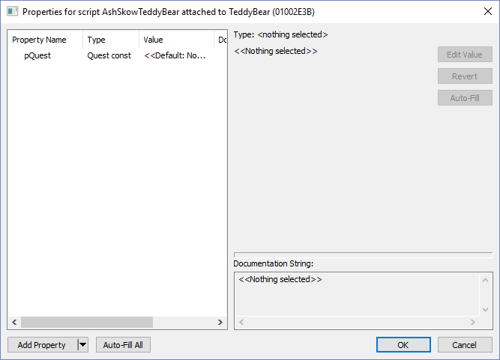
Select pQuest | 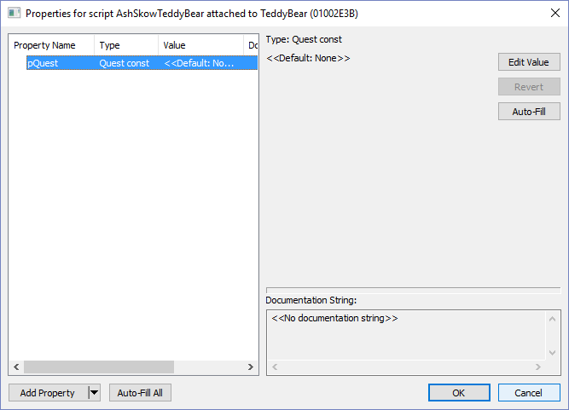
Click the Edit Value button | 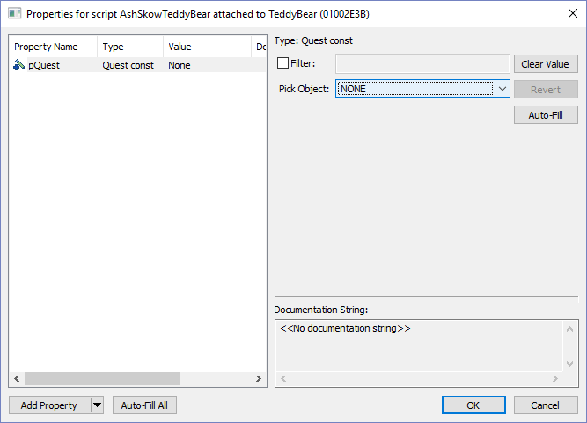
Select AshSkowQuest in the Pick Object: drop-down | 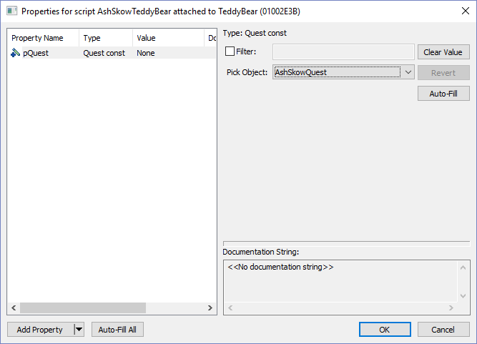
Click OK | 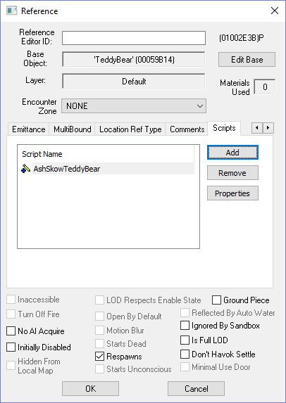
Right-click over the Script Name | 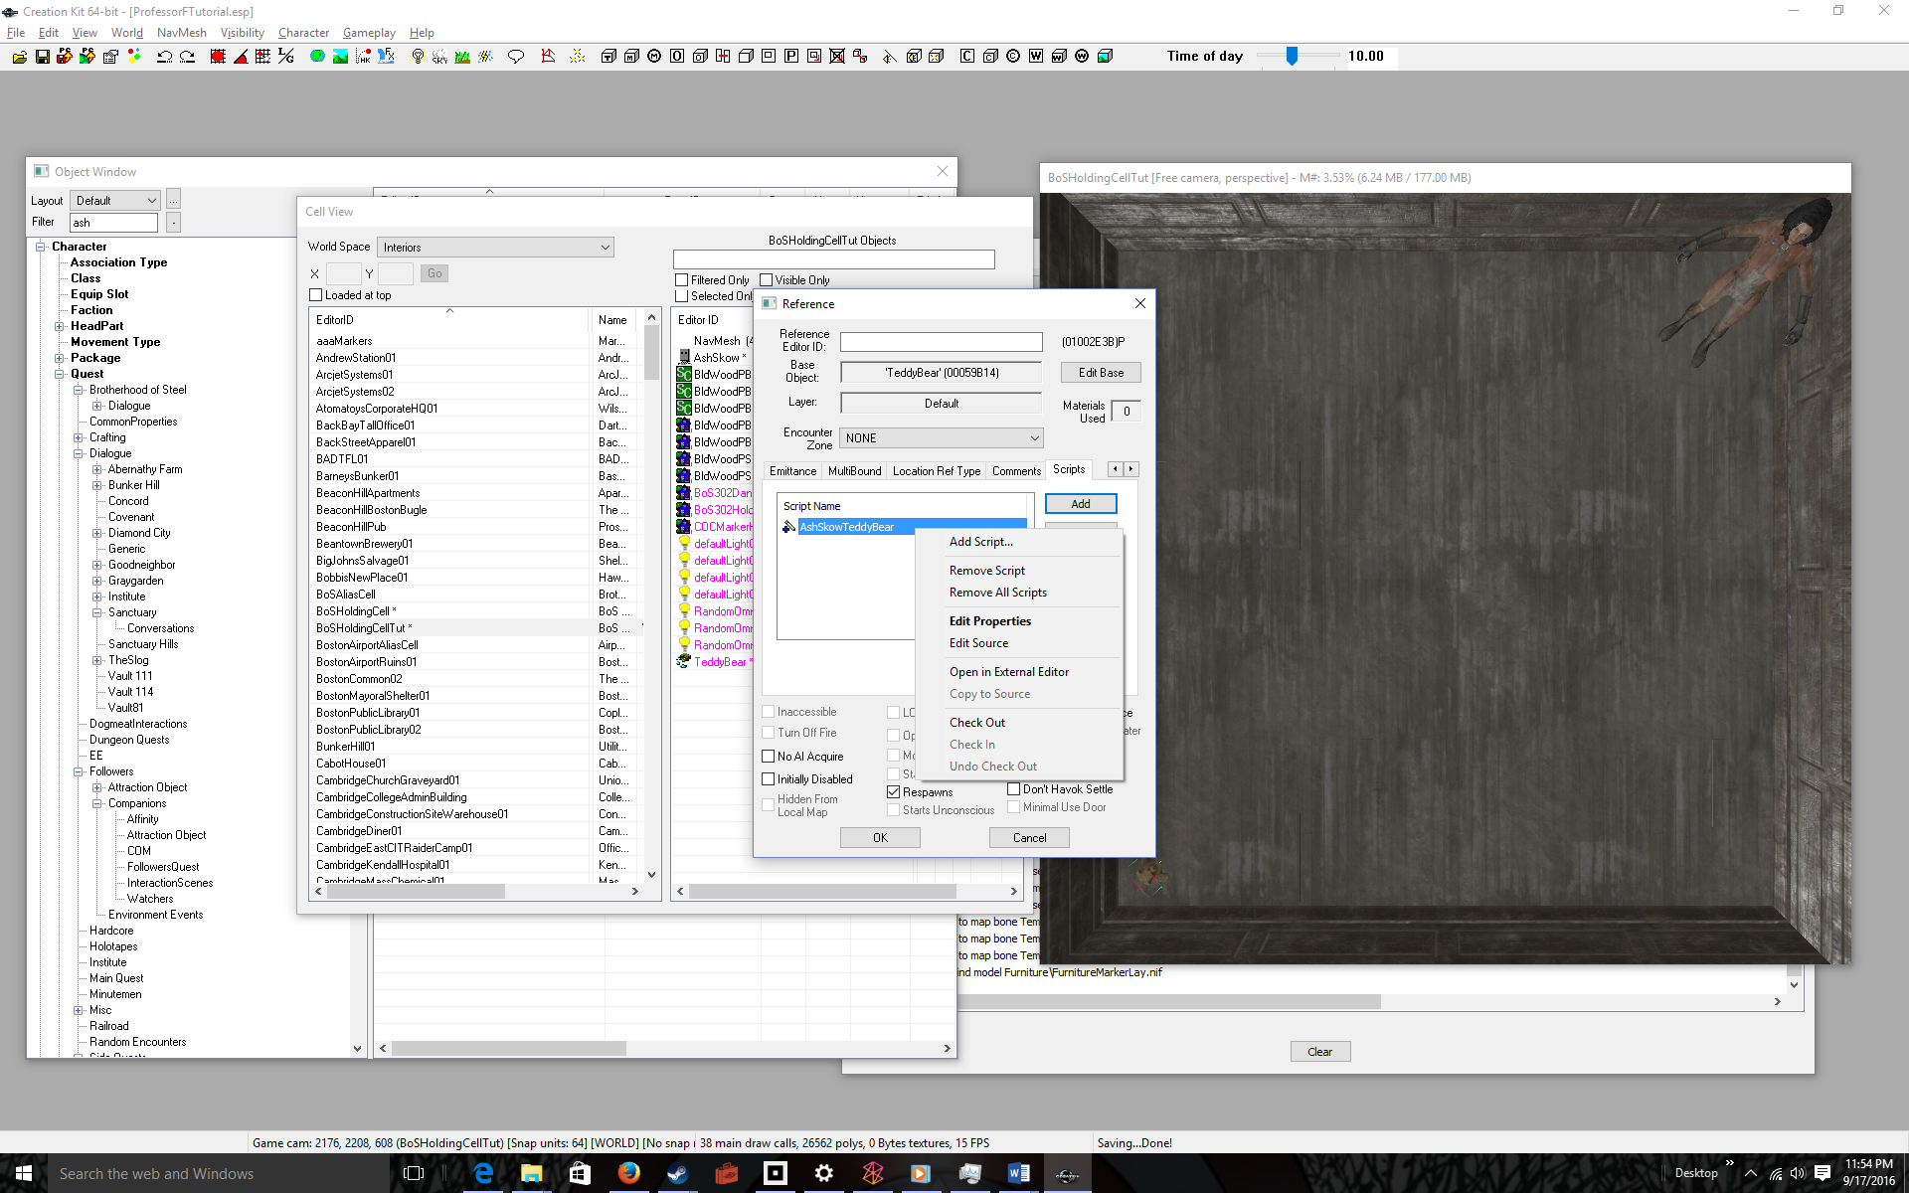
Select Edit Source | 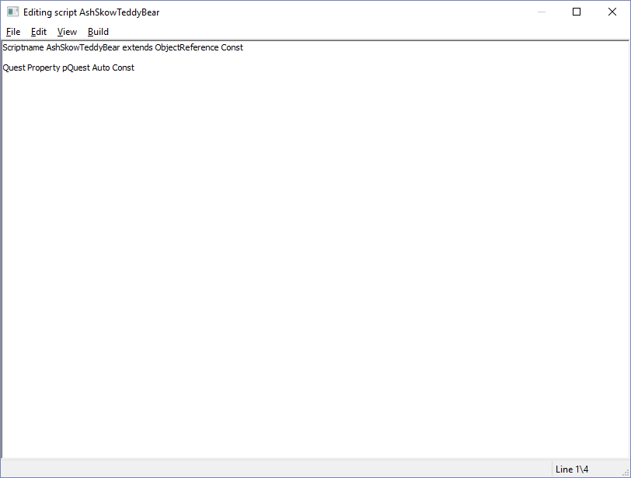
Add the following code to advance the Quest Stage # to the retrieved index  Event OnActivate(ObjectReference akActionRef)  pQuest.SetStage(30)  EndEvent | 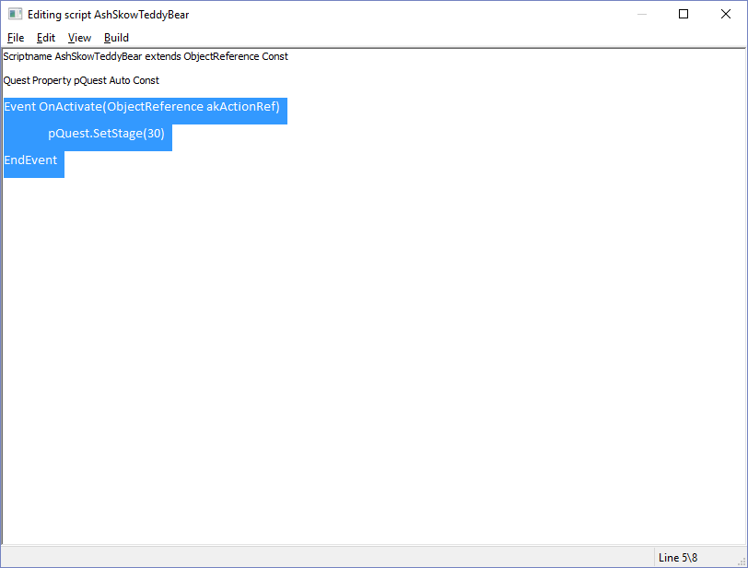
File > Save to compile | 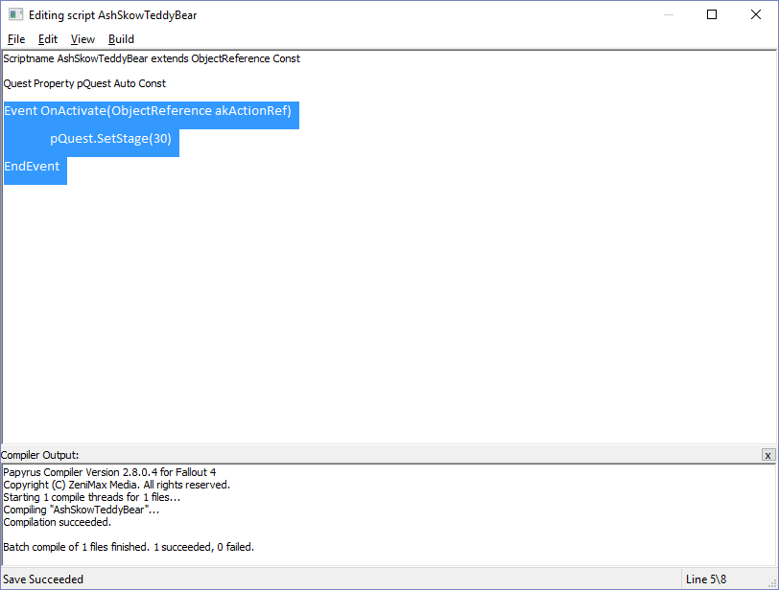
Close the Window | 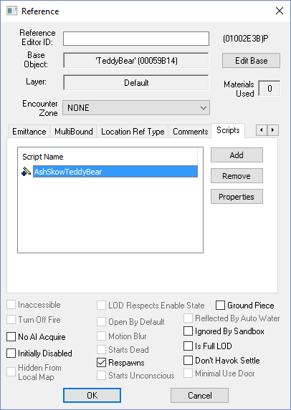
Click OK  END: PROCEDURE ADDING CODE TO AN OBJECT  So, your Teddy Bear now updates the stage to 30 (object retrieved) when the user clicks on it.  Next we need to tell the player the retrieve subquest (20) is completed, and display the objective or returning the object to the NPC (30) | 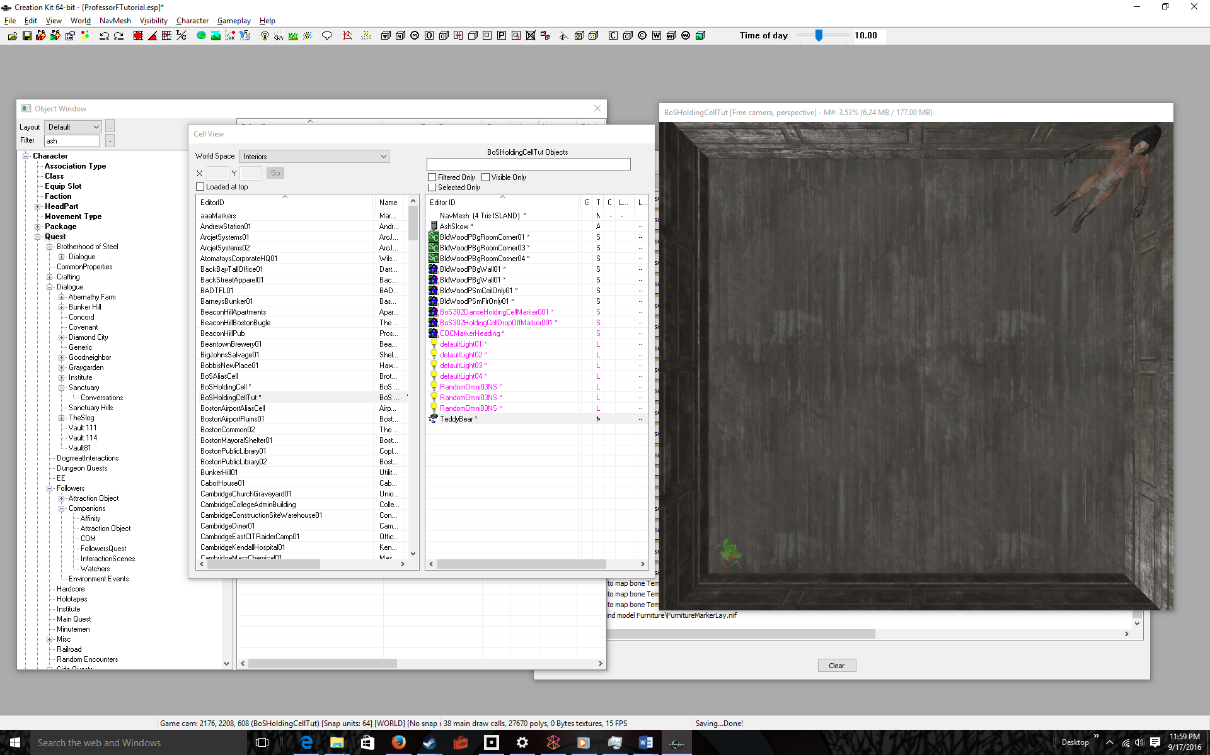
Bring up the Quest and select the Quest Stages tab | 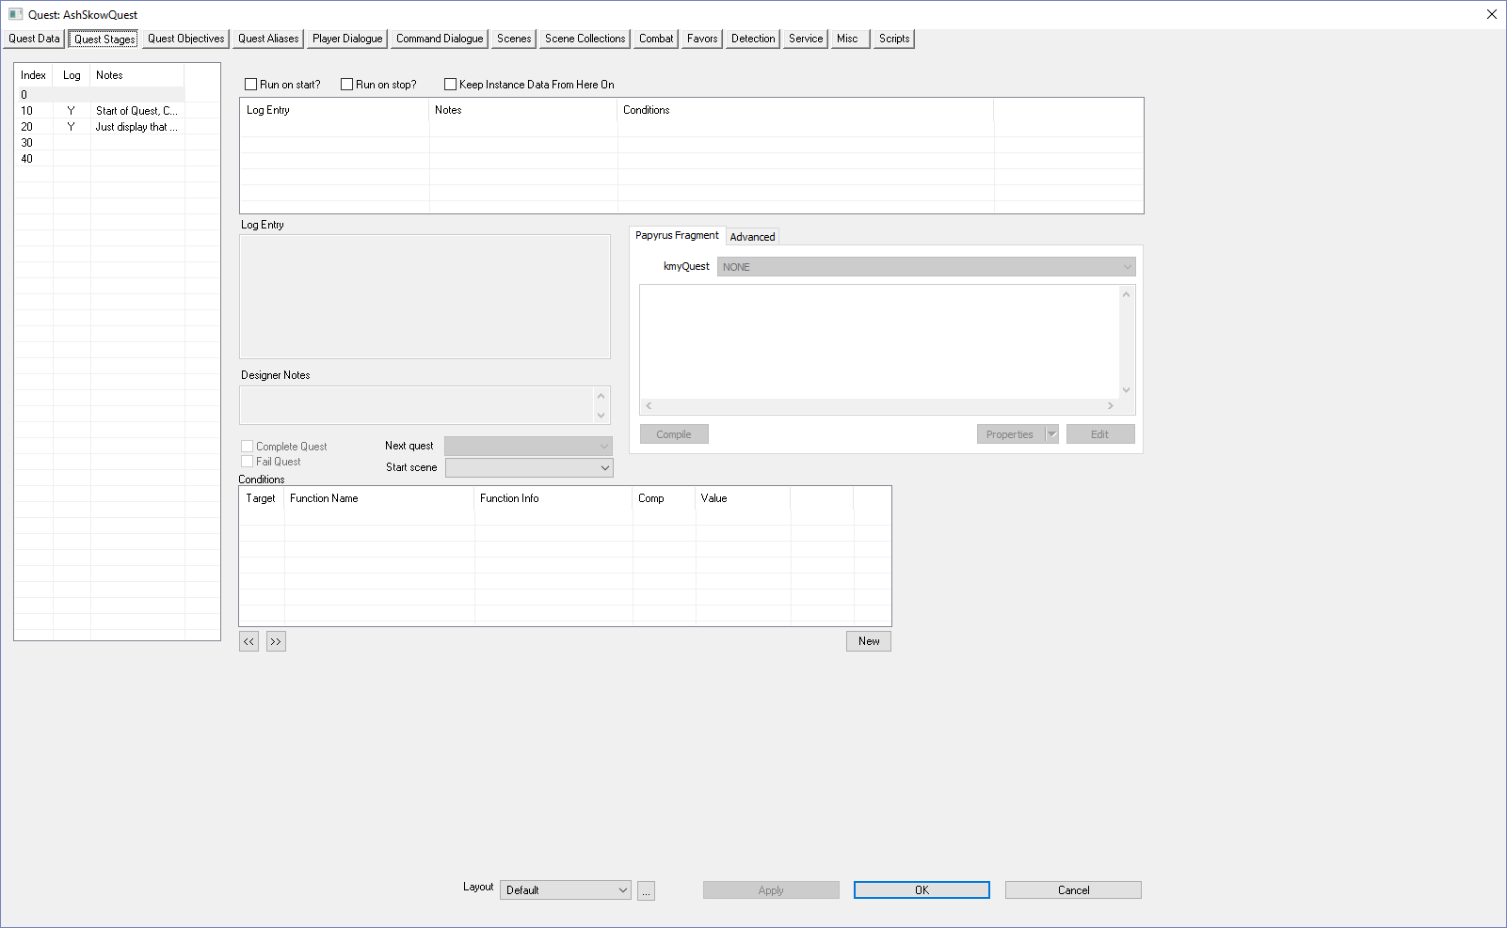
Select the Retrieved Quest Stage Index (30) | 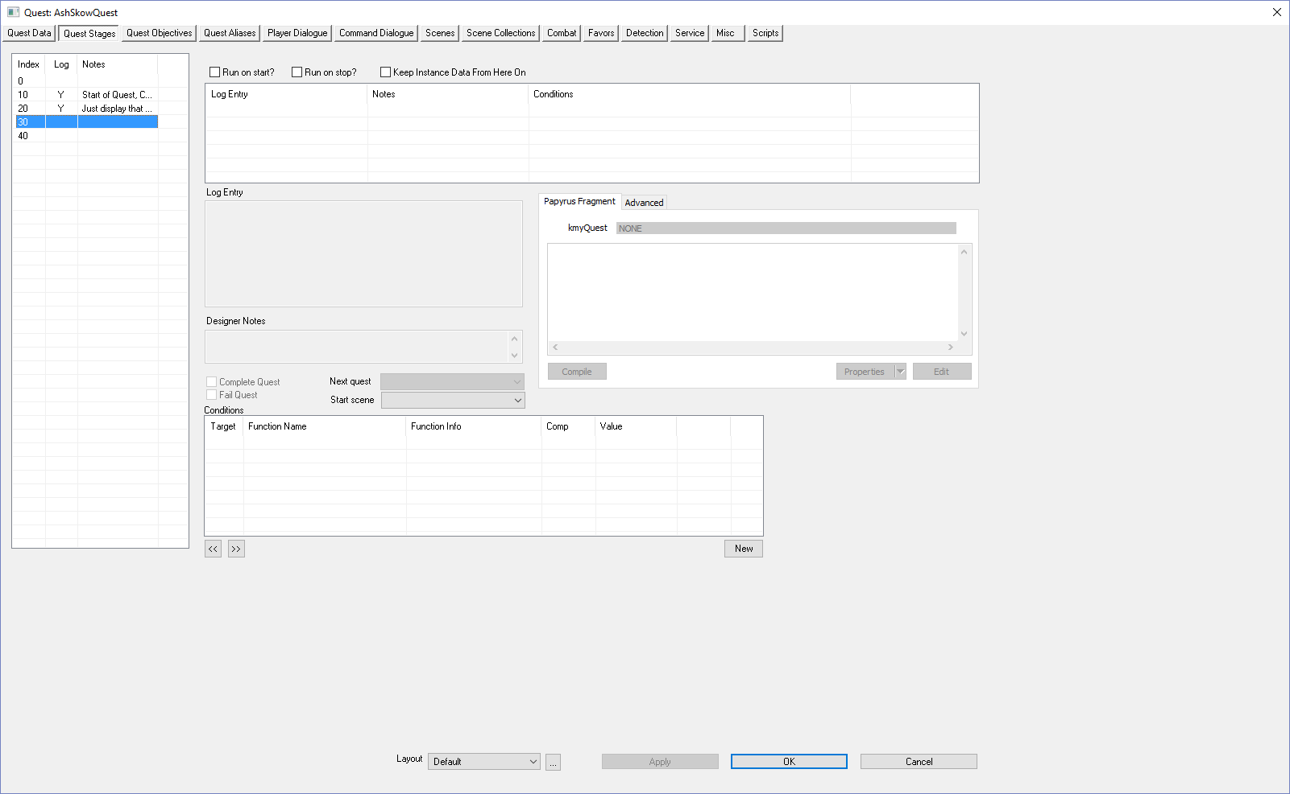
Right-Click over Log Entry | 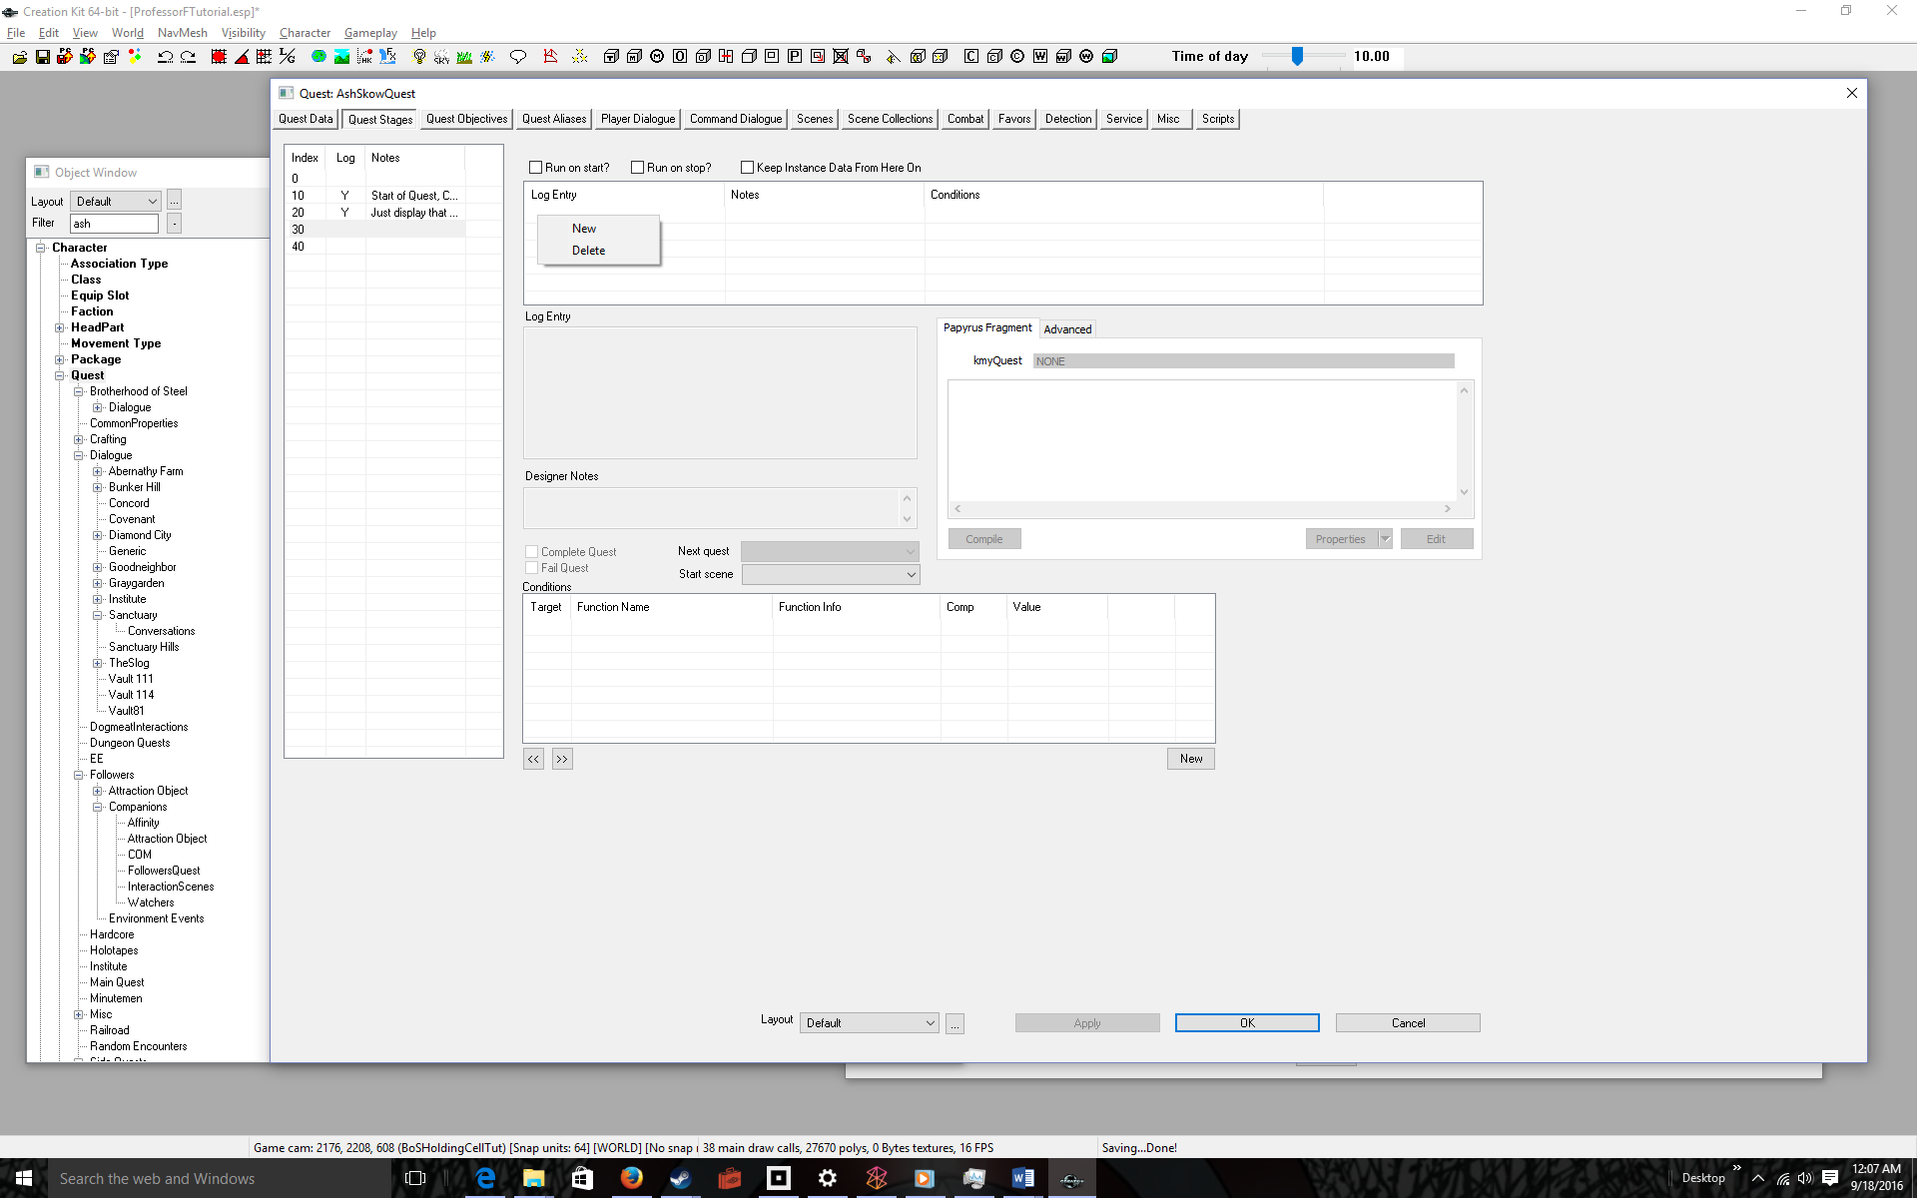
Select New | 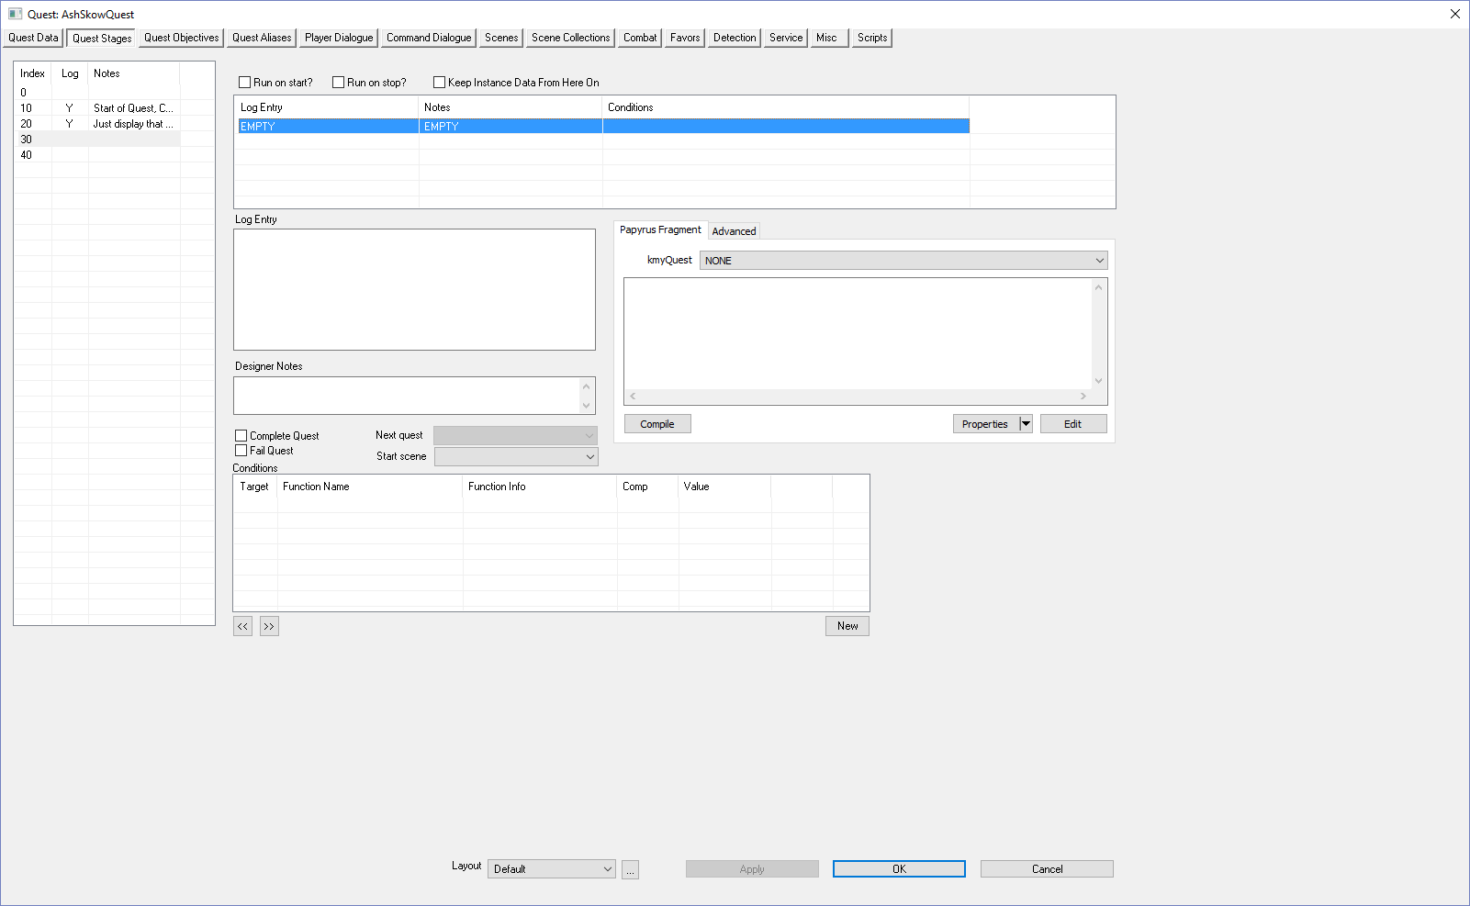
Add a Log Entry, Designer Notes, and finally the Code to complete the previous objective (20) and to display the new objective (30).  Compile | 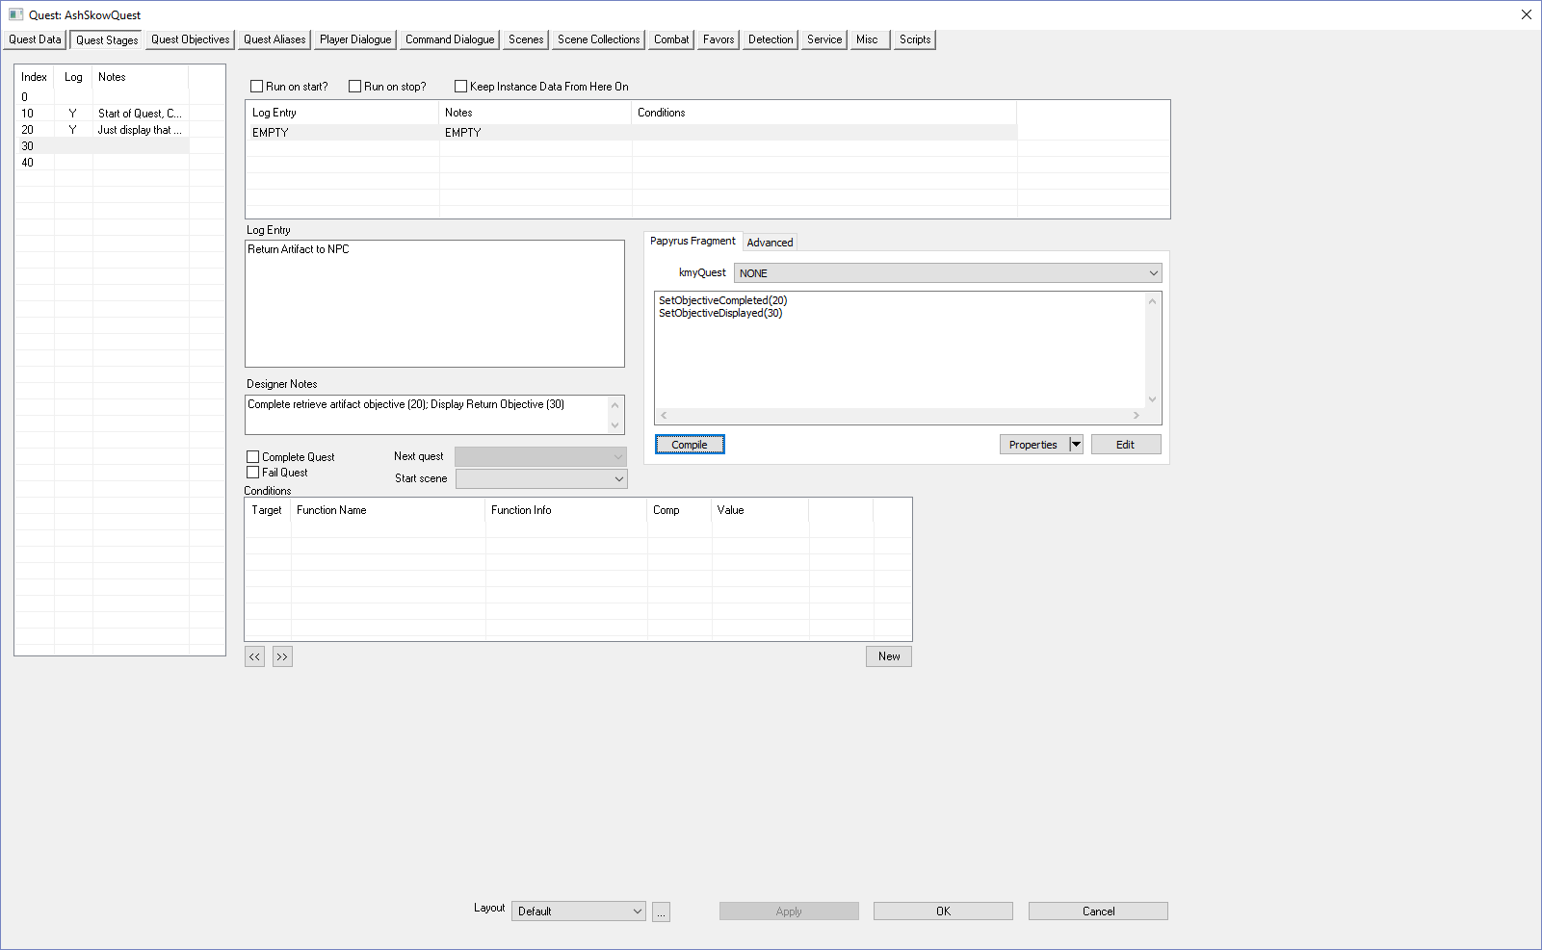
Click on the Quest Objectives Tab  Make sure you understand why we completed Objective Index 20 and displayed Objective Index 30 | 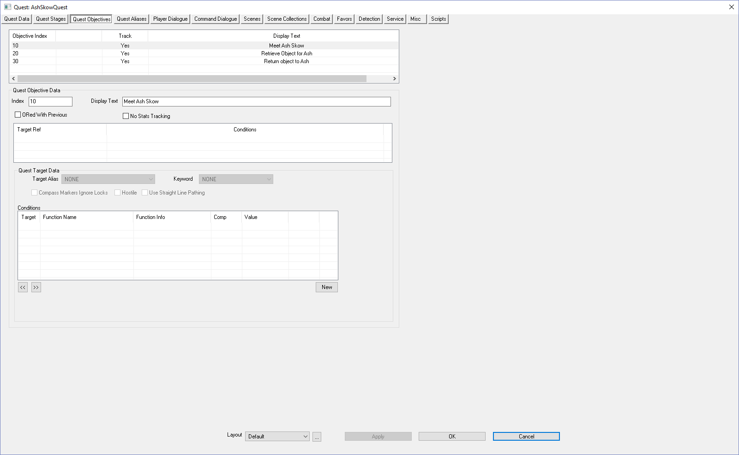
Go Back to The Quest Stages Tab | 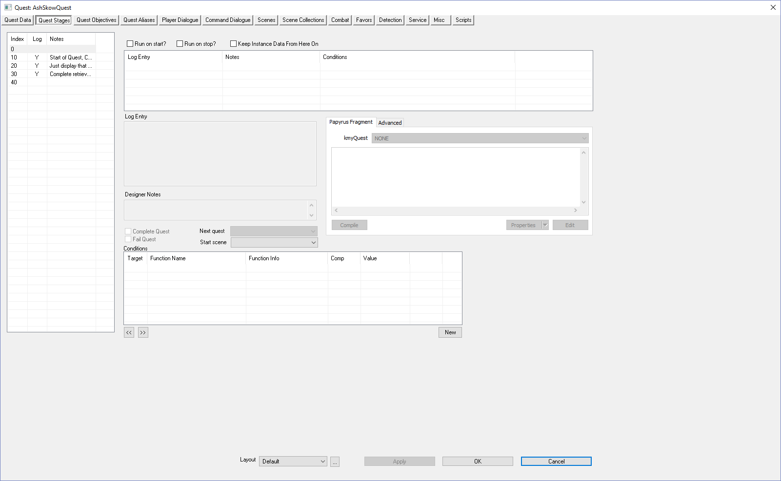
Click OK  Yes, we could have clicked OK in Quest Objectives, but I wanted you to see that the Quest Stage Index panel had updated.  Time to test. | 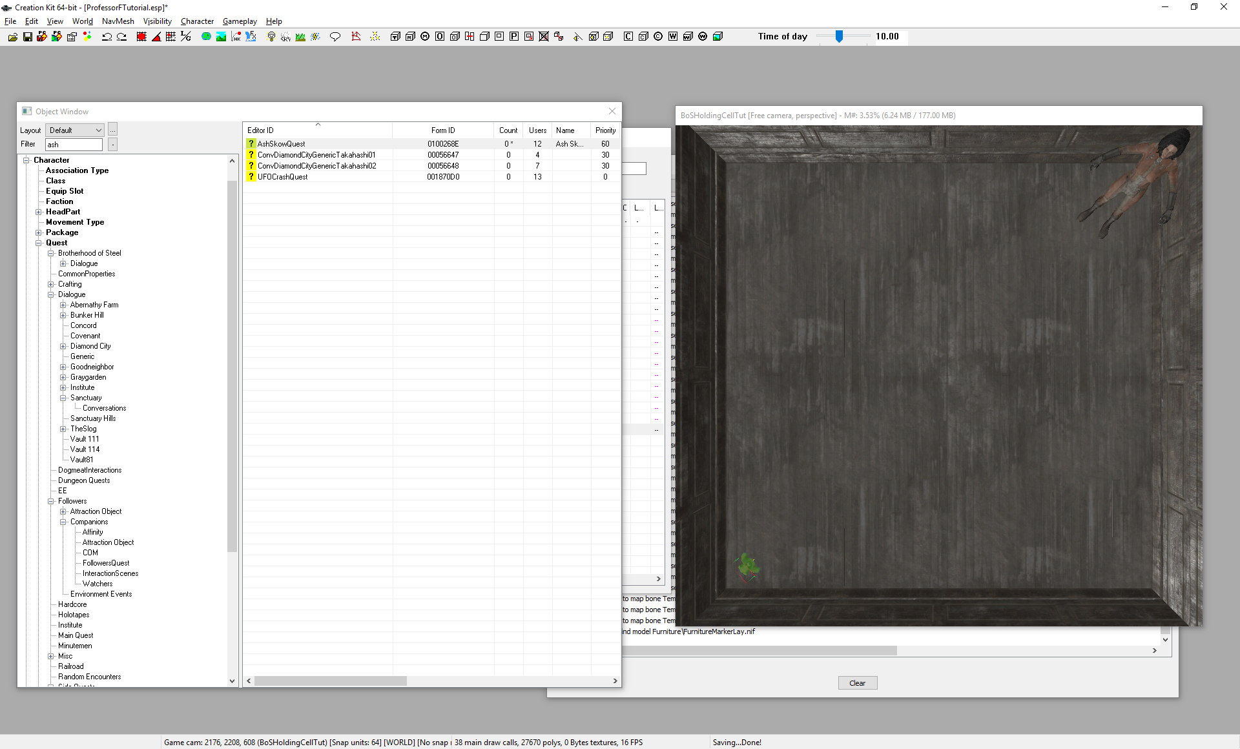
File > Save | 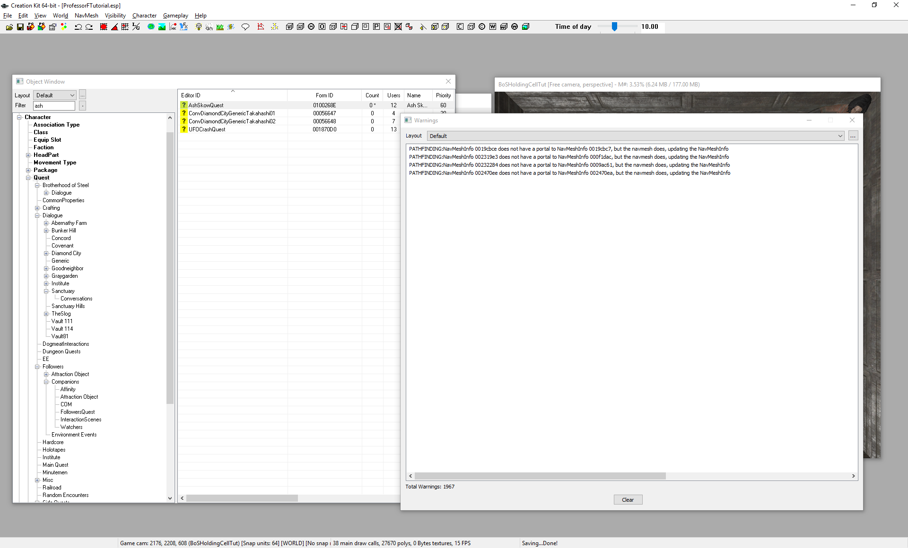
Run Fallout 4 and ACCEPT THE QUEST, then turn around.  Yes, many steps not shown, but you know the drill. | 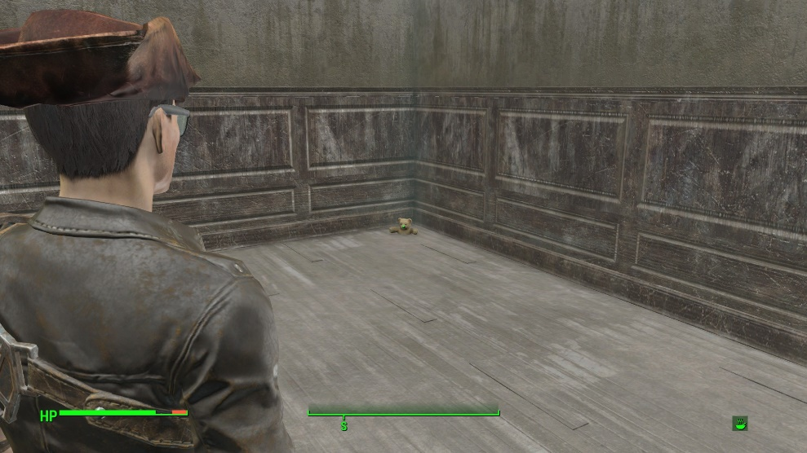
Get close to the artifact | 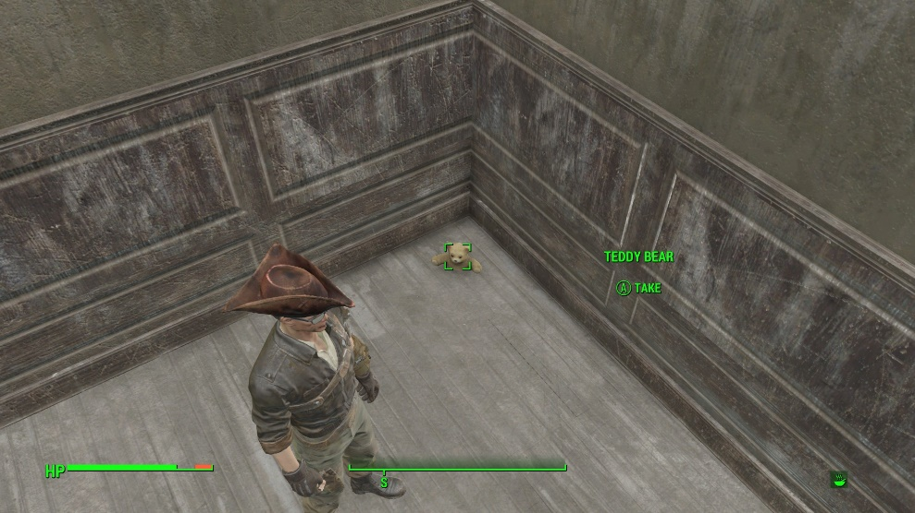
Take (A) the artifact.  You’re done. Now we just have to add dialog & code where we give the artifact back to the NPC, and end the quest. | 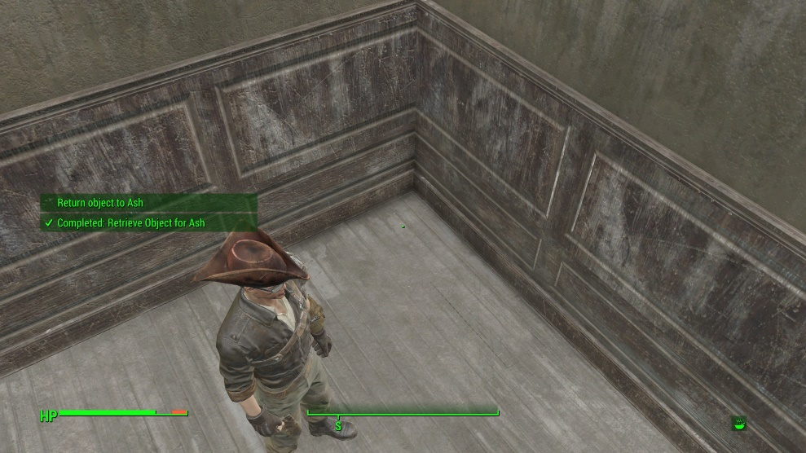

Don’t forget to quit out of the game! (ALT-F4 for the PC Master Race)

