How to Create a Fallout 4 Quest: Part 13— Ending Dialog
Nick V. Flor (nickflor@unm.edu)

*Start up your Mod in the GECK  Open up your Quest  Click on the Scenes tab  Note: *This is only if the GECK isn’t running, and yes I skipped a lot of steps because we’re far into these tutorials!  Having accepted the quest and having the artifact update the Object Stage to retrieved (30), we need to add a scene to handle the dialog when the player returns to the NPC. | 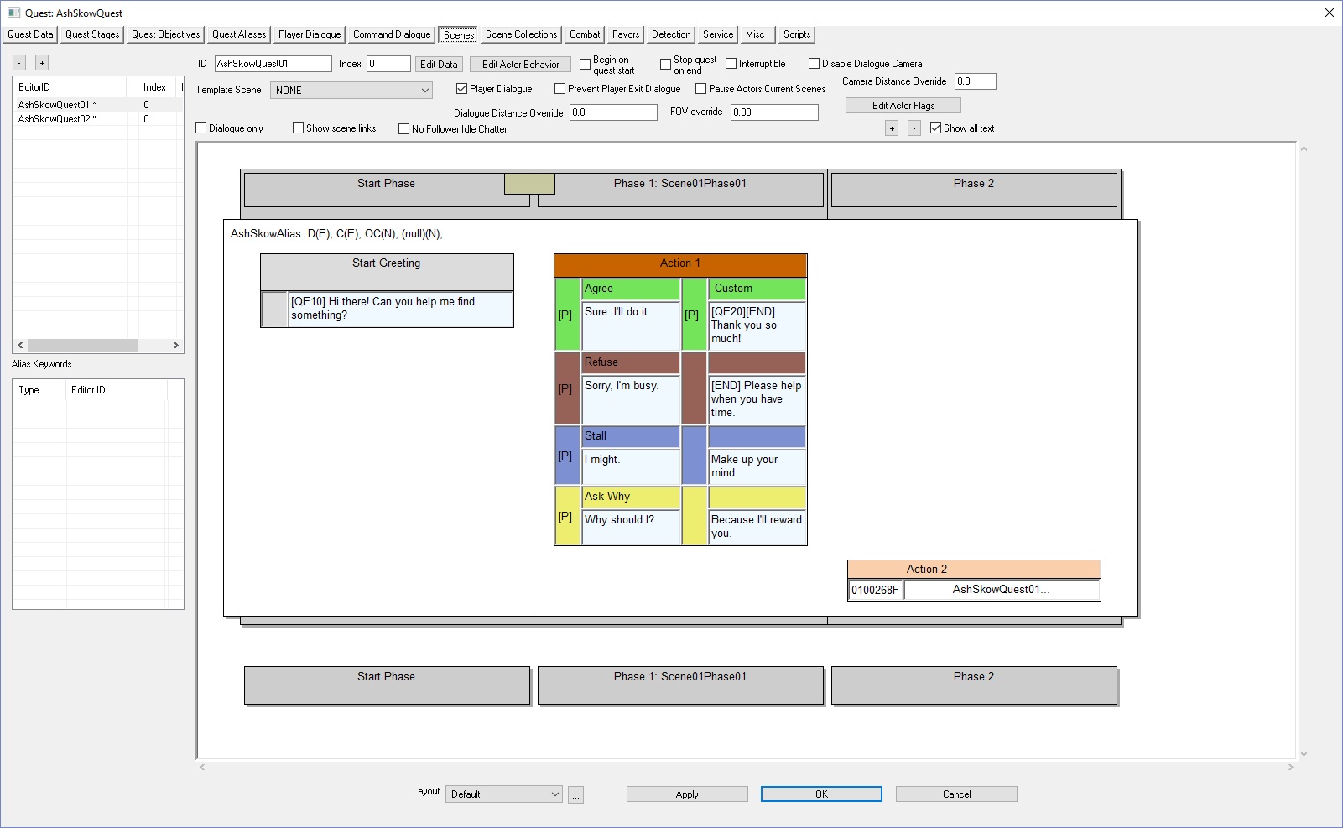
Right-Click over the EditorID panel  What we’re going to do is create a scene for returning the artifact to the NPC. The dialog will include text for refusing to give the artifact as well as text for being evasive. | 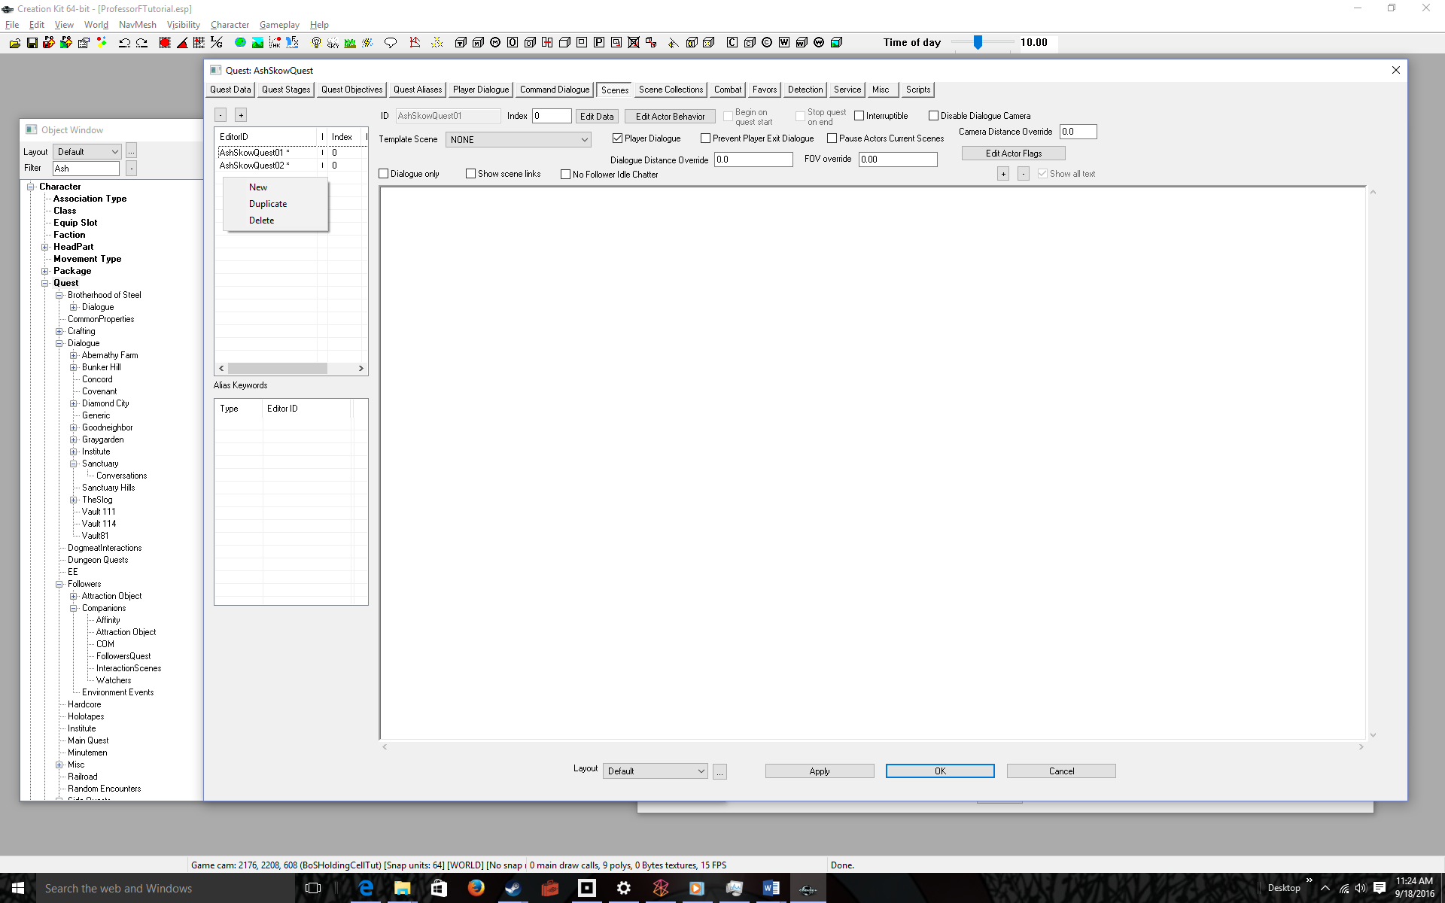
Select New  The quest ID is shown as a prefix. Don’t use that as a scene ID, do the next step | 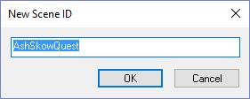
Append NN to the text  Where NN is the number of the scene, in our case 03. | 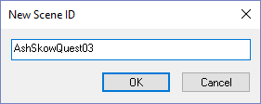
Click OK  Note the scene name appears in the EditorID list, AshSkowQuest03 | 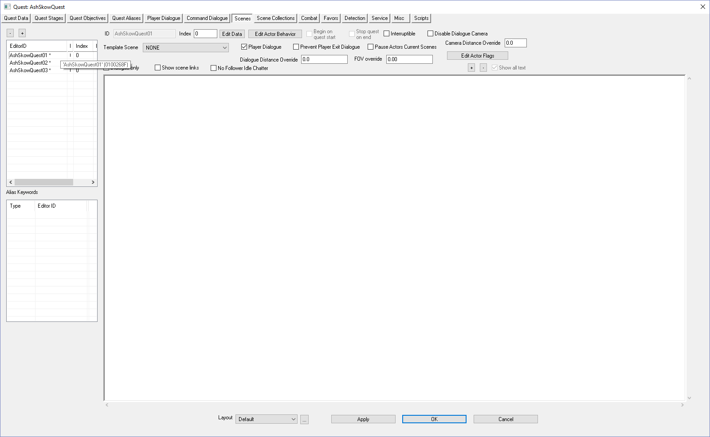
Click on the scene name  Note that the ID text box fills in with your scene name, AshSkowQuest03 | 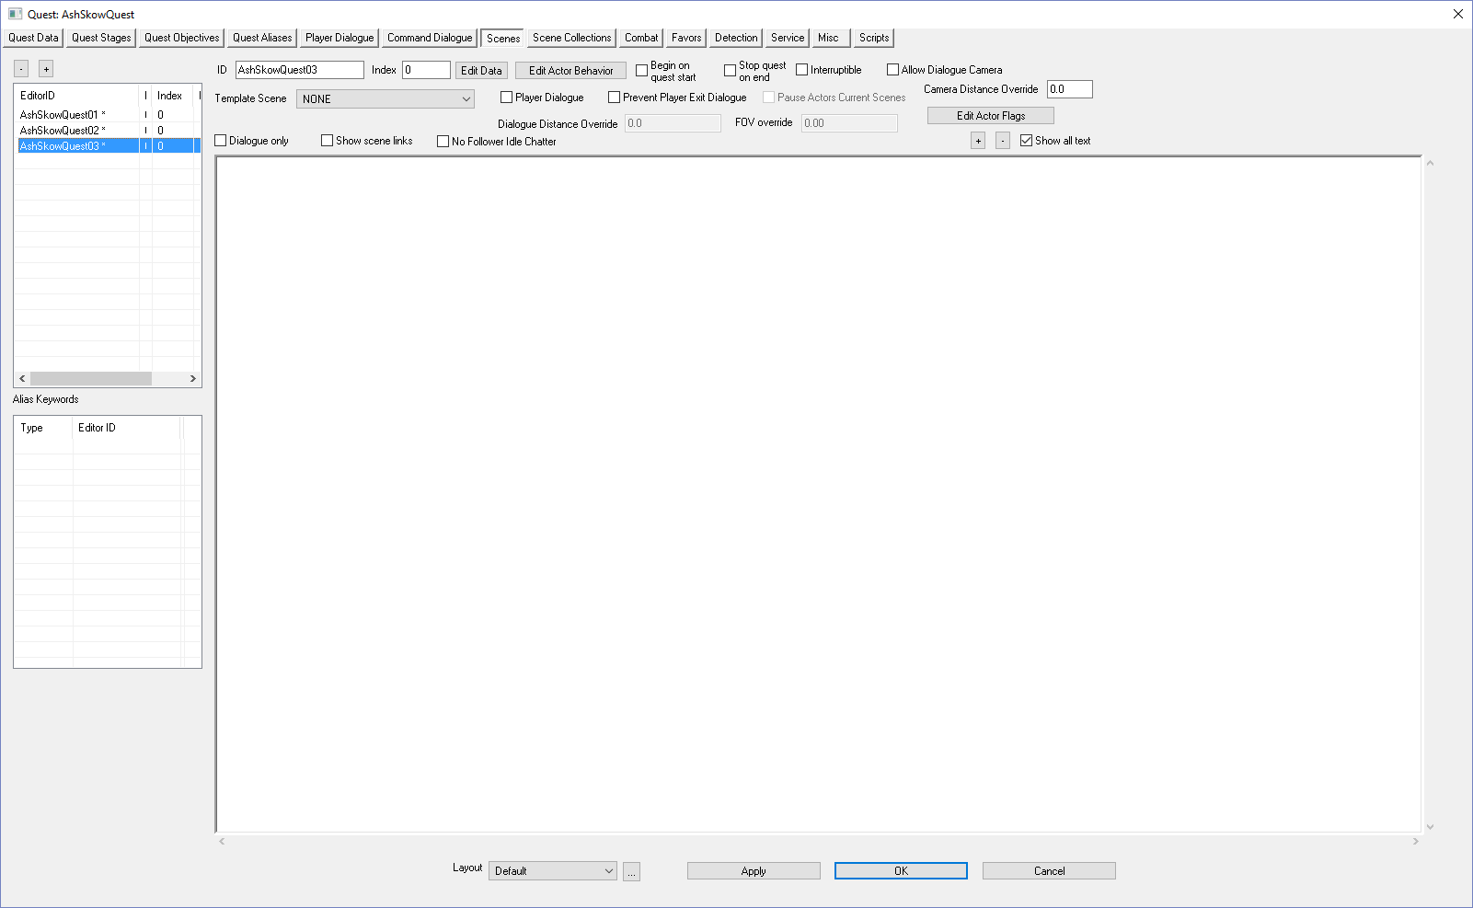
Click on the Player Dialogue checkbox | 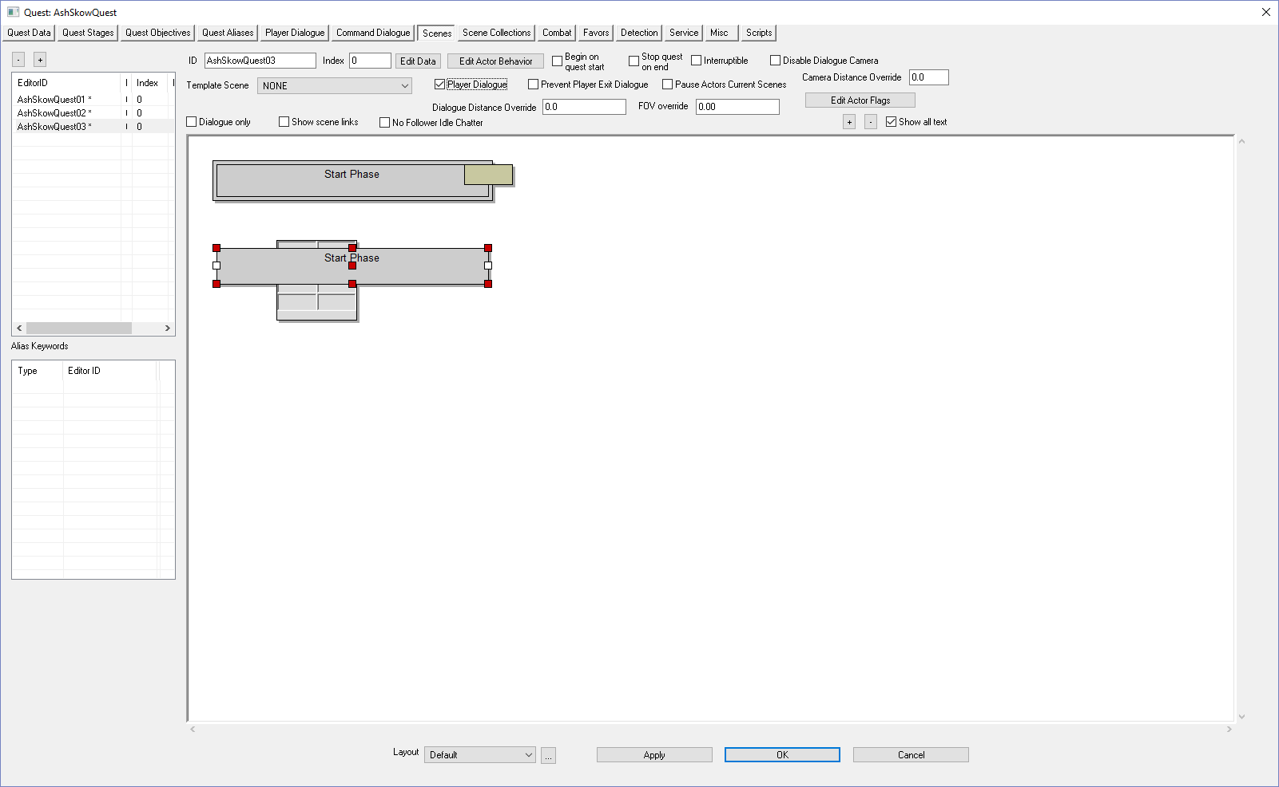
Right-click anywhere in the white area | 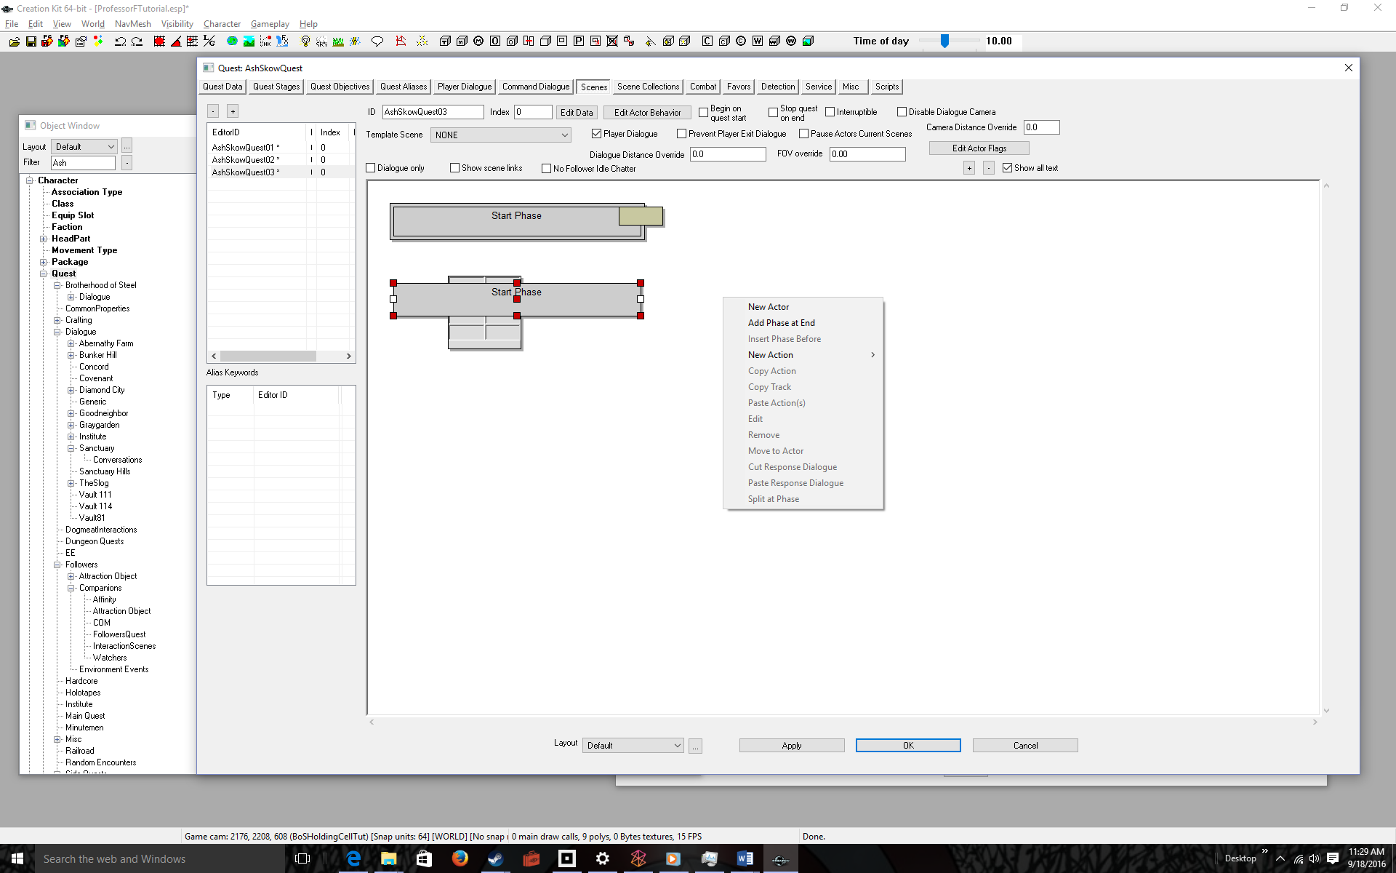
Select New Actor | 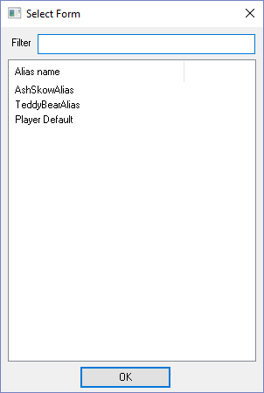
Click on your NPC alias (AshSkowAlias) then click the OK button | 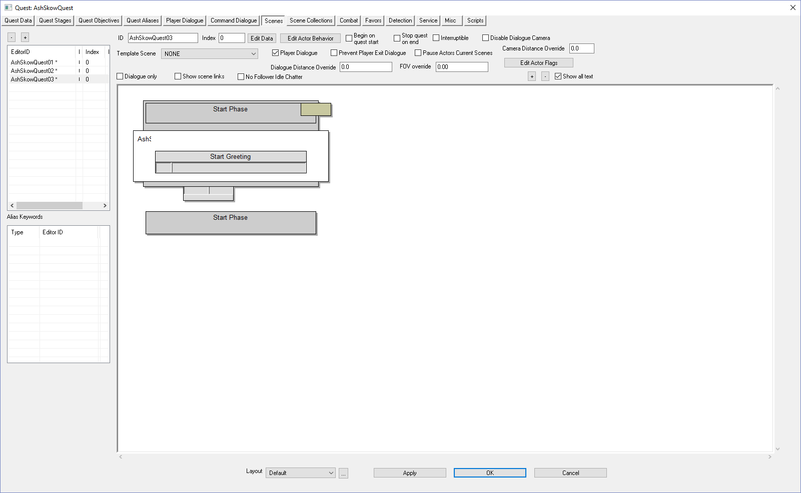
Double-click the empty gray box underneath Start Greeting  There are many inputs here, but the only one that matters is the Response Text. This is the greeting the player will see when prompted to talk to the NPC | 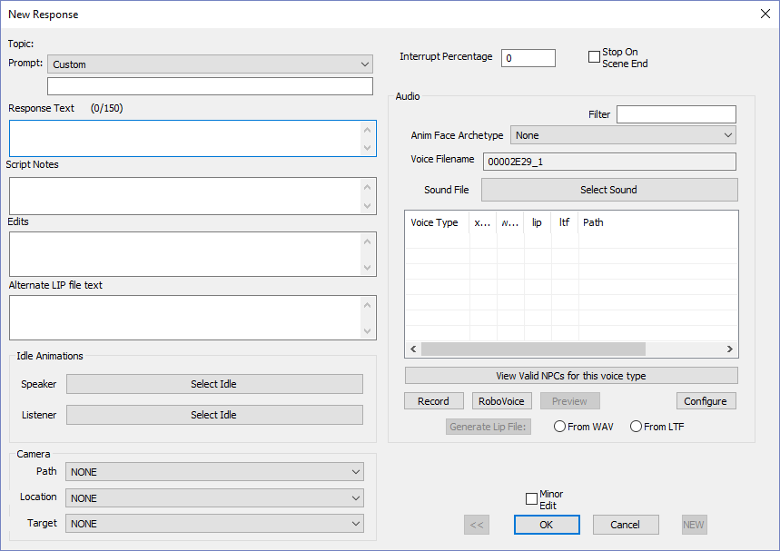
Type a greeting into the Response Text box  Example: “You’re back! Have you found anything?”  Remember, this is the ending scene and the player has retrieved the artifact already. | 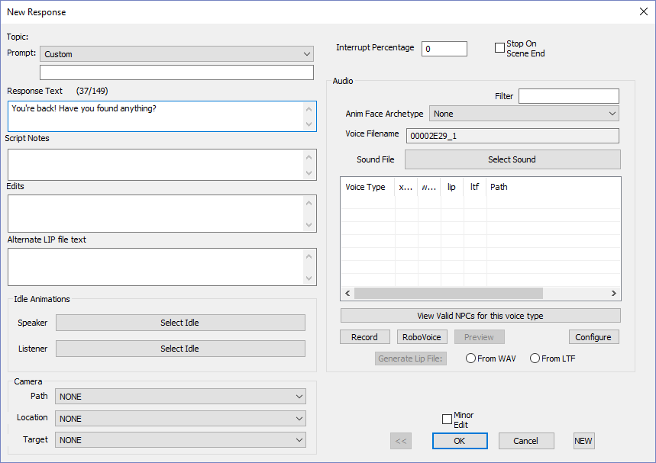
Click the OK button  Note the Response Text is filled with your greeting.  Now let’s restrict this dialog to the NPC and to only activate when the player has retrieved the artifacts (Quest Stage #30 ➔ < 40) | 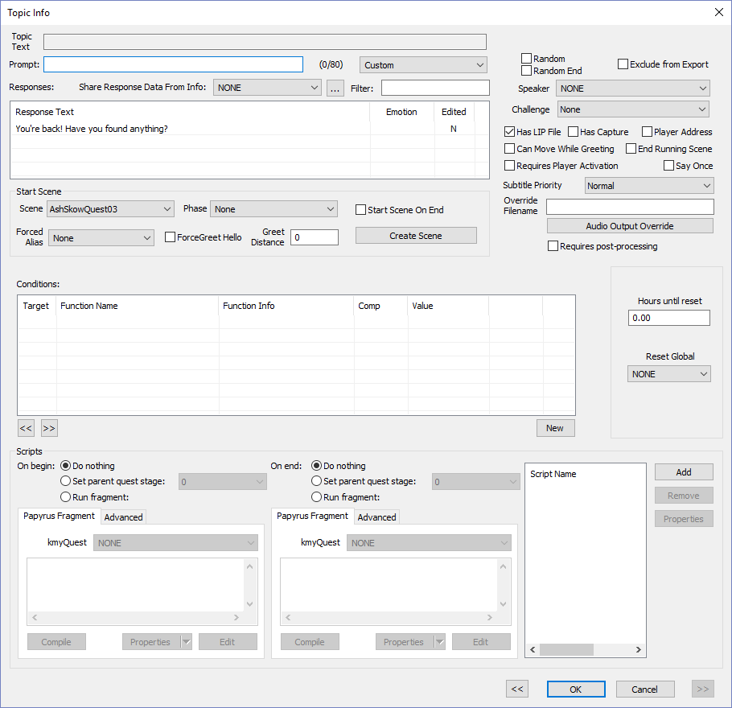
Click New | 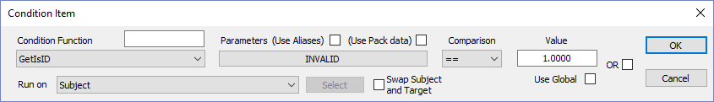
Click INVALID | 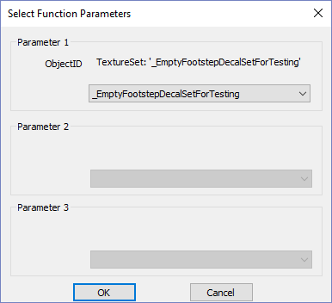
Select the NPC in the dropdown for Parameter 1 | 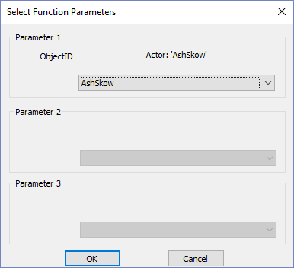
Click the OK button  So now, only the NPC (AshSkow) can say the dialog. If you don’t add this, the player or any NPC can do the dialog, if near. | 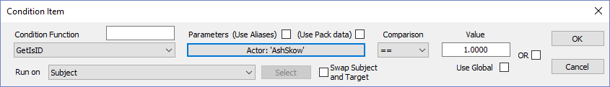
Click the OK button again  So we’ve restricted the dialog to our NPC (AshSkow). The last restriction (condition) for the dialog is to only activate it if the user has retrieved the artifact (Quest Stage #30, i.e., <40). | 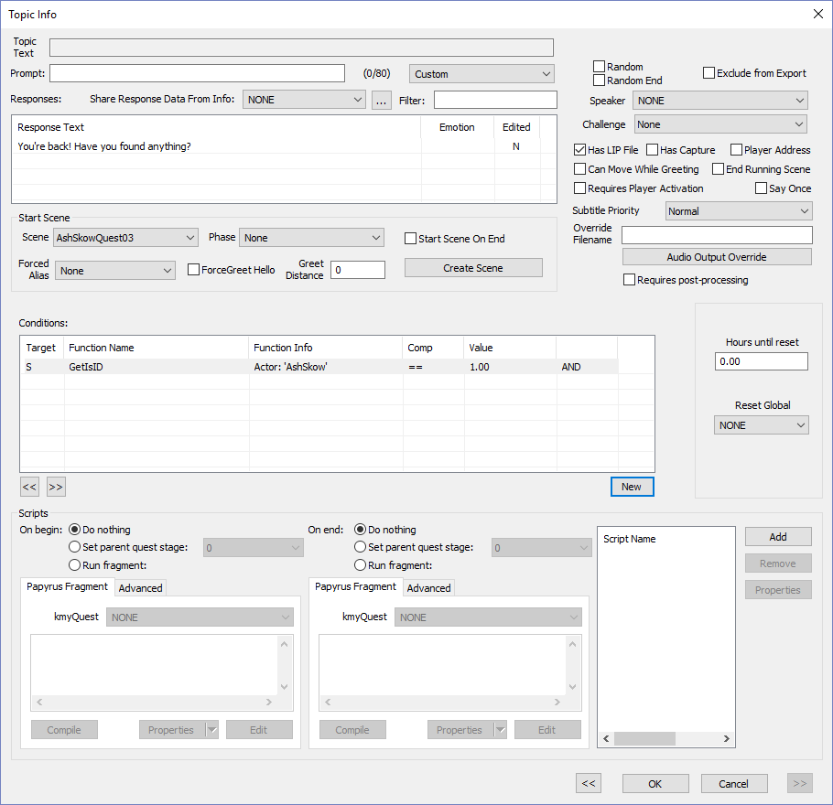
Click New
Select GetStage in the Condition Function drop-down, Set Comparison to <, and the Value to 40 | 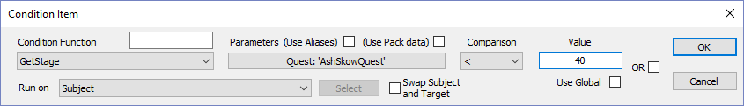
Click the OK button | 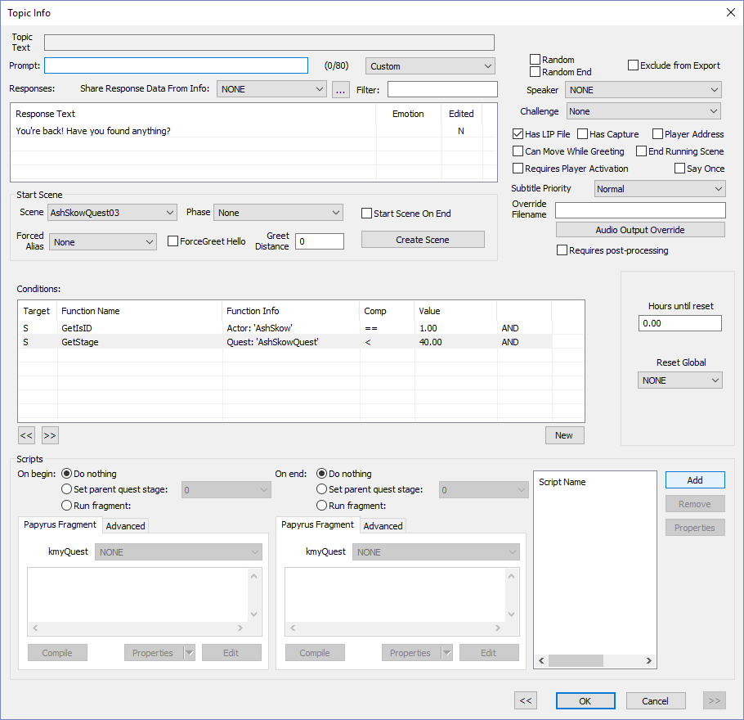
Click the OK button  You see all the greetings for all the scenes | 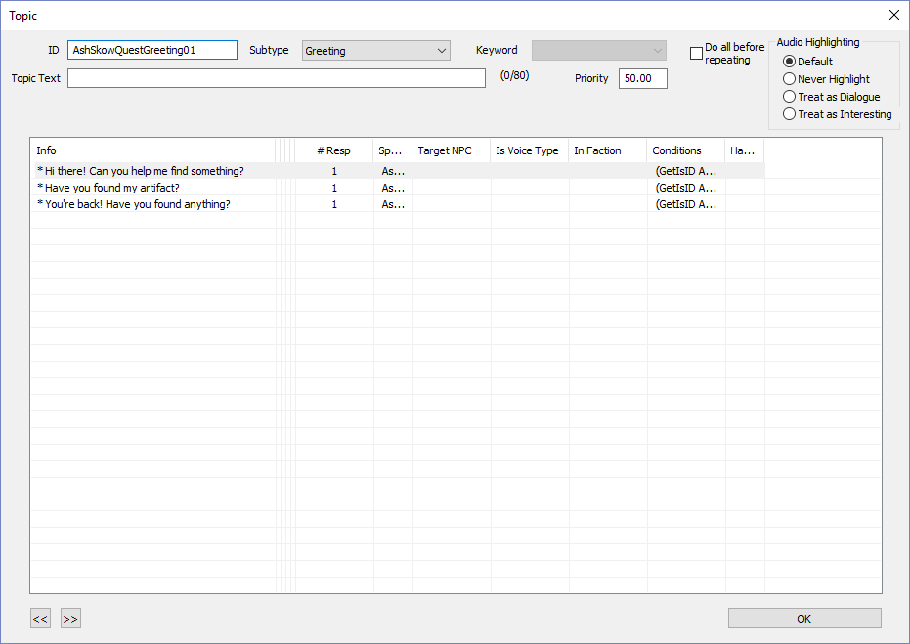
Click the OK button  Finally we’re back to the main scene window. | 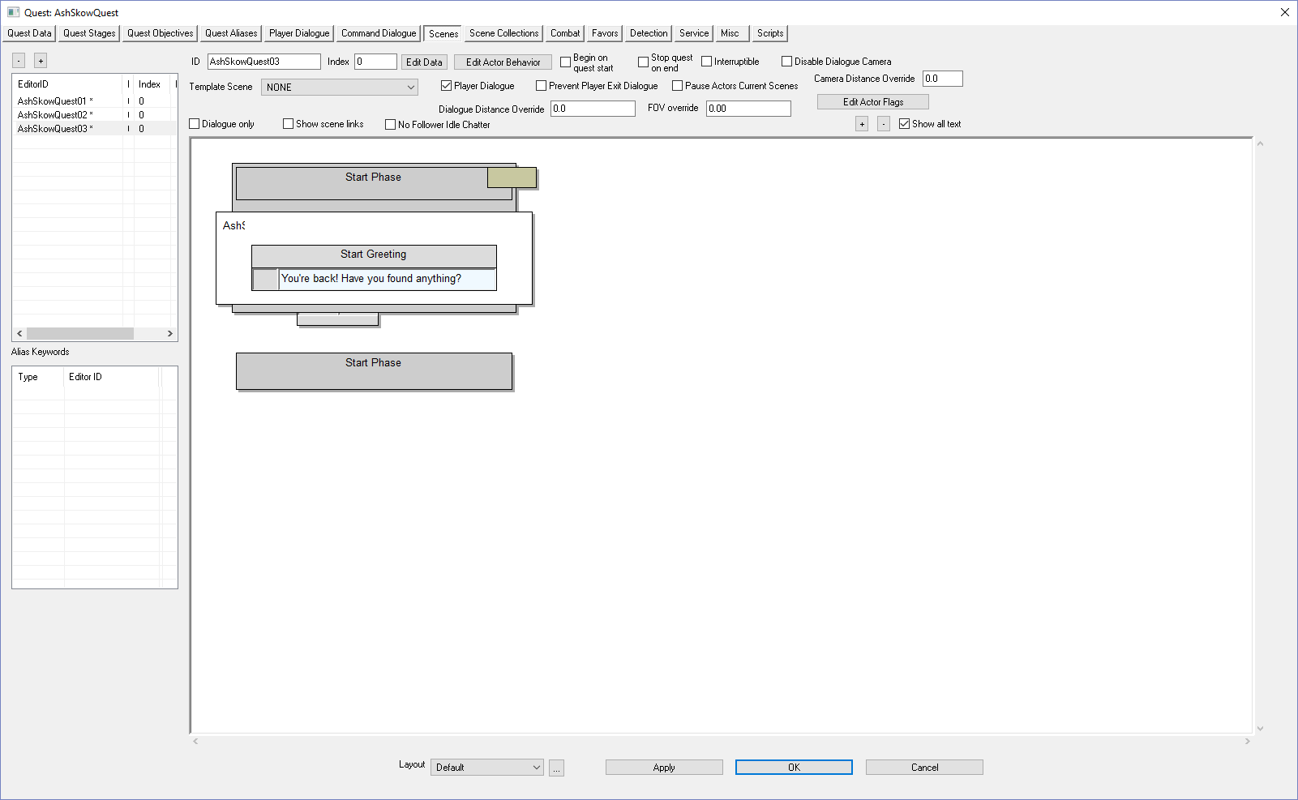
Right-click on the white scene area | 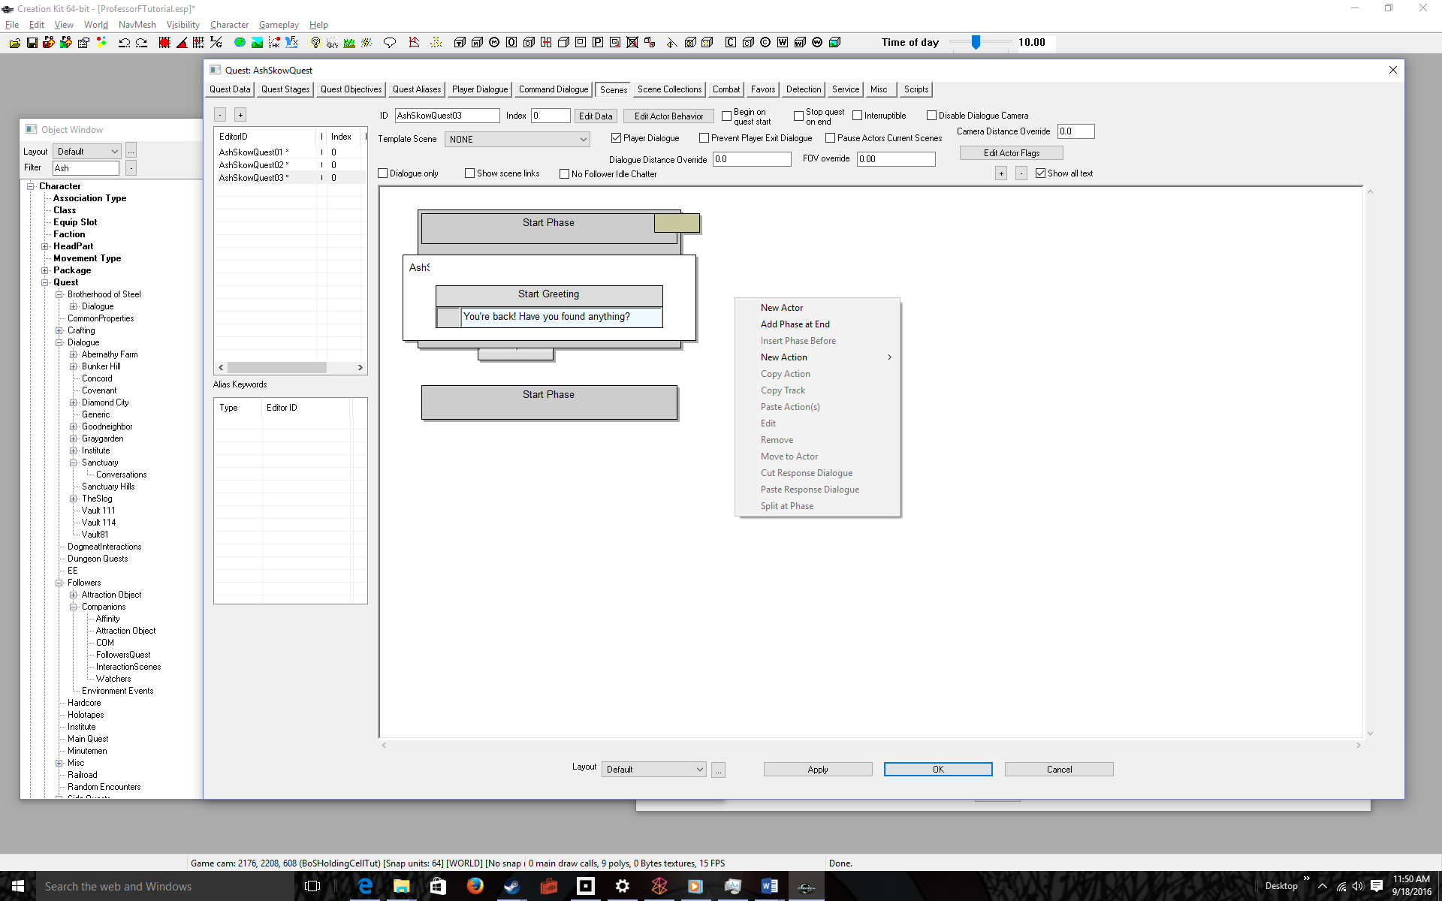
Select Add Phase at End  Typically each phase contains dialog. After the greeting, we will add 4-part interactive dialog, which requires adding a Phase 1 | 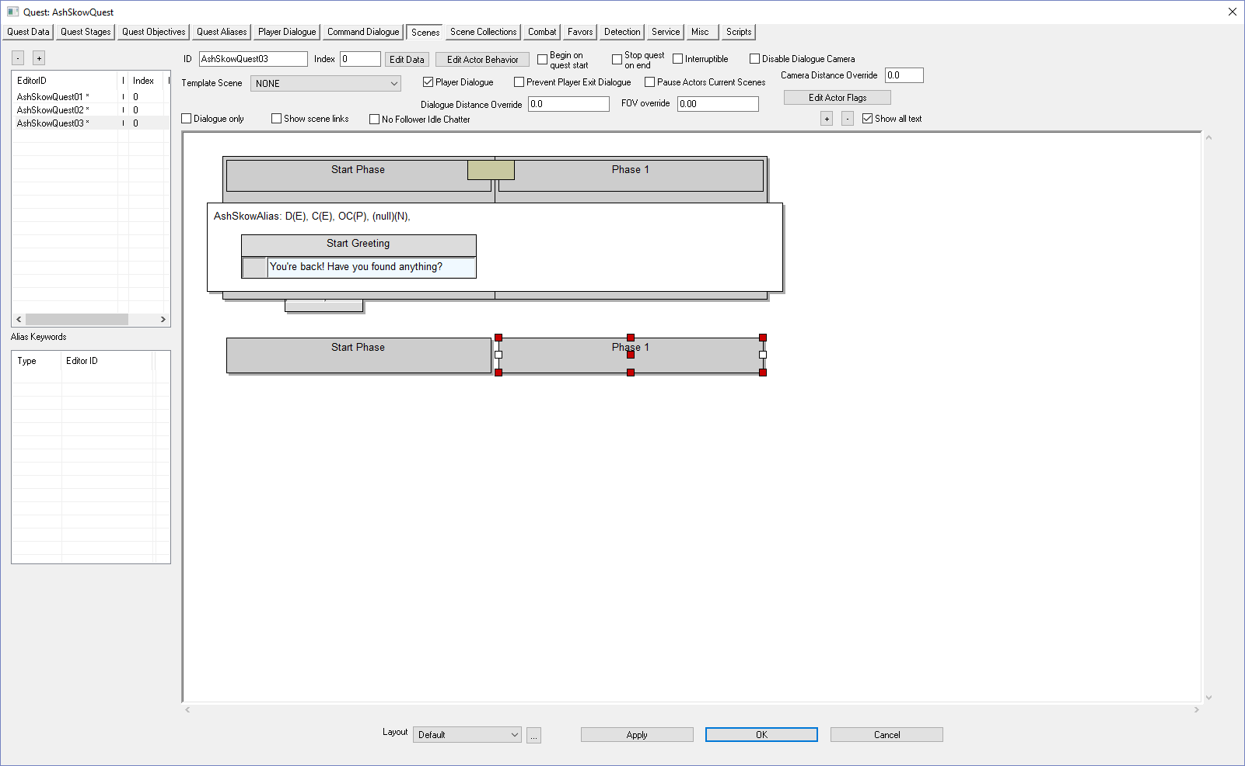
Right Click Over the Phase name | 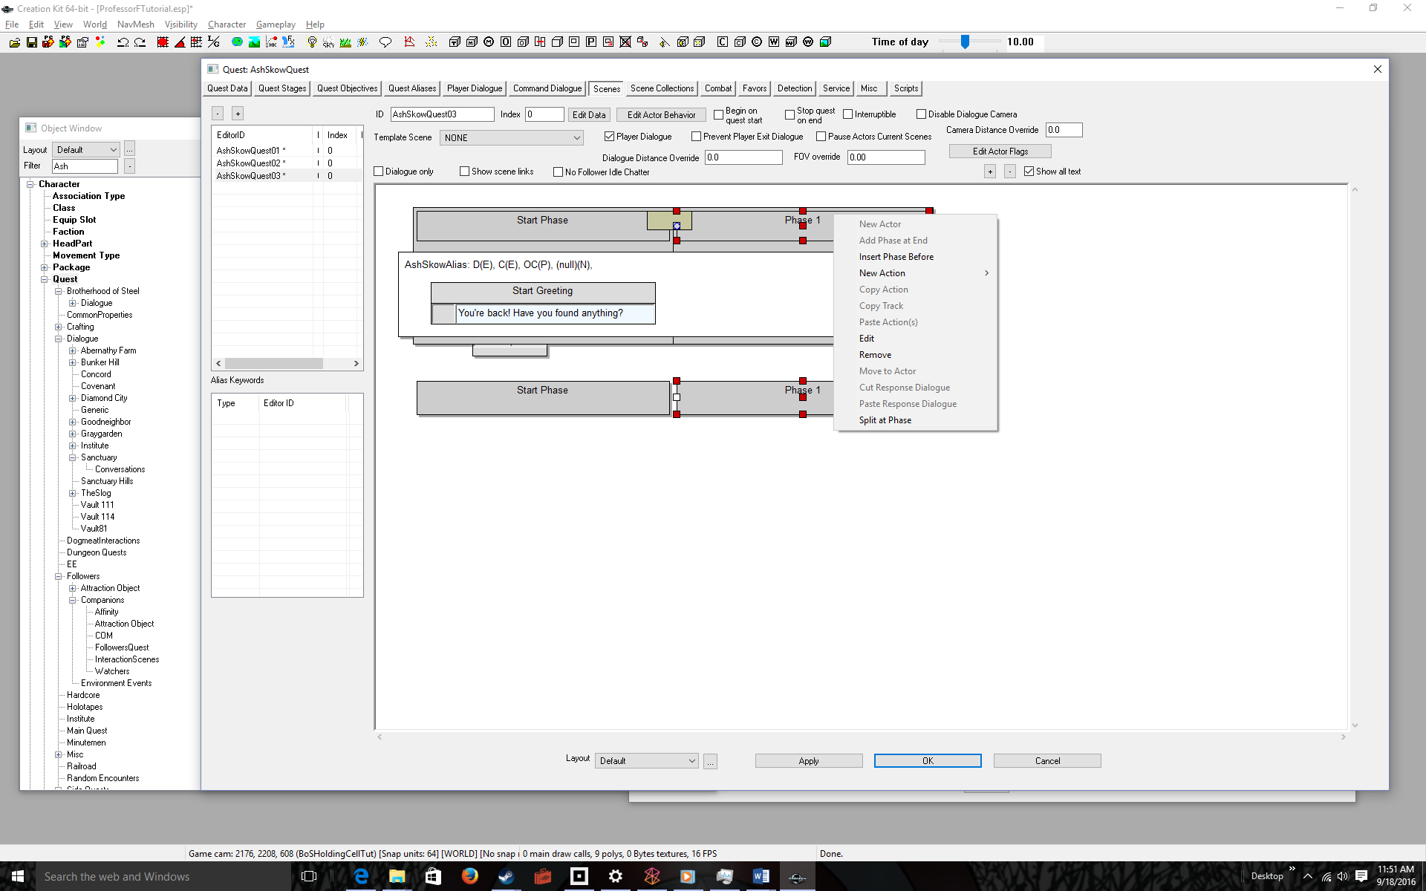
Select Edit | 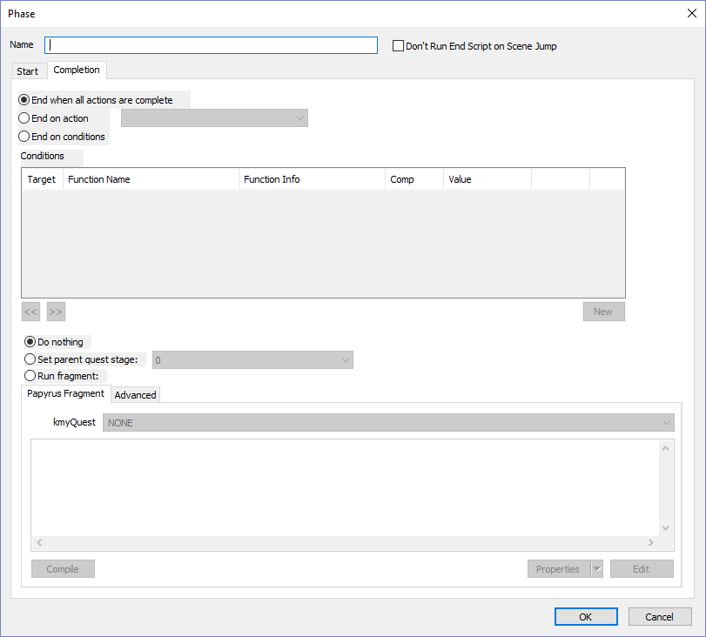
Give the Phase a name  Like Scene03Phase01  Why are we doing this? Because it will allow us to loop to the phase and repeat the 4-part dialog until the player either accepts or denies the quest. | 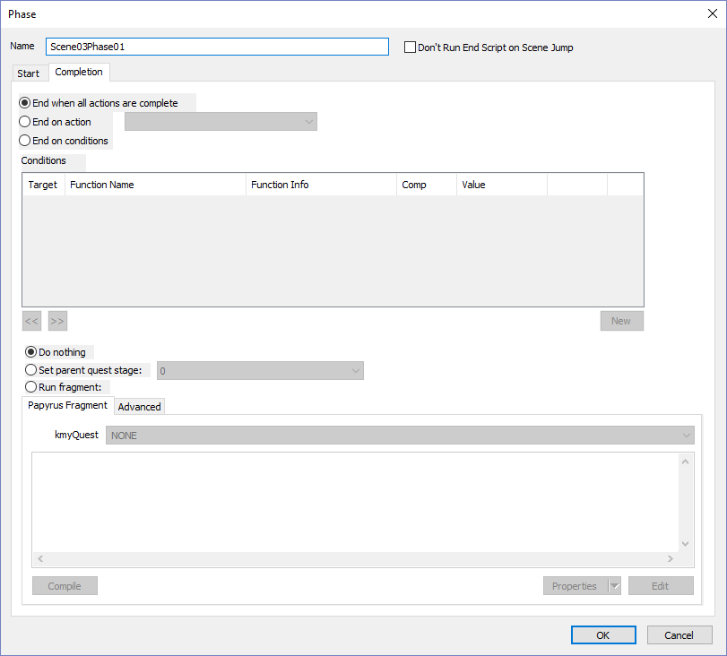
Click the OK button  We’re ready to add interactive dialog | 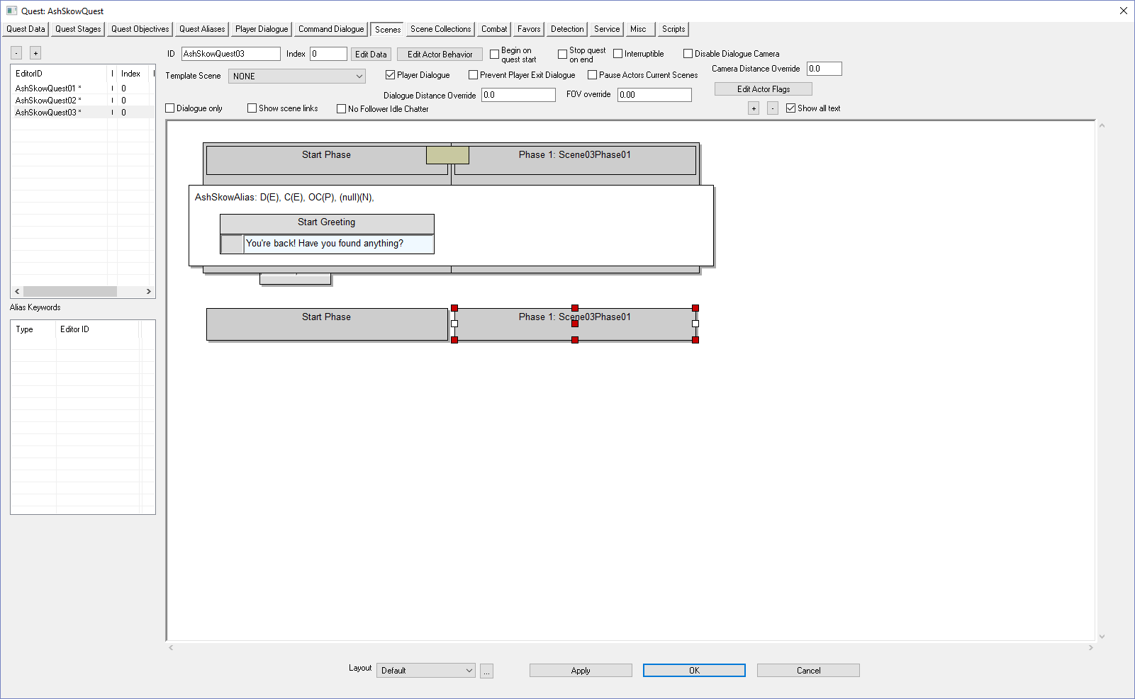
Right-click over the white area under the phase | 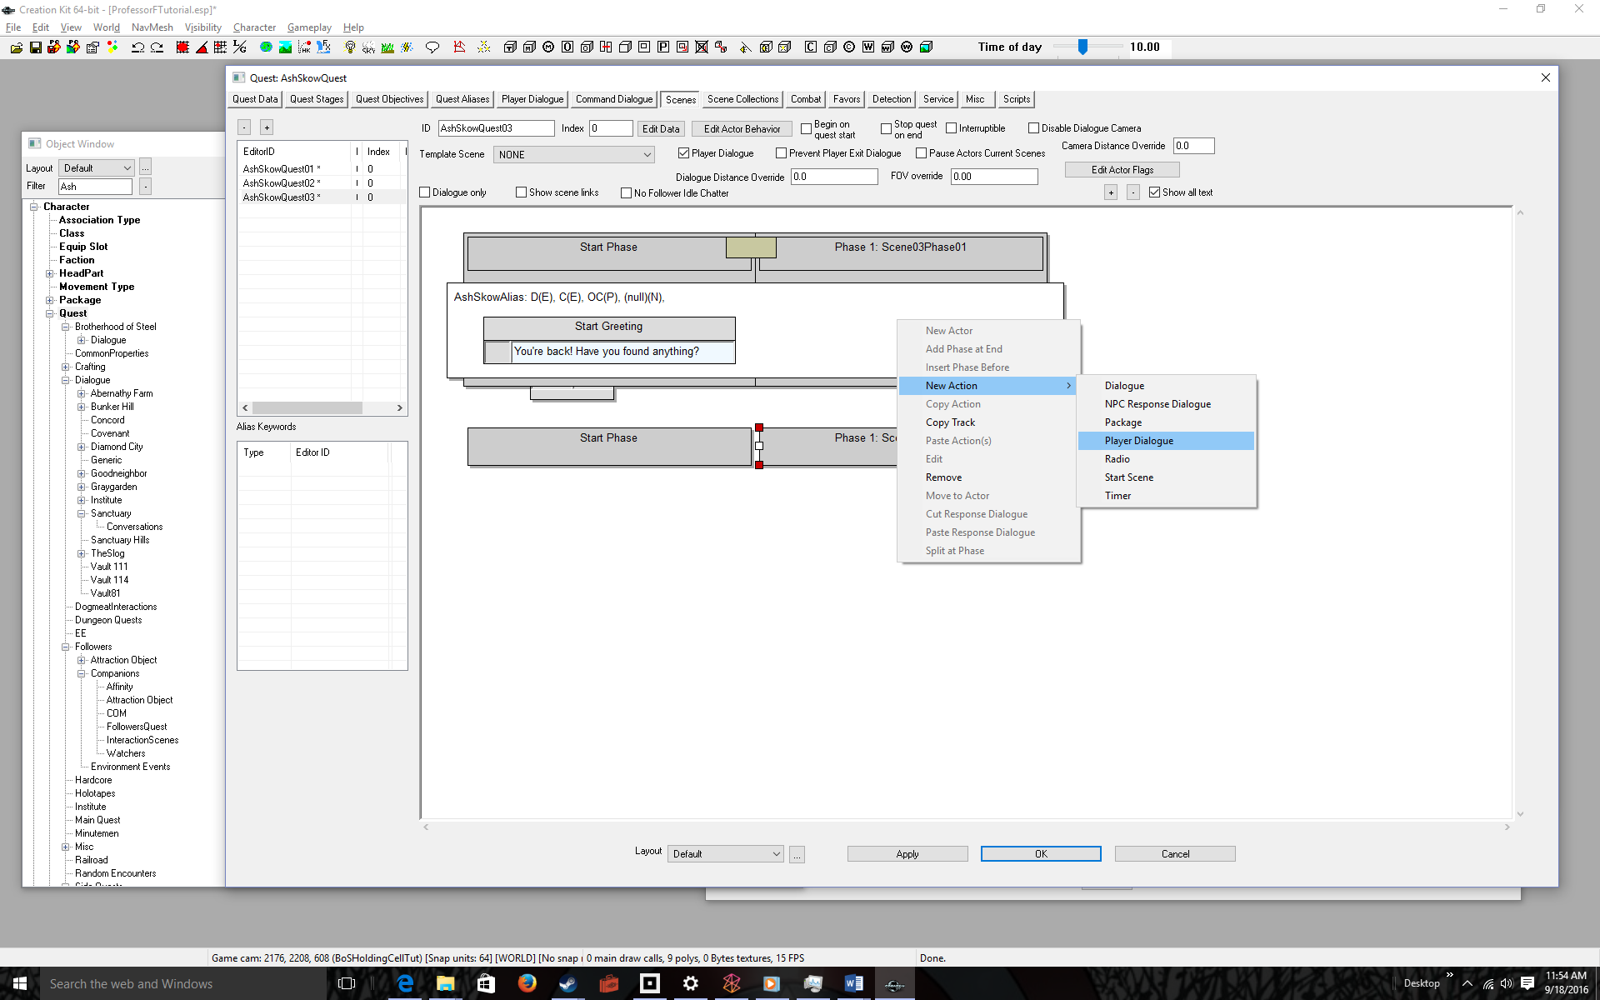
Select New Action > Player Dialogue  The Topic Info dialog pops up allowing you to set initial options.  Conditions are the most likely option you will set, but since we did set conditions in the greeting, and this follows from the greeting, it shouldn’t be necessary. | 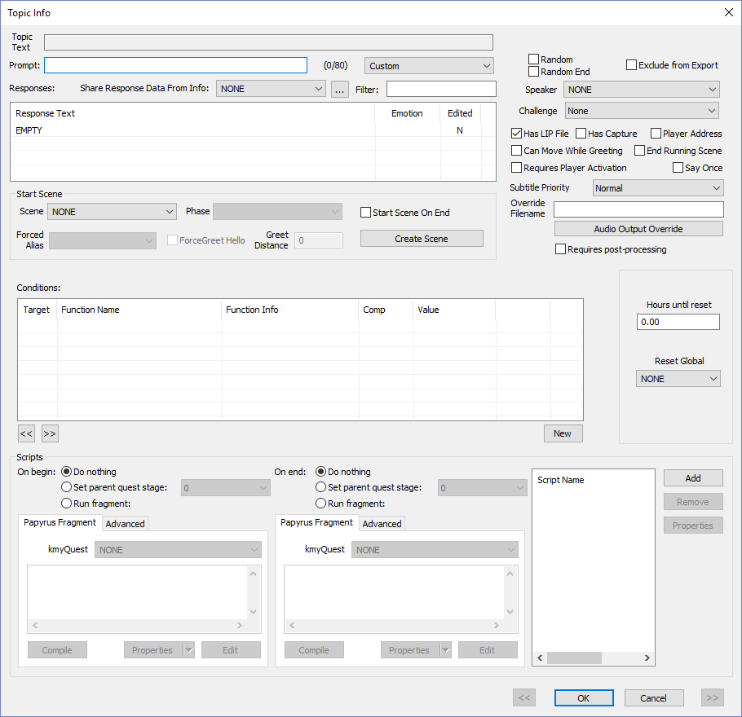
Click the OK button  The 4-part dialog box pops up. | 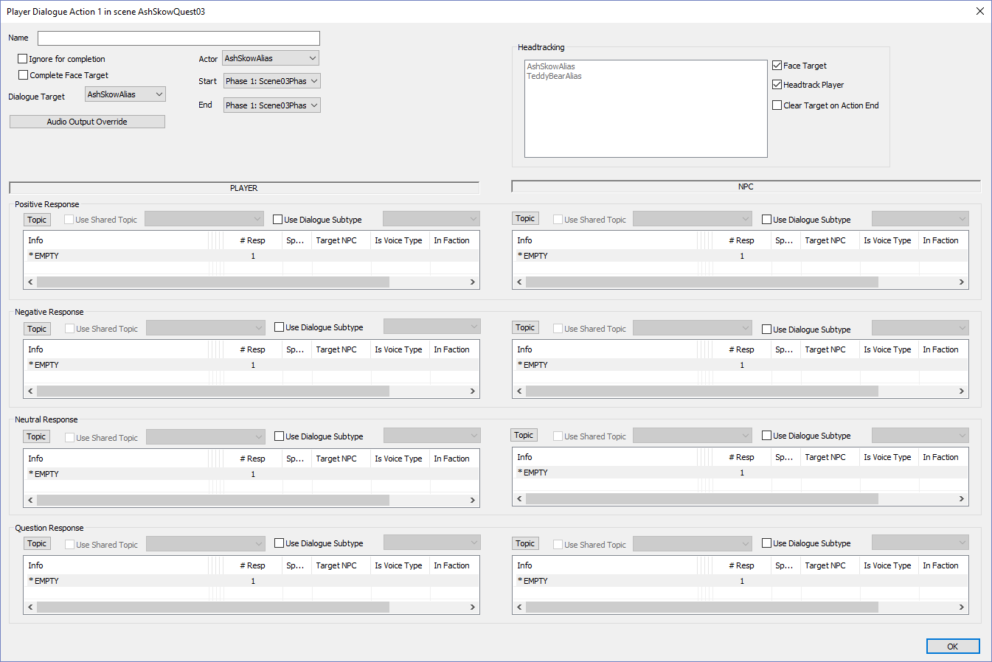
Enter Prompts & Reesponses  (Details not shown-see Quest Dialog Beginning tutorial)  Do the following for the PLAYER  Sentiment: Prompt—Response  Positive: Give Artifact — Yes, here it is.  Negative: Do Not Give — No, I haven’t found it yet.  Neutral: Be Evasive — Maybe.  Question:Ask for Caps — Can I have caps first?  Do the following for the NPC  Sentiment: (NO PROMPTS for NPCs)—Response  Positive: () — Yuck! It’s dirty. You keep it.  Negative: () — Please try to find it.  Neutral: () — Either you’ve found it or not. Which one?  Question: () — Sorry, I don’t have any money  IMPORTANT: Check End Running Scene for the positive and negative NPC responses. | 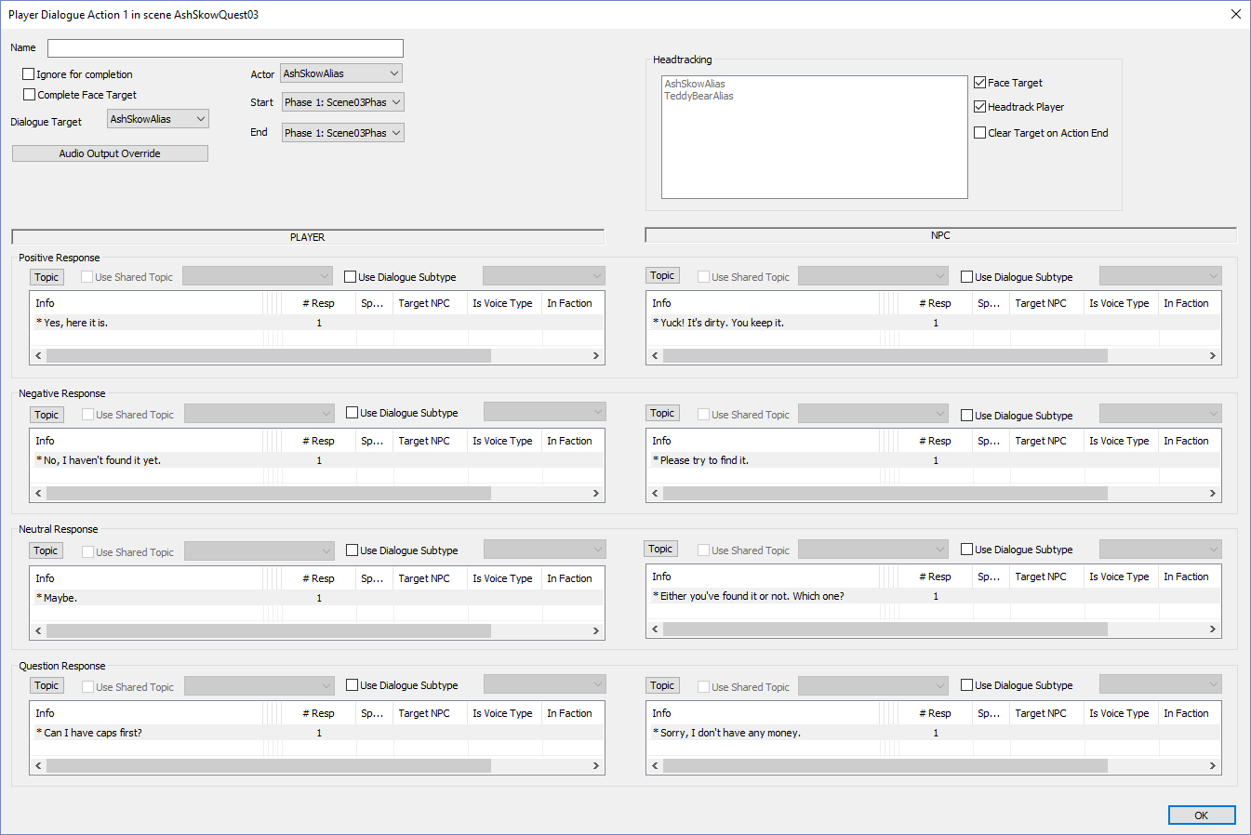
Click OK  You’re almost done. You have to loop to main dialog until either the player agrees to give the artifact or the player refuses.  Notice the [END] in the Positive and Negative NPC responses. If you don’t see it, double click on those responses and check the End Running Scene checkbox. | 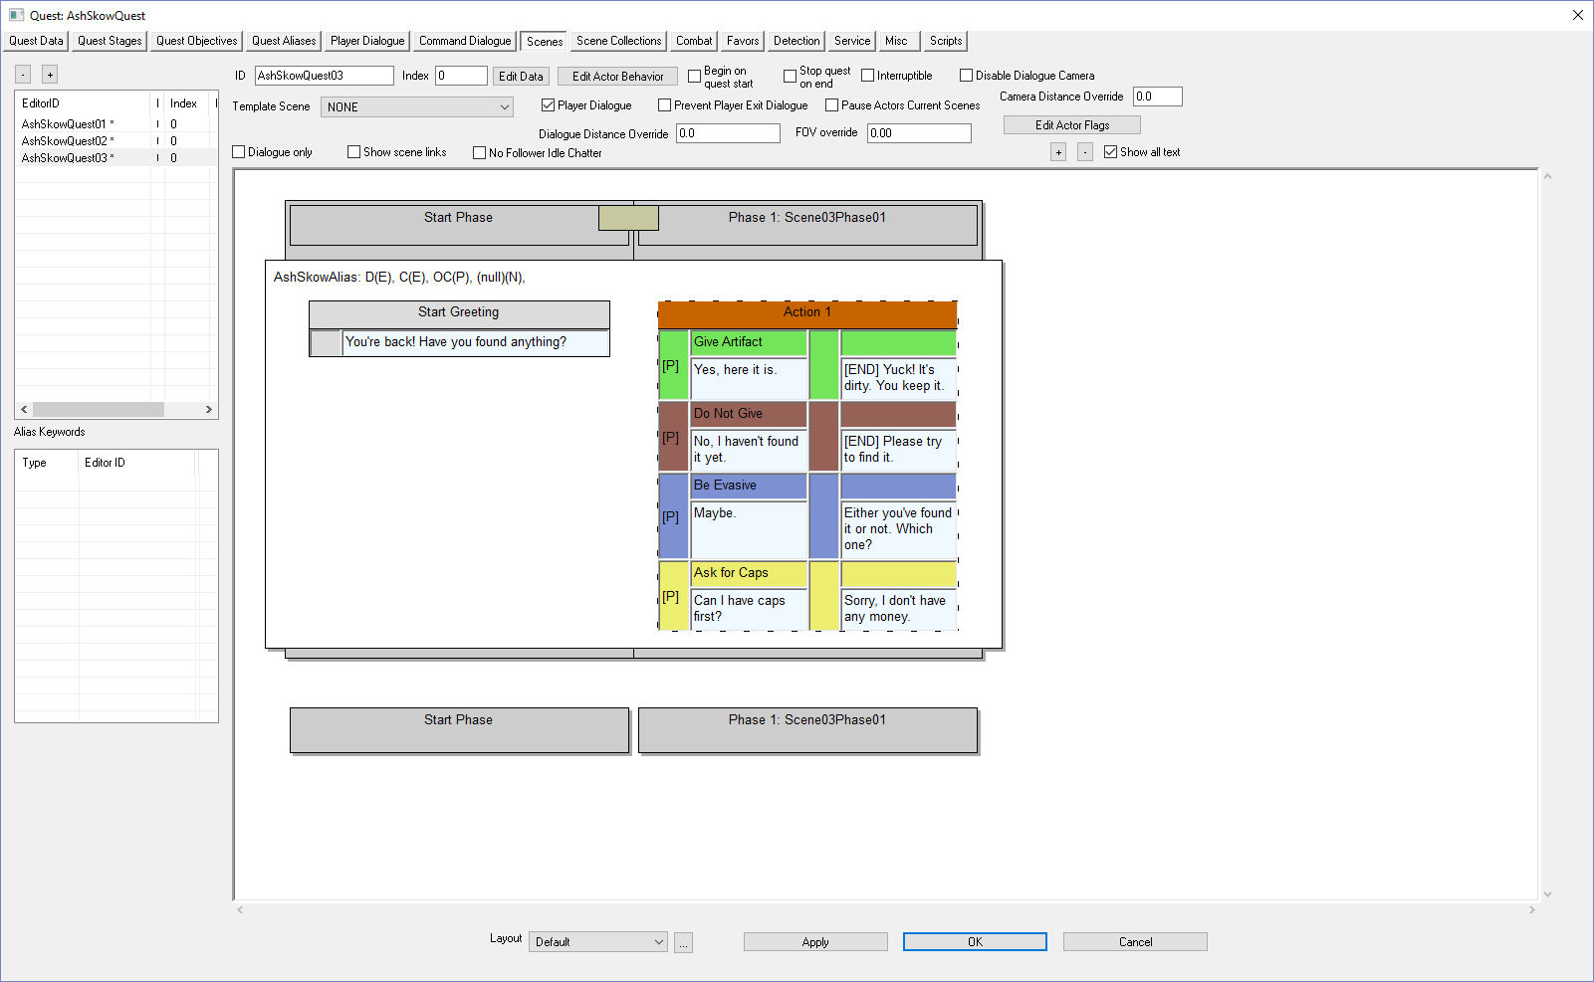
Right-click in the white scene area | 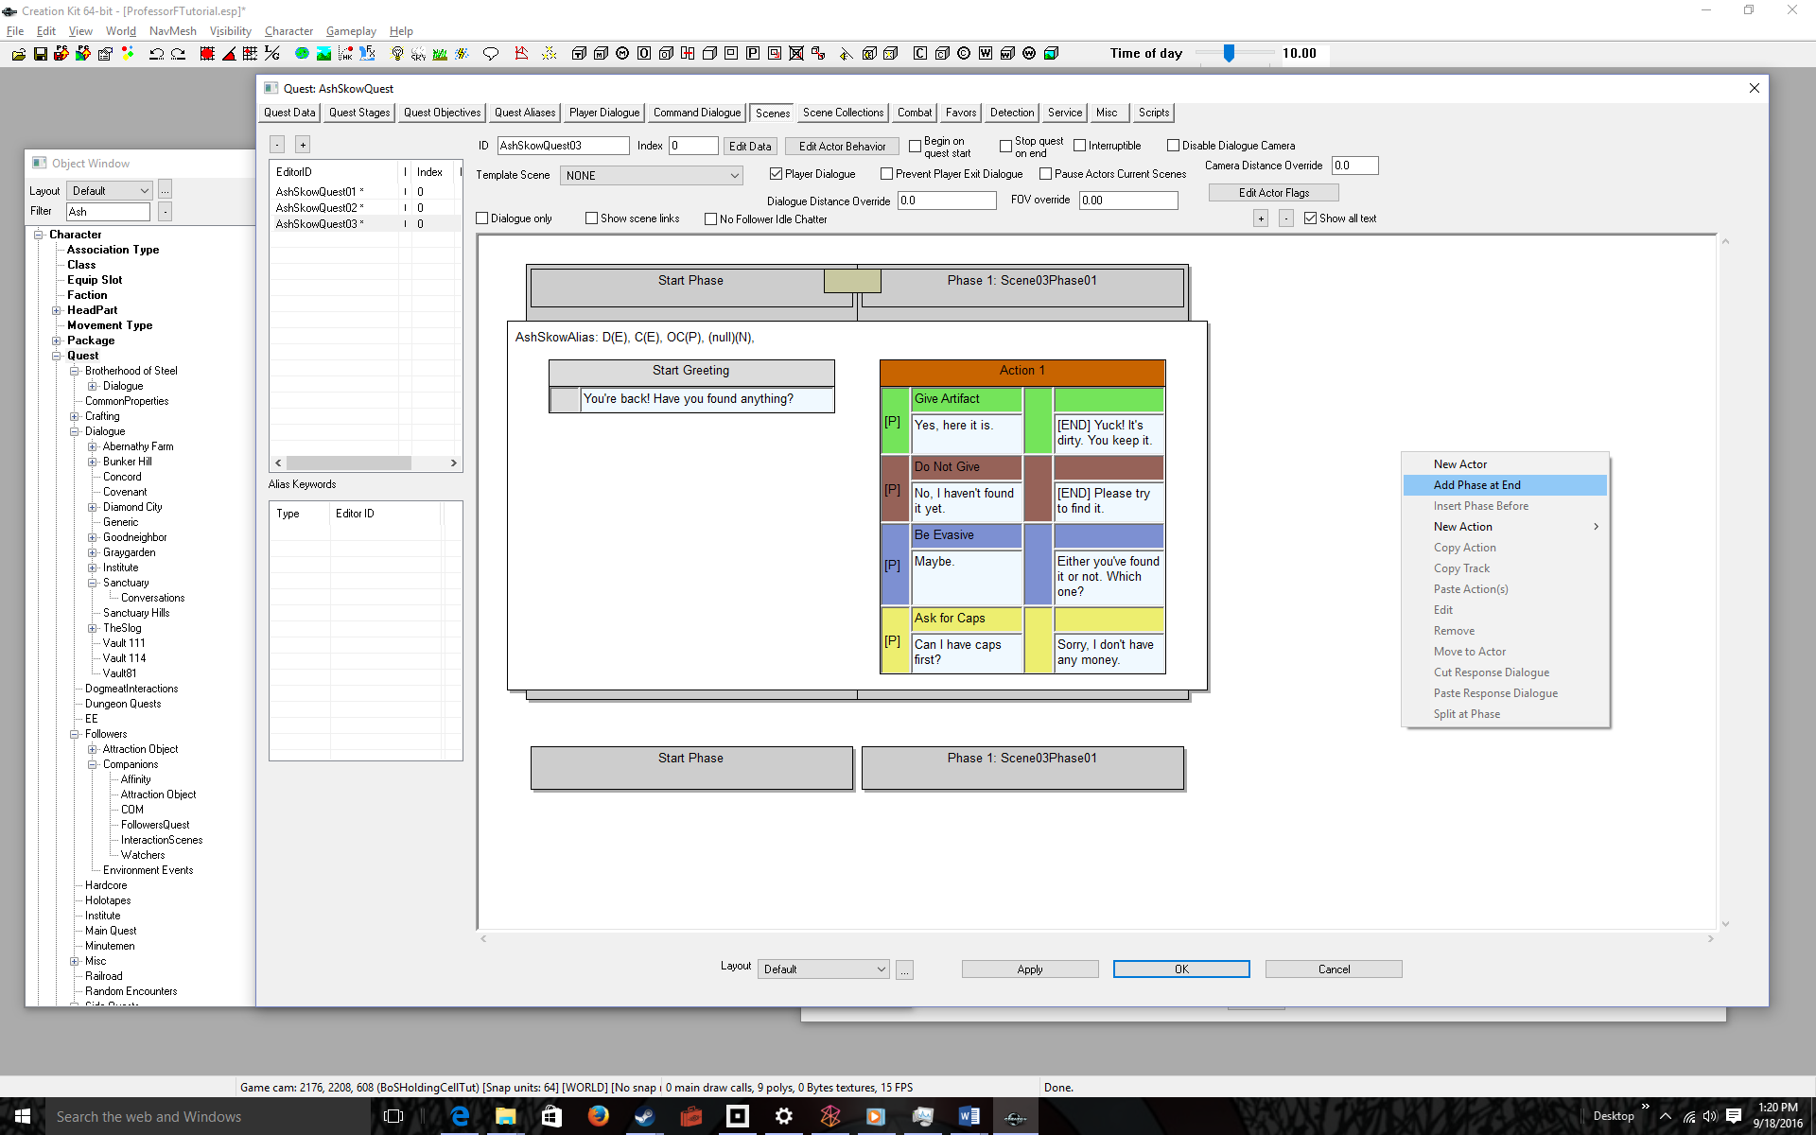
Select Add Phase at End | 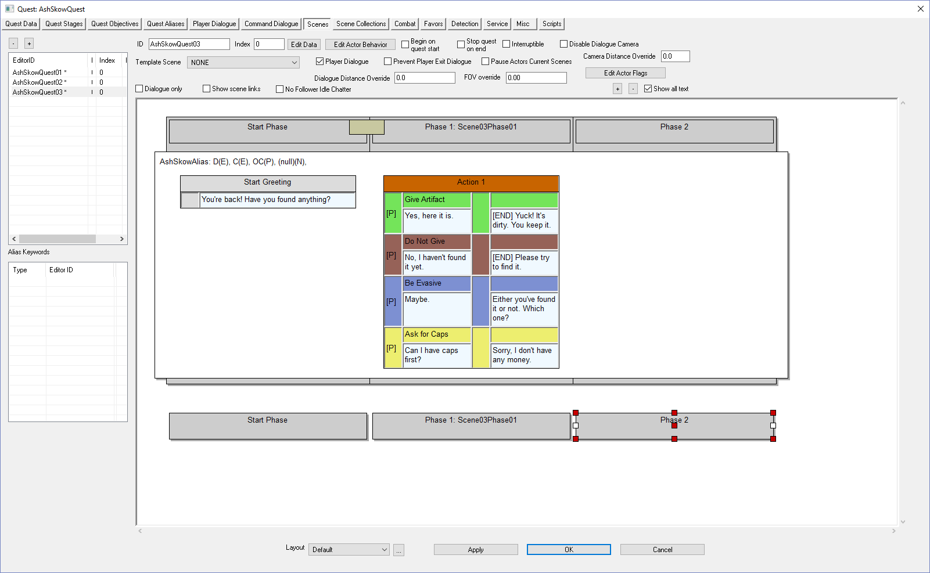
Right-click in the white phase area | 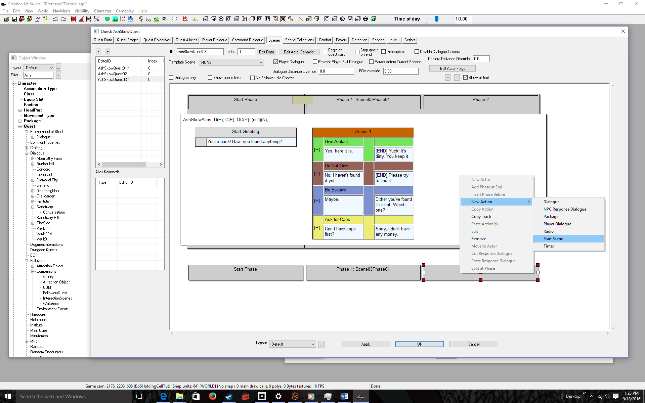
Select New Action > Start Scene | 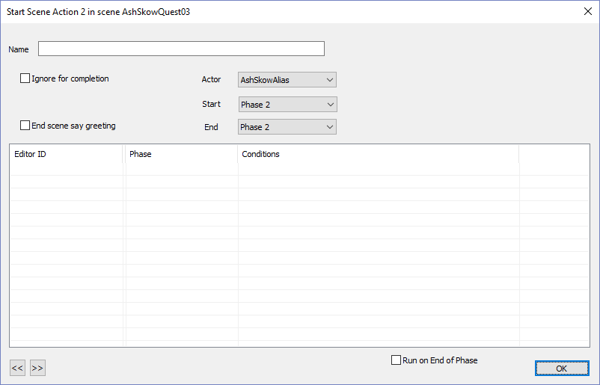
Click OK | 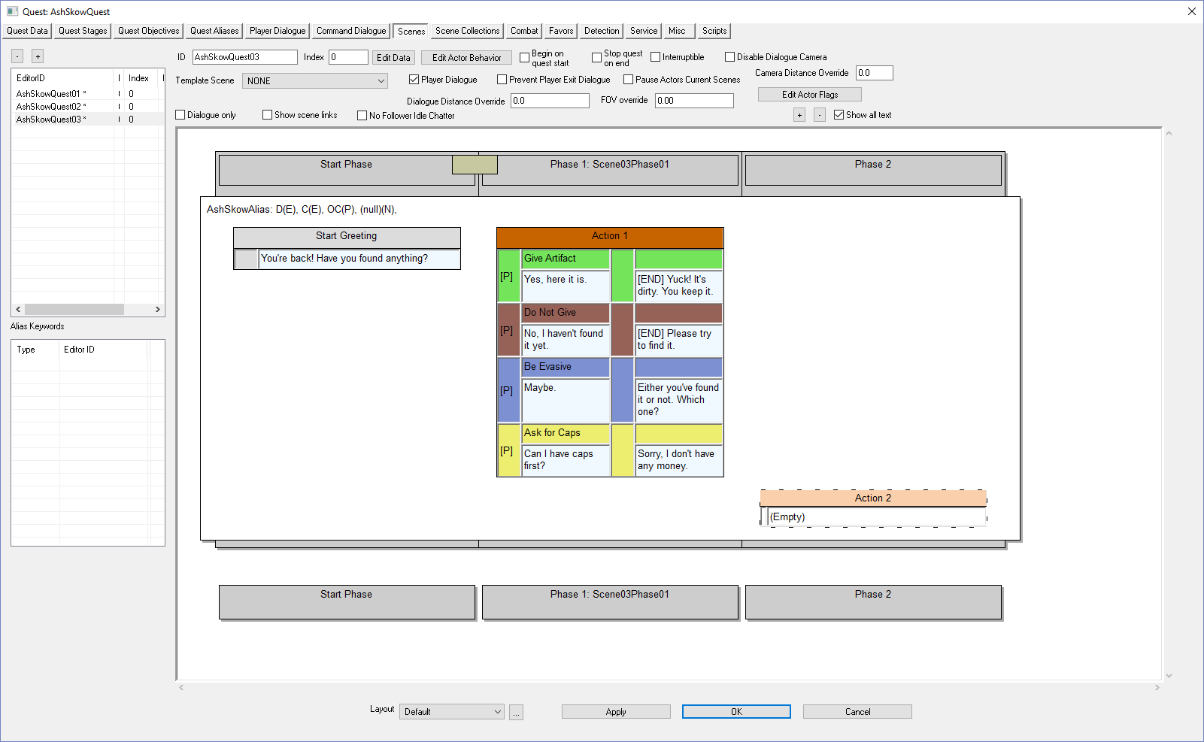
Double-click (Empty) | 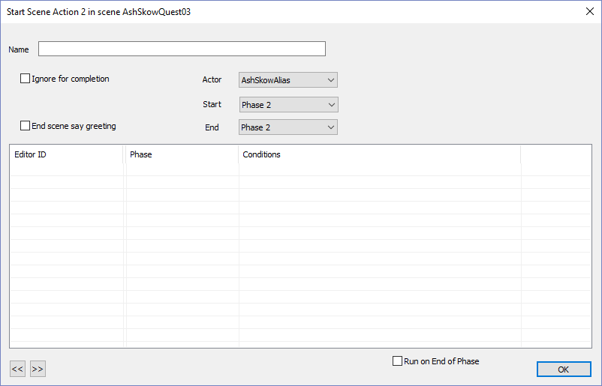
Right-click under Editor ID | 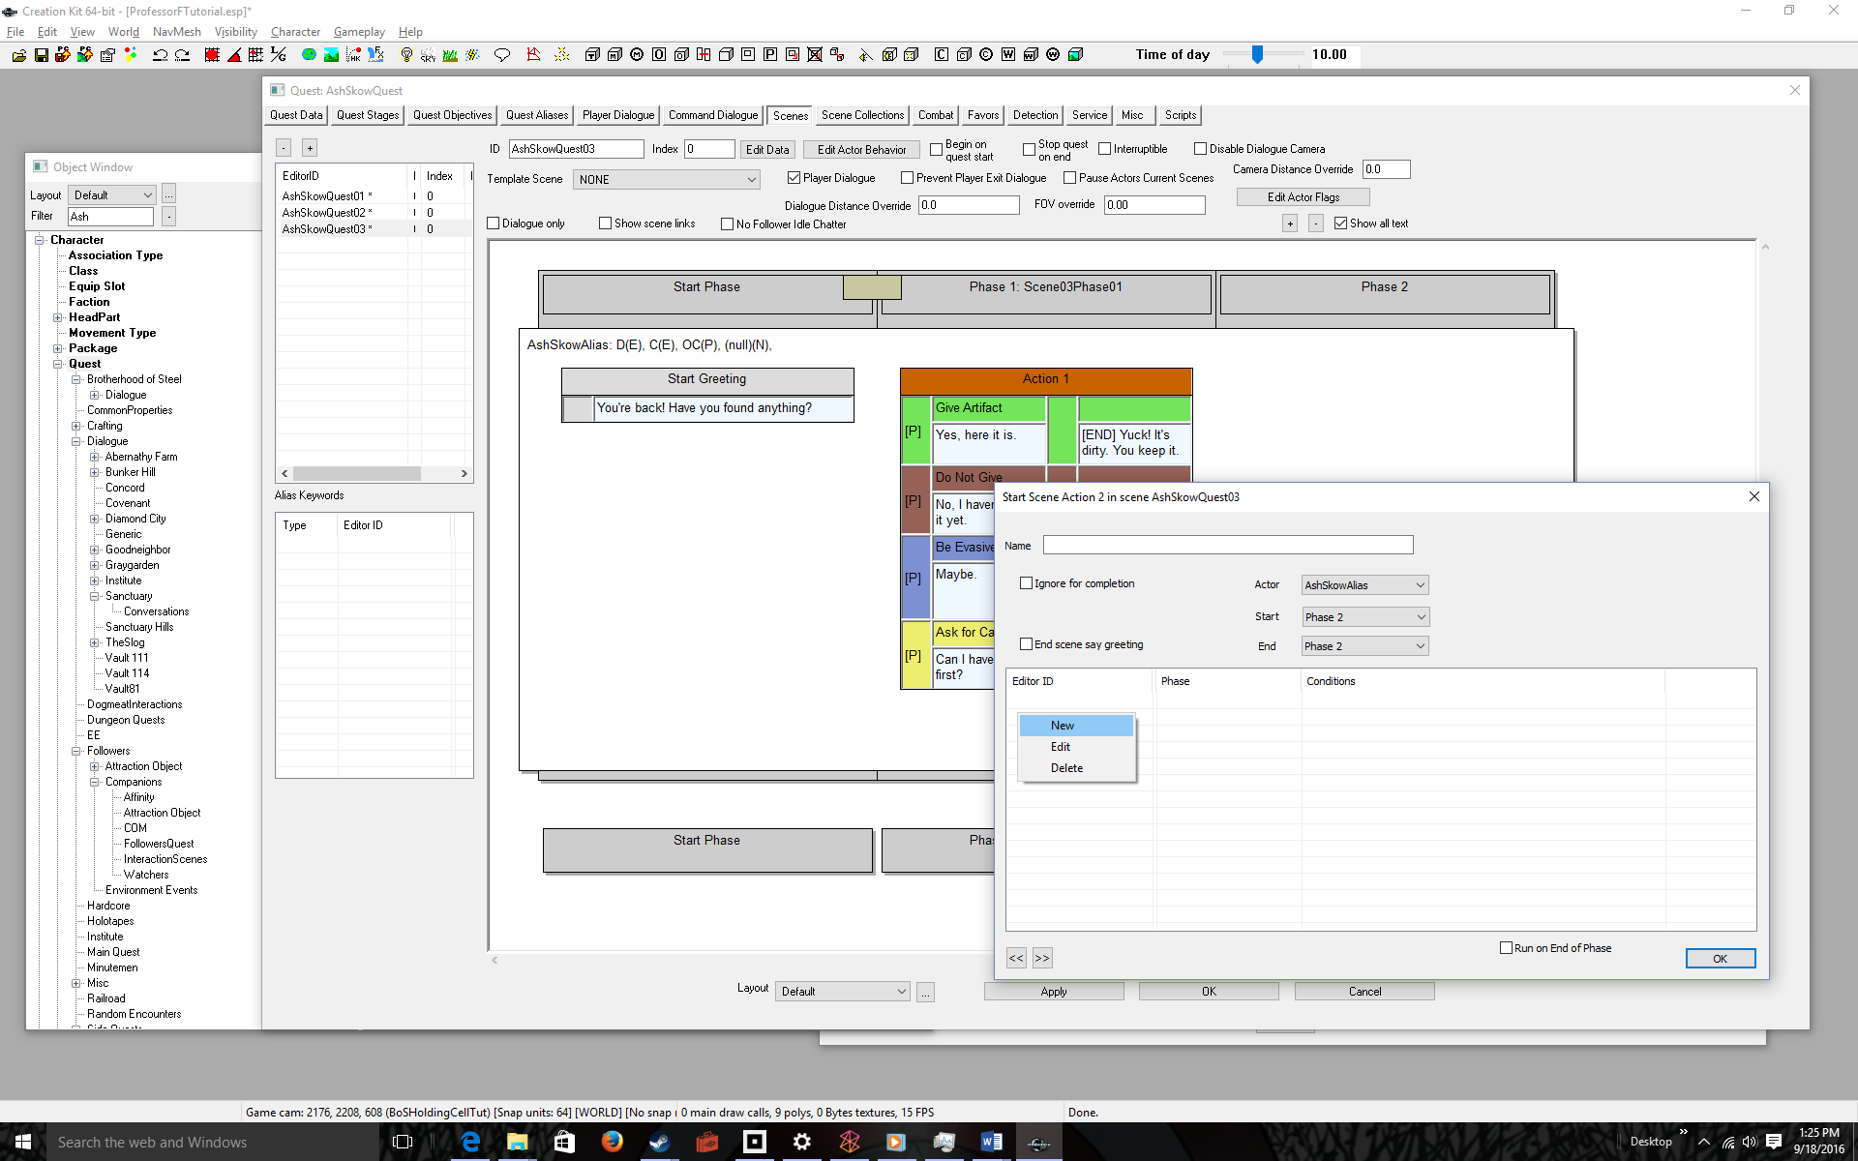
Select New | 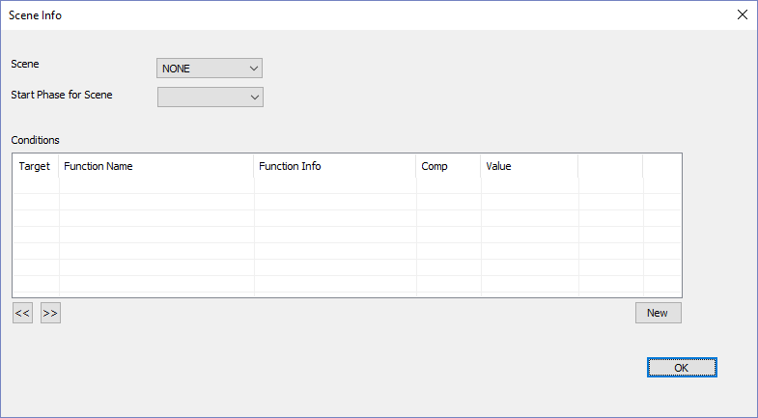
Select the Scene and Start Phase in the drop down boxes  In our example AshSkowQuest03 and Scene01Phase03, respectively  Note: Sometimes it doesn’t let you select the Start Phase for Scene (like this example). None, is the only option. So just go to the next step. | 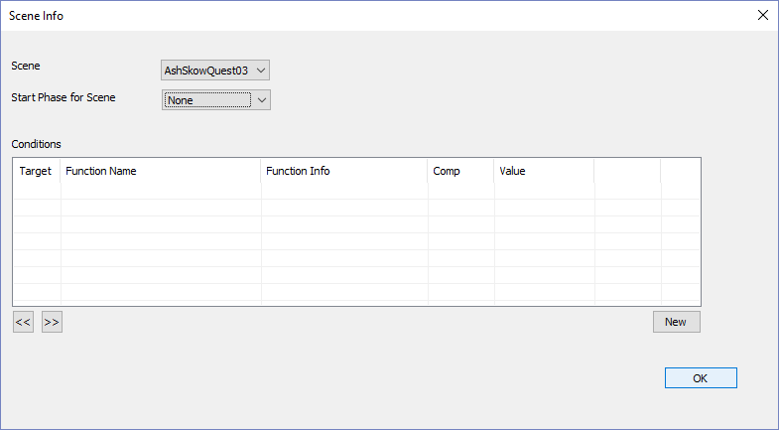
Click OK | 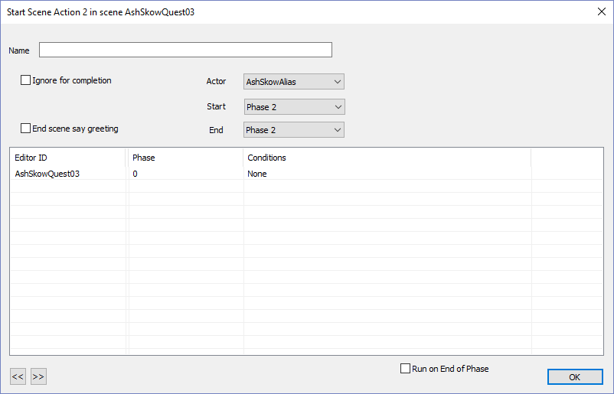
Click OK  Now after any four-way response, the scene should loop properly.  Almost done, first a possible bug fix | 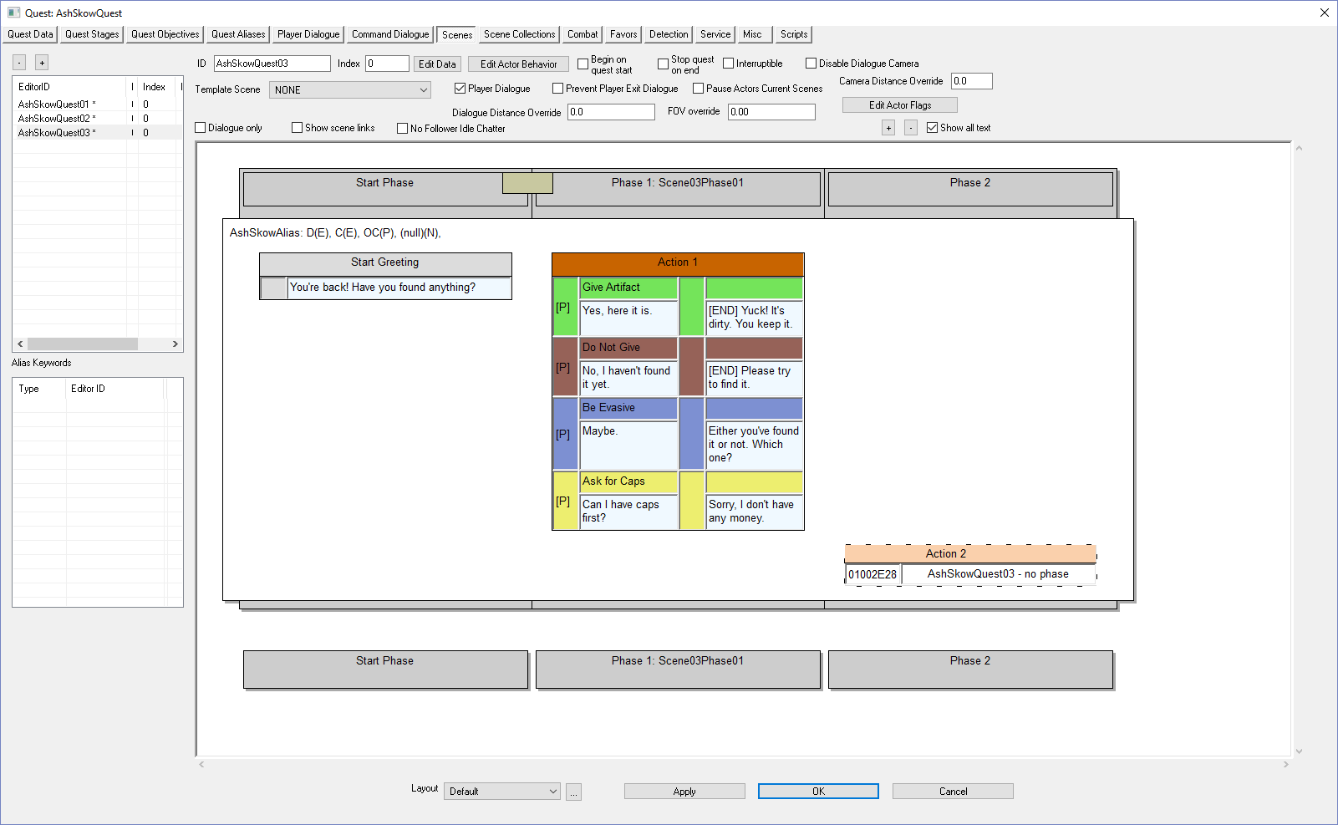
BUG FIX: If under Action 2’s label, you see “- no phase” do this:  Click the Quest Objectives Tab, then Click the Scenes tab  This somehow fixes the bug in the GECK and fills in the phase with Scene03Phase01. You can verify this by double clicking on the text under Action 2:  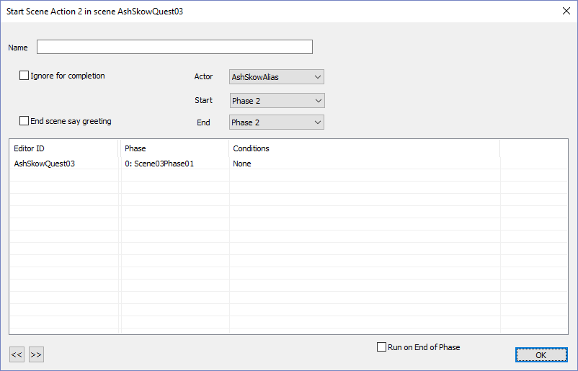 | 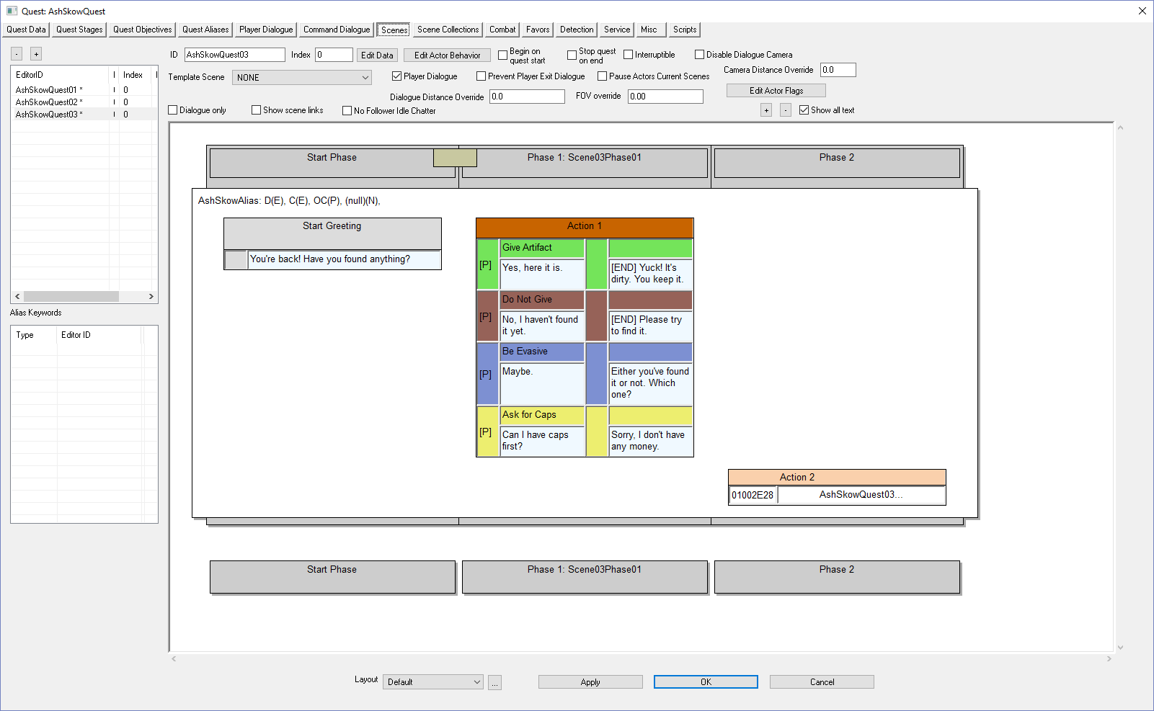
Double-click on the NPC positive response  To end the quest we have to set the Quest Stage ID to completed (40) | 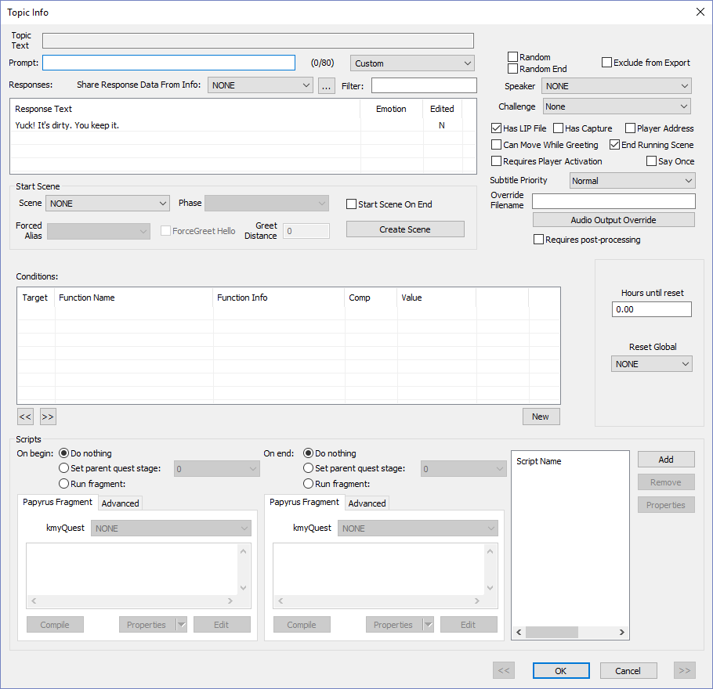
Check the Set Parent Quest Stage radio button and set the drop down to the End Quest Stage # (40) | 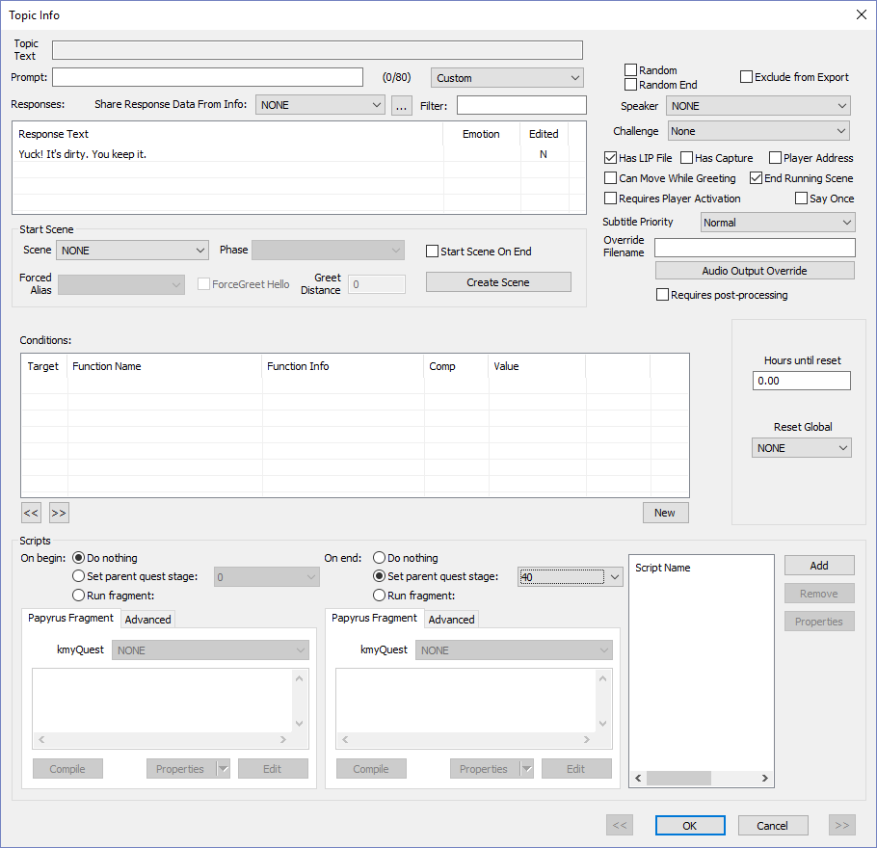
Click OK  Note the [QE40] in the NPC positive response, which indicates that the Quest Stage is set to 40, which is the ending quest index. We now have to code the ending response. | 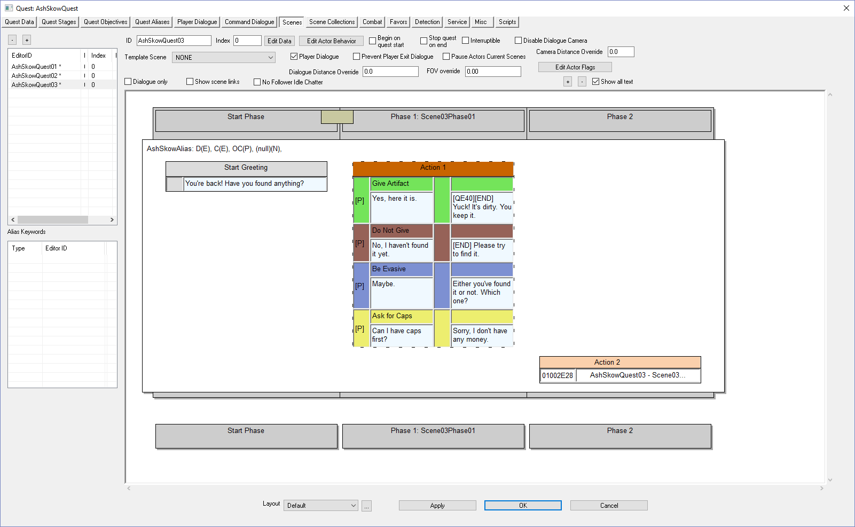
Click on the Quest Stages tab | 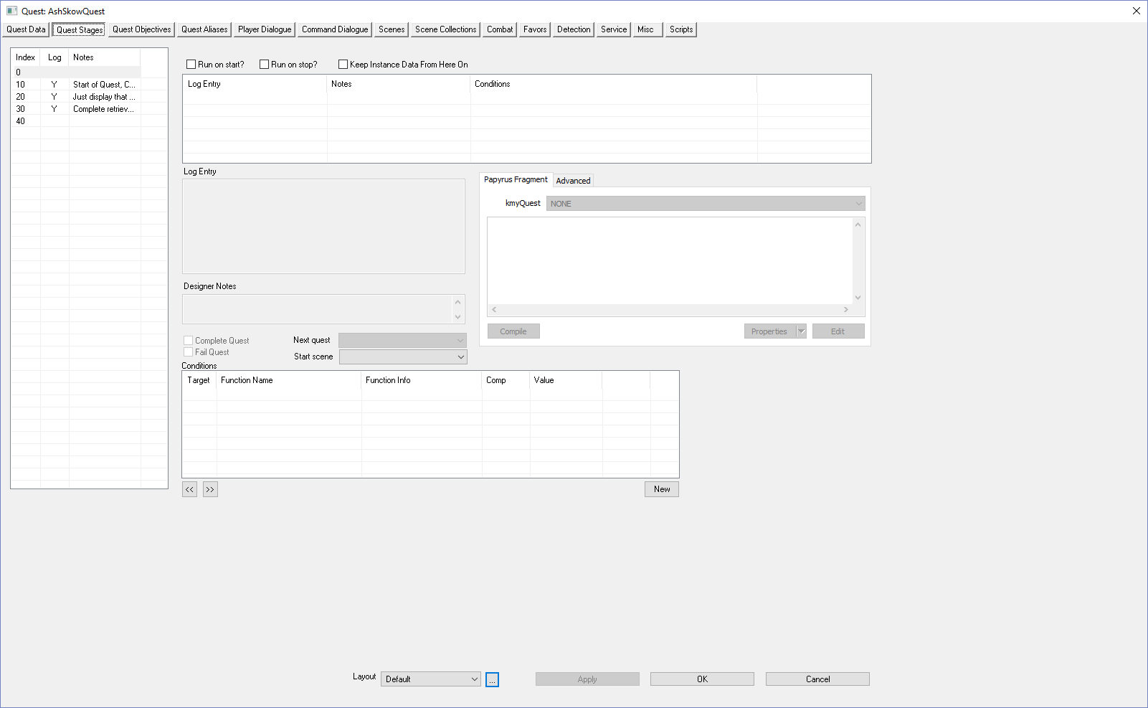
Select the Ending Quest Index (40) | 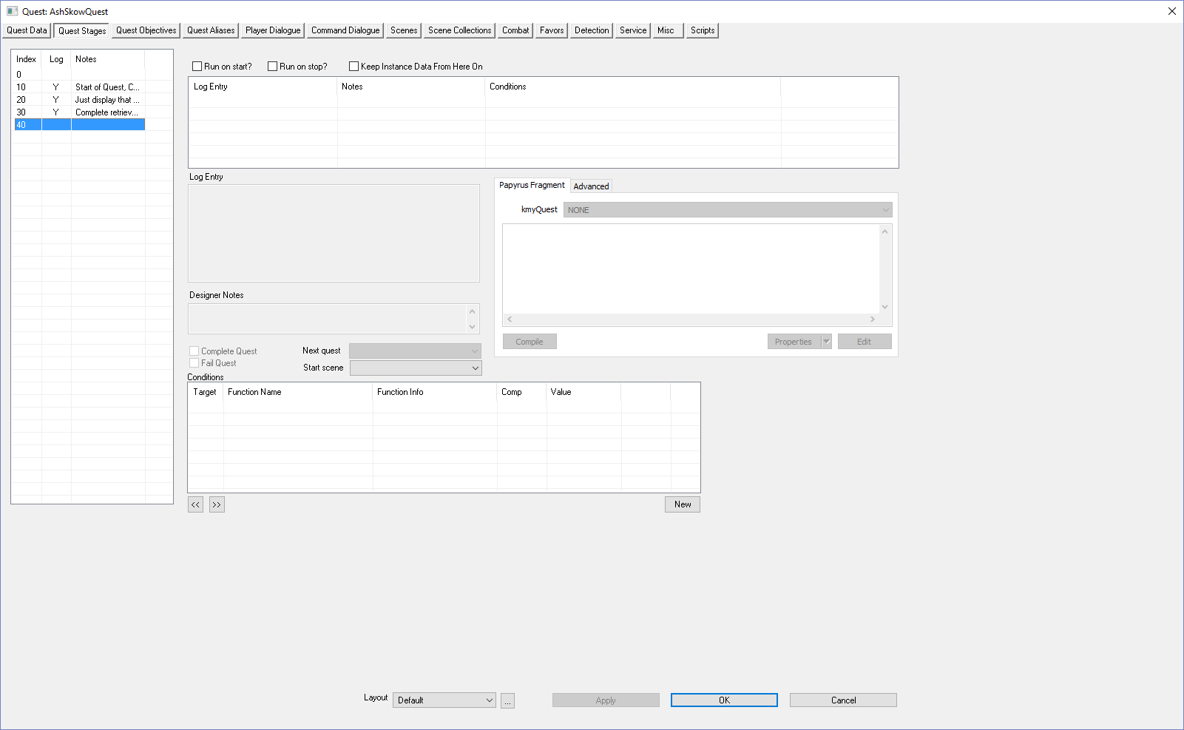
Right-Click under Log Entry | 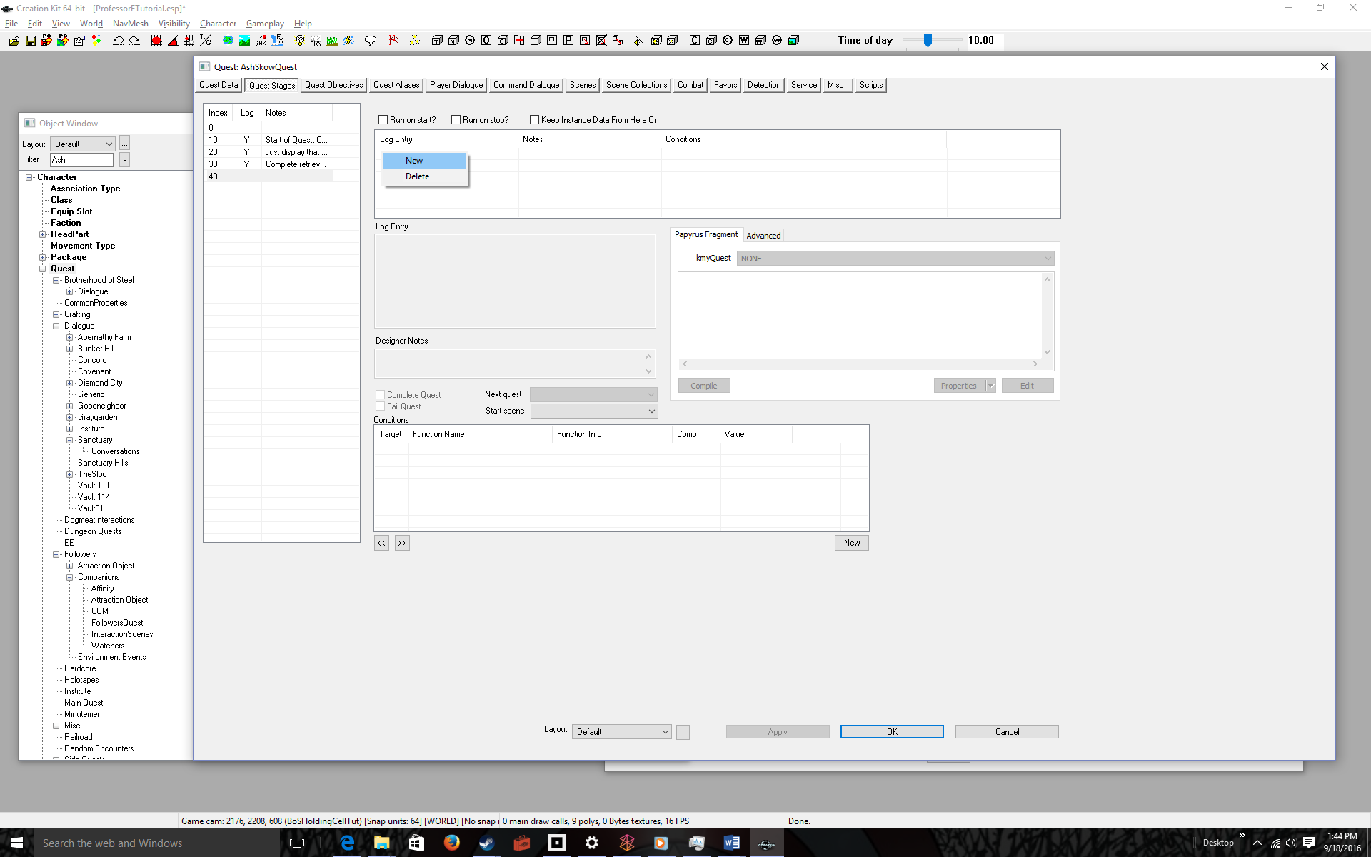
Select New | 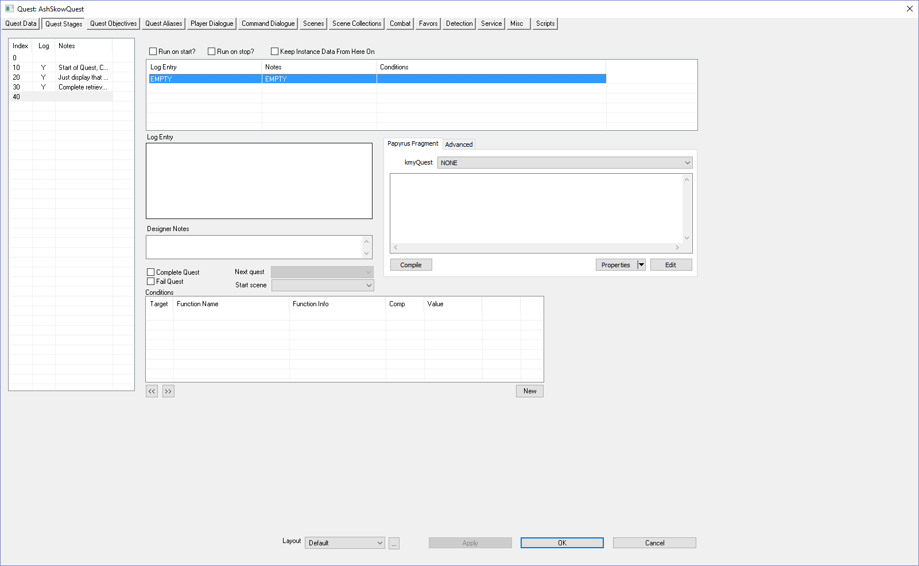
Enter a Log Entry, Designer Notes, Code, and CHECK the Complete Quest box  The code is:  SetObjectiveCompleted(30)  Where 30 is Quest Objective # for returning the artifact to the NPC (see Quest Objectives tab) | 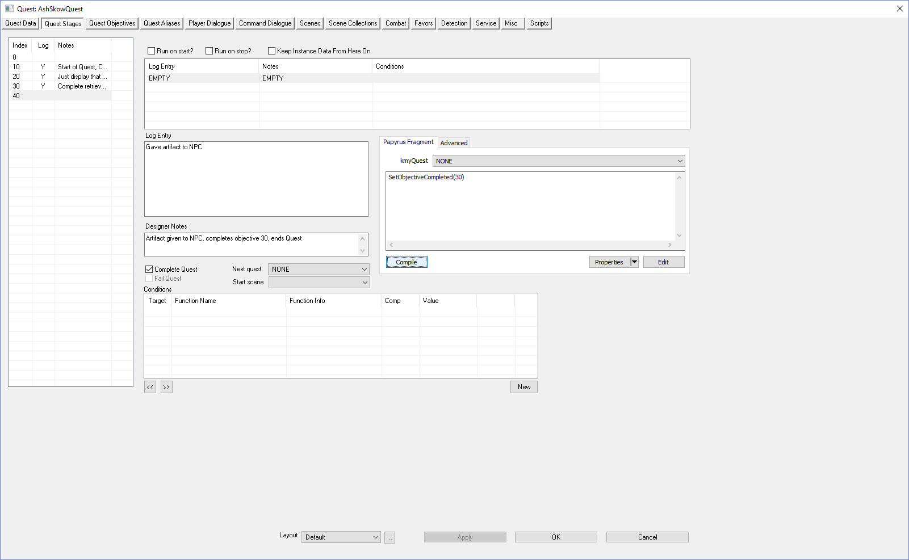
Click OK  You’re ready to test your completed quest. | 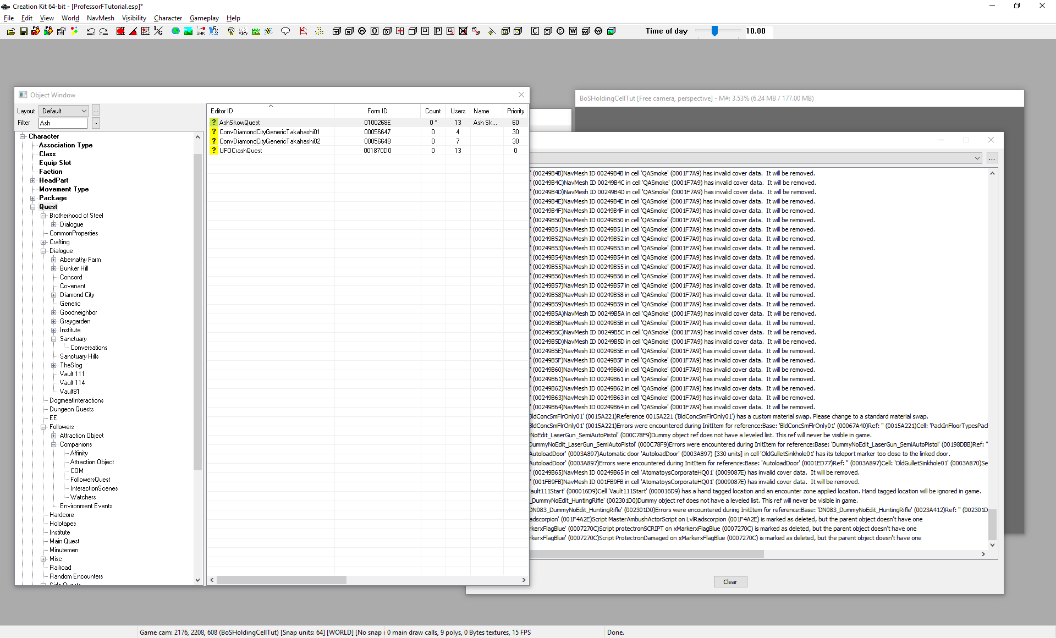
File > Save | 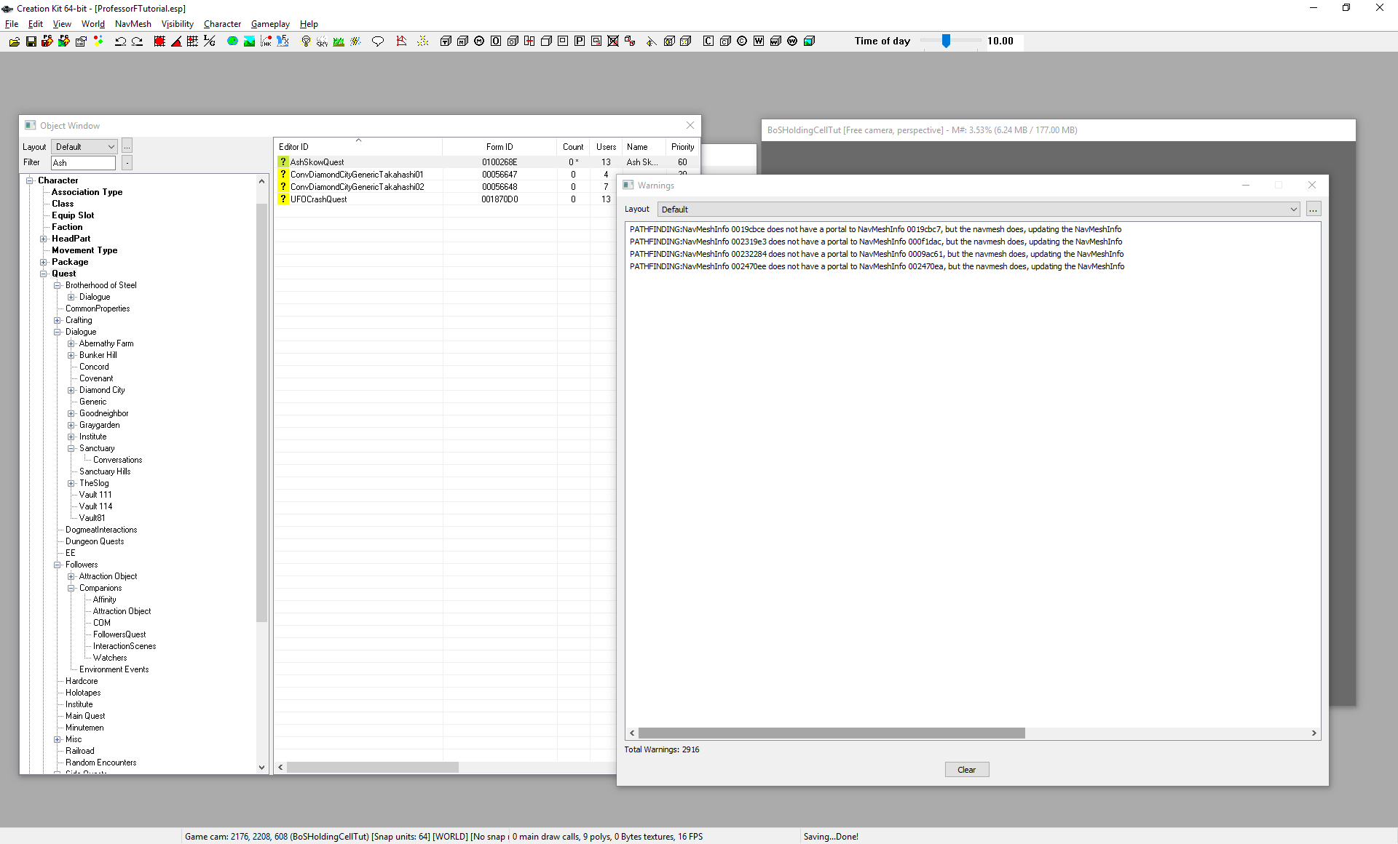
Run Fallout 4 and advance the quest up to the point where you’ve retrieved the artifact have returned to talk to the player  Yes, I know I skipped a lot of steps, but you know how to do all those things already! | 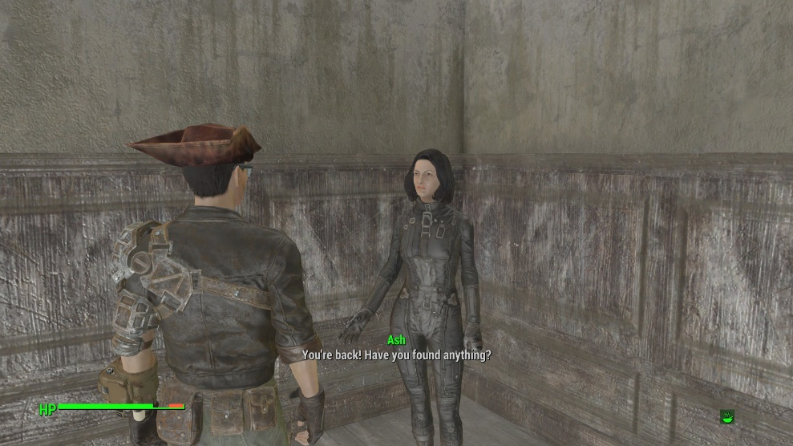
Wait for prompts | 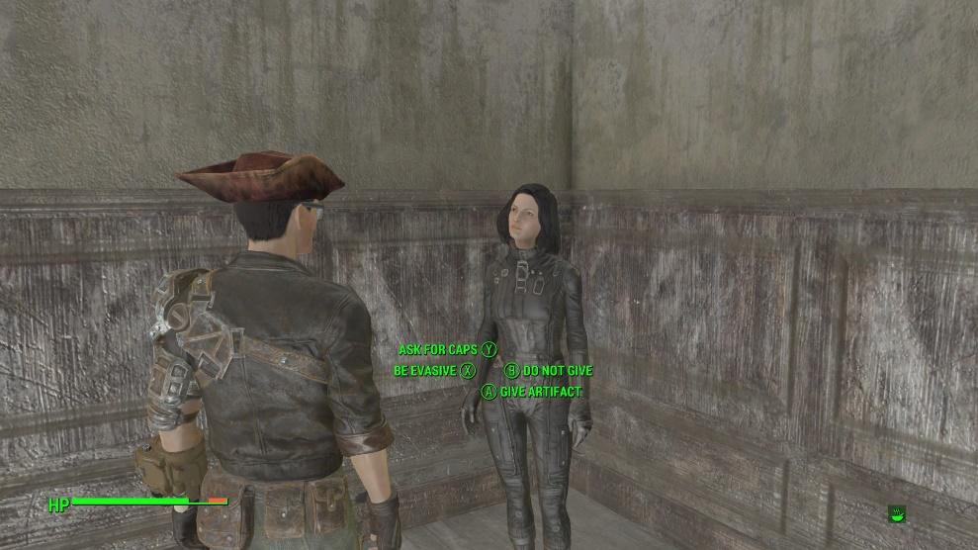
Give the artifact (or you can play with responses, but end by giving it) | 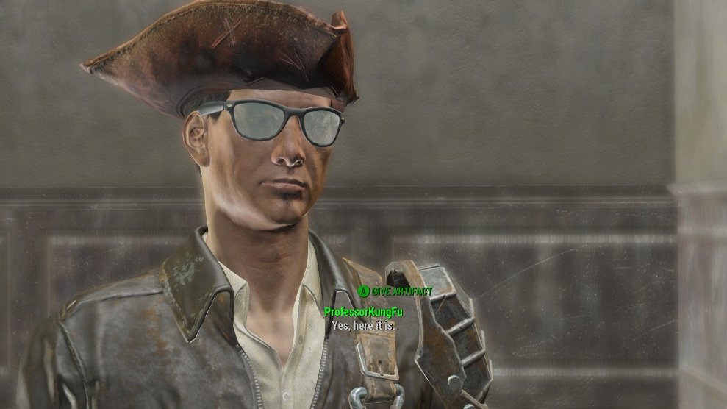
Wait for NPC response | 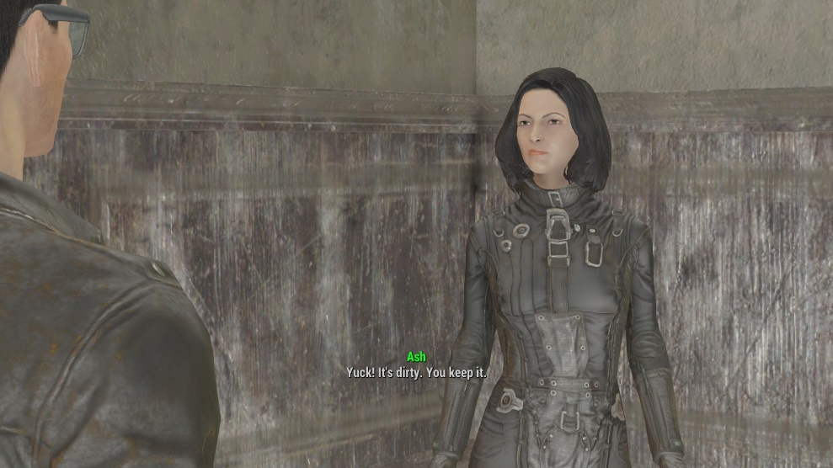
Wait for Quest Complete message  You are done! Congratulations ☺  Now read the next tutorials to make enhancements to the game like voices. | 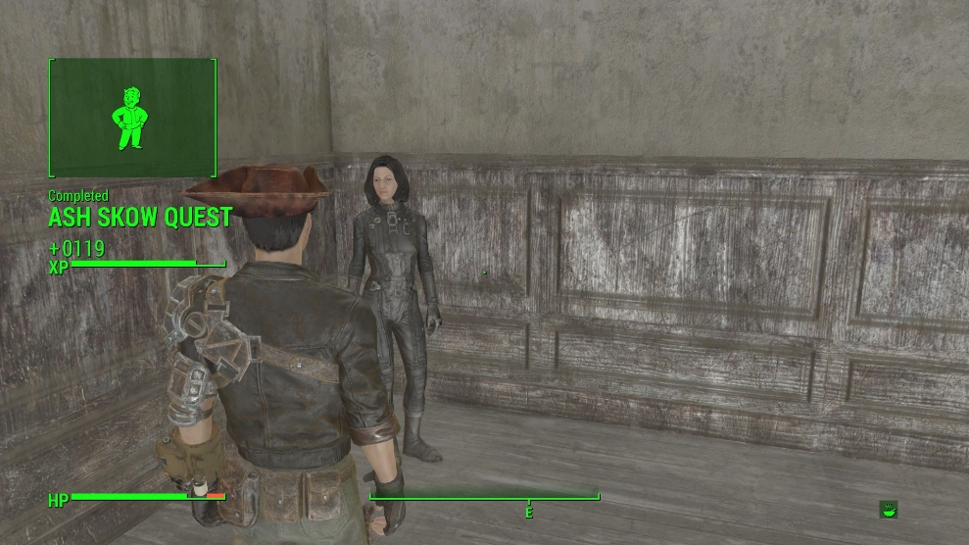

Don’t forget to quit out of the game! (ALT-F4 for the PC Master Race)

