How to Create a Fallout 4 Quest: Part 2— One-Time Mod Load
Nick V. Flor (nickflor@unm.edu)

Start up Fallout 4  You should have played the game up to the point where you wake up and escape the Vault. If you haven’t play the game before doing this tutorial. | 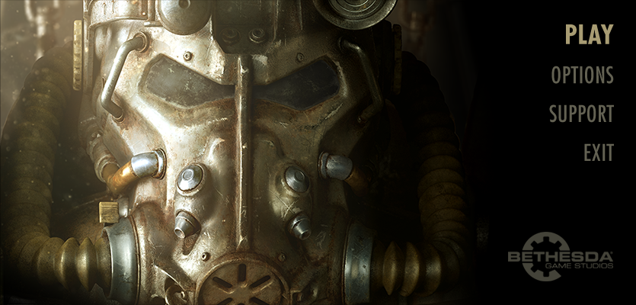
Click the Play label (upper right corner) | 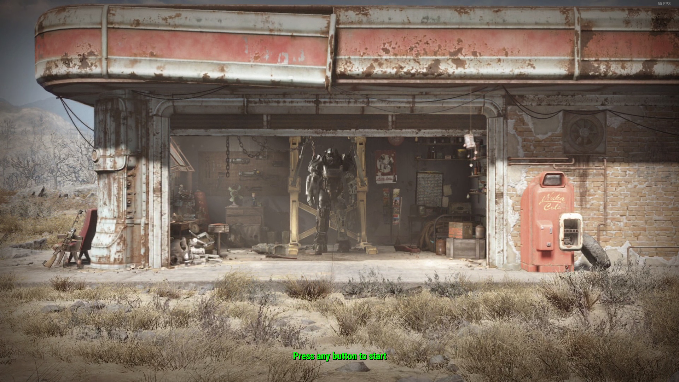
Click any button on your controller or keyboard to start | 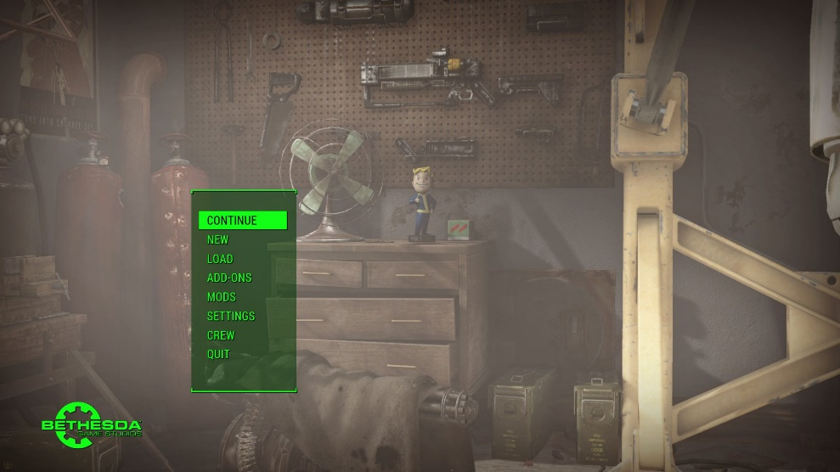
Click MODS in the green pop-up  Note: You’ll only do this once. After it loads your mod, you only need to click CONTINUE from the previous step thereafter. | 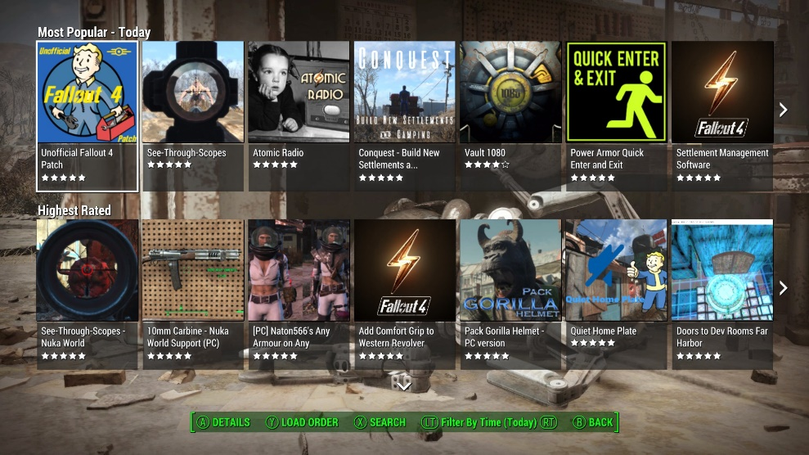
Select: (Y) LOAD ORDER  On the left, you will see all your mods with a .esp extention. I have 3 mods in addition to the ProfessorFTutorial.esp | 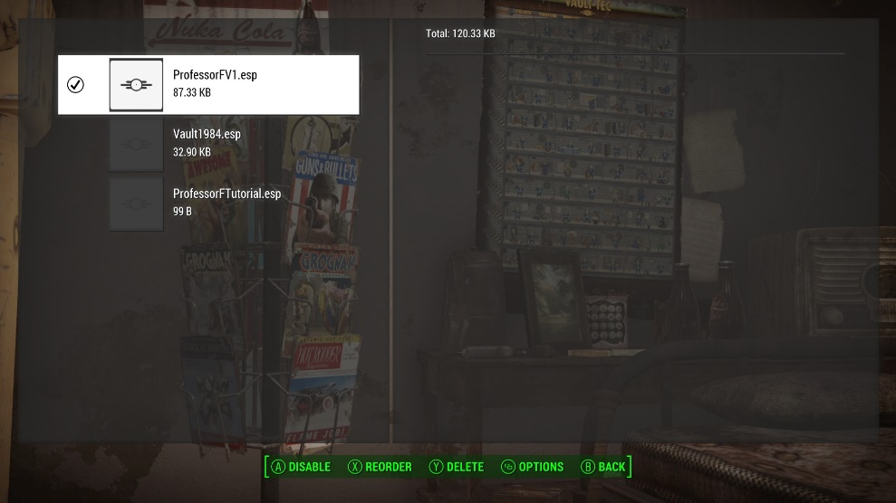
Highlight: (Your Mod File).esp  Mine is ProfessorFTutorial.esp, from the previous tutorial. | 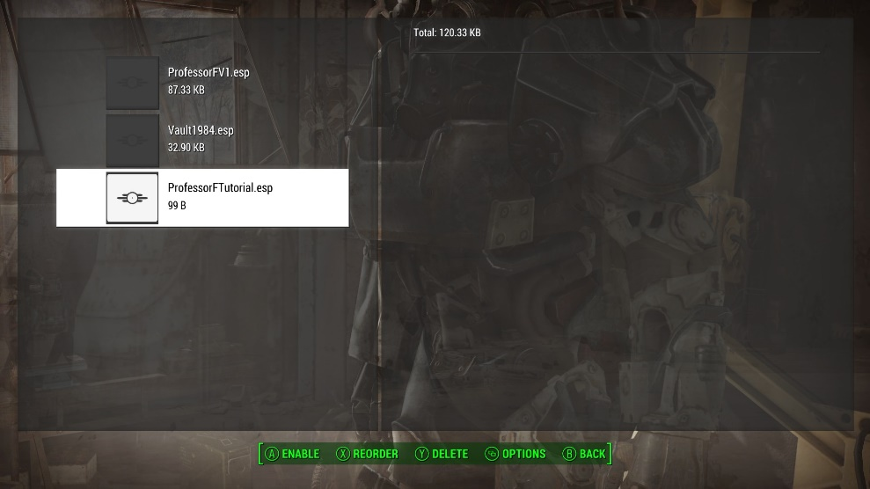
Select: (A) ENABLE | 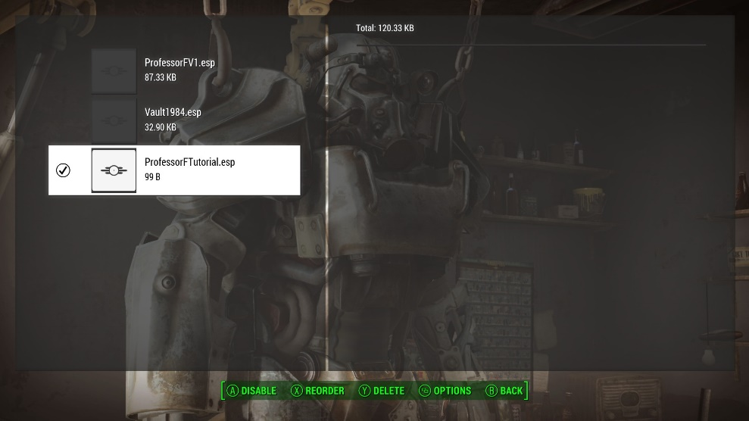
Select: (B) BACK | 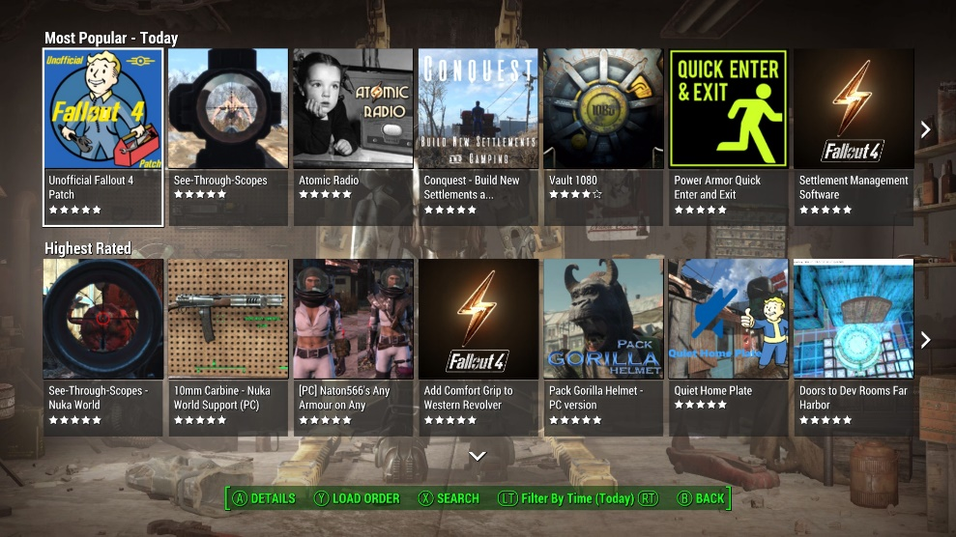
Select: (B) BACK | 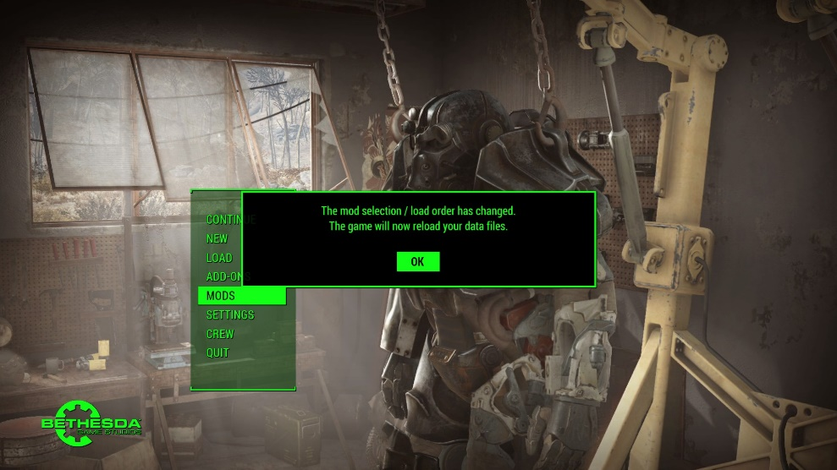
Click: OK | 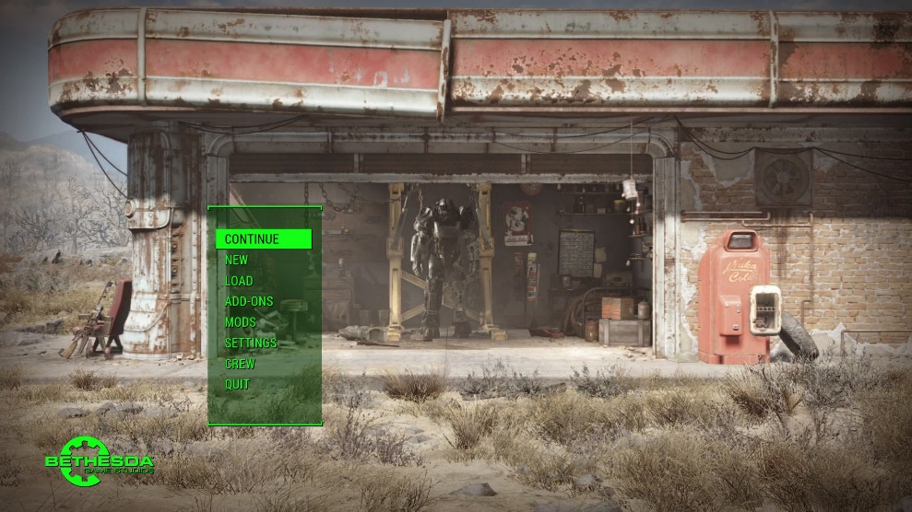
Click: CONTINUE | 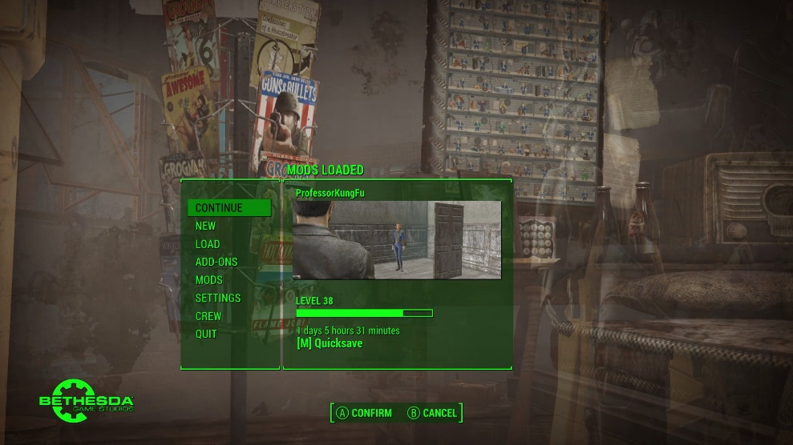
Click: (A) CONFIRM  Note: You’ll be taken to wherever you left off the game.  You’re now ready to actually do a mod. | 

