How to Create a Fallout 4 Quest: Part 3— Loading Your Mod As The Active File
Nick V. Flor (nickflor@unm.edu)

Start up the GECK by running the Bethesda.Net Launcher  Note: I’m assuming:  - You have Fallout 4  - You’ve downloaded the GECK (inside the Bethesda.net Launcher)  - You’ve have signed up for an account on Bethesda and are logged in. | 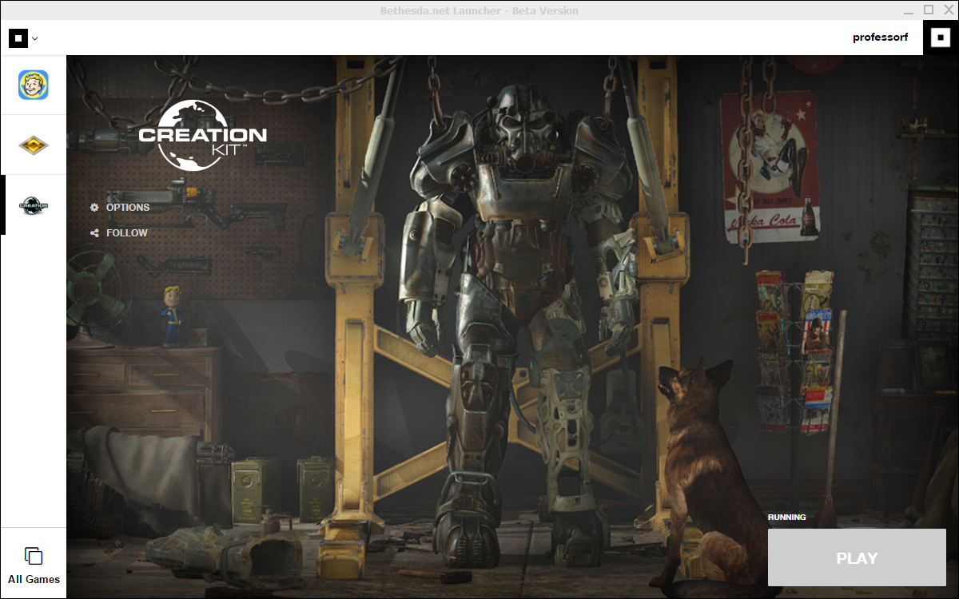
Click the Play button (lower right corner)  Click OK to any dialogs that pop up.  Three windows will appear:  - Object Window: Eventually will contain all the objects in the Fallout 4 world. Basically, everything you see in the game has an object that is referenced here  - Cell View: Specific “cells” in the world, like rooms and towns  - Render Window: Displays the current cell you’re editing | 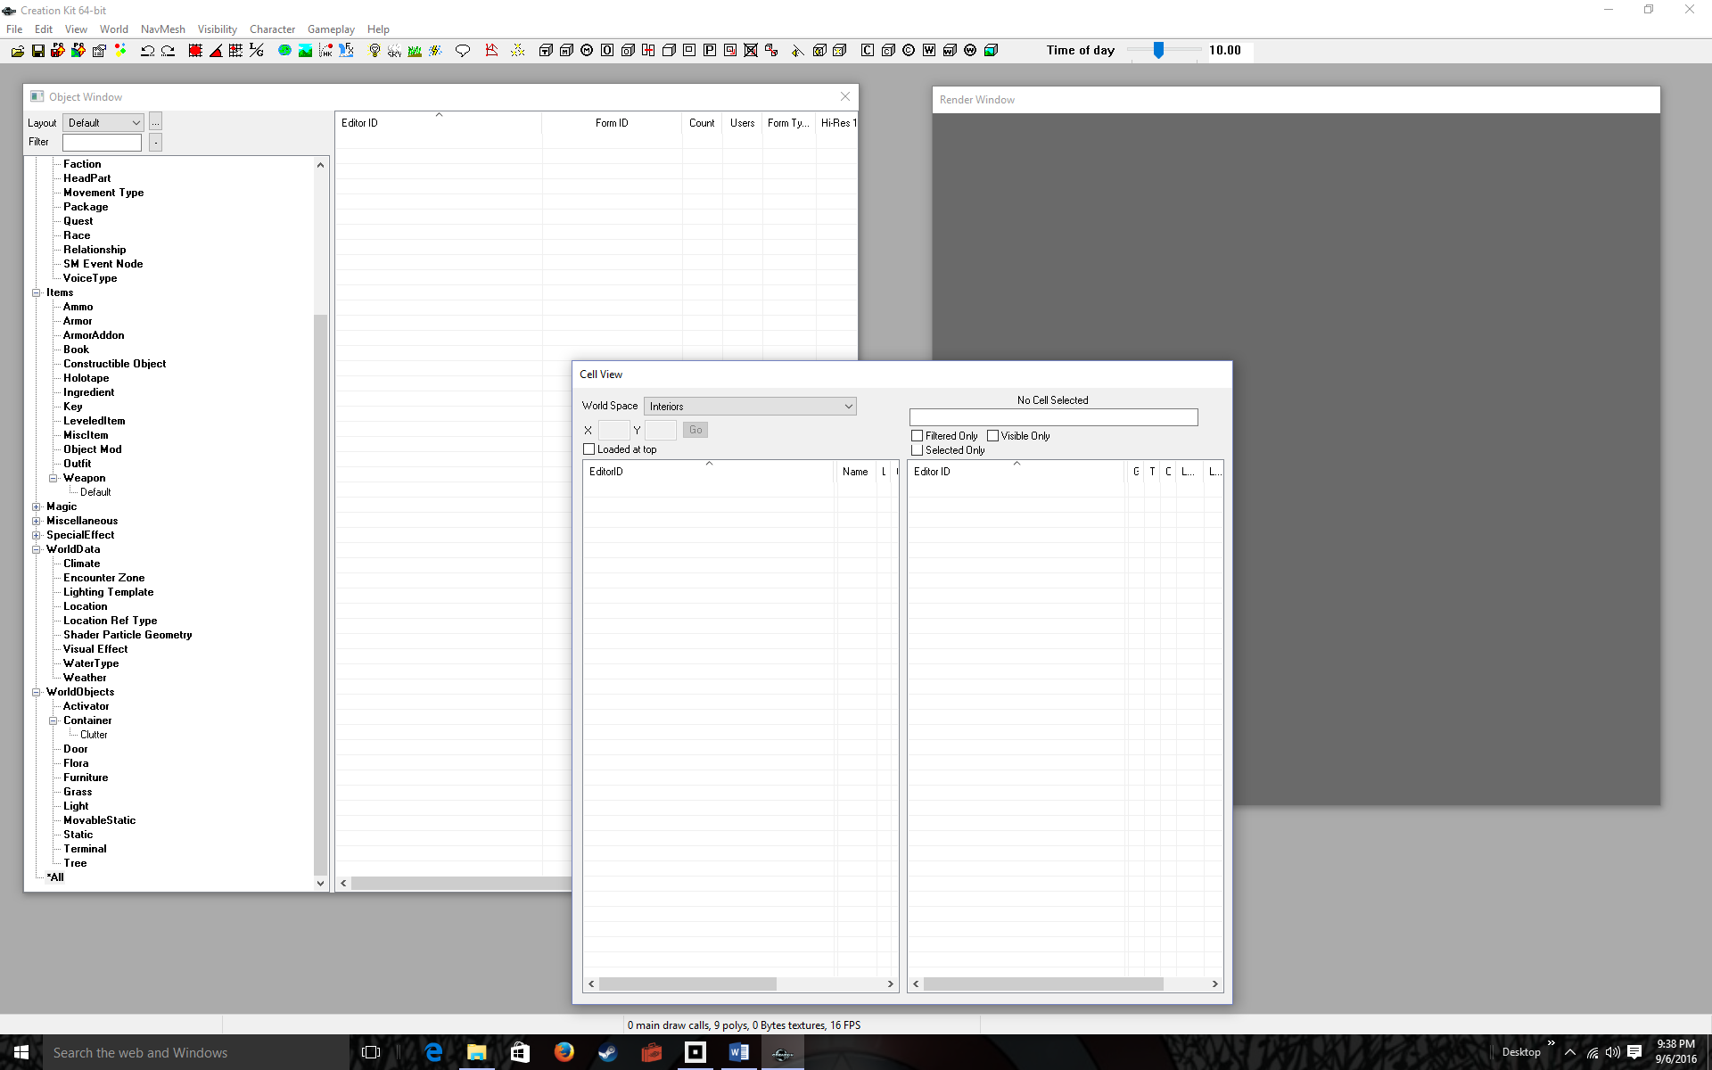
Menu-Select File > Data…  Note: your tutorial created in Part 1 should show up at the bottom of this list. My tutorial is named ProfessorFTutorial.esp | 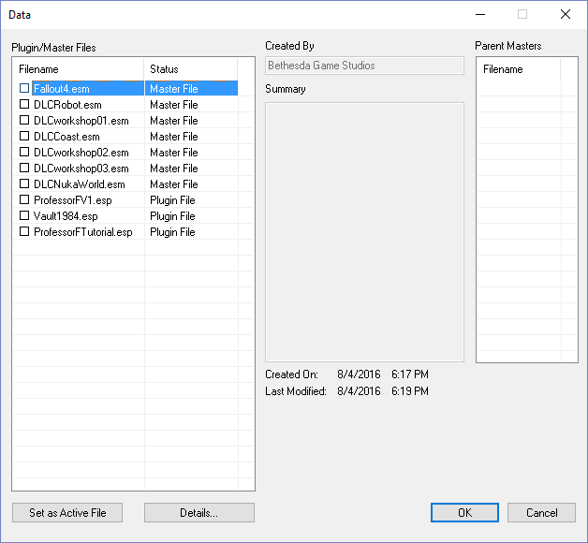
Double-click BOTH Fallout4.esm and (your mod).esm  Again, the name of my mod is ProfessorFTutorial.esp | 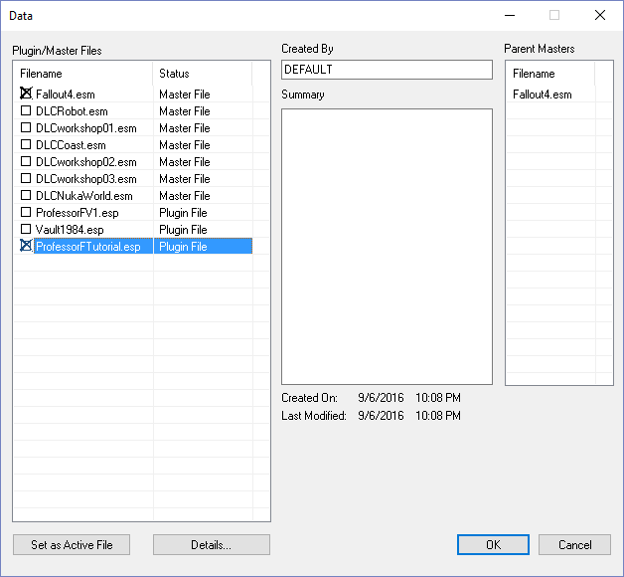
Click the Set as Active File button  Note that the Status column next to your mod’s filename changes to Active File | 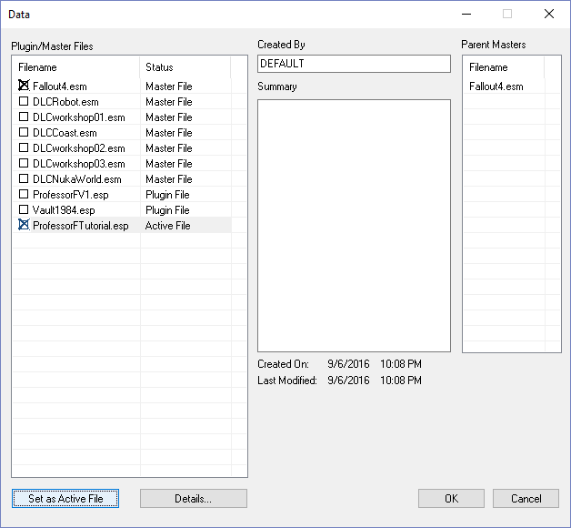
Click the OK button  Your windows fill with the Fallout 4 and with any of your mod objects. | 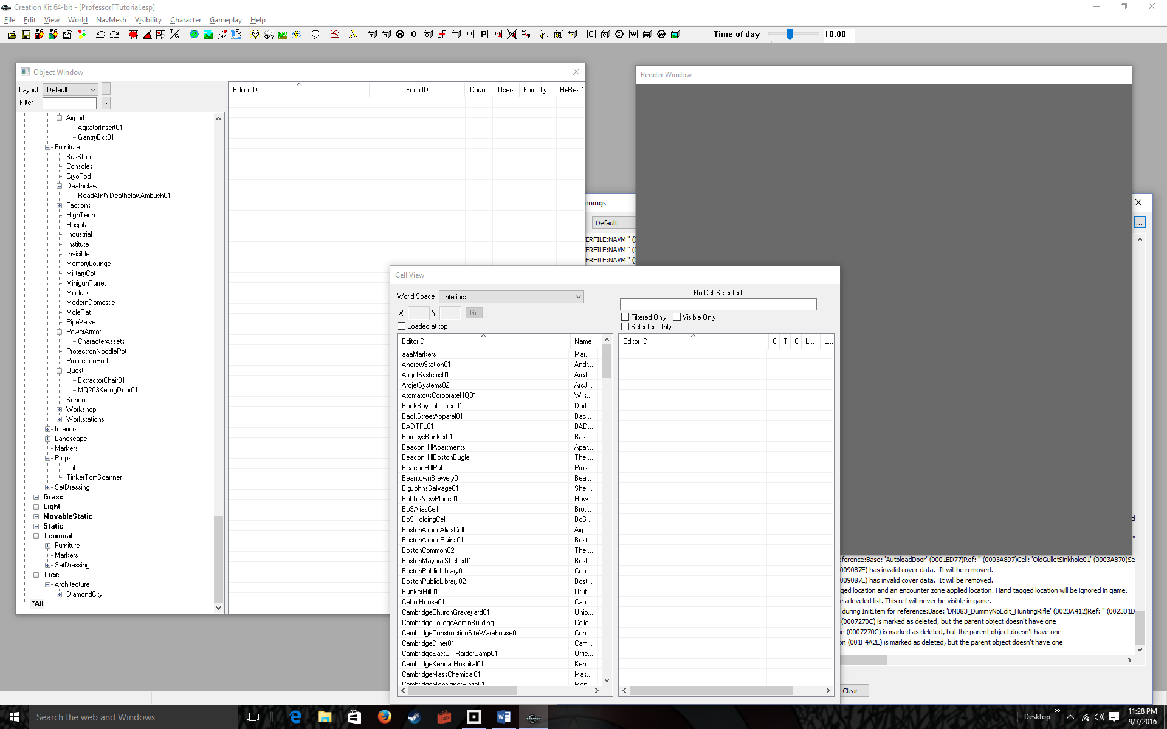
Menu-Select File > Save  Notice that a Warnings window pops up. Ignore all the warnings, they’re normal.  The point is that any changes you make are automatically saved to the active file.  Get in the habit of saving your file regularly. Once saved you can run Fallout 4 without exiting the program and it should pick up your mods. | 