How to Create a Fallout 4 Quest: Part 4— Creating a Test Room via Copying
Nick V. Flor (nickflor@unm.edu)

Start up the GECK by running the Bethesda.Net Launcher and Open up your Mod (as in Tutorial 3)  What we’re going to do is copy and modify an existing room | 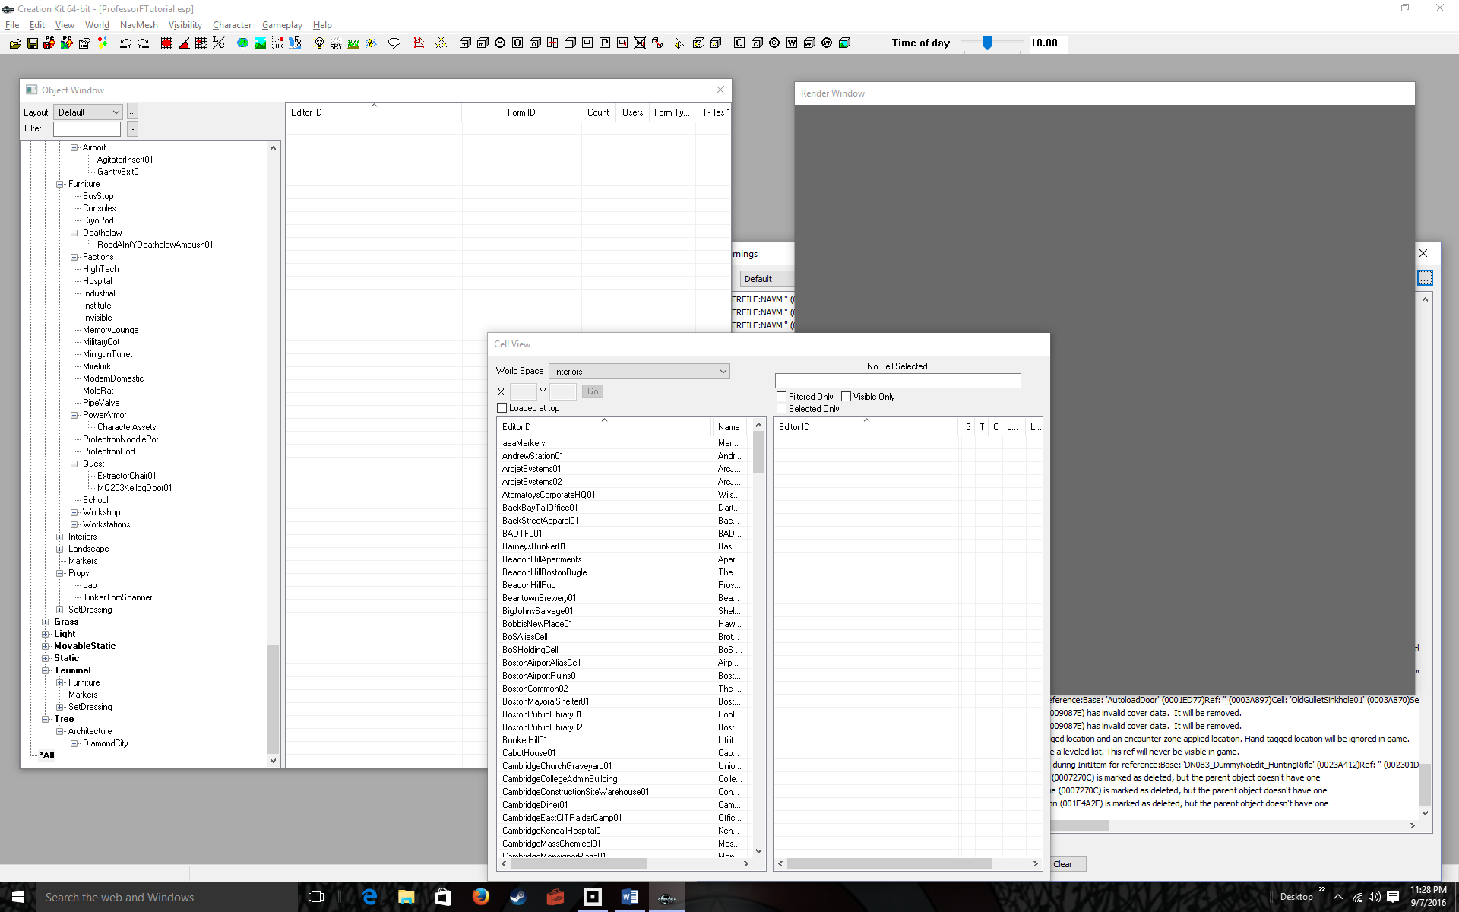
Double-Click BoSHoldingCell in the Cell View window, and Zoom-Out using the Mouse Scroll Wheel  We’re using the Brotherhood of Steel holding cell because it’s just a simple room with 4 walls, and that’s perfect for experimenting with adding objects and quests.  Of course, later on you can modify more complex spaces, but learn the basics first. | 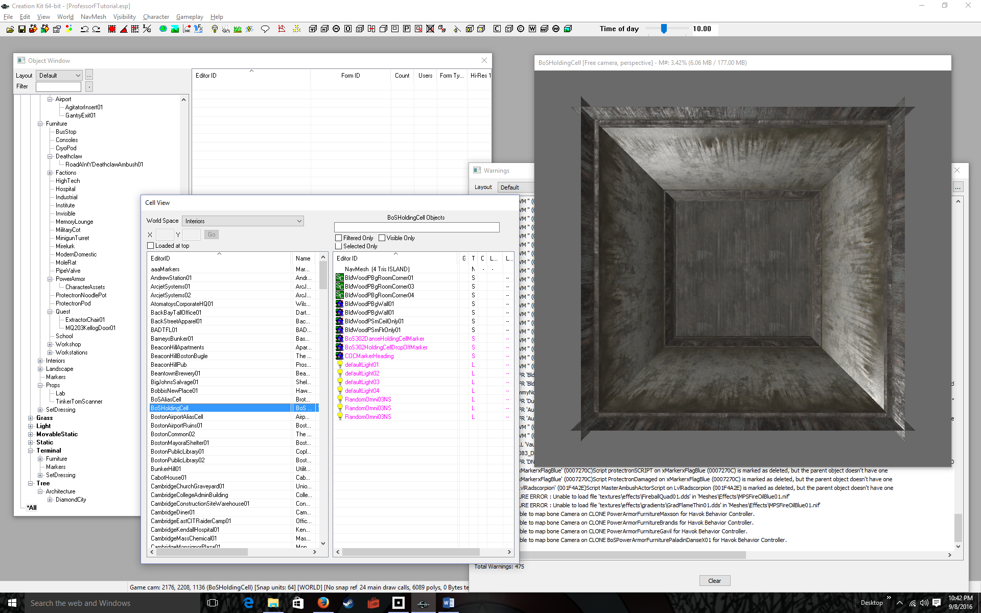
Right-Click over BoSHoldingCell | 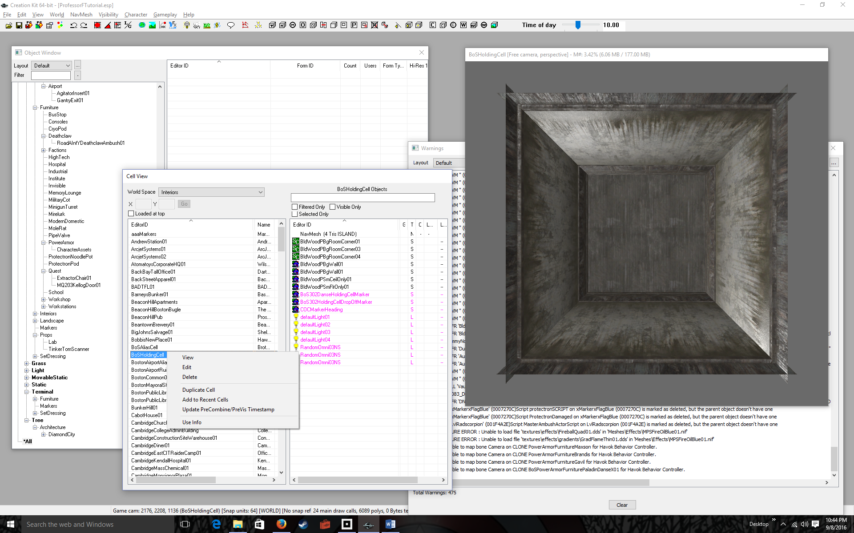
Click Duplicate Cell in the pop-up menu  Congratulations, you’ve just made a copy of BoSHoldingCell. Whenever you duplicate a cell, it places the new cell underneath the copied cell and appends COPY0000, e.g., BosHoldingCellCOPY0000  Let’s change the name to something better | 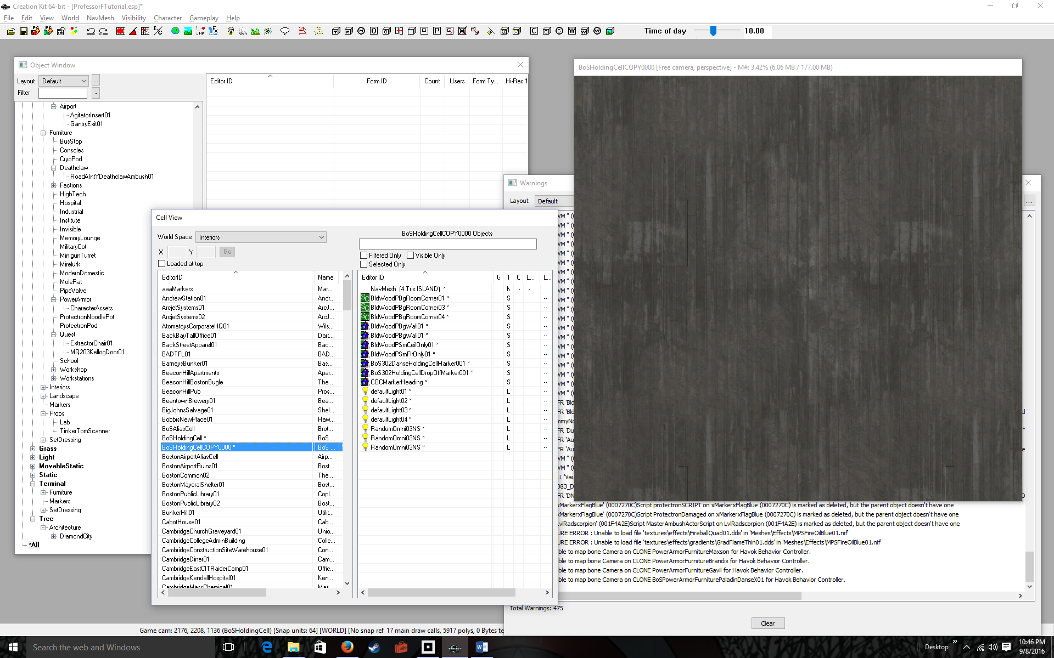
Click once on the duplicate cell’s name, then Click again  This will allow you to change the name | 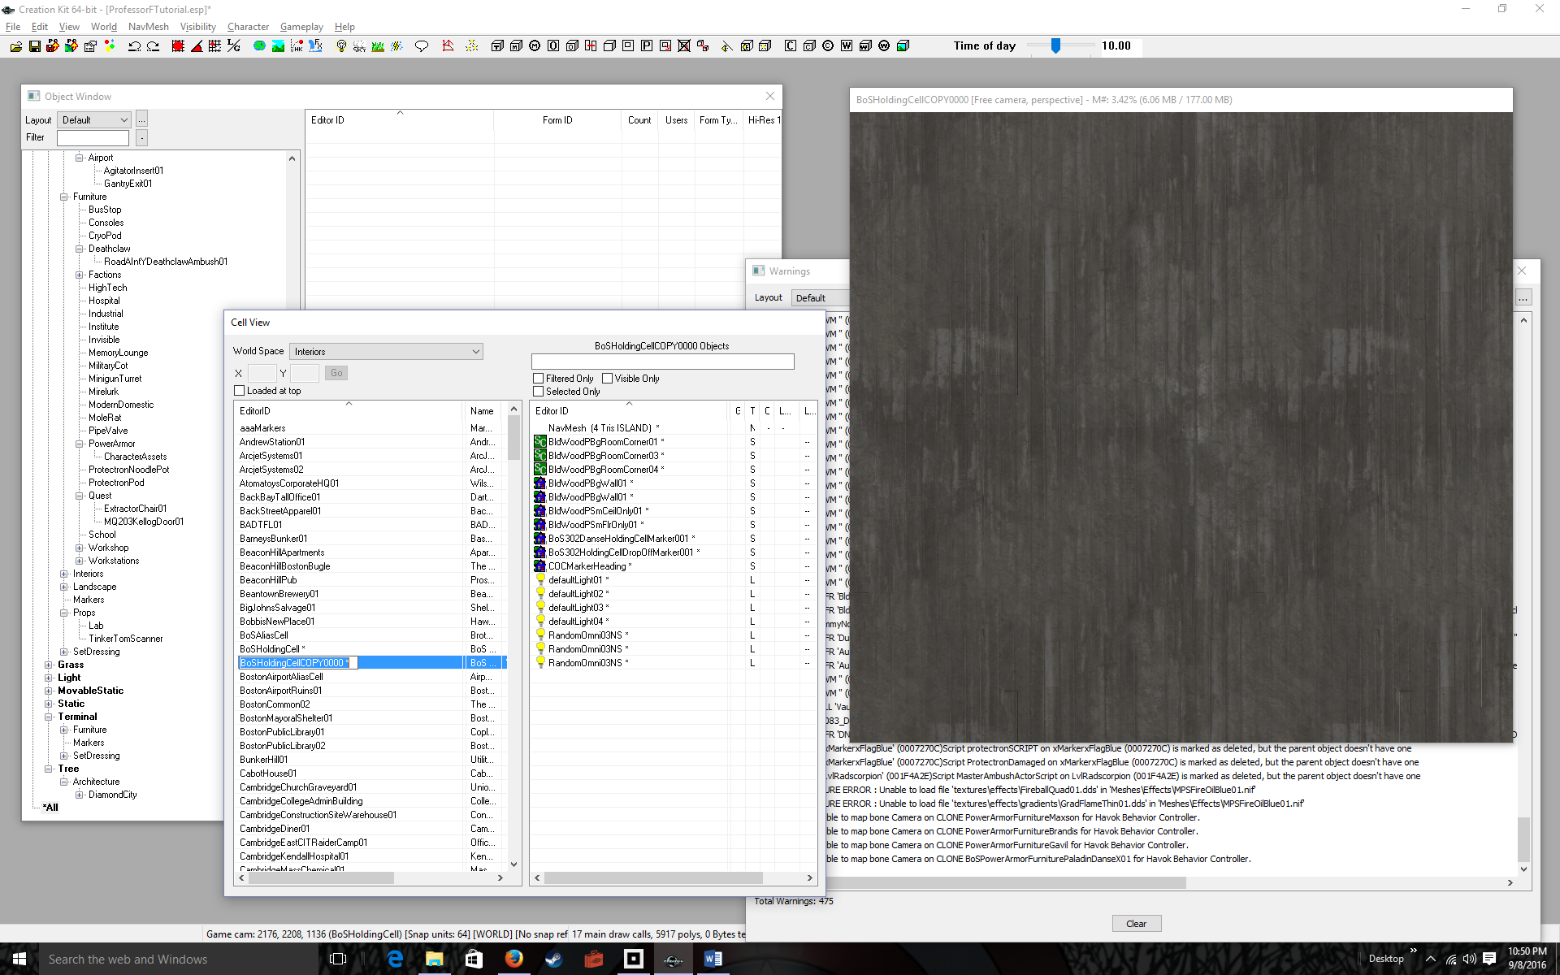
Change the name to BosHoldingCellTut  “Tut” for tutorial  You might also want to zoom out using the scroll wheel, just to make sure you copied the right room. | 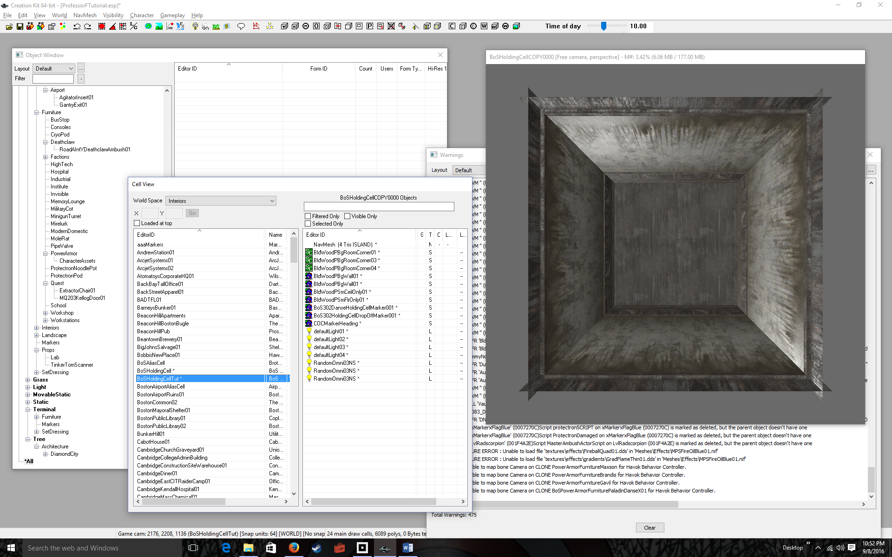
Menu-Select File > Save  It’s very important to save, anytime you make a change to your mod file, like duplicating a cell. Get in the habit of saving often.  Now let’s test our mod by placing our avatar in the room. | 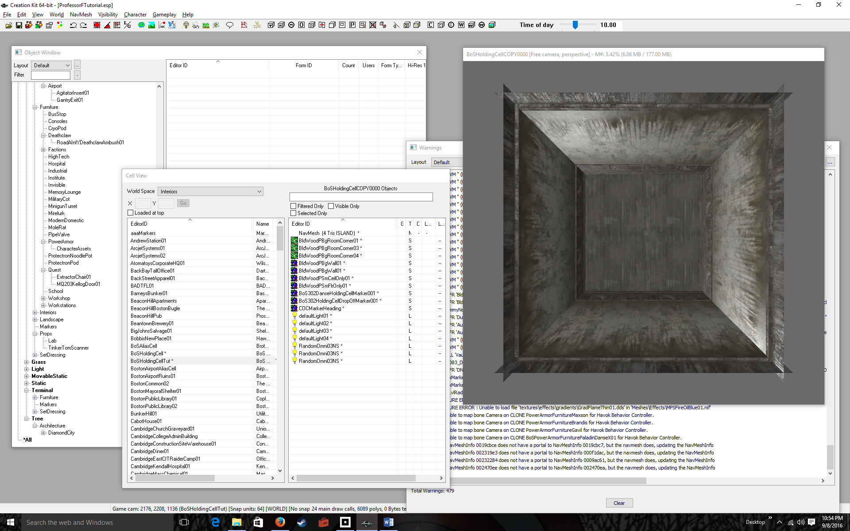
Run Fallout 4  DON’T CLOSE YOUR GECK, otherwise you’ll have to reload everything after you’re finished testing. Instead, just minimize the GECK, so you can click on your Fallout 4 icon. | 
Click PLAY then Press any button to start | 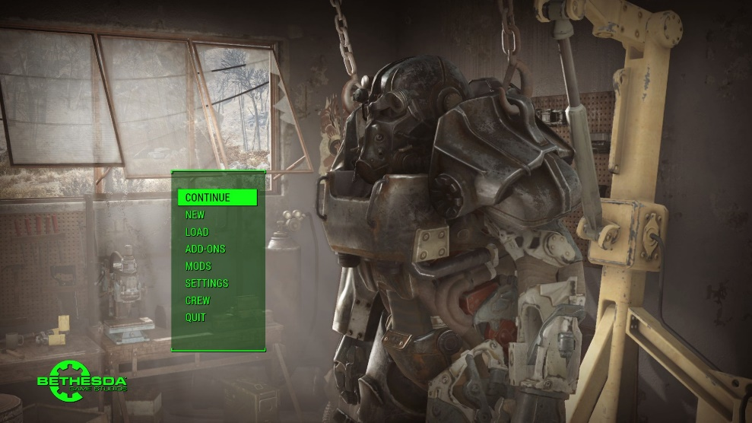
Select CONTINUE and (A) Confirm  Note you don’t have to go to the MOD menu to load your MOD as you did in a previous tutorial.  Your screen my look different from mine, depending on where you left off in your game. I’m actually in the original BoSHoldingCell  Let’s switch to BosHoldingCellTut (the tutorial version) | 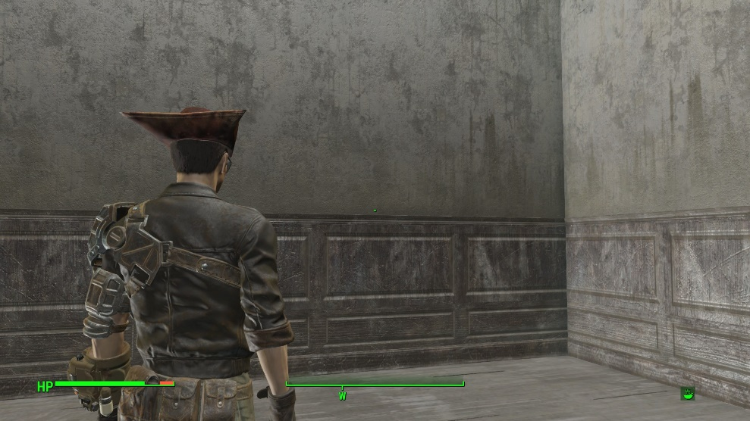
Type `coc BoSHoldingCellTut  The backquote (`) puts you in command mode. coc is the command to teleport to a new cell. Cells are rooms, town, and other spaces in Fallout 4. I’m told it’s short for Center on Cell. It takes as an argument a cell name, in our case BoSHoldingCellTut | 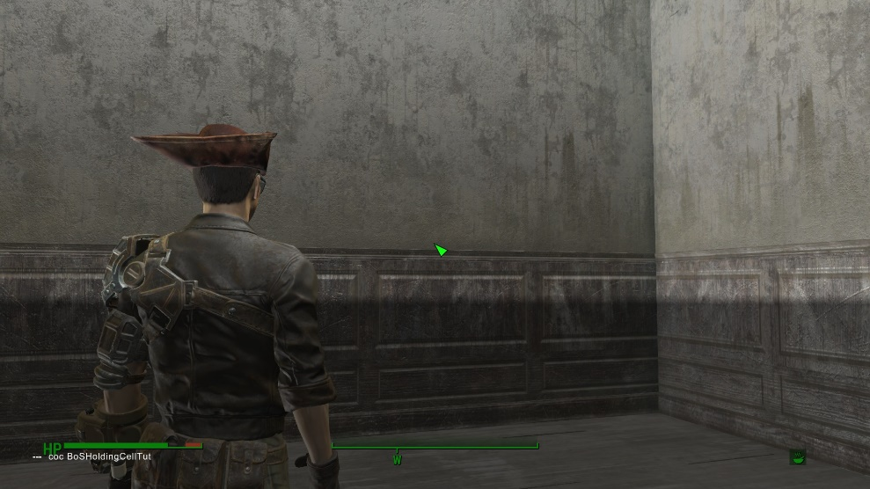
Type Enter  You’re now in your copy of the BoSHoldingCell, aka BosHoldingCellTut | 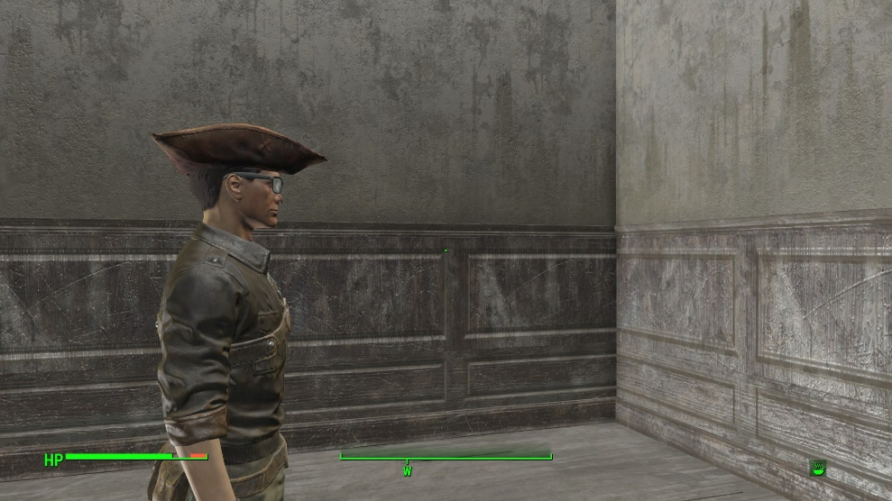
Bring Up the QUICKSAVE menu (shown). Select QUICKSAVE then QUIT out of Fallout 4 (not shown)  I usually just QUICKSAVE once, after I’ve teleported into the room. Afterwards, I just QUIT because I’m testing out mods and I don’t want my actions saves.  Okay you’re done with creating your own room and teleporting into that room.  In the next tutorial, we’ll populate that room with objects. | 

