How to Create a Fallout 4 Quest: Part 6— Creating Dialog
Nick V. Flor (nickflor@unm.edu)

Start up the GECK by running the Bethesda.Net Launcher and Open up your Mod (as in Tutorial 3) | 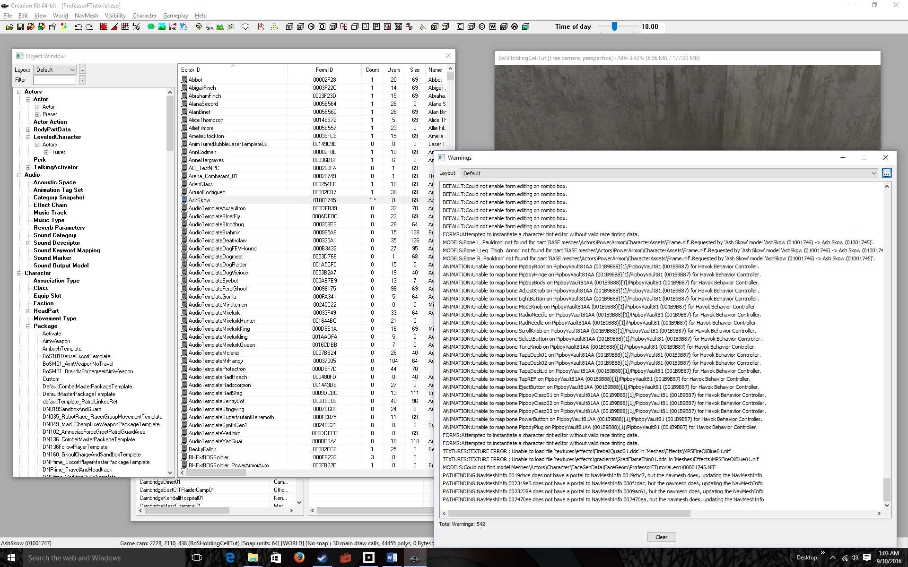
Click on the Object Window, Scroll Down the left list, and expand Quest  This list contains all the Quests in the world, and all Dialog is contained in Quests. The right list contains specific quests. | 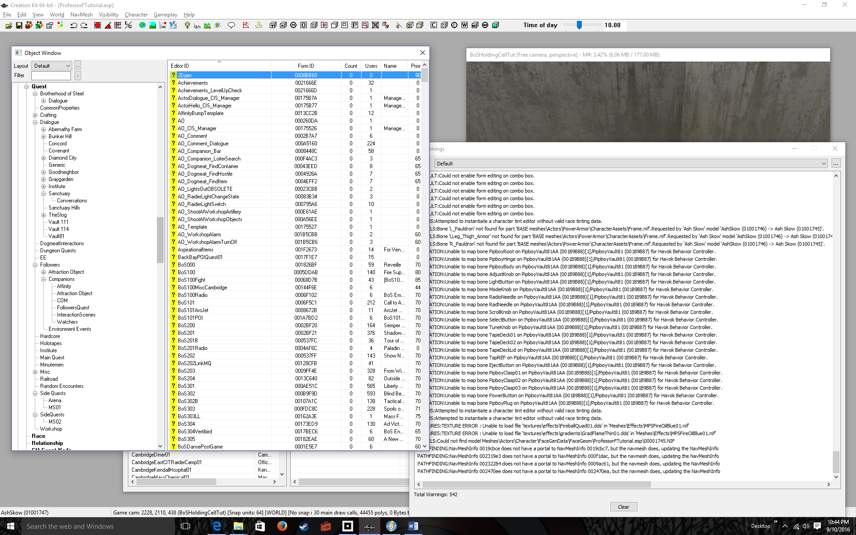
Right-Click in the right list to bring up a pop-up.  The right list fills up with all the actors in the world. | 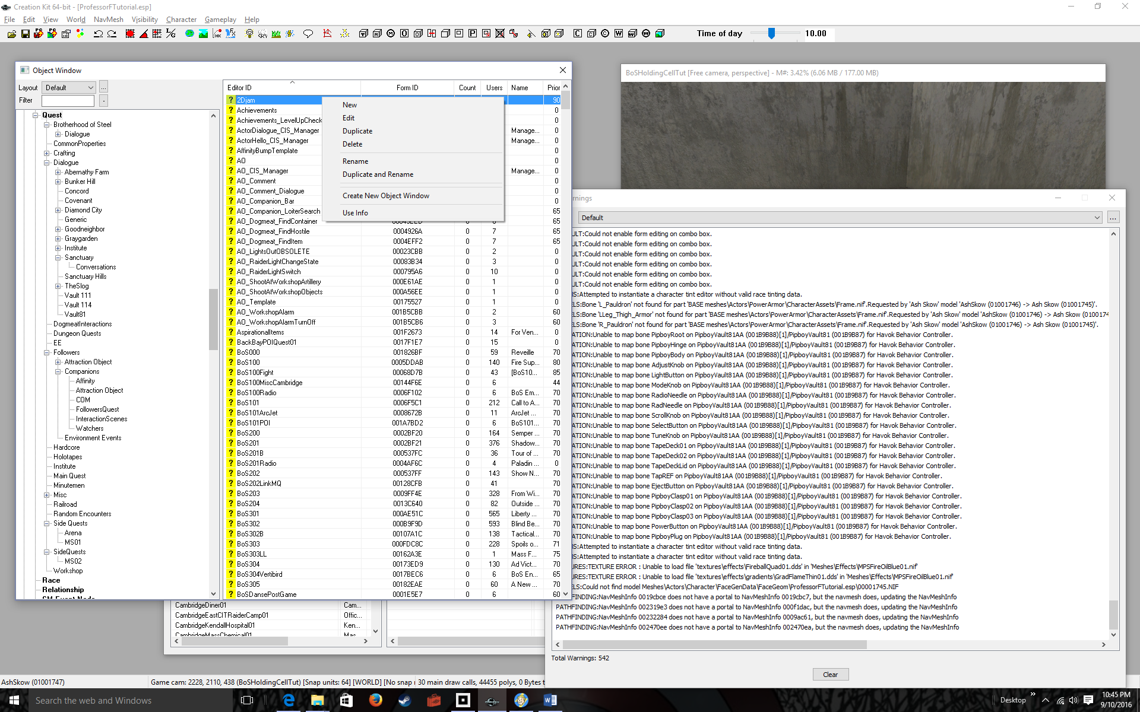
Select New  The Quest Window pops up. This is where you design an entire quest. | 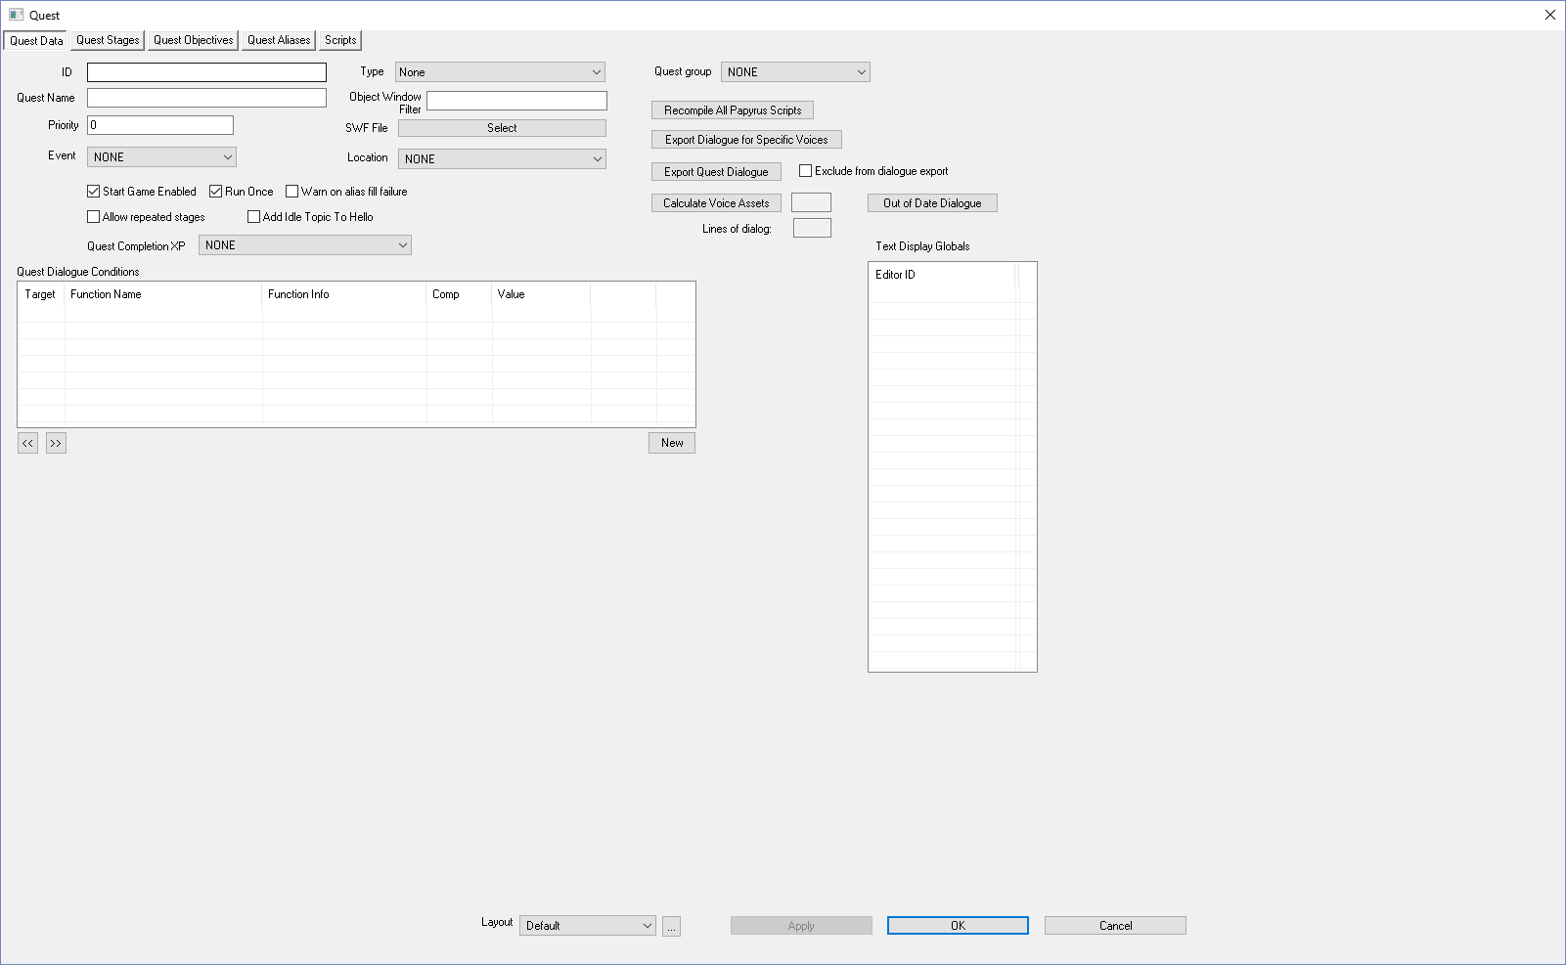
Enter a label for your quest in the ID textbox (AshSkowQuest)  Enter a name for your quest in the Quest Name textbox (Ash Skow Quest)  Note, your ID should follow proper coding variable conventions (starts with a letter, letters and numbers only, no spaces). The quest name can contain spaces, and is what is displayed to the user when the quest starts. | 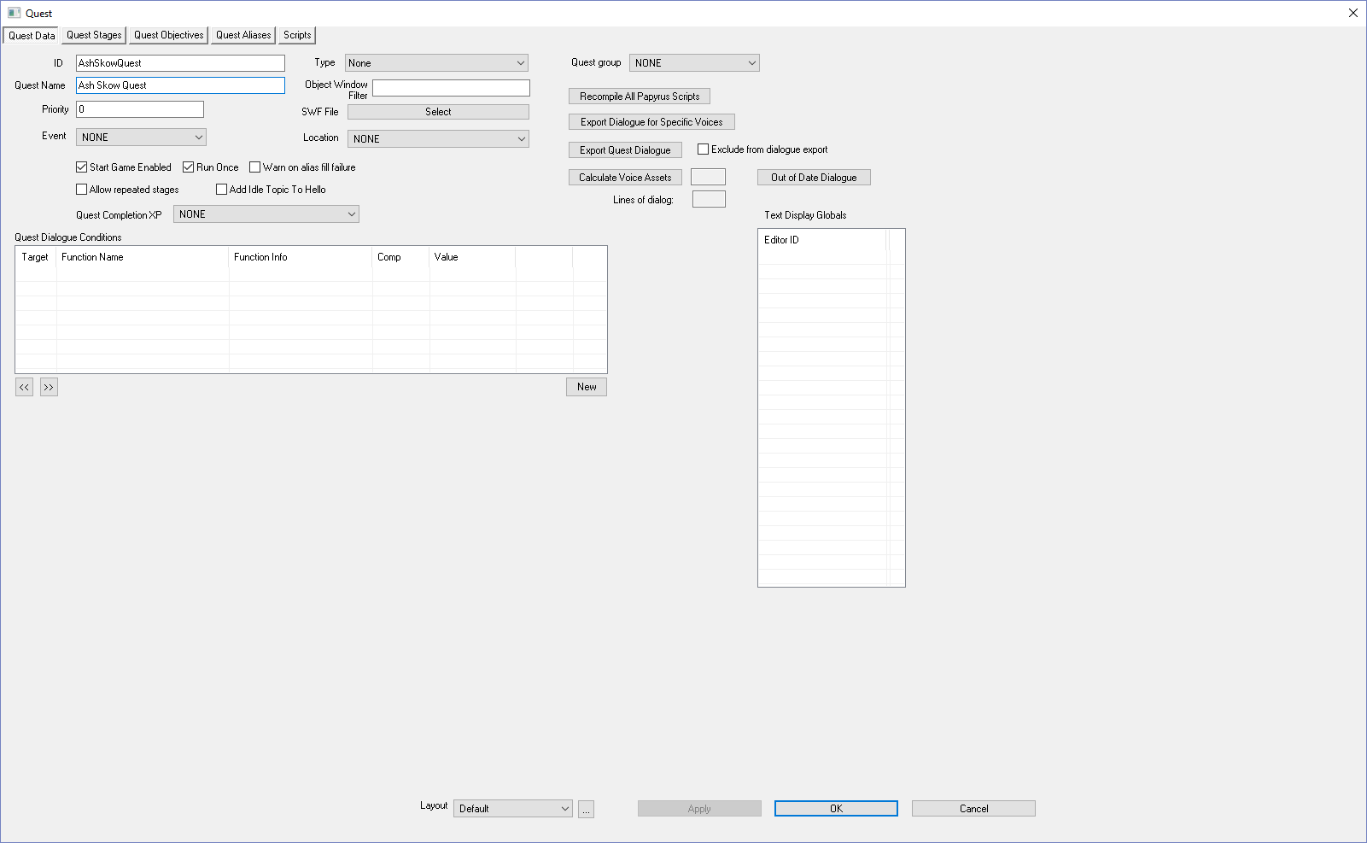
Click the OK button  Note: AshSkowQuest appears in the right list as a quest. OK saves your quest and exits, but clicking on any tab in the Quest window also saves your quest. | 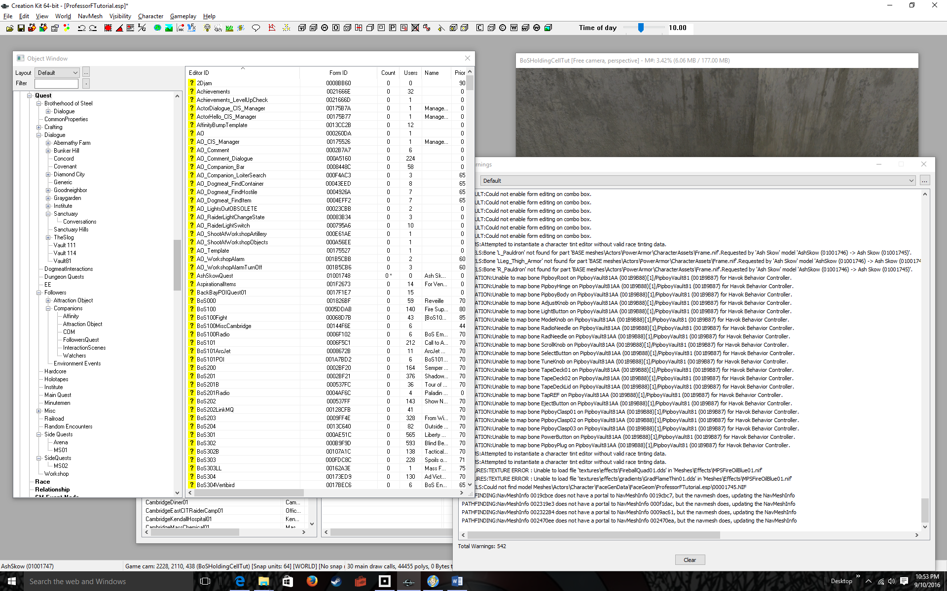
Double-Click the AshSkowQuest  Click on the Quest Aliases tab  Any NPC or item that can have a quest marker should be added hear. That means AshSkow! | 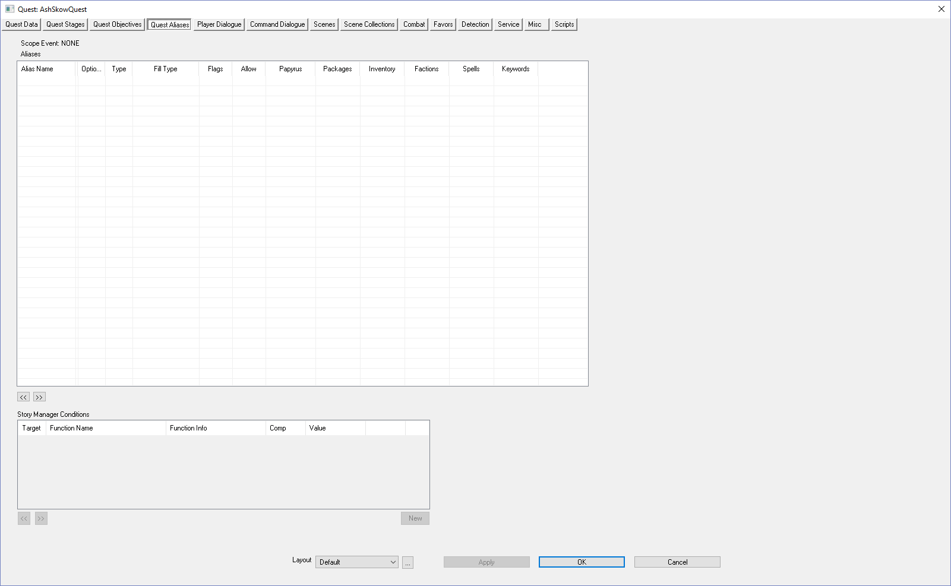
Right-Click over Alias Name | 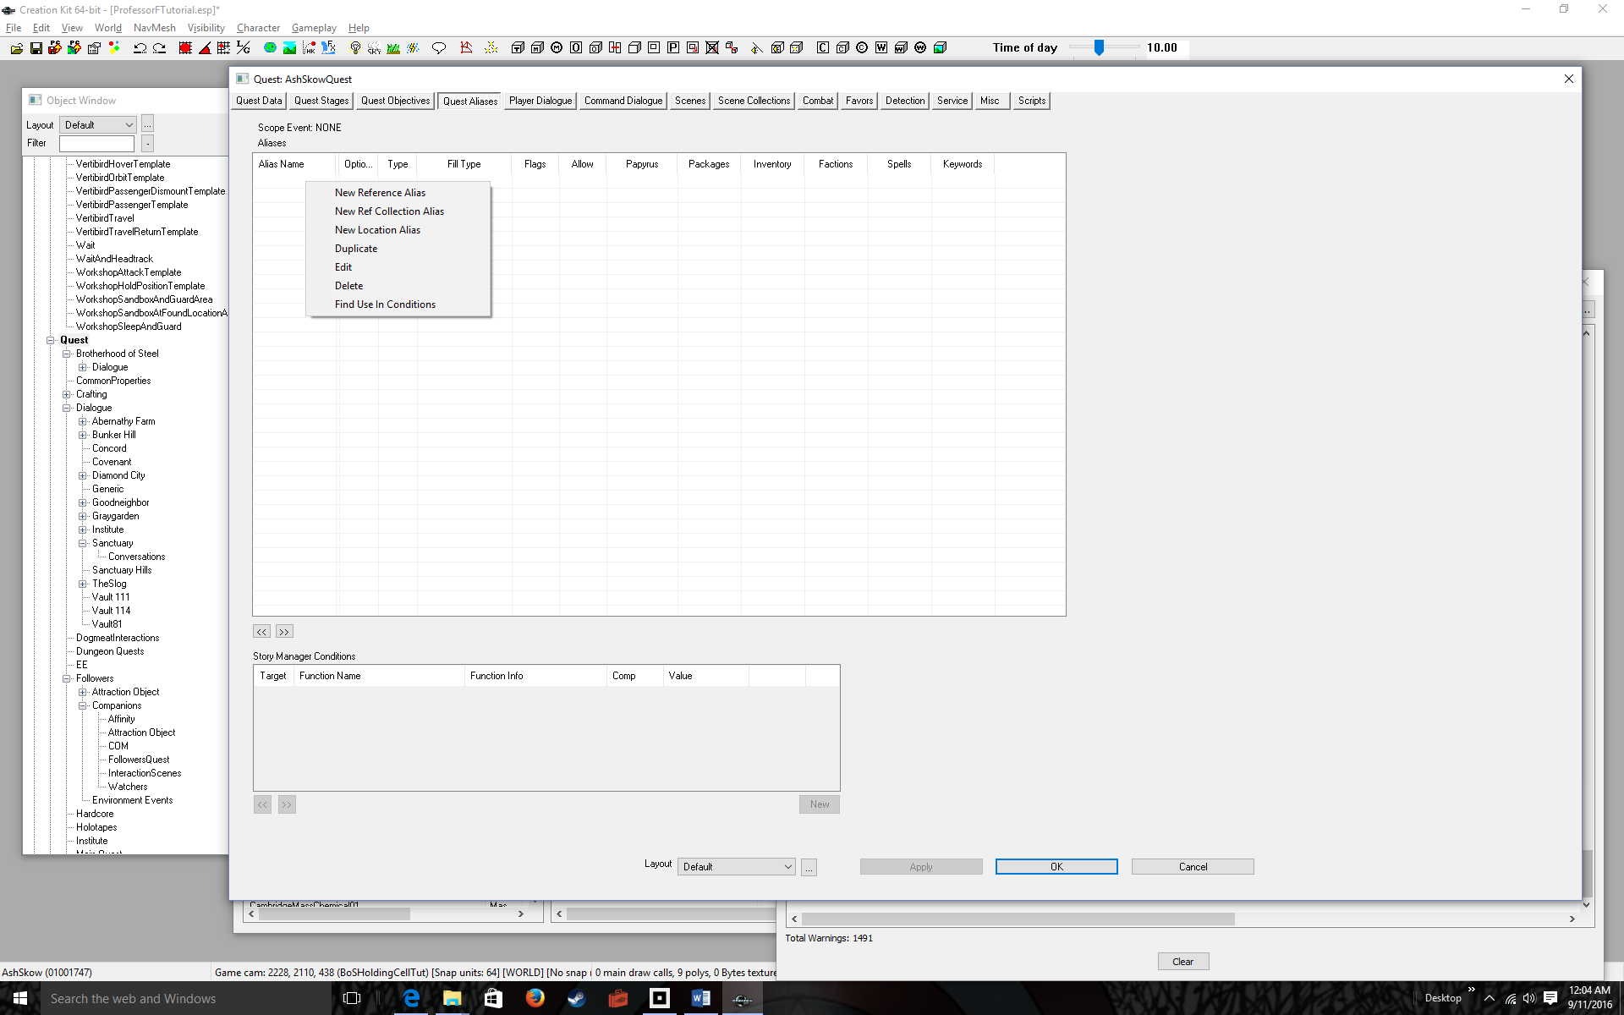
Select New Reference Alias | 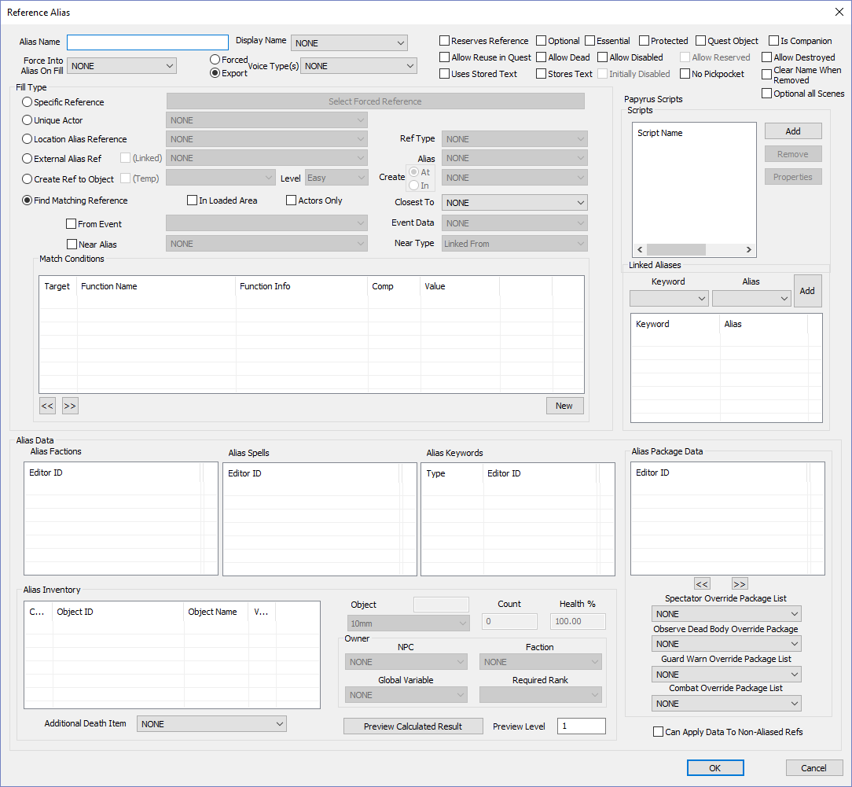
Enter a name into the Alias Name text box (AshSkowAlias)  Select the radio button for Unique Acotr  Select AshSkow in the Drop Down | 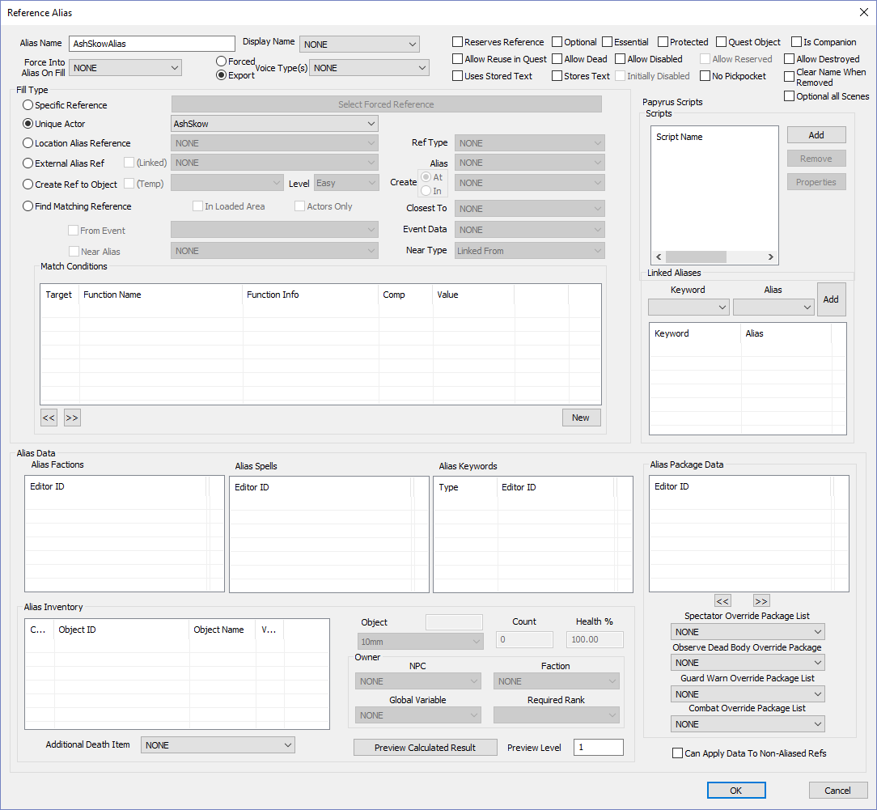
Click the OK button  AshSkowAlias appears. This allow her to be used as a marker that shows up on the map in quests (I think!) | 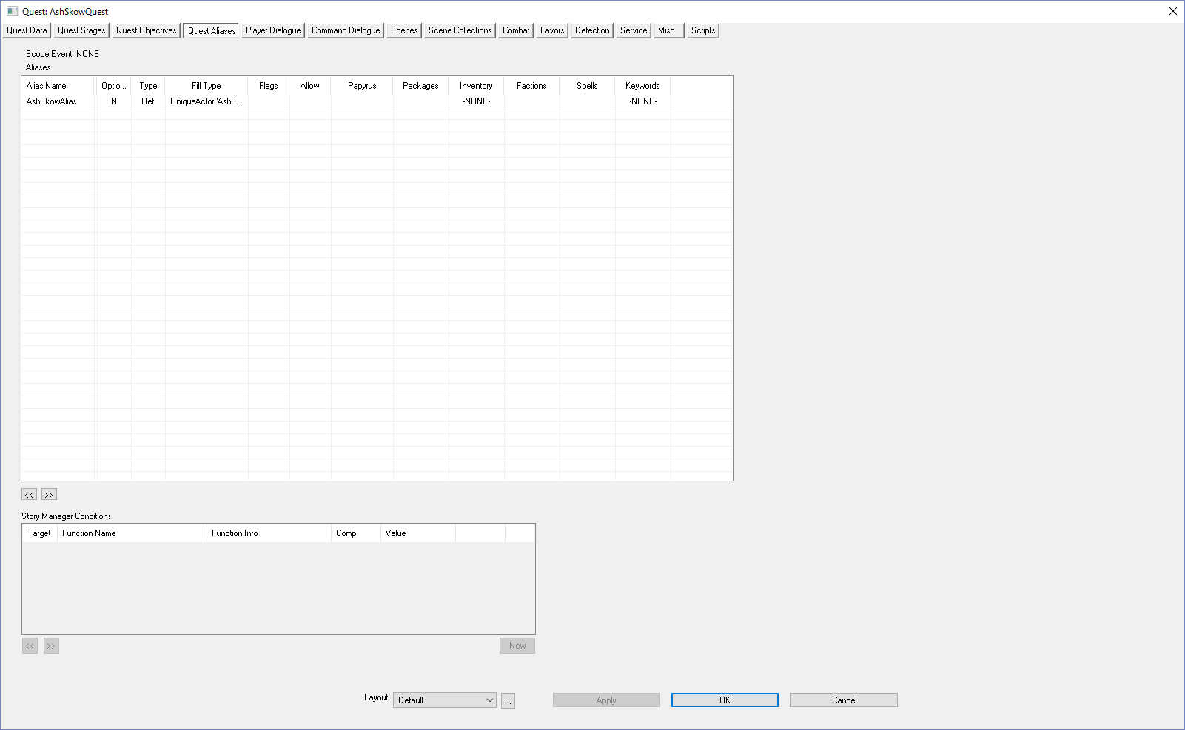
Click on the Scenes tab  Notice, you now have more tabs to play with. We’ll go over the major ones in more detail later. But the main tabs are Scenes (where the dialog takes place), Quest Stages & Quest Objectives (where you keep track of Quest progress and add most of your code). | 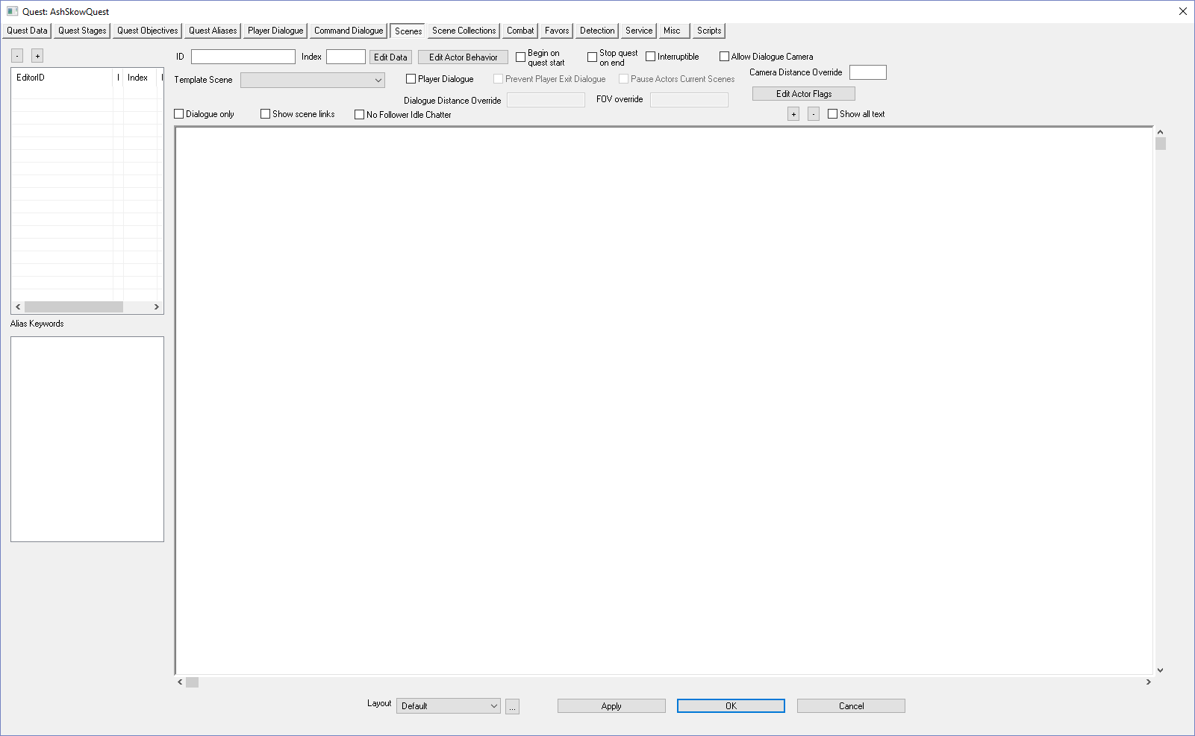
Right-Click over the EditorID panel  What we’re going to do is create a scene. Each scene is associated with dialog. It is also associated with a Quest “state”. For example, in the first state of a quest you usually have dialog where the NPC asks the player for help. The second state of a quest is asking if the player has completed. The third and final state of the quest is where the player has completed and gets a reward. | 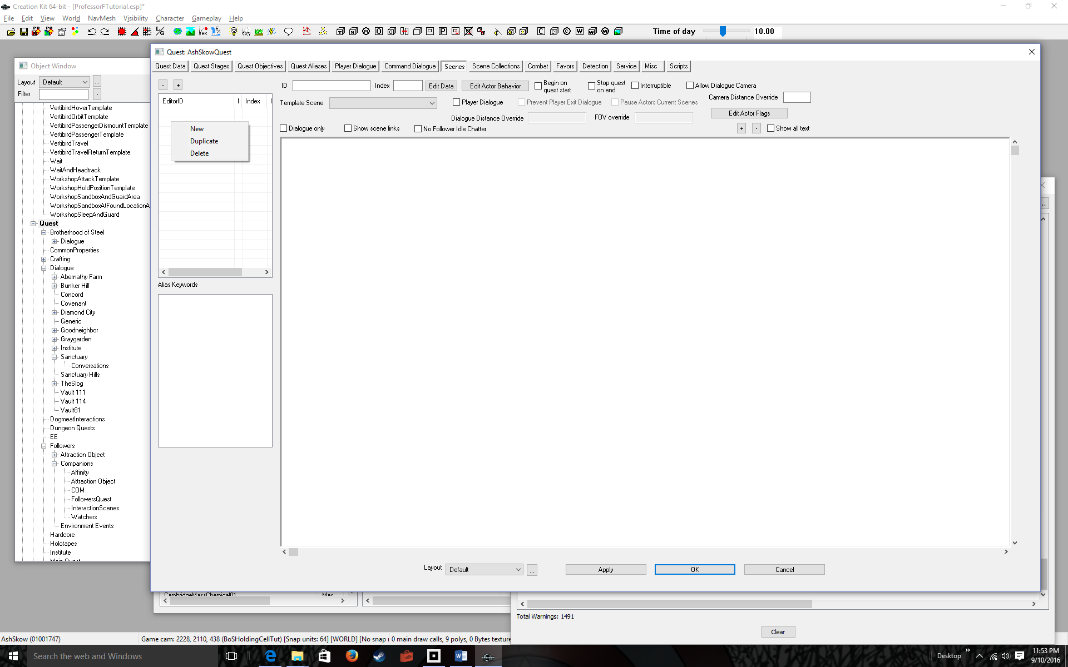
Select New  The quest ID is shown as a prefix. Don’t use that as a scene ID, do the next step | 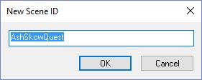
Append NN to the text  Where NN is the number of the scene | 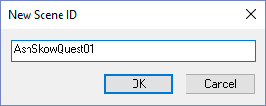
Click OK  Note the scene name appears in the EditorID. | 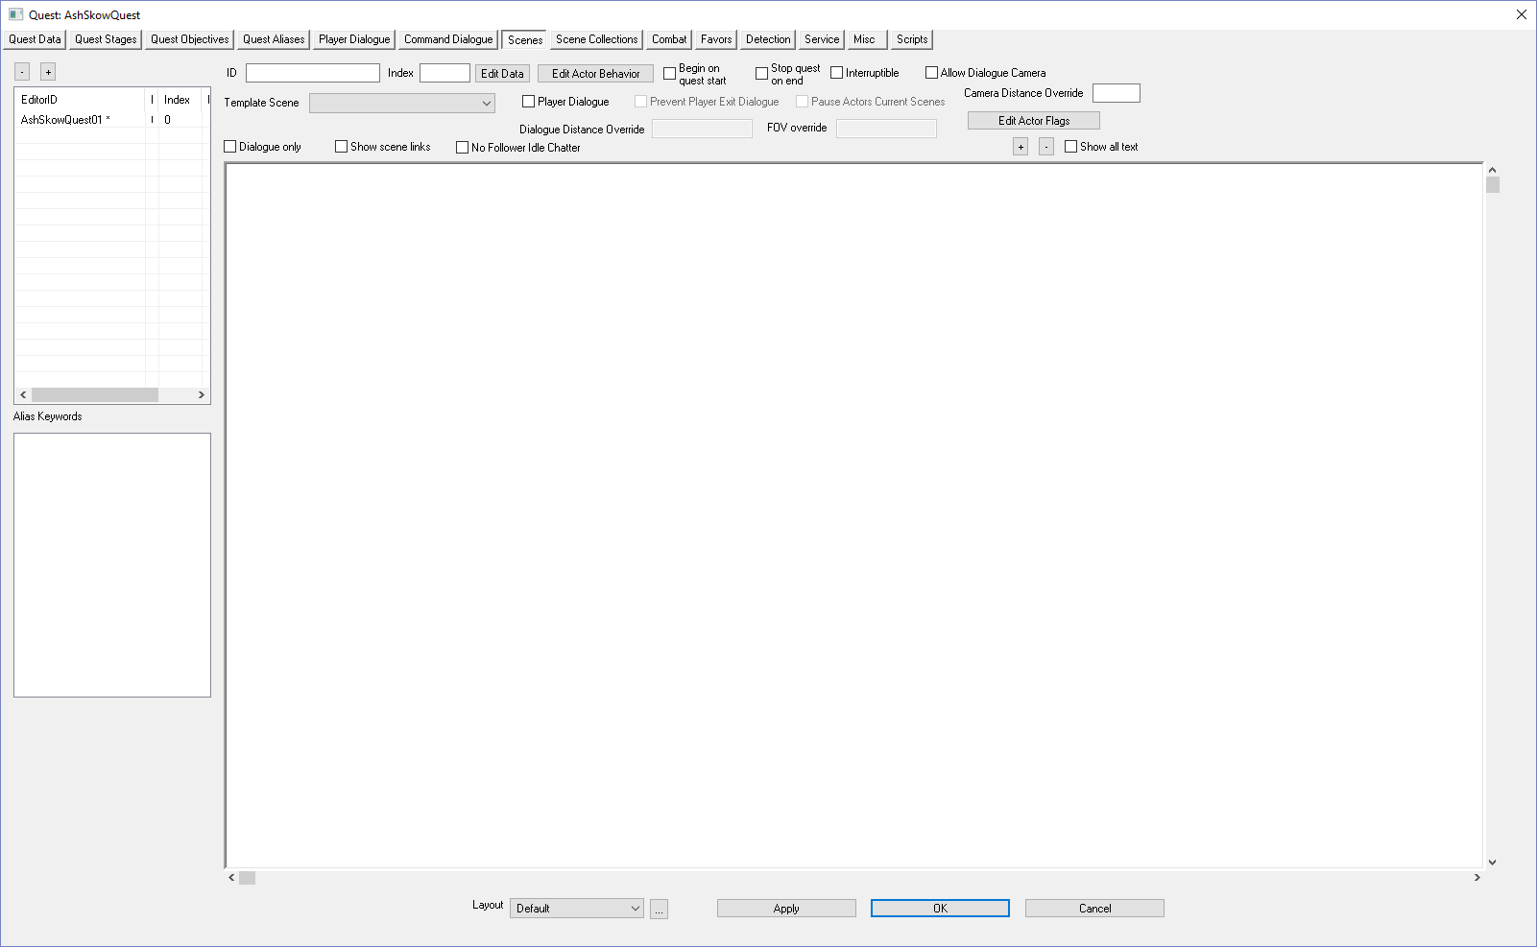
Click on the scene name  Note that the ID text box fills in with your scene name, AshSkowQuest01 | 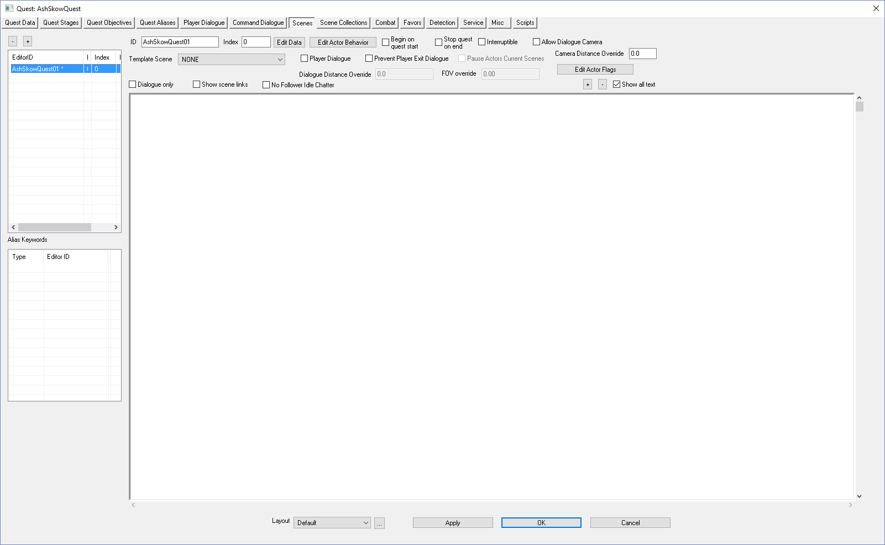
Click on the Player Dialogue checkbox | 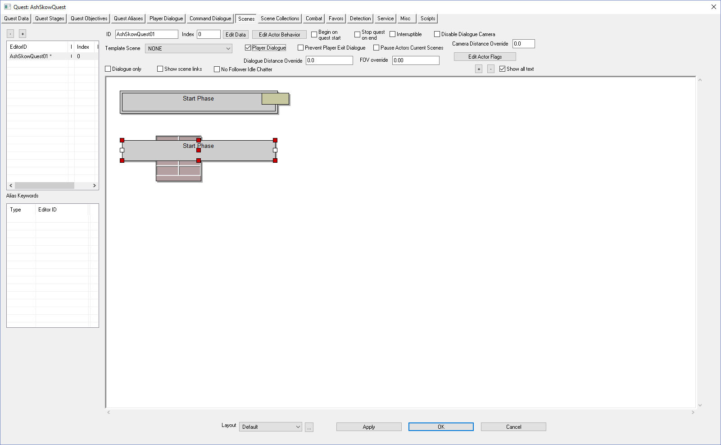
Right-click anywhere in the white area | 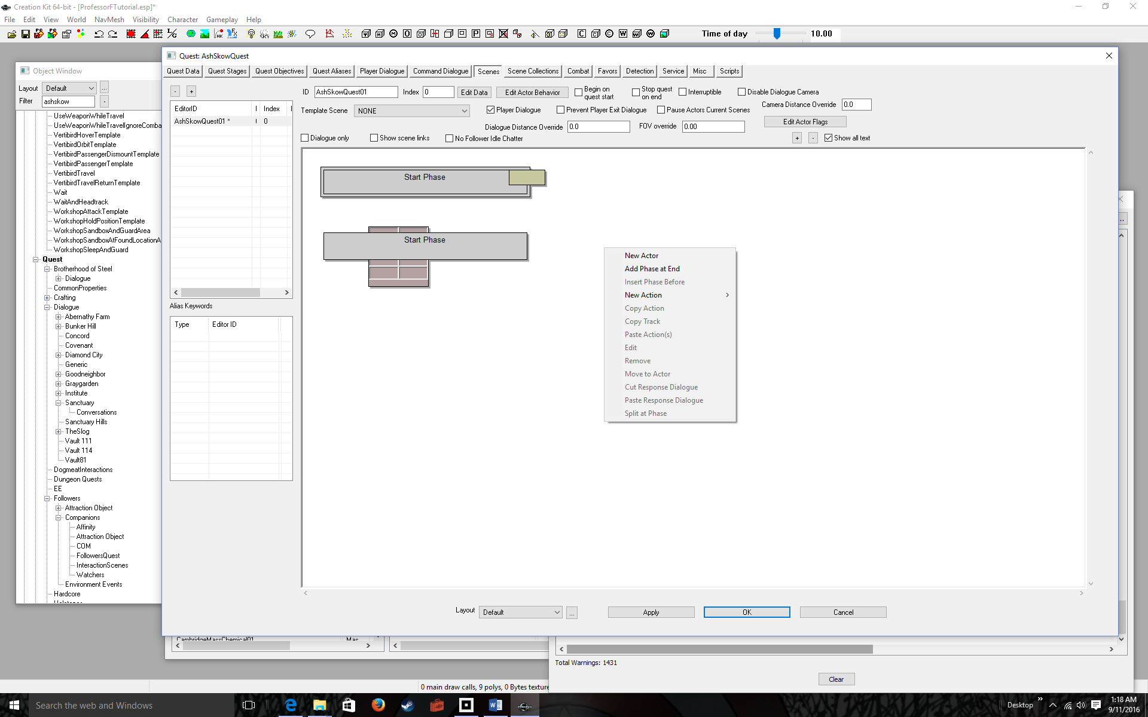
Select New Actor | 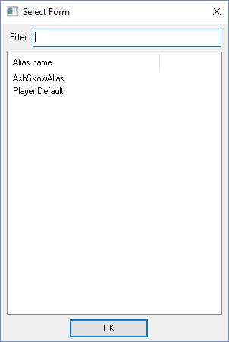
Click on your NPC alias (AshSkowAlias) then click the OK button | 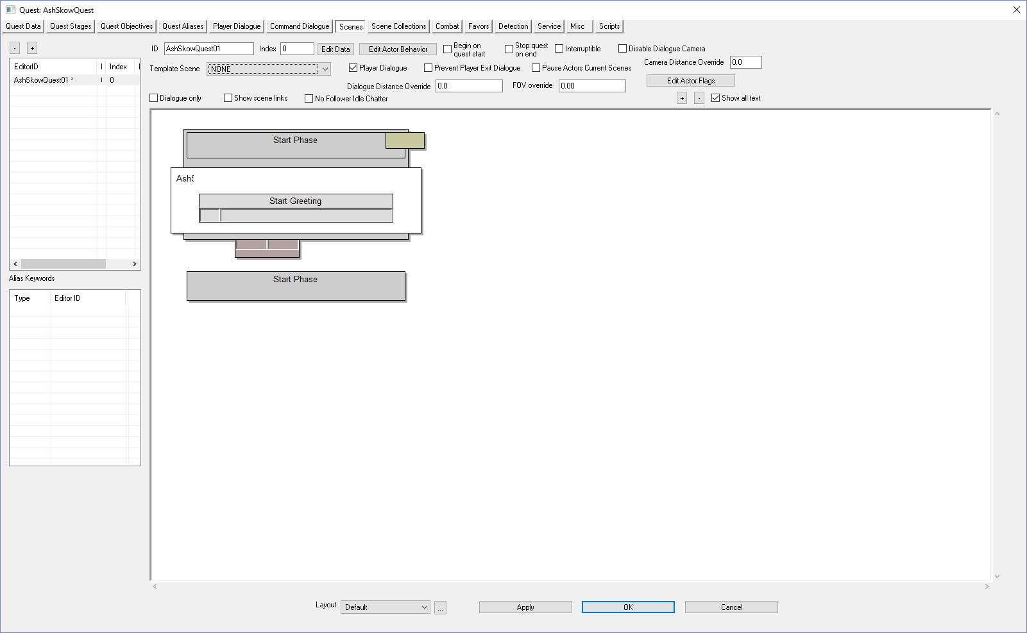
Double-click the empty gray box underneath Start Greeting  The Quest ID is prefixed, but don’t you dare click OK, instead… | 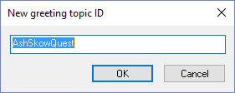
Append GreetingNN  Where NN is some unique greeting number like 01 | 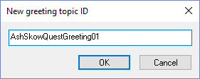
Click the OK button  There are many inputs here, but the only one that matters is the Response Text. This is the greeting the player will see when prompted to talk to the NPC | 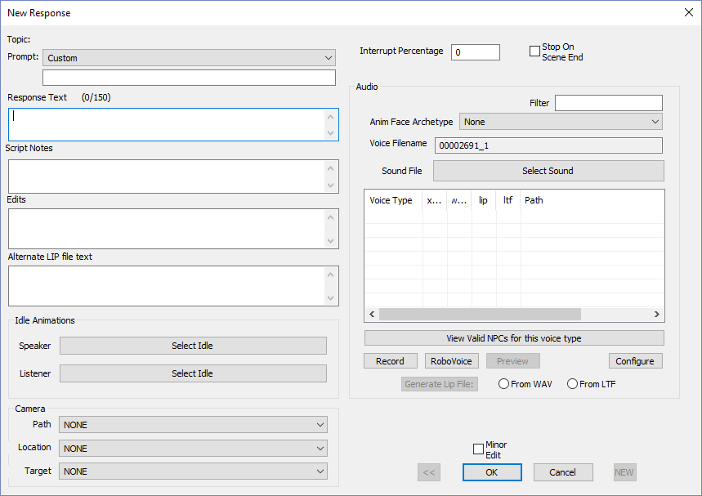
Type a greeting into the Response Text box  Example: “Hi there! Can you help me find something?”  Again, this is what the player will seen when prompted to talk to the character. | 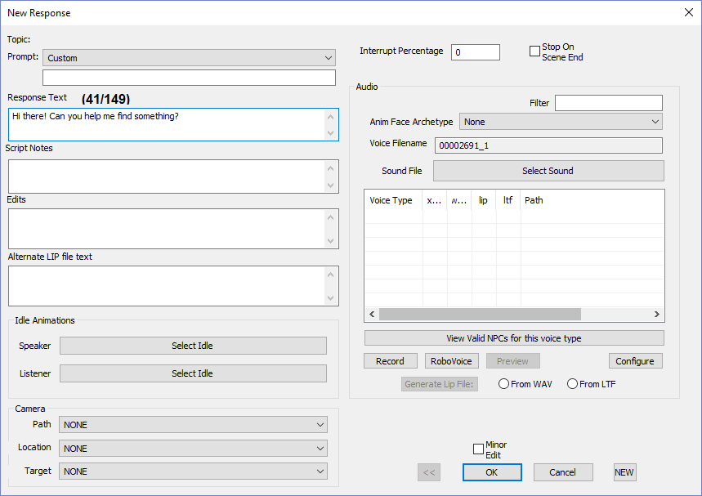
Click the OK button  Note the Response Text is filled with your greeting. This pop-up also allows you to change many options when we start scripting the quest—like when the greeting appears. But for now, we can ignore most of what’s in this box. | 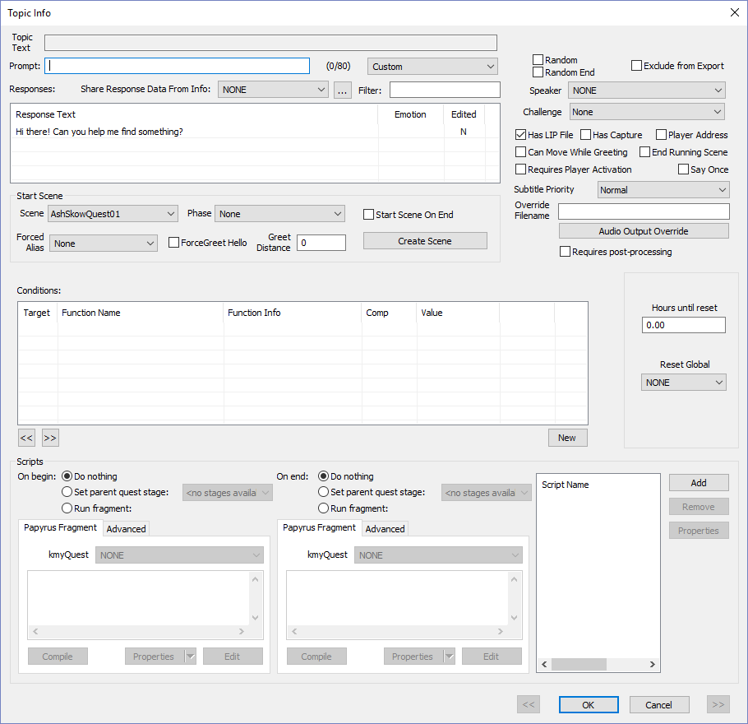
Click the OK button again  Yet another dialog box pops up allowing you to change options. Again, you don’t need to do anything at this point in your quest-scripting knowledge. | 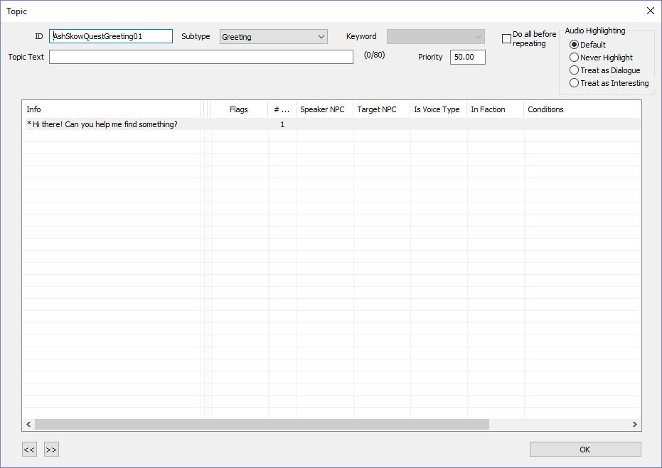
Click the OK button  Finally we’re back to the main scene window.  Remember: the Start Greeting is what the player will see when he or she first engages the NPC (usually by selecting the Talk option) | 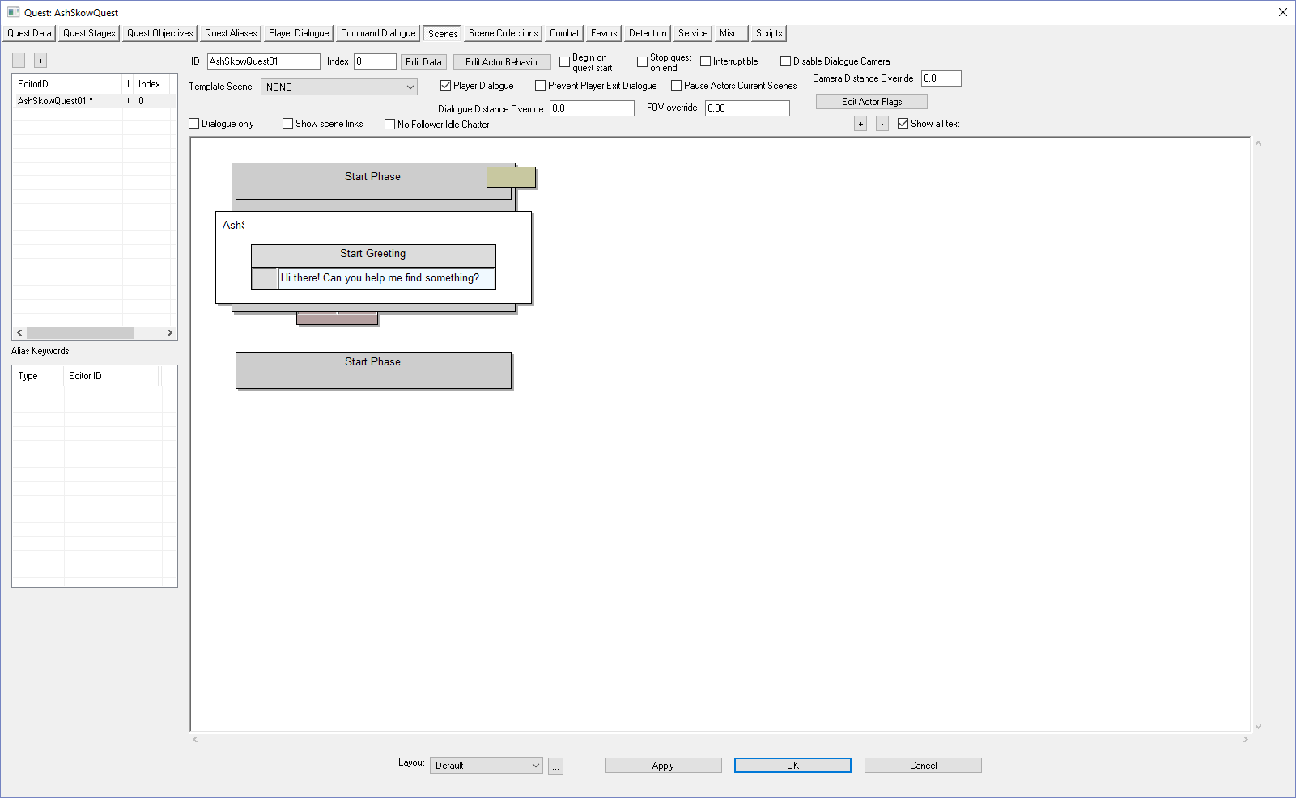
Right-click on the white scene area | 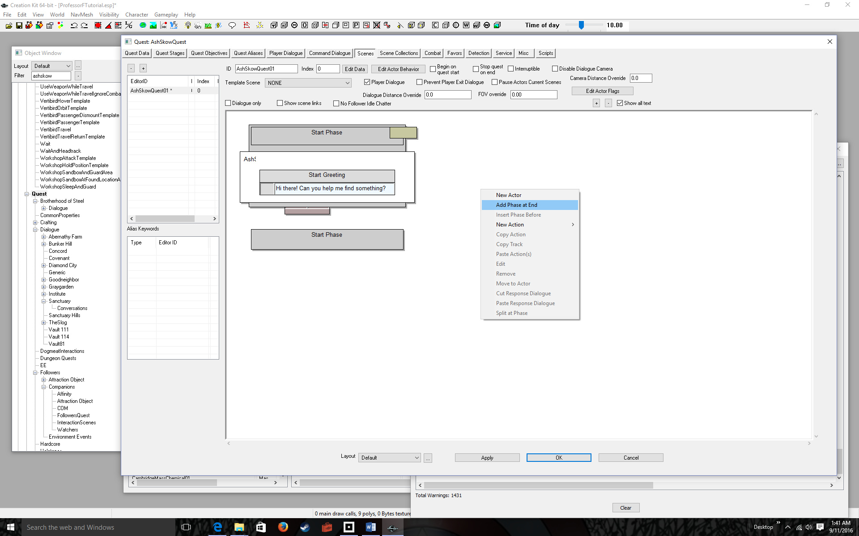
Select Add Phase at End  Typically each phase contains dialog. After the greeting, we will add 4-part interactive dialog, which requires adding a Phase 1 | 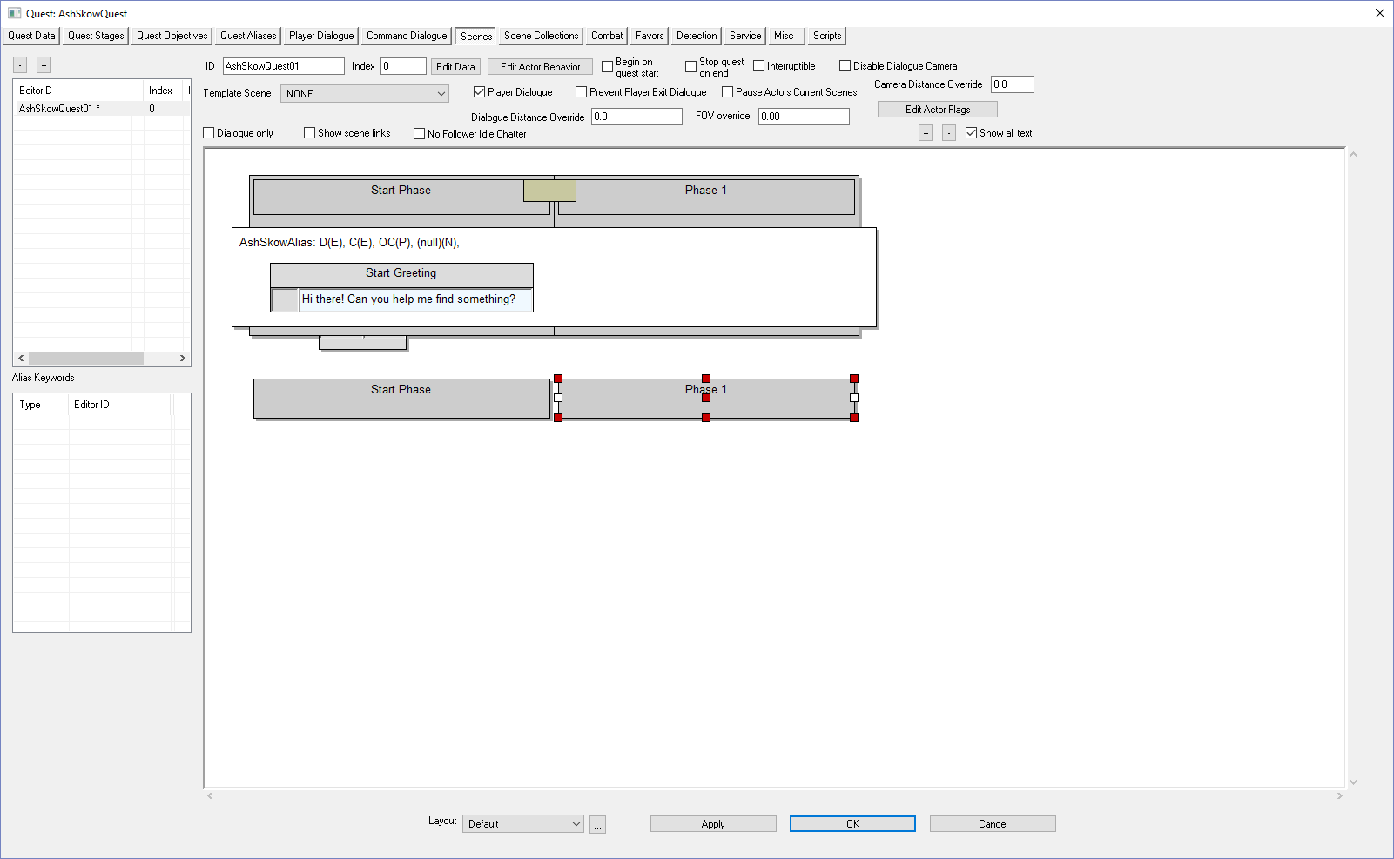
Right Click Over the Phase name | 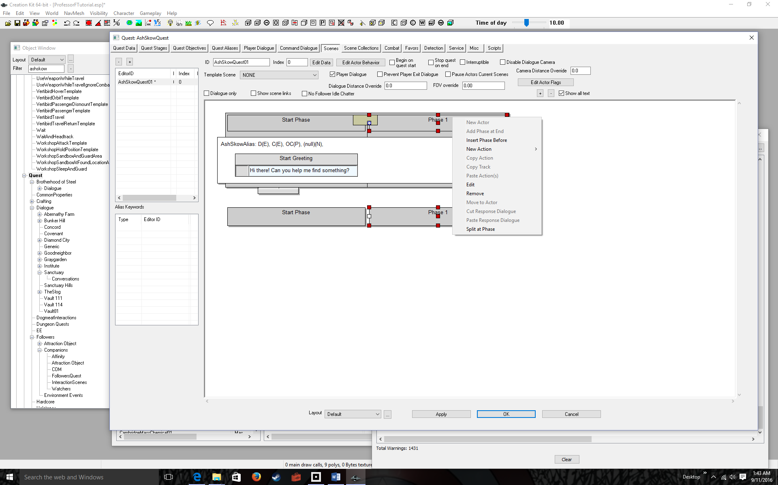
Select Edit | 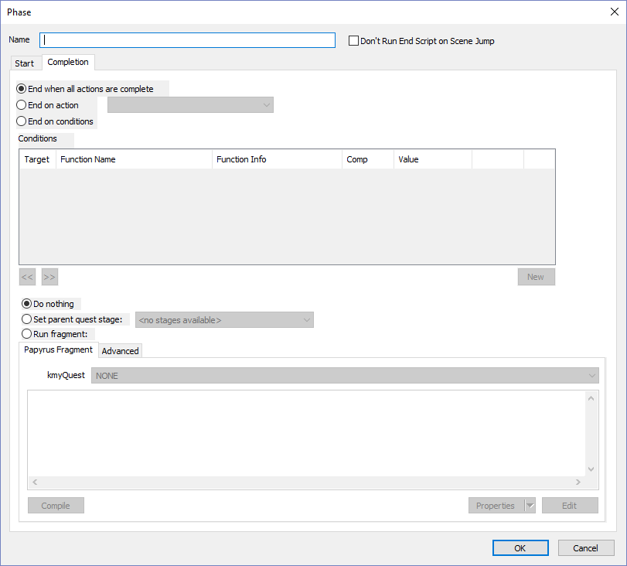
Give the Phase a name  Like Scene01Phase01  Why are we doing this? Because it will allow us to loop to the phase and repeat the 4-part dialog until the player either accepts or denies the quest. | 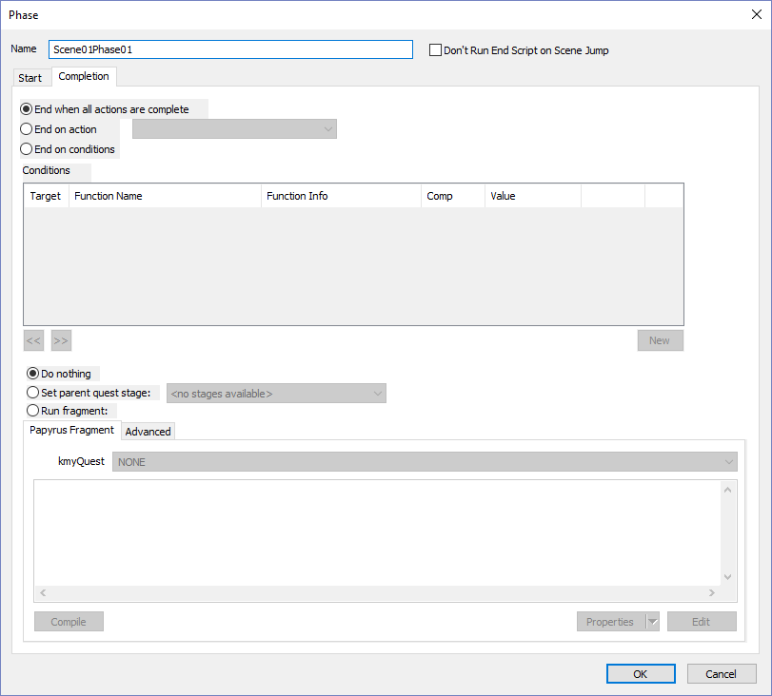
Click the OK button  We’re ready to add interactive dialog | 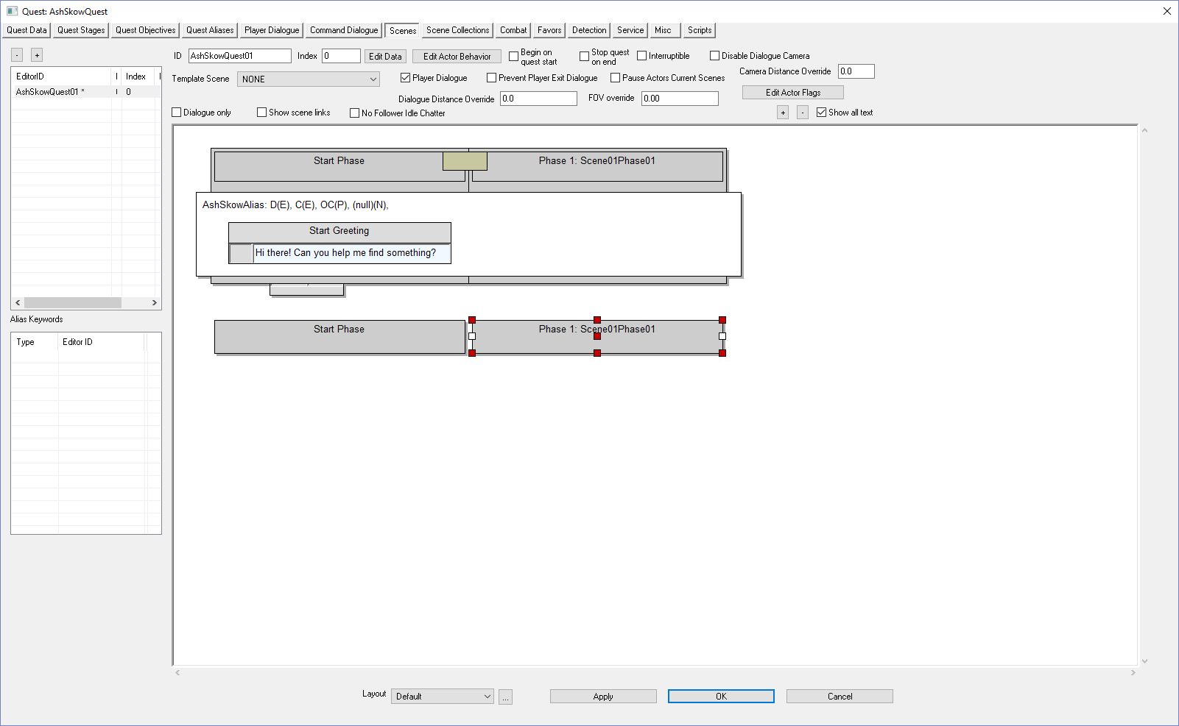
Right-click over the white area under the phase | 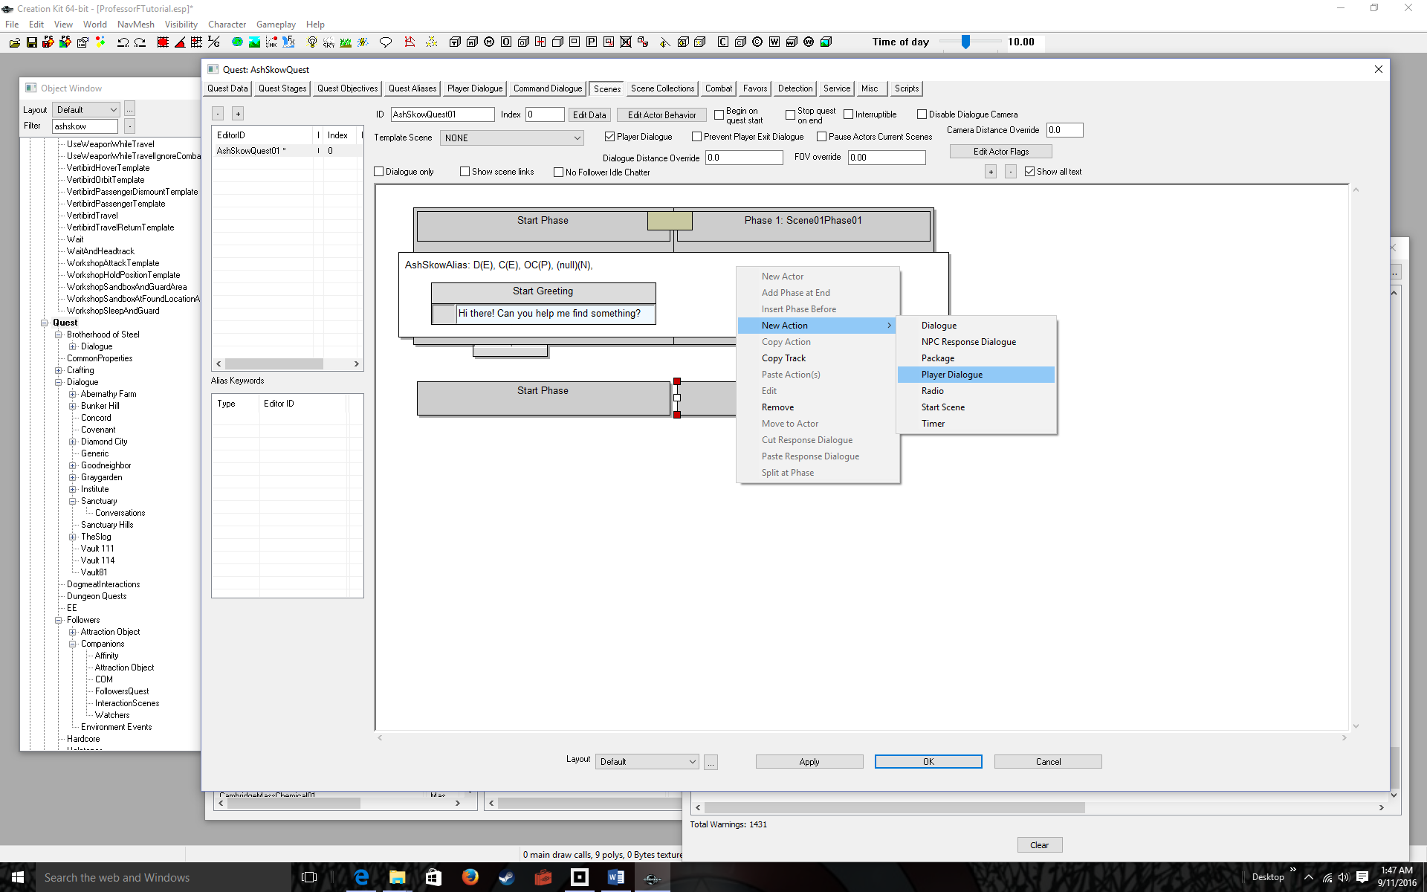
Select New Action > Player Dialogue  The Topic Info dialog pops up allowing you to set initial options. We aren’t ready just yet to add any options. | 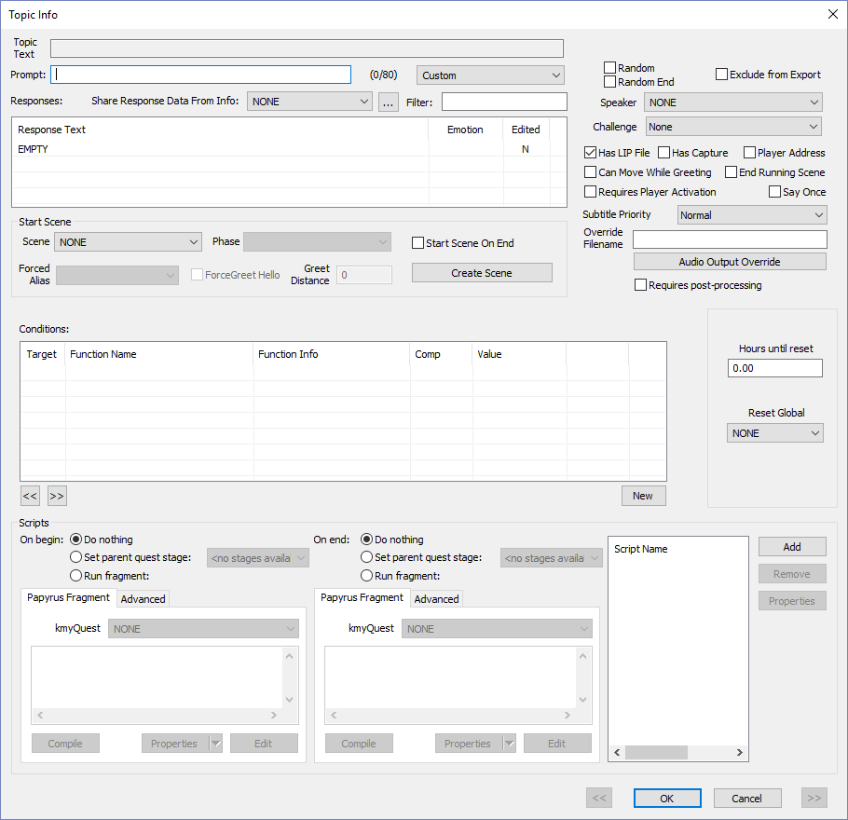
Click the OK button  The 4-part dialog box pops up. This is the most important box. You will enter player prompts and player responses, followed by NPC responses.  The prompt is a short description of what your player will say. An example is “Agree”  The response is what your player actually says. Example: “I agree to your quest”  NPC’s have no prompts | 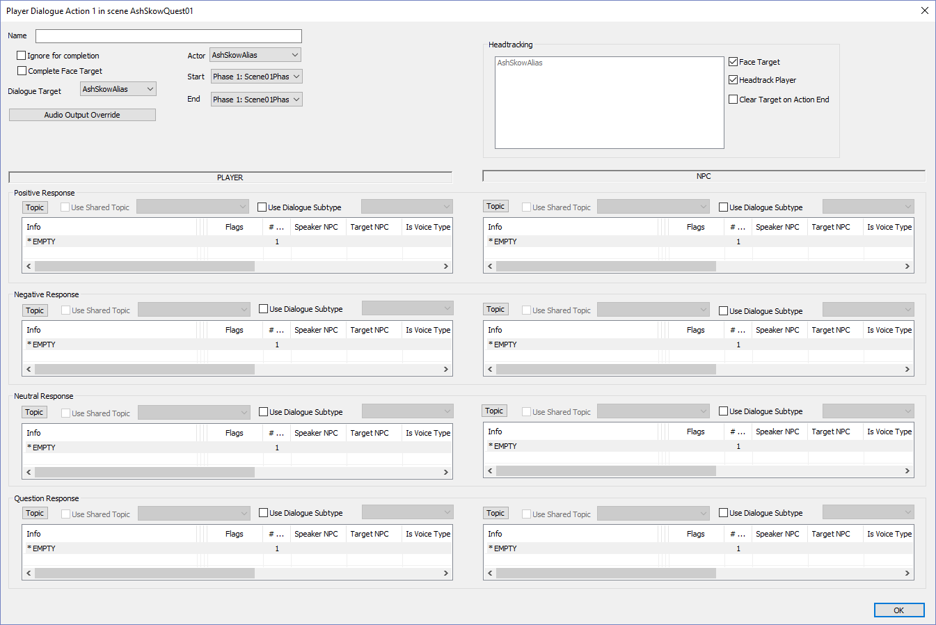
BEGIN PROMPT-RESPONSE PROCEDURE  Double-click * EMPTY under Positive Response | 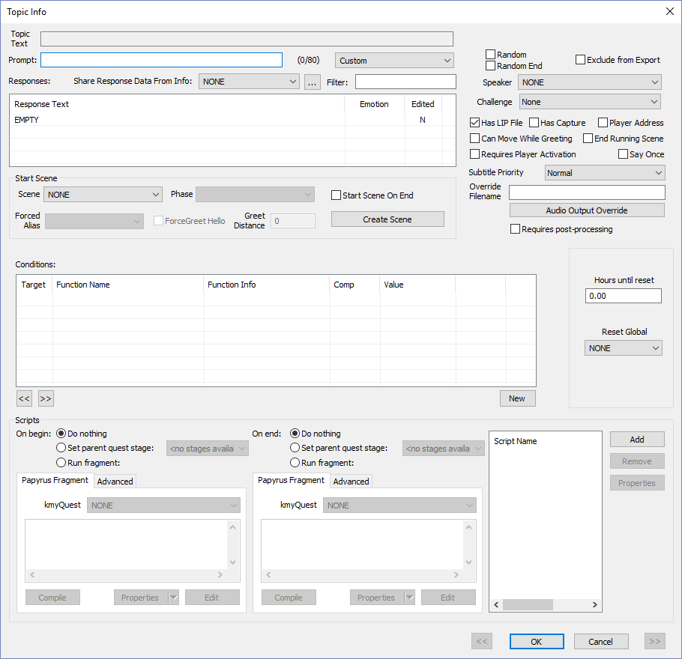
Enter a prompt in the Prompt: box | 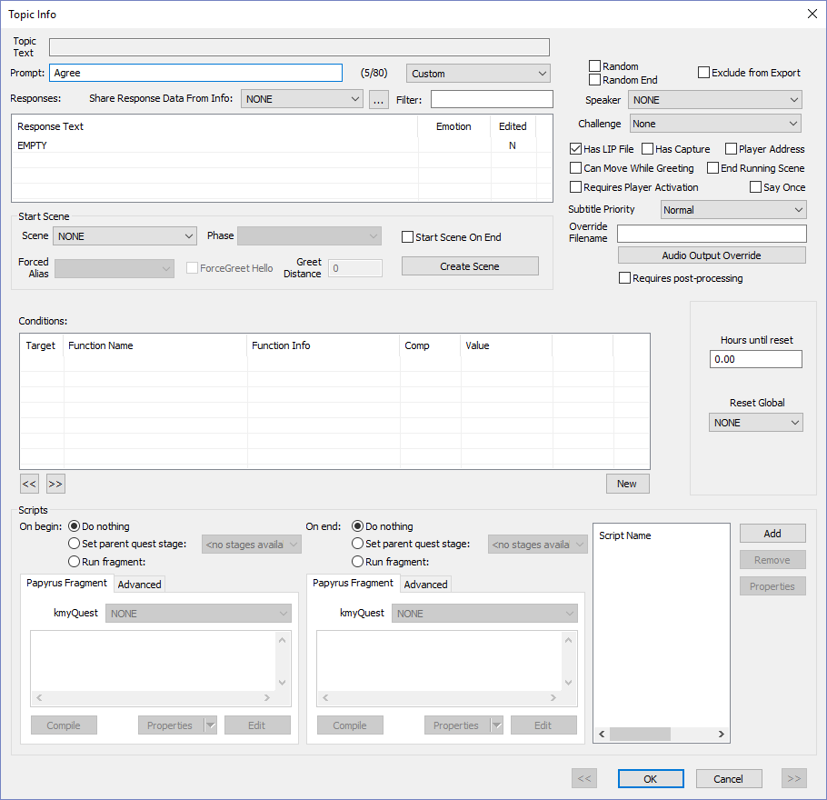
Double-click EMPTY under Response Text  Note the prompt is filled in “Agree” | 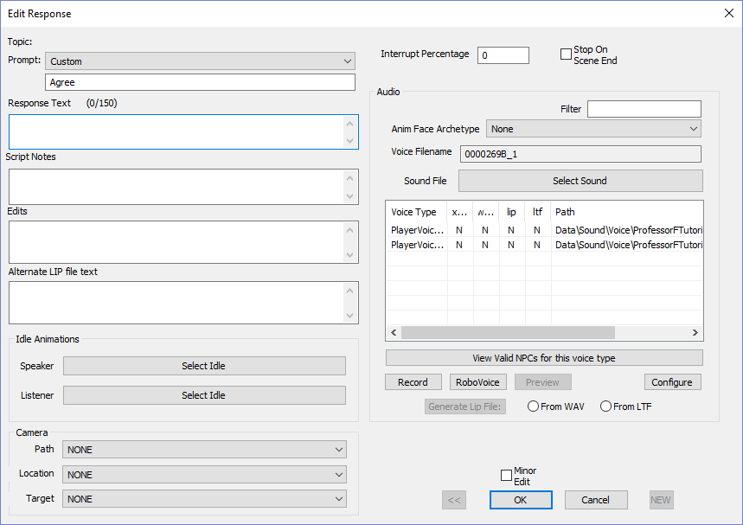
Enter a response under the Response Text box.  Example: Sure. I’ll do it.  Note you only have 150 characters—slightly more than a Tweet | 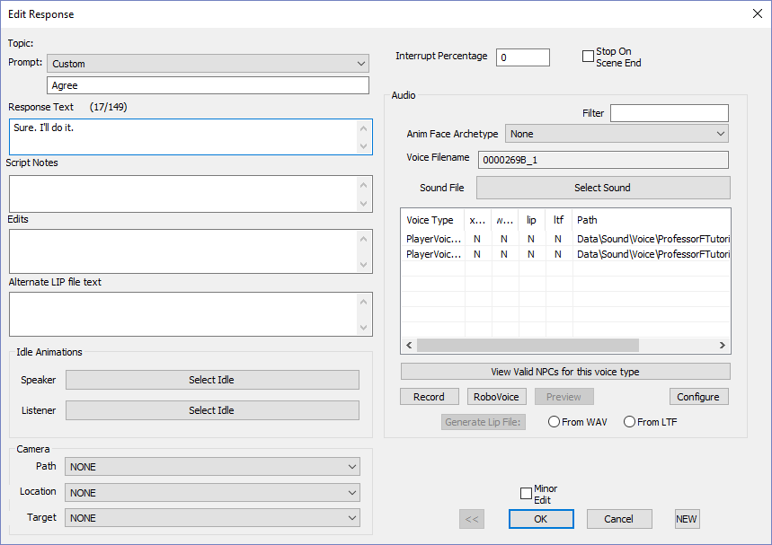
Click the OK button  Note both Prompt and Response Text boxes are filled in. | 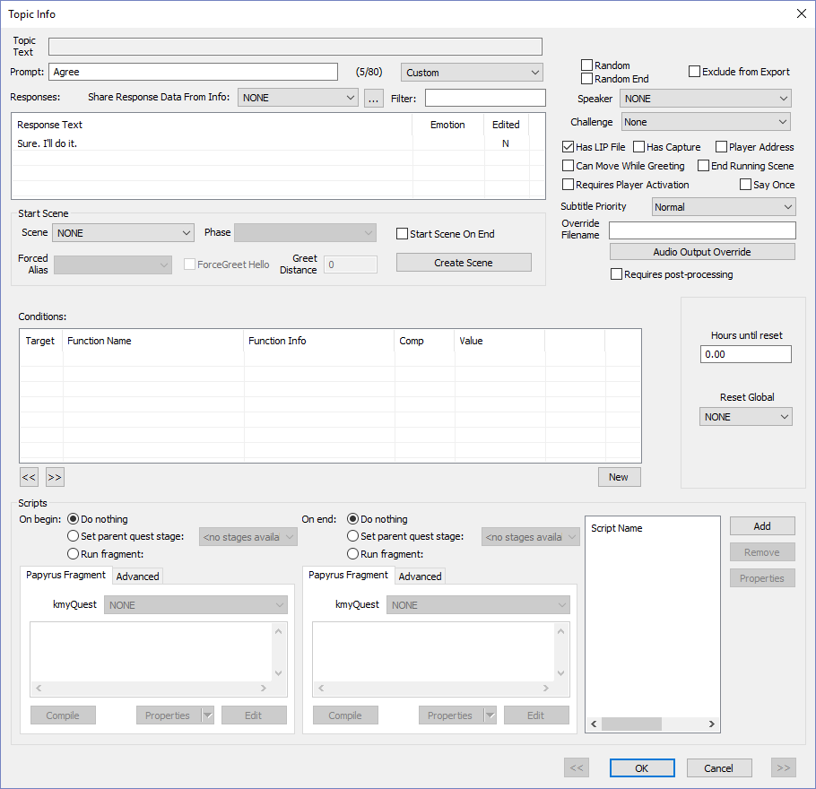
Click the OK button  Note the positive response is already filled in  END PROMPT-RESPONSE PROCEDURE | 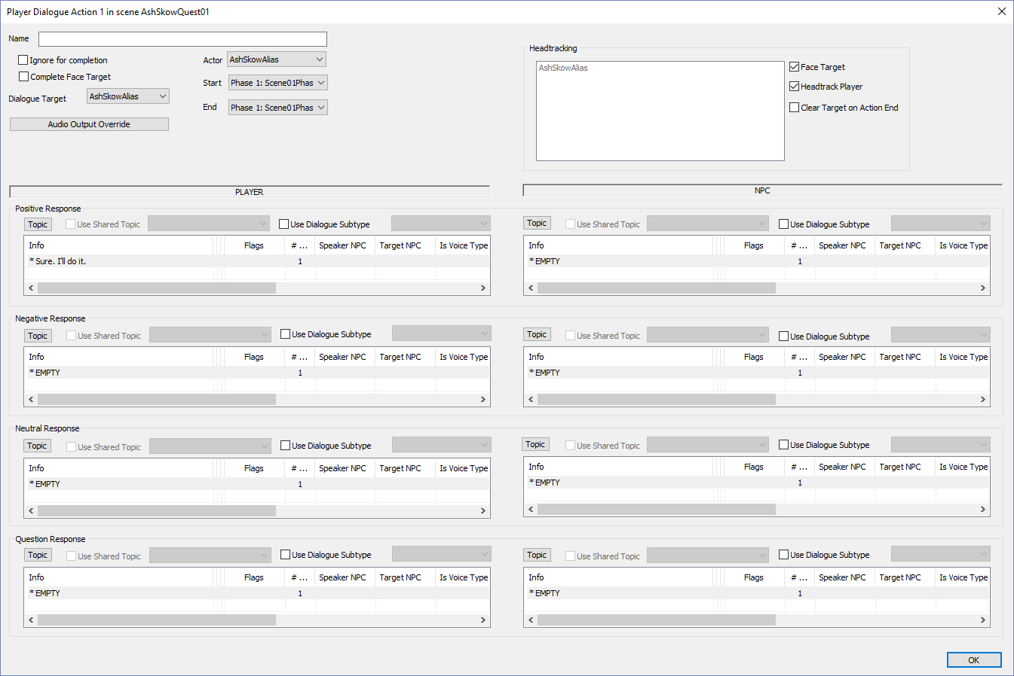
Do a similar Prompt-Response Procedure for the PLAYER’s Negative, Neutral, and Question Responses  Use the following Prompt—Response  (Negative) Refuse—Sorry, I’m busy.  (Neutral) Stall—I might.  (Question) Ask Why—Why should I? | 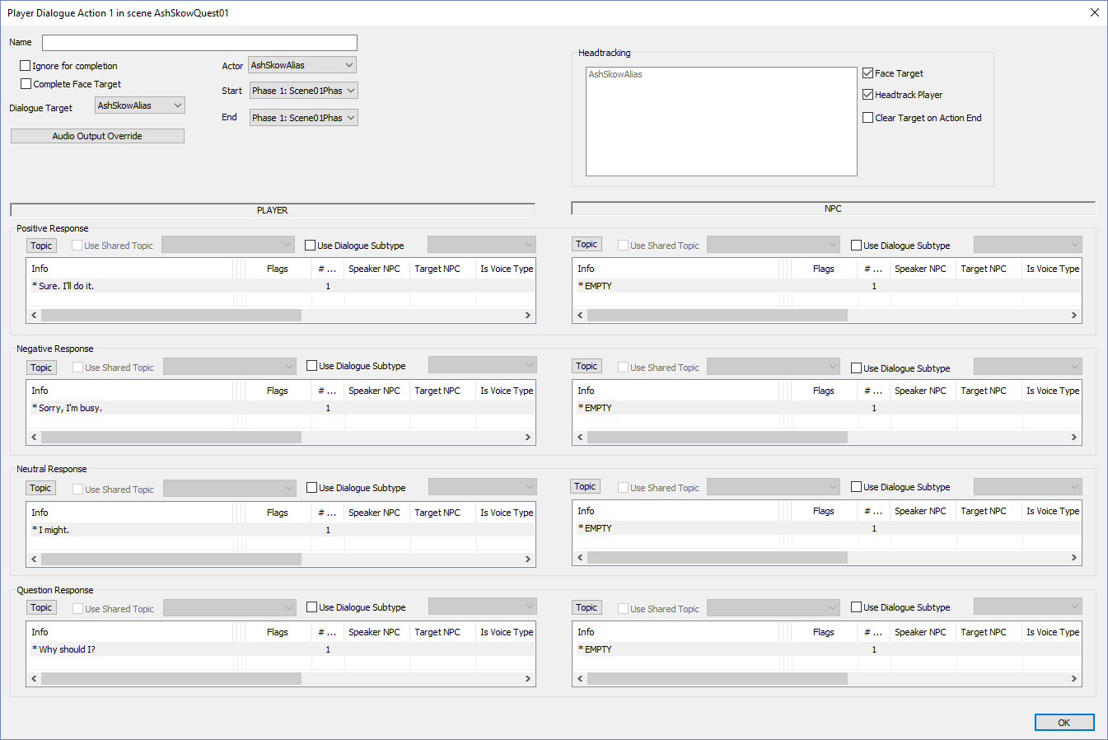
Do a similar Prompt-Response Procedure for the NPC’s Positive Negative, Neutral, and Question Responses  Remember NPC’s don’t have prompts so only add the Response Text. Use the Following  (Positive) Thank you so much!  (Negative) Please help when you have time.  (Neutral) Make up your mind.  (Question) Because I’ll reward you.  Before you do anything, note that the positive & negative responses end the dialog. You must check “End Running Scene” in the Topic Info window for these responses:  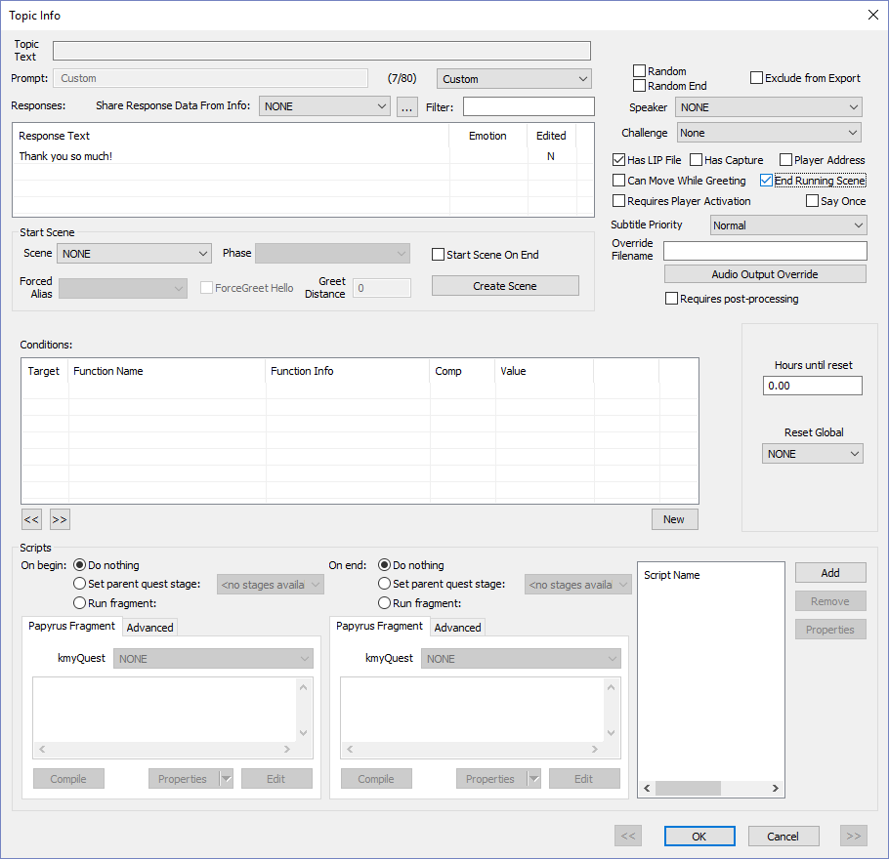 | 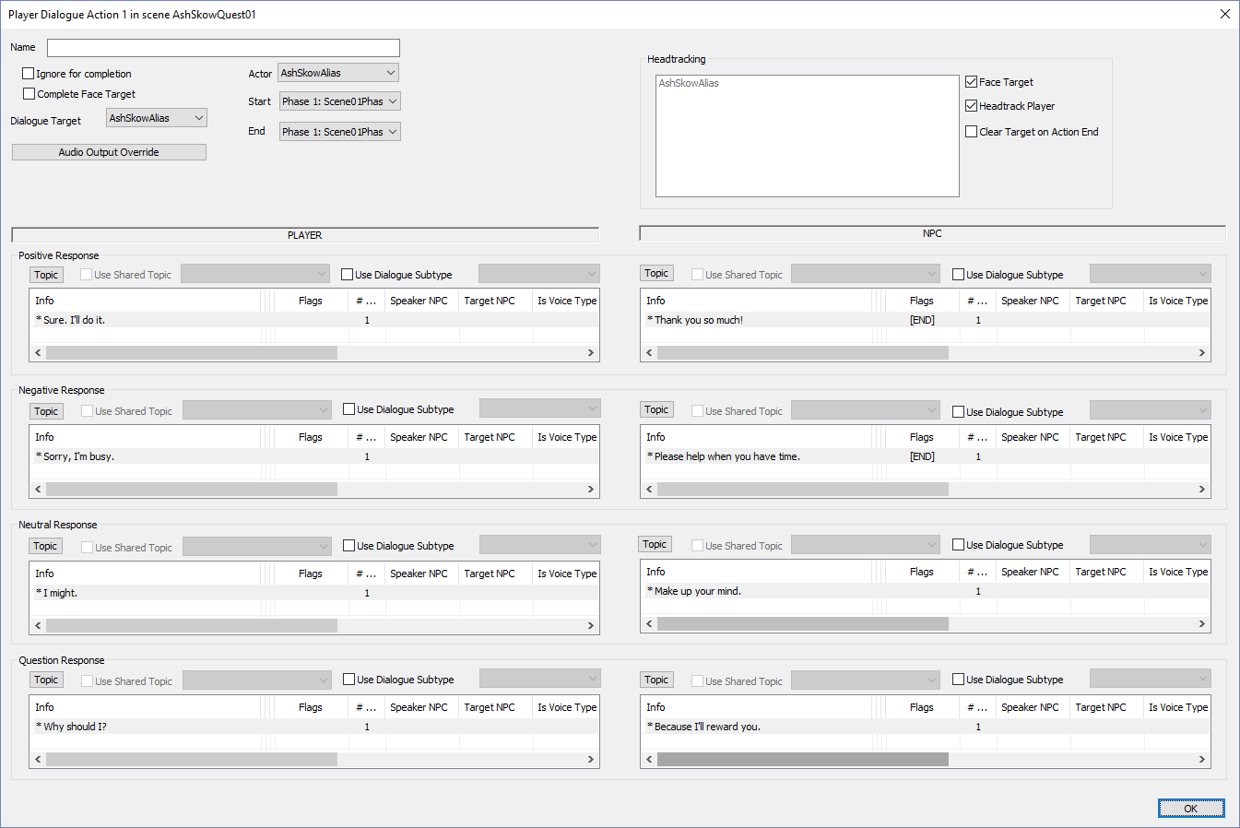
Click OK  You’re almost done. You have to loop to main dialog until either the player refuses or the player agrees. | 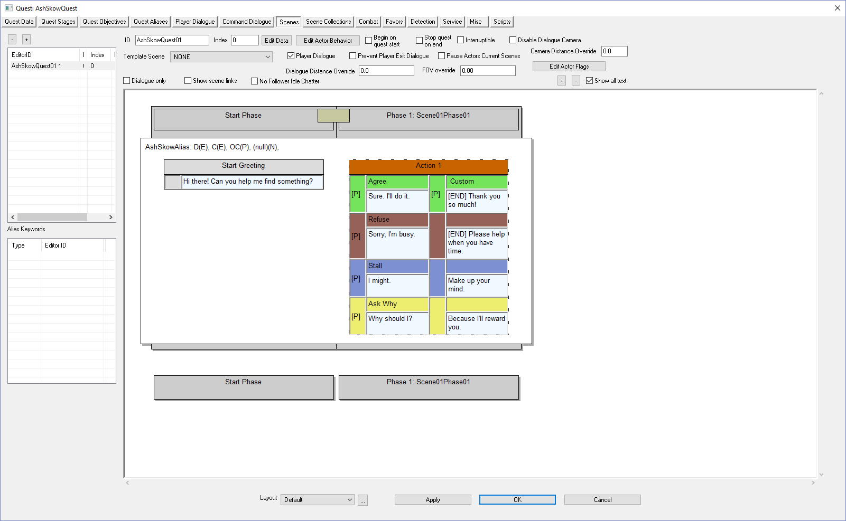
Right-click in the white scene area | 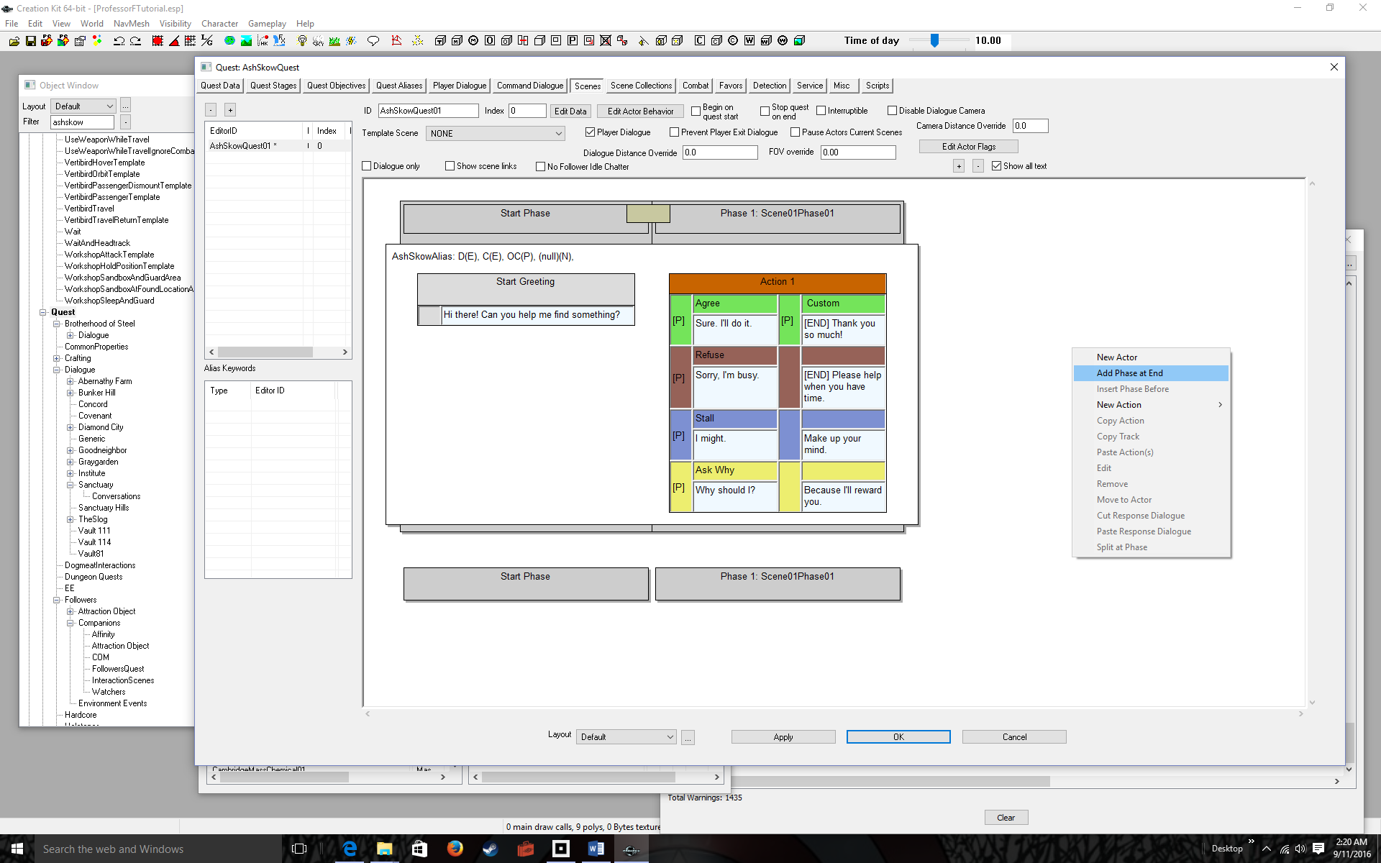
Select Add Phase at End | 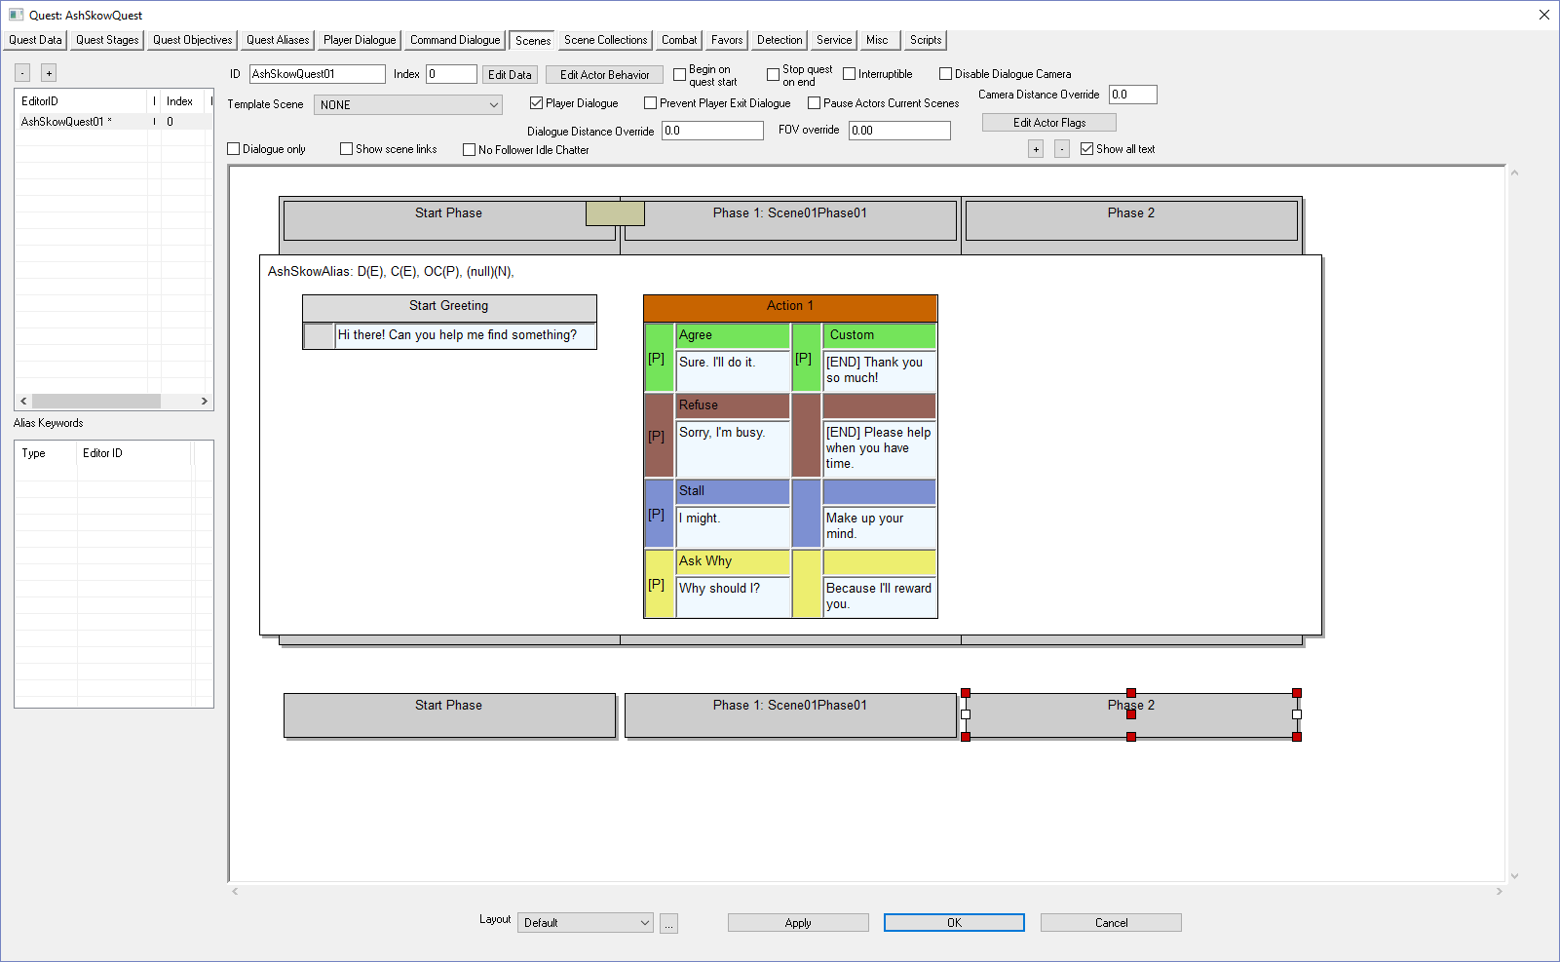
Right-click in the white phase area | 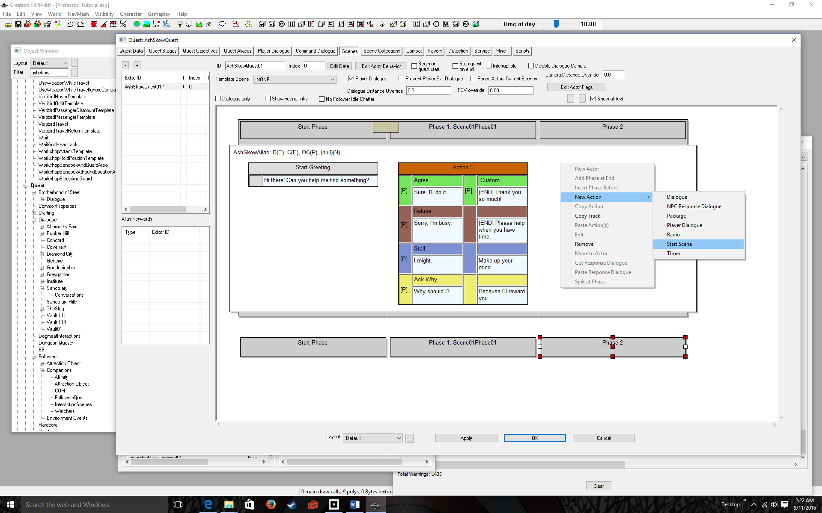
Select New Action > Start Scene | 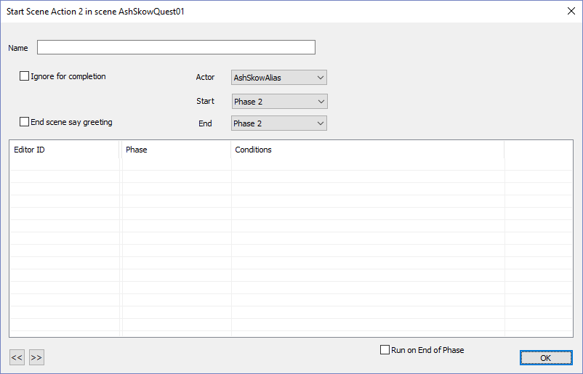
Click OK | 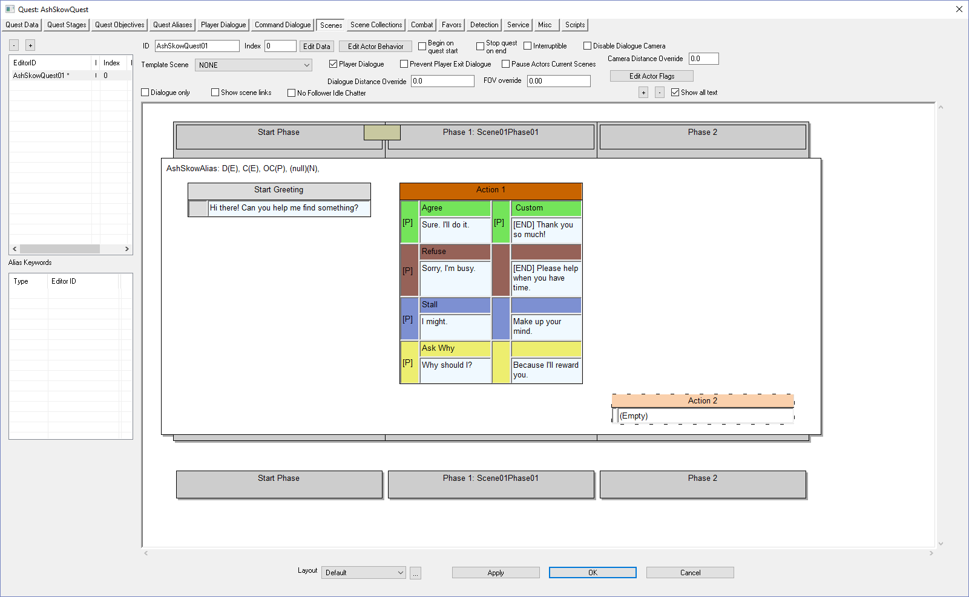
Double-click (Empty)
Right-click under Editor ID | 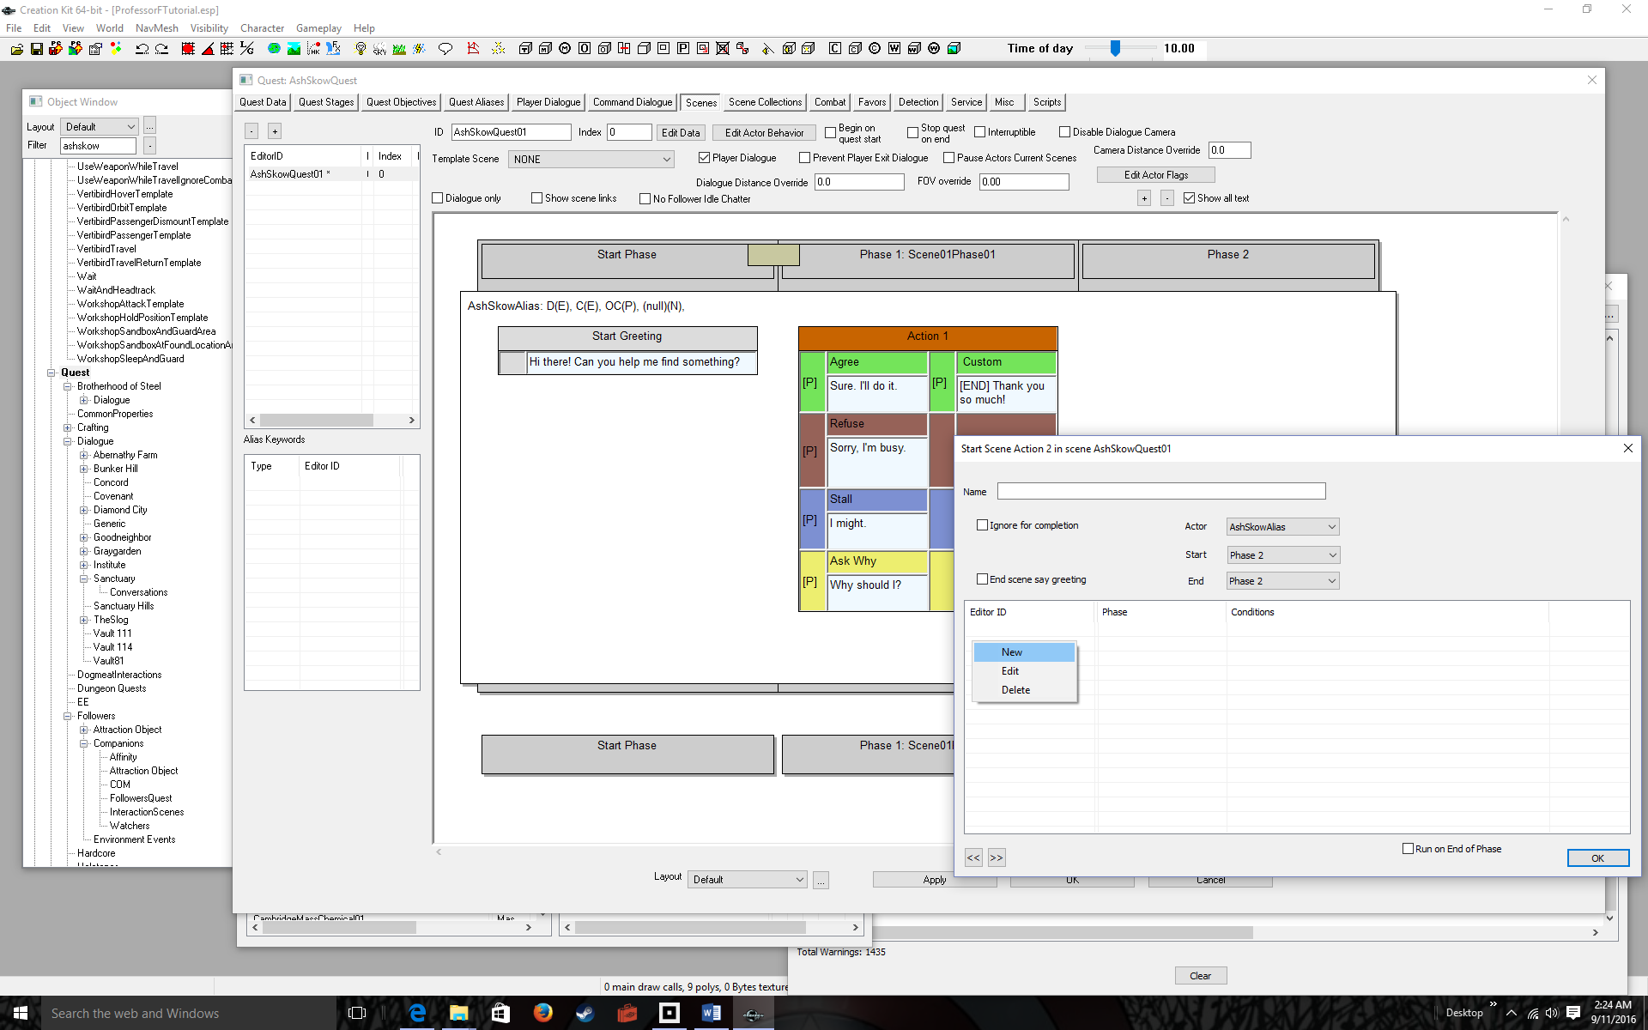
Select New | 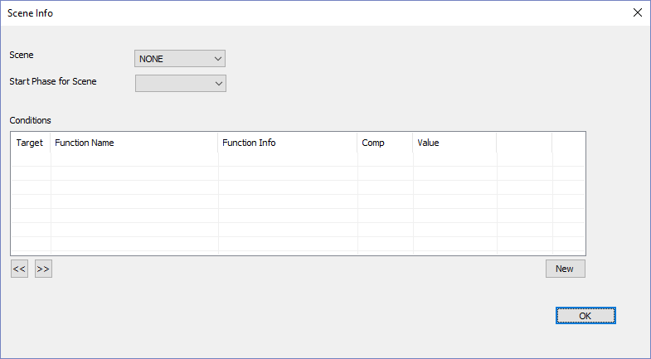
Select the Scene and Start Phase in the drop down boxes  In our example AshSkowQuest01 and Scene01Phase01, respectively | 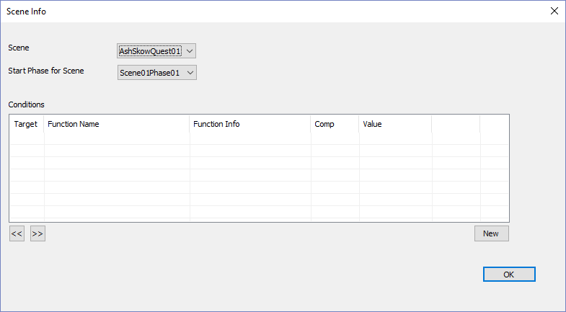
Click OK | 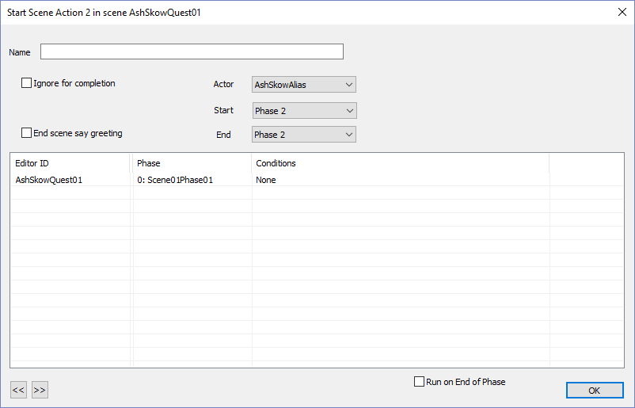
Click OK  Now after any four-way response, the scene loop properly.  You’re ready to test. | 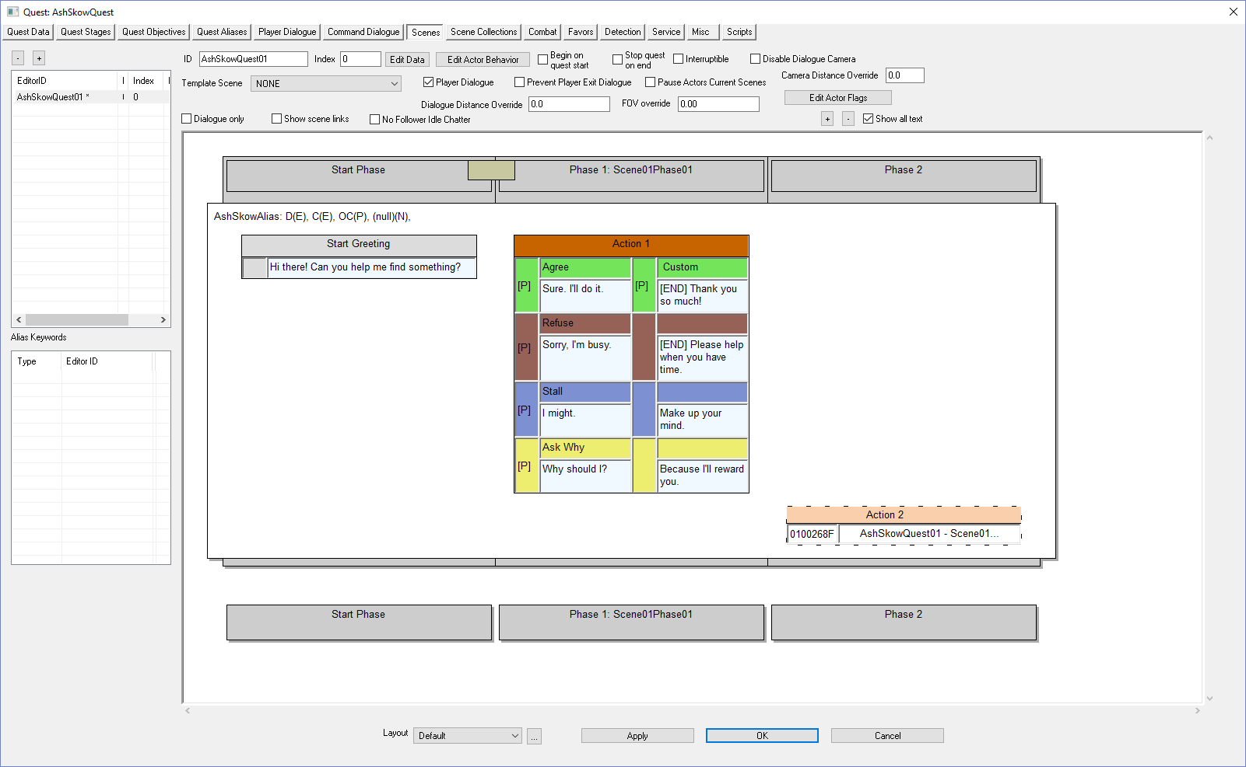
Click OK to exit the scene tab | 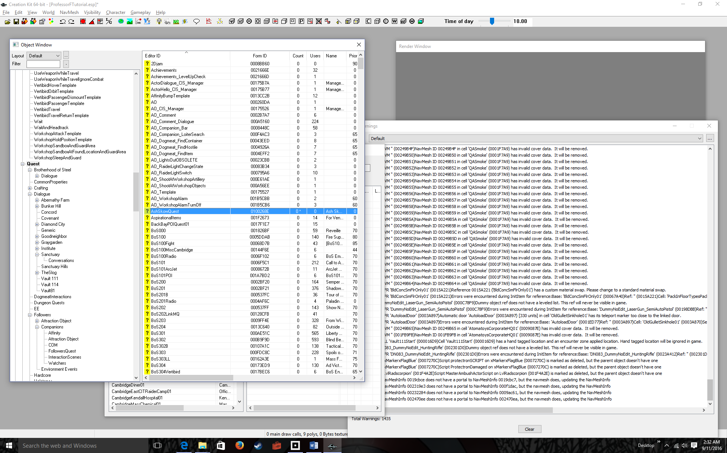
File > Save | 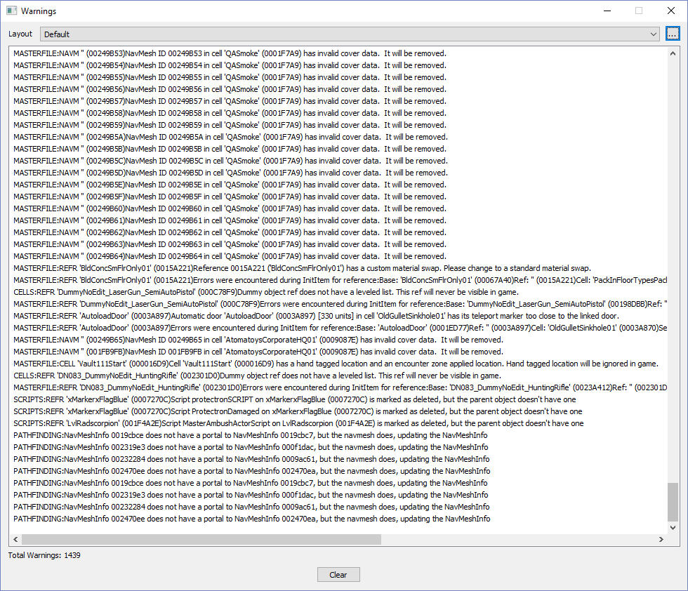
Run Fallout 4  (you know how to do this, so I’ll skip all the steps. Continue until you get to the room) | 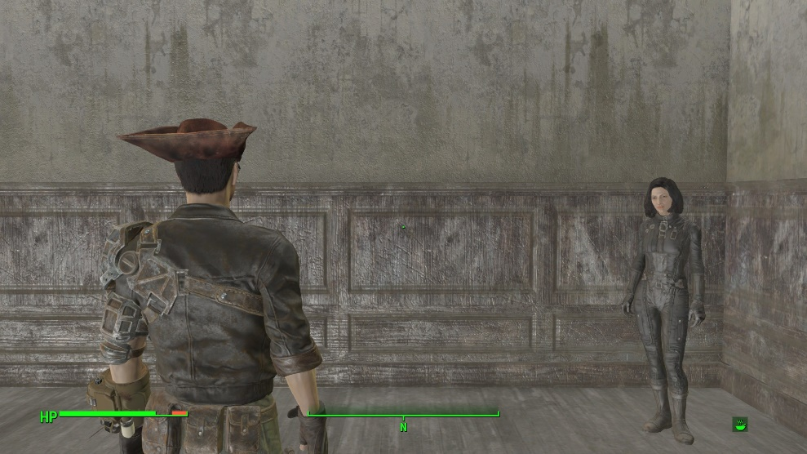
Position the dot over Ash Skow | 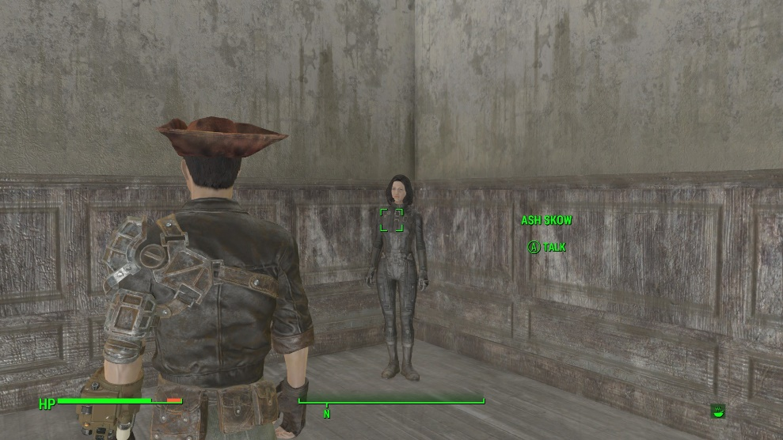
Select Talk | 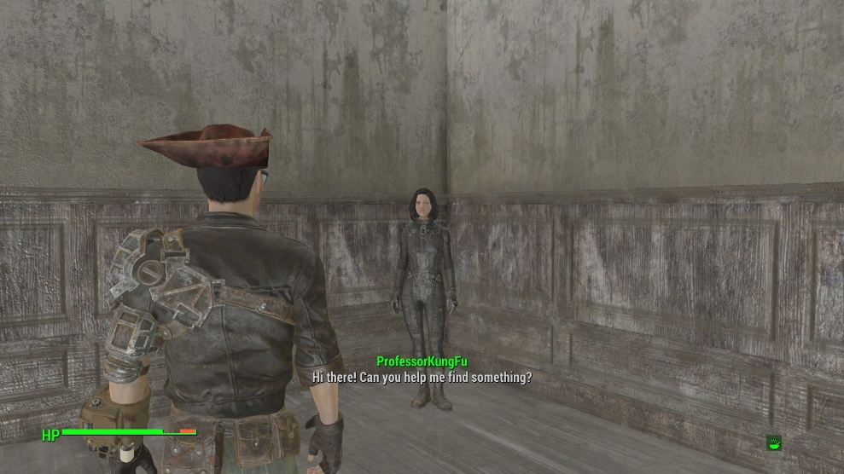
(Wait) | 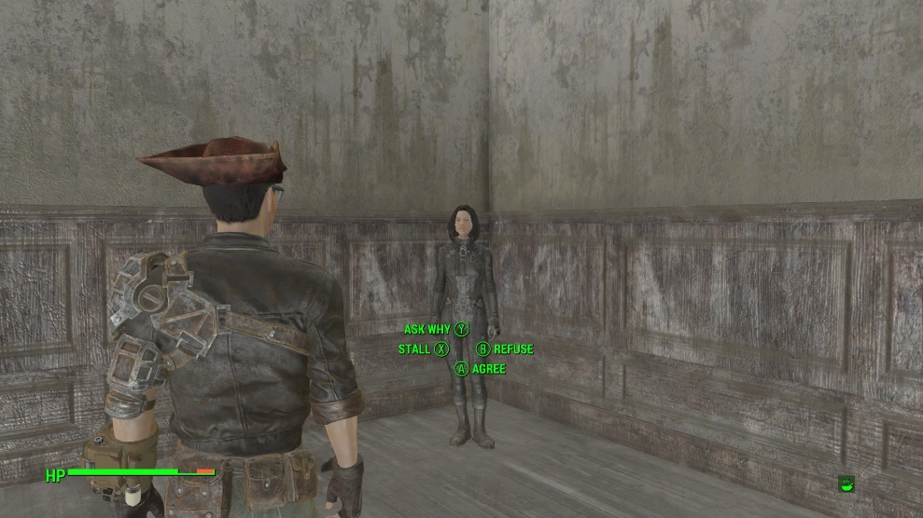
Enjoy the rest of the dialog!  In the next tutorial we’ll do code. | 

