How to Create a Fallout 4 Quest: Part 7— Adding an Object to Fetch
Nick V. Flor (nickflor@unm.edu)

Start up the GECK by running the Bethesda.Net Launcher and Open up your Mod (as in Tutorial 3)  Note: This is only if the GECK isn’t running.  Now let’s an object to fetch… say a Teddy Bear. | 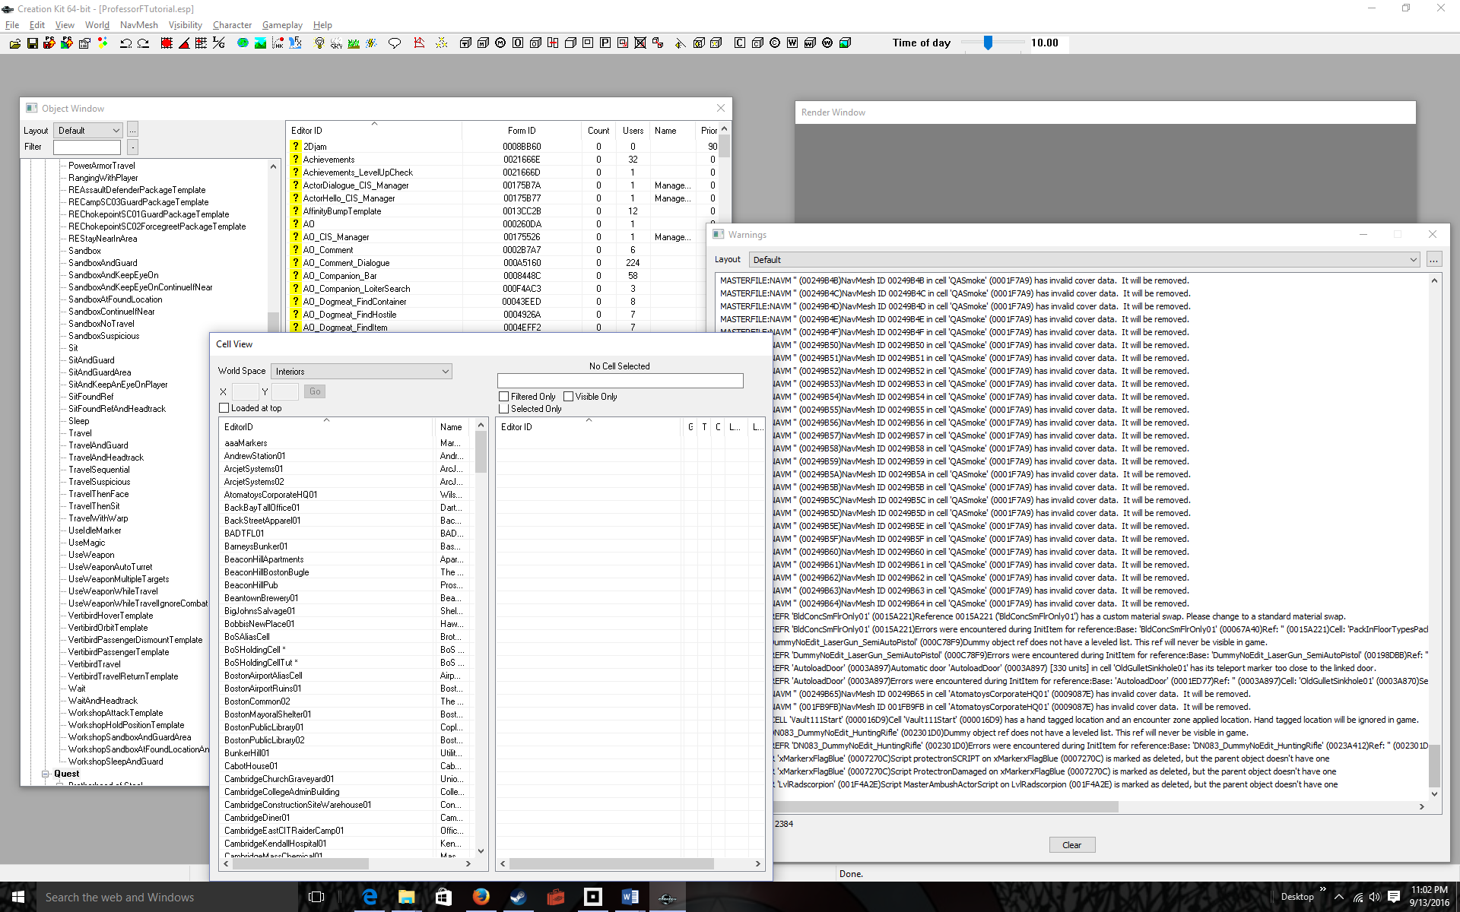
Click on the Cell View window, then Double Click on BoSHoldingCellTut  I also used the mouse wheel to zoom out in the Render Window | 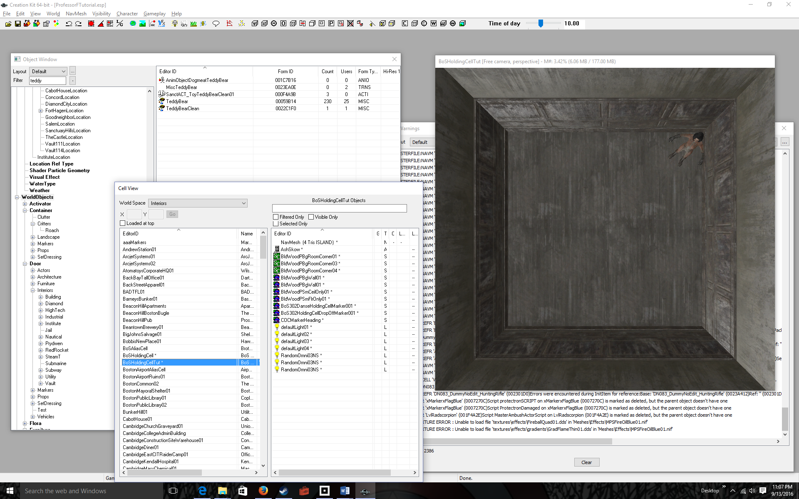
Click on the Object Window, the Click on World Objects in the left list.  This contains all the objects in the world. | 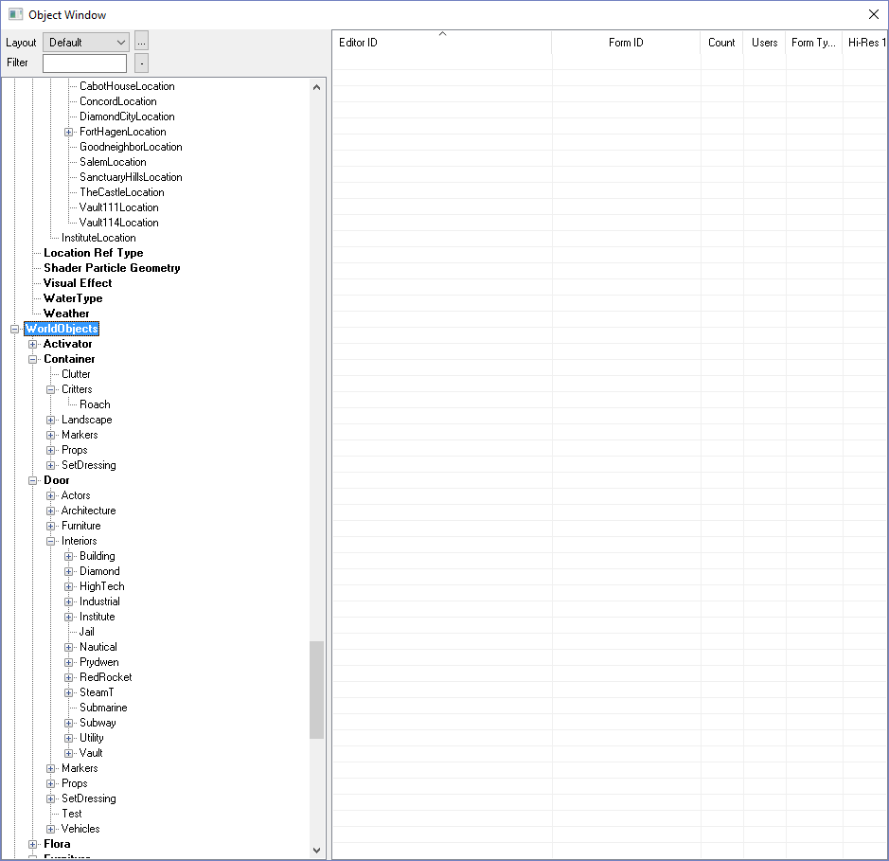
Type the partial name of an object in the Filter text box  I typed “teddy” because I wanted to find a teddy bear, and I was guessing there had to be a teddy bear in the game.  The right list fills up with all the objects in the world that match the partial name. I’m sure if you typed “car”, you’d find a lot of cars | 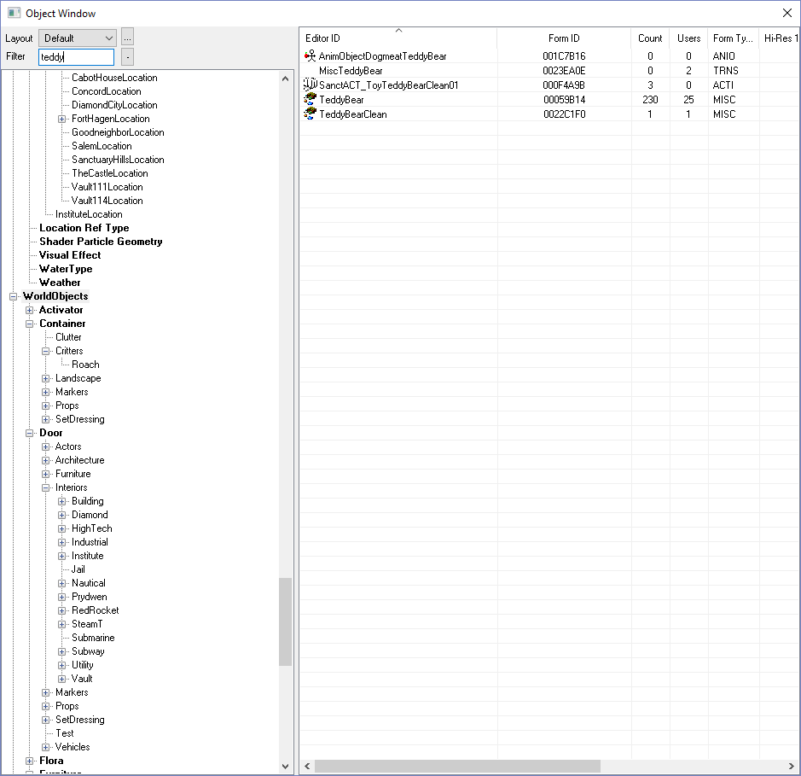
Left-Click Hold-and-Drag the object (TeddyBear) into the lower-left corner of the room in the Render window  The teddy bear is tiny, so he’s hard to see. But he’s there.  Remember, you can position and object by clicking it and dragging. And you can rotate an object by clicking it to select it, then using the right-mouse button and dragging to rotate it. | 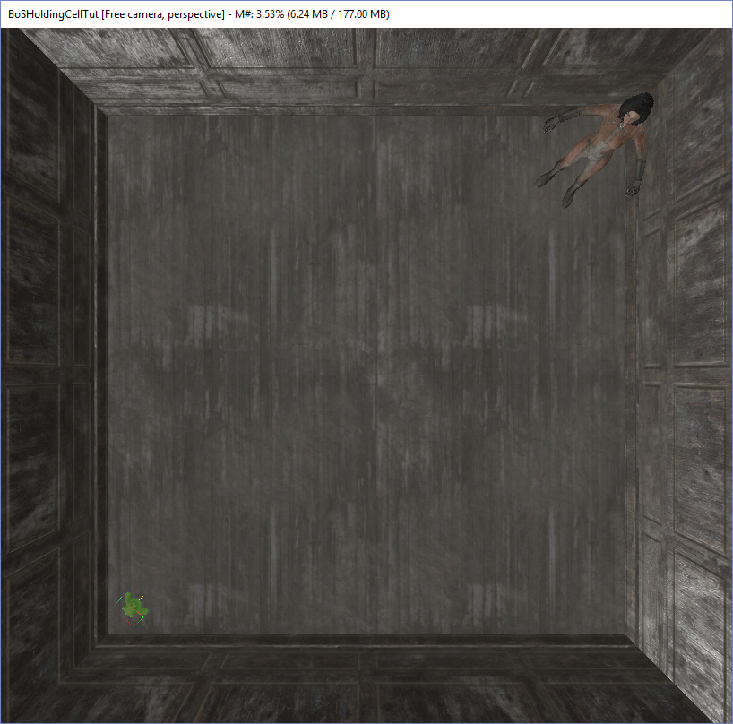
File > Save | 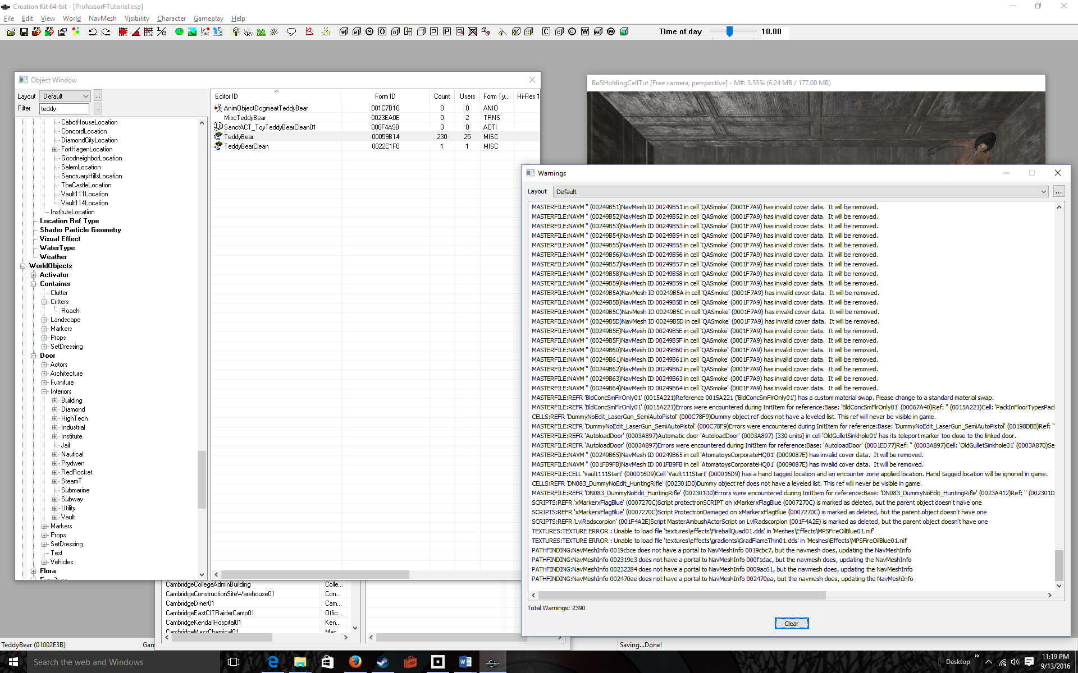
Run Fallout 4  (you know how to do this, so I’ll skip all the steps. Continue until you get to the room) | 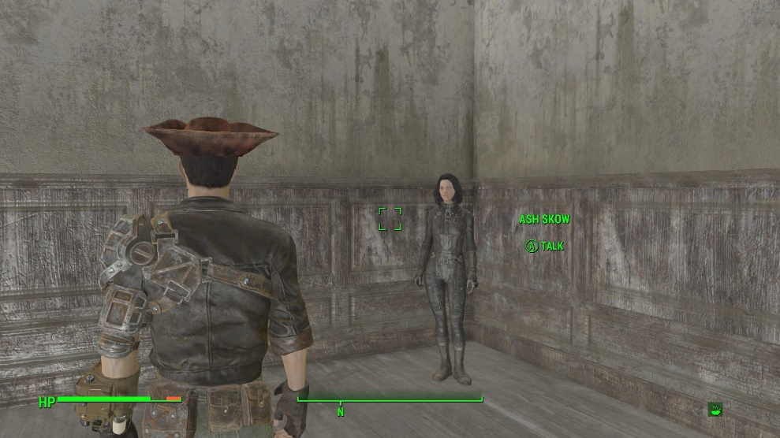
Turn around to see the object to be fetched | 