How to Create a Fallout 4 Quest: Part 8— Quest Setup
Nick V. Flor (nickflor@unm.edu)

Start up the GECK by running the Bethesda.Net Launcher and Open up your Mod (as in Tutorial 3)  Note: This is only if the GECK isn’t running. | 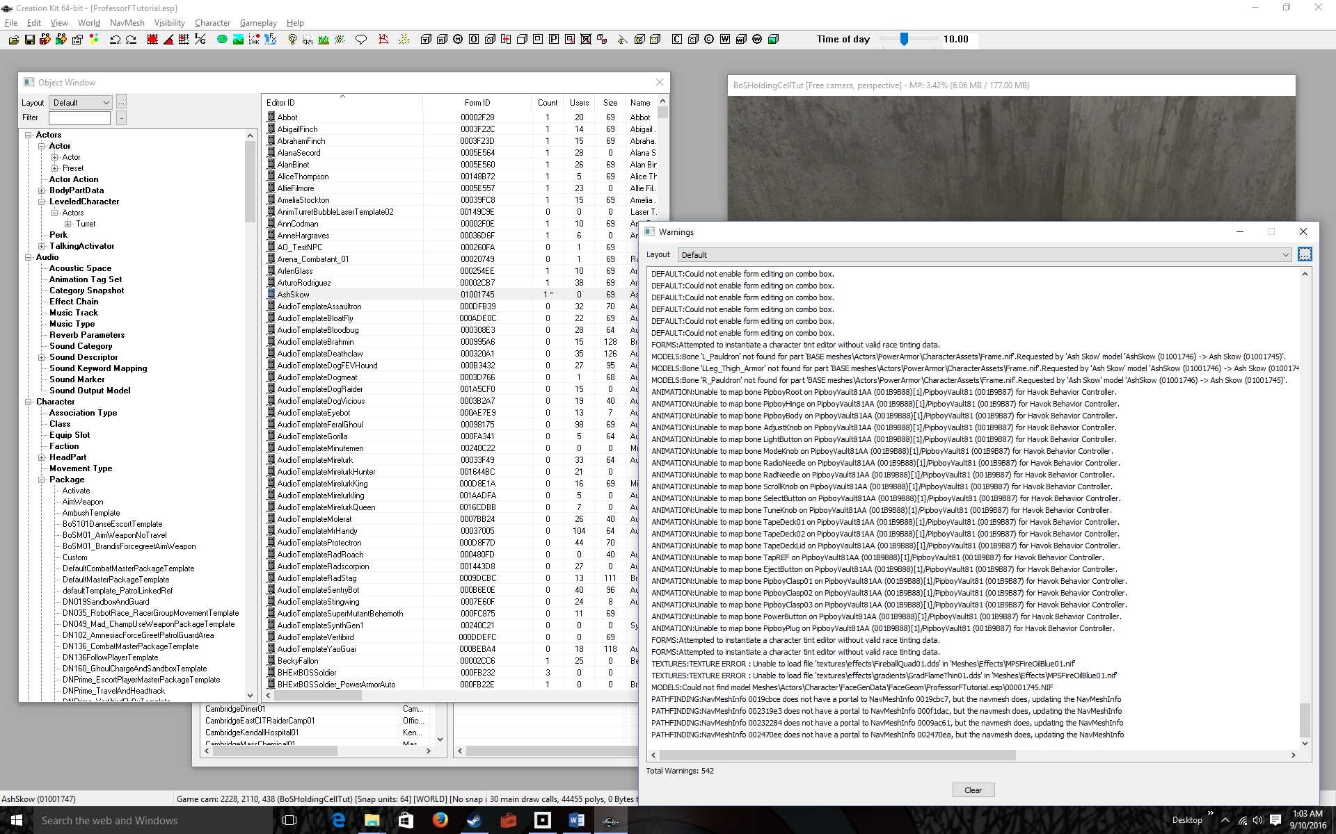
Active that Object Window  Expand Character > Quest in the left index  Find your quest (AshSkow) in the right window and double click to open | 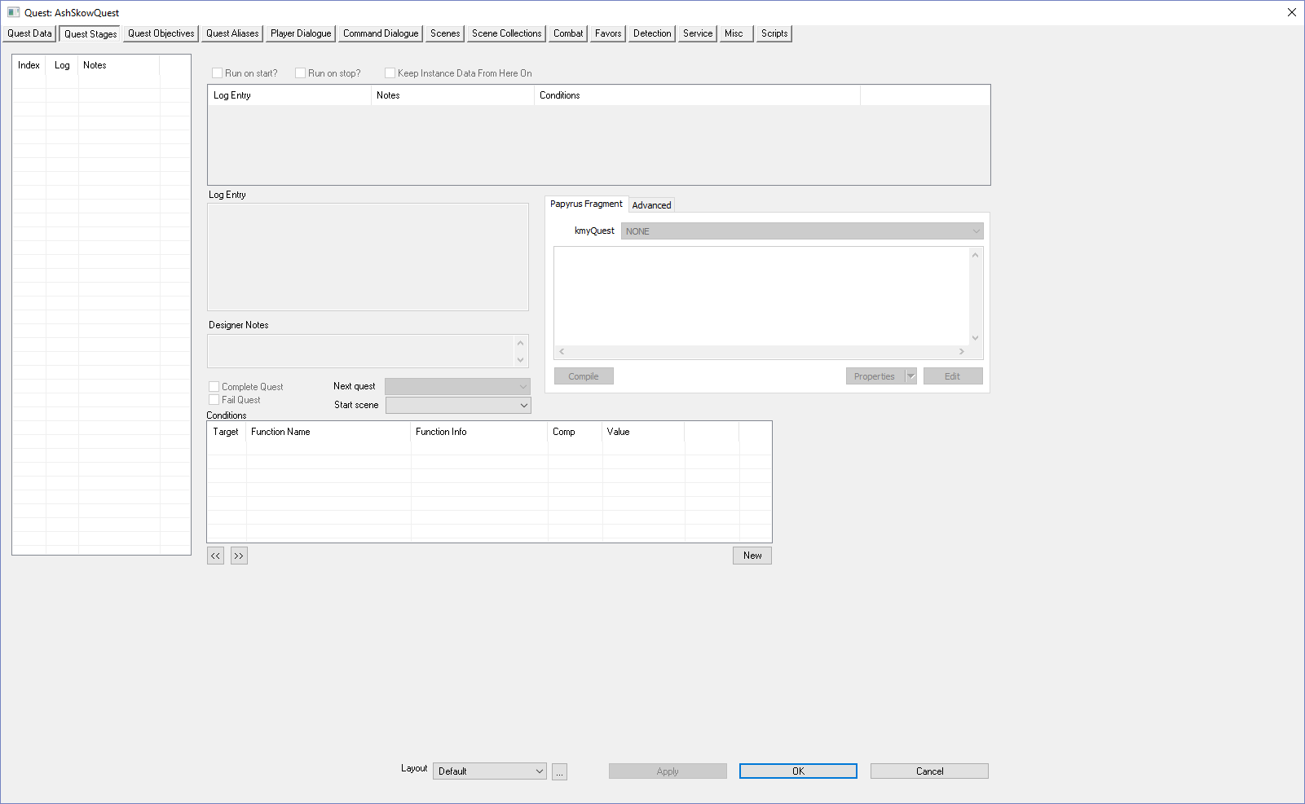
Click on the Quest Data tab  Before we just set the ID and Quest Name. The ID is used by code, and the Quest Name is what shows up in Fallout when the player begins the quest. | 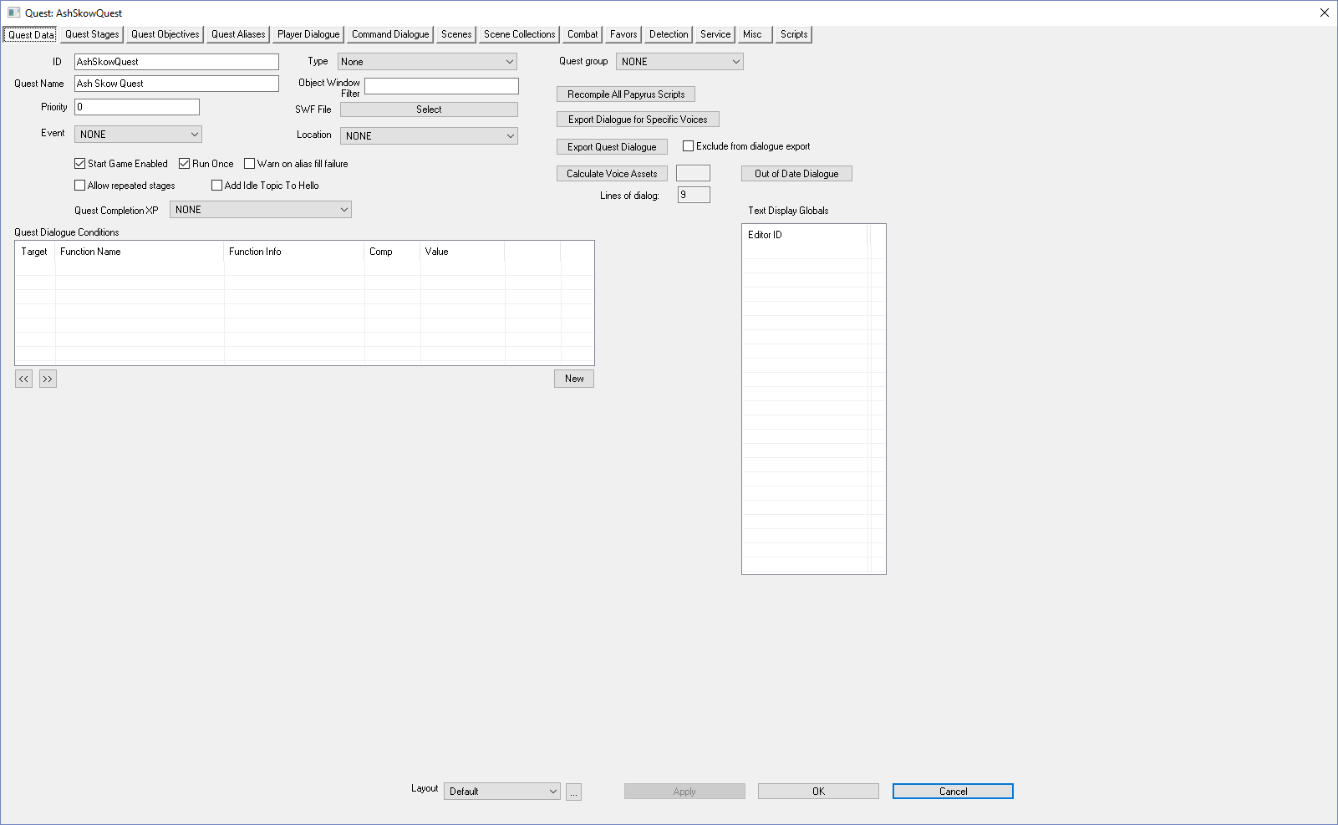
Set the Priority textbox to 60  Set the Quest Completion XP dropdown to XPRadiant  If there are competing quests that could be started at the same time, priority determines which quest goes first.  It is very important to set Quest Completion XP, otherwise you won’t see the Quest Completed message in Fallout. This is how much XP you get for completing the Quest. | 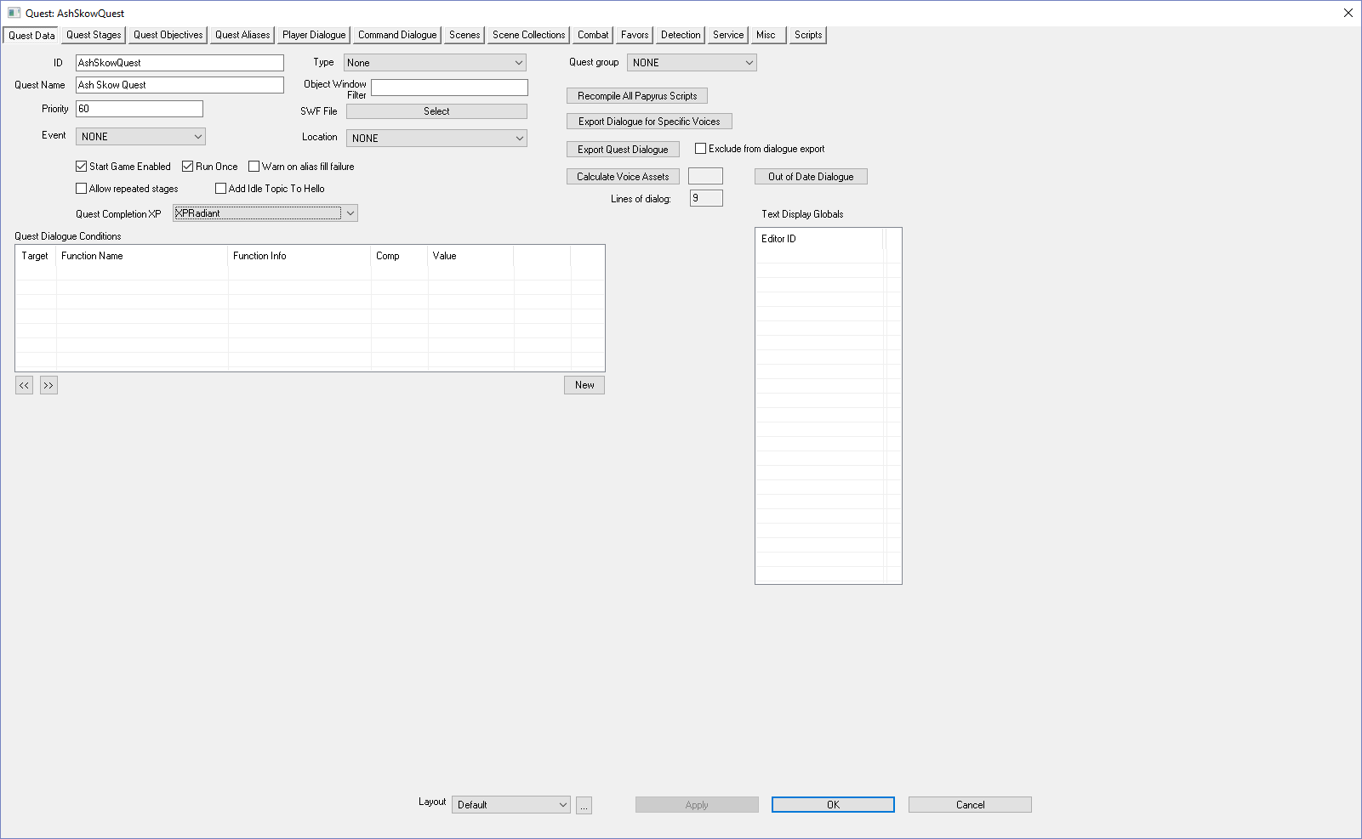
Click on the Quest Stages tab  Note: If you clicked hastily on the OK button in the previous step, that saves & closes out the Quest window and you will have to reopen. Clicking on another tab also saves your progress, but it doesn’t close the window.  Quest Stages is where you add code that controls the labels the players sees as he or she progresses in the game.  For a simple quest you need four stages. | 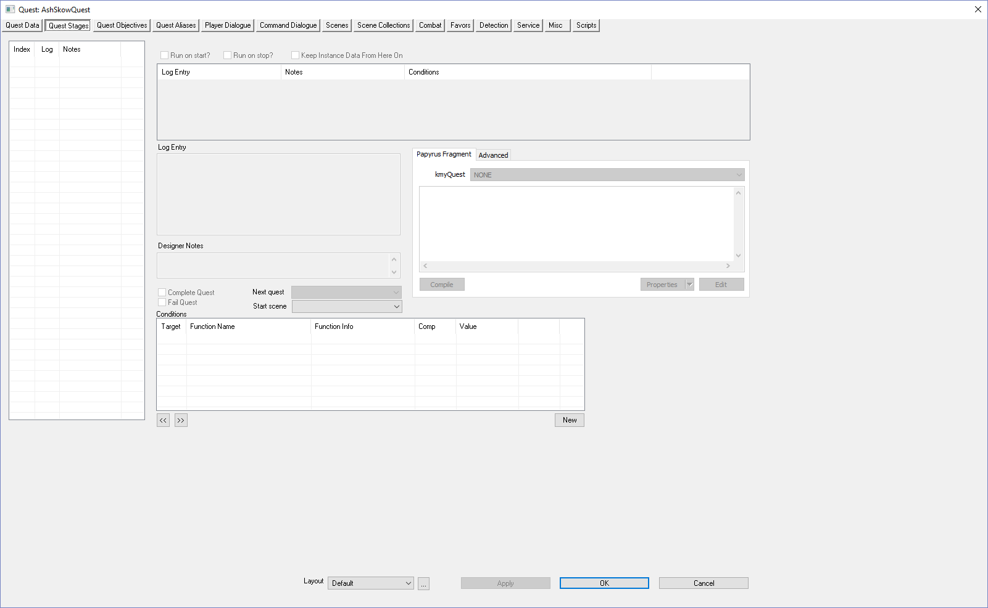
Right-Click over the Index window | 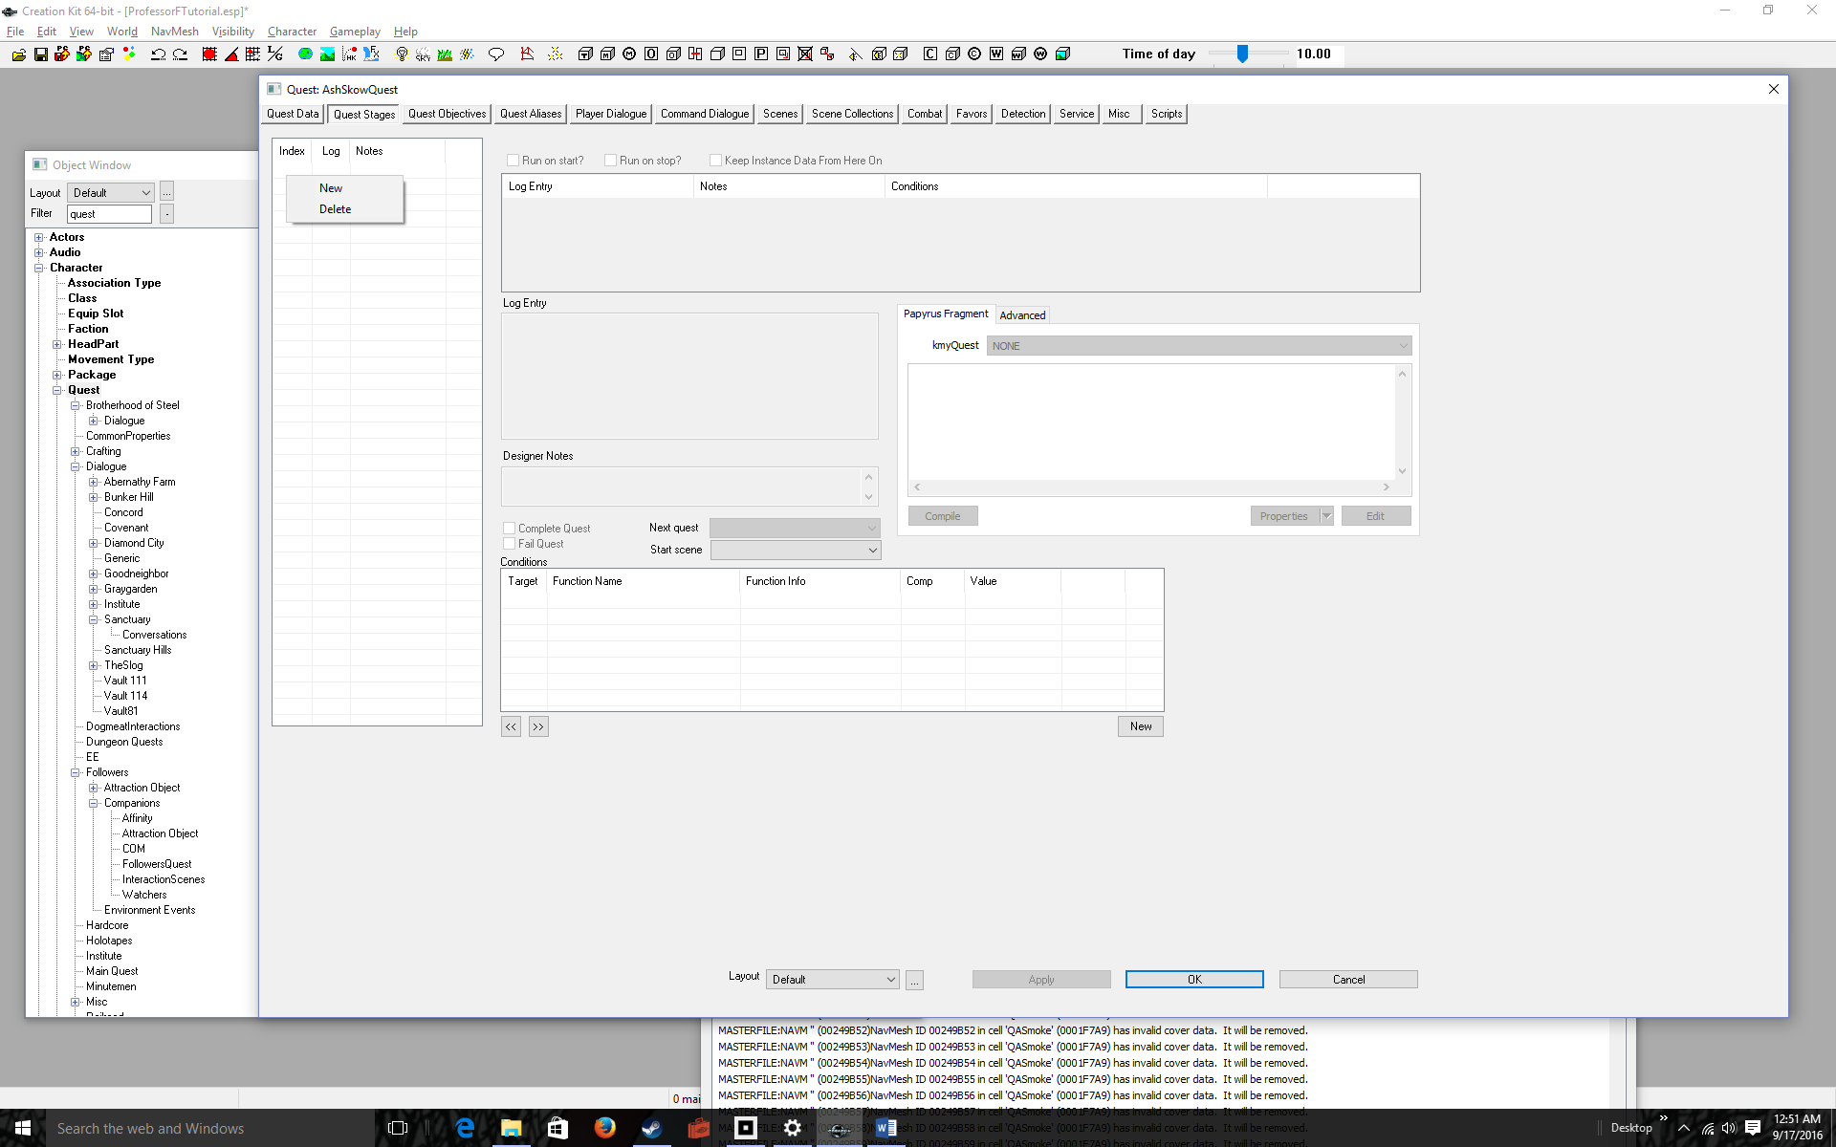
Click New  Keep index 0. When the game starts, you can think of your Quest as being at Index 0 | 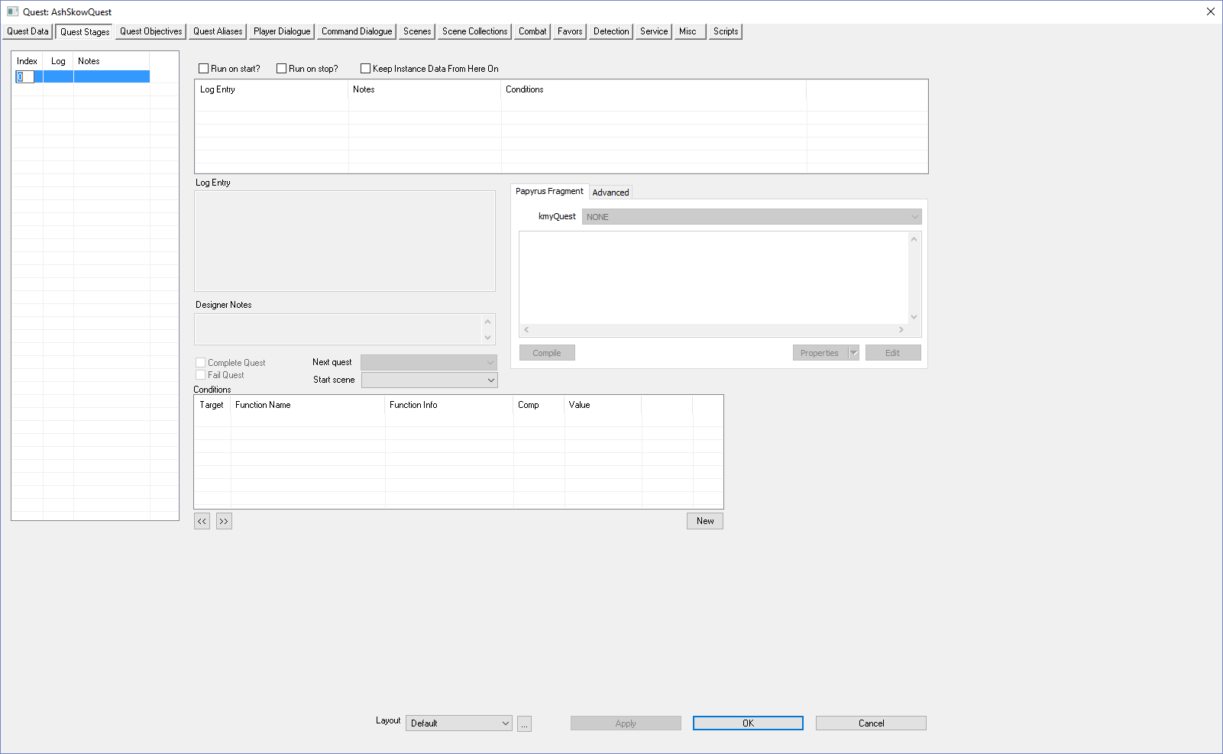
Type [Enter] to keep Index 0  Use the right-click New procedure to Add four more indices labeled 10, 20, 30, 40.  I’ll show you how to add code to the indices later, but for now you can think of the indices as corresponding to the following events:  0: Start of game, Quest Idle  10: Meeting the NPC  20: Accepting the NPC’s Quest  30: Completed the NPC’s Quest  40: End Quest | 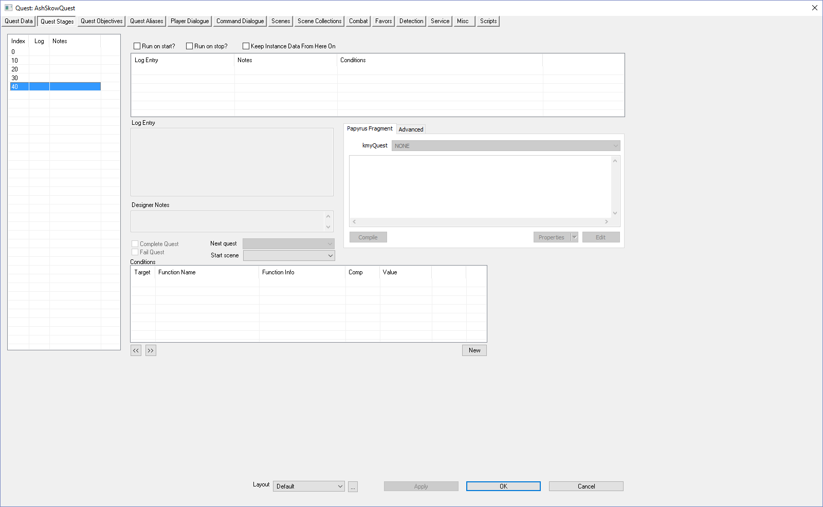
Click on the Quest Objectives Tab  This is where you set the labels the player sees as he or she progresses through the game | 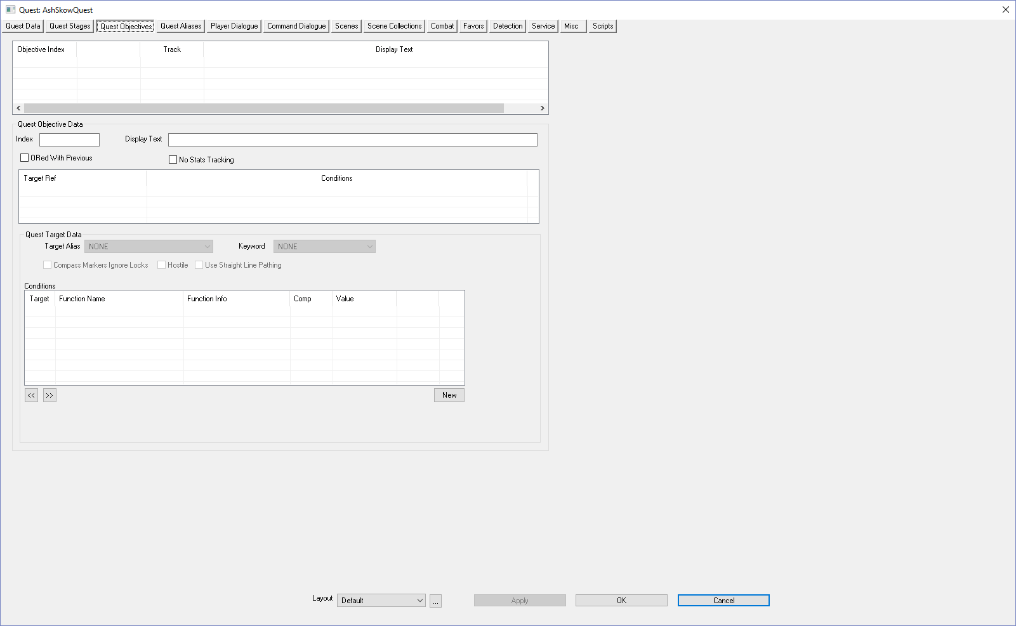
Right-click over the Objective Index | 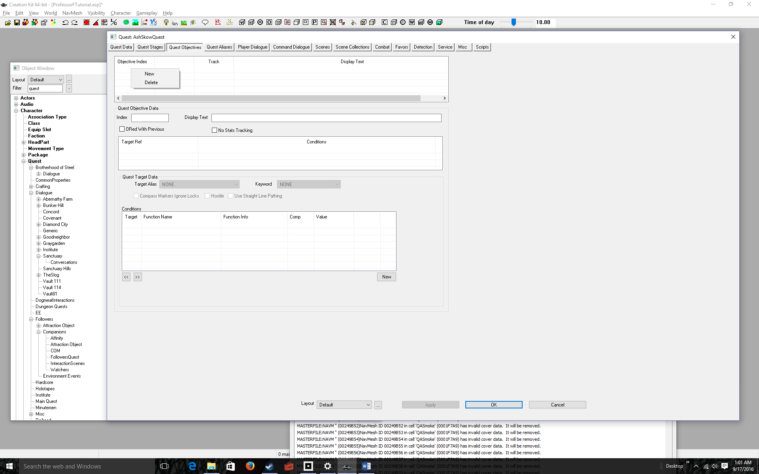
Select New | 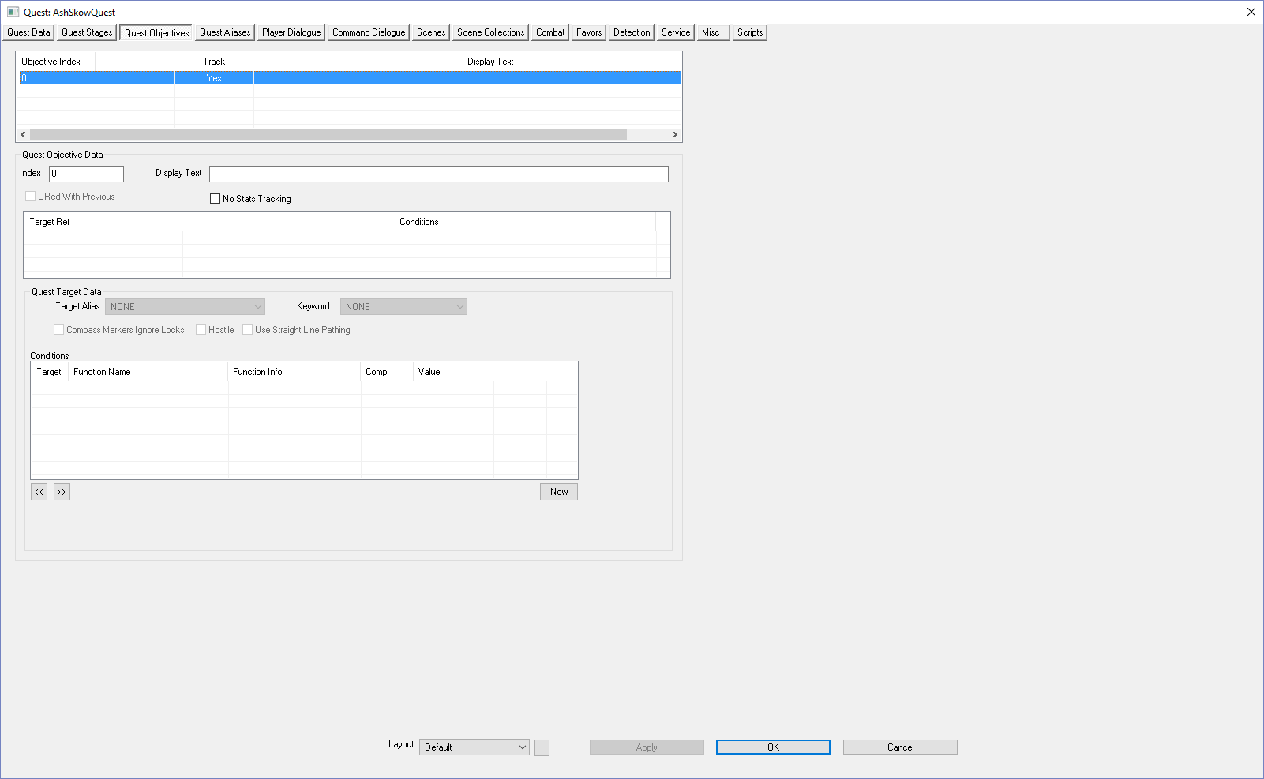
Enter an Index and a Display Text in the corresponding boxes underneath Quest Objective Data  For example: 10 and Meet Ash Skow | 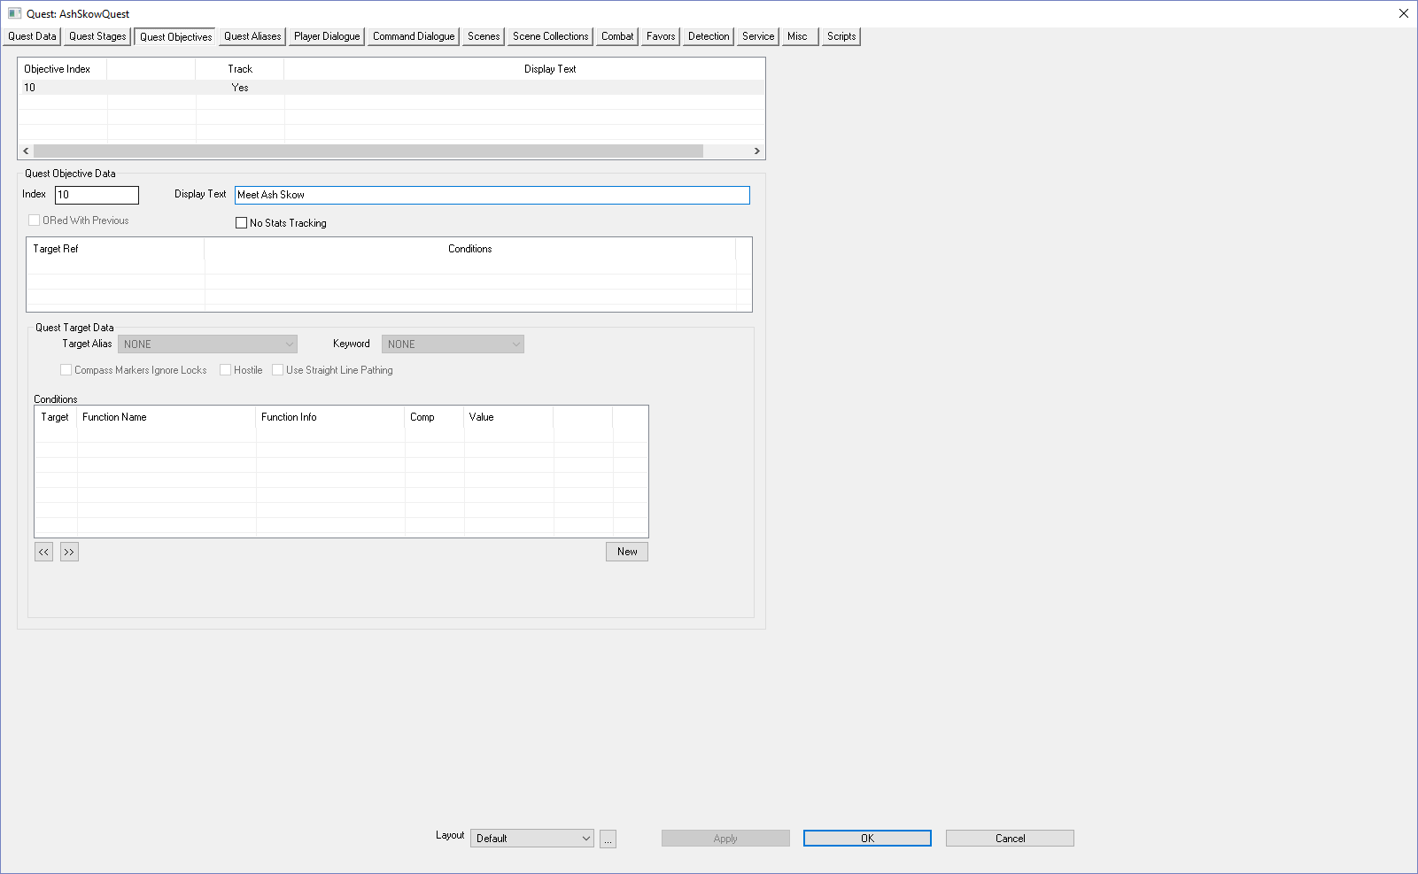
Follow this procedure and add two more objectives for retrieving the object and returning the object  For example:  20 Retrieve object for Ash  30 Return object to Ash  That’s it for setting up the quest. Now we need to write code to link player actions to quest stages.  But first we need to add Aliases. Aliases create markers on the map that guide the player | 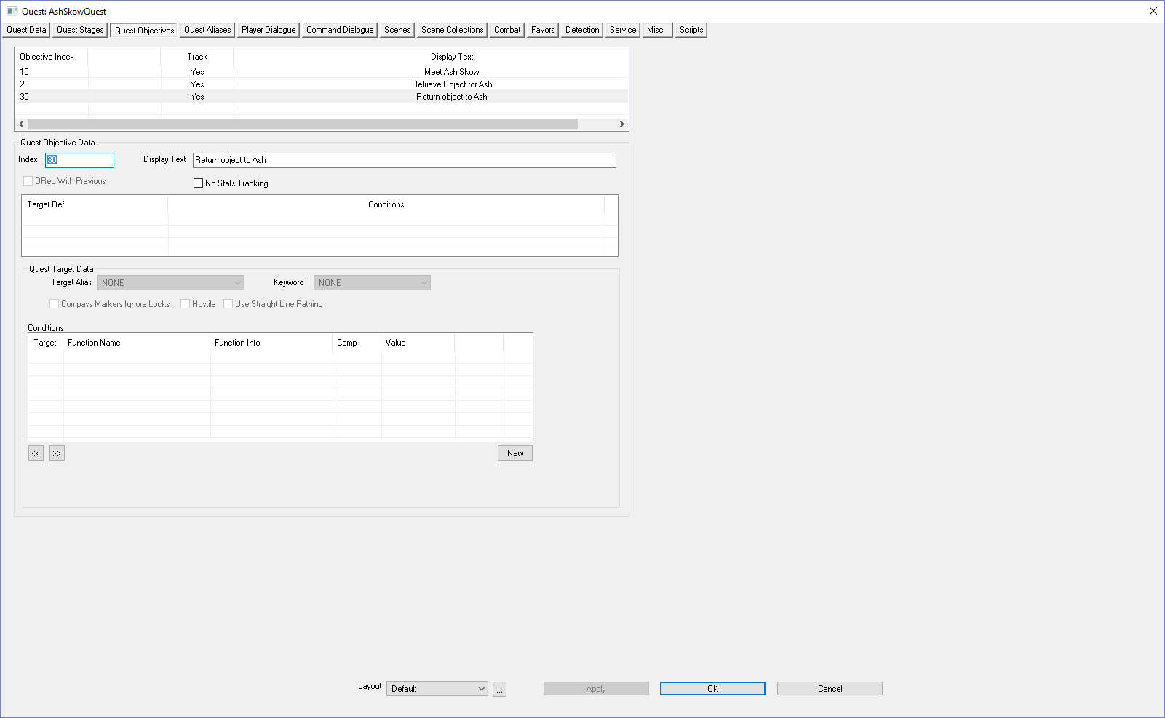
Click the Quest Aliases tab | 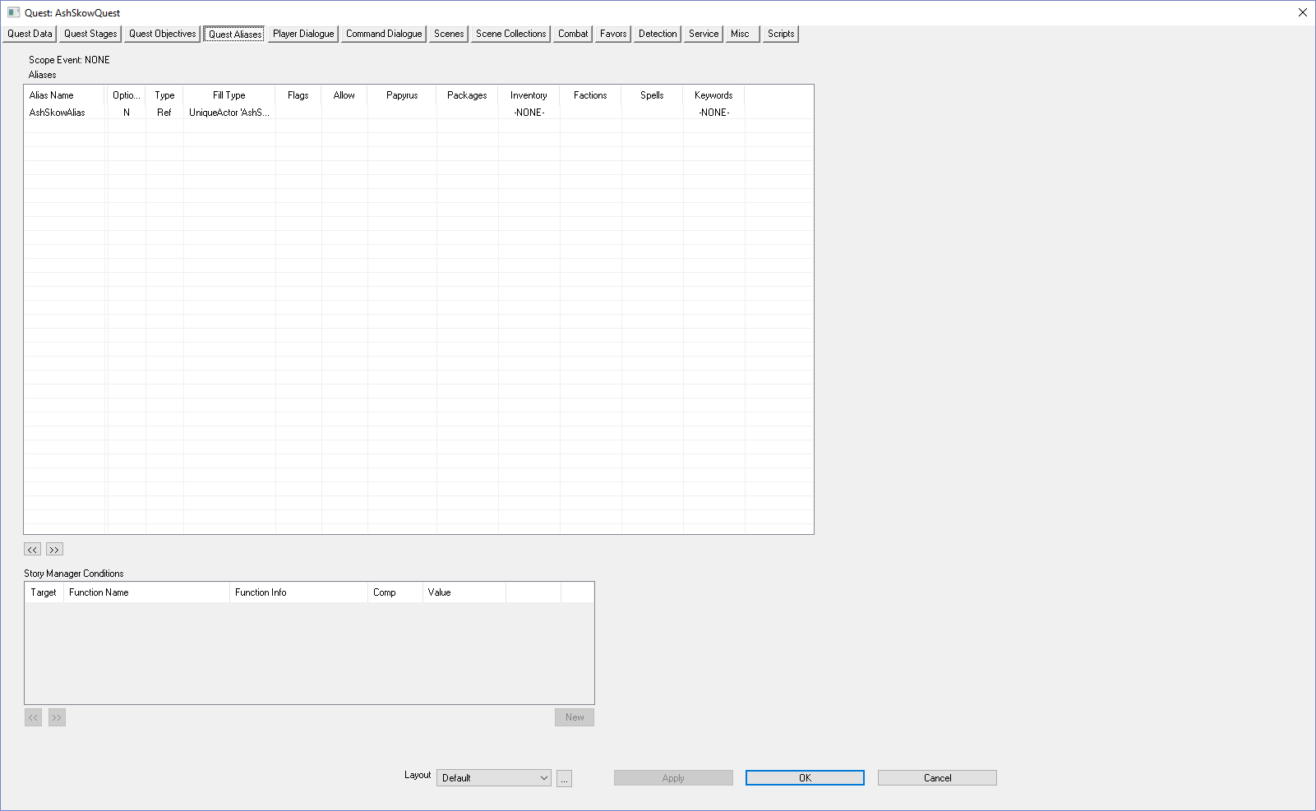
Right-click over the Alias Name column | 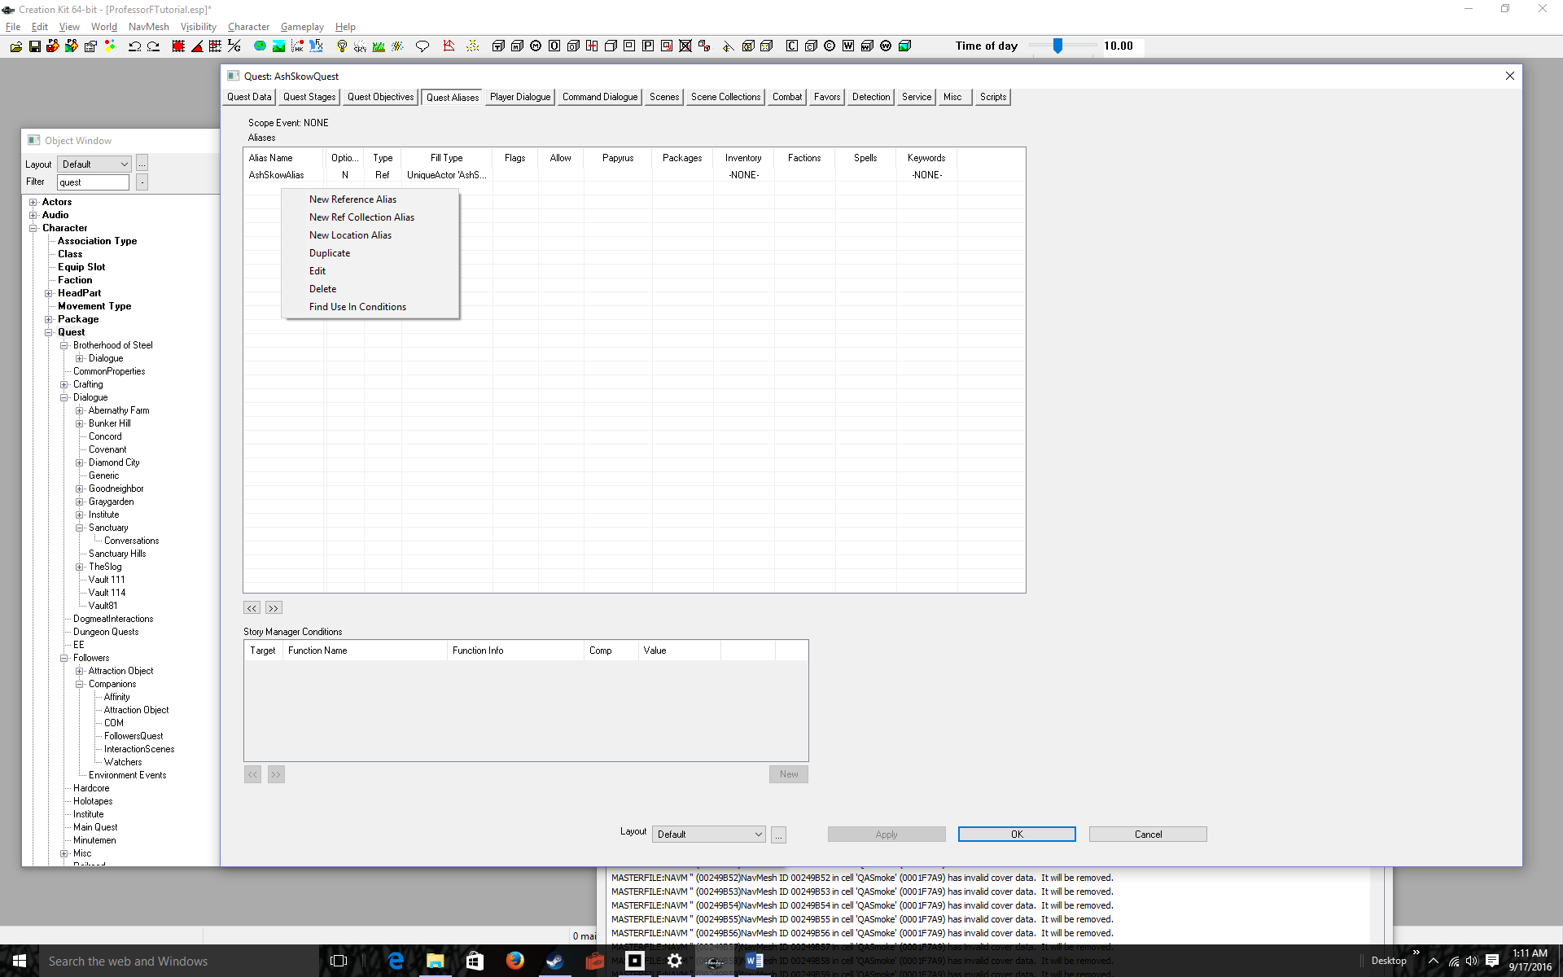
Click New Reference Alias | 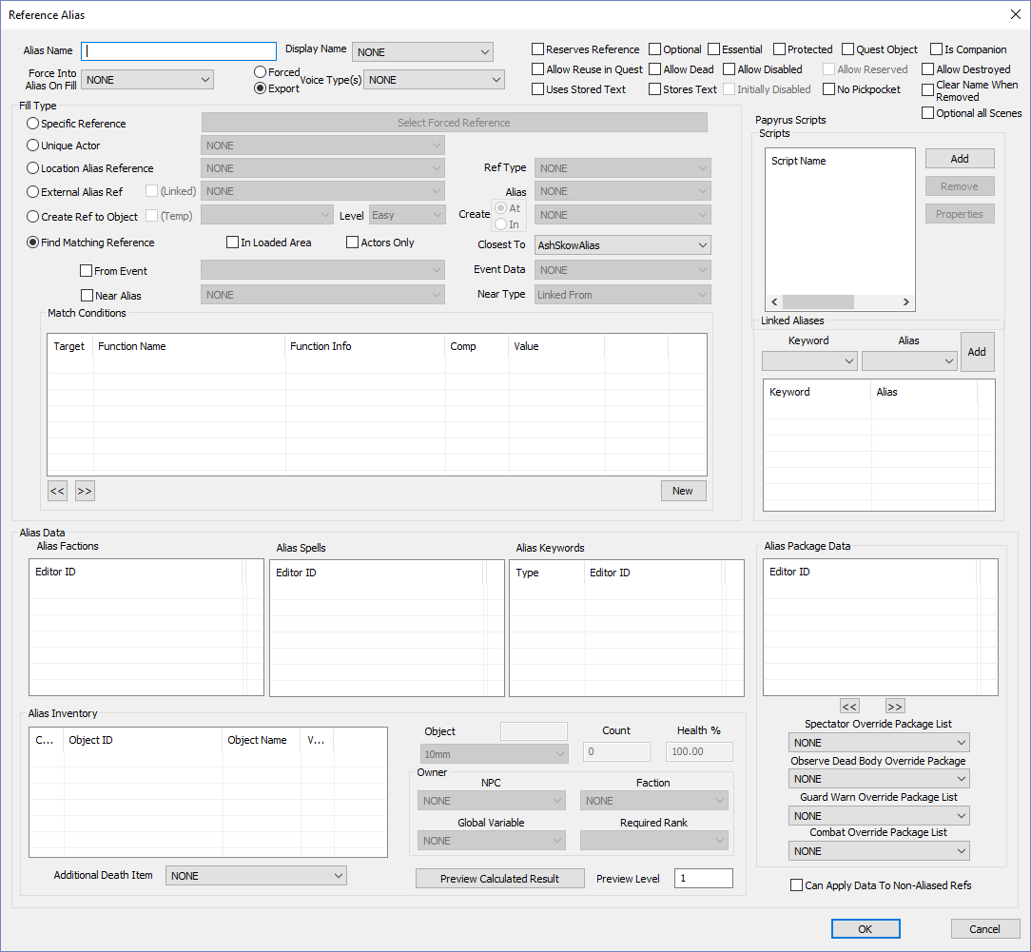
Enter a label for the Target Object into the Alias Name box  For Example: TeddyBearAlias | 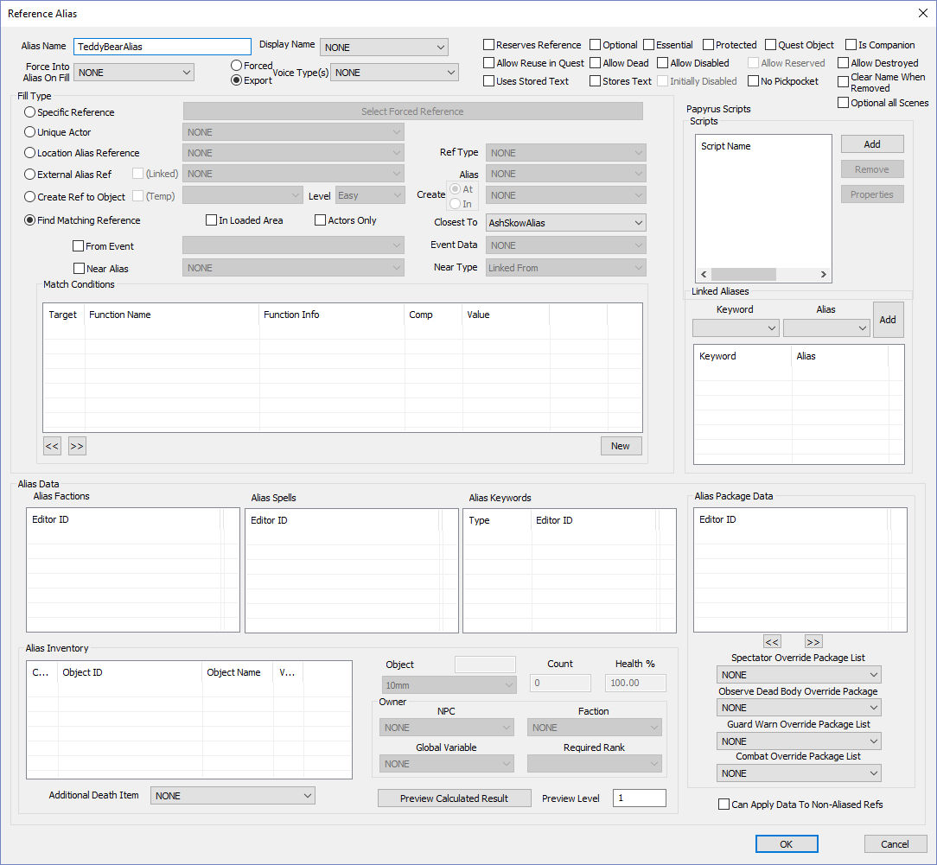
Click on the Radio Button, Specific Reference, the click on the button Select Forced Reference | 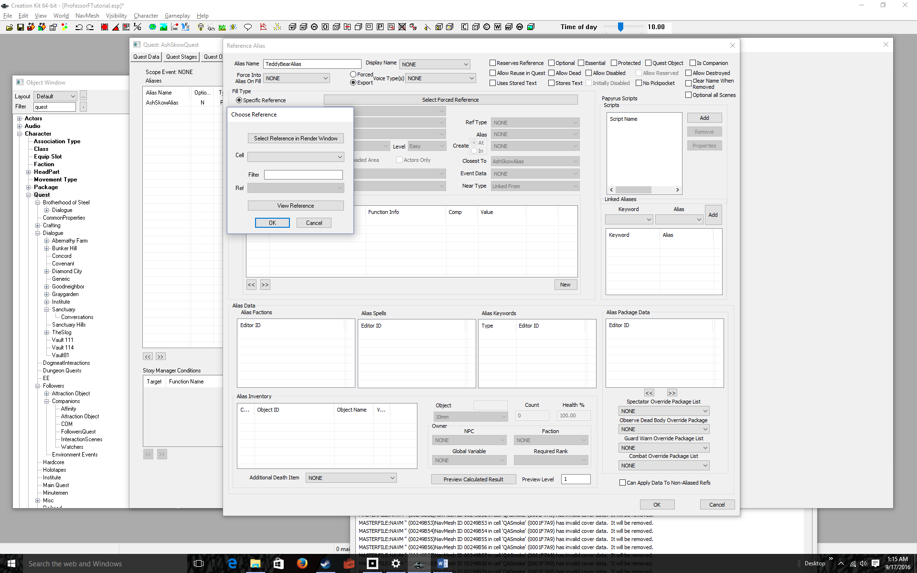
Set the Cell dropdown to your test cell  Set the Ref dropdown to your target object  Remember we are working inside the BoSHoldingCellTut, so I added that to the dropdown  TeddyBear was our target object ignore the numbers after the label. | 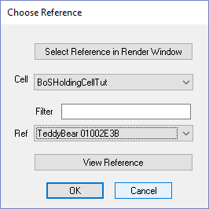
Click OK | 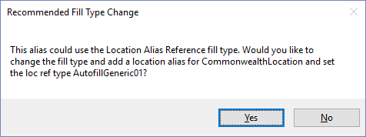
Click No | 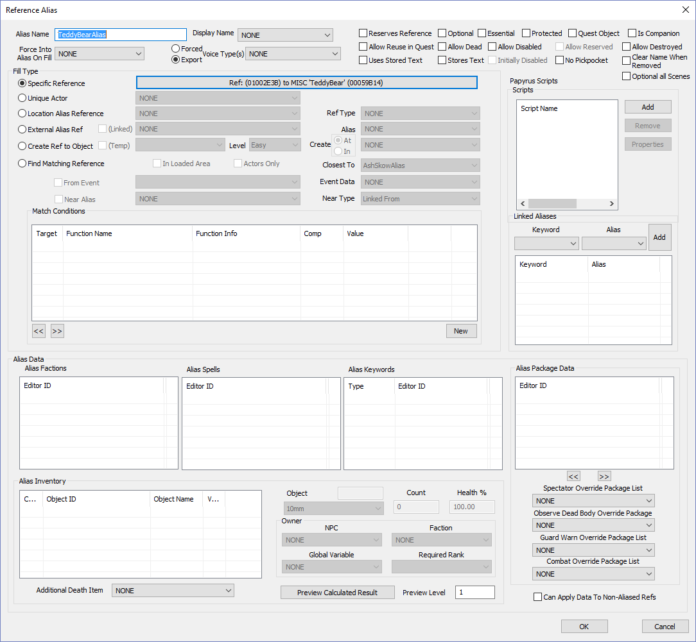
Click OK  That’s it! We’re ready to add code. | 