How to Create a Fallout 4 Quest: Part 9— Quest Startup
Nick V. Flor (nickflor@unm.edu)

- Start up the GECK by running the Bethesda.Net Launcher,  - Open up your Mod (as in Tutorial 3) then  - Bring up your Quest  Yes I skipped a lot of steps, but by now you should know how to bring up your quest. | 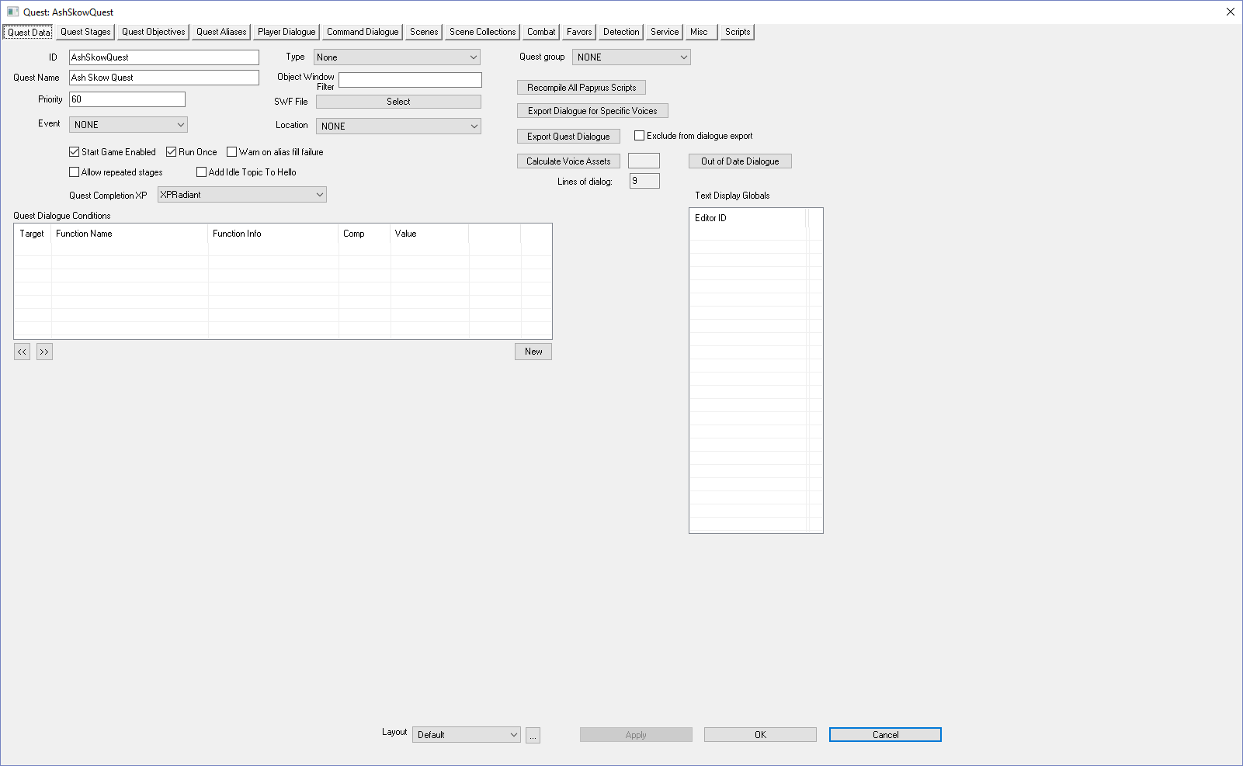
Click the Scenes Tab  What we’re going to do is set it up so that greeting the NPC starts the quest. | 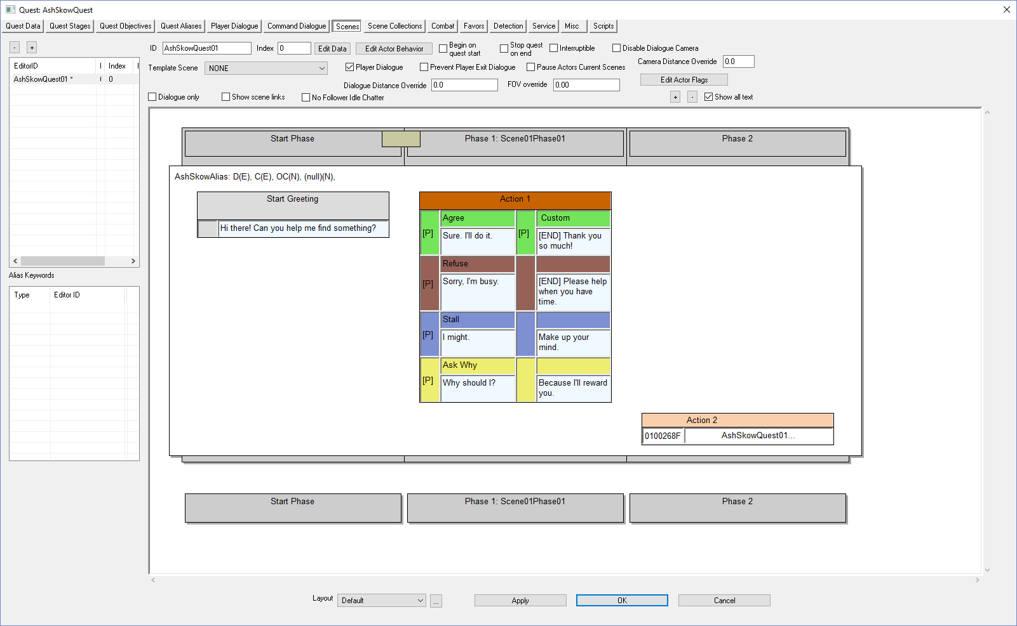
Double-Click on the Start Greeting text  Now things get interesting. The general scripting steps go like this:  - NPC says dialog  - At the end of the dialog you set a parent quest stage number. This is a number you have added within the Quest Stages tab  - Add code to update and display new objectives.  What you want to remember is that generally:  - NPC dialog updates Quest Stage #s  - Quest Stage #s update Quest Objectives | 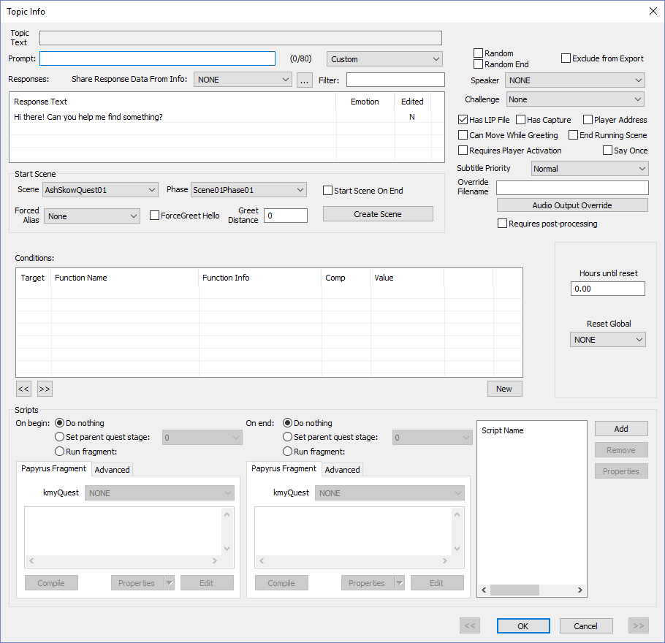
- Click the Set parent quest stage radio button (near bottom middle in the Scripts section)  - Set drop-down list to the starting stage (usually 10)  Note that the drop-down lists all the stage number you added in the Quest Stages tab.  So what will happen is after the NPC says her dialog, the Quest Stage # will be set to 10.  Next, we associate code with Quest Stage 10 | 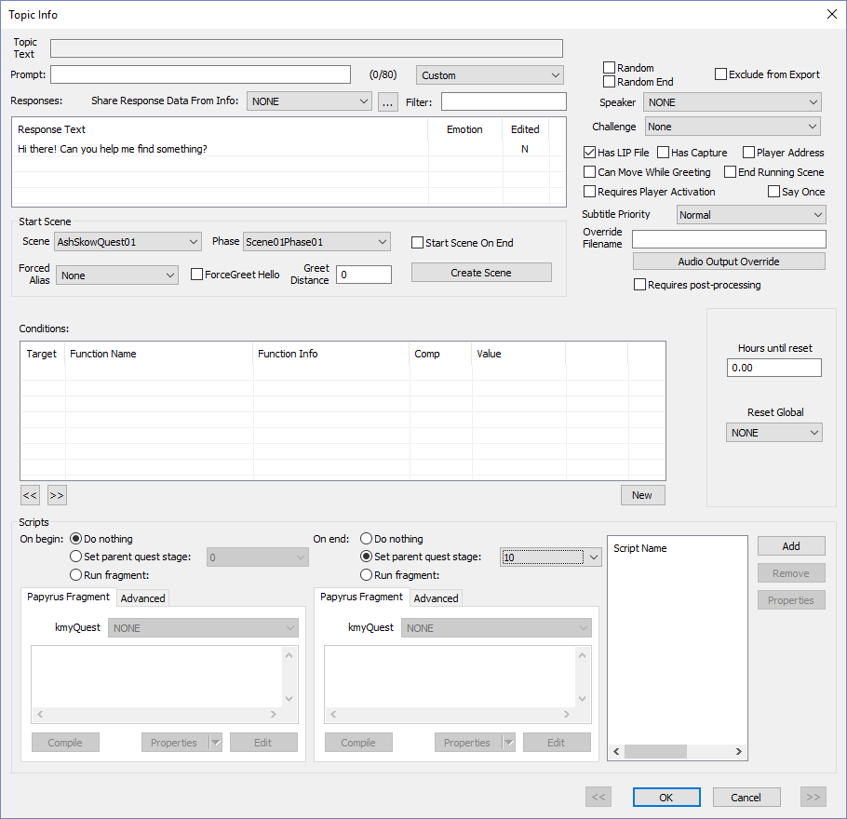
Click OK  Click on the Quest Stages Tab | 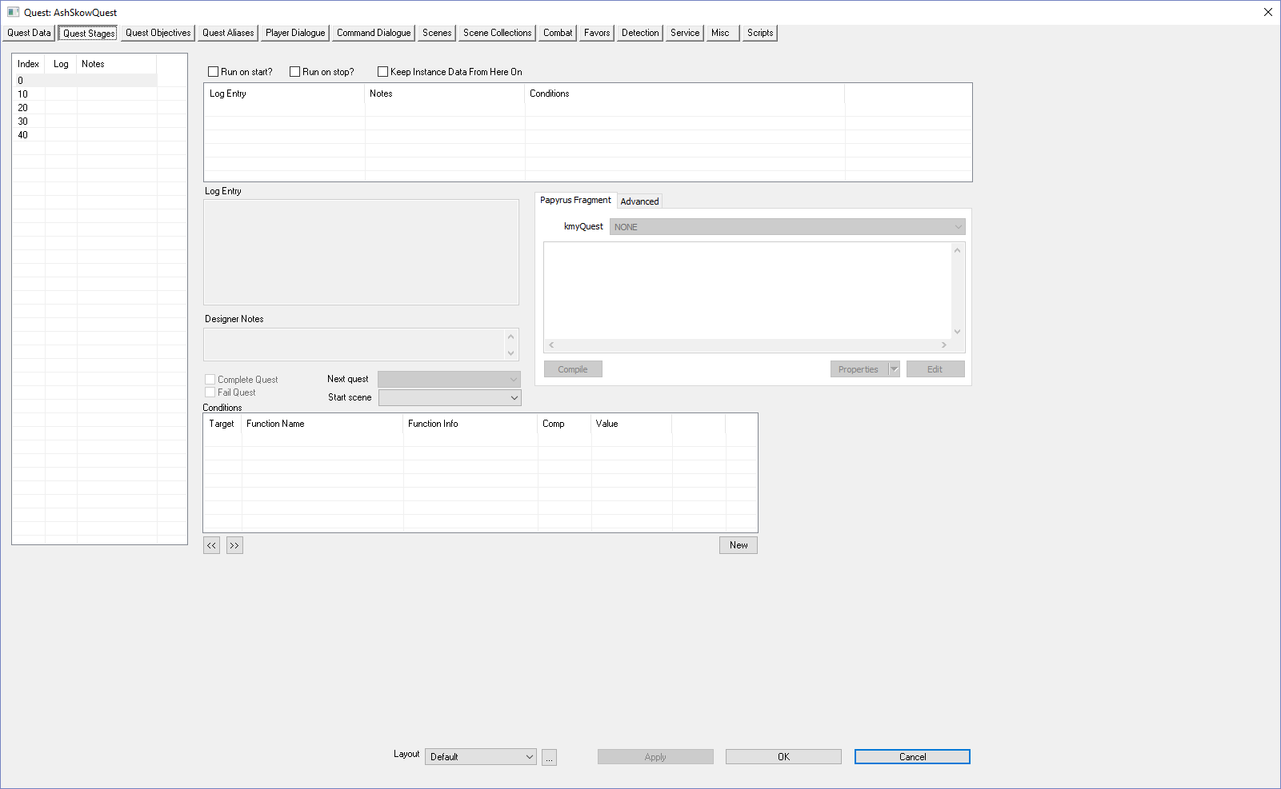
Click on the starting index (usually 10) | 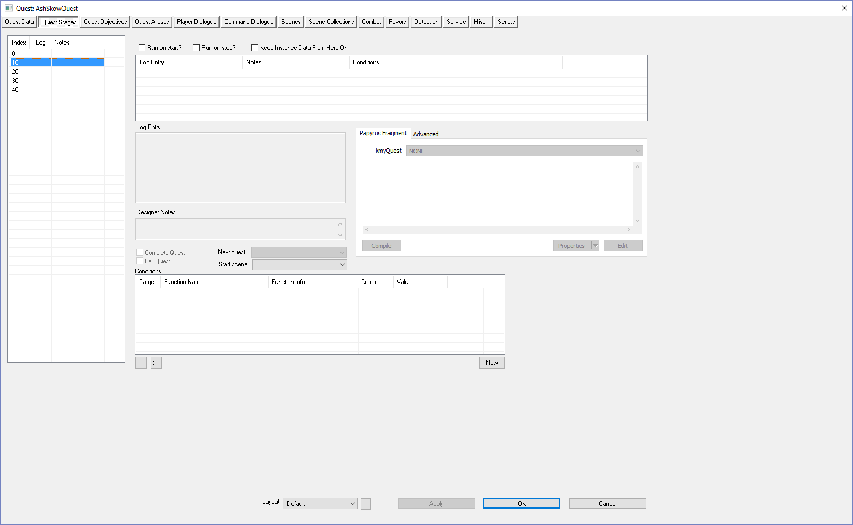
Right-click on Log-Entry  Keep index 0. When the game starts, you can think of your Quest as being at Index 0 | 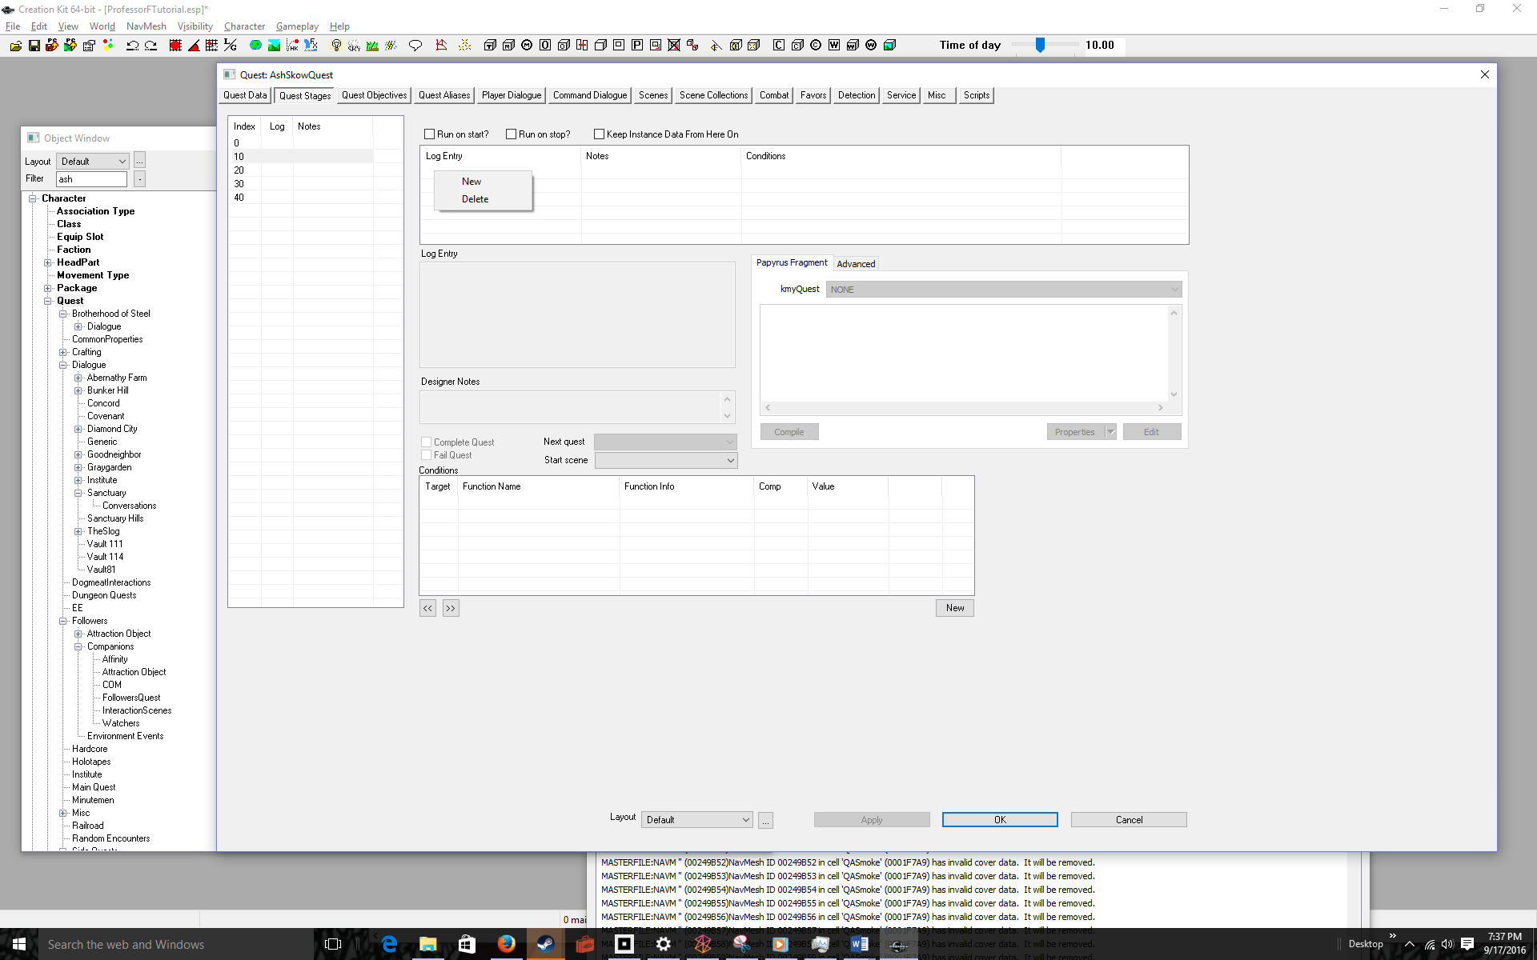
Type [Enter] to keep Index 0  Use the right-click New procedure to Add four more indices labeled 10, 20, 30, 40.  I’ll show you how to add code to the indices later, but for now you can think of the indices as corresponding to the following events:  0: Start of game, Quest Idle  10: Meeting the NPC  20: Accepting the NPC’s Quest  30: Completed the NPC’s Quest  40: End Quest | 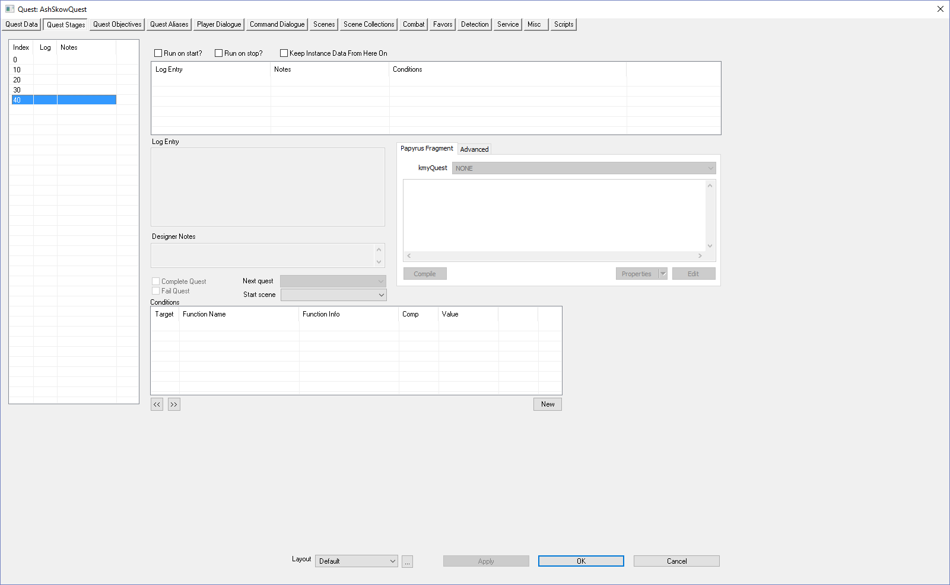
Click on the Quest Objectives Tab  This is where you set the labels the player sees as he or she progresses through the game | 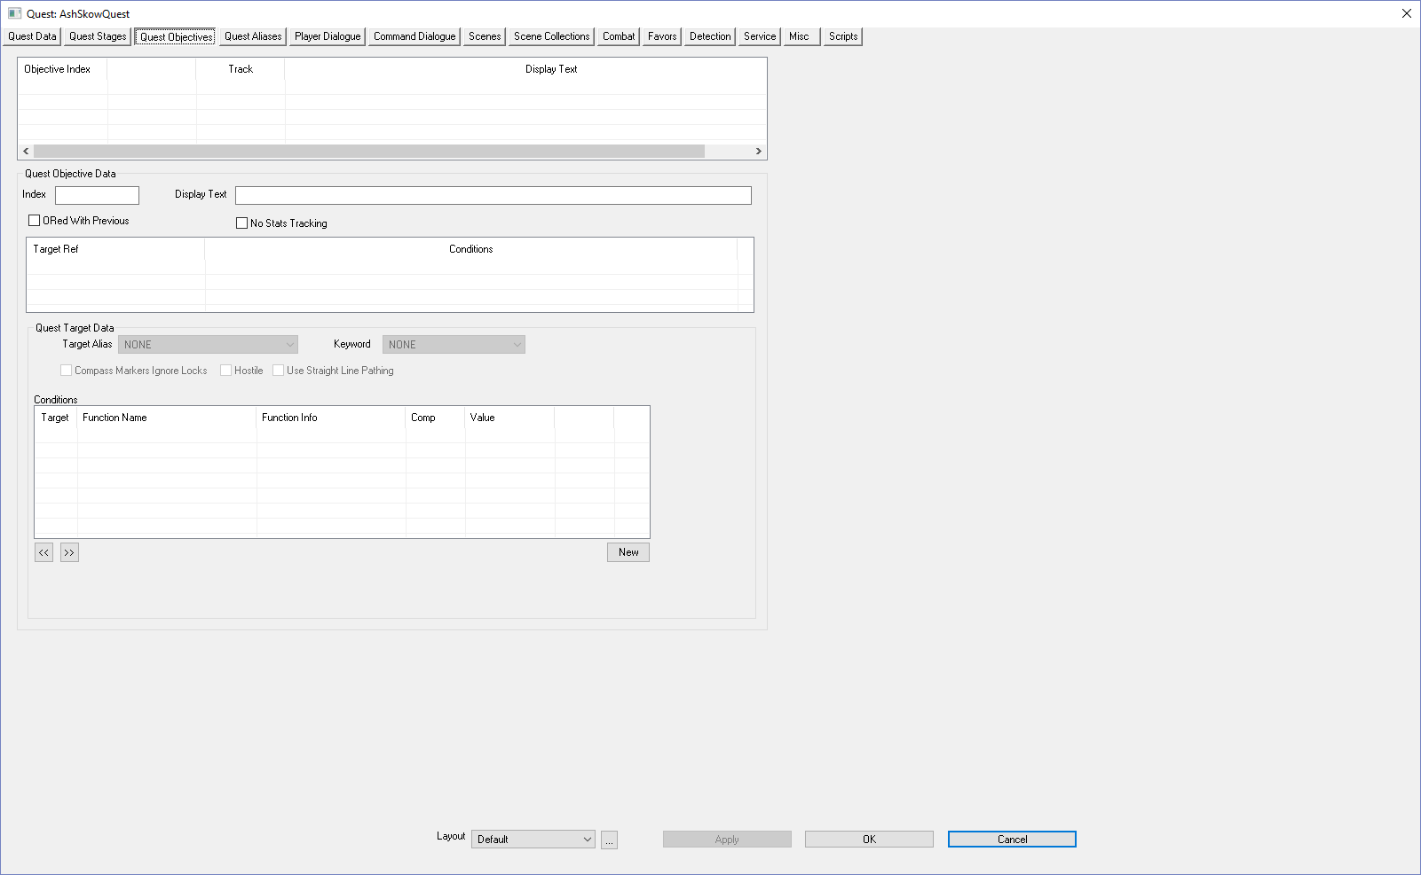
Right-click over the Objective Index | 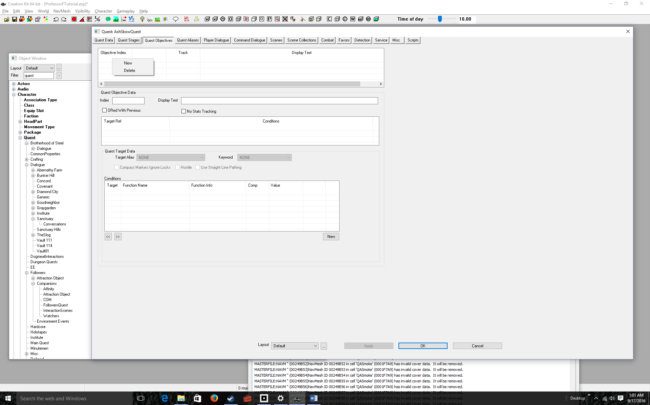
Select New | 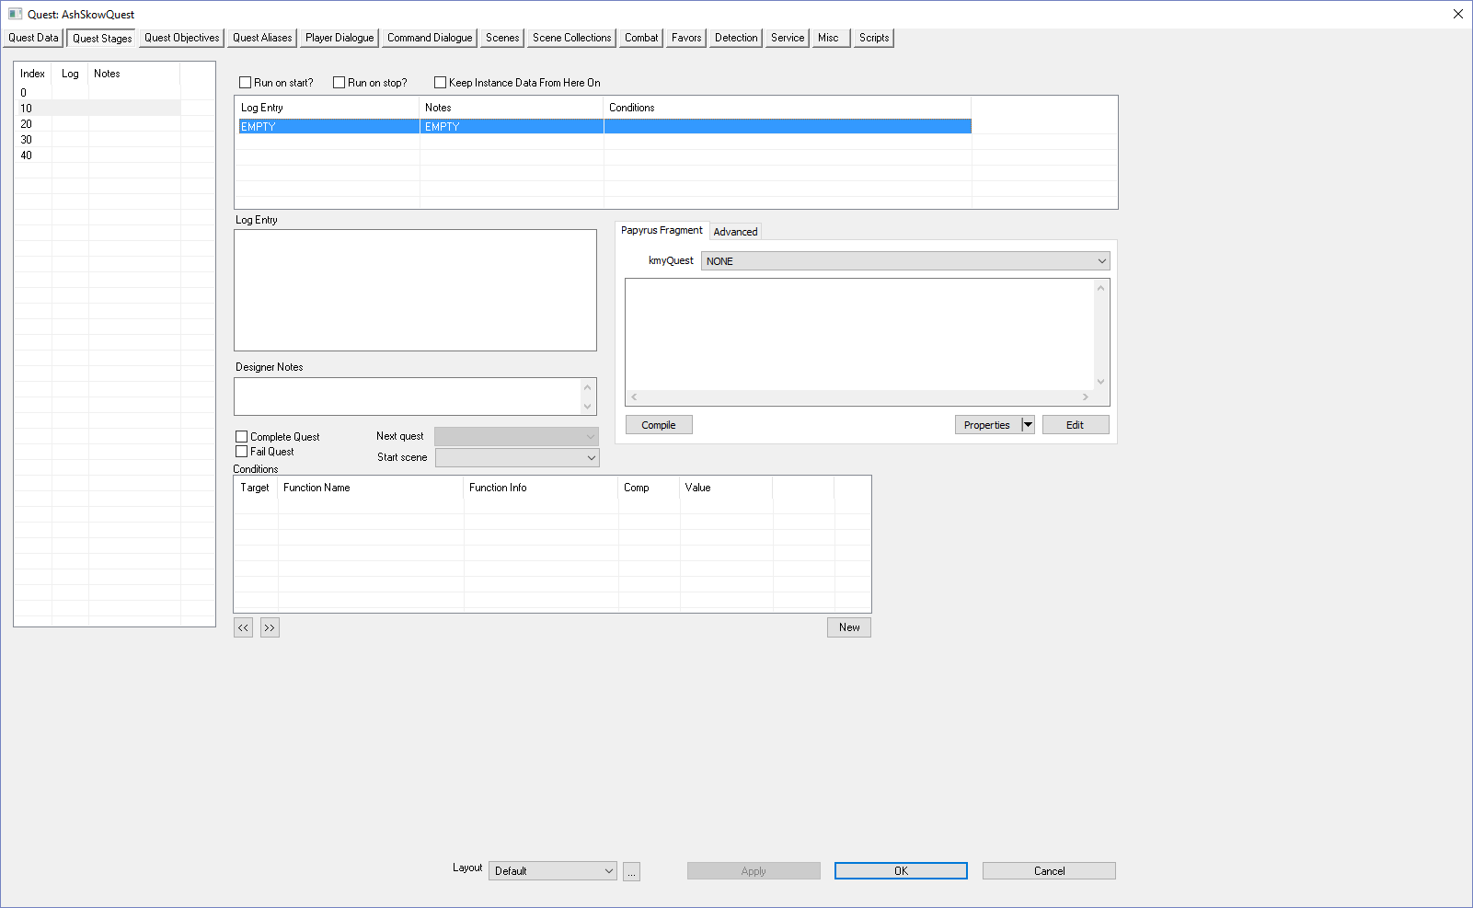
- Enter information about this stage in the Log Entry  - Enter notes in the Designer Notes section  - Add Code to set Meeting Objective # to Completed  - Click the Compile Button  You’re free to enter whatever you want for the Log Entry and Designer notes. What matter is the code:  SetObjectiveDisplayed(10)  SetObjectiveCompeted(10)  If you typed this code exactly, when you click compile you’ll get no error messages. | 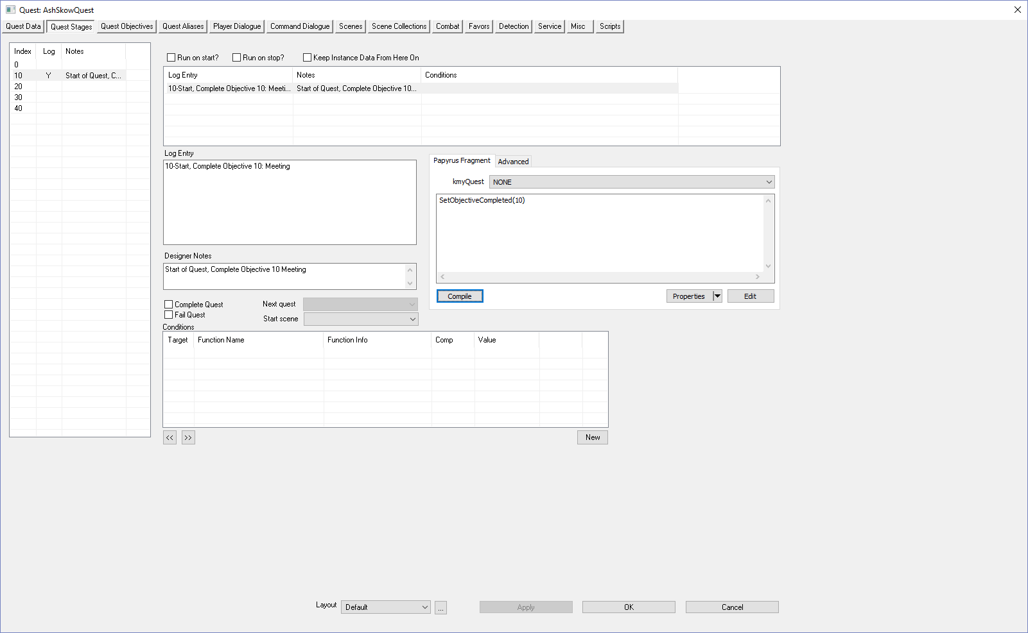
(Optional) Click on the Quest Objectives tab  Now what did we just do? In the previous step, we added the code:  SetObjectiveDisplayed(10)  SetObjectiveCompeted(10)  Objective Index 10 is associated with the Display Text: Meet Ash Skow.  So that piece of code will display to the player:  Meet Ash Skow  Completed: Meet Ash Skow  The first time SetObjectiveDisplayed is called, it will also show the Quest Name | 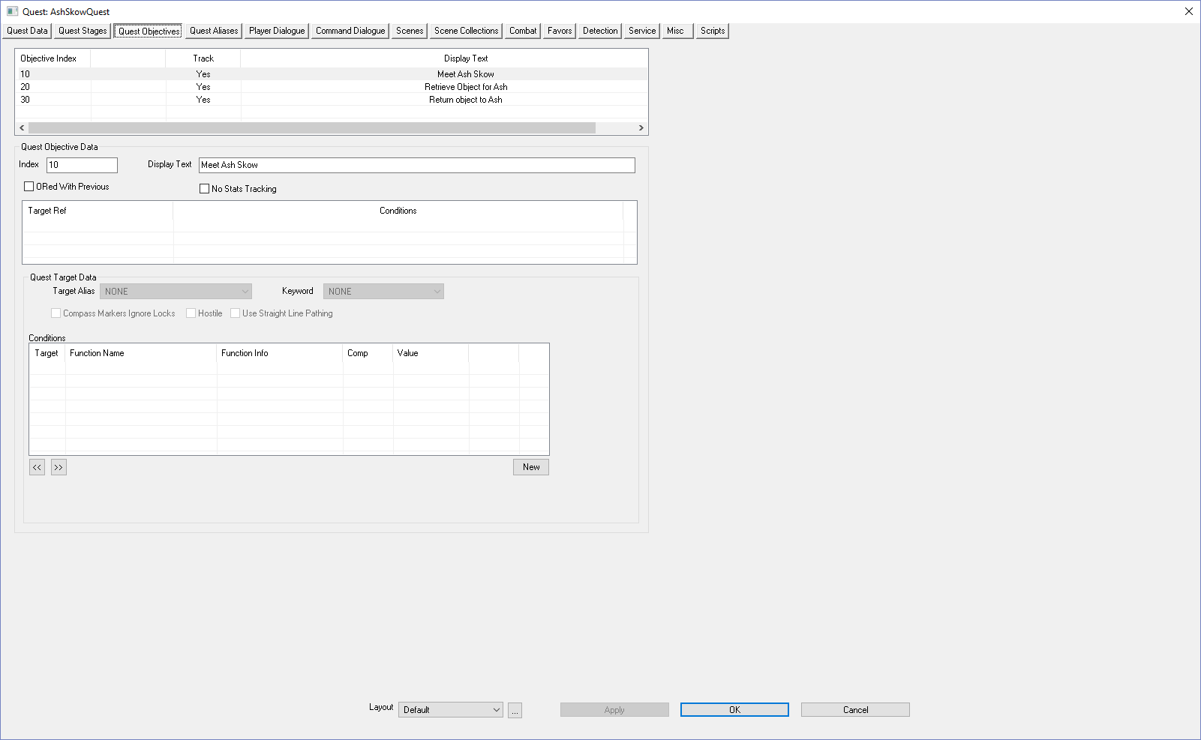
- Click the OK button to close out the Quest dialog box  - File > Save | 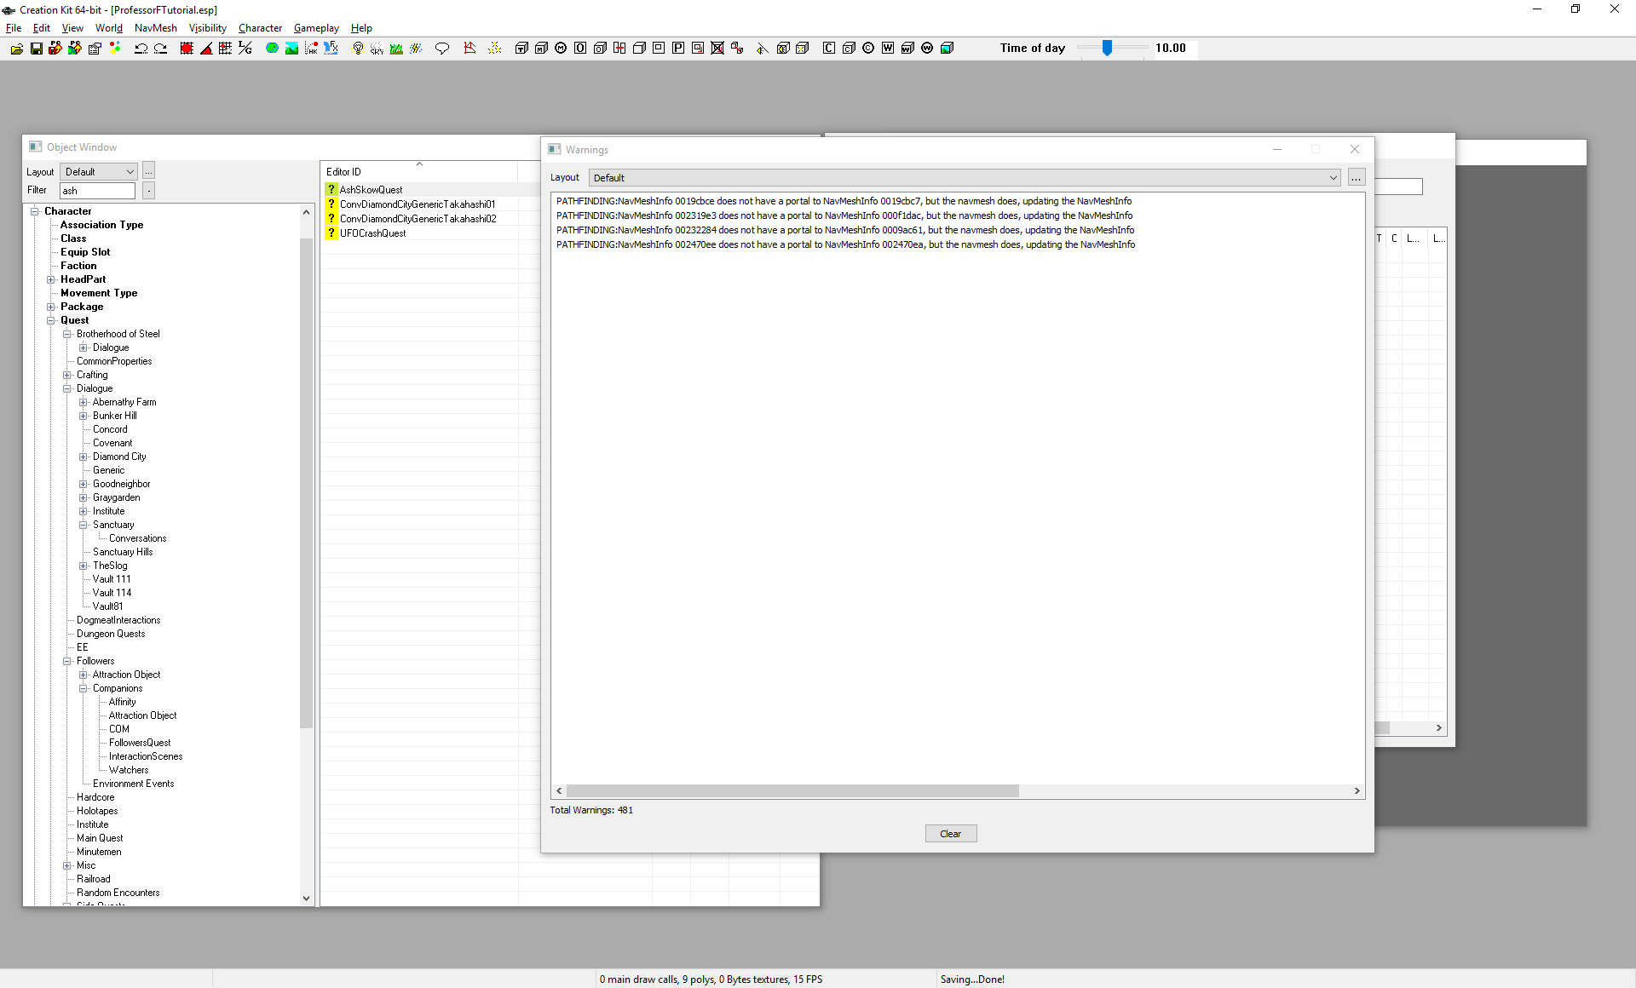
- Minimize the GECK  - Start Fallout 4 & goto whatever room your NPC is in, if you aren’t there already  Yes, I skipped a lot of steps, but you should know how to do this by now. | 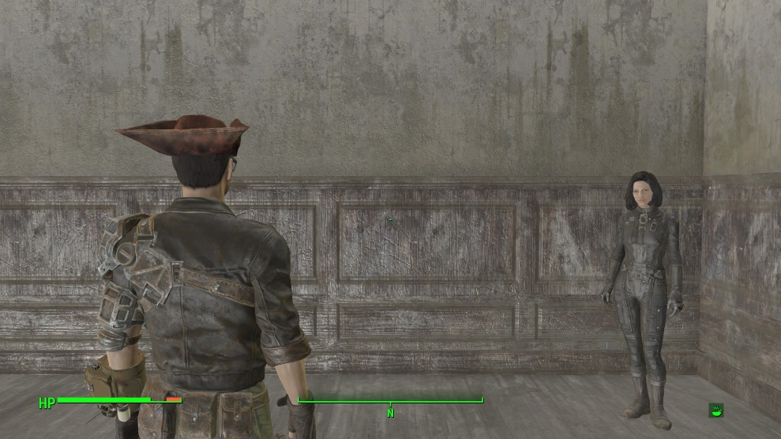
- Approach the NPC  The greeting text starts. | 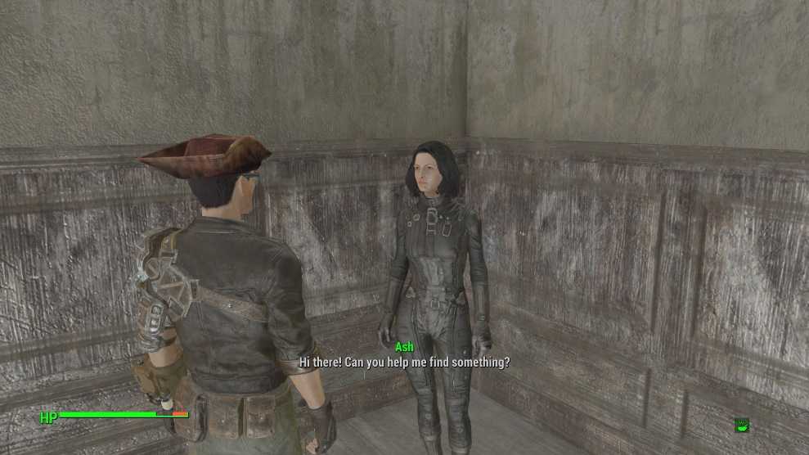
Wait for the greeting to finish | 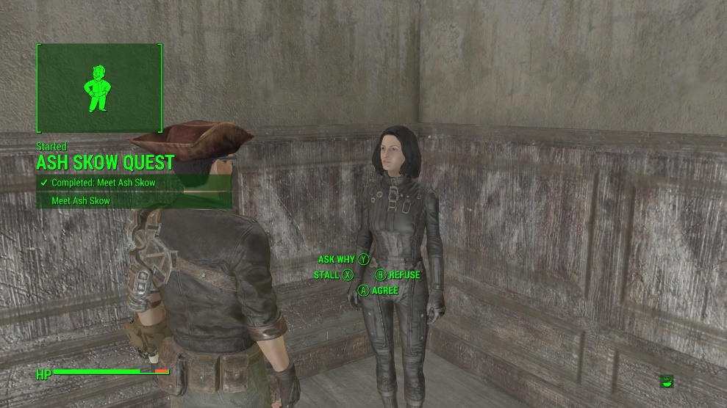
Wait for the Quest text to go away  Next, we’ll add code to go to the next objective if you agree to the Quest.  You’re done with starting up a quest. No problem, eh? But things will get a little hairier when we have to enable conditions for our quests.  Just remember  - Dialog sets Stage #s  - Stage #s execute objective displayed & completed code | 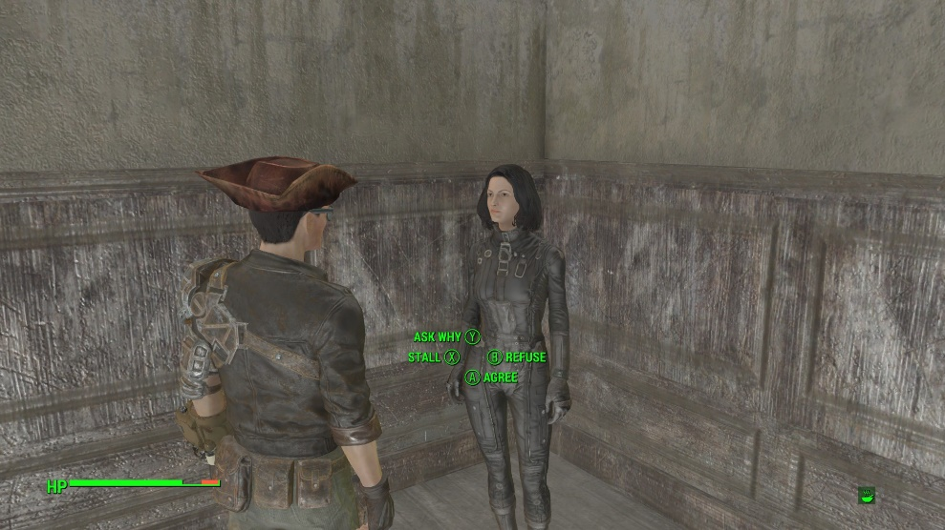

Don’t forget to quit out of Fallout 4 WITHOUT SAVING OR QUICKSAVING, before going back to the GECK. You can stay in the GECK, you just have to quit out of Fallout 4 each time. If you save, then Fallout4 remembers your Stage & Objectives (and you’ll have to into the coc to reset them)

