**Assignment 2**

Name: Omkar Bhor

Roll no: BECOD478

1. Login

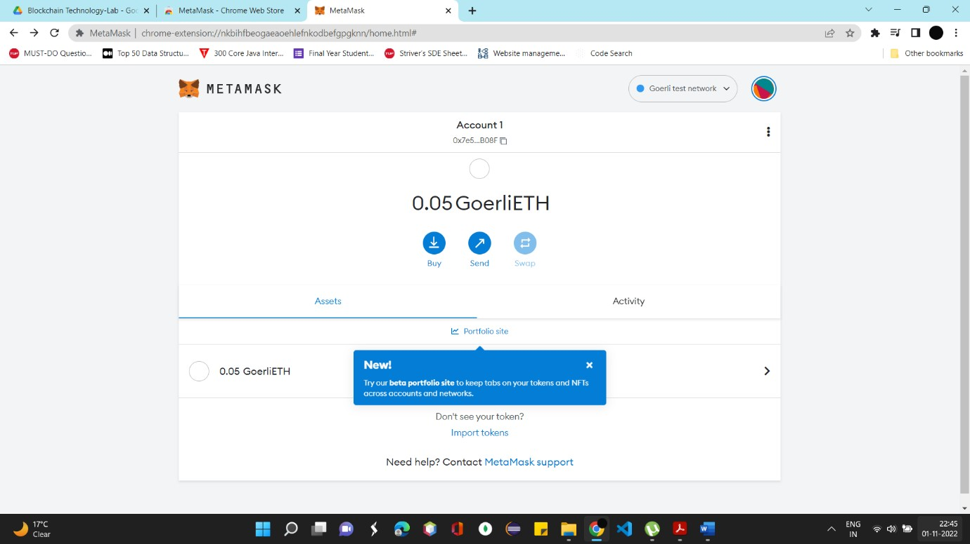

1. Enter the amount and click send.

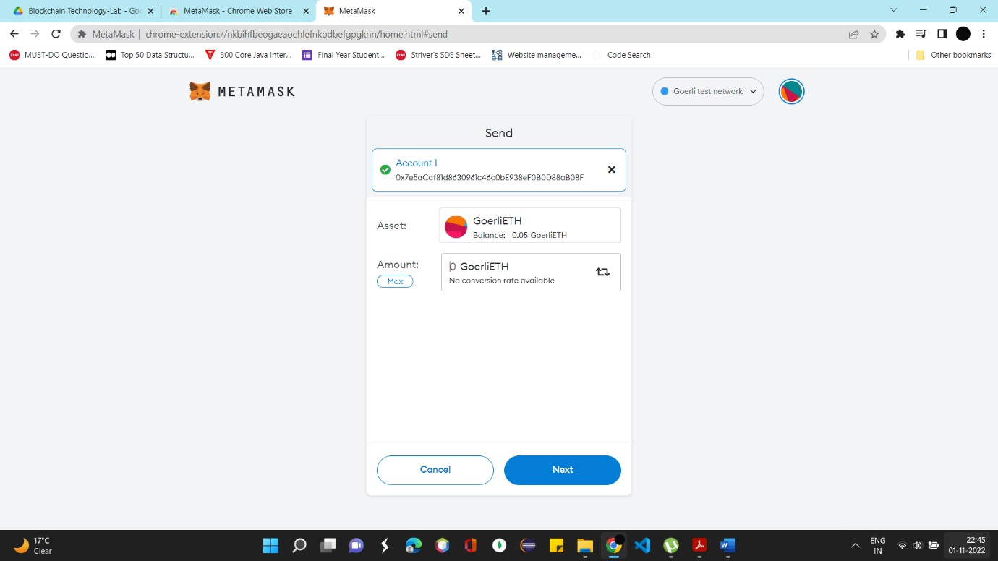

1. Copy the link of account on which you want to transfer the eth. Check the assets details and click on confirm.

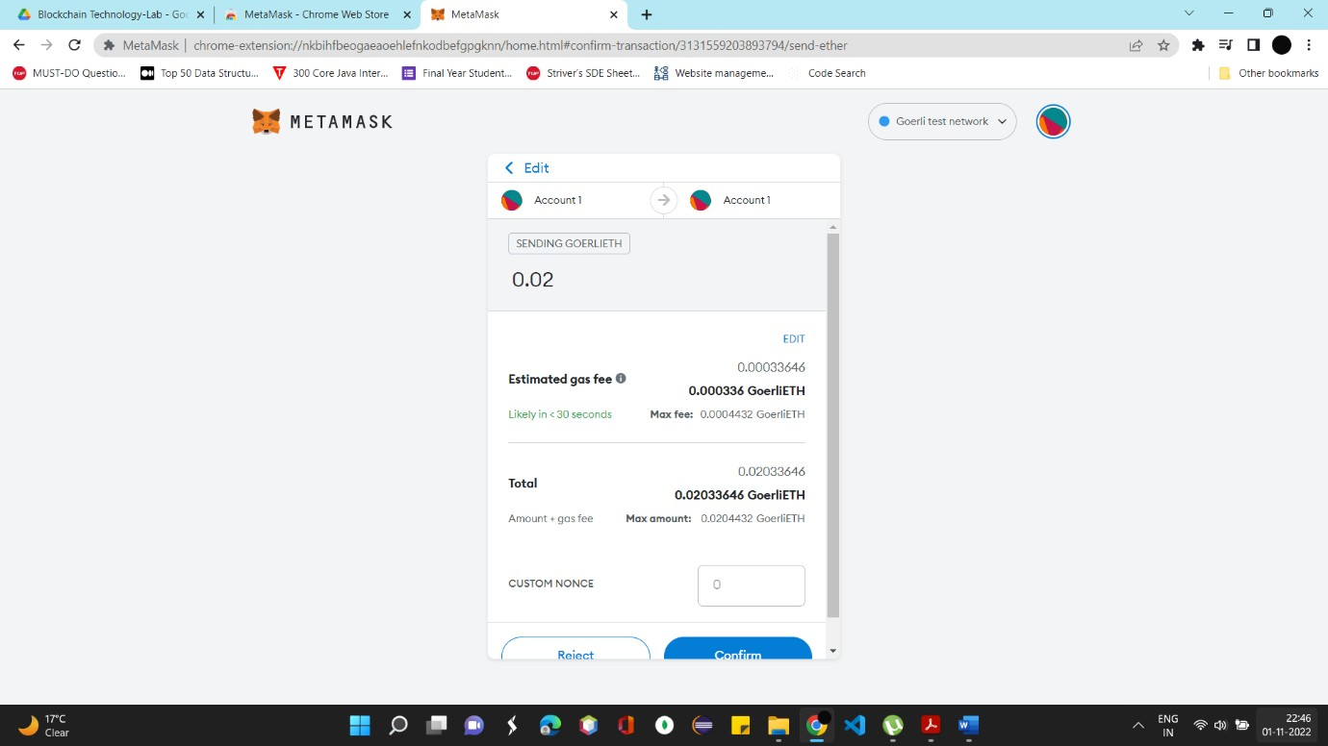

1. Status will be shown as “Pending”

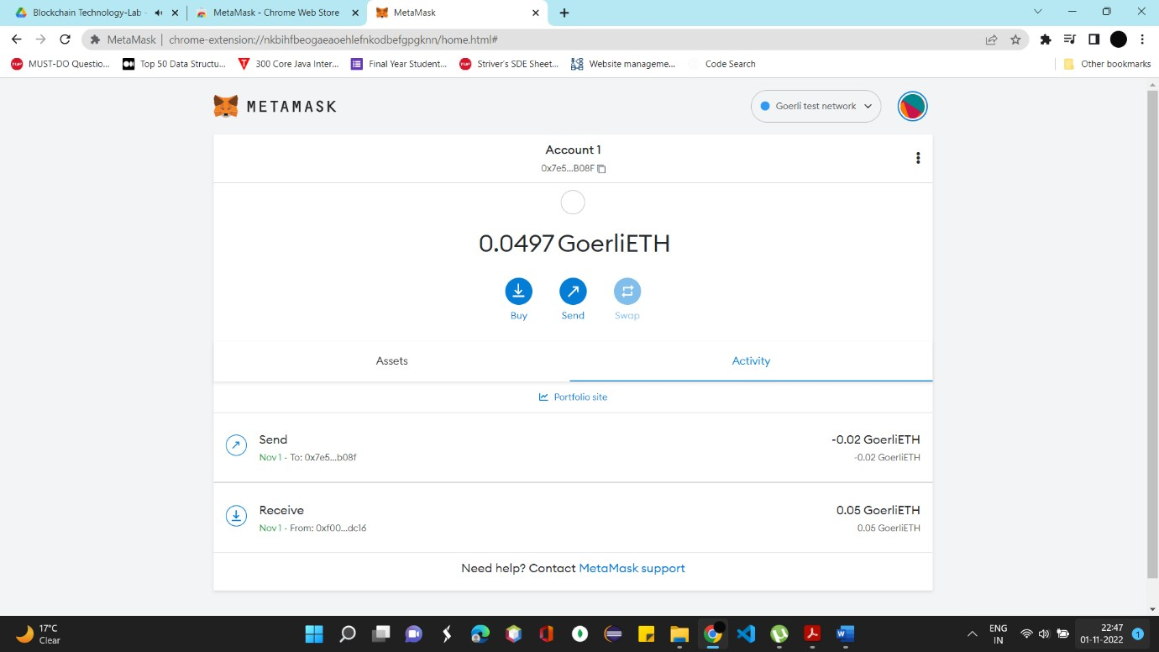

1. Transaction completed

