Chapter 1: Foundations of Generative AI

Introduction
Welcome to your journey into the fascinating world of Generative Artificial Intelligence! If you've ever wondered how ChatGPT writes coherent essays, how DALL-E creates stunning artwork from text descriptions, or how GitHub Copilot suggests code completions, you're about to discover the foundational principles that make these remarkable capabilities possible.
This opening chapter lays the groundwork for understanding how machines can create human-like text, images, and other content that often seems indistinguishable from human-generated work. We'll explore the remarkable evolution from simple rule-based systems of the 1960s to today's powerful Large Language Models (LLMs) that can write essays, answer complex questions, engage in creative storytelling, and even help with programming tasks.
But this isn't just a theoretical exploration. Throughout this chapter, you'll not only learn the fundamental concepts but also get your hands dirty by building the foundation of an AI-powered research assistant. This practical component will help solidify your understanding as you see these concepts come to life in working code.

What You'll Learn
By the end of this chapter, you will:
- Understand the core principles that enable machines to generate human-like content
- Trace the historical evolution from early AI systems to modern generative models
- Grasp the key concepts of neural networks, transformers, and attention mechanisms
- Distinguish between different types of generative AI approaches and their use cases
- Build a working prototype research assistant that demonstrates multiple AI techniques
- Evaluate the strengths, limitations, and ethical considerations of generative AI systems

Your Practical Project
As we progress through the theoretical concepts, you'll simultaneously develop an AI-powered research assistant that can:
- Accept user queries in natural language
- Generate responses using different AI approaches (rule-based, retrieval-based, and generative)
- Demonstrate the evolution of AI capabilities we'll discuss
- Serve as a foundation for more advanced projects in subsequent chapters
This hands-on approach ensures that abstract concepts become concrete understanding, preparing you not just to use generative AI tools, but to build and customize them for your own needs.

A Note on the Journey Ahead
Generative AI represents one of the most exciting frontiers in computer science today. While the underlying mathematics can be complex, our approach will be to build intuition first, then gradually introduce the technical details. Don't worry if some concepts seem challenging at first, each chapter builds carefully on the previous one, and by the end of this book, you'll have both the theoretical knowledge and practical skills to work confidently with large language models.
Let's begin this adventure together!

Introductory Video
https://www.youtube.com/watch?v=NRmAXDWJVnU
Generative AI Explained In 5 Minutes

Learning Outcomes
By the end of this chapter, you will be able to:
- Define generative AI and explain how it differs from traditional AI approaches
- Identify the key components and architecture of generative systems
- Understand the evolution from rule-based systems to neural networks to transformers
- Explain fundamental concepts like tokens, embeddings, and probability distributions
- Set up a complete development environment for generative AI projects
- Build a simple text generator using multiple approaches (Markov chains and API-based)
- Compare the outputs and limitations of different generative approaches
- Implement the foundational architecture for an AI research assistant

Key Terminologies and Concepts
Term | Definition | Example/Context
Generative AI | AI systems that create new content (text, images, code) rather than just classifying or predicting existing data | ChatGPT writing an essay, DALL-E creating images
Large Language Model (LLM) | Neural networks trained on vast amounts of text data to understand and generate human-like language | GPT-4, Claude, Llama 2
Token | The smallest unit of text that a model processes, often words or parts of words | "Hello" = 1 token, "ChatGPT" = 2 tokens
Embedding | A numerical representation of text that captures semantic meaning in high-dimensional space | Converting "dog" to a vector like [0.2, -0.1, 0.8, ...]
Transformer | A neural network architecture that uses attention mechanisms to process sequential data | The "T" in GPT (Generative Pre-trained Transformer)
Attention Mechanism | A technique that allows models to focus on relevant parts of input when generating output | Focusing on "Paris" when answering "What is the capital of France?"
Pre-training | The initial phase where models learn language patterns from massive text datasets | Training GPT on books, articles, and web content
Fine-tuning | Adapting a pre-trained model for specific tasks or domains | Training a medical AI assistant using healthcare data
Inference | The process of using a trained model to generate new outputs | Asking ChatGPT a question and receiving an answer
Prompt | The input text given to a generative model to elicit a specific response | "Write a professional email about..."
Temperature | A parameter controlling randomness in model outputs (0 = deterministic, 1+ = creative) | Low temperature for factual answers, high for creative writing
API (Application Programming Interface) | A way for different software applications to communicate and share functionality | Using OpenAI's API to access GPT models in your app

What is Generative AI?
Imagine having a conversation with a computer that doesn't just understand what you're saying, but can respond with original thoughts, create stories you've never heard, or even write code to solve problems you describe in plain English. This isn't science fiction; it's the reality of Generative Artificial Intelligence.
Generative Artificial Intelligence (GenAI) is a subset of AI that focuses on creating new, original content, such as text, images, music, videos, or even code, rather than merely analyzing or classifying existing data. Think of it as the difference between a critic who can tell you whether a painting is a Picasso or a Monet, versus an artist who can create an entirely new painting in either style.
Unlike traditional AI systems that operate on discriminative models (like spam detection or sentiment analysis), generative AI leverages sophisticated probabilistic models to synthesize novel outputs that capture and extend the patterns found in their training data.

Key Distinctions: The Analyst vs. The Creator
To understand what makes generative AI special, let's compare it with traditional AI approaches:
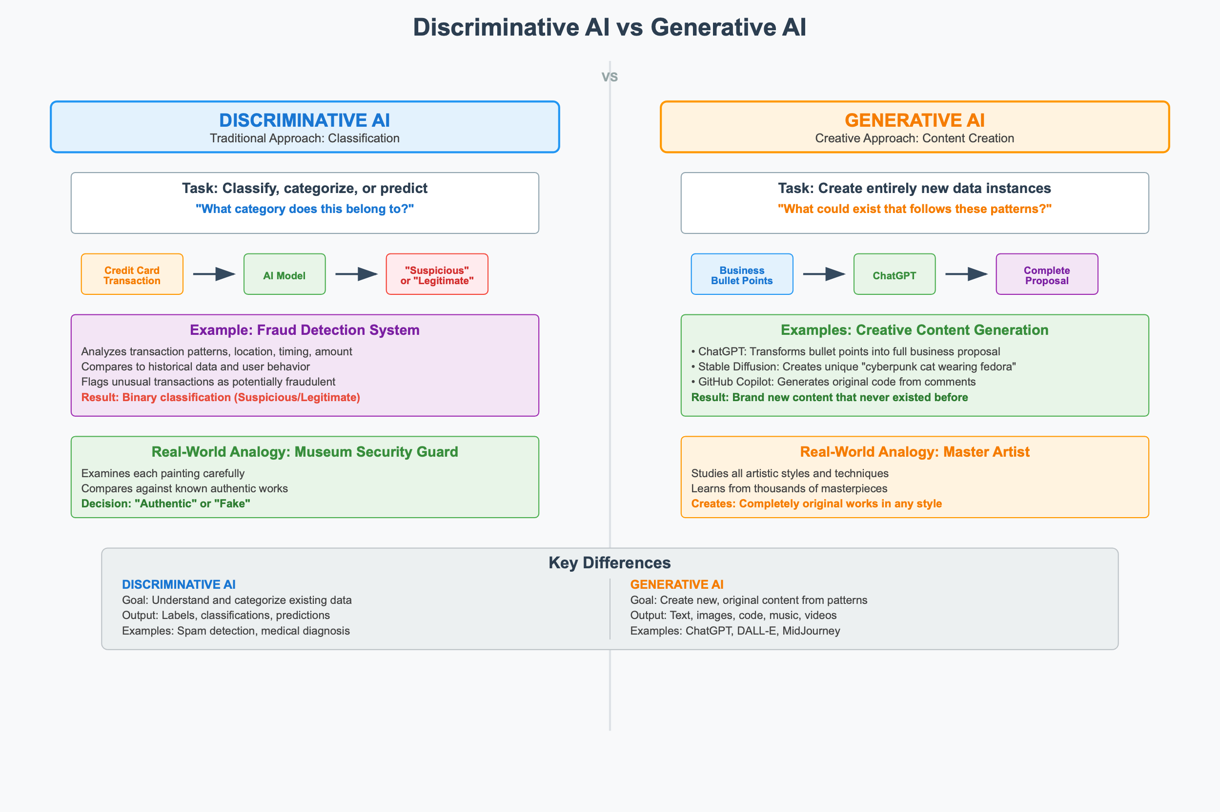
Figure: Discriminative AI vs Generative AI - Fundamental Approaches to Artificial Intelligence
To understand what makes generative AI truly revolutionary, we need to appreciate the fundamental difference between the two approaches to artificial intelligence.
Discriminative AI represents the traditional approach that most people associate with AI systems. These systems excel at classification, categorization, and prediction based on input data. When you feed information into a discriminative AI system, it essentially answers the question "What category does this belong to?" A fraud detection system perfectly exemplifies this approach; it analyzes a credit card transaction and determines whether it should be flagged as "suspicious" or "legitimate." Think of discriminative AI as a highly skilled museum security guard who has studied thousands of paintings and can expertly spot a fake, but whose expertise lies entirely in recognition and classification.
Generative AI takes a fundamentally different and far more creative approach. Instead of simply categorizing existing data, these systems create entirely new data instances that didn't exist before. The question generative AI answers is profoundly different: "What could exist that follows these patterns?" When ChatGPT crafts a personalized business proposal from your bullet points, or when Stable Diffusion generates a completely unique image of a "cyberpunk cat wearing a fedora," you're witnessing true creative synthesis. Rather than just recognizing patterns, generative AI extrapolates from them to produce novel content. The best analogy here is an artist who has studied the techniques of every master painter throughout history and can work in any style but instead of copying existing works, creates completely original pieces that have never existed before.
This distinction isn't just academic; it represents a fundamental shift in what we can expect from AI systems. While discriminative AI helps us understand and categorize our world, generative AI helps us imagine and create new possibilities within it.

Why It's Revolutionary: Beyond Pattern Matching
Here's what makes generative AI truly remarkable: it doesn't just copy or regurgitate its training data. Instead, it extrapolates and interpolates, creating something genuinely new by understanding deep patterns and relationships. Consider these examples:
Text Generation: Given the prompt "Describe a futuristic city," a model might generate:
"Neon towers stretched into smog-choked skies, their glass facades rippling with holographic advertisements. Below, rain-slick streets reflected the kaleidoscope of colors while autonomous drones hummed through the air like mechanical insects, weaving between sky-bridges that connected floating garden terraces."
Code Generation: Tools like GitHub Copilot can transform natural language into functional code:
Creative Synthesis: Most impressively, these models can combine concepts in novel ways, like asking for "a recipe for happiness written as a cooking instruction" or "explain quantum physics as if you're a pirate."

The Underlying Magic: Learning Probability Distributions
But how does this actually work? At its core, generative AI models learn to understand the probability distribution of their training data. For text, this means the model develops an intuitive understanding of:
Syntax: The grammatical rules and structures that make language coherent
- "The cat sat on the..." (high probability: "mat", "chair", "roof")
- "The cat sat on the..." (low probability: "happiness", "seven", "quantum")
Semantics: The meaning of words and phrases in context
- Understanding that "bank" means something different in "riverbank" vs. "savings bank"
- Recognizing that "hot" can refer to temperature, spiciness, or attractiveness
Pragmatics: The contextual appropriateness and style
- Writing a medical report requires formal, precise language
- A social media post might be casual, abbreviated, and emoji-filled
- A children's story needs simple words and engaging imagery
Cultural and Contextual Patterns: The subtle rules that make content feel "right"
- Understanding humor, irony, and cultural references
- Knowing when to be formal or informal based on context
- Recognizing emotional tone and responding appropriately
This probabilistic understanding allows the model to generate content that feels naturally human while being entirely original. It's like having learned the "rules" of human creativity so well that it can play by them to create something new.

From Theory to Practice
As we'll see in our hands-on project, building a research assistant will help you experience this evolution firsthand. We'll start with simple rule-based responses, then progress to retrieval-based methods, and finally implement true generative capabilities. This progression will make the power and complexity of modern generative AI much more tangible.
But first, let's explore how we got here by tracing the fascinating history that led to today's remarkable capabilities.

1.2 The Evolution of Text Generation
The journey from today's sophisticated AI assistants to the first computer programs that could "talk" is a fascinating story of incremental breakthroughs, each solving critical problems while revealing new challenges. Understanding this evolution will help you appreciate not just how far we've come, but why each advancement was necessary and how they all build upon each other.
Think of this journey as learning to have a conversation, first with flashcards, then with a dictionary, then with growing understanding, and finally with true comprehension and creativity.

1. Rule-Based Systems (1950s–1980s): The Flashcard Era
In the beginning, making computers generate human-like text was like trying to have a conversation using only pre-written flashcards. Early systems relied entirely on hardcoded rules and templates, essentially sophisticated scripts that could respond to specific inputs with predetermined outputs.
The Pioneer: ELIZA (1966)
ELIZA, created by MIT's Joseph Weizenbaum, was one of the first programs to fool people into thinking they were talking to a human. It mimicked a Rogerian psychotherapist using clever pattern matching and response templates.
Conversation example:
- User: "I feel lonely."
- ELIZA: "Why do you think you feel lonely?"
- User: "My girlfriend left me."
- ELIZA: "Tell me more about your girlfriend."
ELIZA worked by identifying keywords and applying transformation rules. If it saw "I feel [emotion]," it would respond with "Why do you think you feel [emotion]?" It was remarkably convincing for its time, but had a fundamental limitation: no true understanding whatsoever. It was essentially playing an elaborate game of Mad Libs.
Why This Mattered: ELIZA proved that even simple pattern matching could create surprisingly engaging interactions, laying the groundwork for all chatbot development that followed.
The Reality Check: If you asked ELIZA something outside its templates, like "What's the weather like?", it might respond with "Why are you concerned about the weather?" It had no concept of context, memory, or actual meaning.

2. Statistical Methods (1990s–2000s): The Dictionary Era
As computers became more powerful, researchers realized they could move beyond rigid rules by learning patterns from real text data. This was like upgrading from flashcards to having access to a massive dictionary that could tell you which words typically follow other words.
N-gram Models: Learning Word Neighborhoods
N-gram models analyzed massive amounts of text to learn probability patterns. A bigram model might learn that after "happy," the word "birthday" appears frequently, while "elephant" rarely does.
Example progression:
- Input: "I wish you a happy..."
- Model thinking: "After 'happy,' I've seen 'birthday' 1,247 times, 'ending' 89 times, 'life' 156 times..."
- Output: "birthday" (highest probability)
This worked surprisingly well for short phrases, but had a critical flaw: no long-range memory. Consider this sentence: "The cat, which had been stalking mice all morning and was quite tired from the chase, was hungry." An n-gram model couldn't connect "cat" at the beginning with the correct verb form "was" at the end.
Hidden Markov Models (HMMs): Adding Some Context
HMMs tried to solve this by maintaining hidden "states" that could represent context. They were particularly successful in speech recognition, where they could distinguish between different meanings of words based on acoustic context.
The Problem: While better than pure n-grams, these models still struggled with ambiguity and couldn't capture the rich, complex relationships that make human language so nuanced.

3. Neural Networks (2010s): The Memory Era
The introduction of neural networks to text generation was like giving our text-generating system actual short-term memory. Instead of just looking at immediate neighbors, these systems could remember and use information from earlier in the conversation.
RNNs and LSTMs: Sequential Memory
Recurrent Neural Networks (RNNs) and their more sophisticated cousins, Long Short-Term Memory networks (LSTMs), processed text word by word while maintaining an internal "memory state." This allowed them to generate much more coherent text:
Example LSTM generation:
"The concert was canceled because the singer was sick. Many fans who had traveled from distant cities were disappointed, but the venue offered full refunds and promised to reschedule the show for next month."
Notice how the LSTM maintains coherence across multiple sentences, remembering that we're talking about a concert and its consequences.
The Breakthrough: For the first time, AI could write paragraphs that felt genuinely coherent and contextually appropriate.
The Limitation: Processing text sequentially was inherently slow, each word had to wait for the previous word to be processed. Additionally, the "memory" would gradually fade over long passages, causing the model to forget important context from earlier in the text.

4. The Transformer Revolution (2017–Present): The Understanding Era
In 2017, a team at Google published a paper with the deceptively simple title "Attention Is All You Need." This paper introduced the Transformer architecture, which fundamentally changed how AI systems process language. Instead of reading text word by word like a human, Transformers could examine entire passages simultaneously and learn complex relationships between any words, regardless of distance.
The Self-Attention Breakthrough
Think of attention as the ability to highlight the most relevant parts of a text when processing any given word. When processing "The cat sat on it," the model can simultaneously consider:
- "cat" (the subject)
- "sat" (the action)
- "it" (what does this refer to?)
- The entire context to determine what "it" means
This parallel processing solved both major problems of previous approaches: speed (no more sequential bottleneck) and long-range dependencies (every word can "attend" to every other word).
Real-World Impact
The results were staggering:
GPT-3 (2020): With 175 billion parameters, this model demonstrated zero-shot learning, the ability to perform tasks it had never been explicitly trained for:
- Translation: "Translate to French: 'The weather is nice'" → "Le temps est beau"
- Code generation: "Write a Python function to calculate prime numbers" → generates working code
- Creative writing: "Write a haiku about artificial intelligence" → creates original poetry
ChatGPT and Beyond: Today's models can engage in extended conversations, maintain context across thousands of words, write in specific styles, and even help debug their own generated code.
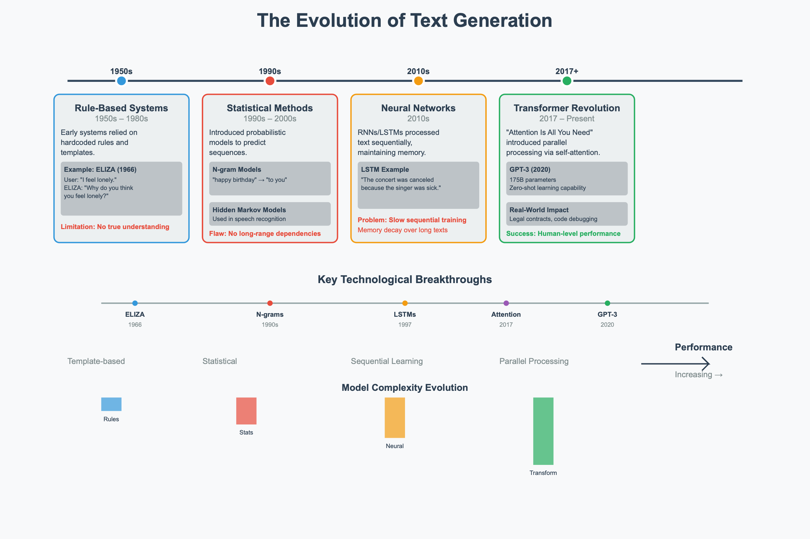

Connecting to Your Journey
As you build your research assistant throughout this chapter, you'll experience this evolution firsthand:
- Phase 1: Rule-based responses (like ELIZA)
- Phase 2: Retrieval-based answers (like statistical methods)
- Phase 3: Generative responses (using modern transformers)
This hands-on progression will make the theoretical concepts we've just covered much more concrete and help you understand why each advancement was necessary.

Looking Forward
We've come from systems that could barely maintain a coherent conversation to AI that can write novels, solve complex problems, and even engage in philosophical discussions. But this is just the beginning. As we'll explore in the next section, understanding the different types of generative models will help you choose the right approach for different tasks and understand the exciting developments still to come.
The most remarkable part? We're still in the early days of this revolution.

1.3 Understanding Tokens and Embeddings
Before we dive into how modern AI generates text, we need to understand how it "sees" and "thinks about" language. Just as you might break down a complex recipe into individual steps, AI systems need to break down text into manageable pieces they can work with.

Tokenization: Breaking Language into Building Blocks
Imagine trying to teach someone a language by showing them individual LEGO blocks versus showing them complete LEGO structures. Tokenization is the process of deciding what size "blocks" to use when feeding text to an AI model.
Word-Level Tokenization: The Whole LEGO Sets Approach
The most intuitive approach treats each word as a single token:
- "The quick brown fox" → ["The", "quick", "brown", "fox"]
This seems natural to humans, but creates problems for AI:
- Vocabulary explosion: English has hundreds of thousands of words, and new ones appear constantly ("selfie," "blockchain," "unfriend")
- Unknown words: What happens when the model encounters "supercalifragilisticexpialidocious"?
- Memory inefficiency: Storing every possible word requires enormous vocabulary lists
Subword-Level Tokenization (BPE): The Smart LEGO Approach
Byte-Pair Encoding (BPE) finds the sweet spot by learning meaningful chunks smaller than words but larger than characters. It's like having LEGO blocks of different sizes, some individual pieces, some pre-assembled sections.
Example breakdown:
- "Unhappiness" → ["un", "happiness"]
- "Unfriendly" → ["un", "friendly"]
- "Preprocessing" → ["pre", "process", "ing"]
Why this is brilliant:
- The model learns that "un-" typically means negation
- It can handle new words by combining familiar pieces
- "Unfathomable" → ["un", "fathom", "able"] (even if it's never seen this exact word)
Character-Level Tokenization: The Individual LEGO Brick Approach
Breaking text down to individual characters:
- "Hello" → ["H", "e", "l", "l", "o"]
While this eliminates vocabulary issues entirely, it's like trying to understand a book by looking at one letter at a time, technically possible, but requiring enormous context to make sense of meaning.

Embeddings: Teaching AI the Geography of Meaning
Here's where things get fascinating. Once text is tokenized, each token needs to be converted into numbers that a computer can actually work with. But not just any numbers, these numbers need to capture the meaning and relationships between words.
The Vector Space of Language
Imagine a vast multidimensional space (typically 768 or 1,024 dimensions, though we can only visualize 2 or 3) where every word has a specific location. Words with similar meanings live in the same neighborhood, while different concepts are far apart.
The Famous Example:
Vector("king") - Vector("man") + Vector("woman") ≈ Vector("queen")
This isn't just a mathematical curiosity, it reveals that the model has learned conceptual relationships:
- Gender relationships: king/queen, man/woman, actor/actress
- Comparative relationships: good/better/best, big/bigger/biggest
- Categorical relationships: dog/puppy/canine cluster together
Real-World Implications
When you ask ChatGPT about "canines," it automatically connects this to dogs, wolves, puppies, and veterinarians, not because it was explicitly programmed with these connections, but because these concepts live close together in its learned embedding space.
In your research assistant project, you'll see how embeddings allow the system to find relevant information even when your question uses different words than the source material.

1.4 The Transformer Architecture
Now that we understand how text becomes numbers, let's explore the revolutionary architecture that processes these numbers to generate intelligent responses.

The Attention Revolution: Focus on What Matters
Imagine reading a complex sentence while highlighting the most important words for understanding its meaning. The self-attention mechanism does exactly this, for every word, it determines which other words in the sentence are most relevant for understanding it.
Self-Attention in Action
Consider the sentence: "The animal didn't cross the street because it was tired."
When processing the word "it," the attention mechanism:
- Looks at all other words in the sentence
- Calculates relevance scores: How important is each word for understanding "it"?
  - "animal": High relevance (0.8)
  - "street": Low relevance (0.1)
  - "tired": Medium relevance (0.4)
  - "didn't": Low relevance (0.1)
- Creates a weighted understanding of "it" based on these scores
This is why modern AI can correctly understand that "it" refers to "the animal," not "the street", something that tripped up earlier AI systems regularly.
Multiple Attention Heads: Different Perspectives
Transformers don't just use one attention mechanism, they use many (typically 8-16) attention "heads" simultaneously, each focusing on different types of relationships:
- Head 1: Might focus on subject-verb relationships
- Head 2: Might track pronoun references
- Head 3: Might identify cause-and-effect connections
- Head 4: Might recognize sentiment patterns

Core Architecture Components
1. Encoder-Decoder Structure (in some models)
Think of this like a translator who first completely understands a sentence in one language (encoder) before producing the translation (decoder):
- Encoder: "Je suis heureux" → [deep understanding representation]
- Decoder: [deep understanding] → "I am happy"
Note: GPT models are decoder-only, while BERT is encoder-only. Different architectures excel at different tasks.
2. Positional Encoding: Keeping Track of Order
Since Transformers process all words simultaneously (unlike humans who read left-to-right), they need a way to understand word order. Positional encoding adds a unique "position signature" to each word:
- "Dog bites man" vs. "Man bites dog" have the same words but very different meanings
- Positional encoding ensures the model knows which word came first
3. Layer Stacking: Deep Understanding
Modern Transformers stack many layers (GPT-3 has 96 layers), with each layer building more sophisticated understanding:
- Layer 1: Basic grammar and syntax
- Layer 20: Complex relationships and context
- Layer 50: Abstract reasoning and world knowledge
- Layer 96: Sophisticated inference and generation

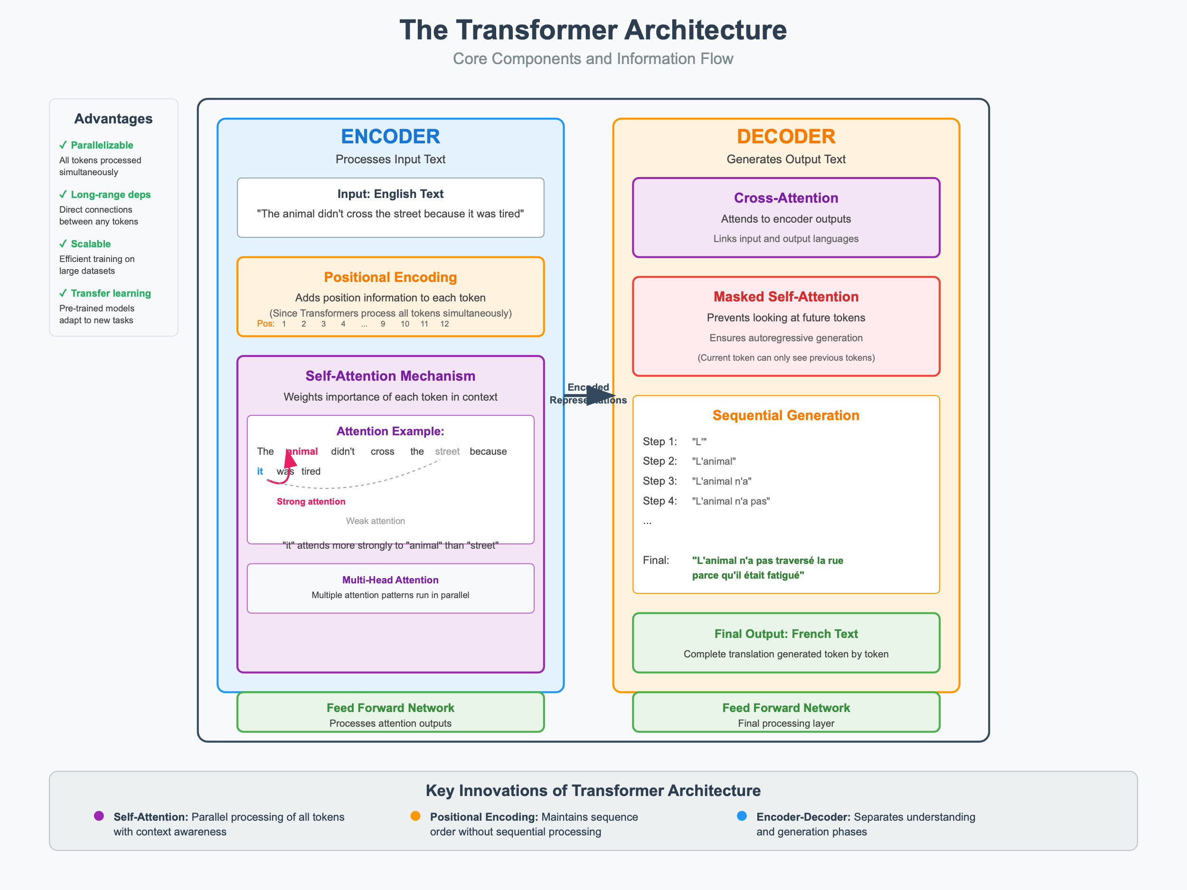
Figure: Transformer Architecture - Core Components and Information Flow

1.5 How Large Language Models Work
Now let's put it all together and understand how these components combine to create the AI assistants we interact with today.

Training Phase: Learning from the Internet
The Objective: Becoming a Prediction Master
LLMs are trained on a deceptively simple task: predict the next word. Given "The sky is ___," the model learns that "blue," "gray," or "cloudy" are more likely than "purple" or "triangular."
But this simple objective, applied to trillions of words, leads to emergent understanding of:
- Grammar: Learning language rules through pattern recognition
- Facts: "The capital of France is ___" → "Paris"
- Reasoning: "If it's raining, then the ground will be ___" → "wet"
- Style: Formal vs. casual language patterns
- Context: Understanding how meaning changes in different situations
The Scale is Staggering
Modern LLMs are trained on:
- Trillions of tokens (roughly 750 billion words)
- Diverse sources: Wikipedia, books, academic papers, code repositories, news articles
- Multiple languages: Though English-dominant, they learn multilingual patterns
Emergent Abilities: The Magic
Something remarkable happens at scale, abilities that weren't explicitly taught begin to emerge:
- Few-shot learning: "Here are 3 examples of Spanish translations. Now translate this new sentence."
- Chain-of-thought reasoning: "Let me work through this step by step..."
- Code generation: Understanding programming logic from natural language descriptions
- Creative synthesis: Combining concepts in novel ways

Inference Phase: From Probability to Prose
When you interact with ChatGPT, here's what happens behind the scenes:
Autoregressive Generation: One Word at a Time
- Your input: "Write a haiku about winter"
- Model processing:
  - Tokenizes your input
  - Processes through all transformer layers
  - Generates probability distribution over next possible tokens
- Token-by-token generation:
  - Most likely first word: "Frost" (probability: 0.23)
  - Given "Frost," next word: "paints" (probability: 0.18)
  - Given "Frost paints," next word: "the" (probability: 0.31)
  - Continue until complete...
Final output:
Frost paints the silent pane,
Wind whispers through barren trees,
Snow blankets the lane.

Sampling Strategies: Balancing Creativity and Coherence
The model doesn't always pick the most probable word, that would make responses boring and repetitive. Instead, it uses sophisticated sampling:
Temperature Control:
- Low temperature (0.1): Conservative, predictable output
  - "The weather today is sunny and warm."
- High temperature (0.9): Creative, potentially unexpected output
  - "The weather today dances with golden whispers of warmth."
Top-k and Top-p Sampling:
- Instead of considering all possible words, focus on the most likely candidates
- Prevents the model from occasionally choosing completely random words

Real-World Limitations: The Honesty Check
Despite their impressive capabilities, LLMs have important limitations:
Hallucinations: Confident Incorrectness
Models can generate information that sounds authoritative but is completely false:
- Inventing fake research papers with realistic titles and authors
- Creating plausible but incorrect historical "facts"
- Generating code that looks correct but contains subtle bugs
Why this happens:
- The model is optimized to generate plausible-sounding text, not necessarily true text
- It has learned to sound confident even when uncertain
- Training data includes misinformation alongside accurate information
Knowledge Cutoffs:
Models are trained on data up to a specific date and don't learn new information after training. They might not know about recent events or discoveries.

Connecting to Practice
In your research assistant project, you'll experience these concepts firsthand:
- Tokenization when preprocessing user queries
- Embeddings when matching questions to relevant documents
- Attention mechanisms when the model focuses on key parts of your input
- Generation strategies when crafting responses
- Hallucination mitigation when implementing fact-checking features
Understanding these fundamentals will help you build more effective AI applications and debug issues when they arise.
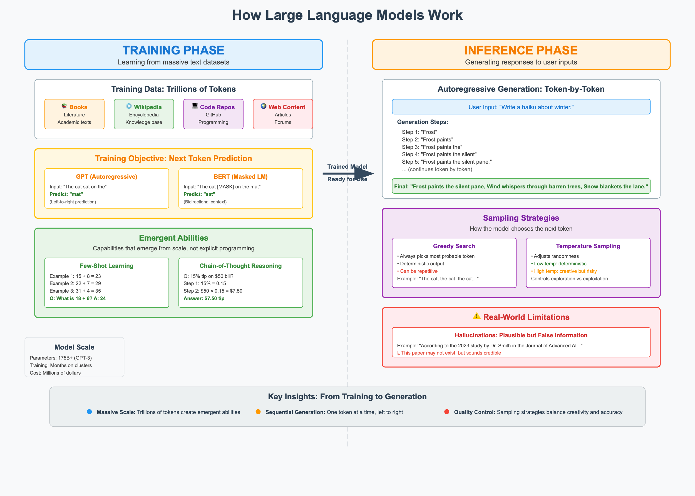

Core Project: Building an AI-Powered Research Assistant

Project Overview
Welcome to the beginning of an exciting journey! Over the course of this book, we'll progressively build a sophisticated AI-powered research assistant. This chapter focuses on laying the foundation, creating a simple but extensible system that we'll enhance with new capabilities in each subsequent chapter.
What We're Building in Chapter 1: By the end of this chapter, you'll have a basic research assistant that can:
- Accept user research queries through a clean web interface
- Generate responses using Markov chains (demonstrating statistical text generation from the 1990s)
- Compare those responses with modern LLM outputs (showing the power of current AI)
- Provide a solid foundation for the advanced features we'll add in later chapters
This isn't our final destination; it's the launchpad for a system that will eventually include RAG capabilities, multimodal processing, fine-tuned models, and production deployment features.
What You'll Learn in This Foundation:
- How to structure a modular, extensible AI application
- The practical differences between statistical and neural text generation
- How to integrate modern LLM APIs safely and effectively
- Best practices for building user-friendly AI interfaces
- How to create a codebase that can grow throughout this book

Project Structure
Let's start with a clean, simple structure that we'll expand throughout the book:
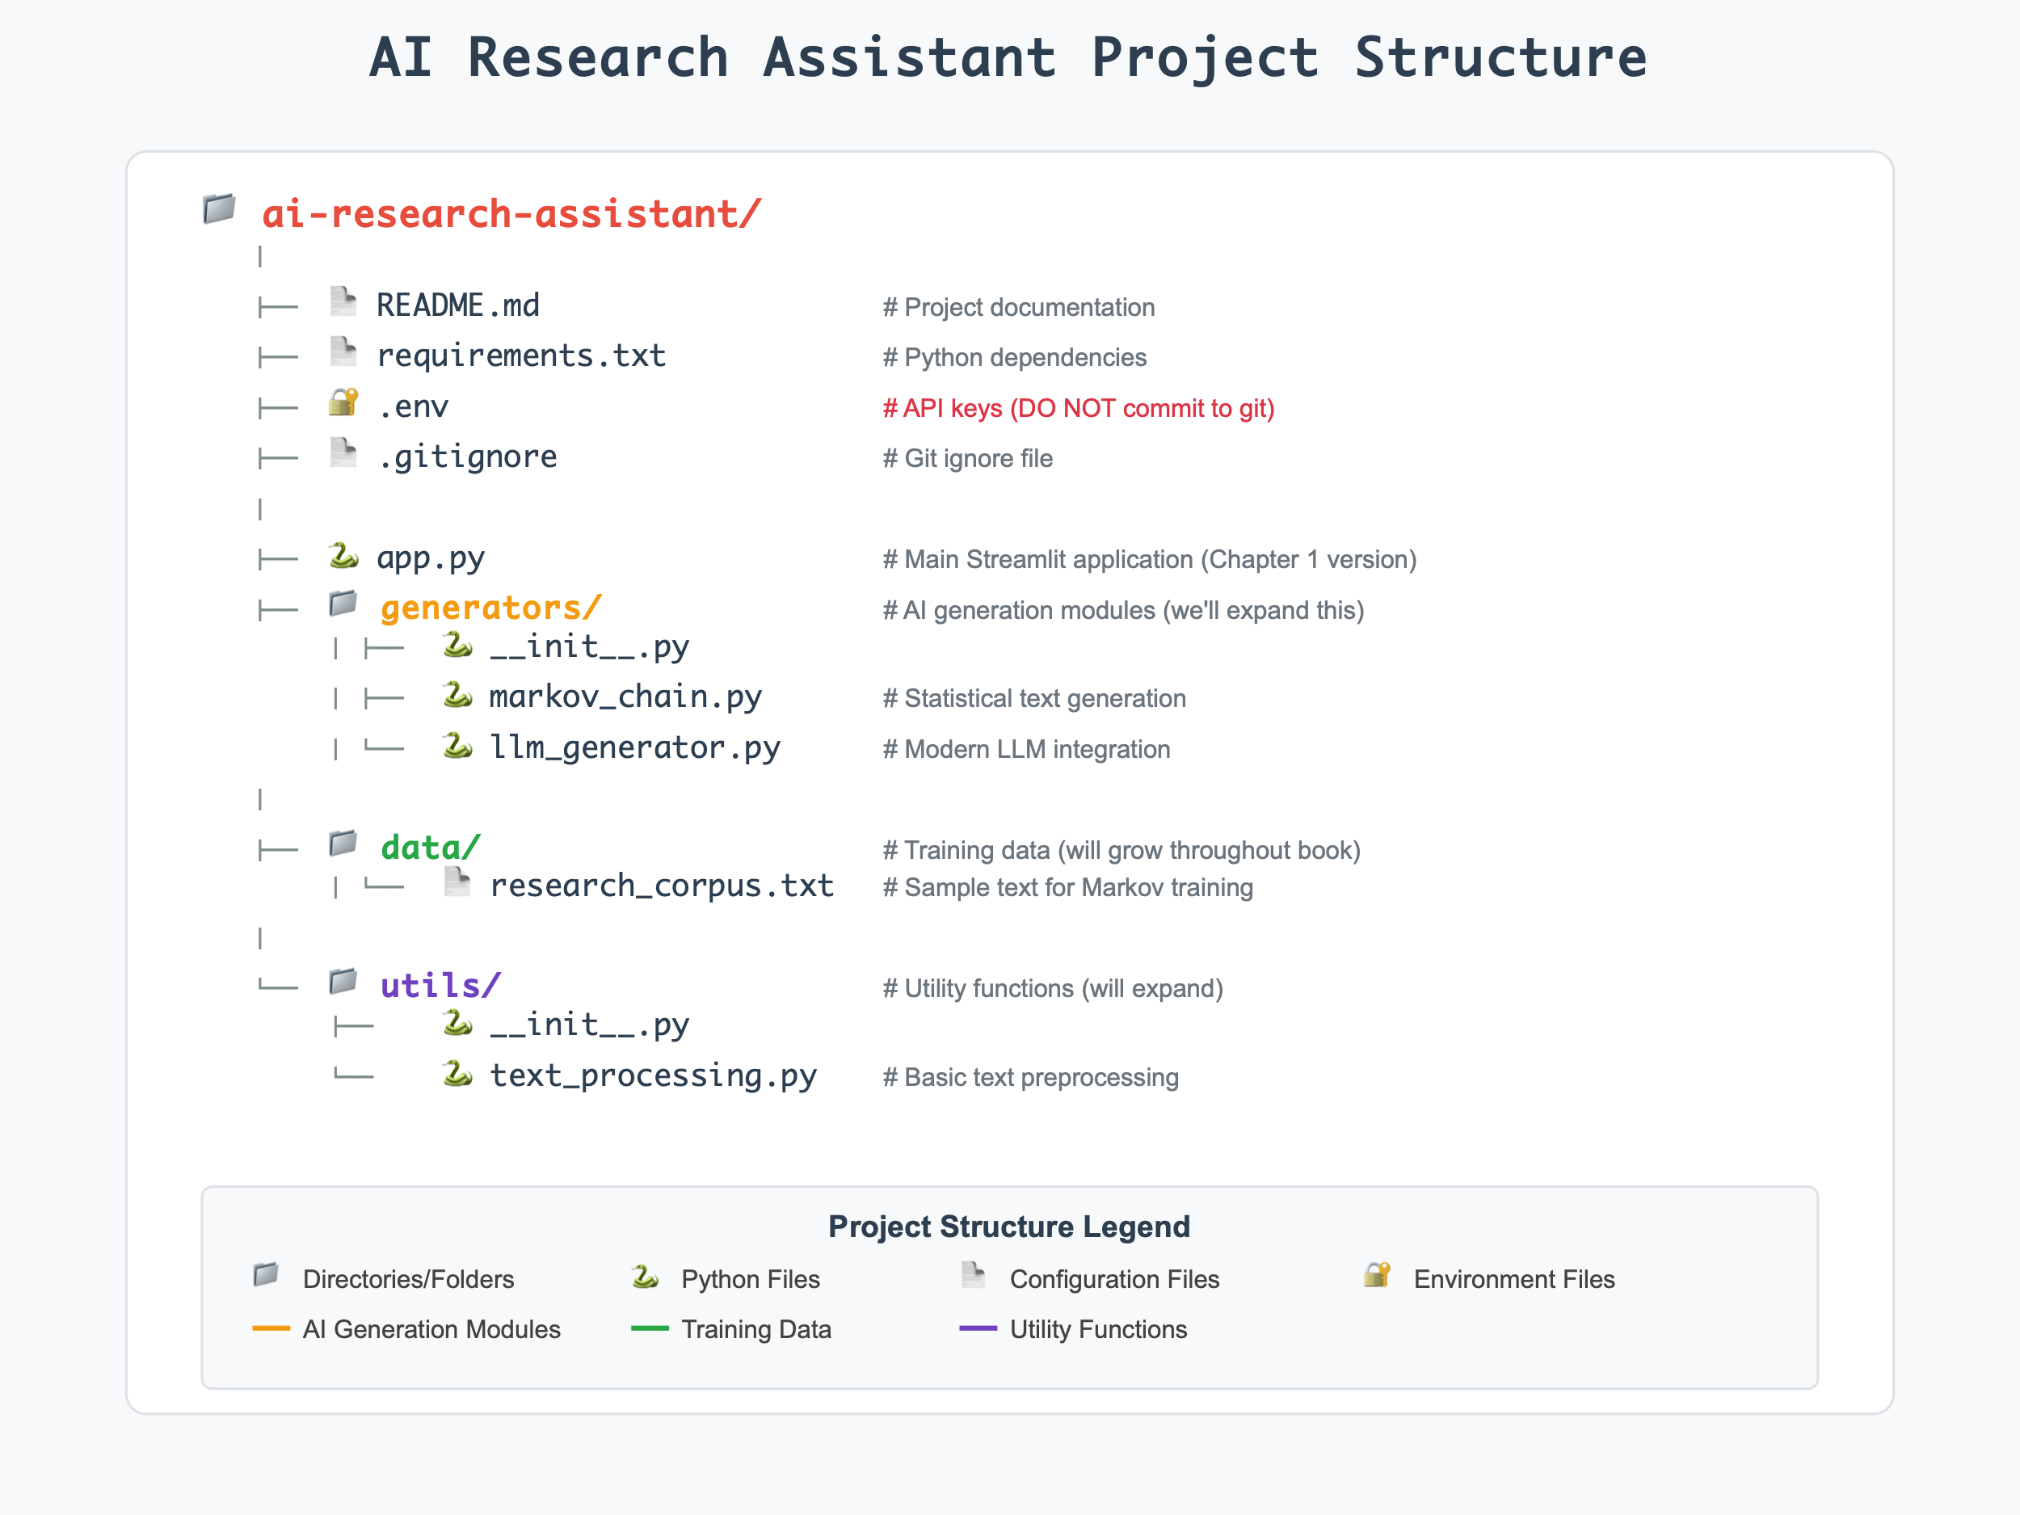
Note: This is our starting structure. As we progress through the book, we'll add:
- Chapter 2: Model comparison and selection tools
- Chapter 3: Advanced prompt engineering modules
- Chapter 4: Multi-provider API integration
- Chapter 5: Vector database and RAG components
- Chapter 6: Fine-tuning and model customization tools
- ...and much more!

Step 1: Setting Up Your Development Environment

Prerequisites Checklist
- ✅ Python 3.8 or higher - Modern AI libraries require recent Python versions
- ✅ Text editor or IDE (VS Code, PyCharm, or similar) - Professional development tools
- ✅ OpenAI API key - Access to state-of-the-art language models
💡 Why These Requirements Matter: Python 3.8+ includes essential features like the walrus operator and improved type hints that modern AI libraries depend on.

1.1 Project Structure Foundation
1 # Create and enter the project directory
2 mkdir ai-research-assistant
3 cd ai-research-assistant
4
5 # Create the subdirectories
6 mkdir generators data utils
Architectural Decision: This modular structure separates concerns:
- generators/ - Different AI generation approaches
- data/ - Training corpus and datasets
- utils/ - Reusable text processing functions

1.2 Python Virtual Environment Setup
7 # Create virtual environment
8 python -m venv venv
9
10 # Activate it
11 # On Windows:
12 venv\Scripts\activate
13 # On macOS/Linux:
14 source venv/bin/activate
15
16 # You should see (venv) in your terminal prompt
🔑 Critical Concept: Virtual environments prevent dependency hell - the nightmare scenario where different projects require conflicting package versions. This is especially important in AI development where libraries evolve rapidly.

1.3 Dependencies Management
Create requirements.txt:
1 openai==1.3.0 # ① Latest OpenAI API client
2 streamlit==1.28.0 # ② Web interface framework
3 python-dotenv==1.0.0 # ③ Environment variable management
4 numpy==1.24.0 # ④ Numerical computing foundation
5 pandas==2.1.0 # ⑤ Data manipulation and analysis
6 requests==2.31.0 # ⑥ HTTP requests for API calls
Package Selection Rationale:
- ① OpenAI Client: Direct access to GPT models with proper error handling
- ② Streamlit: Rapid prototyping of ML interfaces with minimal code
- ③ Python-dotenv: Secure API key management following industry best practices
- ④⑤ NumPy + Pandas: Essential data science stack for text processing
- ⑥ Requests: Robust HTTP handling for API integration
Install dependencies:
17 pip install -r requirements.txt

1.4 API Key Management (Security-First Approach)

Obtaining Your OpenAI API Key
- Navigate to platform.openai.com
- Create account or sign in to existing account
- Go to API Keys section in dashboard
- Generate new secret key
- ⚠️ Critical: Copy immediately - you won’t see it again!

Secure Storage
Create .env file in project root:
1 # .env - Never commit this file to version control!
2 OPENAI_API_KEY=your_actual_api_key_here
🔐 Security Note: API keys are credentials that can incur charges. Never hardcode them in source code or commit them to repositories.

1.5 Version Control Setup
18 # Initialize git repository
19 git init
20
21 # Create .gitignore
22 echo "venv/
23 .env
24 __pycache__/
25 *.pyc
26 .streamlit/" > .gitignore
Best Practice: Always set up version control before writing code. The .gitignore prevents committing sensitive files and build artifacts.

Step 2: Building the Foundation Files

2.1 Text Processing Utilities

Package Initialization
utils/__init__.py:
1 # This file makes the utils directory a Python package
2 # Enables: from utils.text_processing import clean_text

Core Text Processing Functions
utils/text_processing.py:
3 import re
4 import string
5 from typing import List, Dict
6
7 def clean_text(text: str) -> str:
8 """Clean and normalize text for processing"""
9 # ① Remove extra whitespace and normalize spacing
10 text = ' '.join(text.split())
11 # ② Remove special characters but preserve sentence structure
12 text = re.sub(r'[^\w\s\.\!\?]', '', text)
13 return text.strip()
14
15 def tokenize_simple(text: str) -> List[str]:
16 """Simple word tokenization"""
17 # ③ Convert to lowercase for consistency
18 # ④ Extract word boundaries using regex
19 words = re.findall(r'\b\w+\b', text.lower())
20 return words
21
22 def extract_keywords(text: str) -> List[str]:
23 """Extract potential keywords from text"""
24 # ⑤ Define stop words - common words with low semantic value
25 stop_words = {
26 'the', 'a', 'an', 'and', 'or', 'but', 'in', 'on', 'at', 'to', 'for',
27 'of', 'with', 'by', 'is', 'are', 'was', 'were', 'be', 'been', 'have',
28 'has', 'had', 'do', 'does', 'did', 'will', 'would', 'could', 'should'
29 }
30
31 words = tokenize_simple(text)
32 # ⑥ Filter out stop words and very short words
33 keywords = [word for word in words if word not in stop_words and len(word) > 2]
34 return keywords
35
36 def calculate_similarity(text1: str, text2: str) -> float:
37 """Calculate simple similarity between two texts"""
38 # ⑦ Convert to sets for mathematical operations
39 words1 = set(tokenize_simple(text1))
40 words2 = set(tokenize_simple(text2))
41
42 # ⑧ Handle edge case: empty inputs
43 if not words1 or not words2:
44 return 0.0
45
46 # ⑨ Jaccard similarity: intersection over union
47 intersection = len(words1.intersection(words2))
48 union = len(words1.union(words2))
49
50 return intersection / union if union > 0 else 0.0
Deep Dive Explanation:
- ①② Text normalization prevents inconsistencies that confuse AI models
- ③④ Case folding and word boundary detection create consistent tokens
- ⑤⑥ Stop word removal focuses attention on content-bearing words
- ⑦⑧⑩ Set-based operations enable efficient similarity computation
- ⑨ Jaccard Index provides a robust similarity metric for text comparison

2.2 Training Data Corpus
data/research_corpus.txt:
1 Research involves systematic investigation to establish facts and reach new conclusions.
2 Scientific research requires careful methodology and rigorous analysis of data.
3 Data collection is a crucial component of any serious research project.
4 Analysis of research results leads to meaningful and actionable conclusions.
5 Research questions should guide the entire investigation process from start to finish.
6 Literature review helps researchers understand the current state of knowledge.
7 Hypothesis formation is an important step in the scientific method.
8 Peer review ensures the quality and validity of research findings.
9 Statistical analysis helps researchers identify patterns and relationships in data.
10 Research ethics are fundamental to conducting responsible scientific inquiry.
11 Reproducibility is essential for validating research results and building scientific knowledge.
12 Interdisciplinary research often leads to breakthrough discoveries and innovations.
Corpus Design Principles:
- Domain-focused: All sentences relate to research methodology
- Vocabulary consistency: Repeated key terms (research, data, analysis)
- Varied sentence structure: Provides diverse patterns for generation
- Educational content: Actual factual information about research

Step 3: Building the AI Generators

3.1 Markov Chain Generator (1990s Statistical Approach)

Package Initialization
generators/__init__.py:
1 # This file makes the generators directory a Python package

Statistical Text Generation
generators/markov_chain.py:
2 import random
3 import re
4 from collections import defaultdict, Counter
5 from typing import Dict, List
6 from utils.text_processing import tokenize_simple, clean_text
7
8 class MarkovChainGenerator:
9 """
10 Statistical text generator using Markov chains.
11 Demonstrates probabilistic text generation from the 1990s-2000s era.
12 This is our first step beyond simple rules into learning from data.
13 """
14
15 def __init__(self, order: int = 2):
16 """
17 Initialize Markov chain generator
18
19 Args:
20 order: The n-gram order (how many previous words to consider)
21 """
22 self.order = order # ① N-gram order for context
23 self.transitions = defaultdict(list) # ② Transition probability table
24 self.word_counts = Counter() # ③ Word frequency tracking
25 self.trained = False # ④ Training state flag
26
27 # Train on our sample corpus
28 self.train_on_corpus()
29
30 def train_on_corpus(self):
31 """Train the Markov chain on our research corpus"""
32 try:
33 with open('data/research_corpus.txt', 'r') as f:
34 corpus = f.read()
35 self.train_on_text(corpus)
36 except FileNotFoundError:
37 # ⑤ Graceful fallback for missing data file
38 fallback_text = """
39 Research involves systematic investigation to establish facts.
40 Scientific research requires careful methodology and analysis.
41 Data collection is crucial for research projects.
42 Analysis leads to meaningful conclusions in research.
43 """
44 self.train_on_text(fallback_text)
45
46 def train_on_text(self, text: str):
47 """Train the Markov chain on given text"""
48 # Clean and tokenize the text
49 cleaned_text = clean_text(text)
50 sentences = re.split(r'[.!?]+', cleaned_text)
51
52 for sentence in sentences:
53 if not sentence.strip():
54 continue
55
56 # ⑥ Add sentence boundary markers
57 words = ['<START>'] + tokenize_simple(sentence) + ['<END>']
58
59 # Count individual words for statistics
60 for word in words:
61 self.word_counts[word] += 1
62
63 # ⑦ Build transition table with n-gram context
64 for i in range(len(words) - self.order):
65 # Create n-gram key
66 key = tuple(words[i:i + self.order])
67 next_word = words[i + self.order]
68 self.transitions[key].append(next_word)
69
70 self.trained = True
71
72 def generate_response(self, query: str, max_length: int = 40) -> str:
73 """Generate a response using Markov chain"""
74 if not self.trained:
75 return "I need to be trained on data first!"
76
77 # ⑧ Try to start with words from the query for relevance
78 query_words = tokenize_simple(query)
79
80 # Find a good starting point
81 start_key = self.find_starting_key(query_words)
82 if not start_key:
83 # Fallback to random start
84 start_key = random.choice(list(self.transitions.keys()))
85
86 # ⑨ Generate text following transition probabilities
87 current_key = start_key
88 result_words = list(current_key)
89
90 for _ in range(max_length):
91 if current_key not in self.transitions:
92 break
93
94 next_word = random.choice(self.transitions[current_key])
95
96 if next_word == '<END>':
97 break
98
99 result_words.append(next_word)
100
101 # ⑩ Update key for next iteration (sliding window)
102 current_key = tuple(result_words[-self.order:])
103
104 # Clean up and format the result
105 response_words = [w for w in result_words if w not in ['<START>', '<END>']]
106
107 if not response_words:
108 return "I'm having trouble generating a response. Could you try rephrasing your question?"
109
110 response = ' '.join(response_words)
111 return response.capitalize() + '.'
112
113 def find_starting_key(self, query_words: List[str]) -> tuple:
114 """Find a good starting n-gram that relates to the query"""
115 # ⑪ Look for direct word matches in transition keys
116 for word in query_words:
117 for key in self.transitions.keys():
118 if word in key:
119 return key
120
121 # If no direct match, try partial matches
122 for word in query_words:
123 for key in self.transitions.keys():
124 for key_word in key:
125 if word in key_word or key_word in word:
126 return key
127
128 return None
129
130 def get_generation_info(self) -> str:
131 """Return information about this generation method"""
132 return f"""
133 **Markov Chain Generation (1990s-2000s Approach)**
134
135 This generator uses statistical patterns learned from text data.
136
137 **How it works:**
138 - Analyzes word sequences in training data
139 - Builds probability tables for word transitions
140 - Generates text by following likely word sequences
141 - Order: {self.order} (considers {self.order} previous words)
142
143 **Improvements over rule-based:**
144 - Can generate novel combinations
145 - Learns from actual text data
146 - More varied responses
147
148 **Limitations:**
149 - No long-range coherence
150 - Can produce nonsensical combinations
151 - No understanding of meaning or context
152 """
Algorithm Deep Dive:
- ① N-gram Order: Higher order = more context but less flexibility
- ② Transition Table: Maps word sequences to possible next words
- ③ Word Counting: Enables frequency-based improvements
- ④ Training State: Prevents generation before learning
- ⑤ Robust Error Handling: Graceful degradation for missing files
- ⑥ Boundary Markers: Help model understand sentence structure
- ⑦ N-gram Construction: Sliding window creates overlapping contexts
- ⑧ Query Relevance: Attempts to start generation near query topics
- ⑨ Probabilistic Generation: Random selection from learned transitions
- ⑩ Context Sliding: Maintains n-gram context throughout generation
- ⑪ Smart Starting: Multiple strategies for finding relevant start points

3.2 Modern LLM Generator (2020s Approach)
generators/llm_generator.py:
153 import os
154 from openai import OpenAI
155 from typing import Optional
156
157 class LLMGenerator:
158 """
159 Modern Large Language Model generator using OpenAI's API.
160 Demonstrates current state-of-the-art text generation.
161 """
162
163 def __init__(self):
164 """Initialize the LLM generator with OpenAI client"""
165 # ① Secure API key retrieval
166 api_key = os.getenv('OPENAI_API_KEY')
167 if not api_key:
168 raise ValueError("OpenAI API key not found. Please set OPENAI_API_KEY in your .env file")
169
170 # ② Initialize OpenAI client with proper authentication
171 self.client = OpenAI(api_key=api_key)
172 self.model = "gpt-3.5-turbo"
173
174 # ③ System prompt engineering for consistent behavior
175 self.system_prompt = """
176 You are a helpful research assistant designed to help students and researchers.
177
178 Your role:
179 - Answer research-related questions clearly and accurately
180 - Provide guidance on research methodology
181 - Help with understanding complex concepts
182 - Suggest relevant research directions
183
184 Your style:
185 - Be concise but comprehensive
186 - Use examples when helpful
187 - Acknowledge when information might be uncertain
188 - Encourage critical thinking
189
190 Keep responses focused and under 150 words unless more detail is specifically requested.
191 """
192
193 def generate_response(self, query: str, temperature: float = 0.7) -> str:
194 """
195 Generate a response using OpenAI's GPT model
196
197 Args:
198 query: The user's research question
199 temperature: Controls randomness (0.0 = deterministic, 1.0 = very creative)
200 """
201 try:
202 # ④ API call with carefully tuned parameters
203 response = self.client.chat.completions.create(
204 model=self.model,
205 messages=[
206 {"role": "system", "content": self.system_prompt},
207 {"role": "user", "content": query}
208 ],
209 max_tokens=200, # ⑤ Response length control
210 temperature=temperature, # ⑥ Creativity vs consistency balance
211 top_p=0.9, # ⑦ Nucleus sampling for quality
212 frequency_penalty=0.1, # ⑧ Reduce repetition
213 presence_penalty=0.1 # ⑨ Encourage topic diversity
214 )
215
216 return response.choices[0].message.content.strip()
217
218 except Exception as e:
219 # ⑩ Graceful error handling for API issues
220 return f"I apologize, but I encountered an error: {str(e)}. Please try again or check your API configuration."
221
222 def generate_with_reasoning(self, query: str) -> str:
223 """Generate a response with step-by-step reasoning"""
224 # ⑪ Prompt engineering for structured thinking
225 reasoning_prompt = f"""
226 Please answer this research question with clear step-by-step reasoning:
227
228 {query}
229
230 Structure your response as:
231 1. Understanding the question
232 2. Key considerations
233 3. Answer with explanation
234 """
235
236 return self.generate_response(reasoning_prompt, temperature=0.3)
237
238 def get_generation_info(self) -> str:
239 """Return information about this generation method"""
240 return f"""
241 **Large Language Model Generation (2020s Approach)**
242
243 This generator uses OpenAI's GPT-3.5, a 175B parameter transformer model.
244
245 **How it works:**
246 - Trained on vast amounts of internet text
247 - Uses transformer architecture with self-attention
248 - Generates contextually appropriate responses
249 - Can perform reasoning, creativity, and task-following
250
251 **Advantages:**
252 - Coherent, contextually appropriate responses
253 - Can handle complex, nuanced questions
254 - Demonstrates emergent abilities like reasoning
255 - Adapts to different styles and formats
256
257 **Current limitations:**
258 - May generate plausible but incorrect information
259 - Knowledge cutoff date limitations
260 - Computational requirements for training/inference
261 - Can be influenced by biases in training data
262 """
Modern AI Engineering Concepts:
- ① Secure Credential Management: Environment variables prevent key exposure
- ② Client Initialization: Proper SDK usage with authentication
- ③ System Prompt Engineering: Defines AI behavior and personality
- ④ API Parameter Tuning: Optimized settings for quality responses
- ⑤ Token Management: Cost and response length control
- ⑥ Temperature Control: Balances creativity with reliability
- ⑦ Nucleus Sampling: Advanced probability filtering for quality
- ⑧⑨ Penalty Parameters: Reduce repetition and encourage diversity
- ⑩ Production Error Handling: User-friendly error messages
- ⑪ Advanced Prompting: Structured reasoning through prompt design

Step 4: Building the Main Application
app.py - Complete Streamlit Interface:
263 import streamlit as st
264 import os
265 from dotenv import load_dotenv
266 import time
267
268 # Load our custom generators
269 from generators.markov_chain import MarkovChainGenerator
270 from generators.llm_generator import LLMGenerator
271
272 # Load environment variables
273 load_dotenv()
274
275 class ResearchAssistant:
276 """
277 Chapter 1 version of our research assistant.
278 This is the foundation we'll build upon throughout the book.
279 """
280
281 def __init__(self):
282 """Initialize our basic generators"""
283 self.generators = {}
284
285 # ① Statistical generator (1990s approach)
286 self.generators['markov'] = MarkovChainGenerator()
287
288 # ② Modern LLM generator (2020s approach)
289 try:
290 self.generators['llm'] = LLMGenerator()
291 self.llm_available = True
292 except ValueError as e:
293 self.llm_available = False
294 self.llm_error = str(e)
295
296 def process_query(self, query: str, method: str = "llm") -> tuple:
297 """
298 Process a research query using the specified method
299
300 Returns:
301 tuple: (response, generation_time, method_info)
302 """
303 if method not in self.generators:
304 return "Invalid generation method selected.", 0, ""
305
306 # ③ Performance measurement for comparison
307 start_time = time.time()
308
309 try:
310 response = self.generators[method].generate_response(query)
311 generation_time = time.time() - start_time
312 method_info = self.generators[method].get_generation_info()
313
314 return response, generation_time, method_info
315
316 except Exception as e:
317 generation_time = time.time() - start_time
318 return f"Error generating response: {str(e)}", generation_time, ""
319
320 def main():
321 """Main Streamlit application - Chapter 1 Foundation"""
322
323 # ④ Page configuration for professional appearance
324 st.set_page_config(
325 page_title="AI Research Assistant - Chapter 1",
326 page_icon="🔬",
327 layout="wide",
328 initial_sidebar_state="expanded"
329 )
330
331 # ⑤ Educational introduction and context
332 st.title("🔬 AI Research Assistant - Foundation")
333 st.markdown("""
334 **Chapter 1: Compare Statistical vs. Modern AI**
335
336 This is the beginning of our journey! In this foundation chapter, we're comparing:
337 - **Markov Chain generation** (1990s statistical approach)
338 - **Large Language Model responses** (modern transformer approach)
339
340 *Throughout this book, we'll add sophisticated features like multi-model support,
341 RAG capabilities, fine-tuning, and production deployment.*
342 """)
343
344 # ⑥ Session state management for persistent data
345 if 'assistant' not in st.session_state:
346 st.session_state.assistant = ResearchAssistant()
347
348 # ⑦ Sidebar for method selection and information
349 with st.sidebar:
350 st.header("⚙️ Generation Methods")
351
352 # Available methods for Chapter 1
353 available_methods = ["markov"]
354 if st.session_state.assistant.llm_available:
355 available_methods.append("llm")
356
357 method_names = {
358 "markov": "Markov Chain (1990s)",
359 "llm": "Large Language Model (2020s)"
360 }
361
362 # ⑧ Multi-select for comparing different approaches
363 selected_methods = st.multiselect(
364 "Select methods to compare:",
365 available_methods,
366 default=available_methods,
367 format_func=lambda x: method_names[x]
368 )
369
370 if not st.session_state.assistant.llm_available:
371 st.warning("⚠️ LLM generator unavailable. Please check your OpenAI API key in the .env file.")
372
373 st.markdown("---")
374
375 # ⑨ Sample questions for testing and education
376 st.header("📝 Try These Questions")
377 sample_questions = [
378 "What is scientific research?",
379 "How do I conduct a literature review?",
380 "What is data analysis?",
381 "Explain research methodology",
382 "What makes good research?"
383 ]
384
385 for question in sample_questions:
386 if st.button(question, key=f"sample_{question}"):
387 st.session_state.current_query = question
388
389 st.markdown("---")
390
391 # ⑩ Educational roadmap for future chapters
392 st.header("🚀 Coming Next")
393 st.markdown("""
394 **Chapter 2**: Model selection & comparison
395 **Chapter 3**: Advanced prompt engineering
396 **Chapter 4**: Multi-provider API integration
397 **Chapter 5**: RAG with vector databases
398 **Chapter 6**: Fine-tuning capabilities
399 **...and much more!**
400 """)
401
402 # ⑪ Main content area with responsive layout
403 col1, col2 = st.columns([2, 1])
404
405 with col1:
406 # User input with helpful placeholder
407 query = st.text_area(
408 "🎯 Enter your research question:",
409 value=st.session_state.get('current_query', ''),
410 height=100,
411 placeholder="e.g., What is the scientific method?"
412 )
413
414 # ⑫ Generation trigger with validation
415 if st.button("🚀 Generate Responses", type="primary") and query:
416 if not selected_methods:
417 st.error("Please select at least one generation method.")
418 else:
419 # Generate responses for each selected method
420 responses = {}
421
422 for method in selected_methods:
423 with st.spinner(f"Generating {method_names[method]} response..."):
424 response, gen_time, method_info = st.session_state.assistant.process_query(query, method)
425 responses[method] = {
426 'response': response,
427 'time': gen_time,
428 'info': method_info
429 }
430
431 # ⑬ Results comparison with adaptive layout
432 st.markdown("## 📊 Results Comparison")
433
434 # Create side-by-side comparison for two methods
435 if len(selected_methods) == 2:
436 col_left, col_right = st.columns(2)
437 cols = [col_left, col_right]
438 else:
439 cols = [st.container()]
440
441 # ⑭ Display results with metrics and explanations
442 for i, method in enumerate(selected_methods):
443 container = cols[i] if len(selected_methods) == 2 else cols[0]
444
445 with container:
446 st.subheader(f"{method_names[method]}")
447
448 # Response
449 st.markdown("**Response:**")
450 st.write(responses[method]['response'])
451
452 # Performance metrics
453 st.markdown(f"**Generation time:** {responses[method]['time']:.2f} seconds")
454
455 # Educational information (expandable)
456 with st.expander("ℹ️ How this method works"):
457 st.markdown(responses[method]['info'])
458
459 if len(selected_methods) == 2:
460 st.markdown("---")
461
462 # ⑮ Educational sidebar with learning objectives
463 with col2:
464 st.header("📚 Chapter 1 Goals")
465 st.markdown("""
466 **What you're learning:**
467 - Setting up AI development environment
468 - Statistical vs. neural text generation
469 - Basic API integration
470 - Foundation for future enhancements
471
472 **What you're building:**
473 - Modular AI application structure
474 - Markov chain text generator
475 - LLM API integration
476 - Comparison interface
477 """)
478
479 st.header("🎯 Key Observations")
480 st.markdown("""
481 **Markov Chains:**
482 - Learn statistical patterns from text
483 - Can produce novel word combinations
484 - Often lack long-range coherence
485 - Represent 1990s AI approach
486
487 **Large Language Models:**
488 - Contextually appropriate responses
489 - Handle complex, nuanced questions
490 - Demonstrate reasoning abilities
491 - Represent current AI capabilities
492 """)
493
494 # ⑯ Reset functionality for testing
495 if st.button("🔄 Reset Application"):
496 st.session_state.clear()
497 st.experimental_rerun()
498
499 if __name__ == "__main__":
500 main()
Application Architecture Highlights:
- ① Modular Generator System: Easy to add new AI approaches
- ② Graceful Degradation: Works even if API keys are missing
- ③ Performance Monitoring: Enables speed comparisons
- ④ Professional UI Configuration: Production-ready interface
- ⑤ Educational Context: Clear learning objectives throughout
- ⑥ Session State Management: Preserves user interactions
- ⑦⑧ Interactive Method Selection: Compare different approaches
- ⑨ Guided Learning: Sample questions help users explore
- ⑩ Pedagogical Roadmap: Sets expectations for future learning
- ⑪ Responsive Layout: Adapts to different screen sizes
- ⑫⑬ Smart Validation: Prevents errors before they occur
- ⑭ Rich Results Display: Shows responses, metrics, and explanations
- ⑮ Continuous Learning: Side-by-side educational content
- ⑯ Development Tools: Easy reset for testing and development

Step 5: Running your Research Assistant
Final Project Structure Check
Your project should now look like this:
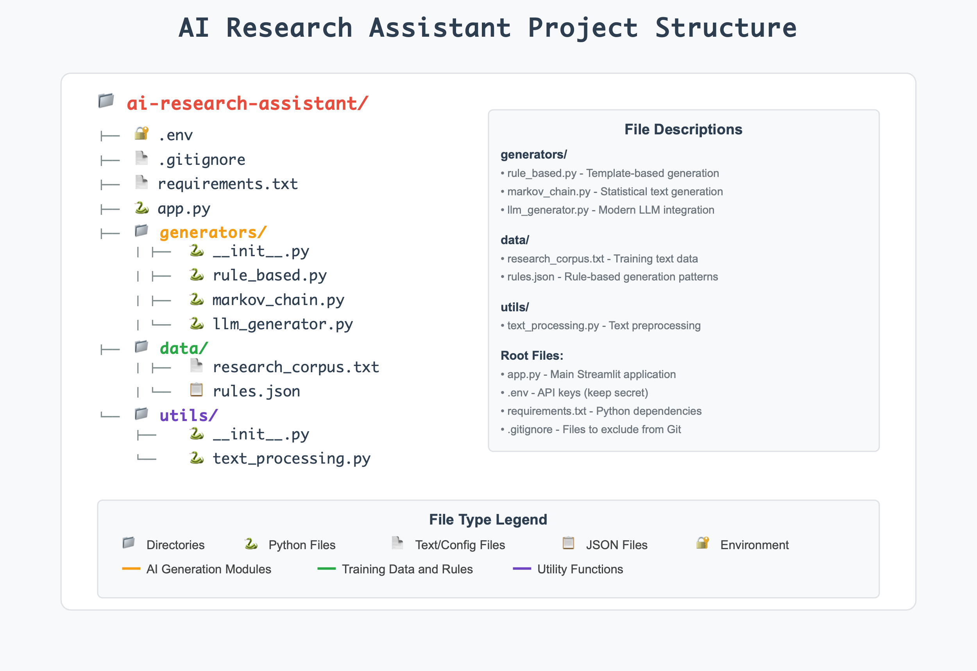

Usage Instructions

Running the Application
# Activate your virtual environment
source venv/bin/activate # macOS/Linux
# or
venv\Scripts\activate # Windows
# Start the Streamlit application
streamlit run app.py

Expected Output
Terminal:
You can now view your Streamlit app in your browser.
Local URL: http://localhost:8501
Network URL: http://192.168.1.100:8501
Browser Interface:
- Left Panel: Input area and generation controls
- Right Panel: Educational content and learning objectives
- Sidebar: Method selection and sample questions
- Results: Side-by-side comparison of generation approaches

Key Learning Outcomes
Technical Skills Developed:
- Environment Management: Virtual environments and dependency handling
- API Integration: Secure credential management and error handling
- Statistical AI: Understanding Markov chain text generation
- Modern AI: Large language model integration and prompt engineering
- Web Application Development: Streamlit interface creation
- Comparative Analysis: Understanding trade-offs between AI approaches
Conceptual Understanding:
- Evolution of AI: From statistical to neural approaches
- Text Processing Pipeline: Normalization, tokenization, filtering
- Generation Strategies: Statistical patterns vs. learned representations
- Performance Trade-offs: Speed vs. quality vs. cost considerations
- Production Considerations: Error handling, security, user experience
This foundation provides the building blocks for advanced topics like retrieval-augmented generation (RAG), fine-tuning, and production deployment covered in subsequent chapters.

Conclusion
In this foundational chapter, you've journeyed from understanding the basic concepts of generative AI to building your first AI-powered application. You've seen firsthand how different approaches to text generation work and their relative strengths and limitations, not just in theory, but through direct, hands-on experience with working code.

What You've Discovered

Conceptual Breakthroughs
Key Takeaways:
Generative AI creates new content rather than just analyzing existing data. Through your research assistant, you've experienced the difference between a system that can classify or analyze text versus one that can actually create novel, contextually appropriate responses. This distinction isn't just academic, it represents a fundamental shift in what we can expect from AI systems.
The evolution from rule-based systems to transformers represents increasingly sophisticated pattern recognition. You've witnessed this evolution firsthand by comparing your Markov chain generator with modern LLMs. The jump from simple statistical patterns to deep contextual understanding illustrates why the transformer revolution was so significant.
Tokens and embeddings are fundamental to how modern AI systems understand language. While these concepts might have seemed abstract initially, building your text processing utilities has shown you how AI systems actually "see" language, not as words humans understand, but as mathematical representations that capture meaning, relationships, and context.
Simple approaches like Markov chains can generate text but lack coherence and understanding. Your experiments have probably shown you responses that are grammatically interesting but semantically confused. This limitation isn't a flaw, it's a feature that demonstrates how statistical patterns alone aren't sufficient for true language understanding.
Large Language Models demonstrate emergent capabilities through scale and sophisticated training. When you compared your Markov responses with GPT responses, you likely noticed that the LLM doesn't just generate better text, it seems to actually understand your questions, provide relevant information, and maintain coherence across complex topics. This emergence of apparent understanding from pattern recognition is one of the most remarkable aspects of modern AI.

Practical Insights
Beyond the conceptual understanding, you've gained invaluable practical experience:
You've built a working AI application from scratch. This isn't a trivial accomplishment. You've created a modular, extensible system that integrates multiple AI approaches, handles errors gracefully, and provides a user-friendly interface. These are the building blocks of production AI systems.
You understand the engineering behind AI applications. You've seen how text preprocessing, API integration, error handling, and user interface design all work together. You've experienced the difference between a working demo and a robust application.
You've directly compared AI generations. Most people interact with modern AI without understanding what came before. You've experienced the progression from statistical methods to neural networks, giving you unique insight into why current AI capabilities seemed so sudden and surprising to the broader public.

Connecting Theory to Practice
One of the most powerful aspects of this chapter has been seeing abstract concepts become concrete through your hands-on work:
When we discussed tokenization, you implemented actual text processing functions that break down language into manageable pieces. When we explored embeddings, you saw how similar concepts cluster together in your LLM responses. When we explained attention mechanisms, you experienced the difference between local statistical patterns (Markov chains) and global contextual understanding (transformers).
This connection between theory and practice is crucial. You're not just learning about AI, you're developing the intuition and practical skills to build, debug, and improve AI systems yourself.

The Foundation You've Built
The research assistant you've created serves as more than just a learning exercise, it's the architectural foundation for all future enhancements. You've established:
A modular codebase that can gracefully accommodate new AI capabilities without requiring complete rewrites. The generator pattern you've implemented will easily extend to support multiple models, fine-tuned variants, and specialized AI approaches.
Proper separation of concerns between text processing, generation logic, API integration, and user interface. This clean architecture will prove invaluable as we add complexity in subsequent chapters.
Error handling and user experience patterns that will scale to production-ready applications. You've learned to handle API failures, provide informative feedback, and create intuitive interfaces.
A testing ground for AI concepts where you can experiment with new ideas, compare different approaches, and understand the practical implications of theoretical concepts.

Looking Forward: The Journey Ahead
In subsequent chapters, we'll add increasingly sophisticated capabilities, transforming this simple prototype into a powerful, production-ready research tool. But more importantly, each enhancement will deepen your understanding of how modern AI systems work and how to build them effectively.
You're ready for what's coming because you've built the foundation with your own hands. You understand how text becomes tokens, how APIs integrate with applications, how different AI approaches complement each other, and how to create user experiences that make complex AI accessible.
Chapter 2 will introduce you to the nuances of different language models, their strengths, weaknesses, costs, and optimal use cases. You'll add model selection intelligence to your research assistant, learning to choose the right AI approach for different types of questions.
Chapters 3-5 will transform your assistant into a sophisticated AI application with advanced prompt engineering, multi-provider integration, and retrieval-augmented generation. You'll see how the foundation you've built today seamlessly accommodates these advanced capabilities.
Chapters 6-10 will take you into production-ready territory with fine-tuning, optimization, multimodal capabilities, safety considerations, and deployment strategies. By the end, you'll have built something genuinely impressive, and more importantly, you'll understand every component of how it works.

Your Achievement
Don't underestimate what you've accomplished in this chapter. You've:
- Mastered foundational AI concepts through direct implementation
- Built a working AI application with proper software engineering practices
- Gained intuitive understanding of how different AI approaches work and why they evolved
- Created an extensible foundation ready for sophisticated enhancements
- Developed practical skills in AI development, API integration, and application design
You're no longer just a user of AI systems, you're becoming a builder of them. This shift in perspective will serve you well as AI continues to transform industries and create new opportunities.

The Bigger Picture
As you continue through this book, remember that you're learning more than just how to use AI tools, you're developing the skills to shape how AI gets integrated into research, business, and society. The understanding you're building of how these systems work, their capabilities and limitations, and the engineering practices needed to deploy them responsibly will be increasingly valuable.
The research assistant you've started building today could genuinely become a useful tool for real research work. But more importantly, the skills and understanding you're developing will enable you to build AI applications that solve real problems and create genuine value.
Welcome to the future of AI development, and congratulations on taking your first significant step as an AI application builder!
Ready to dive deeper? In Chapter 2, we'll explore the fascinating world of different language models and add intelligent model selection to your research assistant. The foundation you've built is about to become much more sophisticated.

End-of-Chapter Interactive Content

Assignment: Chapter 1 Core Project Submission
Objective: Submit your working AI research assistant with comparative text generation capabilities.
Requirements:
- Code Submission: Submit your complete project folder including:
  - app.py (main application)
  - generators.py (generation classes)
  - requirements.txt (dependencies list)
  - Screenshots of your running application
- Experimentation Report: Create a brief report (500-750 words) addressing:
  - Compare responses from Markov chain vs LLM for at least 3 different queries
  - Analyze the strengths and weaknesses of each approach
  - Describe any challenges you encountered during setup
  - Suggest one improvement you'd like to add to the current system
- Reflection Questions (Answer in 2-3 sentences each):
  - How does understanding tokenization change your perspective on how AI processes language?
  - What surprised you most about the difference between Markov chain and LLM outputs?
  - Based on this chapter, what aspect of generative AI are you most excited to explore further?
Submission Format:
- Zip file containing: code folder, report (PDF), reflection answers (PDF or text file)
- File naming: Chapter1_[YourLastName]_[YourFirstName].zip
Grading Criteria:
- Functionality (40%): Code runs without errors, both generators work
- Analysis (30%): Thoughtful comparison and experimentation report
- Code Quality (20%): Clean, well-commented code following provided structure
- Reflection (10%): Demonstrates understanding of key concepts
Due Date: [To be specified by instructor]

Discussion Forum: Chapter 1 - Foundations & First Insights
Welcome to our learning community!
Congratulations on completing Chapter 1 and building your first AI-powered research assistant! You've just taken a significant step from being an AI user to becoming an AI builder. This discussion board is where we'll share insights, learn from each other's experiences, and build a community of AI practitioners.

Your Introduction & Reflection
Please introduce yourself to your fellow learners by sharing:
Personal Introduction
- Your name and background (academic, professional, or personal interest)
- What drew you to learn about generative AI and LLMs
- Any prior experience with AI, programming, or related fields (don't worry if this is your first time, we welcome all levels!)
Your Biggest "Aha!" Moment
After working through Chapter 1's concepts and building your research assistant, share one surprising insight you gained about generative AI. This could be something that:
- Changed how you think about AI systems
- Surprised you about how AI actually works "under the hood"
- Made you realize something new about the evolution from statistical to neural approaches
- Emerged from comparing your Markov chain outputs with LLM responses
- Challenged a preconception you had about AI technology
Examples might include: "I was surprised that..." "I never realized that..." "It was fascinating to discover..." "The biggest difference I noticed was..."
Your Burning Question
As we embark on this 10-chapter journey together, what's one specific question you're hoping we'll answer as we progress? This could be:
- Something technical you want to understand better
- A practical application you're curious about
- An ethical or societal concern about AI
- A specific capability you want to learn to build
- A challenge you've encountered that you hope we'll address
Examples: "How do I know which AI model to use for different tasks?" "Can I really build something as sophisticated as ChatGPT?" "How do I ensure my AI applications are unbiased and safe?" "What does it take to deploy AI in a real business environment?"

Discussion Guidelines
Engage Meaningfully:
- Read and respond to at least 2-3 of your classmates' posts
- Ask follow-up questions about their insights or experiences
- Share related experiences or observations
- Offer encouragement and support, we're all learning together!
Be Curious and Respectful:
- There are no "dumb" questions here, if you're wondering about something, others probably are too
- Different backgrounds bring different perspectives, embrace this diversity
- Share both successes and struggles from building your research assistant
Connect and Build:
- Look for classmates with similar interests or complementary skills
- Consider forming study groups or collaboration partnerships
- Share resources, articles, or tools you discover along the way

Getting the Most from This Discussion
This isn't just an assignment, it's the beginning of your network of AI practitioners and learners. The connections you make here could lead to:
- Study partnerships for challenging concepts
- Collaboration opportunities on projects
- Professional networking in the AI field
- Ongoing learning communities beyond this course
Many of the most valuable insights will come not just from the course material, but from seeing how different people approach the same concepts and challenges.

Ready to share? Jump in with your introduction, insight, and question. We're excited to get to know you and learn alongside you as we build increasingly sophisticated AI applications together!
Looking forward to your perspectives and to supporting each other through this exciting journey into the world of generative AI!
P.S. If you encountered any technical challenges while building your research assistant, feel free to mention them here too, chances are others faced similar issues, and troubleshooting together is a great way to learn!

