Guidelines

Writing the Master’s Project/Thesis

The student who plans to graduate in the Spring semester, should begin thinking about the Master’s Project topic as early as possible, but no later than in early Fall of the preceding year.

The guidelines below provide basic information on writing a Master’s Project paper. The Chair of the student’s Master’s Committee may have different expectations than the ones spelled out below. The student is responsible for finding out the expectations of his/her Chair at the outset.

Students who wish to write a Master’s Thesis should obtain the specific format guidelines for writing a thesis from the University’s Thesis office. That said, the content and structure of a Master’s Thesis is substantially the same as a Project, so the information below is relevant for writing Master’s Theses as well.

I. Forming the Master’s Committee

The Master’s Committee consists of the Chair and two additional faculty members. The student is responsible for approaching faculty members to form the Master’s Committee, starting with contacting the Chair of the Committee.

It is strongly advisable that the Chair be a faculty member whose course directly pertains to the Master’s project topic and whose course the student has successfully completed. In addition, it would be helpful if the student has taken a 6000-level course with one or both of the committee members and/or they are instructors of fields that closely relate to the Project topic. This committee composition would best support the successful completion of the Project, since the student will then have strong foundation in the relevant field(s) and will be prepared to do research on the specific topic. If the Project topic does not fall in the subjects studied in one of the courses taken by the student, then the student will have to first become proficient in the general field that pertains to the specific topic and then review the narrow literature on the specific question. As a result, this latter approach is more time consuming and difficult to undertake. By the same token, a faculty member may be reluctant to chair such a Master’s Project.

II. Basic Features of a Master’s Project

The Master’s Project is a research paper that is more substantial than a term paper for a 6000-level course. Depending on the topic and methodology, it can range from 25 pages to 75 pages, exclusive of any tables or figures and the list of references. Projects that entail extension of a mathematical model will tend to be shorter than those that rely on applied econometrics or descriptive statistical analysis, or the Projects that rely on interpretive methodologies (for example, history of thought in any field).

The Master’s Project goes beyond a literature review on the narrow topic in a field. It will have to build upon and extend the relevant literature in the field. The relevant literature is likely to be covered in one or more of the 6000-level courses in the Master’s program. The project should discuss this literature as background to the more detailed literature that pertains specifically to the project (See Appendix, D. The Relevant Literature).

The Master’s Project entails a contribution to the literature in the field. Thus the student has to identify a gap in the literature, through the discussion of the literature, which the Project then fills through the use of the appropriate research methodology. In empirical research papers typical contributions entail an evaluation of either new or more recent data sources and/or application of a new methodology. For example, the contribution of an empirical paper could be to update an existing regression (or descriptive statistical) analysis using data for recent years. The contribution of a theoretical paper, on the other hand, may be a new interpretation of the literature taking into consideration the latest writings on the subject (See Appendix, E. Situating Your Research in the Literature).

The Master’s Project should have the standard sections of a research paper, each of which addresses basic questions:

1. Introduction
What is the project about?
Why is this an important research question?
How will you analyze this issue?
2. Literature Review
What do we already know about this issue? (What have others said and provided evidence for?)
3. Methodology
How will you examine this issue?
4. Discussion of Results
What are the main findings of the project?
In what ways do these modify/add to the existing literature?
5. Conclusions
What are the theoretical or policy implications of these findings?
What are the fruitful research directions on this topic
6. References
Which sources did you consult?
7. Appendix (for example, Description of Datasets; robustness checks of econometric
analysis)

Having sections is necessary and invaluable for the student as well as for any reader of the paper. It helps the student to keep track of the flow and substance in the paper and helps the committee/other readers get a sense of the nature of the project without having to strain themselves, fishing for clues and solving a mystery embedded somewhere in the 25-30 page text. The section titles do not have to be cut and dried as above, but it is important to choose section headings that are clear enough to indicate to the reader what’s in the section. For example, in a Project examining the effects of microcredit in developing countries, the literature review section could be titled “The Debates on Microcredit.” Since there are different sets of debates on microcredit, then it may be a good idea to have subsections that summarize and evaluate the separate debates: “Impacts on Poverty Alleviation” and “Impacts on Empowerment of Women.” (See the Appendix below for more details on the Introduction and Literature Review sections of the paper.)

III. The Writing Process

The student should be in regular communication with his/her Chair, keeping the Chair up-to-date on his/her progress in the form of e-mail contact and/or print-outs of list of potential sources, statistical output (if relevant), and drafts of the paper. This interaction and the approval of each step facilitate student success. The student should absolutely avoid bringing his/her master’s project draft paper to the Chair in the last month of the expected graduation semester, without having consulted the Chair on the Project in the preceding months. Turning in a draft paper does not guarantee either approval of the project or graduation in that semester.

A Suggested Timeline for Spring Graduation:

September- October Topic selection and consultation with potential Chair and Committee members

November 1 Deadline to submit the Program of Study and Request for Supervisory Committee to the Graduate School (Master’s Committee is formed)

November-December Student narrows down topic through research; student provides Chair/Committee a short proposal and list of references that are potentially useful for the Project

January-February First draft of Project

March Chair/committee members give feedback

April Defense

IV. Suggested Sources on Writing Research Papers

There are many books that offer useful guidance to students in writing their Master’s Projects/Theses.

One popular book, now in its 2009 edition, is Susan Hubbuch, Writing Research Papers Across the Curriculum, Cengage Learning.

For pointers on good writing practice for economists, students may wish to consult Deirdre McCloskey. 1999. Economical Writing, Waveland Press.

Appendix: Detailed Guidelines on Writing Your Paper

I. Writing the Introduction

The Introduction section should include the following:

An overview of the research problem.
- Why this problem is worth exploring (spelling out the main positions in the literature to situate the problem, and, if relevant, your personal interest in it).
- What contribution your research is likely to make to the literature (the gap you will fill).

In about two pages you should be moving from laying out the broad context for the study to the narrowly-focused definition of the problem/research question.

The wording of the narrowly-focused research question should be explicit and be clear to even the most inattentive reader. For example, “I will be examining the extent to which microcredit has enabled the twin goals of poverty alleviation and women’s empowerment in Kenya.” Notice the choice of “extent to which” over “whether” to allow for a more wide-ranging discussion of the outcomes of microcredit.

It is O.K. to cite one or more studies that are either directly relevant or that inspired this research project or provide the justification for the study, but the Introduction is not where one evaluates these studies.

Invariably, one cannot write the final version of the Introduction section before completing the Literature Review and Methodology sections. Bear in mind that this section (along with the Conclusion section) will probably be the last section of the research paper to be completed.

II. The Literature Review

A. Your Main Objective: The purpose of your literature review is to justify your research project by evaluating the state of knowledge on the topic (that is, what we already know, what is contested, what we don’t know). It provides the context for your study. It is the responsibility of the researcher to identify the relevant literature (that is, the most influential theories/writing on the topic, the methods used, the findings/conclusions), be familiar with these, and locate their own study in relation to the literature.

B. Identifying your argument and the evidence you need: A literature review is the necessary step to identify your argument/specific hypothesis and to develop your guide for gathering the evidence to examine this argument/hypothesis. At the outset—in the Fall semester of your second year—you are likely to have a “working hypothesis” based on reading a small number of articles and/or your personal experiences. Through reading and evaluating the relevant literature, the working hypothesis has to develop into a refined argument/hypothesis, by your becoming more informed about what others have argued or shown and your reactions to what they have said. You will also become informed about the types of methodology others have used and be able to identify your own methodology (e.g. what kind of variables you might need statistics on, what kind of empirical methodology is necessary and feasible--given your strengths and the time frame and the data availability; or what kinds of text you will be interpreting). Note: “evidence” covers a broad range of sources—from statistics to texts—depending on your methodology.

C. Identifying the Basic Trends and Patterns in the Literature:

In your literature review your strategy is to identify the main trends and patterns in the articles/books you read.

Pay attention to the following:
- What theories seem to be referred to/used most often?
- What are the common assumptions most researchers are making?
- What are the common methods used?
- What are the points of agreement/disagreement among the authors?
- How has each scholar contributed with their work—are they the first to apply a particular method, first to survey a particular group, first to make a particular argument, and by doing so, how have they advanced the debate on the subject (shifted the question of interest etc.)?
- Do any other researchers share your views (your “working thesis”)?
- How has the literature on the topic evolved in recent years?

One strategy for identifying the trends and patterns in the literature (suggested by Hubbuch, 1992, 133) is to make a table as follows:

Author | Theory | Main Argument/  Hypothesis | Key concepts/ assumptions | Method | Results | Major point to make in my discussion (evaluation + connection)
A
B

Fill the boxes corresponding to each row (article/book), and then based on this table compose the literature review through a critical, thematic evaluation. Obviously, you need to fill brief and most pertinent notes in each box to keep the table manageable and make this strategy useful for you. The column headings can be as specific and detailed as you deem necessary. The table helps you summarize the literature, but is not included in the Literature Review section of the paper.

A critical, thematic evaluation:

A literature review is not a list in paragraph form, composed on the basis of the above table, where you “stack” the summary of each article/book you have read. Example: “A argued and found…” “B showed…” “C concluded…” Instead, relevant studies need to be critiqued and evaluated, with a view to building an argument. Thus, based on the above table (or your own approach) you need to identify themes in the literature. For example, a number of authors may be arguing the same point (when you glance at your table columnwise). Then, you would write summary sentences explaining this theme in the literature and attach citations to specific authors as illustrations of this pattern.

An example of a thematic evaluation is: “Many proponents of microcredit have argued that microcredit not only reduces household poverty but also increases the autonomy of women credit recipients (A, B, C). This claim has been the subject of intense debate, with many authors devising measures of empowerment to assess this argument. Some of these empirical studies have found support for the empowerment argument (C, D), while others have shown the empowerment effect to be contingent on other factors, such as asset ownership by women credit recipients (E). Yet others have pointed to the design of these programs as a major obstacle to increasing women’s autonomy (F, G). The premise of the arguments by A, B and C is that…which assumes…”

Notice that the thematic evaluation not only reflects your own thinking but also shifts the focus of the literature review from the work of others to the argument you are developing. You do not take at face value (report) what has been said by others but you evaluate it in light of the writings you’ve read in this topic, pointing out any flaw or weakness.

In your evaluation of the literature you should evaluate content for its application to your research (which you identify in the last column of the table above). Your literature review does not necessarily include everything you have read on the topic. For each potential reference ask yourself: “Why am I including this reference?” The answer has to indicate how it helps build your argument. You want to include it because, for example, it makes a similar argument or it is an argument you are disagreeing with or it illustrates a weakness that you propose to overcome with research.

D. The Relevant Literature:

Levels of Relevance: The literature that is relevant to your research project is likely to be of three types that will demand differing amounts of attention and space in your review. Example:

- Background: You need to acknowledge these writings but not summarize them at length or in detail. These studies pertain to one aspect or “variable” in the research question. For the microcredit in Kenya paper, for example, studies that describe the shift in development policy toward neoliberal macroeconomic policies would be background literature. You may discuss key studies emphasizing that promotion of microcredit with its emphasis on self-employment, entrepreneurship, individual solutions, is consistent with market reforms and privatization.
- Somewhat relevant: you need to provide a greater attention to this literature but not evaluate these studies in critical detail. For example, the literature on poverty reduction policies in developing countries.
- The most relevant: You need to provide careful examination of these; these could be a set of studies that directly pertains to the research project. For example, studies on microcredit, quickly moving from a few well known South Asian studies to focus in depth on Sub-Saharan Africa. (see the type of thematic evaluation illustrated above).

Thus, your thematic literature review would move from general statements on the background literature to the detailed evaluation of the most relevant literature progressively providing more detailed, critical evaluation of the existing studies. In the figure from Hubbuch, the top triangle, narrowing to a tip, symbolizes this aspect of your literature review.

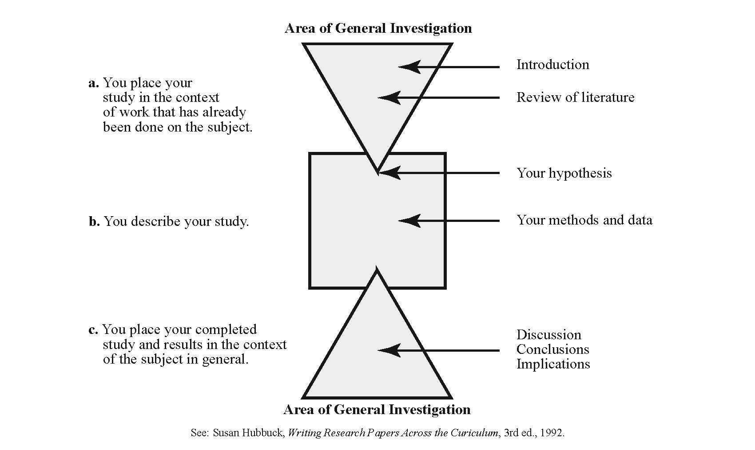
Theoretical vs. Empirical Literature: There could be a theoretical and an empirical literature that pertains to your research question. This means that you need to include a review of the relevant empirical studies as well as the theoretical literature. The goal in your evaluation of these studies would be to identify their findings, shortcomings, adequacy, strengths, with a view to how your study will be exploring these questions (e.g. whether in a different or similar manner; how different etc.). Likewise, if no one seems to have explored these questions through a particular methodology, but you are doing so, then you would indicate this gap in your literature review (i.e. “There are no studies that have examined…”) as a way to justify your research project. There are more detailed ways of identifying gaps in the literature, of course. For example, it could be the case that the available studies have not examined the differences between microcredit recipient men and women, or program participant women and non participant women. Note that in identifying the empirical literature to be reviewed in a Master’s Project, the aims are modest. If there is a vast empirical literature on your topic, then you should selectively aim to discuss in detail the most pertinent ones.

Conceptual Clarity: The literature review is also where you sort the differing usages of key concepts (again in a thematic manner), and identify your own usage.

A note on the use of quotations: Avoid overusing quotations in your literature review. As a rule, include as quotations only those sentences that have a particular impact or that are phrased in a unique manner that cannot be captured by a paraphrase. Ask yourself: “Why am I including this quotation?” “Can I paraphrase this text?”

E. Situating Your Research in the Literature: When reading and evaluating the literature you have to keep in mind its connection to your proposed research (for example, by keeping track in the last column of the table above). The general question you need to keep in mind is: what contribution will my study make to what has already been said?

Examples of how your research may relate to (“fit in”/fill the gap in) the literature:
- New Question: It may be a question that has not been studied before (this is not very likely, but possible).
- Old Question, New Evidence: The question may be one addressed in the literature. Your study would add new material to illustrate these trends, seek to extend them. For example, if you are examining a pattern observed at the national level in the U.S. for the case of Utah, or has been examined for Utah, but you are updating another study.
- Old Question, New Methodology (and Evidence): You may take a quite different direction, for example, use a methodology that has not been used before to examine an old question)
- Test a Theory: It may aim to test a theory from the literature (for example, the Prebisch-Singer hypothesis).

With a Master’s Project your most likely contribution would be to confirm, challenge/ disconfirm what others have shown.

F. Ending your literature review with the statement of the research problem: As you progressively narrow the focus by critically and thematically evaluating the literature, and reach the end of your review, the reader will be anticipating the research question you will pose and your expectation/hypothesis about this question. This is the point at which you need to state your research problem/question (when you reach the tip of the first triangle in the figure from Hubbuch.). This will entail writing a couple of summary sentences on the existing scholarship in the most relevant literature (that you already reviewed) and on the work that still needs to be done on the topic. Then, you need a few sentences on how your study will fit in and fill the gap/add to the scholarship and what you expect to find/show. Thereby, you will be indicating to your reader how you will be connecting and contributing to the accumulated knowledge on the topic as well as bridging into the next (Methodology) section of your paper.

Example: Here is a potential statement of the problem for the Project on “Microcredit in Kenya.”

“This review showed that most studies of outcomes of microcredit have focused on South Asia, in particular Bangladesh and India. There are few evaluations on Sub-Saharan Africa and these suggest more limited success of this approach in terms of poverty alleviation compared to the South Asian cases. The programs that have been successful in Sub-Saharan Africa appear to have been helped by x, y features of the design. I expect these conditions to hold in Kenya as well. In this paper I will examine the microcredit programs in Kenya in terms of their poverty alleviation effects paying particular attention to the x, y features in their design.”

Note: in this case, your Project will produce new evidence for the hypothesis that factors x, y are crucial for the poverty alleviation effects of microcredit in Kenya. The “new evidence” here may involve looking up statistics and/or systematic examination of statistics or qualitative evidence reported in earlier studies.

An alternative statement of the research problem: If your research question involves interpretive analysis, without any a priori expectations, your statement of the problem would be more open-ended. For example, if you are using a framework drawn from Thorstein Veblen’s writings to interpret (explain) rising consumerism in China, you would first discuss/identify Veblen’s views on consumerism and others’ interpretations of Veblen, then you would end your literature review with a series of propositions of Veblen’s framework. You would then use these propositions in the Methodology/Results section(s) to interpret the case of rising Chinese consumerism. In such a paper you may need an empirical section that discusses Chinese consumerism prior to the Results (Veblenian interpretation) section.

Note: In this case, there is no (implicit) hypothesis x, y affects successful outcomes in poverty reduction. Rather it is a series of propositions to use interpret in the case of China.

III. Methodology

This is the section that lays out how you will go about examining the research problem. You describe the methodology and the data you will use. The common methodologies used in Economics Master’s Projects are applied econometrics, descriptive statistical analysis, an interpretive methodology that relies of various texts as data sources. In the example of the microcredit in Kenya project you would examine various studies on microcredit and might tabulate the key features and outcomes of these microcredit programs in Kenya.

IV. Discussion of Results

This section would include your analysis and what you find. If you are pursuing a statistical methodology, then this section would include the statistical analysis (for example, the regression analysis) and discuss the findings.

V. Conclusions

This section sums up the main findings of the study and then discusses the implications of the study. The conclusion section is more than a reiteration of the research findings. The implications could be at the theoretical, empirical or policy levels. For example, the conclusion of the microcredit project could entail discussion of fruitful avenues for making microcredit projects more successful in the African context, based on your study. This section could also identify gaps that future research could examine, such that your research points the way to further studies.

G. Berik 5/2010

