 |  | Test
 |  | Test result is positive  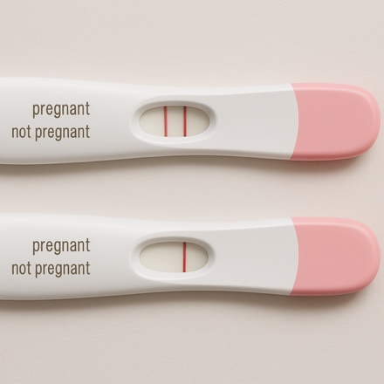 | Test result is negative  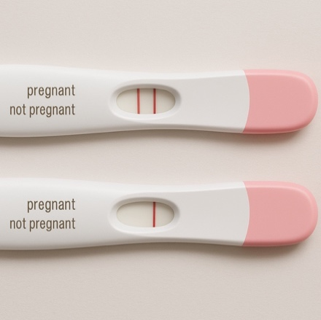
Reality | Susan is pregnant   | True Positive  (the test is true) | False Negative:  (the test is false)  Type II Error
 | Susan is not pregnant   | False Positive:  (the test is false)  Type I Error | True Negative  (the test is true)

Accuracy: correct / all cases | Test result is positive | Test result is negative
True: Susan is pregnant
False: Susan is not pregnant

Precision: true positive / all positive | Test result is positive | Test result is negative
True: Susan is pregnant
False: Susan is not pregnant

Recall: true positive / all true | Test result is positive | Test result is negative
True: Susan is pregnant
False: Susan is not pregnant

Is this a valid target? | Test is positive | Test is negative
Yes, is a valid target | TP | FN | All  valid
No, is not a valid target | FP | TN | All  invalid
 | All  positive | All  negative | All


Accuracy: TP+TN / all
Precision: TP/(all positive)
Recall: TP/(all valid)
