A Correlation = -.97, p = 0
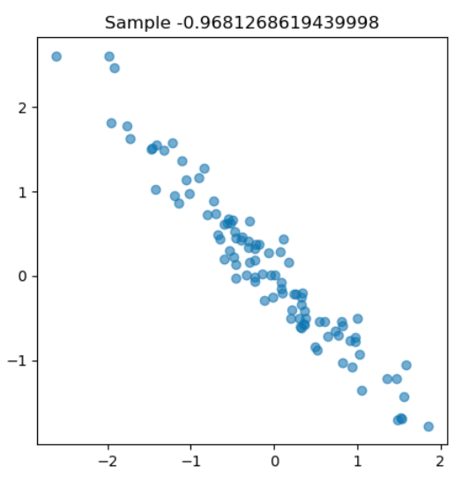
C Correlation = .05, p = .4
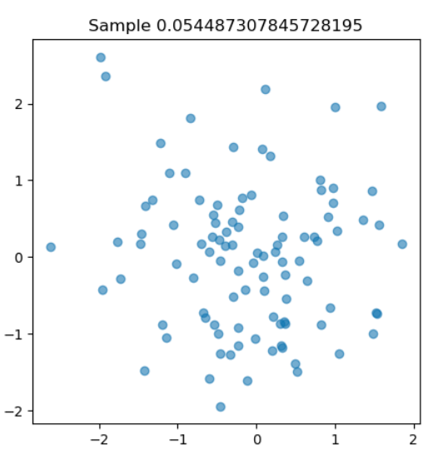
E Correlation = 0.7, p=0

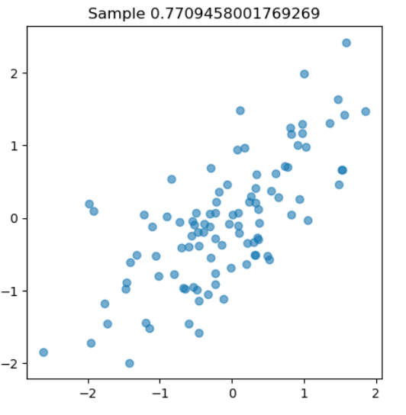
B Correlation = -.31, p = 0 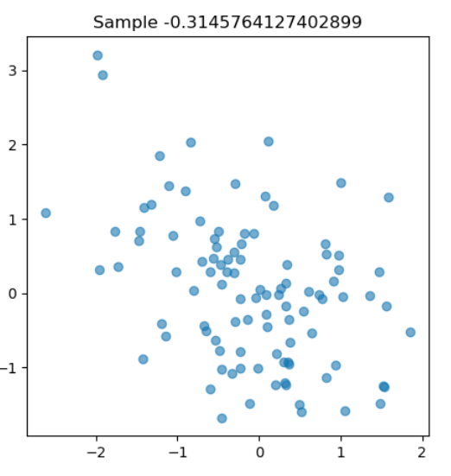
D Correlation = 0.165, p = .1

F Correlation = -.25, p = 0.1
