Visualizing linear regression error
Draw a line through the points that minimizes error. What equation describes that line?
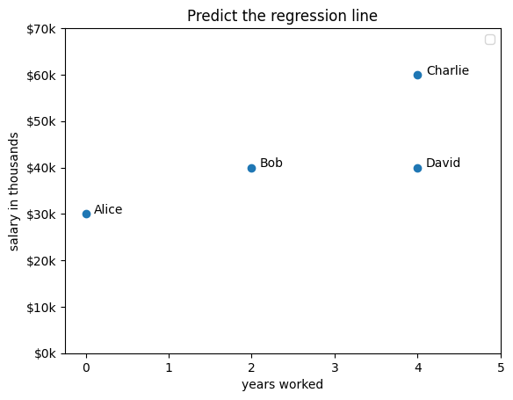

What is the equation? ____________________________________________________

Fill in the missing values in the table below for prediction, residual, and residual squared. Ignore decimals (round all figures to integers).
 | x | y | Predicted value from equation | Residual (error)  y - predicted | Squared Residual | Difference between y and y_avg  y - y_avg | Squared difference  (total)
Alice | 0 | 30
Bob | 2 | 40
Charlie | 4 | 60
David | 4 | 40
Sum |  | 170 |  | SSE |  | SST
Avg |  | 43

Calculate the following:
- RMSE (root mean squared error) is the average error of a single prediction
  - Find each residual, square it, find the average, take its square root
  - RMSE = __________
- R² is the proportion of variation accounted for by the model (don’t round this number!)
  - Formula: 1 - (Sum of Squared Errors / Sum of Squared Total differences)
  - R²: _________

