Visualizing linear regression error
Draw a line through the points that minimizes error. What equation describes that line?
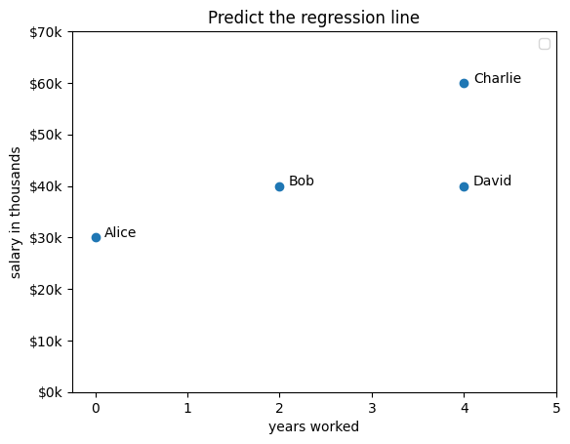
What is the equation? y (salary) = 30,000 + 5,000 * x (years_worked)

Fill in the missing values in the table below for prediction, residual, and residual squared. Ignore decimals (round all figures to integers).
 | x | y | Predicted value from equation | Residual (error)  y - predicted | Squared Residual | Difference between y and y_avg  y - y_avg | Squared difference  (total)
Alice | 0 | 30 | 30 | 0 | 0 | -13 | 178
Bob | 2 | 40 | 40 | 0 | 0 | -3 | 11
Charlie | 4 | 60 | 50 | 10 | 100 | 17 | 278
David | 4 | 40 | 50 | -10 | 100 | -3 | 11
Sum |  | 170 |  | SSE | 200 | SST | 478
Avg |  | 43 |  |  | 50

Calculate the following:
- RMSE (root mean squared error) is the average error of a single prediction
  - Find each residual, square it, find the average, take its square root
  - RMSE = 7
- R² is the proportion of variation accounted for by the model (don’t round this number!)
  - Formula: 1 - (Sum of Squared Errors / Sum of Squared Total differences)
  - R²: 0.58

