Building a decision tree by hand: ANSWER KEY
Name: ______________________________
A company wants to predict which invoices will be paid late so the collections team can follow up early. Below are 12 past invoices (the training data). The chart shows the same 12 invoices.
Customer | Invoice amount ($k) | Years as customer | Pays by | Paid
Ava | 9 | 0 | Check | Late
Ben | 2 | 0 | Check | On time
Cara | 7 | 4 | ACH | On time
Dan | 7 | 1 | ACH | Late
Eli | 3 | 6 | ACH | Late
Fay | 4 | 1 | ACH | On time
Gus | 8 | 1 | ACH | Late
Hana | 9 | 5 | Check | On time
Ivan | 3 | 0 | Check | On time
Jade | 6 | 0 | Check | Late
Kurt | 2 | 8 | ACH | On time
Lina | 10 | 8 | Check | Late

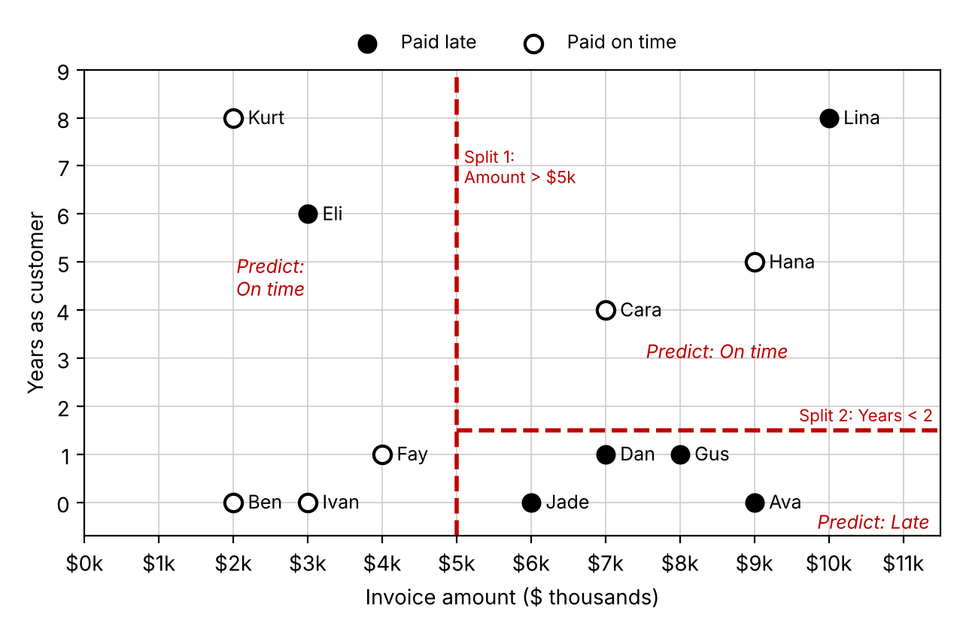
Step 1: Pick the first split
A decision tree asks one yes/no question at a time. For each candidate question below:
- Count the late and on-time invoices on the Yes side and on the No side.
- Each side predicts its majority outcome (Late or On time). If a side is tied, write Tie.
- Mistakes = the minority count on each side, added together. Fewer mistakes = better split.
Candidate question | Yes side |  |  | No side |  |  | Total mistakes
Candidate question | # Late | # On time | Predict | # Late | # On time | Predict | Total mistakes
Amount > $5k? | 5 | 2 | Late | 1 | 4 | On time | 3
Years as customer < 2? | 4 | 3 | Late | 2 | 3 | On time | 5
Pays by check? | 3 | 3 | Tie | 3 | 3 | Tie | 6
Best first split: Amount > $5k (3 mistakes) Draw it as a line on the chart.
Why is Pays by check? a useless split? Both sides are still 3 late / 3 on time, the same 50/50 mix as before. 6 mistakes is no better than guessing.
Step 2: Split again
Look only at the invoices on the side of your first split that has more mistakes. How many invoices are on that side? 7 (the Yes side of Amount > $5k) Test two more questions on just those invoices.
Candidate question | Yes side |  |  | No side |  |  | Total mistakes
Candidate question | # Late | # On time | Predict | # Late | # On time | Predict | Total mistakes
Years as customer < 2? | 4 | 0 | Late | 1 | 2 | On time | 1
Pays by check? | 3 | 1 | Late | 2 | 1 | Late | 2
Best second split: Years as customer < 2 (1 mistake) Draw it on the chart, only on that side of your first line.
Try the same two questions on the other side of the first split. Does either one reduce its mistakes? Should we split that side? No. Years < 2 gives 0 late/3 on time and 1/1; Pays by check gives 0/2 and 1/2. Both still make 1 mistake (Eli), so splitting adds complexity without improving accuracy.
Step 3: Draw the tree
Fill in each question and the counts in each leaf (bottom box). Each leaf predicts its majority outcome.
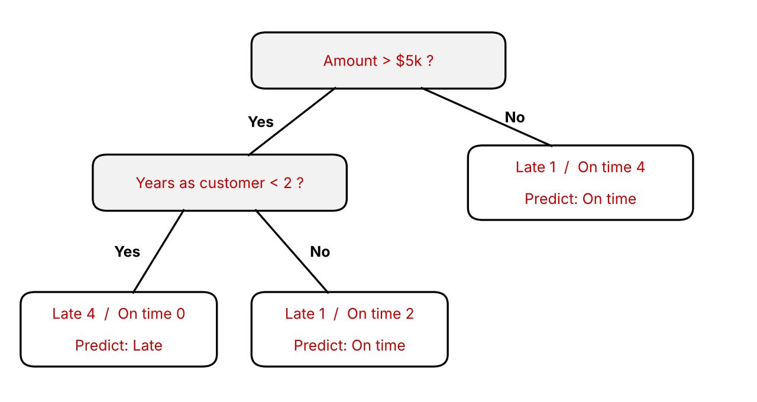
Training accuracy = correct ÷ total. A fraction is fine.
- After one split: 9 / 12 (75%)
- After two splits: 10 / 12 (about 83%)
Software such as scikit-learn measures how mixed a node is with gini = 1 − (share late)² − (share on time)². A gini of 0 means every invoice in the node has the same outcome.
- Gini of the starting data (6 late, 6 on time): 1 − 0.25 − 0.25 = 0.5
- Gini of a leaf with 4 late, 0 on time: 1 − 1 − 0 = 0
Step 4: Predict new invoices
These 10 invoices were not used to build the tree (the test data). Follow your tree to predict each one, then mark whether the prediction was correct.
Customer | Amount ($k) | Years as customer | Pays by | Tree predicts | Actually paid | Correct?
Mia | 7 | 5 | ACH | On time | On time | Yes
Nate | 8 | 0 | ACH | Late | Late | Yes
Omar | 2 | 0 | ACH | On time | Late | No
Pia | 4 | 3 | ACH | On time | On time | Yes
Quinn | 6 | 1 | Check | Late | Late | Yes
Raj | 7 | 0 | Check | Late | On time | No
Sam | 9 | 6 | Check | On time | Late | No
Tess | 1 | 1 | Check | On time | On time | Yes
Uma | 10 | 1 | ACH | Late | Late | Yes
Vic | 9 | 3 | Check | On time | On time | Yes
Step 5: Measure performance on the test data
Count the results from Step 4. Treat Late as the positive outcome, since it is what we are trying to catch.
 | Predicted Late | Predicted On time
Actually Late | TP = 3 (true positive) | FN = 2 (false negative)
Actually On time | FP = 1 (false positive) | TN = 4 (true negative)

Measure | Formula | Your answer | What it means
Accuracy | (TP + TN) ÷ total | 7 / 10 = 70% | Share of all predictions that were correct
Precision | TP ÷ (TP + FP) | 3 / 4 = 75% | Of invoices predicted late, share that really were late
Recall | TP ÷ (TP + FN) | 3 / 5 = 60% | Of invoices that really were late, share we caught
Step 6: Interpret
- Training accuracy was about 83% but test accuracy was 70%. Why is test accuracy usually lower? The tree was built to fit the training invoices, so it has already seen them. New invoices include cases it never saw (e.g., Omar is new with a small invoice but paid late).
- A classmate keeps splitting until every training invoice is predicted correctly. Would you expect test accuracy to go up or down? What setting could stop this? Probably down. The tree would memorize odd cases such as Eli and Lina (overfitting). Limit max_depth or set a minimum leaf size (min_samples_leaf), and check with test data or cross-validation.
- Collections will call every invoice the tree predicts as late. Missing a late payer is costly; an extra call is cheap. Which matters more here, precision or recall? Why? Recall. It measures how many real late payers we catch. Low precision only costs a few unneeded calls.
Teacher notes
- Years < 2 and Years < 4 create identical groups in the training data (no customer has 2 or 3 years); likewise Amount > $4k and > $5k. Accept either in Steps 1–3. In Step 4, Years < 4 would flip Vic ($9k, 3 years) to Late, so the key assumes the printed Years < 2.
- Every threshold on every attribute was checked: Amount > $5k is the best first split (3 mistakes; next best is 4), and Years < 2 is the best second split. Only the equivalent thresholds above tie them.
- scikit-learn (gini, max_depth=2) picks the same splits (amount ≤ 5.0, then years ≤ 2.5). It also splits the Amount ≤ $5k side, but both of those leaves still predict On time, so its test predictions match this tree.

