Building a decision tree
A company wants to predict which invoices will be paid late so the collections team can follow up early. Below are 12 past invoices (the training data). The chart shows the same 12 invoices.
Customer | Invoice amount ($k) | Years as customer | Pays by | Paid
Ava | 9 | 0 | Check | Late
Ben | 2 | 0 | Check | On time
Cara | 7 | 4 | ACH | On time
Dan | 7 | 1 | ACH | Late
Eli | 3 | 6 | ACH | Late
Fay | 4 | 1 | ACH | On time
Gus | 8 | 1 | ACH | Late
Hana | 9 | 5 | Check | On time
Ivan | 3 | 0 | Check | On time
Jade | 6 | 0 | Check | Late
Kurt | 2 | 8 | ACH | On time
Lina | 10 | 8 | Check | Late

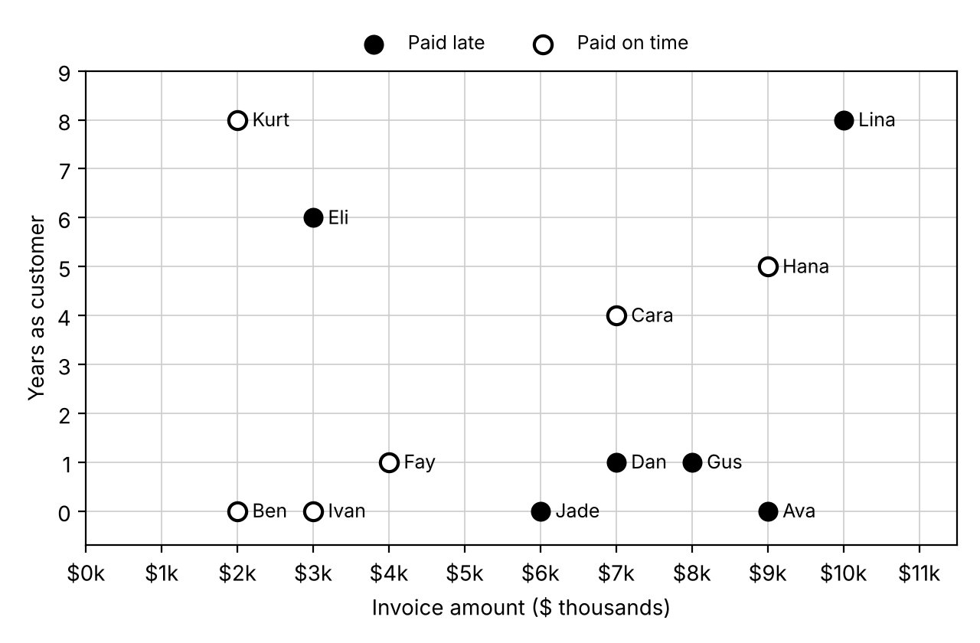

Step 1: Pick the first split
A decision tree asks one yes/no question at a time. For each candidate question below:
- Count the late and on-time invoices on the Yes side and on the No side.
- Each side predicts its majority outcome (Late or On time). If a side is tied, write Tie.
- Mistakes = the minority count on each side, added together. Fewer mistakes = better split.
Candidate question | Yes side |  |  | No side |  |  | Total mistakes
Candidate question | # Late | # On time | Predict | # Late | # On time | Predict | Total mistakes
Amount > $5k?
Years as customer < 2?
Pays by check?
Best first split: ______________________________ Draw it as a line on the chart.
Why is Pays by check? a useless split? ______________________________________

Step 2: Split again
Look only at the invoices on the side of your first split that has more mistakes. How many invoices are on that side? ______ Test two more questions on just those invoices.
Candidate question | Yes side |  |  | No side |  |  | Total mistakes
Candidate question | # Late | # On time | Predict | # Late | # On time | Predict | Total mistakes
Years as customer < 2?
Pays by check?
Best second split: ______________________________ Draw it on the chart, only on that side of your first line.
Try the same two questions on the other side of the first split. Does either one reduce its mistakes? Should we split that side? ______________________________

Step 3: Draw the tree
Fill in each question and the counts in each leaf (bottom box). Each leaf predicts its majority outcome.
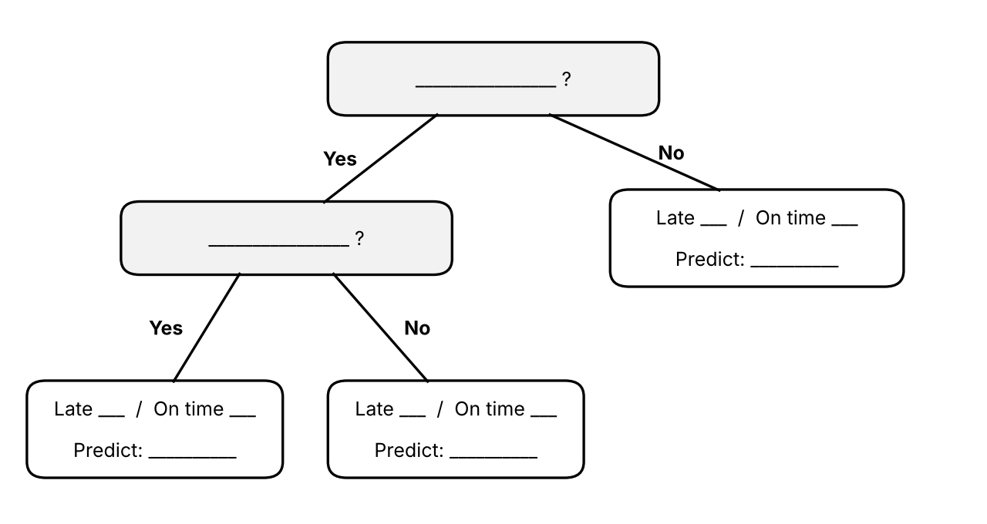
Training accuracy = correct ÷ total. A fraction is fine.
- After one split: ______ / 12 correct
- After two splits: ______ / 12 correct
Software such as scikit-learn measures how mixed a node is with gini = 1 − (share late)² − (share on time)². A gini of 0 means every invoice in the node has the same outcome.
- Gini of the starting data (6 late, 6 on time): __________
- Gini of a leaf with 4 late, 0 on time: __________
Step 4: Predict new invoices
These 10 invoices were not used to build the tree (the test data). Follow your tree to predict each one, then mark whether the prediction was correct.
Customer | Amount ($k) | Years as customer | Pays by | Tree predicts | Actually paid | Correct?
Mia | 7 | 5 | ACH |  | On time
Nate | 8 | 0 | ACH |  | Late
Omar | 2 | 0 | ACH |  | Late
Pia | 4 | 3 | ACH |  | On time
Quinn | 6 | 1 | Check |  | Late
Raj | 7 | 0 | Check |  | On time
Sam | 9 | 6 | Check |  | Late
Tess | 1 | 1 | Check |  | On time
Uma | 10 | 1 | ACH |  | Late
Vic | 9 | 3 | Check |  | On time
Step 5: Measure performance on the test data
Count the results from Step 4. Treat Late as the positive outcome, since it is what we are trying to catch.
 | Predicted Late | Predicted On time
Actually Late | TP = ____ (true positive) | FN = ____ (false negative)
Actually On time | FP = ____ (false positive) | TN = ____ (true negative)

Measure | Formula | Your answer | What it means
Accuracy | (TP + TN) ÷ total | ____ / ____ = ____% | Share of all predictions that were correct
Precision | TP ÷ (TP + FP) | ____ / ____ = ____% | Of invoices predicted late, share that really were late
Recall | TP ÷ (TP + FN) | ____ / ____ = ____% | Of invoices that really were late, share we caught
Step 6: Interpret
- Training accuracy was about _____ but test accuracy was _____. Why is test accuracy usually lower?

- A classmate keeps splitting until every training invoice is predicted correctly. Would you expect test accuracy to go up or down? What setting could stop this?

- Collections will call every invoice the tree predicts as late. Missing a late payer is costly; an extra call is cheap. Which matters more here, precision or recall? Why?

