Lab 1 Check-Off

Student Name: ___________________________________

Date of Lab: ___________________________________

Check-Offs

_____ An HTML document has been created with all the appropriate tags and structure. The tags are correctly used and have corresponding end tags. The content is also appropriate for this lab.

TA Signature: _________________________________
Lab 1 Instructions

Lab Objectives: This lab is designed to familiarize students with basic HTML tags. In addition, this lab will help students learn how to organize HTML code to later be complimented with CSS. We will not be using any styling in today’s lab. You are going to build a personal web page which contains your favorite movies.

Directions:

Note: Please make use of the resource http://www.w3schools.com

1. You will need any text editor (textpad, textedit, textmate, etc) as well as a web browser. You do not need to have a web editor such as Dreamweaver or FrontPage. Create a file named home.html.

2. Open the file and enter the below text:

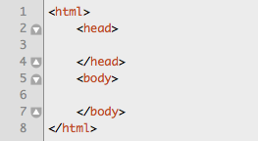

We are using three HTML tags. The <html> tag lets the browser know what type of file it is reading and the <head> tag contains general information about the document also referred to as meta-information. The <body> tag is where we put our HTML code that is displayed to the user. Notice that all tags have a corresponding end tag with the forward slash.

3. We are going to add a page <title> in the <head> tags. If you want to see what other information is stored in the <head> of the HTML page, visit: http://www.w3schools.com/tags/tag_meta.asp.

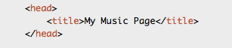

The <title> tag will display in the title bar of the web browser.

4. Now we are going to create the structure of the main content. Our goal is to organize our HTML code cleanly without any styling. We will add styling in a later lab by only adding a single file. We are adding the <div> HTML tags with one special attribute.

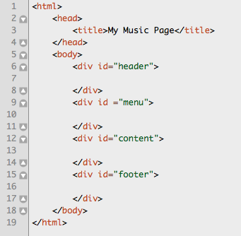

We have added in the <body> tag three <div> tags with corresponding end </div> tags. <div> tags define a division or section of an HTML document. We will organize our information into <div> tags which will allow use to do more complex things later on. We have also included an “id” attribute. You will see “class” attributes as well as many others. Please search for “div” at w3schools.com to find out more information. A <div> can have an “id” and “class” attribute. However, only one div in a particular document can have the same “id” value, whereas you may have many <div>’s with the same “class” value.

We want to declare four distinct <div>’s which will create the desired page structure. Create the structure given above with the id’s “header”, “menu”, “content”, and “footer”.

5. Now add a page heading to your HTML document within the “header” div. We are going to use the <h1> tag but you can find other <h2> or <h3> tags at w3schools.com. The <h1> tag will display text in a larger font-size.

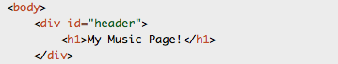

6. Now we are going to create a menu list. We are not going to worry about appearance. Remember, we are going to add styling later. However, it is very important that we create the structure for our menu to allow us to change the appearance and styling from the external file which is to come. We are going to add an unordered HTML list, which displays as a bulleted list if there is no additional styling. HTML ordered list are also available with the <ol> tag, but we will stick to <ul> or unordered lists. Within the <ul> tags, you put list items or <li>’s. Each list item or <li> defines a bullet for your unordered or ordered list. Create 5 list items

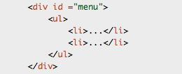

7. We are going to make each list item a link using the <a> or anchor tags. Anchor tags are used for creating links or bookmarks inside a document. If you give the <a> tag the “href” attribute, it will act as a link, and the url of the link is the value of the “href” attribute. Make the first list item a link to the current page (when we add more pages this will bring the visitor back to the home page). Now add 4 more links to your HTML document. You may pick any appropriate links.

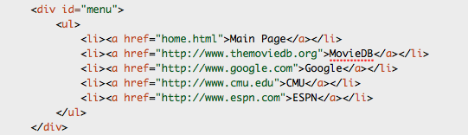

8. Now to the content <div>. We are going to add several more HTML tags. The first is a <h2> tag with some welcome text. We are then going to make two line breaks with the <br/> tag. *Notice that this HTML tag does not need a corresponding end tag!

The next step is to add a table to hold information about your favorite movie. Start with the beginning and end <table> tags. Then make the first table row or <tr>. Within each row you can place a “header cell”/<th> or “standard cell”/<td>, which can have different styling. Make the first row have only “header cells” or <th>’s and the other rows have <td>’s or standard cells. Now create a total of four rows and a total or four columns (have four <th>’s or <td>’s in each <tr>). The headers should be “Title”, “Year”, “Overview”, and “Link”. And you should list 3 of your favorite movies in the remaining rows with the appropriate data in each cell. Use www.themoviedb.org for your data.

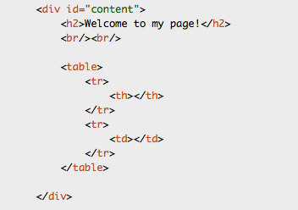

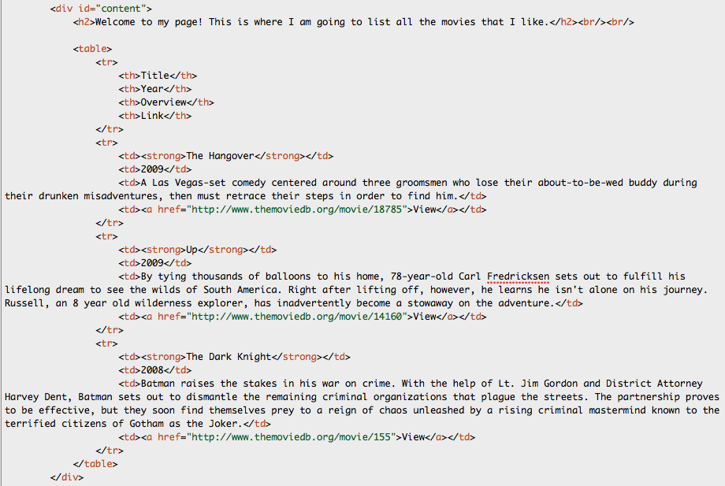

Please notice the <strong> tag used for the Titles of the movies: <strong>Up</strong>. This adds a bolder look to the text and can be changed later in the CSS style sheet, which we will add later.

9. Now complete your HTML document by adding some text in the footer div.

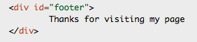

10. Open the html page with your browser and make sure things look good. Remember, you should not worry about appearance. You are done at this point and can get the TA to sign off after showing him/her your document structure and HTML code.

11. Once the TA verifies this final step, you are finished. Be sure that the check-off sheet has your name clearly printed and is signed by a TA. Take this sheet with you and save it as proof that you did the lab (just in case there are any questions). Make sure the TA marks on the main sheet that your lab was completed.
HTML Quick Reference

Tags
<html></html> | This is the basic
<head></head>
<body></body>
<title></title> | This tag is used to set the
<div></div>
<h1></h1>, <h2></h2>…
<table></table>
<tr></tr>
<th></th>
<td></td>

Attributes
id | An id is assigned to an individual HTML element (div, table, h1, etc). Akin to a personal driver’s license, there exists only 1 id per webpage. Each HTML element can only have 1 id.
class | Classes can be assigned to individual HTML elements.

