Lab 2 Check-Off

Student Name: ___________________________________

Date of Lab: ___________________________________

Check-Offs

_____ An external CSS file has been created and linked properly to the HTML page.

_____ A new HTML page has been created and added to the navigation and a contact form has been created and able to submit to the predefined remote script.

TA Signature: _________________________________
Lab 2 Instructions

Lab Objectives: This lab is designed to familiarize students with basic CSS and HTML forms. In addition, this lab will help students learn what information is collected and sent over the Internet when submitting a form.

Directions:

- You are going to be building off of last week’s lab. You may use your code from last week or you can download the code from http://rook.hss.cmu.edu/~67272/labs/101_labs/lab1.zip

2. You are first going to add a new folder for your CSS file. Create the folder “css” in the same directory as “home.html”. Now create a file named “style.css” inside of the “css” folder.

3. Notice that if you view your home.html in a web browser you will see some space between the edge of the browser window and where the text is actually displayed. Your are going to control this space as well as other attributes shared by the whole page such as Font Family, Font Size, and Color.

Insert the following code into the style.css file:

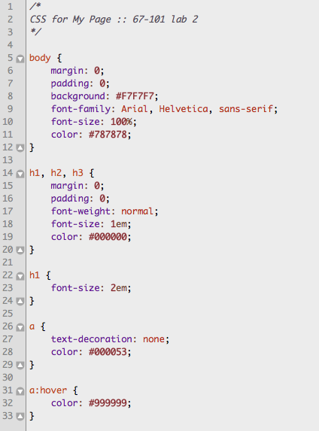

First, you create a comment using the /* & */ with a description of the css file.

Font-Size: You may be familiar with using pixels when dealing with font-size but to avoid the resizing problem with Internet Explorer, many developers use em instead of pixels. The em size unit is recommended by the W3C. 1em is equal to the current font size. The default text size in browsers is 16px. So, the default size of 1em is 16px.
The size can be calculated from pixels to em using this formula: pixels/16=em. Since some browsers render text differently, the solution that works in all browsers, is to set a default font-size in percent for the body element and use em’s for resizing the other text accordingly.

CSS Syntax
A CSS rule has two main parts: a selector, and one or more declarations:

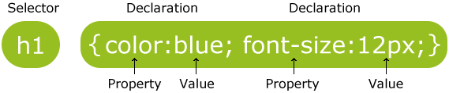

The selector is normally the HTML element you want to style.
Each declaration consists of a property and a value.
The property is the style attribute you want to change. Each property has a value.

Placing Declarations on a single line will make the css file easier to read and debug.

4. Now you need to tell the browser to load the CSS file with the home.html file. To do this you need to open home.html and insert the line below in the <head> section.

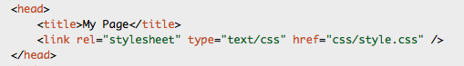

You are creating a link to a “stylesheet” located in a certain directory.

Save home.html and style.css and open home.html in a browser. Notice how only adding a single file has changed the style of the page. You can imagine how much time and effort has been saved by extracting this styling information, which can be applied to any number of html files.

Have a TA verify your HTML & CSS documents before proceeding to the next step.

5. Open the home.html file and go to the menu <div> and add another list item at the bottom. Create a link to “contact.html”.

6. Now create a new file and name it “contact.html”. Copy and paste all of the HTML code from “home.html”.

7. Clear out the table code and change the <h2> to a more relevant contact page heading.

8. You are now going to add a form using the <form> tags. A form is a designated area that contains form elements, which collect user input. You must have all of you form elements (textbox, checkbox, etc) within the <form> and </form> tags.

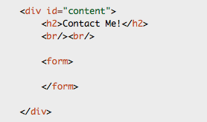

9. When you include a form in your HTML page you need to specify a few form attributes to go with the opening <form> tag. Your form must have an id, and name as well as an HTTP verb and action URL. The HTTP verb tells the browser how to submit the data. You can either use GET or POST where GET is normally used for pure query form submits and POST is used for other transactions. We wont go into more detail on these HTTP methods. Just stick with “POST” for you lab.

<form id="myform" name="myform" method="post" action="http://rook.hss.cmu.edu/~profh/labs/contact.php">

Note that the “action” is pointing to an external PHP script. This script reads the information submitted by the form and displays it on another page. You are NOT required to know PHP; however, you can use this external script to see what you are really submitting. You will also need access to the Internet since this is a remote script.

10. You collect user data by using <input> tags, which have several attributes to choose from. You will normally have an “id”, “name”, and “type”. You may also have “size”, “maxlength”, “class”, and “onchange”. Create two input fields one with type of “text” and name “Name” and the other with type “text” and name “Email”. Also, put both input fields within a paragraph or <p> tag.

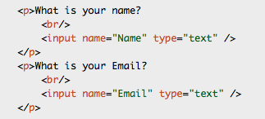

Notice that you also need to include some kind of text description as to what should be entered in the input field. And don’t forget to insert a line break after the input description.

11. Now add a new kind of form element called a <textarea>. You can use <textarea>’s for multi-line inputs and control how many rows and columns should be displayed. Create a <textarea> with name “Comment” with 30 columns and 5 rows (See below for the exact syntax).

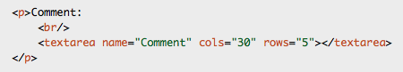

12. You can now add a submit button, which is another <input> field with the type of “submit”:

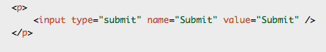

13. If you open the HTML file in a web browser you will notice that the input text boxes do not stretch as far as the textarea. Try adding the “size” attribute to the input text boxes and give them values to even the form out (make all three boxes stretch the same width).

14. Save your HTML document and open it in a browser. Go to the Form and enter some text and submit the form. Notice that you not only submit what was entered into the form, but you also send information about your browser and operating system. Have a TA verify your work.

15. Once the TA verifies this final step, you are finished. Be sure that the check-off sheet has your name clearly printed and is signed by a TA. Take this sheet with you and save it as proof that you did the lab (just in case there are any questions). Make sure the TA marks on the main sheet that your lab was completed.

