Lab 3 Check-Off

Student Name: ___________________________________

Date of Lab: ___________________________________

Check-Offs

_____ All new element classes are in place and appropriate CSS is rendering.

TA Signature: _________________________________
Lab 3 Instructions

Lab Objectives: This lab is designed to familiarize students with CSS and custom <div>’s as well as HTML & CSS commenting. This lab also applies CSS to tables with rotating odd/even styles.

Directions:

*You can Download the HTML & CSS code for lab 2 from the below link or you can use your own code:

http://rook.hss.cmu.edu/~67272/labs/lab2.zip

1. Revisit the CSS file you created last week:

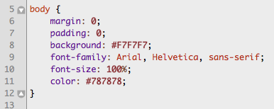

You are telling the browser to display everything within the HTML <body> tag with no “margin” or “padding”. Margin is the space around the actual HTML box and padding is the space within the HTML box. You will see more examples later in this lab. Just know that you are removing that extra space around your page so the edges extend all the way to the edge of the browser window.

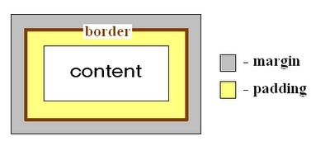

You are also changing the “background” slightly and changing the text “color” to a grey color. You are establishing the “font-family” for the text and the “font-size”

CSS Syntax Review:
A CSS rule has two main parts: a selector, and one or more declarations:

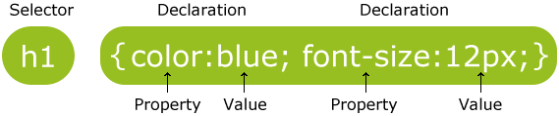

The selector is normally the HTML element you want to style.
Each declaration consists of a property and a value.
The property is the style attribute you want to change. Each property has a value.

Placing Declarations on a single line will make the css file easier to read and debug.

Also remember the HTML page structure you created for the pages:

<div id="header">
<div id="menu">
<div id="content">
<div id="footer">

You are now going to create the CSS for these HTML elements.

2. You have commented before in Java or Ruby code and you can comment in CSS or HTML code as well. To comment in CSS you begin you comment with “/*” and end it with “*/”

Place a comment in your CSS code noting where you are about to enter new code:

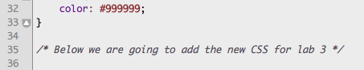

*Also make sure you have a comment at the beginning of the file describing the content of the CSS file.

3. Commenting in HTML starts with “<!--“ and ends with “-->”. Place a comment in your home.html file inside the header div:

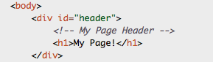

4. Now go back to the CSS file and add some styling for the header div. First, remember that we declared an “id” attribute for the <div>’s and we mentioned there was a difference between “id”s and “class”s. There is also a difference in how you reference (or “select”) them from CSS. You select a <div> using a “#” and you select a class using a period. Select the header div and define the following CSS. Don’t forget to add a CSS comment before the CSS code for the header.

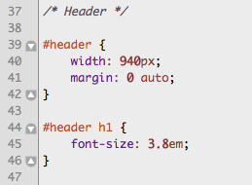

5. The menu is set using an unordered list because of the styling techniques that can be applied using CSS. Right now the Menu is contained within the “menu” <div> which we will assign CSS to. Next we will assign CSS to the <ul> element and then the <li> or list items which we use to organize our navigation links. We will get to the actual text links and rollover CSS later. Enter the below CSS:
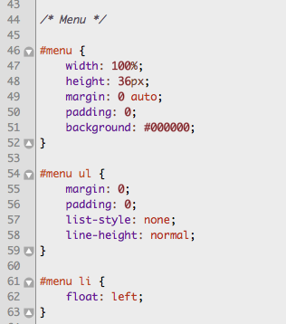
6. Now we get to the link CSS and the rollover action:
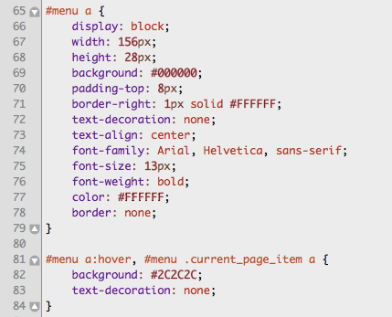

Using the “display: block:” you create an element that will generate a block box (a line break before and after the element)

Text decoration refers to the underline you are used to seeing in links

7. Now add the following CSS for the “content” and “footer” <div>s:

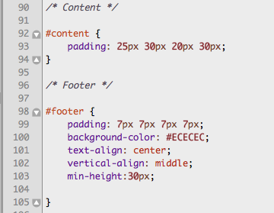
8. If you take a look at your page now you should notice a considerable difference. The best part is that you can manage the CSS very easily from within one file. Now you are going to work on the <table> the movie data is stored in. You need to add a “class” attribute to the table with the value “movie_table”. You may also want to throw in an HTML comment:

Adding a “class” attribute to the table element will give you more flexibility and control. The next thing we are going to add is CSS styling to the table rows. However, you want the rows to rotate styling slightly to make the table easier to digest. You will need to create two different HTML classes to control odd and even rows. Add the following “movie_line_odd” and “movie_line_even” appropriately:

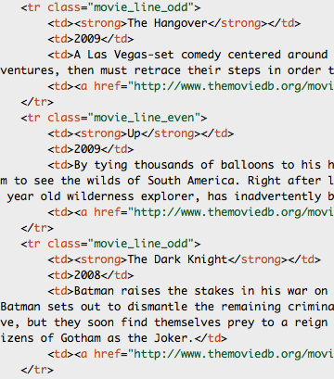

You will also need to have two corresponding CSS elements to control the styling.
9. In your CSS file, you need to first select the “table” element and define the class “movie_table” as show below. You will do a similar technique for all “a href” links, “th”s, and “td”s within any table assigned the class “movie_table”

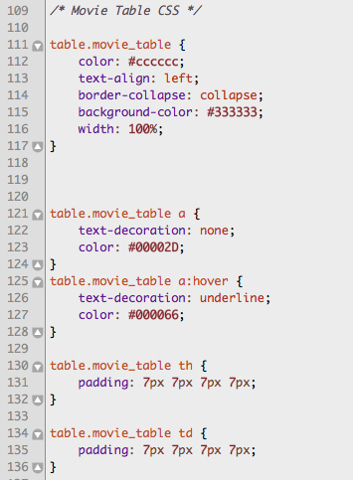

10. You need to finish up with assigning the CSS for both the odd and even lines as show below:

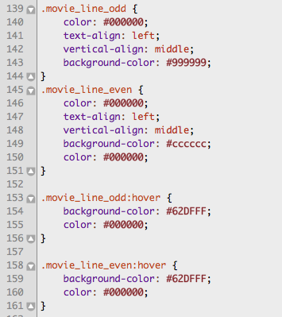

11. Now take a look on the next page at the graphic detailing element padding, margin, and other attributes.

12. Once the TA verifies this final step, you are finished. Be sure that the check-off sheet has your name clearly printed and is signed by a TA. Take this sheet with you and save it as proof that you did the lab (just in case there are any questions). Make sure the TA marks on the main sheet that your lab was completed.

