超市销售管理系统

一． 需求分析
研究意义：
当今社会，超市已成为社会不可缺少的一部分，不论大中小城市，都存在或大或小或多或少的超市。对于一个稍有规模的超市，都需要一个超市管理系统，进行规范化管理。因此超市管理系统的开发，显得十分有必要。
目的、内容：
超市管理系统的目的：
用最简单的操作完成最繁琐的细节，从繁重的脑力劳动脱离出来，由软件统一管理。进销存的管理，使人一目了然。
本文的主要内容：
语言采用C#.NET，采用SqlConnection连接 数据库 SQLsever2005.
超市系统的缺点：
系统整体性都不够完善。制作过程代码不够完善。
需求模块分析：
整个系统基本包括了小型超市所要用到的模块。
包括前台（收银操作，商品查询，会员注册，会员充值，退货服务）管理，后台（基本信息（商品供应商信息，仓库信息，商品资料，员工档案，会员档案）管理，采购查询，采购管理，库存查询，库存管理，销售查询，销售管理）管理等等。
1.前台管理系统：
1）收银台：
A。商品搜索：可以对顾客需要的商品进行查询，输入商品名称（如有要求，还可输入可接受的商品价格范围），查看是否有该商品及其价格，支持模糊查询，即输入商品名称关键字即可。
B。收银业务：通过直接输入商品ID及购买数量，点击购买，界面将自动显示该商品的详细信息。明确显示商品ID、商品名称、现卖价、会员价，填入购物单号，日期，收银员ID及付费方式，点击结帐，将计算本次交易的总金额。支持现金交易，会员卡交易。
C。当日销售数据查询
2）服务台：
A。会员注册：增加会员，输入会员基本档案，发放会员卡。
B。退货服务：已售出商品退货功能。
C。会员充值

2.后台管理系统：
1）基本信息管理
A。商品供应商信息管理：对供货商基本信息进行登记管理，通过基本信息进行查询，修改更新，删除。
B。员工档案管理：基本信息登记管理。信息查询，修改更新，删除。
C。商品资料管理：基本信息登记管理，信息查询，修改更新，删除。
D。会员管理：增加、修改、删除会员档案。启用、禁用会员卡，查看会员基本信息及会员消费积分、会员储值。
E。仓库信息管理：仓库信息搜索及明细记录
2）销售管理：显示销售明细记录。可查询某一商品在某一时间段的销售情况。
3） 库存管理： 可显示库存明细记录。可以增加新的入库单，也可以查询以往入库信息记录。
4）采购管理：可显示商品供应明细记录。可以增加新的商品供应单，也可以查询历史采购信息。
5）系统设置：（未完成）

二．数据分析与建模
E-R图
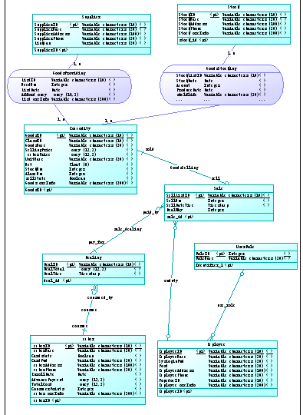

系统表：
Commodity:
GoodsID varchar(10) Unchecked
GoodsName varchar(20) Checked
SellingPrice numeric(12, 2) Checked
MemberPrice numeric(12, 2) Checked
StockNum int Checked
AlarmNum int Checked
sellstate bit Checked
GoodsMoreInfo varchar(200) Checked

Dealing:
DealID varchar(10) Unchecked
DealTotal numeric(12, 2) Checked
DealDateTime timestamp Unchecked
MemberID varchar(10) Unchecked

Employee:
EmployeeID varchar(10) Unchecked
EmployeeName varchar(20) Unchecked
SysLoginPwd varchar(20) Unchecked
Post varchar(20) Checked
EmployeeAddress varchar(100) Checked
EmployeePhone varchar(20) Checked
PopedomID int Unchecked
EmployeeMoreInfo varchar(200) Checked

GoodsProviding:
ListID varchar(10) Unchecked
GoodsID varchar(10) Unchecked
SupplierID varchar(10) Unchecked
NeedNum int Checked
ListDate datetime Checked
AffordMoney numeric(16, 2) Checked
ListMoreInfo varchar(200) Checked

GoodsStocking:
StockListID varchar(10) Unchecked
StockID varchar(10) Unchecked
GoodsID varchar(10) Unchecked
StockDate datetime Checked
Amount int Checked
ProduceDate datetime Checked
shelflife varchar(20) Checked
PurchasePrice numeric(16, 2) Checked

Member:
MemberID varchar(10) Unchecked
MemberName varchar(20) Unchecked
Cardstate bit Checked
CardPwd varchar(20) Unchecked
MemberAddress varchar(100) Unchecked
MemberPhone varchar(20) Unchecked
EnrollDate datetime Unchecked
AdvancePayment numeric(12, 2) Checked
TotalCost numeric(12, 2) Checked
ConsumerPoints int Checked
MemberMoreInfo varchar(200) Checked

Sale:
SellListID varchar(10) Unchecked
GoodsID varchar(10) Unchecked
SellNum int Checked
SellDateTime datetime Unchecked
Dealway int Unchecked
DealID varchar(10) Checked
EmployeeID varchar(10) Unchecked

Stock:
StockID varchar(10) Unchecked
StockName varchar(20) Checked
StockAddress varchar(100) Checked
StockPhone varchar(20) Checked
StockMoreInfo varchar(200) Checked

Supplier:
SupplierID varchar(10) Unchecked
SupplierName varchar(20) Checked
SupplierAddress varchar(100) Checked
SupplierPhone varchar(20) Checked
Linkman varchar(20) Checked

UserRole:
RoleID int Unchecked
RoleName varchar(20) Unchecked

三．数据库建立
数据库及表建立的SQL语言
use [Supermarket Management System ]
create table Commodity(
GoodsID varchar(10) not null,
GoodsName varchar(20),
SellingPrice numeric(12,2),
MemberPrice numeric(12,2),
StockNum int,
AlarmNum int,
sellstate bit,
GoodsMoreInfo varchar(200),
primary key(GoodsID)
)

use [Supermarket Management System]
create table supplier (
SupplierID varchar(10) not null,
SupplierName varchar(20),
SupplierAddress varchar(100),
SupplierPhone varchar(20),
Linkman varchar(20),
primary key(SupplierID)
)

use [Supermarket Management System]
create table Stock (
StockID varchar(10) not null,
StockName varchar(20),
StockAddress varchar(100),
StockPhone varchar(20),
StockMoreInfo varchar(200),
primary key(StockID)
)

use [Supermarket Management System]
create table GoodsProviding (
ListID varchar(10) not null,
GoodsID varchar(10) not null,
SupplierID varchar(10) not null,
NeedNum int,
ListDate datetime,
AffordMoney numeric(16,2),
ListMoreInfo varchar(200),
Primary key(ListID),
foreign key(SupplierID)references Supplier,
foreign key(GoodsID)references Commodity
)

use [Supermarket Management System]
create table GoodsStocking (
StockListID varchar(10) not null,
StockID varchar(10) not null,
GoodsID varchar(10) not null,
StockDate datetime,
Amount int,
ProduceDate datetime,
shelflife varchar(20),
PurchasePrice numeric(16,2),
primary key(StockListID),
foreign key(StockID)references Stock,
foreign key(GoodsID)references Commodity
)

use [Supermarket Management System]
create table Member (
MemberID varchar(10) not null,
MemberName varchar(20),
Cardstate bit,
CardPwd varchar(20),
MemberAddress varchar(100),
MemberPhone varchar(20),
EnrollDate datetime,
AdvancePayment numeric(12,2),
TotalCost numeric(12,2),
ConsumerPoints int,
MemberMoreInfo varchar(200),
primary key(MemberID)
)

use [Supermarket Management System]
create table Dealing (
DealID varchar(10) not null,
DealTotal numeric(12,2),
DealDateTime timestamp,
MemberID varchar(10) not null,
primary key(DealID),
foreign key(MemberID)references Member
)

use [Supermarket Management System]
create table Employee (
EmployeeID varchar(10) not null,
EmployeeName varchar(20),
SysLoginPwd varchar(20),
Post varchar(20),
EmployeeAddress varchar(100),
EmployeePhone varchar(20),
PopedomID varchar(10),
EmployeeMoreInfo varchar(200),
primary key(EmployeeID)
)

use [Supermarket Management System]
create table Sale (
SellListID varchar(10) not null,
GoodsID varchar(10) not null,
SellNum int,
SellDateTime timestamp,
Dealway int not null,
DealID varchar(10),
EmployeeID varchar(10) not null,
primary key(SellListID),
foreign key(GoodsID)references Commodity,
foreign key(DealID)references Dealing,
foreign key(EmployeeID)references Employee
)

use [Supermarket Management System]
create table UserRole(
RoleID int identity(1,1) not null,
RoleName varchar(20) not null,
RoleLevel int not null,
primary key(RoleID)
)

数据库表关系图
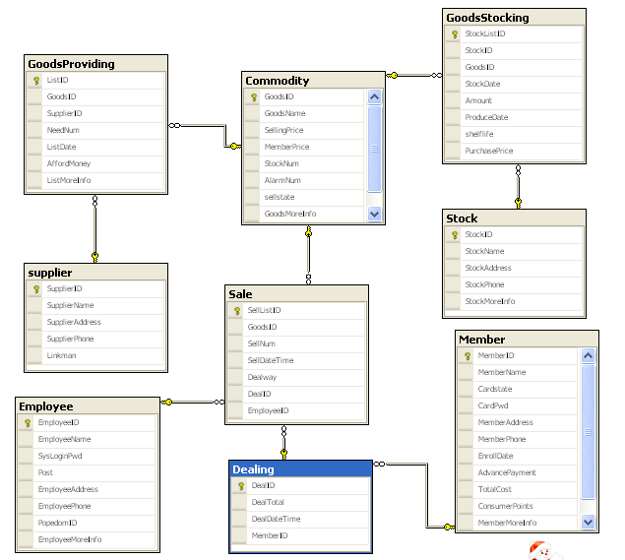

四．数据库应用开发与运行
采用ASP.net平台，用C#面向对象语言，SqlConnection连接数据库SQL SERVER2005
系统分为3个模块——前台收银，服务前台，后台管理。其中每个模块里又有各自的细分功能实现。
每个部分都大同小异，所以下面列出4个模块界面：登录界面，商品搜索，会员注册，商品入库信息管理。

1、系统登录模块：
效果图：
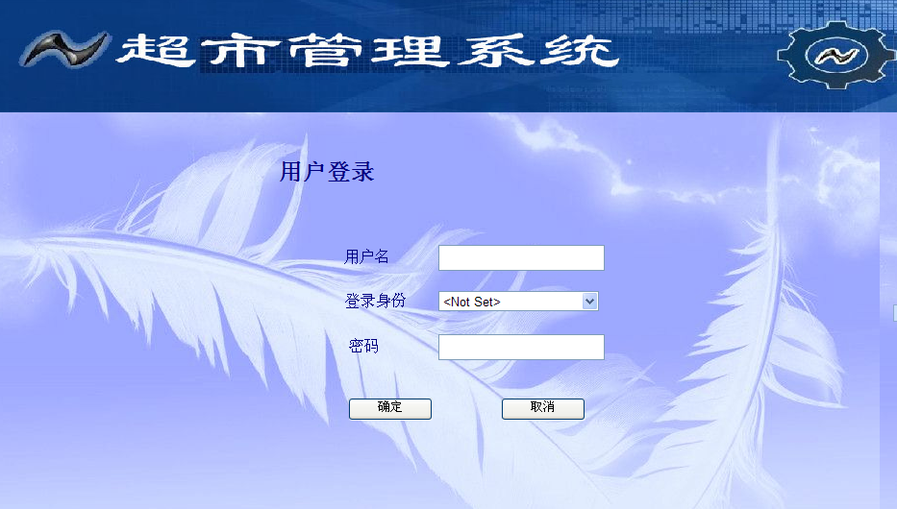
代码实现：

using System;
using System.Data;
using System.Configuration;
using System.Collections;
using System.Web;
using System.Web.Security;
using System.Web.UI;
using System.Web.UI.WebControls;
using System.Web.UI.WebControls.WebParts;
using System.Web.UI.HtmlControls;
using System.Data.SqlClient;

public partial class Login : System.Web.UI.Page
{
private static string strConnect = System.Configuration.ConfigurationManager.AppSettings["connStr"];
protected void Page_Load(object sender, EventArgs e)
{
if(!IsPostBack)
{
initLoginRole();
}

}

private void initLoginRole()
{
LoginRole.Items.Clear();
LoginRole.Enabled = true;
LoginRole.Items.Add("<Not Set>");
LoginRole.Items.Add("Cashier");
LoginRole.Items.Add("Receptist");
LoginRole.Items.Add("Manager");

}

protected void LoginButton_Click(object sender, EventArgs e)
{
//数据库连接
SqlConnection objConnection = new SqlConnection(strConnect);
//数据库命令
SqlCommand objCommand = new SqlCommand("", objConnection);
//设置Sql语句
objCommand.CommandText =
"SELECT EmployeeID, SysLoginPwd, " +
"RoleName ";
objCommand.CommandText +=
"FROM Employee, UserRole ";
objCommand.CommandText +=
"WHERE PopedomID=RoleID AND EmployeeID = @NAME AND SysLoginPwd = @PASSWORD AND RoleName = @ROLE";
//设置Sql语句参数
objCommand.Parameters.Add("NAME", SqlDbType.VarChar);
objCommand.Parameters.Add("PASSWORD", SqlDbType.VarChar);
objCommand.Parameters.Add("ROLE",SqlDbType.VarChar);
//Sql语句能数赋值
objCommand.Parameters["NAME"].Value = tbxName.Text.Trim();
objCommand.Parameters["PASSWORD"].Value = tbxPassword.Text.Trim();
objCommand.Parameters["ROLE"].Value = LoginRole.SelectedValue.ToString();

try
{
//打开数据库连接
if (objConnection.State == ConnectionState.Closed)
{
objConnection.Open();
}

//获取运行结果
SqlDataReader result = objCommand.ExecuteReader();
if (result.Read() == true)
{
//设置用户ID的Session全局变量
Session["EmployeeID"] = result["EmployeeID"].ToString();
Session["SysLoginPwd"] = result["SysLoginPwd"].ToString();
Session["RoleName"] = result["RoleName"].ToString();
//根据登录用户的权限，跳转到不同的页面
if (Session["RoleName"].ToString() == "Manager")
{
//如果是管理员，跳转到Manager.aspx
Response.Redirect("Manager/Manager.aspx");
}
else
{
//如果是收银员，跳转到Cashier.aspx
if (Session["RoleName"].ToString() == "Cashier")
{
Response.Redirect("Cashier/CheckOut.aspx");
}
else
{
if (Session["RoleName"].ToString() == "Receptist") //如果是服务台人员，跳转到Welcom.aspx
Response.Redirect("ReceptionDesk/ReceptionDesk.aspx");

}
}

}
//出错的话，显示labError
else
{
labError.Visible = true;
}
}

catch (SqlException exp)
{
//填充session里的错误信息,并跳转到错误显示页面
Session["Error"] = exp.Message;
Response.Redirect("Error.aspx");
}

finally
{
//关闭数据库连接
if (objConnection.State == ConnectionState.Open)
{
objConnection.Close();
}
}
}

protected void CancelButton_Click(object sender, EventArgs e)
{
LoginRole.Items.Clear();
tbxName.Text = "";
tbxPassword.Text = "";
labError.Visible = false;
initLoginRole();
}
}

2.商品搜索：
效果图：
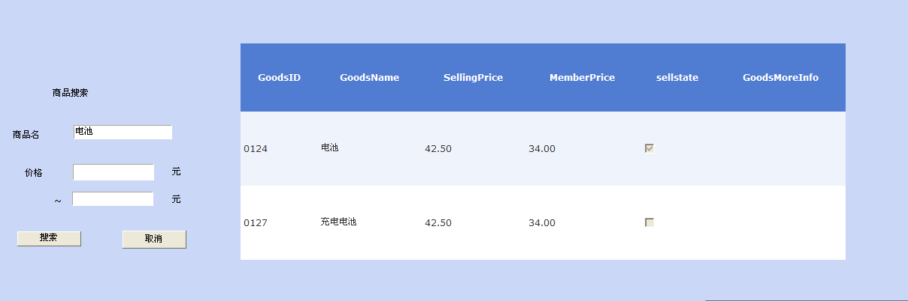
代码实现：
using System;
using System.Data;
using System.Configuration;
using System.Collections;
using System.Web;
using System.Web.Security;
using System.Web.UI;
using System.Web.UI.WebControls;
using System.Web.UI.WebControls.WebParts;
using System.Web.UI.HtmlControls;
using System.Data.SqlClient;

public partial class Cashier_GoodsQuery : System.Web.UI.Page
{
private static string strConnect = System.Configuration.ConfigurationManager.AppSettings["connStr"];
protected void Page_Load(object sender, EventArgs e)
{
if (!IsPostBack)
gvCommoditySearch.Visible = true;
}

//单击搜索事件
protected void btnSearch_Click(object sender, EventArgs e)
{
//数据库连接
SqlConnection objConnection = new SqlConnection(strConnect);
//数据库命令
SqlCommand objCommand = new SqlCommand("", objConnection);
//设置Sql语句
objCommand.CommandText = "SELECT GoodsID, GoodsName, SellingPrice, MemberPrice, sellstate, GoodsMoreInfo " + "FROM Commodity " + "WHERE 1=1 ";

if(tbxCommodityName.Text != "")
{
objCommand.CommandText += "AND GoodsName like '@COMMODITYNAME'";
}

if(tbxPriceFrom.Text != "")
{
objCommand.CommandText += "AND SellingPrice >= @PRICEFROM";
objCommand.Parameters.Add("PRICEFROM", SqlDbType.Decimal);
objCommand.Parameters["PRICEFROM"].Value = tbxPriceFrom.Text.Trim();
}
if(tbxPriceTo.Text != "")
{
objCommand.CommandText += "AND SellingPrice <= @PRICETO";
objCommand.Parameters.Add("PRICETO", SqlDbType.Decimal);
objCommand.Parameters["PRICETO"].Value = tbxPriceTo.Text.Trim();
}

//设置Sql语句参数类型
objCommand.Parameters.Add("COMMODITYNAME", SqlDbType.VarChar);

//Sql语句参数赋值
objCommand.Parameters["COMMODITYNAME"].Value = "%" + tbxCommodityName.Text.Trim() + "%";

//这里使用DataAdapter和DataSet获取数据
DataSet objDataset = new DataSet();
SqlDataAdapter objAdapter = new SqlDataAdapter();
objAdapter.SelectCommand = new SqlCommand(objCommand.CommandText, objConnection);

try
{
//打开数据库连接
if (objConnection.State == ConnectionState.Closed)
{
objConnection.Open();
}
//数据填充
objAdapter.Fill(objDataset);
}
catch (SqlException exp)
{
Session["Error"] = exp.Message;
Response.Redirect("Error.aspx");
}
finally
{
//关闭数据库连接
if(objConnection.State == ConnectionState.Open)
{
objConnection.Close();
}
}

//设置数据源
//gvCommoditySearch.DataSource = objDataset.Tables["Commodity"];
//绑定数据源
//gvCommoditySearch.DataBind();

}

protected void btnClearSearch_Click(object sender, EventArgs e)
{
tbxCommodityName.Text = "";
tbxPriceFrom.Text = "";
tbxPriceTo.Text = "";
}
protected void gvCommoditySearch_SelectedIndexChanged(object sender, EventArgs e)
{

}
}

3.会员注册：
效果图：
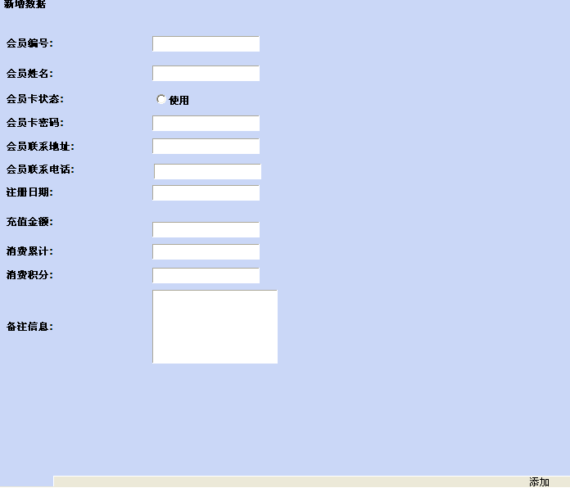
代码实现：
using System;
using System.Data;
using System.Configuration;
using System.Collections;
using System.Web;
using System.Web.Security;
using System.Web.UI;
using System.Web.UI.WebControls;
using System.Web.UI.WebControls.WebParts;
using System.Web.UI.HtmlControls;
using System.Data.SqlClient;

public partial class Manager_Info_MemData : System.Web.UI.Page
{
private static string strConnect = System.Configuration.ConfigurationManager.AppSettings["connStr"];
protected void Page_Load(object sender, EventArgs e)
{

}

protected void btnInsert_Click(object sender, EventArgs e)
{
//数据库连接
SqlConnection objConnection = new SqlConnection(strConnect);
//数据库命令
SqlCommand objCommand = new SqlCommand("", objConnection);
//设置Sql语句，插入会员输入的注册信息
objCommand.CommandText = "INSERT INTO Member " + "(MemberID, MemberName, Cardstate, CardPwd, MemberAddress, MemberPhone, EnrollDate, AdvancePayment, TotalCost, ConsumerPoints)"
+ "VALUES" + "(@MEMID, @MEMNAME, @CARDSTATE, @CARDPWD, @MEMADD, @MEMPHONE, @ENROLLDATE, @ADVANCEPAY, @TOTALCOST, @CONSUMERPOINTS)";

//设置Sql语句参数的类型
objCommand.Parameters.Add("MEMID", SqlDbType.VarChar);
objCommand.Parameters.Add("MEMNAME", SqlDbType.VarChar);
objCommand.Parameters.Add("CARDSTATE", SqlDbType.Bit);
objCommand.Parameters.Add("CARDPWD", SqlDbType.VarChar);
objCommand.Parameters.Add("MEMADD", SqlDbType.VarChar);
objCommand.Parameters.Add("MEMPHONE", SqlDbType.VarChar);
objCommand.Parameters.Add("ENROLLDATE", SqlDbType.DateTime);
objCommand.Parameters.Add("ADVANCEPAY", SqlDbType.Decimal);
objCommand.Parameters.Add("TOTALCOST", SqlDbType.Decimal);
objCommand.Parameters.Add("CONSUMERPOINTS", SqlDbType.Int);

//Sql语句参数赋值
objCommand.Parameters["MEMID"].Value = TextBox1.Text.Trim();
objCommand.Parameters["MEMNAME"].Value = TextBox2.Text.Trim();
objCommand.Parameters["CARDSTATE"].Value = RadioButton1.Checked.ToString();
objCommand.Parameters["CARDPWD"].Value = TextBox4.Text.Trim();
objCommand.Parameters["MEMADD"].Value = TextBox5.Text.Trim();
objCommand.Parameters["MEMPHONE"].Value = TextBox6.Text.Trim();
objCommand.Parameters["ENROLLDATE"].Value = TextBox7.Text.Trim();
objCommand.Parameters["ADVANCEPAY"].Value = TextBox10.Text.Trim();
objCommand.Parameters["TOTALCOST"].Value = TextBox9.Text.Trim();
objCommand.Parameters["CONSUMERPOINTS"].Value = TextBox11.Text.Trim();

try
{
//打开数据库连接
if (objConnection.State == ConnectionState.Closed)
{
objConnection.Open();
}

//插入数据
objCommand.ExecuteNonQuery();
}

catch (SqlException exp)
{
Session["Error"] = exp.Message;
Response.Redirect("Error.aspx");

}

finally
{
//关闭数据库连接
if (objConnection.State == ConnectionState.Open)
objConnection.Close();
}

}
}

4.商品入库信息管理：
效果图：
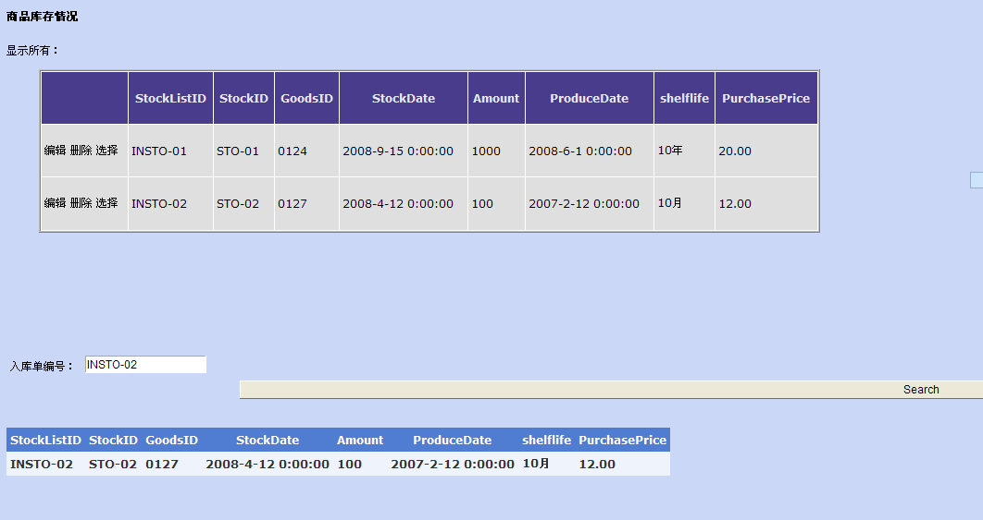
代码实现：
using System;
using System.Data;
using System.Configuration;
using System.Collections;
using System.Web;
using System.Web.Security;
using System.Web.UI;
using System.Web.UI.WebControls;
using System.Web.UI.WebControls.WebParts;
using System.Web.UI.HtmlControls;
using System.Data.SqlClient;

public partial class Manager_StockMag : System.Web.UI.Page
{
private static string strConnect = System.Configuration.ConfigurationManager.AppSettings["connStr"];
protected void Page_Load(object sender, EventArgs e)
{

}
protected void btnInsert_Click(object sender, EventArgs e)
{
//数据库连接
SqlConnection objConnection = new SqlConnection(strConnect);
//数据库命令
SqlCommand objCommand = new SqlCommand("", objConnection);
//设置Sql语句，插入会员输入的注册信息
objCommand.CommandText = "INSERT INTO GoodsStocking " + "(StockListID, StockID, GoodsID, StockDate, Amount, ProduceDate, shelflife, PurchasePrice)"
+ "VALUES" + "(@STOCKLIST, @STOCKID, @GOODSID, @STOCKDATE, @AMOUNT, @PRODUCEDATE, @SHELFLIFE, @PURCHASEPRICE)";

//设置Sql语句参数的类型
objCommand.Parameters.Add("STOCKLIST", SqlDbType.VarChar);
objCommand.Parameters.Add("STOCKID", SqlDbType.VarChar);
objCommand.Parameters.Add("GOODSID", SqlDbType.VarChar);
objCommand.Parameters.Add("STOCKDATE", SqlDbType.DateTime);
objCommand.Parameters.Add("AMOUNT", SqlDbType.Int);
objCommand.Parameters.Add("PRODUCEDATE", SqlDbType.DateTime);
objCommand.Parameters.Add("SHELFLIFE", SqlDbType.VarChar);
objCommand.Parameters.Add("PURCHASEPRICE", SqlDbType.Decimal);

//Sql语句参数赋值
objCommand.Parameters["STOCKLIST"].Value = TextBox1.Text.Trim();
objCommand.Parameters["STOCKID"].Value = TextBox2.Text.Trim();
objCommand.Parameters["GOODSID"].Value = TextBox3.Text.Trim();
objCommand.Parameters["STOCKDATE"].Value = TextBox4.Text.Trim();
objCommand.Parameters["AMOUNT"].Value = TextBox5.Text.Trim();
objCommand.Parameters["PRODUCEDATE"].Value = TextBox6.Text.Trim();
objCommand.Parameters["SHELFLIFE"].Value = TextBox7.Text.Trim();
objCommand.Parameters["PURCHASEPRICE"].Value = TextBox8.Text.Trim();

try
{
//打开数据库连接
if (objConnection.State == ConnectionState.Closed)
{
objConnection.Open();
}

//插入数据
objCommand.ExecuteNonQuery();
}

catch (SqlException exp)
{
Session["Error"] = exp.Message;
Response.Redirect("Error.aspx");

}

finally
{
//关闭数据库连接
if (objConnection.State == ConnectionState.Open)
objConnection.Close();
}

}

}

