Table of Contents

Screenshots 1

Debugging 3

Basic Principles 4

Hardware 4

Network 4

Database management systems 4

Object-oriented programming 4

Open-source development tools 4

Small-size and medium-size applications 5

Programming methodologies and SDLC 5

Waterfall: 5

Spiral: 5

Proto typing: 5

Agile: 5

Data Structures 6

Object-oriented programming concepts 6

GUI Process and techniques 7

Using API 7

Bibliography 8

## Screenshots

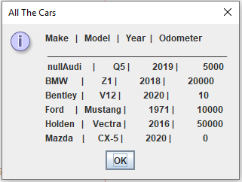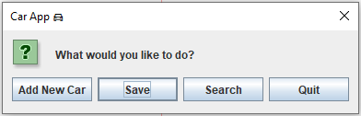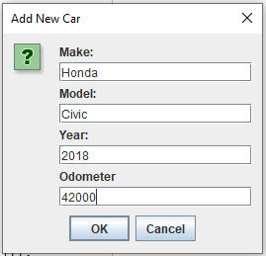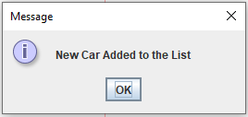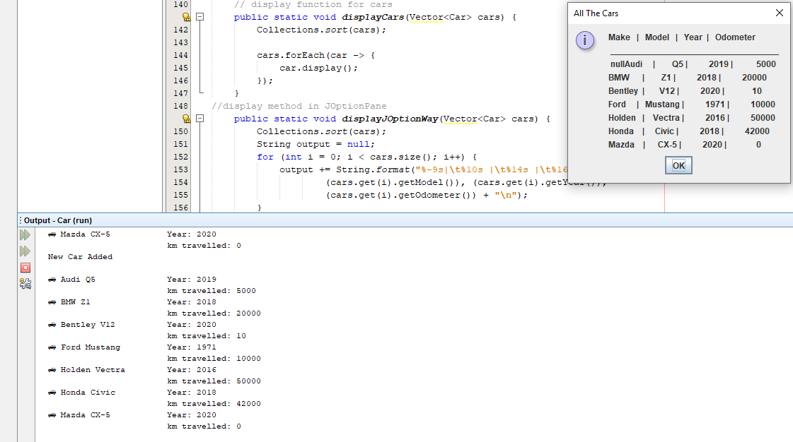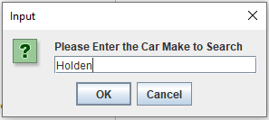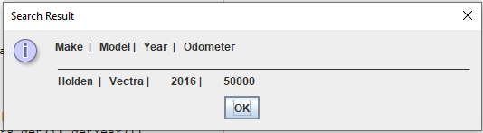

## Debugging

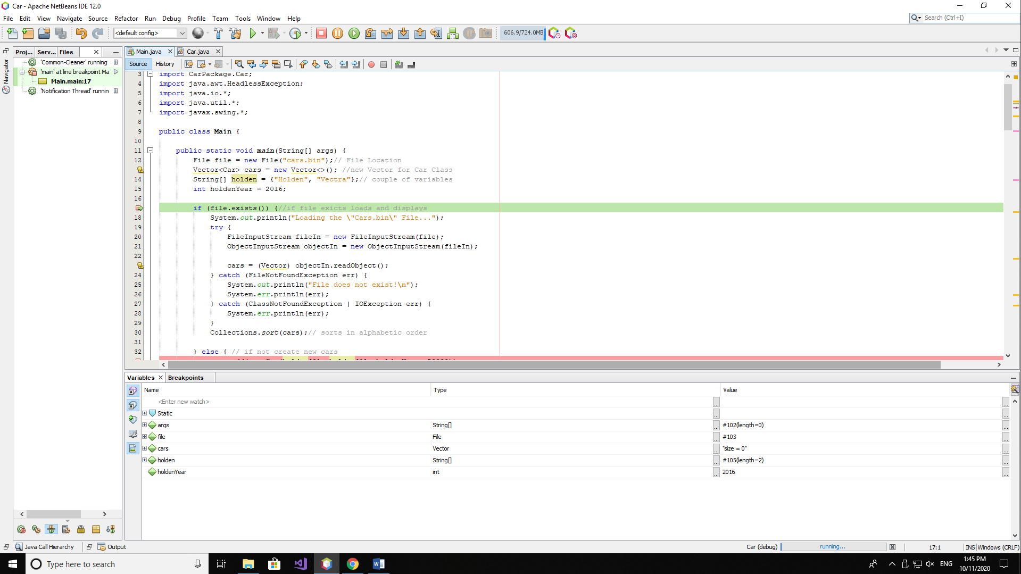

## 

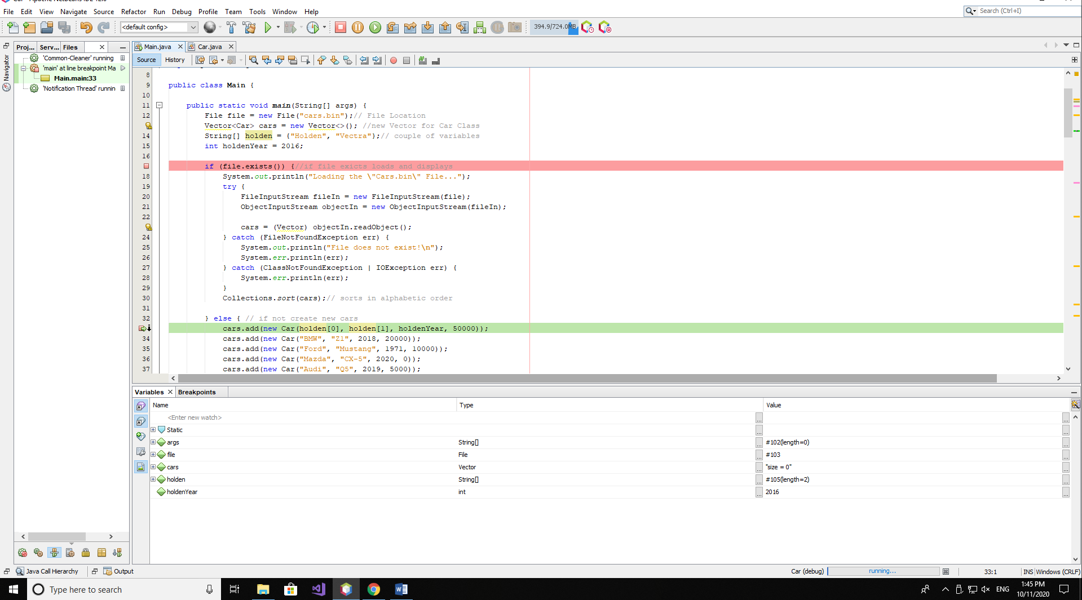

Above show how do I debug on NetBeans and seems like everything is working perfectly.

## Basic Principles

### Hardware

Software uses hardware to perform four basic functions: input, processing, storage, and output. An application is specialized software that performs a certain function, such as word processing or media reproduction. (Wikibook, 2017)

### Network

Networks are the means by which computing and telecommunications technologies are merged. Network components may consist of computers, telephones, data terminals, switches, communication channels, network protocols and operating software, all of which function together to provide for the exchange of information. (questia, 2018)

### Database management systems

Principles of Database Management provides readers with the comprehensive database management information to understand and apply the fundamental concepts of database design and modeling, database systems, data storage, and the evolving world of data warehousing, governance and more. (Wiley, 2017)

### Object-oriented programming

Knowledge of computer programming is in high demand in today's technology-driven society. Having knowledge of object-oriented programming (OOP) can be valuable when developing and maintaining software programs. In this article, we discuss the basic principles of OOP and explain them in easy-to-understand examples. (indeed, 2020)

### Open-source development tools

Free redistribution: An individual may use all or parts of the open source software as a component in a larger software application without the requirement of a royalty or a fee. Creation of derived works: Individuals are allowed to change or expand the open source software and distribute the newly created software. (Ardal, 2011)

# Small-size and medium-size applications

Earlier, small-scale application development was defined as following a waterfall and iterative process. An iteration is the software development of one or more use-case scenarios. A schedule, developed as part of the analysis, defines the order of iterations for the implementation and test phases of the process. Where medium size applications focused set of deliverables requiring a significant amount of work. Generally take 3-6 months. There may be multiple stakeholders who are generally in agreement on project goal. Some unfamiliar work may be involved. Involves a small team of individuals

## Programming methodologies and SDLC

The Systems Development Life Cycle (SDLC) gives structure to the challenges of transitioning from the beginning to the end of your project without forgetting a step.

### Waterfall:

The oldest and most straightforward of the structured SDLC methodologies — finish one phase, then move on to the next.

### Spiral:

One of the most flexible SDLC methodologies, the Spiral model takes a cue from the Iterative model and its repetition; the project passes through four phases over and over in a “spiral” until completed, allowing for multiple rounds of refinement.

### Proto typing:

Software development model in which prototype is built, tested, and reworked until an acceptable prototype is achieved. It also creates base to produce the final system or software.

### Agile:

Quickly delivers a working product and is considered a very realistic development approach. This model emphasizes interaction, as the customers, developers and testers work together throughout the project.

## Data Structures

In computer science, a data structure is a data organization, management, and storage format that enables efficient access and modification. More precisely, a data structure is a collection of data values, the relationships among them, and the functions or operations that can be applied to the data.

ArrayList is part of collection framework in Java. Therefore array members are accessed using [], while ArrayList has a set of methods to access elements and modify them. an Array is a fixed size data structure while ArrayList is not. One need not to mention the size of Arraylist while creating its object. (Abiola, 2018)

## Object-oriented programming concepts

Object-oriented programming has four basic concepts: encapsulation, abstraction, inheritance and polymorphism. Even if these concepts seem incredibly complex, understanding the general framework of how they work will help you understand the basics of a computer program. (indeed, indeed, 2020)

**Instances or objects can have their own attributes. The easiest way to create an instance attribute is just assigning a new value to a new variable using instance name. Class and instance attribute differences can be explained using __dict__ attribute and the term namespace. A namespace is a mapping from names to objects, with the property that there is zero relation between names in different namespaces.**(Frank, 2019)

## GUI Process and techniques

**A GUI uses**[**windows**](https://www.computerhope.com/jargon/w/windows.htm)**,**[**icons**](https://www.computerhope.com/jargon/i/icon.htm)**, and**[**menus**](https://www.computerhope.com/jargon/m/menu.htm)**to carry out commands, such as opening, deleting, and moving files. Although a GUI operating system is primarily navigated using a**[**mouse**](https://www.computerhope.com/jargon/m/mouse.htm)**, a keyboard can also be used via**[**keyboard shortcuts**](https://www.computerhope.com/jargon/k/keyboard-shortcut.htm)**or the**[**arrow keys**](https://www.computerhope.com/jargon/a/arrowkey.htm)**.** (Hope, 2019)

In JavaFX, we can develop GUI applications, web applications and graphical applications. In such applications, whenever a user interacts with the application (nodes), an event is said to have been occurred. (Point, 2018)

**Foreground Events** − Those events which require the direct interaction of a user. They are generated as consequences of a person interacting with the graphical components in a Graphical User Interface. For example, clicking on a button, moving the mouse, entering a character through keyboard, selecting an item from list, scrolling the page, etc. (Point, 2018)

**Background Events** − Those events that require the interaction of end user are known as background events. The operating system interruptions, hardware or software failure, timer expiry, operation completion are the example of background events. (Point, 2018)

## Using API

**JavaDoc tool is a document generator tool in Java programming language for generating standard documentation in HTML format. It generates API documentation. It parses the declarations ad documentation in a set of source file describing classes, methods, constructors and fields. (Geek, 2019)**

# Bibliography

Abiola, E. (2018, 7 15). *medium*. Retrieved from medium: https://medium.com/@Emmanuel.A/data-structures-arraylist-239a5b39cd7e

Ardal, C. (2011, 9 28). *ncbi*. Retrieved from ncbi: https://www.ncbi.nlm.nih.gov/pmc/articles/PMC3206459/

Frank. (2019, 5 29). *medium*. Retrieved from medium: https://medium.com/swlh/oop-basics-class-vs-instance-attributes-in-python3-7a6cfb577282#:~:text=In%20Object%2Doriented%20programming(OOP,of%20the%20class%20or%20instance.&text=One%20can%20think%20of%20attributes,the%20verb%20of%20the%20class.

Geek. (2019, 4 8). *geeksforgeeks*. Retrieved from geeksforgeeks: https://webcache.googleusercontent.com/search?q=cache:iooYy2x7_5oJ:https://www.geeksforgeeks.org/what-is-javadoc-tool-and-how-to-use-it/+&cd=1&hl=en&ct=clnk&gl=au

Hope. (2019, 11 16). *computerhope*. Retrieved from computerhope: https://www.computerhope.com/jargon/g/gui.htm#:~:text=as%20%22gooey.%22-,How%20does%20a%20GUI%20work%3F,shortcuts%20or%20the%20arrow%20keys.

indeed. (2020, 10 28). *indeed*. Retrieved from indeed: https://www.indeed.com/career-advice/career-development/what-is-object-oriented-programming

indeed. (2020, 10 27). *indeed*. Retrieved from indeed: https://www.indeed.com/career-advice/career-development/what-is-object-oriented-programming#:~:text=Object%2Doriented%20programming%20has%20four,basics%20of%20a%20computer%20program.

Point. (2018, 6 14). *tutorialspoint*. Retrieved from tutorialspoint: https://www.tutorialspoint.com/javafx/javafx_event_handling.htm

questia. (2018, 4 5). *questia*. Retrieved from questia: https://www.questia.com/library/journal/1G1-6717279/the-basic-principles-of-networking#:~:text=Networks%20are%20the%20means%20by,for%20the%20exchange%20of%20information.

Wiley. (2017, 1 20). *pdbmbook*. Retrieved from pdbmbook: https://www.pdbmbook.com/#:~:text=Principles%20of%20Database%20Management%20provides,data%20warehousing%2C%20governance%20and%20more.