## Test Tables

|  |  |  |  |  |  |  |  |
| --- | --- | --- | --- | --- | --- | --- | --- |
| Test Report 1 | | | | | | | |
| Project Name: RAD Sprint One | | | Test Type: Black Box | | | | |
| Description: Movie Search Application | | | Date: 29/05/2021 | | | | |
| Developer(s): Blake Topham, Erol Anil, Nathan Tai | | | Tester: Nathan Tai | | | | |
| Test Case # | Test Case Name | Test Steps | | Test Data | Expected Results | Evidence | Pass / Fail |
| 1 | Search by Name | Enter search terms | | Search term | Matching results displayed | Figure 4 | Fail |
| 2 | Search by Name, Genre | Enter search terms | | Search term | Matching results displayed | N/A | N/A |
| 3 | Search by Name, Genre, Rating | Enter search terms | | Search term | Matching results displayed | N/A | N/A |
| 4 | Search by Name, Genre, Rating, Year | Enter search terms | | Search term | Matching results displayed | N/A | N/A |
| 5 | Top Ten Movies | Click “10 Most Searched” button | | 10 movies with highest search count | 10 movies with highest search count displayed | N/A | N/A |
| 6 | Runs on: Desktop PC | Run page in desktop browser | | Page elements | Page runs | N/A | N/A |
| 7 | Runs on:  iPad | Run page in device simulation mode | | Page elements | Page runs | N/A | N/A |
| 8 | Runs on: Galaxy S5 | Run page in device simulation mode | | Page elements | Page runs | N/A | N/A |
| Testing suspended.  Suspension Criteria met:   * #1: Any vital functionality is broken * #2: An error directly prevents further testing | | | | | | | |

|  |  |  |  |  |  |  |  |
| --- | --- | --- | --- | --- | --- | --- | --- |
| Test Report 2 | | | | | | | |
| Project Name: RAD Sprint One | | | Test Type: Black Box | | | | |
| Description: Movie Search Application | | | Date: 29/05/2021 | | | | |
| Developer(s): Blake Topham, Erol Anil, Nathan Tai | | | Tester: Nathan Tai | | | | |
| Test Case # | Test Case Name | Test Steps | | Test Data | Expected Results | Evidence | Pass / Fail |
| 1 | Search by Name | Enter search terms | | Search term | Matching results displayed | Figure 5 | Pass |
| 2 | Search by Name, Genre | Enter search terms | | Search term | Matching results displayed | Figure 6 | Pass |
| 3 | Search by Name, Genre, Rating | Enter search terms | | Search term | Matching results displayed | Figure 7 | Pass |
| 4 | Search by Name, Genre, Rating, Year | Enter search terms | | Search term | Matching results displayed | Figure 8 | Pass |
| 5 | Top Ten Movies | Click “10 Most Searched” button | | 10 movies with highest search count | 10 movies with highest search count displayed | Figure 9 | Pass |
| 6 | Runs on: Desktop PC | Run page in desktop browser | | Page elements | Page runs | Figure 10 | Pass |
| 7 | Runs on:  iPad | Run page in device simulation mode | | Page elements | Page runs | Figure 11 | Pass |
| 8 | Runs on: Galaxy S5 | Run page in device simulation mode | | Page elements | Page runs | Figure 12 | Pass |
| Test Completeness Criteria Achieved:   1. All test cases carried out successfully 2. All bugs fixed | | | | | | | |

### Screenshots

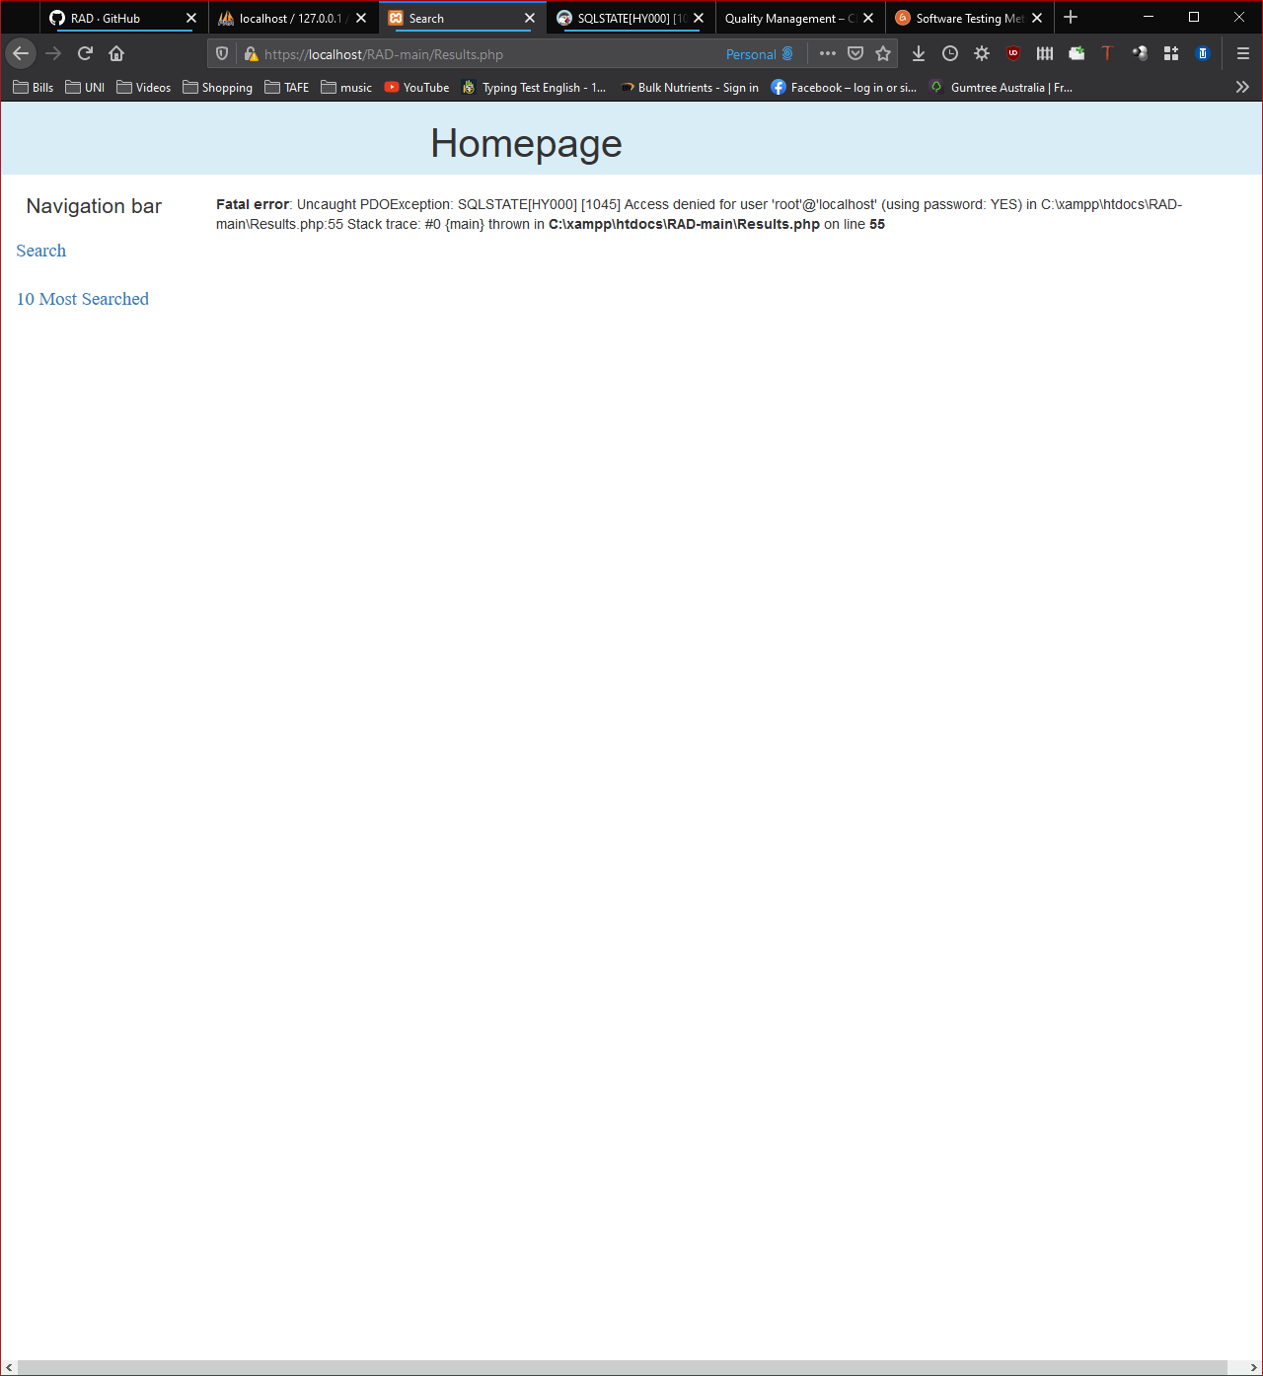

Figure 4- Test Case 1 failed

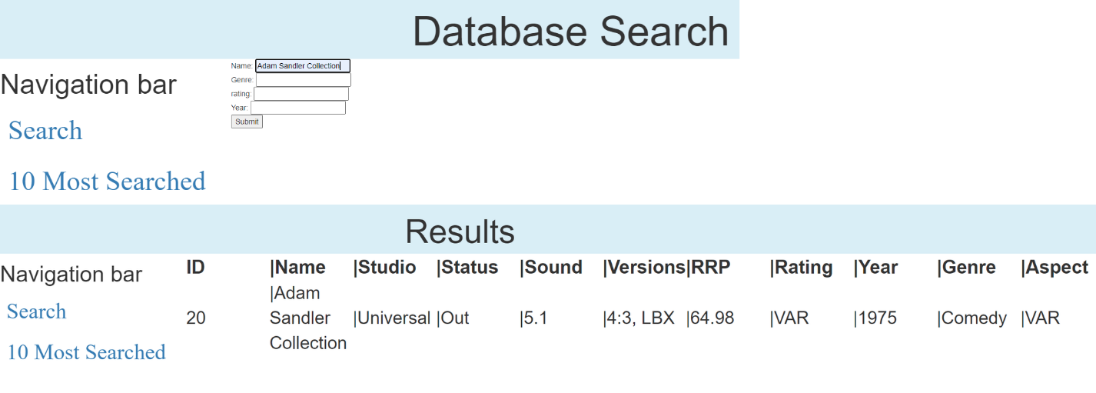

Figure 5- Name search

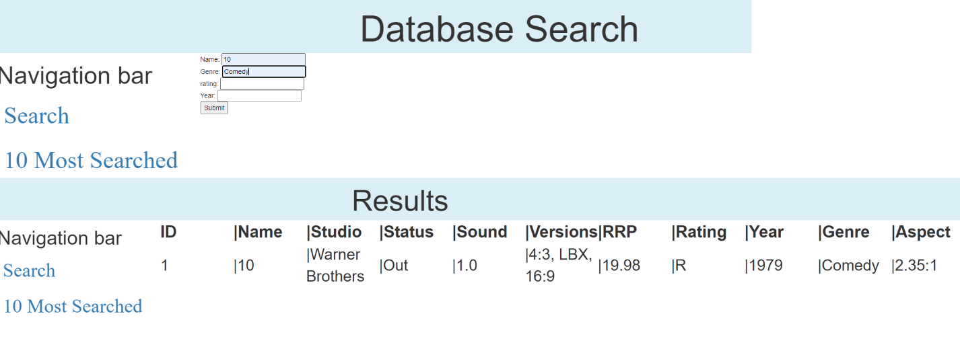

Figure 6- Name, Genre

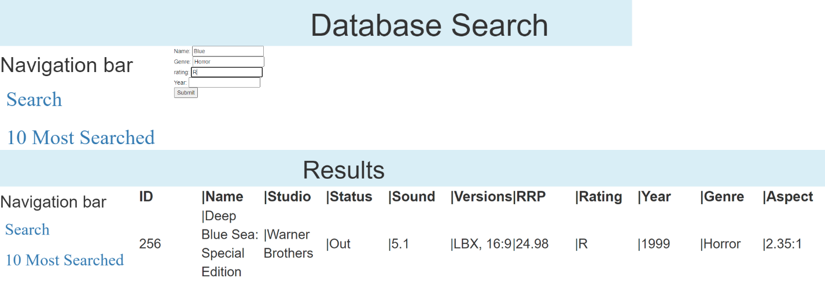

Figure 7-Name, Genre, Rating

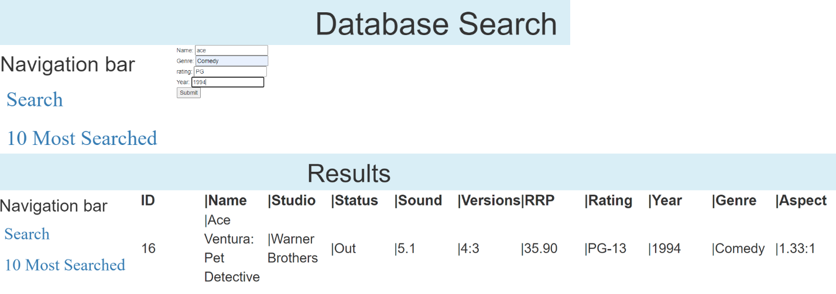

Figure 8- Name, Genre, Rating, Year

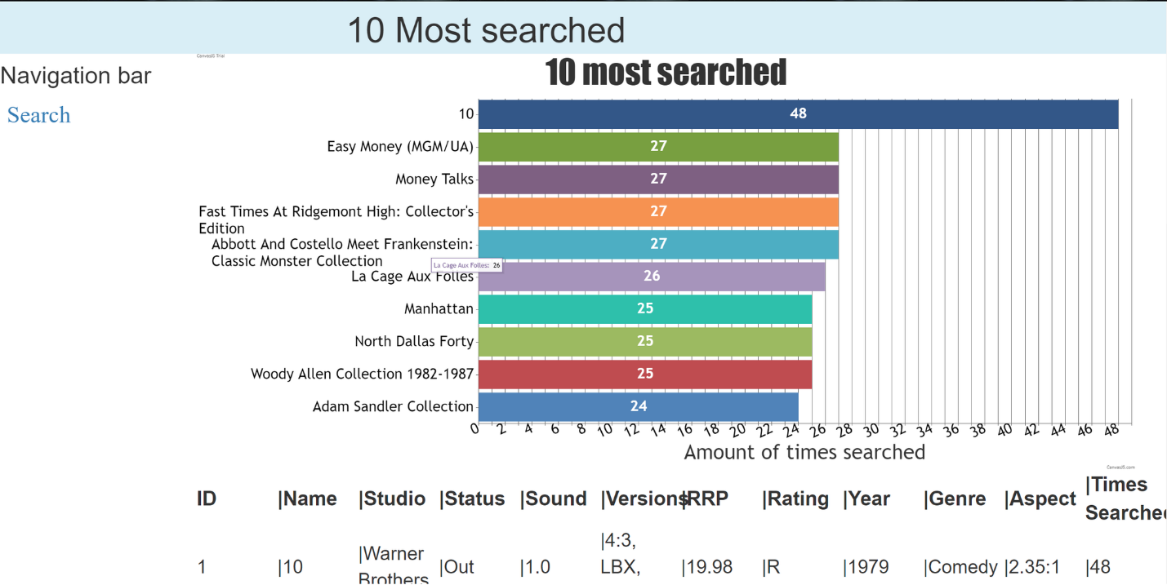

Figure 9- Top ten

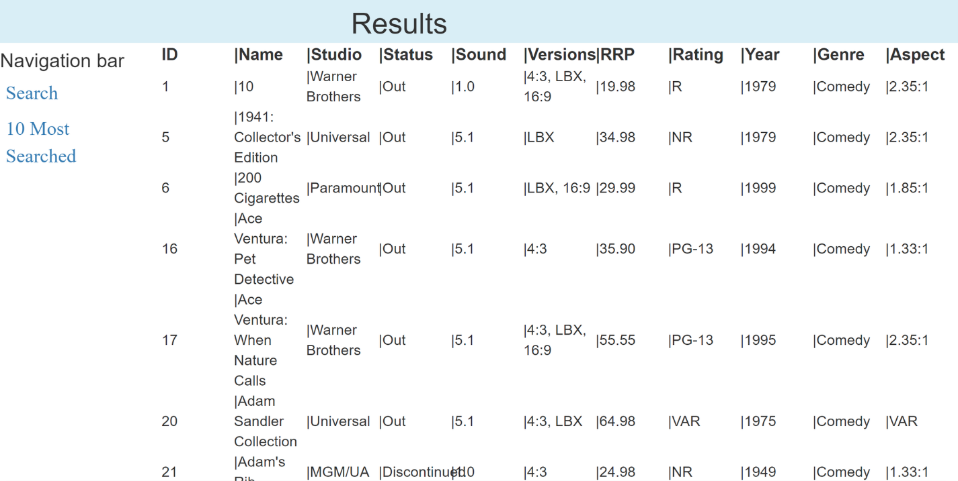

Figure 10- Runs on PC

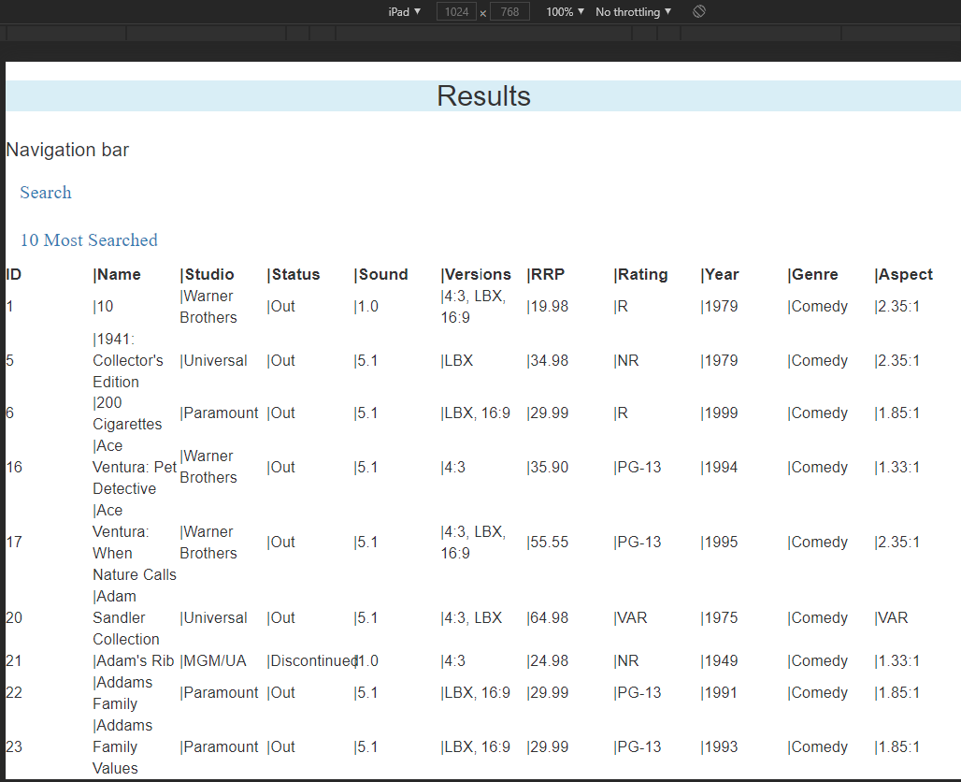

Figure 11- Runs on iPad

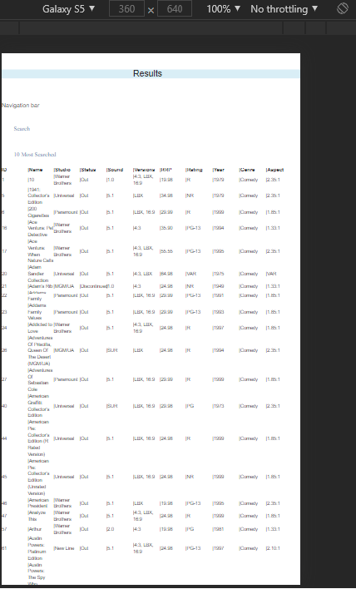

Figure 12- Runs on Galaxy S9

### Bug Triage 1

#### Meeting Minutes

27/05/2021

Present: Blake Topham, Erol Anil, Nathan Tai

Next meeting: 03/06/2021, 9:00AM, Murdoch Campus

**1. Bug Report**

One bug identified and discussed. Database connection broken, in need of modification to fit new server.

**2. Triage (Bug Priority)**

Sole bug takes top priority by default.

|  |  |  |  |  |  |
| --- | --- | --- | --- | --- | --- |
| **#ID** | **DESCRIPTION** | **SEVERITY** | **FREQUENCY** | **RISK** | **PRIORITY** |
| 1 | Database connection fails | **HIGH** | **HIGH** | **HIGH** | **HIGH** |

Table 1- Bug Report 27/05/2021