**Cybersecurity and Infrastructure Card Game**

**Access Denied Quick Play Instructions**

**Designer: Jessica D. Bayliss, Ph.D., Illustrator: Diego Barillas**

**Starting:**

* 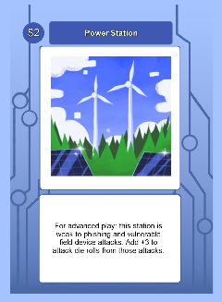Starting Board: Place one of your 2-pt facilities face up (each player)
* Deck shuffling:
  + Shuffle all other facilities per player and place face down.
  + Shuffle the rest of your deck and place cards face down in a separate pile from the facilities deck.
* Starting cards for each player:
  + Each player has a discard pile for cards from their own deck. The discard pile starts out empty.

**Play:**

**Draw, Discard, and Discuss:** Draw until you have 5 cards in your hand. If one or more of the cards are discussion cards, then discuss the topic of the cards for five minutes before discarding that card and drawing another. You may discard up to 2 cards other than discussion cards.

**Defense phase:** Play up to one defense card on a facility if one is in your hand.

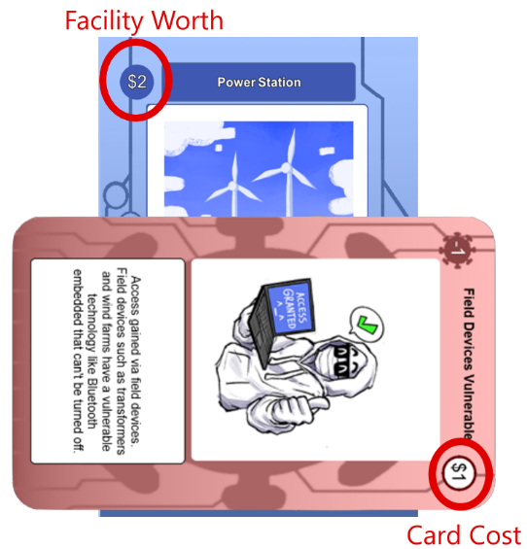**Vulnerability phase:** Spend the number of points in facilities you own (not impacted by current “health” of a facility) to let other players know the vulnerabilities you’ve discovered on their stations.

**Mitigation phase:** Use mitigation cards to mitigate & discard any vulnerabilities on your own facilities to appropriate player’s discard areas.

**Attack phase:** For the vulnerability cards that cannot be countered, roll a d20 to see if the vulnerability is attacked. Anything >10 is assumed to be a successful attack. Discard only vulnerabilities that were successfully attacked, or they stay if not yet countered/attacked. Put a counter on a facility that has lost points but is still > 0. This count is only used to determine facility removal and not facility worth which stays the same throughout.

**Facility phase**: Draw a new station from the facility card pile if there are cards left in it.

**Connection phase**: Decide how to connect the new facility to your grid and note that the optimal number of connections at the end of the game (to score further points) is minimally the original point value of the facility worth.

**Repeat from the Draw, Discard, and Discuss phase**

**End Points: Sum all remaining facility worth points minus lost points and +1 for each facility with >= its facility worth points in connections.**