**Structure:**

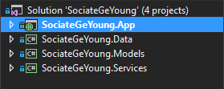

* **SociateGeYoung.App -** Client

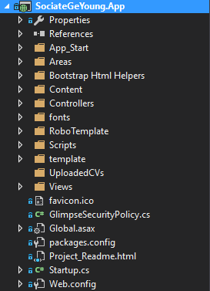

* **SociateGeYoung.Data**

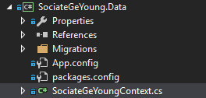

* **SociateGeYoung.Models**

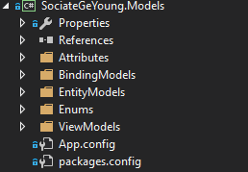

* **SociateGeYoung.Services** - Class Library where Entity Framework querying the database.
* 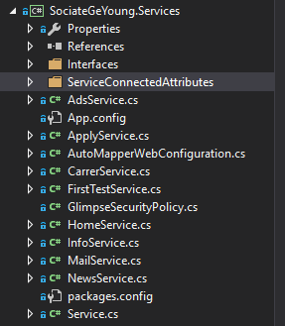

We want:

1. Creation of ASP .NET Web API 2:
   1. The purpose is to exchange files with the client (User’s .pdf, .docx and JSON) . It needs to be configured with file server in the bank.
   2. The result of the career test(s) will need to be displayed in the HR panel for each user.
2. Changing the FRONT-END with our provider's interface. The ChatBot is going to send JSON files with answers of users. They are going to be post on HR Admin panel and related to its users. These files will also be kept on the file server.
3. Allow registration with Facebook and Google+.
4. When the application is ready, it will have to be uploaded to a test and production environment in the bank.

In addition: We'll need a support for security and bug fixing.