# Aggregate

In the study of domain-driven design within the realm of software engineering, the concept of an "Aggregate" emerges as a pivotal construct. Within our designated domain model—focused on snack machines and snacks—two aggregates are discernible. An Aggregate serves as a simplifying mechanism for domain models by encapsulating multiple entities under a singular conceptual umbrella.

Central to the aggregate is its role as a "conceptual whole," serving to cohesively encapsulate specific entities relevant to the domain model. Such a conceptual entity is governed by a set of invariants that are upheld throughout its lifecycle. For instance, within our snack machine aggregate, an invariant could dictate that the machine cannot hold snacks exceeding a weight of 10 pounds. This invariant is intrinsically managed within the aggregate, prohibiting extraneous client code from violating this stipulation.

Each aggregate is demarcated by a 'root,' which functions as the primary entity serving as the anchor for the aggregate. Interactions from classes external to the aggregate are permitted solely with this root entity. In the context of our model, the `SnackMachine` class serves as the root of the snack machine aggregate. This configuration prohibits external entities from holding permanent references to internal, non-root entities, thereby sustaining the aggregate's integrity.

This architectural choice is not merely cautionary but serves a functional purpose. It establishes a defensive barrier against the violation of the aggregate's invariants, thereby safeguarding the aggregate’s internal state from corruption. Consequently, Application Services should operate on the aggregate as a unified operational unit, from retrieval to persistence, to ensure data consistency within the database.

Furthermore, aggregates act as the boundary for consistency, meaning that the data within a single aggregate should be transactionally coherent. In the case of our snack machine, the persistence of the aggregate should encapsulate both the machine and its slots, thereby conforming to the established invariants.

Lastly, it is worth noting that while entities are confined to a single aggregate, value objects can transcend these boundaries. For instance, a money value object can be shared across multiple aggregates, reinforcing the modular nature of domain-driven design.

To summarize, the aggregate serves as a robust construct in domain-driven design, affording simplification, ensuring integrity through invariants, and providing a cohesive approach to data consistency. This study reinforces the critical role of aggregates in establishing a resilient, maintainable, and scalable domain model.

# Bounded Context

The concept of a "Bounded Context" is a cornerstone in Domain-Driven Design (DDD), serving as a mechanism for isolating distinct parts of the model to facilitate manageability and scalability. It is important to differentiate this concept from that of "Sub-domains," which often confounds practitioners in the field.

### Attributes of Bounded Contexts

A Bounded Context delineates the perimeter for a ubiquitous language—a set of terms and concepts specific to a particular model. This language is cohesive within the context but need not maintain coherence across different Bounded Contexts. Essentially, Bounded Contexts can be likened to namespaces in C#, where classes with identical names can co-exist without conflict, so long as they reside in separate namespaces. For example, a "CompositeElement" class in a "SnackMachine" Bounded Context may have no relational or conceptual overlap with a "CompositeElement" class in an "ATM" Bounded Context.

Furthermore, a Bounded Context permeates all layers of the architectural model, manifesting in entities, repositories, factories, Application Services, and so on. This encapsulation underscores the need for self-sufficiency within each Bounded Context.

### Context Maps

To navigate the relationships between Bounded Contexts, Context Maps are employed. These graphical representations illustrate the interplay among various Bounded Contexts and offer a high-level overview of the system’s architecture. Context Maps, as championed by Eric Evans, provide valuable insights into system integration and boundaries.

### Sub-domains and Their Relation to Bounded Contexts

Sub-domains inhabit the problem space; they delineate segments of the larger problem that the software aims to solve. Bounded Contexts, in contrast, exist in the solution space, representing distinct parts of the solution architecture tailored to address specific sub-domains. The ideal correspondence is a one-to-one mapping between Sub-domains and Bounded Contexts, although practical constraints may necessitate deviations from this model.

For instance, consider a legacy ERP project that requires enhancements to its sales sub-domain. If the codebase lacks test coverage, the risk associated with modifications might advocate for a new, separate Bounded Context, partitioned by an anti-corruption layer. In such scenarios, a single sub-domain would be covered by multiple Bounded Contexts—a situation best avoided for maintainability.

### Recommendations for Practice

It is advisable to adhere to a one-to-one mapping between Sub-domains and Bounded Contexts whenever possible, as this facilitates code maintainability and conceptual clarity. For greenfield projects, devoid of legacy code impediments, such adherence is generally more feasible.

In summary, Bounded Contexts and Sub-domains are vital constructs in DDD, each serving distinct yet complementary roles. Understanding their attributes and interrelations is crucial for effective domain modeling and software architecture.

# boundaries

Determining the appropriate boundaries for aggregates within a domain-driven design (DDD) model is an intricate task that remains essential for the efficacy of the model. The question of why our domain model comprises exactly two aggregates—namely "SnackMachine" and "Snack"—instead of a singular or more complex construct, brings forth a discourse on cohesion, coupling, and the iterative nature of domain modeling.

Aggregates are not defined by an objective set of attributes; rather, their boundaries are contingent on the specificities of the domain model under consideration. Cohesion serves as a key criterion in this delineation, whereby entities within an aggregate should display a high degree of cohesion and share minimal coupling with entities in other aggregates. A useful heuristic to consider is the existential interdependence among entities: if an entity's existence is logically untenable without another, it is likely that they belong to the same aggregate.

In our exemplar domain, the entity "Slot" lacks autonomous significance without a "SnackMachine," suggesting its aptitude for inclusion within the "SnackMachine" aggregate. On the contrary, "Snack" exhibits sufficient autonomy to warrant classification as the root of its own aggregate. Therefore, these two aggregates have been formed based on their internal cohesion and relative autonomy from one another.

It is pivotal to recognize domain modeling as an iterative process. As the development lifecycle progresses, the accruing domain knowledge may necessitate a reevaluation and reconfiguration of existing aggregate boundaries. Oversized aggregates pose a particular risk; their complexities can lead to difficulty in maintaining consistency and increased potential for transactional conflicts. Experience has indicated that most functional aggregates contain one to two entities, although this heuristic does not extend to value objects, which can be numerous within an aggregate.

Moreover, attention must be accorded to the "1-to-many" relationships often found in domain models. Despite its nomenclature, it is advisable to perceive this relationship as "1-to-some." Large collections within an entity could serve as an indicator for boundary reassessment. For example, storing all transactions within the "SnackMachine" aggregate may initially appear intuitive but can exacerbate performance issues. In such cases, extracting this collection into a separate aggregate, potentially orchestrated through domain events, becomes a pragmatic approach.

In summary, the task of defining aggregate boundaries is intricate, predicated upon domain-specific criteria of cohesion and coupling, and subject to iterative refinement. The equilibrium between model simplicity and performance scalability is attained through thoughtful aggregation, ensuring both model coherence and operational efficiency.

Determining the boundaries of Bounded Contexts within a system is an intricate task that is shaped by a multitude of factors, ranging from domain-specific nuances to practical considerations involving team size and codebase manageability. While adhering to the one-to-one guideline between Sub-domains and Bounded Contexts is beneficial, it is not always straightforward or feasible due to certain constraints. Below are some key factors and guidelines that can assist in defining these boundaries.

### Input from Domain Experts and Customers

Sub-domains often naturally emerge during discussions with domain experts and customers. These stakeholders articulate specific needs, such as a sales prediction subsystem or a customer support mechanism, that hint at distinct sub-domains. In many instances, careful attention to these conversations is sufficient for identifying sub-domains and consequently establishing Bounded Contexts.

### Team Size and Scalability

If a sub-domain is extensive enough to necessitate a development team exceeding a certain size (e.g., more than 6-8 developers), it may be prudent to subdivide that Bounded Context further. Such division enables the formation of smaller, more manageable teams that can operate independently, thereby reducing complexity and communication overhead.

### Codebase Complexity

The size of the code within a Bounded Context is another dimension that merits consideration. Even with a small team, if the codebase for a single Bounded Context becomes unwieldy, it may indicate the need for further partitioning. As a rule of thumb, the code within a Bounded Context should be comprehensible to an individual developer; it should "fit your head," so to speak.

### Situations with Multiple Sub-domains per Bounded Context

While the reverse—multiple Bounded Contexts for a single Sub-domain—is more commonly discussed, the scenario of a single Bounded Context covering multiple Sub-domains is generally discouraged. Even if the sub-domains are relatively small and could technically be accommodated within a single Bounded Context, maintaining separate contexts enhances modularity and future-proofs the system against potential changes or expansions in either sub-domain.

### Physical Versus Logical Segregation

Bounded Contexts are primarily logical segregations. Decisions concerning their physical isolation—such as whether to create separate code repositories or Visual Studio projects for each—are separate and can be deferred. Initial co-location of code may be permissible for ease of maintenance, particularly when the codebases are small.

### Team-Bounded Context Alignment

Aligning the boundaries of development teams with those of Bounded Contexts is advantageous. This alignment minimizes cross-team dependencies and fosters ownership. It is inadvisable for multiple teams to collaborate on a single Bounded Context, as it can result in communication bottlenecks and increase the complexity of code maintenance.

In summary, defining the boundaries of Bounded Contexts is a nuanced activity that requires balancing domain-specific needs against practical considerations. It involves collaboration with domain experts, consideration of team and codebase sizes, and prudent decision-making regarding physical versus logical segregation. Adherence to these guidelines can significantly contribute to the effective implementation and scalability of systems designed using Domain-Driven Design principles.

The architecture of bounded contexts in a system designed with Domain-Driven Design (DDD) principles can be nuanced, depending on various factors like codebase complexity, development team size, and specific domain requirements. The degree of physical isolation between bounded contexts also adds another layer of complexity, offering different pros and cons. Below are some key considerations regarding varying degrees of physical isolation.

# Degrees of Physical Isolation

#### Same Assemblies, Different Namespaces

- **Pros**: Easier to manage as they are part of the same code base and solution; less overhead.

- **Cons**: Greater potential risk of boundary violation; requires disciplined engineering practices.

- **Database Concerns**: Common database instance but with tables segmented by namespaces or even different schema if SQL Server is used.

#### Separate Assemblies, Same Solution

- **Pros**: Clearer physical boundaries without substantial increase in operational overhead; mitigates the risk of boundary infringement.

- **Cons**: Slightly higher complexity in build and deployment processes.

- **Database Concerns**: May still use a common database but better suited for separate schema or even separate database instances for high isolation.

#### Separate Deployments (Microservices)

- **Pros**: Maximum isolation; Independent deployments facilitate better scaling and fault isolation.

- **Cons**: High operational overhead; Complex data synchronization and transaction management.

- **Database Concerns**: Typically involves entirely separate database instances.

### Guiding Principles

1. **Maintain Logical Boundaries**: Regardless of the degree of physical isolation, it is imperative that the logical boundaries between bounded contexts are rigorously maintained.

2. **Be Pragmatic**: Choose the degree of physical isolation based on actual needs. Starting small and gradually increasing the degree of isolation as the system grows is often a judicious approach.

3. **Evaluate Maintenance Overhead**: Each successive degree of isolation brings additional maintenance overhead. Carefully weigh the benefits against the costs.

4. **Adapt as Needed**: The degree of physical isolation is not a one-time decision and can be adjusted as the codebase evolves or as new complexities emerge.

### Example Case

In the example of a system involving a 'Snack Machine' and 'ATM' bounded contexts, a less rigid degree of physical isolation may suffice initially due to the modest code sizes. The code could be organized into separate folders within the same assembly and perhaps within the same UI project, each corresponding to a bounded context. As a starting point, this approach minimizes operational overhead while maintaining logical separation.

### Code Sharing

Shared Kernel, Common base classes, and utilities can be commonly accessed by all bounded contexts, but one should exercise caution to ensure this does not lead to inadvertent coupling between the contexts.

In summary, the architectural decision concerning the degree of physical isolation for bounded contexts should be pragmatic and adaptive, tailored to the specific needs and constraints of the system. By judiciously choosing the appropriate level of isolation, one can optimize for both modularity and operational efficiency.

# communication between entities

Certainly, the mechanism for communication between entities in different bounded contexts is a critical consideration in system architecture. This mechanism is influenced by several factors, such as the degree of physical isolation between the bounded contexts and the nature of their relationship. Below are some considerations for different scenarios:

### Communication within the Same Process

#### Without Anti-Corruption Layer

- **Method Calls**: Direct method calls between entities are feasible as there's no anti-corruption layer.

- **Domain Events**: Events raised by one entity can be directly subscribed to by another entity in a different bounded context.

#### With Anti-Corruption Layer

- **Proxy Mechanism**: Introduce a proxy that mediates calls between entities in different bounded contexts.

- **Translation Layer**: The proxy can translate data models and adapt interface methods, ensuring that the bounded contexts remain decoupled.

### Communication Across Processes (e.g., Microservices)

#### HTTP-based Protocols

- **REST/SOAP**: Utilize HTTP-based protocols like REST or SOAP for direct API calls between bounded contexts.

- **Advantages**: Established, well-understood protocols with extensive library support.

#### Message Queues

- **Mechanism**: Use message queues (e.g., RabbitMQ, Kafka) for asynchronous, indirect communication.

- **Implied Anti-Corruption**: The message-passing mechanism itself serves as a natural anti-corruption layer.

### When to Use Anti-Corruption Layer

1. **Legacy Code**: To prevent new code from becoming tightly coupled with a poorly designed legacy system.

2. **Complex Subdomains**: When one bounded context is particularly complicated and its complexity shouldn't leak into other bounded contexts.

3. **Ownership and Autonomy**: To ensure that teams working on different bounded contexts can work independently, without needing to understand the intricacies of each other’s domains.

### Considerations for Proxy or Anti-Corruption Layer

- **Overhead**: Introducing such a layer can create latency and requires extra code maintenance.

- **Translation Logic**: Requires careful mapping between different domain models.

- **Versioning**: Ensuring that changes in one bounded context do not adversely affect the other requires thoughtful version control.

In summary, the strategy for communication between bounded contexts should be judiciously chosen based on the specific requirements of the domain, the architecture, and the development teams. By leveraging well-understood patterns like direct calls, domain events, and anti-corruption layers—or a combination thereof—one can achieve a balanced design that aligns well with both technical and business needs.

# Domain events

serve as a critical component in contemporary domain-driven design (DDD) architectures, representing occurrences of business significance within a bounded context or across multiple bounded contexts. Importantly, they differ from system events, which are tied to infrastructure or user-interface actions rather than domain logic. The conceptual distinction between these two types of events is critical for adhering to the principles of domain-driven design. Below is an elaboration on the characteristics, use-cases, and advantages of domain events.

### Characteristics of Domain Events

1. **Business Significance**: Domain events encapsulate business operations that have meaningful implications within the domain.

2. **Immutable**: Once created, domain events should not be altered as they represent factual occurrences.

3. **Temporal Nature**: They often have a timestamp indicating when the event occurred.

4. **Event Data**: They carry the necessary data for interested parties to act upon them.

### Use-cases for Domain Events

1. **Decoupling Bounded Contexts**: Domain events can act as communication mediators between separate bounded contexts, removing the need for direct calls and thereby ensuring loose coupling.

2. **Uni-directional Relationships**: They can replace bi-directional relationships with uni-directional flows, simplifying the domain model.

3. **Internal Communication**: Within a single bounded context, domain events can facilitate interactions between entities or aggregates that should remain decoupled.

4. **Sagas and Process Managers**: In complex business processes that involve multiple steps and entities, domain events can be used to manage the state transitions.

### Advantages of Domain Events

1. **Decoupling**: By acting as a boundary between different parts of a system, domain events enhance modularity.

2. **Scalability**: The asynchronous nature of domain events enables systems to scale more easily.

3. **Extendibility**: New features or behaviors can be added by simply subscribing to existing domain events, without modifying the emitting entities.

4. **Responsibility Segregation**: Domain events allow entities to focus solely on their core responsibilities, outsourcing other actions to other parts of the system.

### Practical Examples

In the context you described regarding ATM and Management bounded contexts, the domain event triggered by a withdrawal action serves multiple purposes. It not only communicates an important domain occurrence but also ensures that the ATM entity remains decoupled from the Management context. This follows the Single Responsibility Principle, allowing the ATM entity to focus on withdrawal operations, while the Management bounded context can separately handle the implications on the HeadOffice balance.

To summarize, domain events serve as a versatile tool for building well-structured, scalable, and maintainable systems. They allow for intricate business logic to be modeled effectively while promoting decoupling and separation of concerns, both within and across bounded contexts.

# Handling Domain Events

, let's dissect the two approaches in the context of domain event handling with respect to principles such as Onion Architecture and the Unit of Work pattern. Each of these approaches has distinct ramifications for system architecture, testability, and transactional integrity.

### Classic Approach: Shortcomings

1. **Isolation Principle Violation**: Utilizing a static `DomainEvents` class within the domain entities, as in the classic approach, violates the isolation principle. The domain layer becomes aware of an outer layer, thus compromising the separation of concerns.

2. **Testing Difficulties**: The static nature of event handling makes unit testing cumbersome and may require awkward delegation or method registration solely for testing, which is generally considered an anti-pattern.

3. **Unit of Work Misalignment**: The classic approach does not integrate well with the Unit of Work pattern. Events are dispatched immediately upon being raised, which makes it difficult to roll back changes if a business operation fails at a later stage.

### A Better Approach: Advantages

1. **Isolation Preservation**: This approach adheres to the Onion Architecture by limiting the responsibility of the domain entities to merely raising events. The dispatching is delegated to the infrastructure layer.

2. **Unit of Work Compliance**: Event dispatching is synchronized with the transaction boundary. This ensures that events are only dispatched after the persistence operation is committed, adhering to the notion of a Unit of Work.

3. **Extensibility and Interoperability**: Leveraging frameworks like NHibernate provides built-in mechanisms for handling persistence and events, making it easier to extend or modify behavior in a consistent manner.

4. **Aggregate Consistency**: By anchoring the collection of domain events to the `AggregateRoot` base class, the model explicitly emphasizes that aggregates are responsible for their own consistency and for the events they generate.

### Implications for System Design

1. **Testability**: The better approach allows for more straightforward unit tests because it separates the responsibilities of event creation and dispatching.

2. **Scalability and Maintenance**: This approach is more resilient to changes and scales well for complex business transactions.

3. **Transactional Integrity**: Ensuring that events are dispatched only after successful persistence increases the robustness of the system and minimizes inconsistencies.

In summary, while the classic approach may serve simpler use-cases, it compromises architectural principles and is not well-suited for more complex or transactional contexts. The "better approach" addresses these limitations by segregating responsibilities and aligning closely with established architectural patterns, thereby providing a more reliable and maintainable solution.

# Further Enhancements

Certainly, you've encapsulated a broad array of DDD (Domain-Driven Design) concepts. Each of these facets plays a critical role in shaping a robust, scalable, and maintainable domain model. Let's break down the key takeaways:

### Factories

**Implication**: Factories enable the encapsulation of complex initialization logic, enhancing the cohesion within domain entities by relegating the responsibility of initialization to specialized classes.

### Domain Services vs. Application Services

**Implication**: Understanding the difference helps in aligning the domain logic within the appropriate boundaries. Domain services concentrate on business rules and validations, while application services focus on orchestrating workflows that might involve multiple domains.

### Always Valid vs. Not Always Valid Entities

**Implication**: Adhering to the 'Always Valid' principle ensures that domain entities maintain their invariants. This contributes to code robustness and minimizes the possibility of business rule violations.

### Anemic Domain Model and Fat Entities

**Implication**: Both extremes compromise the domain's maintainability and scalability. An anemic domain model results in a 'transaction script' antipattern, while fat entities tend to become unmanageable 'god objects'.

### Repositories and Data Transfer Objects (DTOs)

**Implication**: Ensuring that repositories return fully initialized entities helps maintain domain integrity. For partial data, utilizing DTOs avoids unnecessary overhead and potential violation of invariants.

### Mechanical Approach to DDD

**Implication**: A mechanical or formulaic approach to DDD overlooks the essence of domain modeling as a nuanced craft. Paying due diligence to the complexities and subtleties of the domain is imperative for the creation of a well-rounded model.

### Future Enhancements

**Implication**: DDD is not a 'one-and-done' effort. It's a continually evolving strategy that must adapt to new business requirements, technological shifts, and performance criteria.

In summary, Domain-Driven Design provides a structured methodology for translating complex business requirements into a well-organized, maintainable, and extensible domain model. It necessitates a balanced approach, avoiding extremes while ensuring the fidelity of business rules and invariants. The key is to apply these concepts judiciously, adapting them to the specific characteristics and constraints of your domain.

# Commands and Queries

### Abstract

The concepts of Command Query Responsibility Separation (CQRS) and its predecessor, Command Query Separation (CQS), constitute significant advancements in software architecture, offering modular, optimized, and transparent design patterns for contemporary computing systems. This study undertakes a comprehensive examination of these paradigms by elucidating their foundational theories, expounding on their various implementations, and scrutinizing their merits and drawbacks.

### Introduction

In 1988, Bertrand Meyer introduced the concept of Command Query Separation (CQS), which delineates between two types of methods in object-oriented programming: commands, which alter system states without returning values, and queries, which return values without altering system states. Martin Fowler, however, noted exceptions to this rule. CQRS evolved from this paradigm to extend the separation principle to an architectural level, dividing system design into a command stack and a query stack.

### Types of CQRS Architecture

#### Single-Database CQRS

The simplest form utilizes a single database, where commands manipulate the domain model and then persist these changes via an Object-Relational Mapper (ORM). Queries employ a thin data access layer to retrieve data directly from the database.

#### Two-Database CQRS

This variant employs two separate databases—one for reading and another for writing—to leverage the benefits of optimized read and write operations. Eventual consistency models are commonly utilized to synchronize the two databases.

#### Event-Sourced CQRS

The most complex form, event-sourced CQRS, eschews storing the current entity state. Instead, it records the state changes as a sequence of events. This allows for various advanced features, such as auditability and temporal state reconstruction.

### Advantages and Disadvantages

#### Advantages

1. **Coding Efficiency**: CQRS suits domain-centric designs, optimizing both read and write operations.

2. **Performance**: Depending on the CQRS type, substantial improvements in performance can be observed.

3. **Auditability and Debugging**: Event sourcing provides a complete audit trail and simplifies debugging.

#### Disadvantages

1. **Complexity**: The bifurcated architecture adds a layer of complexity and potential for inconsistency.

2. **Eventual Consistency**: The two-database approach could introduce consistency issues.

3. **Cost**: Event sourcing incurs additional costs for development and maintenance.

### Conclusion

CQRS and its architectural variants offer a robust and efficient methodology for system design, albeit with complexities and potential drawbacks. Its application can yield considerable benefits in performance, maintainability, and auditability, dependent on the specific requirements of the system in question. Therefore, CQRS holds considerable merit for complex or highly-regulated environments, while its simpler forms can be applicable to a broad array of computational scenarios.

# Microservices

The exposition on microservices and bounded contexts provides a comprehensive understanding of the architectural decisions involved in building complex, cloud-based systems. The delineation of concerns, especially within the purview of sales and support domains, aptly demonstrates the limitations of a monolithic approach, specifically in terms of the contortions required to harmonize differing domain languages and models.

However, it is critical to recognize that the adoption of a microservices architecture is not without its drawbacks, as outlined in the text. While it does promise scalability and compartmentalization, which could be advantageous in a cloud-based order management system like the one considered in the thesis you're working on, it also necessitates a different organizational mindset and introduces complexities related to distributed systems.

In terms of academic discussion, the subject matter could be enriched by a review of literature on microservices and bounded contexts to substantiate the claims made. For instance, Conway's Law is cited but would benefit from empirical studies demonstrating its applicability to microservices architecture. In addition, the thesis could be augmented by case studies or primary research, such as interviews with professionals who have transitioned from monolithic architectures to microservices, to capture nuances that theoretical discussions may overlook.

The debate over the granularity of microservices is also of academic interest. While smaller microservices offer greater flexibility and ease of deployment, they could introduce communication overhead, thereby negating some benefits. This trade-off warrants further investigation, possibly through simulations or real-world metrics, to determine the optimal size of microservices in specific use cases.

It's equally important to explore alternative approaches, such as modular monoliths or serverless architectures, as a counterpoint to microservices. Such comparisons would provide a rounded view and help organizations make an informed choice based on their specific requirements and constraints.

In summary, while microservices coupled with bounded contexts appear to offer a potent strategy for managing complex, cloud-based systems, their efficacy is not universal. As you delve into this topic further in your thesis, it would be advantageous to adopt a multi-faceted approach that encompasses theoretical discussions, empirical evidence, and alternative viewpoints to present a comprehensive academic treatise.

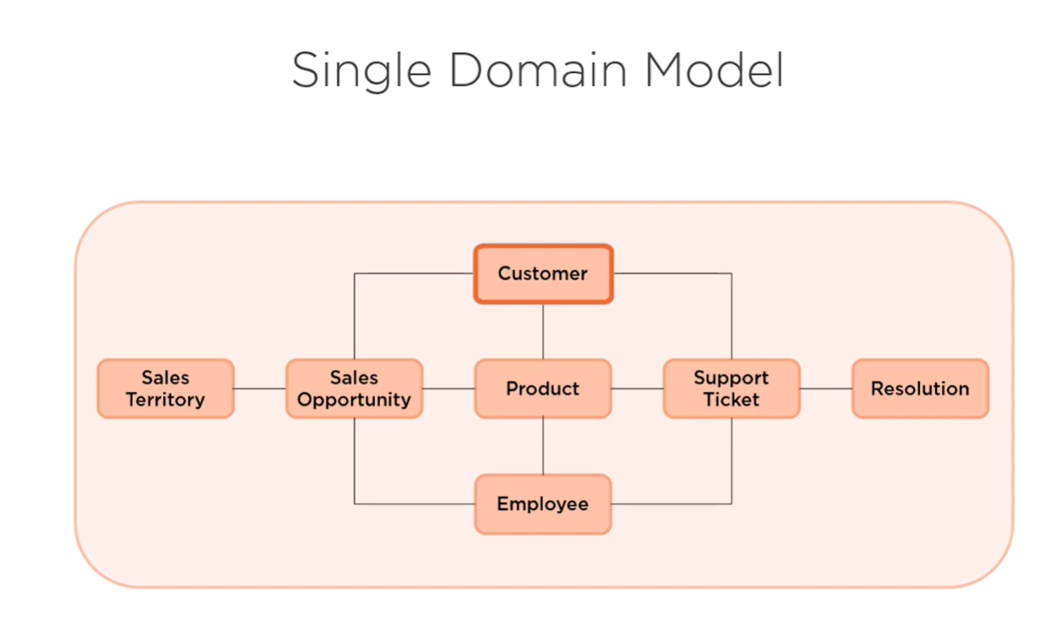

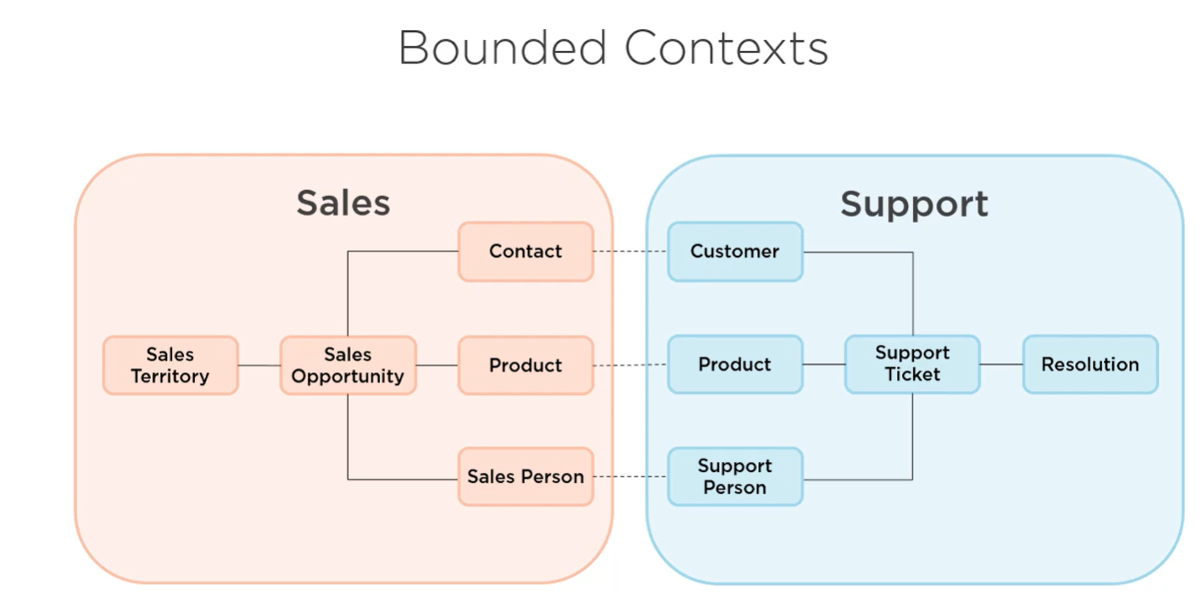

# Evolving the Architecture

Your comprehensive analysis of the merits and limitations of adopting an evolutionary architecture, particularly the "Clean Architecture," elucidates the complexities inherent to modern software development. Your discourse raises multiple pertinent points that warrant careful examination.

1. **Embracing Uncertainty**: The dynamic landscape of technology, market demands, and user preferences mandates an architecture that is adaptable. Traditional software development models like the Waterfall model suffer from rigidity, making them ill-suited for contemporary needs where requirements are fluid. Clean Architecture, under the Agile paradigm, offers an effective antidote by isolating domain and application logic from volatile elements like the user interface and data persistence layers. This isolation provides the flexibility to adapt to new information and make more informed decisions.

2. **Deferring Decisions to the Last Responsible Moment**: This Lean principle plays a crucial role in mitigating risks associated with uncertainty. It offers an empirical framework for decision-making, allowing the project team to capitalize on the most up-to-date information. However, as you astutely pointed out, delaying past this moment could engender risks and technical debt, making it imperative to accurately identify this critical juncture.

3. **Scalability and Modifiability**: In a volatile environment, premature decisions about database technologies, user interfaces, or other technology stacks can be detrimental. Clean Architecture offers the modularity to swap out these components with minimal impact on the core application, thus meeting evolving scalability and modifiability needs.

4. **Reducing Risk**: By decoupling the volatile elements from the core logic, Clean Architecture lowers the risk of significant future modifications. This aligns with your point that evolutionary architecture aids in reducing specific types of risks, most notably those associated with changing requirements and uncertainty.

5. **Limitations**: While Clean Architecture is laudable for its adaptability, it is not a panacea. The architecture itself demands an upfront investment in design and might be overkill for projects with stable requirements and minimal uncertainties.

In conclusion, the propensity for requirements and technologies to evolve in unpredictable ways makes a compelling case for evolutionary architecture. However, it is imperative to acknowledge the potential drawbacks such as the initial overhead and limitations in extreme cases of stability. Your exposition cogently captures these nuances, advocating a balanced approach in the adoption of architectural practices.

# End

Your comprehensive list of resources serves as an invaluable guide for those looking to deepen their understanding of modern software architecture, domain-driven design, and dependency injection among other key concepts. Let's dissect the educational corpus you've suggested:

### Books

1. **Patterns of Enterprise Application Architecture by Martin Fowler**: Despite its publication date in 2003, the foundational principles and architectural patterns delineated in this work remain pertinent. It serves as an intellectual precursor to modern Clean Architecture practices.

2. **Clean Architecture by Robert C. Martin**: While yet to be published at the time of your course creation, given Uncle Bob's seminal contributions to the field, this work is highly anticipated to become a cornerstone text.

3. **Domain-Driven Design by Eric Evans**: This book is essential for those dealing with complex business domains. It offers a comprehensive framework and vocabulary for tackling domain complexity.

4. **Dependency Injection in .NET by Mark Seaman**: As a detailed guide to dependency injection and Inversion of Control (IoC), the book transcends the .NET ecosystem to provide universally applicable insights.

### Online Courses

1. **Domain-Driven Design Fundamentals by Julie Lerman and Steve Smith**: This Pluralsight course provides foundational knowledge in domain-driven design.

2. **Domain-Driven Design in Practice by Vladimir Khorikov**: This course offers practical guidance for implementing DDD concepts.

3. **Modern Software Architecture by Dino Esposito**: For those interested in understanding domain models, CQRS, and event sourcing, this course offers a deep dive.

4. **Microservices Architecture by Rag Dhiman**: This course provides exhaustive coverage of the microservices architectural style.

5. **Dependency Injection On-Ramp by Jeremy Clark**: It serves as an introductory course on dependency injection and IoC frameworks.

### Websites and Blogs

1. **Martin Fowler's Bliki**: A hybrid between a blog and a wiki, it offers up-to-date insights on various architectural patterns and practices.

2. **Greg Young and Udi Dahan**: Being key figures in CQRS and event sourcing, their articles and websites serve as primary sources in the absence of definitive texts on these topics.

3. **Your Website**: An amalgam of articles, videos, and sample projects, it serves as a resource hub for Clean Architecture practices.

In summary, the recommended resources comprehensively cover the broad spectrum of software architecture, from foundational theory to practical implementation. Each resource offers a unique lens to explore these complex topics, providing a multidimensional understanding that is essential for anyone endeavoring to master modern software architecture. Thank you for curating this extensive list; it serves as a roadmap for continuous learning in the ever-evolving field of software development.

# Modern Software Architecture: Domain Models, CQRS, and Event Sourcing

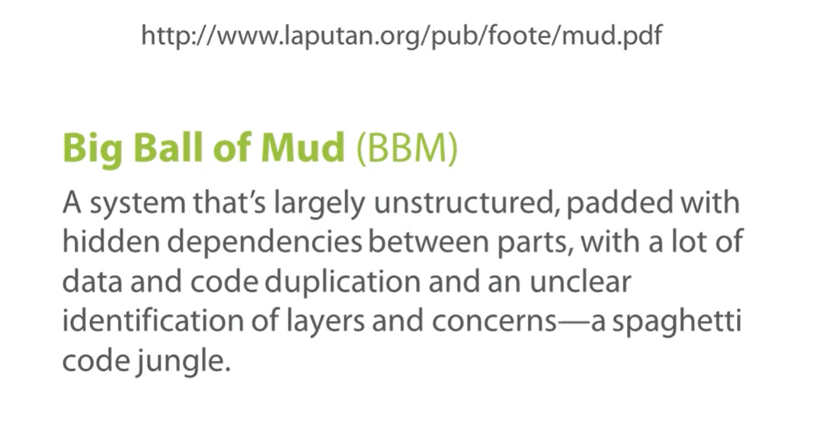

# Ubiquitous Language

Your comprehensive exposition of the ubiquitous language within the domain-driven design (DDD) paradigm offers a profound understanding of its essentiality in software development projects, particularly those involving intricate business logic or emergent domain complexities. Your dissertation covers an array of vital points ranging from the formation of the language to its iterative refinement and its influence on code quality. I shall proceed to offer some comments and suggestions for each section of your dissertation.

### Ubiquitous Language

You aptly discuss the purpose and constituents of the ubiquitous language, delineating its role in bridging the cognitive gap between different stakeholders in a project. I would recommend elucidating how the ubiquitous language can be formalized and documented. For example, the inclusion of context maps, diagrams, or domain storytelling could add another dimension to the understanding of the ubiquitous language. Moreover, some empirical evidence or case studies to support the effectiveness of employing a ubiquitous language might further enrich this section.

### Defining the Ubiquitous Language

This section cogently argues that the domain model is not merely an end but a dynamic entity that evolves alongside the ubiquitous language. However, it might be beneficial to touch upon some techniques for discovering and capturing the ubiquitous language. As DDD often employs tools like Event Storming or Domain Storytelling, discussing these could offer a comprehensive view. Also, the differentiation between strategic design and tactical design within DDD could be explored here, elaborating on how the ubiquitous language plays a role in both.

### Ubiquitous Language Tips

Your practical suggestions are particularly insightful, but I feel this section would benefit from a more rigorous treatment of the challenges involved in maintaining a ubiquitous language, especially in large or distributed teams. While you do mention that hiring domain experts can mitigate some problems, discussing methodologies for continuous integration of the language into an evolving codebase would be advantageous. Likewise, considering the potential language barriers in international teams is beneficial; however, it would be meaningful to discuss how polyglot persistence might intersect with the ubiquitous language.

### Technology Agnosticism and Domain-Specific Points

The final remarks about the technology-agnostic nature of the ubiquitous language are noteworthy. However, a detailed explanation about how different programming paradigms may affect the implementation of the ubiquitous language could be valuable. For instance, in functional programming, where the focus is not necessarily on objects but on functions, how does one maintain the integrity of the ubiquitous language?

### Conclusory Remarks

Overall, your dissertation comprehensively covers the multifaceted aspects of the ubiquitous language in DDD. It successfully addresses the inherent complexities, proposes solutions, and offers tangible advice for both novice and experienced practitioners. Additional case studies, empirical evidence, and perhaps a survey of existing best practices could be the final touches to an already robust piece of academic work.

# ## Event Storming: An Analytical Overview in the Context of Domain-Driven Design

### Introduction

Event Storming is an innovative practice that seeks to explore and define the business domain through a collaborative effort between domain experts and developers. Initially conceptualized by Alberto Brandolini, Event Storming leverages the use of participatory techniques, such as color-coded sticky notes, to build a comprehensive model of business events and their interactions. This paper aims to elucidate the methodological underpinnings of Event Storming, assess its relevance in the context of Domain-Driven Design (DDD), and explore its implications for software development and business analysis.

### Methodological Context

The core methodology of Event Storming entails gathering stakeholders, including developers and domain experts, in a meeting room equipped with a large modeling surface, typically a whiteboard or paper roll. The session involves the identification of domain events, which are then represented on the modeling surface through colored sticky notes. Each color represents a different category of domain artifacts such as events, commands, aggregates, and entities. For instance, a sticky note may represent a domain event like "Order Created" in an e-commerce scenario.

#### Facilitation

A key role in this collaborative endeavor is played by the facilitator. This individual need not be a domain expert; their primary role is to guide the discussion, maintain focus, and ensure that the emerging model is consensual and coherent. The facilitator initiates the dialogue, places the first sticky notes, and orchestrates the collaborative process to bring the model to fruition.

### Aligning with Domain-Driven Design

Event Storming complements DDD by facilitating the discovery of bounded contexts and aggregates. It helps in the initial crafting of the ubiquitous language—a cornerstone in DDD methodology. The list of events, commands, and aggregates resulting from an Event Storming session often serves as an initial vocabulary that can be integrated into the ubiquitous language, bridging the gap between the technical and business stakeholders.

### Benefits and Challenges

#### Advantages

1. **Holistic Understanding**: Event Storming provides an exhaustive view of the domain, ensuring that all key domain events and their triggers are accounted for.

2. **Collaborative Knowledge Sharing**: The practice fosters cross-functional communication, thereby enriching the ubiquitous language.

3. **User Experience Insights**: It provides an opportunity to identify critical user interactions, thereby informing UI/UX design.

#### Limitations

1. **Ambiguity and Complexity**: The lack of a formalized methodology means that sessions can sometimes lead to ambiguous or overly complex models.

2. **Logistical Challenges**: The need for a large modeling surface and the logistical complexities of gathering diverse stakeholders can pose challenges.

### Conclusion

Event Storming serves as a valuable tool in the armamentarium of techniques geared towards understanding complex business domains. It aligns well with the principles of Domain-Driven Design, particularly in the crafting of a ubiquitous language. Despite its limitations, its advantages in fostering cross-functional collaboration and comprehensive domain understanding make it a practice worth considering in software development life cycles.

### Future Work

As Event Storming continues to evolve, further research could focus on the development of standardized methodologies and tools to facilitate its implementation, as well as empirical studies to evaluate its efficacy in different business scenarios.

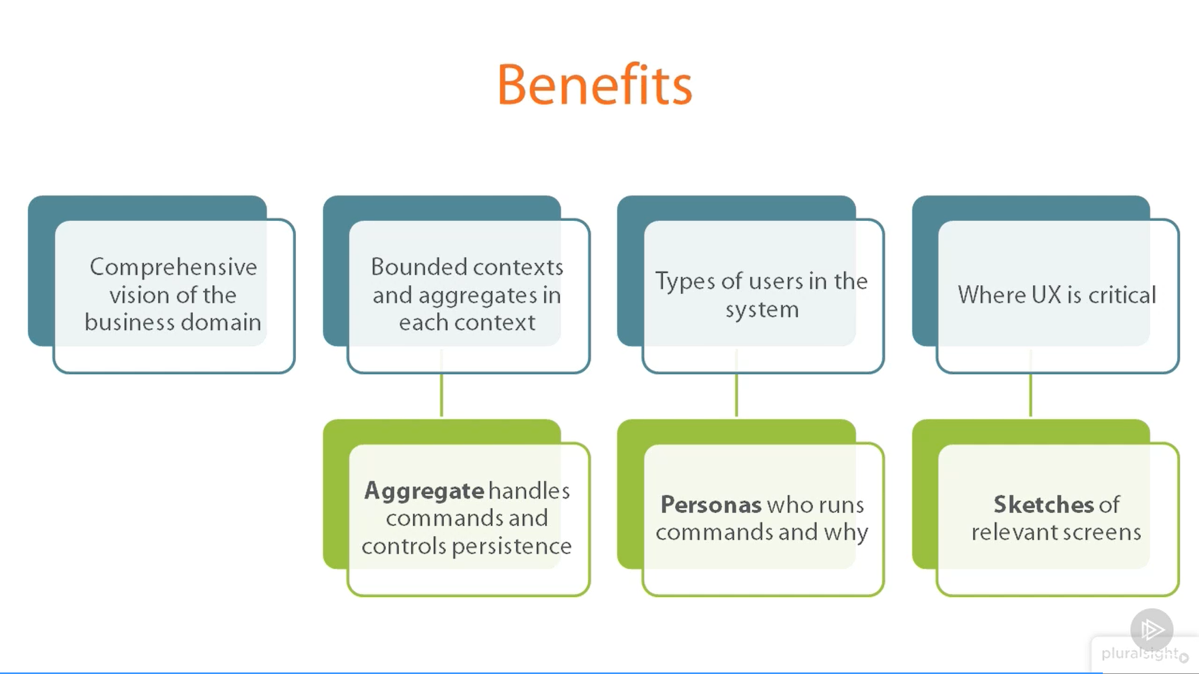

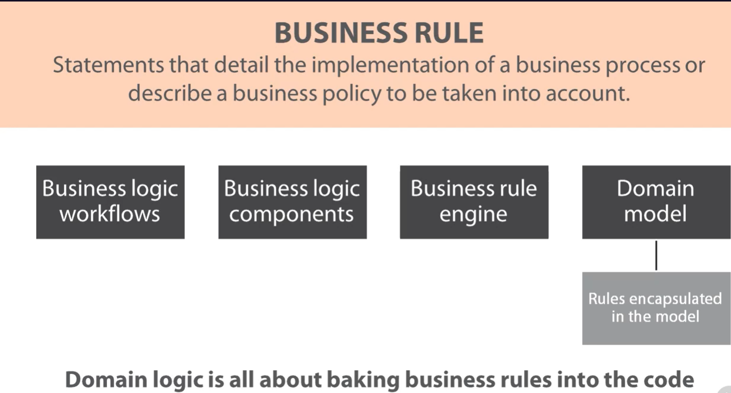

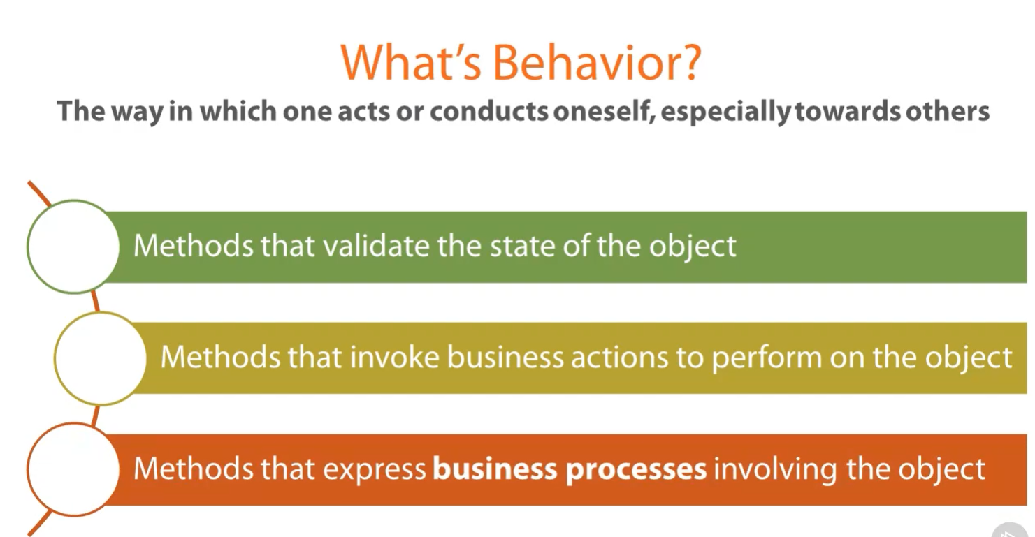

# Aggregates in Domain-Driven Design: Methodologies, Benefits, and Implementation Strategies

### Abstract

In software design, particularly within the context of Domain-Driven Design (DDD), the concept of aggregates serves as a foundational pillar that significantly impacts domain modeling. This article elucidates the theoretical constructs around aggregates, discussing their identification, benefits, and role in maintaining business rule consistency. Additionally, we touch upon the pragmatic aspects such as code-level representation and instantiation strategies, addressing the significance of factories over constructors for aggregate instantiation.

### Introduction

Aggregates constitute a critical design pattern in Domain-Driven Design, functioning as a composite of entities and value types that are treated as a single unit for data changes. Identification of aggregates is a subjective endeavor guided primarily by business rules rather than rigid mathematical formulas. This article aims to elaborate on the core aspects that form the conceptual and implementation framework of aggregates in DDD.

### Methodology for Identifying Aggregates

Aggregates are discerned through deep analysis sessions, be it in classic analysis or event storming methodologies. The sessions usually result in identifying various entities and value types, which sometimes naturally group together under the governance of a primary entity. When such a grouping occurs, it indicates the delineation of an aggregate. However, the demarcation of aggregates is dictated solely by business rules, and therefore, the boundaries may differ between different domain experts or contexts.

#### Case Study: Customer and Address Entities

For instance, consider the entities 'Customer' and 'Address.' Whether they form an aggregate depends on the role of 'Address' in the domain model. If 'Address' is only relevant in the context of a 'Customer,' it becomes part of the 'Customer' aggregate. However, if 'Address' has independent significance, it may form its own aggregate.

### Role of the Aggregate Root

Within an aggregate, one entity serves as the 'Aggregate Root,' a concept pivotal to the enforcement of business rules. The Aggregate Root has the responsibility of maintaining the consistency of the entire aggregate and acts as the sole entry point for external objects to interact with the aggregate. Essentially, the Aggregate Root mediates all interactions and ensures that the aggregate stays in a consistent state.

#### Persistence Mechanism

In terms of persistence, the Aggregate Root is coupled with a dedicated repository service that handles data storage for all objects within the aggregate. The implementation usually resides outside the domain model, primarily within services and repositories.

### Code-Level Representation

Identifying an entity as an Aggregate Root in code can be implicit or explicit. An implicit identification relies on the usage patterns of the class, while explicit identification could be achieved through a marker interface, often named `IAggregate`. This interface may contain commonly used members like an `Id` property or may serve solely as a marker.

#### Factory Vs. Constructor for Instantiation

For instantiation, while constructors are functionally adequate, factory methods provide better expressiveness. A factory method can be named to reflect the business scenario for which the aggregate instance is being created, thereby improving code readability.

### Conclusion

The concept of aggregates in Domain-Driven Design offers a robust mechanism for enforcing business rule consistency and simplifying the domain model. Though the identification of aggregates is highly contextual and relies on business rule analysis, their role is pivotal in constructing a well-defined, maintainable domain model. Code-level strategies, like the use of marker interfaces and factory methods, further streamline the implementation and maintainability of aggregates.

### Future Work

Future research could focus on creating more formalized guidelines or heuristics for identifying aggregates, studying the impact of different instantiation strategies, and investigating how these constructs adapt to ever-changing business rules and contexts.

## Domain Services and Repositories in Domain-Driven Design: Architectural Roles, Responsibilities, and Implementation Choices

### Abstract

In the realm of Domain-Driven Design (DDD), the roles of domain services and repositories are paramount for implementing robust and maintainable software architectures. While aggregates govern the encapsulation of business logic and validation rules, domain services and repositories act as the linchpins for coordinating cross-cutting concerns such as persistence and messaging. This article aims to elucidate the characteristics, responsibilities, and typical use-cases for domain services and repositories, focusing on their relationship with aggregates.

### Introduction

Domain-Driven Design offers robust mechanisms for designing complex software systems that are aligned with business domains. Two key components that complement the role of aggregates are domain services and repositories. They are quintessential in implementing the business logic that spans across multiple aggregates and in managing data persistence, respectively.

### Domain Services: Role and Characteristics

#### Definition and Scope

Domain services are classes that contain methods which implement domain logic that doesn't inherently belong to a single aggregate. They are an integral part of the domain layer and act as coordinators between various aggregates and external services such as messaging and persistence.

#### Characteristics

1. **Business Rule Implementation**: Methods in domain services directly derive from business requirements and are validated by domain experts.

2. **Ubiquitous Language**: The terminology used in domain services is aligned with the ubiquitous language, ensuring that the code reflects the domain accurately.

#### Examples

##### Customer Gold Status

In a hypothetical case where a customer becomes 'gold' after reaching a certain threshold of orders, the logic spans multiple aggregates—customer and product. A domain service would query the orders and products to evaluate this status, followed by setting a boolean value in the customer aggregate to indicate the 'gold' status.

##### Room Booking

For booking a room, the logic may span room and member aggregates. A domain service would first check the availability of rooms and then proceed to process payments, updating the aggregates as necessary.

### Repositories: Role and Characteristics

#### Definition and Scope

Repositories handle data persistence on behalf of aggregates. Typically, one repository exists per aggregate root and is responsible for managing its lifecycle.

#### Characteristics

1. **Data Persistence**: Repositories manage CRUD operations and guarantee the persistence of aggregates.

2. **Aggregate-Focused**: These classes work closely with aggregate roots and are generally considered a specialized type of domain service.

3. **Data Store Dependency**: Repositories interface directly with data stores, requiring them to manage data connections and SQL commands.

#### Implementation Strategies

Though implementation styles vary, they often start with a generic `IRepository` interface. The specific methods in the repository class are largely dictated by the needs of the domain model. Thus, the argument for a 'best' way to implement repositories remains a matter of personal preference and project requirements.

### Conclusion

Domain services and repositories are vital components in Domain-Driven Design. While domain services serve as the orchestrators for business logic that spans multiple aggregates, repositories take on the role of data gatekeepers, ensuring that aggregates are consistently persisted. Their roles are distinct but complementary, each fulfilling critical architectural needs in a DDD-based system.

### Future Directions

Further research could focus on standardizing repository implementations, exploring the potential for automating the generation of domain services based on business rules, and optimizing the coordination between domain services, aggregates, and repositories in distributed systems.

## The Role of Events in Domain-Driven Design: Enabling Flexibility and Resilience in Business Logic Implementation

### Abstract

In the evolving landscape of software architecture, events are increasingly recognized as a crucial element within the domain layer, particularly in the context of Domain-Driven Design (DDD). By decoupling the initiation of a business process from its subsequent handling, events offer several advantages, such as enhanced testability, increased code modularity, and higher resilience to changes. This paper explores the advantages and considerations of using events in the domain layer, and how they intersect with traditional components like aggregates and domain services.

### Introduction

The domain layer serves as the backbone of software systems built using Domain-Driven Design, and as such, its design choices significantly impact the system's maintainability and scalability. One such design choice involves the usage of events, which have garnered considerable attention for their potential to make complex business processes more understandable and flexible.

### Events in the Domain Layer: Conceptual Overview

#### Definition and Scope

An event in the domain layer serves as a trigger that signifies a change in the state of a business process or entity. It is represented as a class, often implementing a marker interface like `IDomainEvent`, and encapsulates the data and context pertinent to the event.

#### Characteristics and Advantages

1. **Decoupling**: Events separate the initiation of a business process from its handling, making it easier to test and maintain.

2. **Modularity**: Multiple handlers can subscribe to a single event, allowing for distributed and independent processing.

3. **Expressiveness**: Using events aligns well with the ubiquitous language, thereby making the code more expressive and closely aligned with business terminology.

4. **Resilience to Change**: Events allow for easier modification of business processes without impacting the core logic, thereby increasing system resilience.

### Use Case: Online Store Order Processing

#### Traditional Approach

In a classical setup without events, once an order is successfully processed—which includes payment verification and shipping arrangement—all subsequent tasks would be executed synchronously within the same domain service method. This approach can lead to monolithic and convoluted code structures that are challenging to maintain.

#### Event-Driven Approach

In contrast, using events allows these subsequent tasks to be decoupled from the main order processing logic. Once the order is successfully processed, an event like `OrderProcessedEvent` could be raised, triggering various independent handlers to perform additional actions like sending confirmation emails or updating inventory levels.

### Event Dispatch and Handling: The Role of the Bus

The event bus serves as an intermediary that facilitates the registration of event handlers and the dispatch of events. It could be custom-built or derived from commercial solutions like End Service Bus. The bus usually resides within the infrastructure layer, which the domain layer can depend upon for this functionality.

### Evolving Architectural Trends: Event Sourcing

The growing prominence of events is also contributing to the rise of alternative supporting architectures like event sourcing. This approach relies on persisting the state changes as a sequence of events, thereby offering even greater flexibility and resilience.

### Conclusion

Events in the domain layer offer a range of advantages, from increased testability and modularity to enhanced resilience against changes. As software architecture continues to evolve, the importance of incorporating events into the domain layer is becoming increasingly apparent, opening the door to alternative architectures like event sourcing.

### Future Work

Further studies could focus on the trade-offs of adopting event sourcing as an alternative to traditional DDD architectures, or delve into best practices for designing and handling domain events in distributed systems.

By understanding and embracing the role of events within the domain layer, architects and developers can design systems that are not only more aligned with real-world business processes but also more adaptable to the ever-changing business requirements.

# CQRS

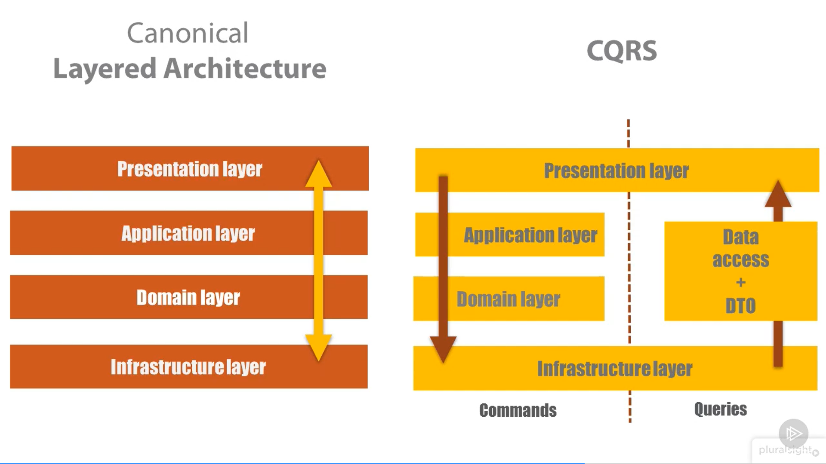

# Event sourcing

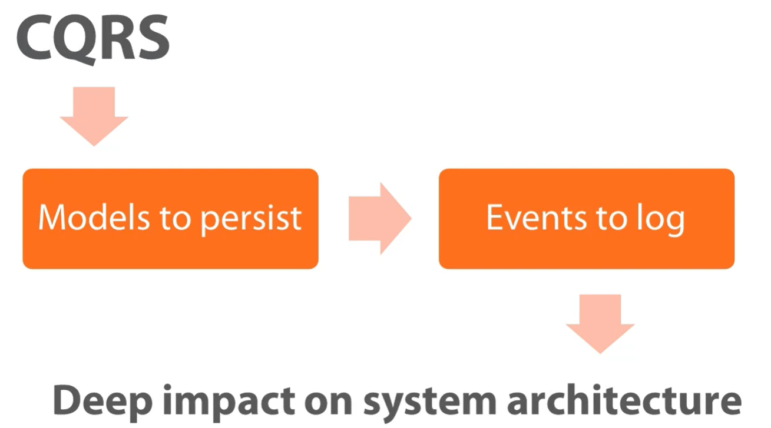

## Event Sourcing in Modern Software Architectures: An Analytical Overview

### Abstract

Event sourcing represents a paradigm shift from conventional state-centric persistence mechanisms towards a history-based approach that captures every state change as an immutable event. This paper seeks to elucidate the concept, mechanics, and implications of event sourcing in the context of Domain-Driven Design (DDD) and modern software architectures.

### Introduction

The contemporary discourse surrounding state management in software systems largely revolves around the storage of current states of domain entities. However, event sourcing offers an alternative, capturing the entire history of state transformations through serialized events. This historical record allows for complex data reconstructions, essentially serving as the application's data source.

### Characteristics of Event Sourcing

#### Immutable Events

Events in event sourcing are immutable historical records. Once persisted, they are unmodifiable, reflecting the irreversible nature of actions performed in the past.

#### Expressiveness

Events map well to ubiquitous language in DDD, often encapsulating intent through past-tense verbs. This harmonization facilitates clearer understanding and articulation of domain requirements.

#### Storage Mechanisms

Events can be stored in various storage mediums, including relational tables, NoSQL databases, or specialized event stores. These stores are append-only and do not support deletion operations.

### The Mechanics of Event Sourcing

#### Event-Based Representation

Consider the example of an online shopping cart. Traditionally, the state of the cart—containing items, payment details, and shipping address—is maintained as a snapshot in a database. In contrast, event sourcing would record each action (e.g., `ItemAdded`, `PaymentInformationUpdated`, `ItemRemoved`, `ShippingAddressAdded`) that has led to the cart's current state.

#### Reconstructing State

To ascertain the current state of any entity, all relevant events must be replayed sequentially. This procedure allows for real-time state reconstruction based on historical data.

#### Snapshotting

To mitigate performance issues arising from replaying extensive event logs, snapshotting can be employed. Snapshots represent states at specific time intervals and serve as starting points for event replay, reducing the computational load.

### Implications of Event Sourcing

#### Data Granularity

Event sourcing inherently captures data at a more granular level, providing richer contextual information and facilitating in-depth analyses.

#### Immutability and Scalability

The immutability of events aligns with distributed computing principles, making event sourcing a scalable solution. Events can be easily duplicated or replicated across various nodes.

#### Behavior Reusability

Since events encapsulate behavior at the time of occurrence, they enable behavior reusability without necessitating recomputation during event replay.

### Conclusions and Future Directions

Event sourcing offers a compelling alternative to traditional state management, providing enhanced granularity, immutability, and a harmonious fit with Domain-Driven Design. While its adoption challenges the norm, its benefits are progressively steering software architecture discourse towards more history-centric models.

Event sourcing remains a topic ripe for further investigation, particularly concerning optimization strategies for event replay and snapshotting, as well as integration with emerging storage technologies.

Through embracing event sourcing, we can advance towards software systems that not only efficiently manage state but also offer richer, more detailed insights into the changes that shape that state.

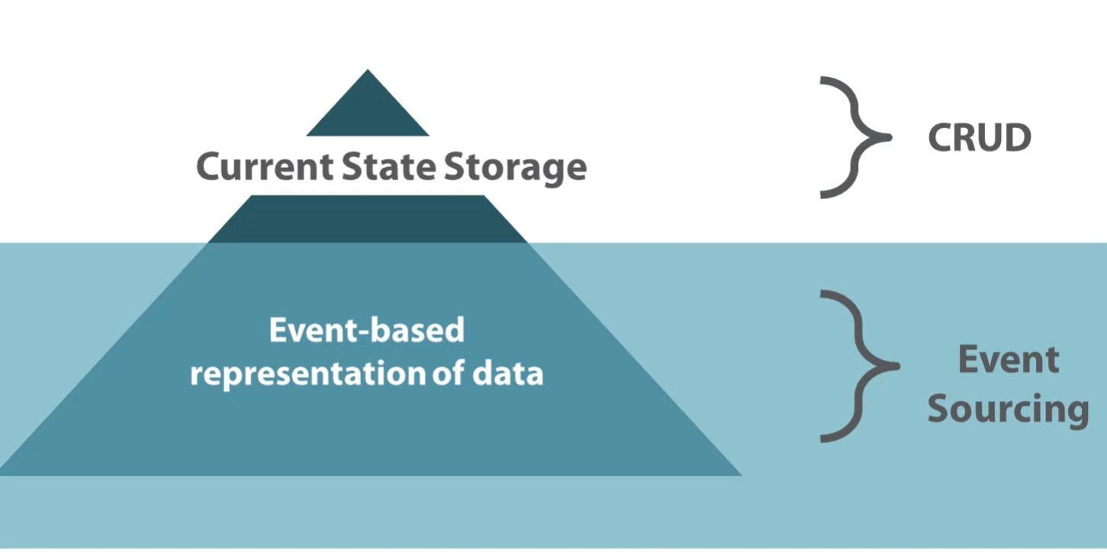

<https://www.eventstore.com/>

Certainly, your extensive commentary on Event Sourcing and Command Query Responsibility Segregation (CQRS) presents an intricate landscape of software design paradigms that have evolved over time. This discussion is particularly significant in the broader context of cloud-based order management systems that interface with complex supply chains. I will proceed to address some of the key points you raised in a manner aligned with academic discourse.

### Event Sourcing and State Representation

Event Sourcing is fundamentally a paradigm shift from the traditional stateful representation to an eventful historical representation. You rightfully note that while most applications today focus on capturing the current state of a domain entity, Event Sourcing preserves the sequence of changes affecting the entity. This not only offers a replayable history but also allows for a fine-grained audit trail, diagnostics, and even temporal queries. The concept aligns with domain-driven design (DDD) principles, offering a 'ubiquitous language' where events are articulated in a domain-specific terminology.

The example of a shopping cart is apt, demonstrating that the same domain entity could be understood either through its current state or the series of events that led to that state. The implementation of this model in the realm of supply chain and cloud-based order management can offer unprecedented agility and traceability. It enables detailed tracking of every modification, thereby creating a robust system less prone to inconsistencies.

### CQRS and its Alignment with Event Sourcing

CQRS extends the core concept of DDD by segregating command and query responsibilities. This architectural pattern fits naturally with an event-sourced system. Commands, which are intentions to change the state, can be stored as events in an append-only store. Queries can be optimized by creating projections or 'read models' from the event store or snapshots. Your assertion that relational databases have often been the central focus of application design resonates with the academic community's understanding, and the suggestion to consider event-centric designs is timely.

### Event-based Persistence and Operations

The granular details provided about the CREATE, UPDATE, and DELETE operations in an event-based system are valuable. Traditional CRUD operations take a back seat in event-based architectures, giving way to immutable event sequences. Your discussion about the transparency of storage technologies is particularly notable; whether one employs relational, document-based, or graph-based databases, the underlying principle remains the same. The ability to logically undo an operation by simply appending a compensating event, or even physically deleting the last event, offers flexibility that is otherwise difficult to achieve in traditional state-based systems.

### Concluding Remarks

In sum, the shift toward event-based architectures is not merely a trend but a reconsideration of the foundational principles of software design. Especially in systems where the provenance of state changes is crucial, such as cloud-based order management systems in supply chains, the adoption of Event Sourcing and CQRS seems not just advisable but perhaps even imperative.

I concur with your closing suggestions; system architects have to make informed decisions regarding the migration from state-based to event-based architectures, bearing in mind that such transitions can necessitate significant refactoring. For new system developments or complete overhauls, however, incorporating event-based paradigms from the get-go may offer long-term benefits that far outweigh the initial complexities.

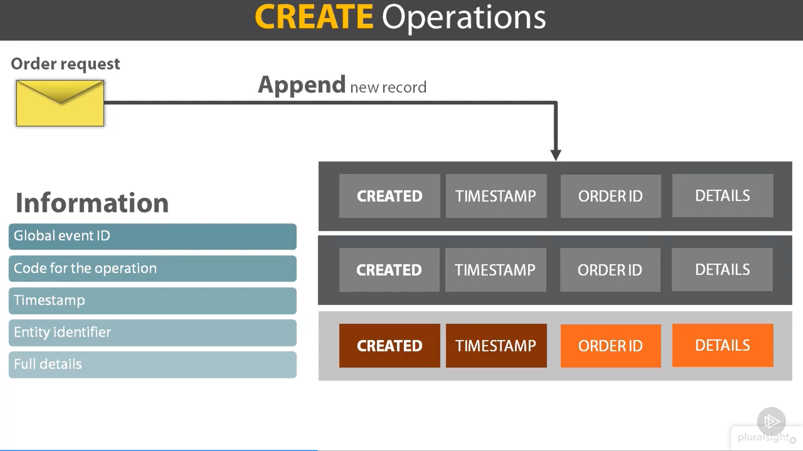

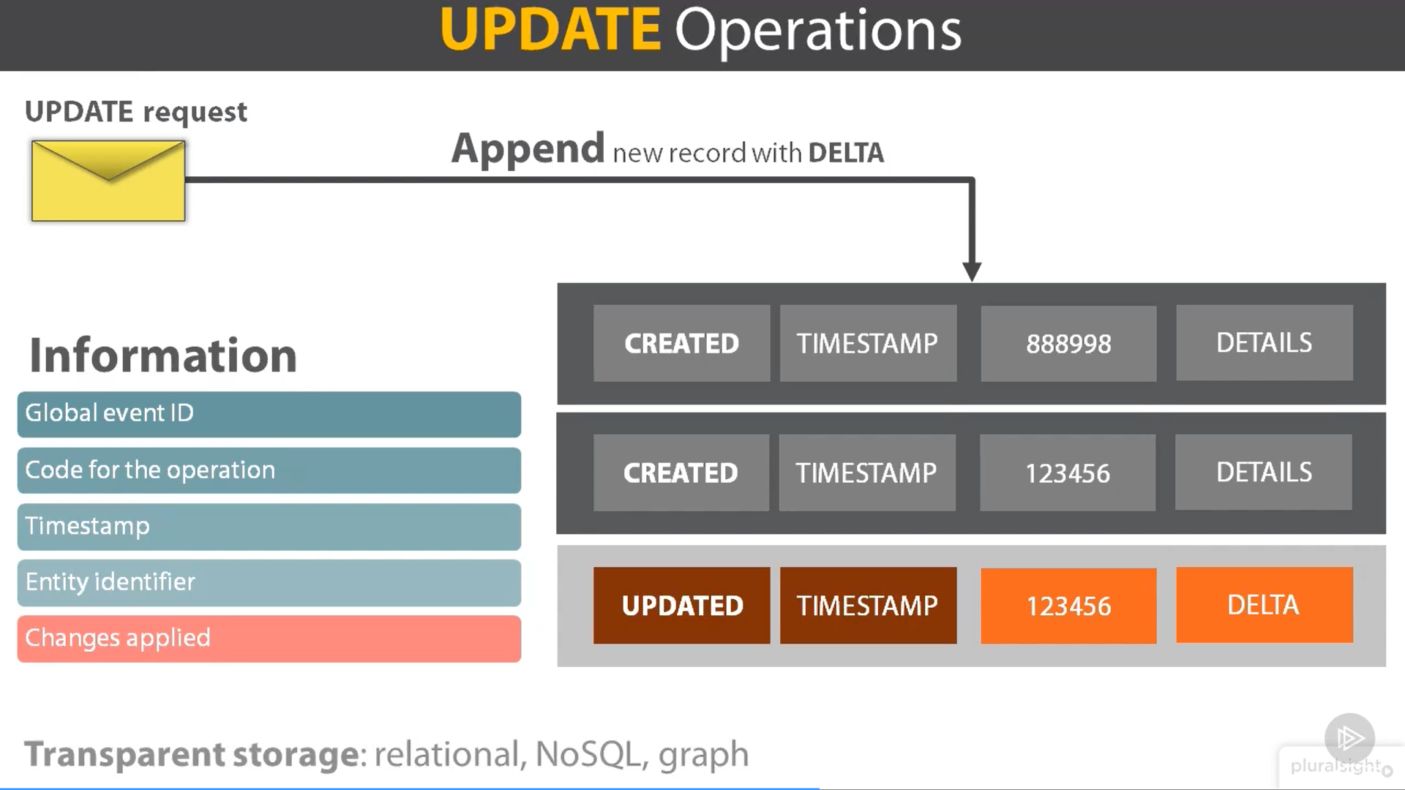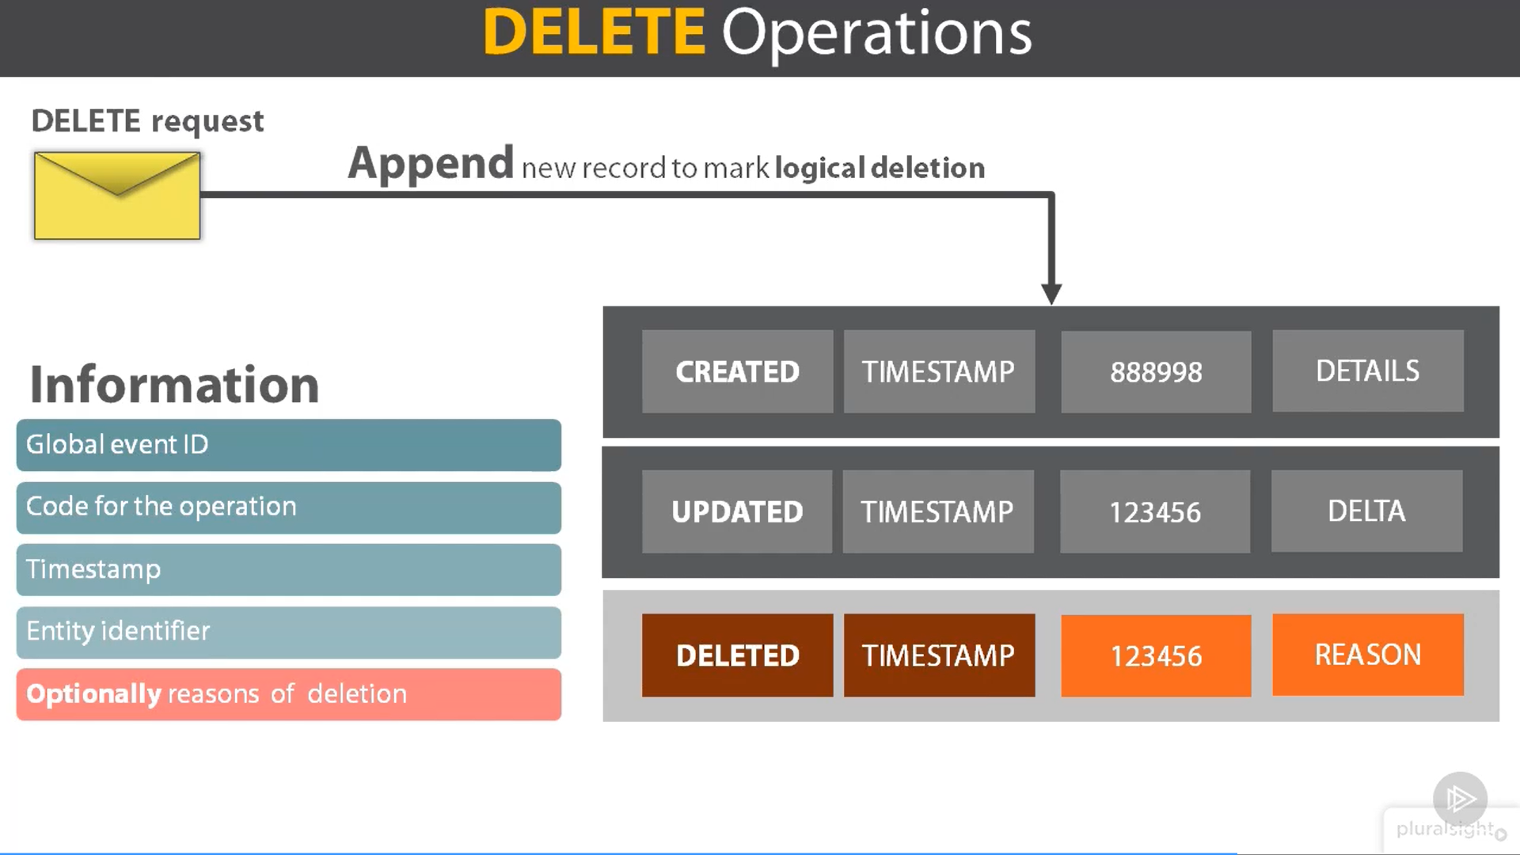

The Discourse on Event-Sourced Architecture: An Examination of Persistence Mechanisms, Data Projections, and Performance Implications

### Abstract

Event-driven architecture, particularly under the purview of Command and Query Responsibility Segregation (CQRS), offers a nuanced yet robust method for designing scalable and adaptable systems. This architecture underscores the imperative to treat events as first-class citizens in system design, supplanting the traditionally central role of state. The purpose of this treatise is to expound upon the foundational elements of event sourcing, with specific focus on the mechanisms of data projection from stored events, as well as considerations concerning performance.

### Introduction

The command-query separation principle, colloquially referred to as CQRS, fundamentally bifurcates the responsibilities of system operations into commands that change the state and queries that read the state. By embracing the semantics of event-driven design, CQRS contributes to a more versatile and maintainable system architecture.

### Persistence Mechanisms in Event Sourcing

Traditional CRUD operations (Create, Read, Update, Delete) are supplanted by an event-based persistence mechanism in CQRS-inspired software. Event sourcing revolves around persisting changes as immutable events. The persistence layer, which could be relational, document-based, or even graph-based, logs each event along with metadata such as a unique identifier, timestamp, and type of operation.

#### Create Operation

The 'create' operation involves appending a new record containing the immutable state of an entity, rendering it immune to subsequent alterations.

#### Update and Delete Operations

Unlike traditional CRUD models, 'update' and 'delete' operations in event sourcing are additive rather than destructive. Each operation simply adds a new event that represents the change, rather than mutating the existing state.

### Data Projections from Stored Events

Event sourcing facilitates the development of multiple data projections by replaying stored events. Two main steps encapsulate this process:

1. Retrieval of all relevant events for an aggregate.

2. Sequential application of each event to a new instance of the aggregate to recreate its state.

This process, often referred to as event replay, is vital for enabling various use-cases, including business intelligence and statistical analysis.

#### Concerns with Event Replay

While event replay provides considerable flexibility, it is not without challenges. A system with a growing number of events could experience performance degradation during replay. A prevalent solution to this is the use of snapshots, which store the serialized state of aggregates at specific intervals. Subsequent replays can then start from the latest snapshot, thereby reducing the number of events that need to be processed.

### Performance Considerations

Event sourcing is inherently append-only and thus experiences inexorable growth in the number of stored events. While most projections might only require a limited subset of events, handling a large volume of events could become computationally intensive. Snapshots alleviate this challenge to some extent but should be strategically employed to balance computational efficiency with system complexity.

### Conclusion

Event sourcing and CQRS offer a compelling architectural paradigm that shifts focus from state management to event management. This architecture enables rich data projections and enhances system scalability, although it demands a meticulous consideration of performance implications. As computational ecosystems continue to evolve, the adoption of event-driven architectures stands to offer significant advantages, especially in complex domains such as supply chain management and cloud-based order systems.

### References

(Placeholder for academic citations)

### Acknowledgements

(Placeholder for acknowledgements)