Design Microservices Architecture with Patterns & Principles (udemy.com)
Learn: CleanArchitecture
Separatesthe elements of a design into circle levels.
Clean architecture was created by Robert C. Martin and promoted on his blog, Uncle Bob.
Organizecode with encapsulates the business logic.
Keepthe core business logic and application domain at the center of the solutionstructurethat independent with presentation and data access layers.
Clean architecture divided into two main elements: the policies and the details.The policies are the business rules and procedures
The details are the implementation code to carry out the policies

Focuson the policiesand business logics that build on project requirements
The internal layers contains the business rules and has not dependency of any third-party library.

The Dependency Rule
The dependencies of a source code can only point inwards.
Code dependencies can only move from the outer levels inward.
Code on the inner layers can have no knowledge of functions on the outer layers.
Innerlayer cannot have any information about elements of an outer layer.
Classes, functions, variables, data format, or any entity declared in an outer layer must not be mentioned by the code of an inner layer.
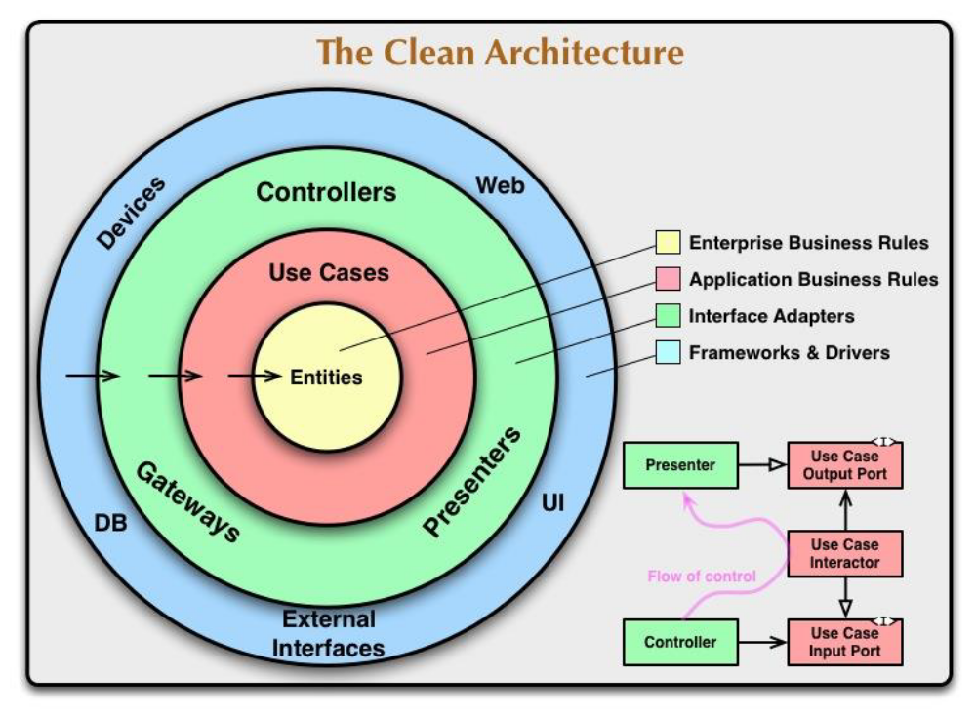
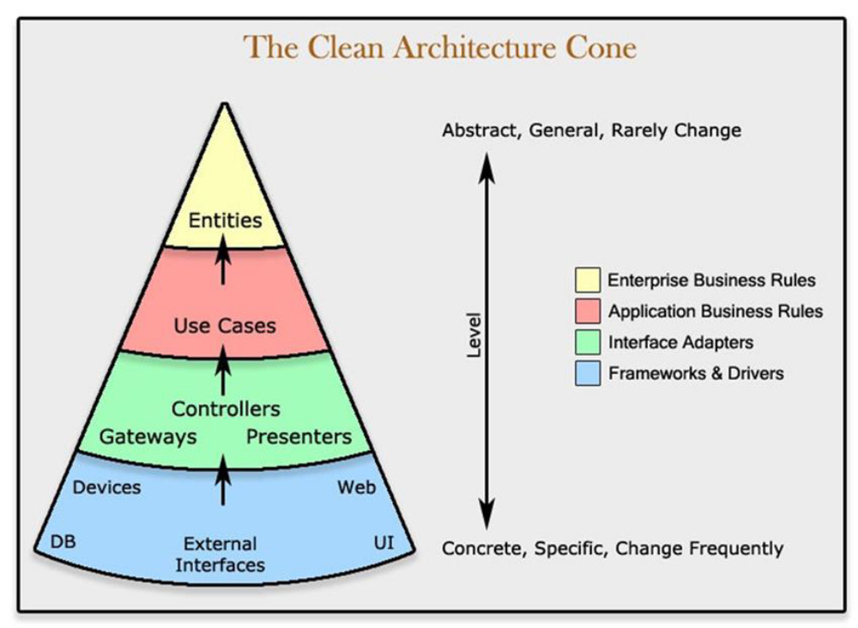
https://blog.cleancoder.com/uncle-bob/2012/08/13/the-clean-architecture.html
Benefits of Clean Architecture
Independent of Database and FrameworksThe software is not dependent on an ORM or Database. You can change them easily.
Independence of UIThe UI can change easily, without changing the rest of the system and business rules.
TestableIt is naturally testable. You can test business rules without considering UI, Database, Mock servers, etc.
Independence of any external agencyIn fact, your business rules simply don’t know anything at all about the outside world.

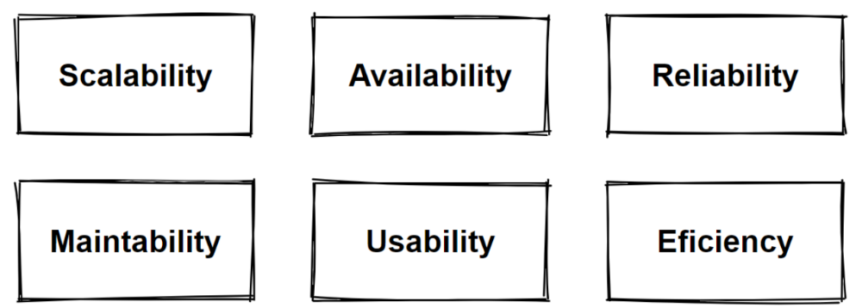
Scalability-Vertical Scaling -Horizontal Scaling
Scalabilityis the number of requests an application can handle
Measuredby the number of requests and it can effectively support simultaneously.
Ifno longer handle any more simultaneous requests,it has reached its scalability limit.
To preventdowntime, and reducelatency, you must scale
Horizontalscaling and verticalscaling both involve adding resources to your computing infrastructure
Horizontal scaling by adding more machines
Vertical scaling by adding more power
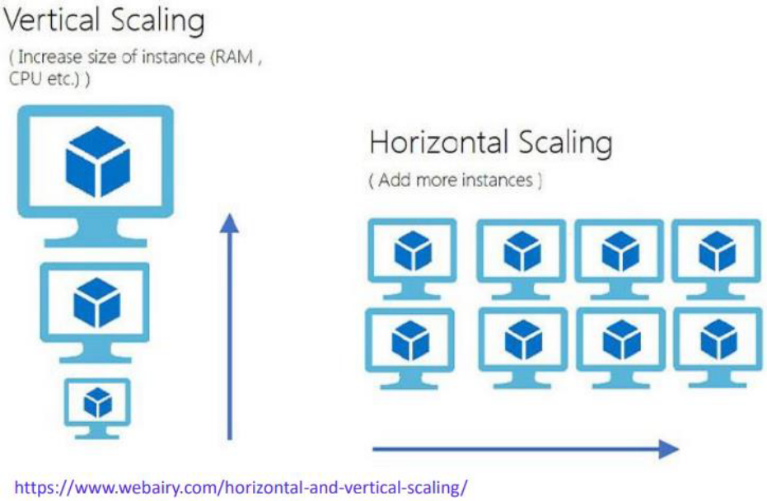

Vertical Scaling -Scale up
Vertical scaling is basically makes the nodes stronger.
Makethe server stronger with adding more hardware. Addingmore resources to a single node.
Make optimizationthe hardware that will allow you to handle more requests.
Vertical scaling keeps your existing infrastructure but adding more computing power.
Your existing codedoesn't need to change.
Addingadditional CPU, RAM, and DISKto cope with an increasing workload.
By scaling up, you increase the capacity of a single machine. And it has limits. That is named Scalability Limits.
Becauseeven the hardware has maximum capacity limitations.
For handling millions of request, we need horizontal scaling or scaling out.

HorizantalScaling -Scale out
Horizontal scaling issplittingthe load between different servers.
Simply adds more instances of machines without changing to existing specifications.
Share the processing power and load balancing across multiple machines.
Horizontal scaling means adding more machines to the resource pool.
Scaling horizontally gives you scalability but also reliability.
Preferred way to scale in distributed architectures.
When splitting into multiple servers, we need to consider if you have a state or not.
if we have a state like database servers, than we need to manage more considerations like CAP theorem.

Load Balancer
Balancethe traffic across to all nodes of our applications.
Spread the traffic across a clusterof serversto improve responsiveness and availability.
Load Balancer sits between the client and the server.
Load Balancer is accepting incoming network and application traffic.
Distributingthe traffic across multiple backend servers using different algorithms.
Load Balancers should be fault tolerance and improvesavailability.
Mostly uses the consistent hashing algorithms. Consistent hashing is an algorithms for dividing up data between multiple machines.
It solves the horizontal scalability problems. Don’t have to re-arrange all the keys.
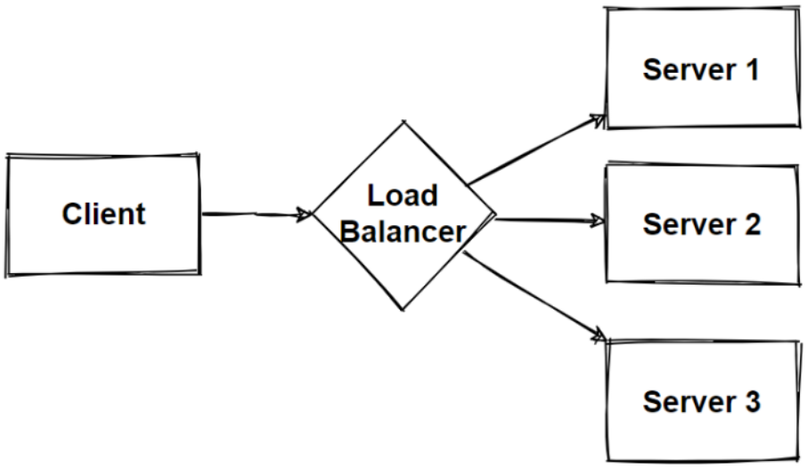

Headless Architecture and Separated UI-SPA
Headless architecture separates the frontend from the backend layer of the application.Separates UI and business logic.
Headless architecture emphasizes mainly decouplingfrontendand backendlayers, and it is the first step before moving to microservices.
It uses APIsto connect the front and backends applications.
Application programming interfaces (APIs) are software intermediaries that enable communication between applications.
REST APIs which created from Backend application are consumes from the Frontend Application.These API consume operations are handled in SPAapplication in frontend side.
Single page applications (SPA) are applications contained in a single web page without having full-page reload,andable to update some portion of the page with responsive way.

Benefits ofHeadless Architecture
Headless architecture separatesthefrontendfromthebackendlayer of the application.Separates UI and business logic.
Flexibleto useany frontendframeworkor modern approach to web developments
Easily shareservicesacross all channel heads
Updatefrontend independentlyof the services
Innovateand experimentwith new channels
Better performance

Microservices (martinfowler.com)
The microservice architectural style is an approach to developing a single application as a suite of small services, each running in its own process and communicatingwith lightweight mechanisms, often an HTTPor gRPCAPI.
Microservices are built around business capabilities and independently deployable by fully automated deployment process.
Microservices architecture decomposes an application into small independent services that communicate over well-defined APIs. Servicesare owned by small, self-contained teams.
Microservices architecture is a cloud native architectural approach in which servicescomposed of many loosely coupled and independently deployable smaller components.
Microservices have their own technology stack, communicate to each other over a combination of REST APIs, are organized by business capability, with the bounded contexts.
Following Single ResponsibilityPrinciplethat referring separating responsibilities as per services.

Benefits of Microservices Architecture
Agility, Innovation and Time-to-marketMicroservices architectures make applications easier to scale and faster to develop, enabling innovation and accelerating time-to-market for new features.
Flexible ScalabilityMicroservices can be scaled independently, so you scale out sub-services that require less resources, without scaling out the entire application.
Small, focused teamsMicroservices should be small enough that a single feature team can build, test, and deploy it.
Small and separated code baseMicroservices are not sharing code or data stores with other services, it minimizes dependencies, and that makes easier to adding new features.
Benefits of Microservices Architecture-2
Easy DeploymentMicroservices enable continuous integration and continuous delivery, making it easy to try out new ideas and to roll back if something doesn’t work.
Technology agnostic, Right tool for the jobSmall teams can pick the technology that best fits their microservice and using a mix of technology stacks on their services.
Resilience and Fault isolationMicroservicesare fault tolerancedand handle faults correctly for example by implementing retry and circuit breaking patterns.
Data isolationDatabasesare separated with each other according to microservices design.Easierto perform schema updates, because only a single database is affected.

Challenges of Microservices Architecture
ComplexityEach service is simpler, but the entire system is more complex. Deploymentsand Communications can be complicated for hundreds of microservices.
Network problems and latencyMicroservicecommunicatewith inter-service communication, we should manage network problems.Chain of services increase latency problems and become chatty API calls.
Development and testingHardto develop and testing these E2E processes in microservices architectures if we compare to monolithic ones.
Data integrityMicroservice has its own data persistence. Dataconsistency can be a challenge.Followeventual consistency where possible.

DeploymentDeployments arechallenging. Require to invest in quite a lot of devopsautomation processes and tools.The complexity of microservices becomes overwhelming for human deployment.
Logging & MonitoringDistributedsystemsare required to centralized logs to bring everything together. Centralizedview of the system to monitor sources of problems.
DebuggingDebuggingthrough local IDE isn’t an option anymore. It won’t work across dozens or hundreds of services.

The Database-per-Service Pattern
Core characteristic of the microservices architecture is the loose coupling of services.every service shouldhave its own databases, it can be polyglot persistence among to microservices.
E-commerce application.We will have Product-Orderingand SCmicroservices that each services data in their own databases. Any changes to one database don’t impact other microservices.
The service’s database can’t be accessed directly by other microservices. Each service’s persistent data can only be accessed via Rest APIs.

Benefits of the Database-per-Service Pattern with Polygot Persistence
Data schema changes made easy without impacting other microservices.
Each databasecanscale independently.
Microservices domaindata is encapsulatedwithin the service.
If one of the database server is down, this will not affect to other services.
Polyglot data persistence gives ability to select the best optimized storageneeds per microservices.

Problems
Our E-Commerce Business is growing
Business teams are separated teams as per departments; Product, Sale, Payment.
Teamswants to agile and add new features immediately to compete the market
Innovate and experiment with new features as soon as possible
Deployfeatures immediately, not waiting for deployment dates
Flexiblescale for market peek timeslike blackfriday sales
Handleand process millions of request in a acceptable latency with better performance.
Requirednot only technology change but also organizational change is mandatory.

Solutions
Microservices Architecture

