CHAPTER 1
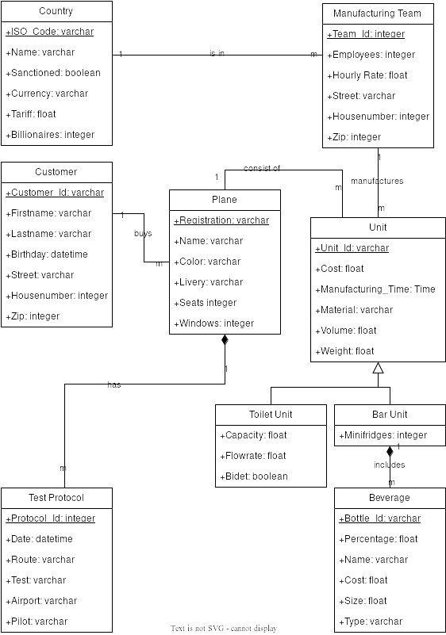  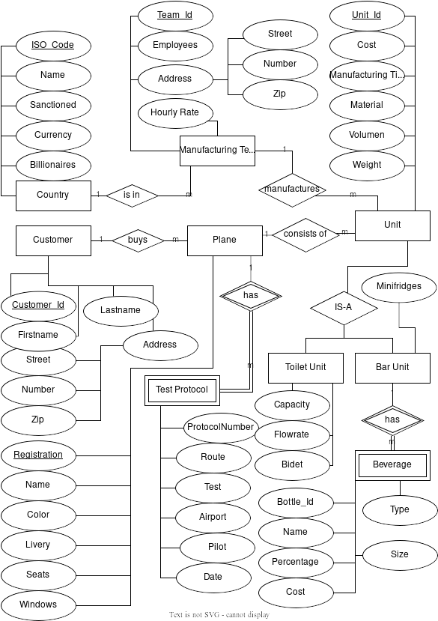  <ER DIAGRAM> | <UML DIAGRAM>

<Chapter 2>
Customer(Customer_Id, Firstname, Lastname, Birthday, Street, Housenumber, Zip)
PK: Customer_Id
Customers have a firstname and lastname, an address and a birthday. Customers are able to buy multiple planes.

Plane(Registration, Customer_Id, Name, Color, Livery, Seats, Windows)
PK: Registration
FK: Customer_Id ◊ Customer
Planes have a unique registration and are mapped to one customer. Customers set their planes name, color, livery and decide how many seats and windows the plane is supposed to have.

Country(ISO_Code, Name, Sanctioned, Currency, Tariff, Billionaires)
PK: ISO_Code
Country is just a lookup table, Countries have a name and additionaly we save if the country is sanctioned, their tariffs, currency and amount of billionaires in the country, so we can tell our lobbyists which country are not to be sanctioned by politicians.

ManufacturingTeam(Team_Id, ISO_Code, Employees, Hourly_Rate, Street, Housenumber, Zip)
PK: Team_Id
FK: ISO_Code ◊ Country
Manufacturing Teams build the different units for the airplanes, they are based in different countries, also have an address and additionally the hourly rate and number of employees.

ToiletUnit(Unit_Id, Registration, Team_Id, Cost, Manufacturing_Time, Material, Volume, Weight, Capacity, Flowrate, Bidet)
PK: Unit_Id
FK: Registration ◊ Plane
FK: Team_Id ◊ ManufacturingTeam
Toilet units are part of an airplane, a plane can have multiple toilet units, they are highly customizable and vary in cost. A toilet unit is made by one manufacturing team for one plane.

BarUnit(Unit_Id, Registration, Team_Id, Cost, Manufacturing_Time, Material, Volume, Weight, Minifridges)
PK: Unit_Id
FK: Registration ◊ Plane
FK: Team_Id ◊ ManufacturingTeam
Bar units are similar to toilet units, except they have a number of minifridges installed.

Beverage(Unit_Id, Bottle_Id, Percentage, Name, Cost, Size, Type)
PK: Unit_Id, Bottle_Id
FK: Unit_Id ◊ BarUnit
Beverages belong to one single bar and have to be destroyed in case the bar unit is discarded, because the plane building company has no license to store alcohol on their premises.

TestProtocol(Registration, Protocol_Id, Date, Route, Test, Airport, Pilot)
PK: Registration, Protocol_Id
FK: Registration ◊ Pilot
Test protocols are created during each test flight of a specific plane. They include the date, pilot, route, airport and type of test. Test protocols have to be destroyed if a plane is discarded due to regulatory compliance.

<Chapter 3>
Customer
Customer_Id | Firstname | Lastname | Birthday | Street | Housenumber | Zip
1 | Paul | Bort | 1.1.1990 | Wallensteinstraße | 124 | 1200
2 | Jack | Mill | 2.7.1950 | Schottenring | 31 | 1010
3 | Pill | Clinton | 17.12.1956 | Am Garten | 2 | 60528
4 | Geoff | Bezos | 1.8.1968 | Kote Avenue | 5146 | 90210
5 | Steve | Bossniak | 5.2.1988 | 531st Street | 3 | 94510

Plane
Registration | Customer_Id | Name | Color | Livery | Seats | Windows
DE156 | 2 | GenericName | White | Eurowhite | 50 | 30
XX512 | 3 | Blaze Machine | White | Eurowhite | 3 | 60
AT130 | 4 | City Hopper | Green | Jelly Bean | 46 | 54
HG503 | 4 | Looking Down | Taupe | Cheatline | 124 | 80
LA450 | 5 | Humblebrag | Gold | Cheatline | 200 | 100

Country
ISO_Code | Name | Sanctioned | Currency | Tariff | Billionaires
AT | Austria | False | EUR | 50000 | 3
DE | Germany | False | EUR | 1000 | 10
DK | Denmark | False | EUR | 10 | 2
US | United States of America | False | USD | 500000 | 120
KP | North Korea | True | KPW | 0 | 1

Manufacturing Team
Team_Id | ISO_Code | Employees | Hourly Rate | Street | Housenumber | Zip
1 | AT | 50 | 1500 | ABC-Gasse | 1 | 1230
2 | AT | 100 | 3000 | XYZ-Straße | 5 | 1210
3 | DE | 30 | 1000 | Industriestraße | 50 | 63414
4 | US | 20 | 8000 | Industrystreet | 6481 | 98101
5 | US | 50 | 6000 | Plane Boulevard | 6447 | 98208

ToiletUnit
Unit_Id | Registration | Team_Id | Cost | Manufacturing_Time | Material | Volume | Weight | Capacity | Flowrate | Bidet
1 | XX512 | 2 | 50000 | 02:50 | Wood | 6500 | 500 | 10 | 5 | True
2 | XX512 | 4 | 60000 | 03:45 | Wood | 8500 | 640 | 20 | 3 | True
3 | LA450 | 1 | 85000 | 04:15 | Chrome | 4500 | 758 | 26 | 6 | False
4 | LA450 | 3 | 134000 | 06:30 | Plastic | 9600 | 587 | 29 | 2 | False
5 | DE156 | 1 | 860000 | 72:00 | Gold | 7800 | 672 | 48 | 1 | True

BarUnit
Unit_Id | Registration | Team_Id | Cost | Manufacturing_Time | Material | Volume | Weight | Minifridges
1 | XX512 | 2 | 50000 | 02:50 | Wood | 6500 | 500 | 5
2 | XX512 | 4 | 60000 | 03:45 | Wood | 8500 | 640 | 3
3 | LA450 | 1 | 85000 | 04:15 | Chrome | 4500 | 758 | 5
4 | LA450 | 3 | 134000 | 06:30 | Plastic | 9600 | 587 | 10
5 | DE156 | 1 | 860000 | 72:00 | Gold | 7800 | 672 | 2

Beverage
Unit_id | Bottle_id | Percentage | Name | Cost | Size | Type
1 | a | 40 | Stolichnaya | 20 | 1 | Vodka
1 | b | 30 | The Botanist | 40 | 0.75 | Gin
2 | a | 5 | GenericBeer | 50 | 0.33 | Beer
2 | b | 5 | GenericBeer | 80 | 0.5 | Beer
4 | a | 40 | Bombay Sapphire | 25 | 0.75 | Gin

TestProtocol
Registration | Protocol_Id | Date | Route | Test | Airport | Pilot
XX512 | a | 2.7.2021 | Open Sea | High-G | FRA | Jack Mullvad
XX512 | b | 1.1.2022 | Alps | Instrument-Test | VIE | Jack Mullvad
LA450 | a | 17.12.2021 | Open Sea | High-G | FRA | Jack Mullvad
LA450 | b | 1.3.2022 | Alps | Instrument-Test | VIE | Peter Donnerballer
DE156 | a | 5.2.2022 | Open Sea | Barrelroll-Test | VIE | Peter Donnerballer

