Software Requirements Specification
for
Store Database Application
Version 1.0
Prepared by Eric Framke, Ryan Cropsey, Renell Sherman, Trifon Yanakiev, Alex Tepolt
NWTC
9/18/2018
Table of Contents
Table of Contents ii
Revision History ii
1. Introduction 1
1.1 Purpose 1
1.2 References 1
2. Overall Description 1
2.1 User Classes and Characteristics 1
2.2 Operating Environment 1
2.3 Design and Implementation Constraints 1
2.4 Assumptions and Dependencies 1
3. External Interface Requirements 2
3.1 User Interfaces 2
3.2 Hardware Interfaces 3
3.3 Software Interfaces 4
3.4 Communications Interfaces 4
4. System Use Cases 4
4.1 Add a Customer 4
4.2 Delete an Item from Inventory 4
4.3 Select an Order 5
5. Other Nonfunctional Requirements 5
5.1 Performance Requirements 5
5.2 Safety Requirements 5
5.3 Security Requirements 6
5.4 Software Quality Attributes See section 7 requirements 55-62 6
6. Other Requirements 6
7. System Requirements Chart 6
Appendix A: Analysis Models 7
Appendix B: To Be Determined List 7

Revision History
Name | Date | Reason For Changes | Version
Alex Tepolt, Renell Sherman, Eric Framke, Trifon Yanakiev, Ryan Cropsey | 12/4/2018 | Merged all branches on Github. | 1.0

Introduction

Purpose
The purpose of this application is to create a database for a store and have a C# application interact with it. The SRS covers the entire scope of the system.

References
None

Overall Description

User Classes and Characteristics
This system will be used by regular user (employees) and administrator (store owner).

Operating Environment
The operating environment will include Visual Studio and a minimum of Windows 8. The application will not run on Linux or Mac.

Design and Implementation Constraints
For our database, we used SQLite as we were unable to use a full version of SQL Server.
Limitations of SQLite:
-Limited data types
-Limited in multi-table queries

Assumptions and Dependencies
Users will need training to use the application.

External Interface Requirements

User Interfaces
All menus have a blue background, grey buttons, and black text. All menus will have a help option as well.
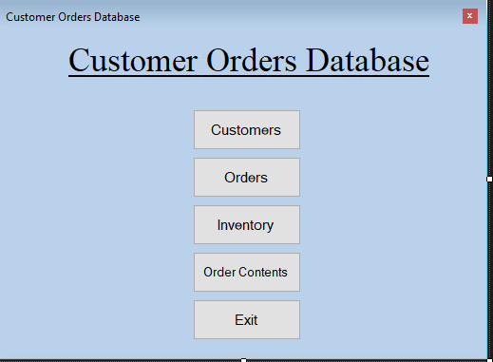

The main menu shows every table that users can work with and includes an exit button.

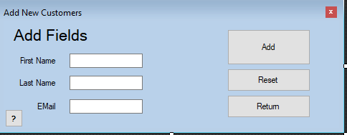

Adding records to a table shows the corresponding fields, an add button, a reset button, and a return button.

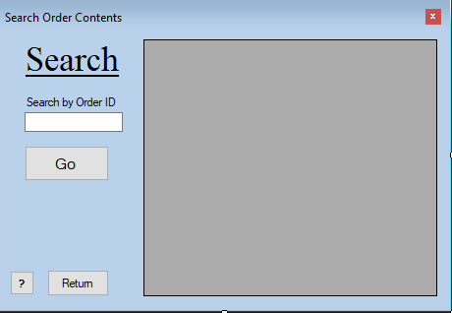

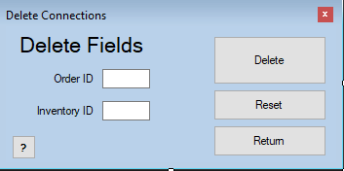
All search forms allow users to search by ID and displays records in a data-grid.

All delete forms must delete by ID and have a delete button, a reset button and a return button.

Hardware Interfaces
Users will need a mouse and keyboard.

Software Interfaces
The application will require a Windows based operating system and the executable file to launch the program. The SQLite database is packaged within the program as a file.

Communications Interfaces
None.

System Use Cases
The overall use case diagram should be here.

The text description of each use case should follow.

Add a Customer
- AddCustomer
- Objective – Add a customer to the customer table.
- Priority – High
- Source – John Smith (end user)
- Actors – Store owner/employee
- Flow of Events
  - Basic Flow –
    - User selects Customer Add
    - User enters in customer information
    - User clicks add
    - Customer is added to database
  - Alternative Flow(s) –
    - User enters in an invalid email or leaves a field null
    - User is shown an error message indicating which field to fix
    - Return to step 6.1.5.
- Preconditions – User is in the customer table
- Post conditions – A new customer will be added to the customer table.

Delete an Item from Inventory
- DeleteInventory
- Objective – The user wishes to delete an item from the inventory table.
- Priority – High
- Source – John Smith (end user)
- Actors – Store owner/employee

- Flow of Events
  - Basic Flow
    - User selects Inventory Delete
    - User enters in the item ID.
    - User clicks Delete
  - Alternative Flow 1 – User enters in an invalid ID
    - An error message is displayed telling the user that they entered in an ID that does not exist.
    - Return to step 6.1.2
    - Alternative Flow 2 – An error message is displayed telling the user that they entered in a negative number or non-integer for an ID.
    - Return to step 6.1.2.
- Preconditions – User is in the inventory menu
- Post conditions – An item is deleted from the inventory table.
- Notes/Issues - None

Select an Order
- SelectOrder
- Objective – The user wishes to select an order from the order table.
- Priority – High
- Source – John Smith (end user)
- Actors – Store owner/employee

- Flow of Events
  - Basic Flow
    - User navigates to Order Main menu
    - If user knows the order ID, they enter in the order ID.
    - If user knows the customer ID, they enter in the customer ID.
    - The user can select an order date
    - The results are shown in the data-grid.
  - Alternative Flow 1 – User enters data that doesn’t exist.
    - The data-grid won’t show any results
    - Return to step 6.1.2
- Preconditions – User is in the main menu
- Post conditions – Program displays matching orders.
- Notes/Issues – Pressing refresh will show all data in the orders table.

Other Nonfunctional Requirements

Performance Requirements
See section 7 requirements 23-27

Safety Requirements
See section 7 requirements 25-32

Security Requirements
See section 7 requirements 35-42

Software Quality Attributes
See section 7 requirements 55-62

Other Requirements
None

System Requirements Chart
< Include a table in this section with the following columns:

ID – 1. AddCustomer
Priority – High
Type – Functional(F)
Source – John Smith(end user)
Contained in Use Case(s) – 1. AddCustomer
Description – Program will access SQLite and run an insert query.

ID – 2. DeleteInventory
Priority – High
Type – Functional(F)
Source – John Smith(end user)
Contained in Use Case(s) – 2. DeleteInventory
Description – Program will access SQLite and run a delete query.

ID – 3. SelectOrder
Priority – High
Type – Functional(F)
Source – John Smith(end user)
Contained in Use Case(s) – 2. SelectOrder
Description – Program will access SQLite and run a select query.

Appendix A: Analysis Models
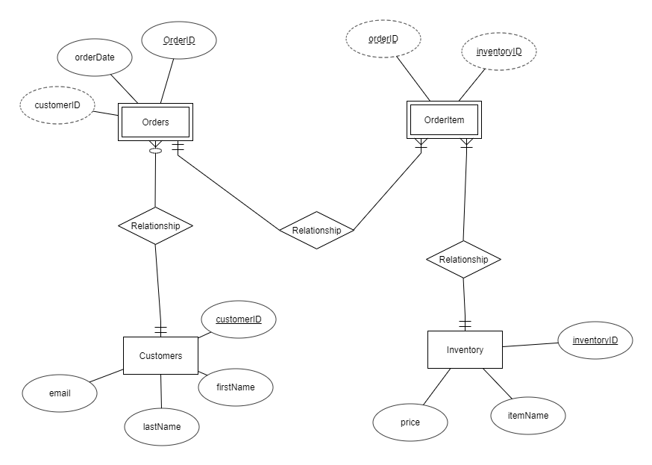
Appendix B: To Be Determined List

