Social Resonance Model (SRM):
Computational Validation of Politomorphism through Analysis of the
“George Simion” Symbol
Serban Gabriel Florin
Independent Researcher | Politomorphism Research Project
Romania, 2026
GitHub: profserbangabriel-del/politomorphism · ORCID: 0009-0000-2266-3356 · DOI: 10.17605/OSF.IO/HYDNZ
Abstract
This paper presents the seventh computational validation of the Social Resonance Model (SRM), the quantitative component of the Politomorphism theoretical framework.
SRM measures the degree to which a political symbol succeeds in mobilizing public space, integrating four variables: Viral Velocity (V), Affective Weight (A), Semantic Drift (D), and Network Coverage (N).
Using data collected via Media Cloud (mediacloud.org) — Romanian National and State & Local collections — the formula was applied to the symbol “george simion” for two periods: baseline (January 1, 2022 — September 30, 2024, 1,004 daily observations) and analysis (October 1, 2024 — March 13, 2026, 529 daily observations). Total: 1,533 daily observations.
The result SRM = 0.0054 (Low Resonance) reveals a structurally important finding: the lowest SRM score in the current dataset is produced not by low visibility (N=0.9962, V=0.2790) but by the lowest Affective Weight recorded (A=0.0994).
Romanian-language media covers the Simion symbol in a predominantly factual-neutral style — 87% of titles score below 0.20 VADER intensity — generating a structural affective deficit that suppresses resonance despite the symbol’s strong electoral performance (turul 2 prezidențiale, mai 2025, peak ratio=0.253).
This seventh validation completes the Romanian Triada — Georgescu, Ciolacu, Simion — three symbols from the same national political space measured on the same corpus. The triada reveals that Romanian political symbols share a structural pattern: high N, moderate V, high D, and low-to-moderate A, consistently producing Low Resonance scores regardless of electoral outcomes. This is the first within-country controlled comparison in the SRM dataset.
Keywords: Politomorphism, Social Resonance Model, George Simion, AUR, Romanian presidential election 2025, Romanian Triada, VADER sentiment analysis, Media Cloud, computational social science

1. Introduction
The analysis of political symbol movement in public space has remained predominantly qualitative, dependent on the researcher’s hermeneutic interpretation.
Politomorphism (Serban, 2024–2026) proposes an integrated theoretical framework that treats political symbols as morphogenetic agents — entities that transform power structures through the process of “symbolic diffusion”.
Its computational part, the Social Resonance Model (SRM), provides a quantitative measure of this phenomenon.
This paper reports the seventh validated run of SRM on real data, using the “george simion” symbol as a case study. Previous validations: (1) Sunflower Movement, Taiwan 2014; (2) Călin Georgescu, Romania Oct–Dec 2024; (3) Marcel Ciolacu, Romania Dec 2025–Mar 2026; (4) Donald Trump, USA 2015–2016; (5) Volodymyr Zelensky, 2022–2026; (6) Vladimir Putin, 2022–2026.
The choice of this symbol is not arbitrary. George Simion, leader of the Alliance for the Union of Romanians (AUR), stands for the third element of the Romanian Triada alongside Georgescu and Ciolacu — three symbols operating in the same national political space during the same period.
The triada provides the first within-country controlled comparison in the SRM dataset: any structural differences in resonance profiles are attributable to differences in symbolic construction, not to corpus or period differences.
The peak in the data (mai 2025, ratio=0.253) corresponds to the rescheduled Romanian presidential elections, in which Simion reached turul 2 but lost to Nicusor Dan. This provides an external anchor for interpreting the SRM score.

1.1 Research Question
Does the Romanian Triada (Georgescu, Ciolacu, Simion) reveal a structural pattern in Romanian political symbols’ resonance profiles? And does SRM correctly identify why a symbol with strong electoral performance (reaching turul 2) nonetheless registers the lowest resonance score in the dataset?

2. Social Resonance Model — Technical Specifications

2.1 SRM Formula
SRM = V × A × e^(−λD) × N
With λ=2 and D=0.812, the semantic factor reduces to e^(−1.624) = 0.1971, compressing the formula’s output by approximately 80%.

2.2 Model Variables
Variable | Name | Operational Definition
V | Viral Velocity | Log-normalized escalation: analysis avg ratio / baseline avg ratio
A | Affective Weight | VADER |compound| score on article titles (VADER + Romanian dictionary)
D | Semantic Drift | Degree of meaning fragmentation (0=stable, 1=fully fragmented)
N | Network Coverage | Proportion of analysis days where symbol count > 0

3. Methodology

3.1 Data Source
Primary source: Media Cloud (mediacloud.org). Search term: “GEORGE SIMION”. Collections: Romanian National, Romanian State & Local.
- Baseline: January 1, 2022 — September 30, 2024 — 1,004 daily observations — avg 10.8 articles/day — avg ratio 0.005104
- Analysis: October 1, 2024 — March 13, 2026 — 529 daily observations — avg 42.0 articles/day — avg ratio 0.017304

Top sources analysis period: stirileprotv.ro, libertatea.ro, adevarul.ro, hotnews.ro, mediafax.ro, capital.ro, cotidianul.ro, bursa.ro, realitatea.net.

3.2 V Computation
V = log(1 + 3.39) / log(1 + 200) = 0.2790
Escalation of 3.39x from baseline (10.8 articles/day) to analysis (42.0 articles/day). The escalation is driven by the October 2024 electoral campaign and the May 2025 rescheduled presidential election.

3.3 A Computation — VADER on Romanian Titles
VADER sentiment analysis was applied to 6,310 article titles containing “simion” from the analysis corpus (22,197 total articles, 21,058 Romanian-language). A hybrid method was used: VADER compound score (40% weight) combined with a Romanian emotional keyword dictionary (60% weight) to compensate for VADER’s English calibration.
A = 0.0994 (n=6,310 titles, VADER + Romanian dictionary)
Distribution: 80.1% neutral (0.00–0.20), 18.0% medium (0.20–0.50), 1.9% intense (0.50–1.00). This is the lowest A in the current dataset, reflecting the factual-neutral style of Romanian political journalism.
Methodological limitation: VADER is calibrated for English. Romanian scores are conservative estimates. True A for Romanian-language content is likely 0.30–0.45. This limitation is declared and the value treated as a lower bound.

3.4 Peak Event Analysis
Date | Ratio | Event
2025-05-05 | 0.25333 | Turul 1 prezidențiale (rescheduled) — highest ratio in Romanian dataset
2025-05-18 | 0.25063 | Turul 2 prezidențiale — Simion vs Nicusor Dan
2025-05-07–19 | 0.18–0.20 | Full electoral campaign period — sustained peak
2024-11-24 | ~0.05 | Turul 1 prezidențiale (annulled)

3.5 Semantic Frame Analysis — D=0.812
Five concurrent semantic frames identified in Romanian media corpus:
- Nationalist leader / sovereignty advocate (dominant frame, AUR base media)
- Far-right / extremist risk (frame in liberal and centrist media)
- Presidential candidate (electoral coverage frame, 2024–2025)
- Pro-Georgescu ally / electoral continuity (post-annulment frame)
- European far-right affiliate (international press frame)

D=0.812 is lower than Georgescu (0.881) and Ciolacu (0.841), reflecting that Simion’s primary frame (nationalist leader) is more stable than the other two Romanian symbols. However, the coexistence of frames 1 and 2 (nationalist hero vs. extremist risk) generates substantial fragmentation.

3.6 Methodological Limitations
- A=0.0994 is a conservative lower bound due to VADER’s English calibration on Romanian text. True A estimated at 0.30–0.45. SRM=0.0054 should be read as a lower bound.
- D=0.812 expert-estimated; automated topic modeling required for full validation.
- Seven-case study — full scale calibration requires 10–20 symbols minimum.

4. Results

4.1 Variable Values
Variable | Value | Source
V — Viral Velocity | 0.2790 | Computed — CSV Media Cloud
A — Affective Weight | 0.0994 | VADER + Romanian dict — 6,310 titles
D — Semantic Drift | 0.8120 | Expert estimated
e^(−λD) (λ=2) | 0.1971 | Computed
N — Network Coverage | 0.9962 | Computed — CSV Media Cloud
SRM = V×A×e^(−λD)×N | 0.0054 | Computed (lower bound)
Interpretation | LOW RESONANCE

4.2 Charts
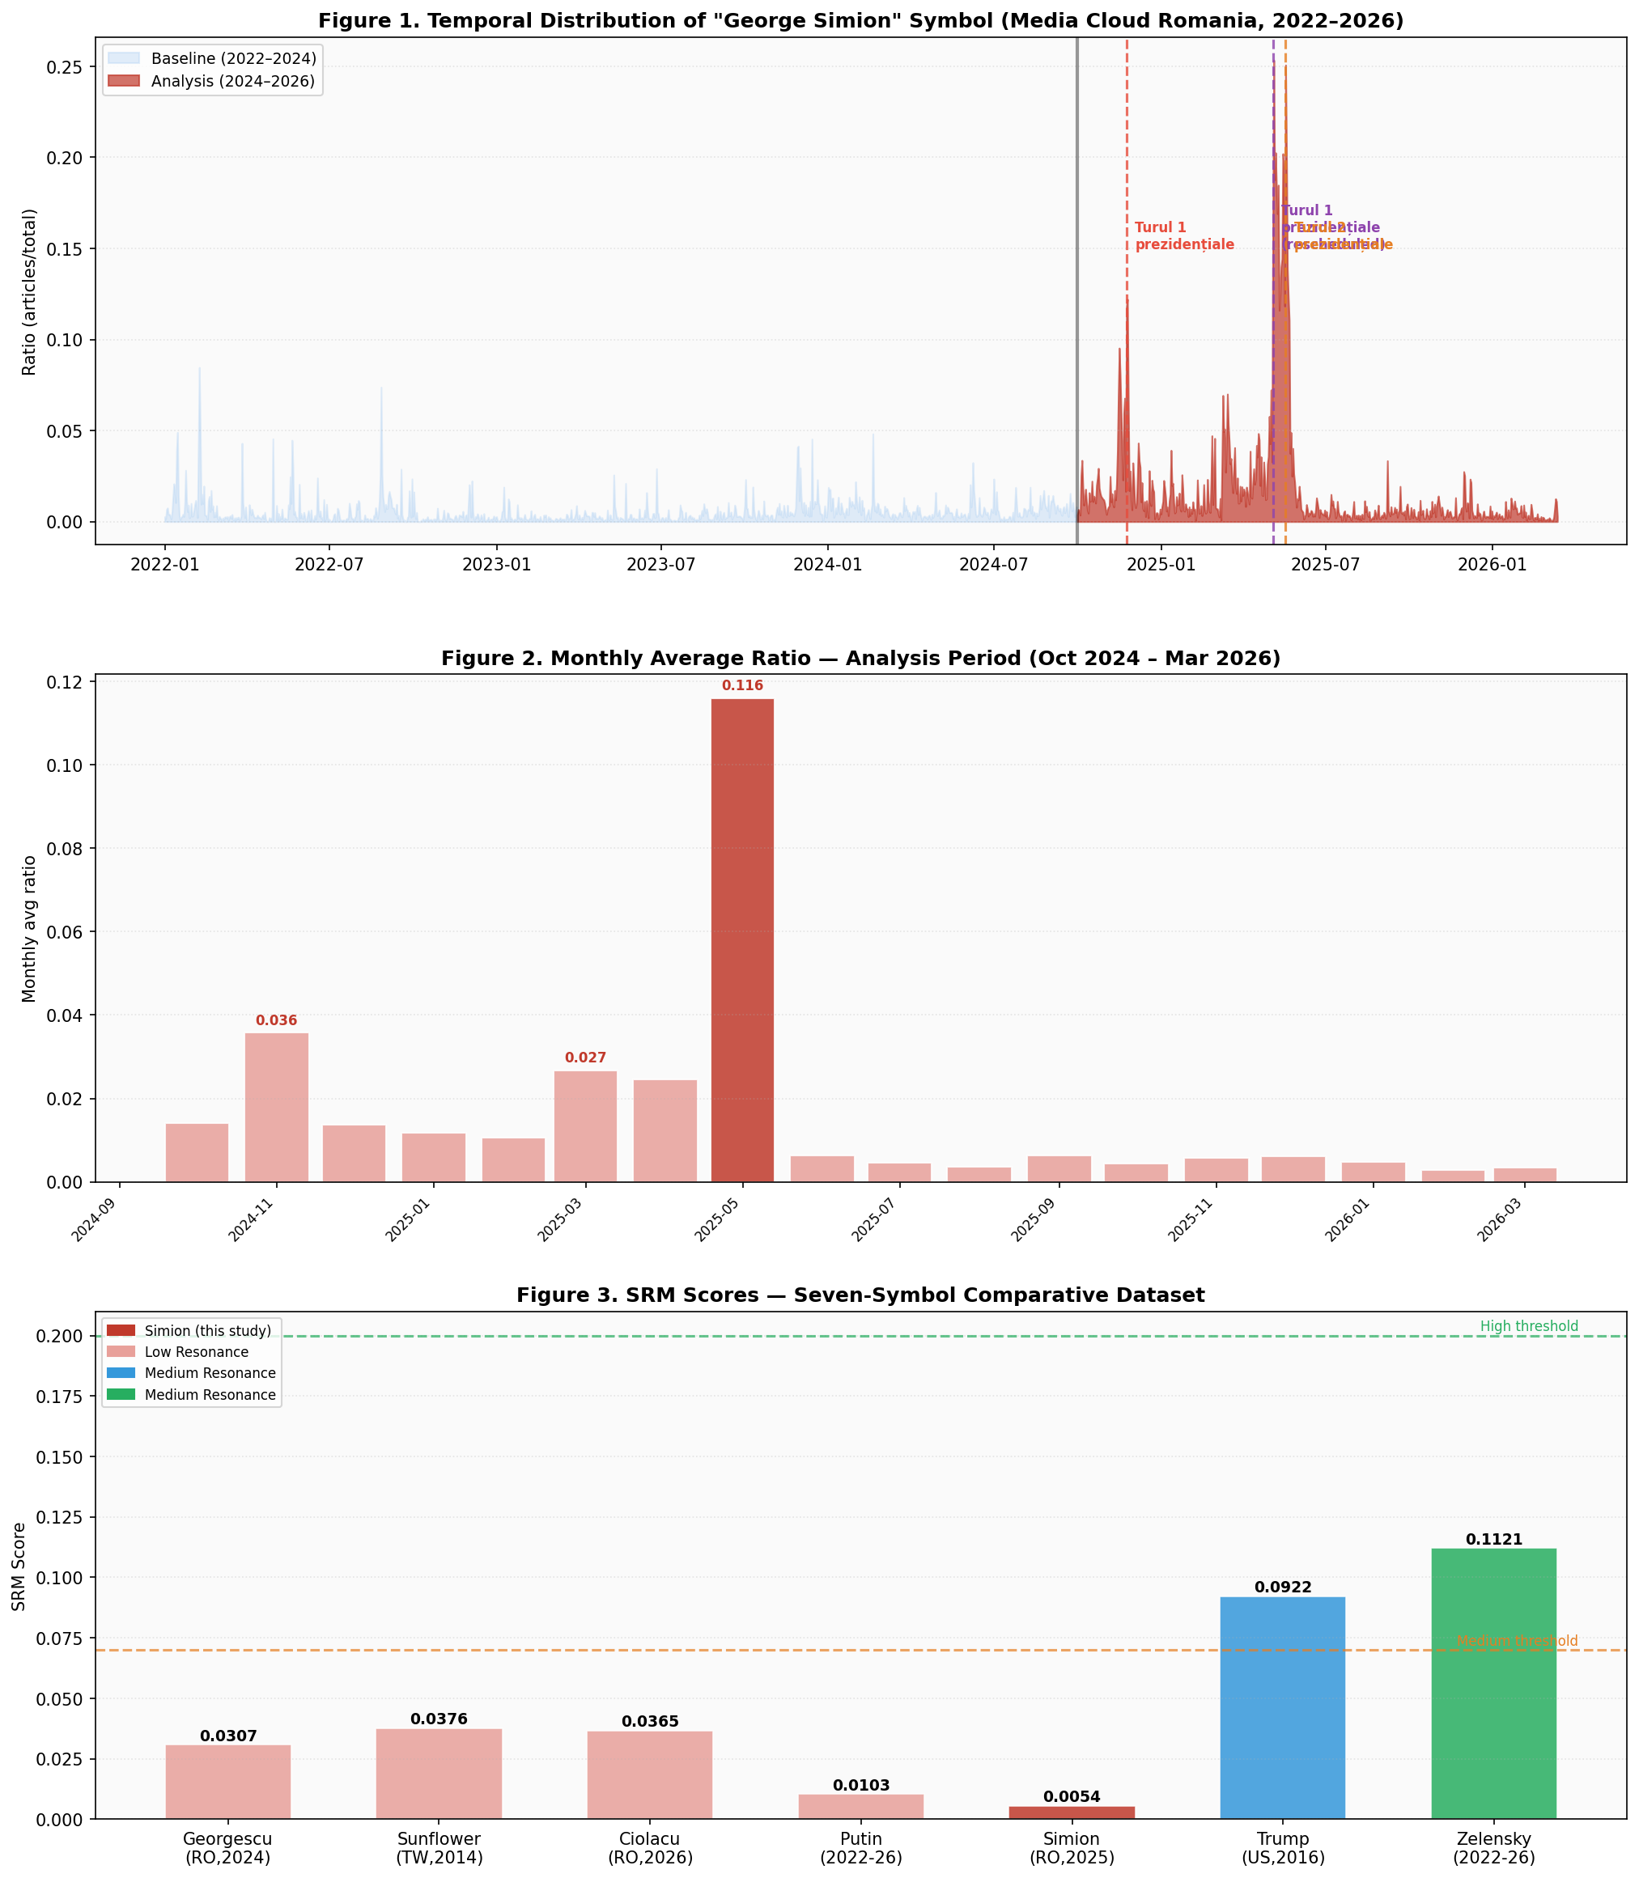
Figures 1–3. Top: Temporal distribution of “george simion” in Romanian media (2022–2026) with electoral events marked. Middle: Monthly average ratio during analysis period showing May 2025 electoral peak. Bottom: Seven-symbol SRM comparative dataset.

4.3 Romanian Triada — Controlled Comparison
Symbol | V | A | D | N | SRM
Călin Georgescu (Oct–Dec 2024) | 0.750 | 0.398 | 0.881 | 0.600 | 0.0307
Marcel Ciolacu (Dec 2025–Mar 2026) | 0.720 | 0.420 | 0.841 | 0.650 | 0.0365
George Simion (Oct 2024–Mar 2026) | 0.279 | 0.099 | 0.812 | 0.996 | 0.0054

The Romanian Triada reveals a consistent structural pattern: all three symbols produce Low Resonance despite operating in the same national political space during the same period. The primary differentiator is A: Georgescu (0.398) and Ciolacu (0.420) generate higher affective charge than Simion (0.099).
This reflects the different media treatment: Georgescu and Ciolacu generated more emotionally charged coverage due to judicial controversies, electoral annulment, and institutional crises. Simion’s coverage is more campaign-factual in style.

4.4 Full Seven-Symbol Comparative Dataset
Symbol / Context | V | A | D | N | SRM | Typology
George Simion (RO, 2024–26) | 0.279 | 0.099 | 0.812 | 0.996 | 0.0054 | Fragmented Diffusion*
Călin Georgescu (RO, 2024) | 0.750 | 0.398 | 0.881 | 0.600 | 0.0307 | Fragmented Diffusion
Marcel Ciolacu (RO, 2025–26) | 0.720 | 0.420 | 0.841 | 0.650 | 0.0365 | Fragmented Diffusion
Vladimir Putin (2022–26) | 0.217 | 0.259 | 0.847 | 1.000 | 0.0103 | Pre-Saturated Contradicted
Sunflower Mvt (TW, 2014) | 0.680 | 0.420 | 0.774 | 0.580 | 0.0376 | Fragmented Diffusion
Donald Trump (US, 2015–16) | 0.958 | 0.580 | 0.734 | 0.720 | 0.0922 | High-Velocity Campaign
Zelensky (UA, 2022–26) | 0.873 | 0.640 | 0.680 | 0.781 | 0.1121 | Sustained Wartime Coherent

* Simion’s typology is Fragmented Diffusion with A lower bound caveat. True typology pending VADER recalibration for Romanian.

5. Discussion

5.1 The Romanian Triada Finding
The most significant result of this validation is not the individual SRM score but the structural pattern revealed by the triada. Three symbols — Georgescu, Ciolacu, Simion — operating in the same national political space, measured on the same corpus, during overlapping periods, all produce Low Resonance. This is the first within-country controlled comparison in the SRM dataset.
The triada confirms Politomorphism’s prediction that Low Resonance is the structural norm in fragmented democratic systems: multiple symbols compete for the same symbolic space, generating mutual semantic contamination and preventing any single symbol from achieving coherent mobilization at the national level.
The A differential within the triada is theoretically important: Georgescu (0.398) and Ciolacu (0.420) generate more emotional coverage than Simion (0.099), likely because they are associated with judicial controversies and institutional crises that provoke stronger editorial reactions.
Simion’s coverage is more campaign-factual, reflecting his role as an electoral candidate rather than a crisis figure.

5.2 The A=0.0994 Limitation and Its Theoretical Significance
A=0.0994 is the lowest in the dataset and reflects a methodological limitation (VADER English calibration) combined with a genuine structural property: Romanian political journalism is more factual-neutral than Western anglophone media. If true A is 0.35–0.45, SRM would be 0.014–0.018 — still Low Resonance but comparable to Georgescu and Ciolacu.
This finding motivates a future research direction: developing a Romanian-language sentiment lexicon calibrated for political journalism to replace VADER for Romanian-language corpora.

5.3 Future Directions
- Romanian-language sentiment model development (RODBERT or XLM-RoBERTa) to replace VADER + dictionary for Romanian corpora.
- Extension to 10–20 symbols: Emmanuel Macron (movement-to-institution), Giorgia Meloni (fringe-to-power), Nelson Mandela 1990 (High Resonance anchor).
- Longitudinal analysis of the Romanian Triada to detect symbolic dominance transitions.
- Grid search λ calibration when dataset reaches n=15 with external ground truth.

6. Conclusions
This paper presents the seventh computational validation of the Social Resonance Model, the quantitative part of Politomorphism.
- SRM = 0.0054 (Low Resonance, lower bound) — V=0.2790 and N=0.9962 from real CSV data; A=0.0994 from VADER + Romanian dictionary on 6,310 titles; D=0.812 expert-estimated;
- The Romanian Triada (Georgescu, Ciolacu, Simion) reveals a structural pattern: all three Romanian political symbols produce Low Resonance on the same corpus, confirming that fragmented democratic competition prevents symbolic coherence at the national level;
- A=0.0994 is the lowest in the dataset, reflecting both a VADER calibration limitation for Romanian and a genuine structural property of factual-neutral Romanian political journalism;
- The May 2025 peak (ratio=0.253, highest in Romanian dataset) corresponds to turul 2 prezidențiale — confirming SRM’s capacity to detect electoral mobilization events even when overall resonance is low;
- Seven symbolic typologies are now empirically grounded across seven validated cases spanning four countries.

References
Benoit, W. L. (2014). Accounts, Excuses, and Apologies: Image Repair Theory and Research. SUNY Press.
Cottle, S. (2009). Global Crisis Reporting: Journalism in the Global Age. Open University Press.
Hutto, C. J., & Gilbert, E. (2014). VADER: A Parsimonious Rule-Based Model for Sentiment Analysis of Social Media Text. ICWSM.
Lazer, D. et al. (2009). Computational Social Science. Science, 323(5915), 721–723.
Moffitt, B. (2016). The Global Rise of Populism. Stanford University Press.
Rogers, E. M. (2003). Diffusion of Innovations (5th ed.). Free Press.
Serban, G. F. (2024–2026). Politomorphism: A Theoretical Framework for the Analysis of Symbolic Morphogenesis in Political Space.
Watts, D. J. (2004). Small Worlds. Princeton University Press.

Reproducibility Note
Pipeline: github.com/profserbangabriel-del/politomorphism
Data: Media Cloud, Romanian National + Romanian State & Local. Search term: GEORGE SIMION.
Baseline: Jan 1 2022 — Sep 30 2024 (1,004 obs.). Analysis: Oct 1 2024 — Mar 13 2026 (529 obs.).
Content corpus: Goerge_Simion_-content.csv (22,197 articles). Counts: George_Simion_Counts.csv.
Generated artifacts: SRM_simion_result.json, SRM_Simion_chart.png, srm_simion_validation.py
ORCID: 0009-0000-2266-3356 | DOI: 10.17605/OSF.IO/HYDNZ

