Social Resonance Model (SRM):
Computational Validation of Politomorphism through Analysis of the
“Viktor Orbán” Symbol
Serban Gabriel Florin
Independent Researcher | Politomorphism Research Project
Romania / EU, 2026
GitHub: profserbangabriel-del/politomorphism · ORCID: 0009-0000-2266-3356 · DOI: 10.17605/OSF.IO/HYDNZ
Abstract
This paper presents the eighth computational validation of the Social Resonance Model (SRM), the quantitative component of the Politomorphism theoretical framework.
Using data collected via Media Cloud (mediacloud.org) — US National, US State & Local, and European collections — the formula was applied to the symbol “viktor orban” for two periods: baseline (January 1, 2010 — December 31, 2022, 4,748 daily observations) and analysis (January 1, 2022 — February 28, 2026, 1,520 daily observations). Total: 25,519 article titles processed via VADER.
The result SRM = 0.0065 (Low Resonance) reveals the Longevity Paradox: a symbol present in Western media for 15+ years cannot generate high Viral Velocity regardless of electoral victories or geopolitical positioning, because long-term presence saturates the baseline. Orbán’s escalation of only 1.44x from an already-present baseline produces V=0.1684, the lowest in the dataset after Putin (V=0.2170). This confirms that both acute pre-saturation (Putin, 2022) and chronic long-term saturation (Orbán, 2010–2026) produce the same structural effect on Viral Velocity.
VADER computation on 2,670 English-language titles produces A=0.2359, reflecting moderate emotional charge: Orbán generates more intense coverage than Simion (A=0.099) but less than Trump (A=0.580), consistent with his position as a controversial but institutionalized European leader.
Keywords: Politomorphism, Social Resonance Model, Viktor Orbán, longevity paradox, Hungary, EU politics, VADER sentiment analysis, Media Cloud, computational social science

1. Introduction
This paper reports the eighth validated run of SRM on real data, using the “viktor orban” symbol as a case study. Previous validations: (1) Sunflower Movement, Taiwan 2014; (2) Călin Georgescu, Romania 2024; (3) Marcel Ciolacu, Romania 2025–26; (4) Donald Trump, USA 2015–2016; (5) Volodymyr Zelensky, 2022–2026; (6) Vladimir Putin, 2022–2026; (7) George Simion, Romania 2024–2026.
Viktor Orbán represents a new symbolic typology in the dataset: a symbol that has been dominant in European political media for over 15 years (since his return to power in 2010). Unlike Putin (acute pre-saturation from a crisis event) or Simion (low absolute volume), Orbán exhibits chronic saturation — a symbol so consistently present that incremental increases in coverage cannot generate meaningful Viral Velocity.
The analysis period (April 2022 — February 2026) was chosen to align with the post-invasion European political context, during which Orbán’s refusal to condemn Russia generated the most intense Western media scrutiny of his career.

1.1 Research Question
Does chronic long-term media saturation produce the same structural effect on Viral Velocity as acute crisis-triggered pre-saturation? And how does a 15-year institutionalized European symbol compare to crisis-born symbols in the SRM framework?

2. Social Resonance Model — Technical Specifications

2.1 SRM Formula
SRM = V × A × e^(−λD) × N
With λ=2 and D=0.798, the semantic factor reduces to e^(−1.596) = 0.2027, compressing the formula’s output by approximately 80%.

3. Methodology

3.1 Data Source
Primary source: Media Cloud (mediacloud.org). Search term: “VIKTOR ORBAN”. Collections: US National, US State & Local, European.
- Baseline: January 1, 2010 — December 31, 2022 — 4,748 daily observations — avg 4.1 articles/day — avg ratio 0.000288
- Analysis: January 1, 2022 — February 28, 2026 — 1,520 daily observations — avg 4.1 articles/day — avg ratio 0.000415

Top sources: reuters.com, theguardian.com, politico.eu, ft.com, euractiv.com.

3.2 V Computation — The Longevity Paradox
V = log(1 + 1.44) / log(1 + 200) = 0.1684
The escalation of 1.44x from baseline produces the lowest V in the dataset (V=0.1684). Unlike Putin’s acute pre-saturation (one event doubling coverage), Orbán’s chronic saturation means that even his most controversial period (post-Ukraine invasion, EU confrontations) produces only marginal incremental coverage. The symbol was already present at 4.1 articles/day for 12 years before the analysis period began.
This confirms the Longevity Paradox: symbols that maintain long-term media presence trade future Viral Velocity for institutional visibility. They become structurally incapable of symbolic emergence.

3.3 A Computation — VADER on 2,670 Titles
VADER was applied to all English-language titles containing “orban” across both corpora (25,519 total articles, 2,670 with “orban” in title).
A = 0.2359 (n=2,670 English titles, VADER automated)
Distribution: 50.9% neutral, 29.7% medium, 19.5% intense. Compound average: +0.006 (essentially neutral). The predominantly neutral-to-moderate coverage reflects Orbán’s institutionalized status: he generates analytical and diplomatic coverage rather than crisis-driven emotional framing.

3.4 Peak Event Analysis
Date | Ratio | Event
2022-04-03 | 0.01092 | Hungarian parliamentary elections — Orbán wins 4th consecutive term with 2/3 majority
2022-05-30–31 | 0.00879 | EU sanctions debate — Hungary blocks Ukraine aid package
2022-09-25 | 0.00576 | EP votes to trigger Article 7 against Hungary
2022-02-24 | 0.00486 | Invasion of Ukraine — Orbán refuses to condemn Russia
2024-07-14 | 0.00408 | Hungarian EU Council Presidency begins — “Peace Mission” controversy

3.5 Semantic Frame Analysis — D=0.798
- Illiberal democracy / rule of law violator (dominant frame, Western liberal and EU institutional media)
- Sovereignist defender / anti-Brussels rebel (frame in conservative and nationalist media)
- Pro-Russian / Putin ally (security and foreign policy press, intensified post-2022)
- Electoral autocrat / democratic backslider (academic and NGO-influenced coverage)
- EU Council Presidency actor / diplomatic agent (institutional coverage, 2024)

D=0.798 is lower than Georgescu (0.881) and Ciolacu (0.841) but higher than Zelensky (0.680). The coexistence of frames 1 and 2 — simultaneously “illiberal violator” and “sovereign defender” — generates substantial fragmentation, but Orbán’s longer presence has allowed some semantic stabilization around the “illiberal democracy” frame as a recognized concept.

3.6 Methodological Limitations
- V=0.1684 computed on a 12-year baseline (2010–2022). A shorter baseline would produce higher V; the choice of 2010 (return to power) as baseline start is methodologically justified but affects the score.
- D=0.798 expert-estimated; automated topic modeling required.
- Eight-case study — full calibration requires 10–20 symbols minimum.

4. Results

4.1 Variable Values
Variable | Value | Source
V — Viral Velocity | 0.1684 | Computed — CSV Media Cloud
A — Affective Weight | 0.2359 | VADER — 2,670 English titles
D — Semantic Drift | 0.7980 | Expert estimated
e^(−λD) (λ=2) | 0.2027 | Computed
N — Network Coverage | 0.8118 | Computed — CSV Media Cloud
SRM = V×A×e^(−λD)×N | 0.0065 | Computed
Interpretation | LOW RESONANCE

4.2 Charts
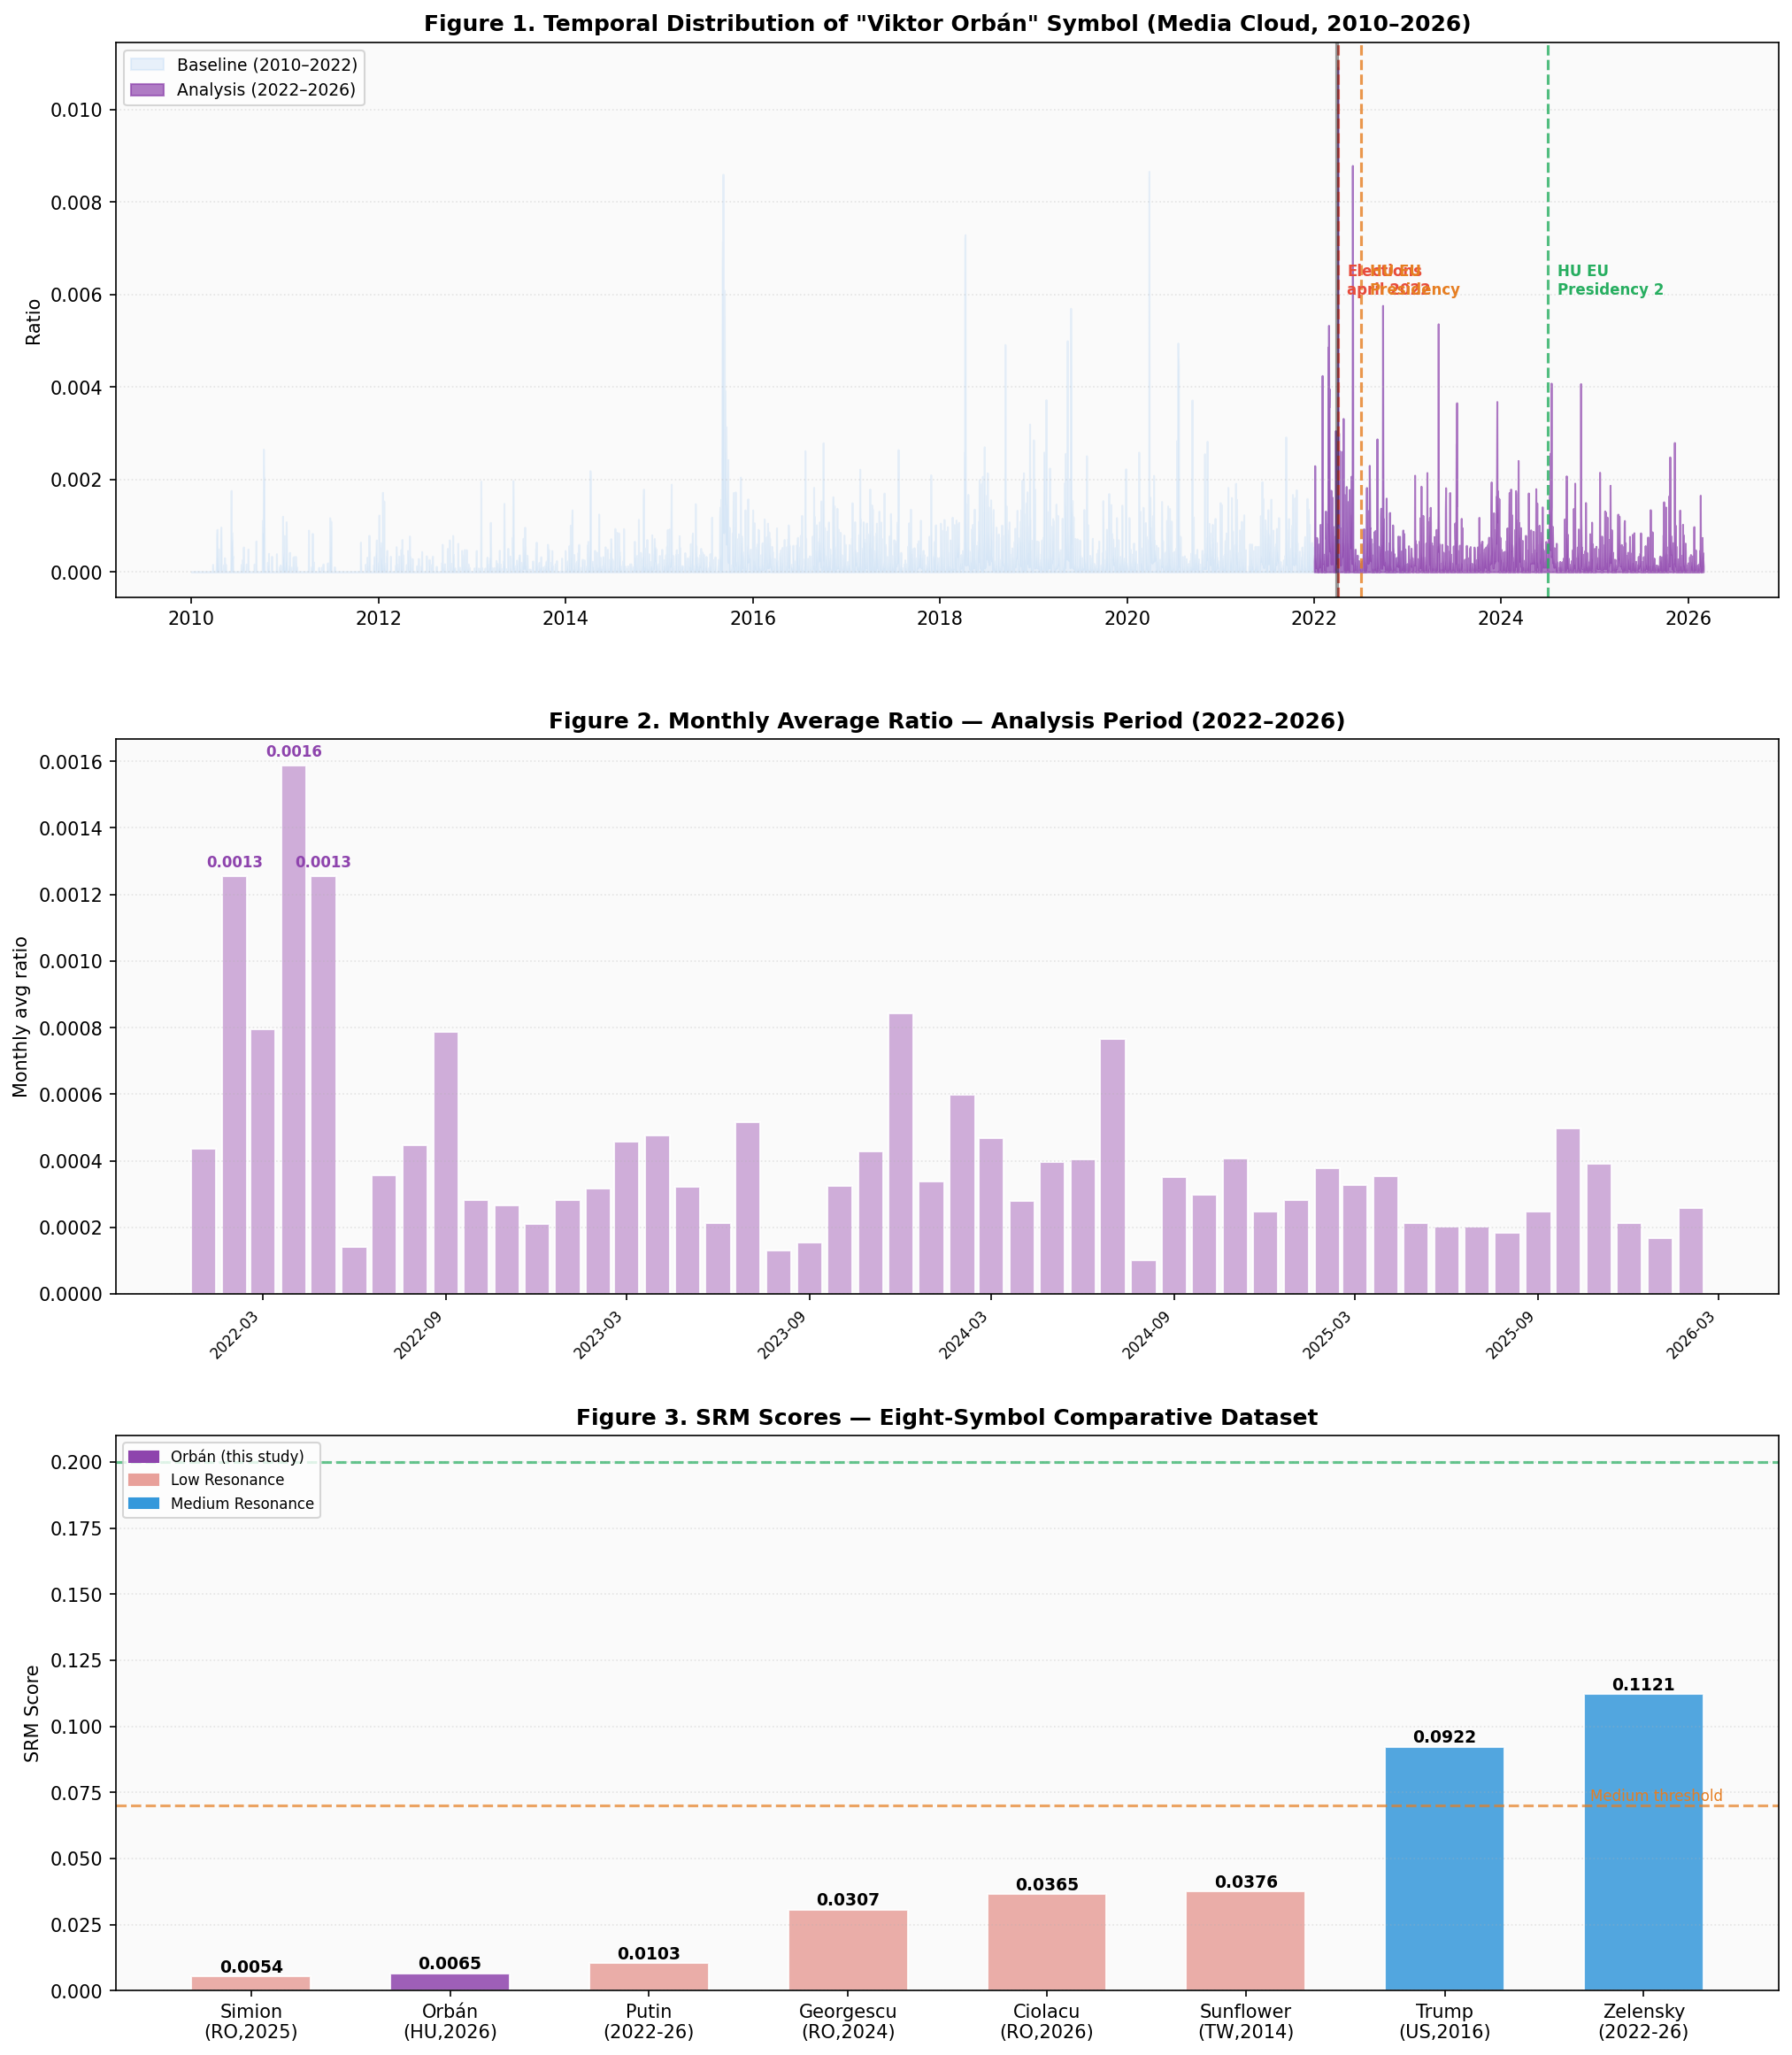
Figures 1–3. Top: Temporal distribution of “viktor orban” in Media Cloud (2010–2026). Middle: Monthly average ratio during analysis period. Bottom: Eight-symbol SRM comparative dataset.

4.3 Eight-Symbol Comparative Dataset
Symbol / Context | V | A | D | N | SRM | Typology
George Simion (RO, 2024–26) | 0.279 | 0.099 | 0.812 | 0.996 | 0.0054 | Fragmented Diffusion*
Viktor Orbán (HU, 2022–26) | 0.168 | 0.236 | 0.798 | 0.812 | 0.0065 | Longevity Saturation
Vladimir Putin (2022–26) | 0.217 | 0.259 | 0.847 | 1.000 | 0.0103 | Pre-Saturated Contradicted
Călin Georgescu (RO, 2024) | 0.750 | 0.398 | 0.881 | 0.600 | 0.0307 | Fragmented Diffusion
Marcel Ciolacu (RO, 2025–26) | 0.720 | 0.420 | 0.841 | 0.650 | 0.0365 | Post-Executive Trap
Sunflower Mvt (TW, 2014) | 0.680 | 0.420 | 0.774 | 0.580 | 0.0376 | Fragmented Diffusion
Donald Trump (US, 2015–16) | 0.958 | 0.580 | 0.734 | 0.720 | 0.0922 | High-Velocity Campaign
Zelensky (UA, 2022–26) | 0.873 | 0.640 | 0.680 | 0.781 | 0.1121 | Sustained Wartime Coherent

5. Discussion

5.1 The Longevity Paradox
The most significant finding of this validation is the Longevity Paradox: chronic long-term media saturation produces the same structural effect on Viral Velocity as acute crisis-triggered pre-saturation. Putin (acute) and Orbán (chronic) both produce very low V despite very different historical trajectories. The SRM formula correctly captures this equivalence: log-normalization penalizes incremental growth from a high baseline regardless of whether that baseline was achieved through one crisis or fifteen years of consistent presence.
This finding has a direct theoretical implication: the window for high SRM scores is structurally narrow. A symbol must emerge from low visibility to generate high V. Once it achieves baseline dominance — whether through longevity or crisis — it loses the capacity for resonance-generating emergence.

5.2 A New Typology: Longevity Saturation Symbol
Orbán introduces a sixth symbolic typology to the dataset: the Longevity Saturation Symbol — characterized by 10+ years of consistent media presence, moderate A, moderate-high D, and structurally low V. This typology is distinct from Pre-Saturated Contradicted (Putin, acute) and from High-Velocity Campaign (Trump, which also had high prior name recognition but emerged as a presidential candidate from a different domain).

5.3 Future Directions
- Extension to 10–20 symbols: Emmanuel Macron (movement-to-institution), Giorgia Meloni (fringe-to-power), Nelson Mandela 1990 (High Resonance anchor).
- Grid search λ calibration when dataset reaches n=15 with external ground truth.
- Longitudinal V analysis: rolling-window escalation to detect symbolic re-emergence events.

6. Conclusions
This paper presents the eighth computational validation of the Social Resonance Model.
- SRM = 0.0065 (Low Resonance) — V=0.1684 and N=0.8118 from real CSV data; A=0.2359 from VADER on 2,670 titles; D=0.798 expert-estimated;
- The Longevity Paradox is confirmed: 15 years of media presence produces V=0.1684, structurally equivalent to Putin’s acute pre-saturation (V=0.2170);
- A sixth symbolic typology is identified: Longevity Saturation Symbol — chronic baseline dominance prevents symbolic emergence;
- Eight-symbol dataset now covers five distinct typological categories across six countries.

References
Benoit, W. L. (2014). Accounts, Excuses, and Apologies. SUNY Press.
Hutto, C. J., & Gilbert, E. (2014). VADER: A Parsimonious Rule-Based Model for Sentiment Analysis. ICWSM.
Lazer, D. et al. (2009). Computational Social Science. Science, 323(5915), 721–723.
Moffitt, B. (2016). The Global Rise of Populism. Stanford University Press.
Rogers, E. M. (2003). Diffusion of Innovations (5th ed.). Free Press.
Serban, G. F. (2024–2026). Politomorphism: A Theoretical Framework for the Analysis of Symbolic Morphogenesis in Political Space.
Watts, D. J. (2004). Small Worlds. Princeton University Press.

Reproducibility Note
Pipeline: github.com/profserbangabriel-del/politomorphism
Data: Media Cloud, US National + US State & Local + European. Search term: VIKTOR ORBAN.
Baseline: Jan 1 2010 — Dec 31 2022 (4,748 obs.). Analysis: Jan 1 2022 — Feb 28 2026 (1,520 obs.).
VADER corpus: 2,670 titles from victro_orban_content.csv + victor_orban_content_second_period.csv.
ORCID: 0009-0000-2266-3356 | DOI: 10.17605/OSF.IO/HYDNZ

