Foundations and Historical Development of Trauma Neurobiology
Chapter 1
Central question. How did the study of trauma become a neurobiological discipline, and what standards of evidence allow biological findings to inform explanation, treatment and policy without claiming more than the data support?

In this chapter

The PDF contains the generated contents and page numbers. Refresh the contents field in Word after editing.

Learning objectives
After studying this chapter, readers should be able to:
• Distinguish trauma exposure, observed responses, explanatory mechanisms, and clinical interpretations.
• Relate cellular, circuit, endocrine, immune, cognitive, developmental, and social levels of analysis without treating them as interchangeable.
• Explain how research design, measurement, timing, and context constrain the interpretation of biological findings.
• Evaluate a proposed application in relation to safety, professional competence, uncertainty, cultural relevance, and resources.
• Critically appraise a study and formulate a defensible research question with appropriate ethical safeguards.

Introduction
Trauma neurobiology examines how experiences of threat and adversity relate to nervous-system structure, signalling, bodily regulation, behaviour, and recovery. Its subject cannot be reduced to a single brain region, hormone, or test result. Explanation requires attention to the processes being measured, the circumstances in which they occur, and their implications for functioning.
Trauma exposure does not identify a uniform biological state. People may respond differently to apparently similar events, and similar difficulties may arise through different pathways. Neurobiological explanations should therefore clarify processes and probabilities rather than assign a fixed identity to a person. Immediate responses during danger must also be distinguished from difficulties that persist after danger has passed.
The chapter establishes a framework for reading the rest of the book: specify the question, identify the relevant level of analysis, examine the evidence, consider alternative explanations, and assess the consequences of acting on the interpretation. Figure 1.1 locates the ten main topics within that framework. The historical discussion explains how research questions changed as investigators moved from regulation and lesion observations to physiological measurement, endocrine assays, and imaging. These developments should be evaluated through their methods and limits rather than treated as a simple accumulation of increasingly definitive tests.
Figure 1.1. Chapter topics and interpretative framework
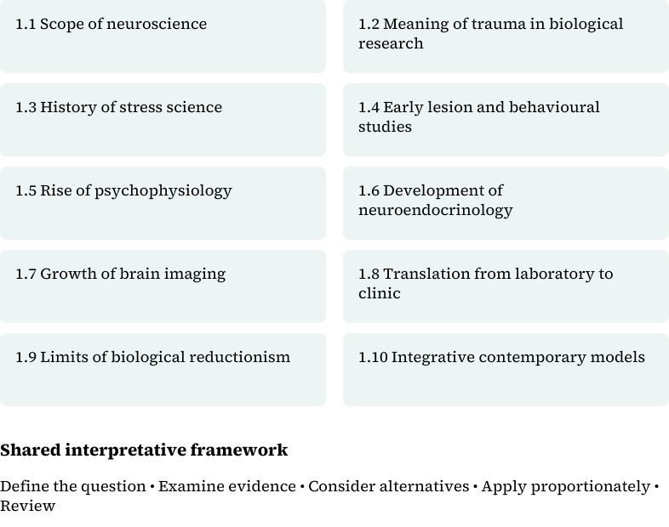
Boxes identify the ten main topics in the source outline; their placement does not imply anatomy or causation. Original editorial schematic derived from the supplied chapter; no empirical data are plotted.

1.1 Scope of neuroscience

1.1.1 Levels of explanation
A neurobiological claim may concern ion flow across a membrane, activity within a local circuit, communication among distributed networks, endocrine feedback, immune signalling, or behaviour during a task. These levels interact, but evidence at one level does not automatically establish what has happened at another. A change in a measured biological characteristic is not, by itself, a complete account of a person's experience or functioning.
The first task is to identify the units and relationships relevant to the question. An explanation should distinguish the exposure, the person's perception and appraisal, bodily responses, memory, action, and subsequent adaptation. This sequence is an analytical framework, not a claim that every response follows a single fixed pathway. Feedback and alternative routes remain important.
Statements such as “trauma changes the brain” are too imprecise to carry much explanatory weight unless they specify what was measured. Readers should ask which tissue or process is involved, when measurement occurred, the direction and magnitude of the reported difference, whether it may change over time, and what it means for functioning. Table 1.1 separates the principal levels of inquiry and their interpretative limits.
Table 1.1. Levels of analysis, methods, and interpretative limits
Level | Question | Evidence or method | Interpretative limit
Cellular and molecular | Which cellular or molecular processes are being examined? | Cell culture, molecular assays, genetics, animal models | Mechanistic evidence requires caution when applied to an individual.
Circuit and systems | How are the relevant processes organised across circuits and systems? | Imaging, electrophysiology, lesion evidence, task performance | Regional activation is not a diagnosis.
Endocrine and immune | How are measured responses related to bodily regulation? | Hormone and immune assays; repeated sampling | Timing, health, medication, sleep, and assay variation affect results.
Behaviour and function | How are observed responses related to daily functioning? | Interviews, questionnaires, behavioural tasks, records | Symptom measures require interpretation alongside function and meaning.
Social context and implementation | How does application vary across settings? | Qualitative and mixed-methods research; implementation and policy evaluation | Resources, culture, law, and unequal access shape application.
Adapted editorially from original PDF pages 130–131. Questions have been clarified without adding measurements or findings; author approval is required. No single row provides a complete explanation.

1.1.2 Observation, mechanism, and inference
An observation describes what was measured. A mechanistic explanation proposes how a process occurs. Researchers may identify a sequence of events, examine intermediate variables, and test whether changing one component affects another. Showing that two observations occur together does not establish such a sequence.
Direct experimental manipulation is often unethical or impracticable in human trauma research. Investigators therefore combine longitudinal observation, experimental learning tasks, physiological recording, imaging, molecular assays, and cautiously interpreted animal models. Each method addresses part of a question. Converging findings can strengthen an explanation, but disagreement between methods should remain visible rather than be dismissed for the sake of a simple narrative.
A defensible account distinguishes established findings, plausible interpretations, and speculative extensions. It also allows for feedback: stress responses can affect attention and memory, while memory and appraisal can influence later responses. The task is to explain these relationships with appropriate evidence, not merely to name additional structures or molecules.

1.2 Meaning of trauma in biological research

1.2.1 Exposure is not an outcome
The manuscript uses trauma to refer to an exposure or experience that may be followed by different responses. Exposure, symptoms, biological measurements, functional impairment, and diagnosis must not be treated as equivalent. A reported event does not establish a particular biological pattern, and a biological difference does not prove that a particular event occurred.
Research should state how exposure and outcomes were defined, how information was obtained, and when it was collected. Interviews, records, behavioural tasks, physiological recordings, imaging, and molecular assays provide different kinds of information. Their agreement cannot be assumed, and differences between studies may reflect different operational definitions rather than incompatible findings.
Clinical interpretation requires an assessment of the person rather than an inference from one research measure. Relevant information includes present safety, symptoms, physical health, medication, pain, sleep, substance use, previous exposure, relationships, resources, cultural meaning, and goals. Neuroscience may contribute to that account; it does not replace medical examination, safeguarding, diagnosis, or collaborative assessment.

1.2.2 Timing and development
Time changes the meaning of biological evidence. Responses that support survival during immediate danger may interfere with sleep, concentration, relationships, or health when they persist in other circumstances. Interpretation should distinguish acute, recurrent, chronic, delayed, and improving patterns rather than assume that a measured difference represents permanent damage.
Developmental stage also matters. Prenatal life, childhood, adolescence, adulthood, and later life differ in maturation, experience, bodily regulation, and social dependence. Research should therefore document the timing, duration, and repetition of exposure, recovery intervals, prior experiences, protective relationships, and current conditions. These factors help explain why the same exposure may be associated with different outcomes and why similar outcomes may have different histories.

1.2.3 Foundational distinctions
Homeostasis concerns regulation that maintains physiological variables within viable ranges. Stability is actively maintained; it does not mean that a living system is static. Allostasis emphasises adjustments in regulation as conditions and demands change. These concepts overlap, and the usefulness of treating them as distinct explanatory frameworks has been debated (Goldstein & Kopin, 2007; Godoy et al., 2018).
Adaptation, in this discussion, denotes physiological or behavioural adjustments through which an organism responds to changing demands. An adjustment that is useful in one setting need not remain useful under persistent or different demands. Allostatic load concerns the cumulative burden associated with sustained or repeated regulatory demands; it should not be used as an interchangeable label for a stressful event, a symptom score, or a diagnosis (Goldstein & Kopin, 2007; Godoy et al., 2018).
A biomarker is a measured characteristic used to indicate a biological process or a biological response to an exposure or intervention. Biomarkers can be molecular, histological, imaging-based, or physiological. Their intended use must be specified. A biomarker is not the same as a measure of how a person feels or functions, and a measured association alone does not establish diagnostic usefulness (U.S. Food and Drug Administration, n.d.).
A mechanism explains how a process occurs; a correlation describes an association. Causal inference concerns whether a change in one factor contributes to a change in another, rather than merely accompanying it. Translation connects research evidence to a defined application and tests whether that application is justified. These working distinctions organise the chapter's methodological discussion; they are not competing diagnoses or distinct biological substances.

1.3 History of stress science

1.3.1 Internal regulation and emergency responses
Claude Bernard's account of the internal environment provided an important foundation for physiological explanations of regulation. Walter Cannon developed the concept of homeostasis and examined coordinated responses to threats. His work linked sympathetic and adrenal responses to the mobilisation of the organism for action, helping establish the framework commonly described as fight or flight. The intellectual shift was from considering organs in isolation towards asking how coordinated physiological adjustments preserve function under changing conditions (Goldstein & Kopin, 2007; Godoy et al., 2018).
Homeostasis did not imply immobility. Its explanatory value lay in showing how stability depends on compensatory processes. A controlled variable can be maintained within a viable range while the activity of the mechanisms regulating it changes. This distinction remains essential when interpreting a hormone or autonomic measure: a changed effector signal does not necessarily mean that regulation has failed (Goldstein & Kopin, 2007).

1.3.2 Selye and subsequent revisions
Hans Selye's 1936 work helped establish a biological research programme concerned with recurring responses to different harmful agents. His general adaptation syndrome described alarm, resistance, and exhaustion. The framework gave prominence to coordinated bodily responses and the potential consequences of sustained demands, but its claim to nonspecificity should be understood as a historical proposition rather than an assumption that every stressor produces the same response in every person (Godoy et al., 2018; Goldstein & Kopin, 2007).
Subsequent systems accounts emphasise patterned responses that depend on the challenge, the organism's interpretation, and its history. Allostasis extends the discussion to changing regulatory demands and anticipatory adjustments, while allostatic load directs attention to cumulative burden. Neither term removes the need to identify the particular process and time scale under investigation. Historical models are most useful when they generate testable questions, not when their vocabulary substitutes for measurement (Goldstein & Kopin, 2007; Godoy et al., 2018).
The implications for trauma research are methodological as well as conceptual. A study must distinguish the event, the measured response, and its interpretation. The existence of a stress response does not establish a psychiatric disorder, while the absence of a proposed laboratory pattern does not invalidate a person's experience. General stress physiology and the neurobiology of a particular disorder are related fields, not identical explanatory systems.

1.4 Early lesion and behavioural studies
Lesion research contributes to neuroscience by examining function after damage or removal of tissue. Scoville and Milner's 1957 report of memory impairment following bilateral medial temporal surgery is a foundational example. Their observations linked extensive damage involving the hippocampal region to persistent difficulty retaining recent experience. The report also distinguished memory impairment from a uniform loss of general intellectual functioning (Scoville & Milner, 1957).
The significance of this work lies partly in the specificity of the question: which aspects of memory were affected, and how did the pattern relate to the extent of the lesion? It did not demonstrate that memory resided in one isolated point or that all forms of memory were lost. The original authors explicitly considered uncertainty about the contribution of neighbouring structures because the operations did not isolate the hippocampus from all adjacent tissue. Anatomy, behavioural testing, and limits of the intervention therefore had to be interpreted together (Scoville & Milner, 1957).
For trauma neurobiology, this history illustrates how evidence about learning and memory can inform a mechanistic framework without directly establishing the cause of a clinical condition. Findings from neurosurgical lesions are not observations of trauma exposure or PTSD. Applying them to traumatic memory requires additional evidence appropriate to the population and question. Likewise, experimental tasks may isolate a learning process without reproducing the personal and social circumstances of an overwhelming event.
The methodological lesson is not that lesion findings are uninformative, but that their explanatory reach must be specified. Readers should identify the affected tissue, the measured function, the comparison, and plausible alternative interpretations before extending a finding to a broader theory of memory or behaviour.

1.5 Rise of psychophysiology
Psychophysiological research connects psychological tasks or experiences with recorded bodily responses. In trauma research, this approach made it possible to investigate responding to trauma-related cues rather than rely only on retrospective descriptions. Pitman and colleagues' 2012 review identified heart-rate, skin-conductance, and facial electromyographic responses during trauma-related imagery and cue exposure as important parts of the biological PTSD literature. These measures concern different aspects of responding and should not be treated as interchangeable indicators (Pitman et al., 2012).
The development of this approach shifted the question from whether a person reports distress to how recorded responses vary with cues, experimental conditions, and comparison groups. Its value is analytical: a defined task and recording method make a proposed relationship open to observation and criticism. It does not follow that physiological reactivity is a unique signature of a particular event or a stand-alone diagnostic test. A response observed under one laboratory condition cannot simply be generalised to every setting or every individual with the same diagnosis (Pitman et al., 2012).
Interpretation requires attention to what the measure represents, the recording conditions, timing, health, medication, and alternative influences. Comparison with interviews, behavioural tasks, or imaging needs an explicit rationale. Concordance should be demonstrated rather than assumed. Psychophysiology therefore complements other methods: it adds measurable information while leaving the researcher responsible for showing what conclusions the task and comparison can support.

1.6 Development of neuroendocrinology
Neuroendocrinology developed through work on communication between the nervous and endocrine systems and through advances that made very small quantities of hormones measurable. The 1977 Nobel account highlights two complementary achievements: Roger Guillemin and Andrew Schally's work on hypothalamic releasing hormones, and Rosalyn Yalow's development of radioimmunoassay with Solomon Berson. Identifying regulatory substances and measuring them were distinct but mutually important steps (Karolinska Institutet, 1977).
The same account records the establishment of the structure of thyrotropin-releasing factor in 1969. This is an example of how a proposed regulatory influence became a chemically characterised signal. Sensitive assays also changed the kinds of questions that could be asked about hormone secretion and disease. These developments supported a research programme in which neural regulation could be investigated through defined endocrine signals rather than inferred only from outward behaviour (Karolinska Institutet, 1977).
Stress research draws on the hypothalamic–pituitary–adrenal axis alongside sympathetic and other regulatory processes. The importance of endocrine regulation does not imply that every form of traumatic stress involves the same hormonal pattern. Pitman and colleagues specifically cautioned that a simple model of chronically increased hypothalamic–pituitary–adrenal activity does not characterise PTSD. General models of stress must therefore be tested rather than transferred uncritically to a clinical diagnosis (Godoy et al., 2018; Pitman et al., 2012).
A hormone result is meaningful only in relation to the sampling conditions, timing, assay, comparison, and question. Health, medication, sleep, and repeated sampling can affect interpretation. Historical advances in assay sensitivity expanded measurement; they did not remove the need for defensible study design or convert a laboratory value into an independent account of an individual's experience.

1.7 Growth of brain imaging
Imaging expanded trauma research beyond peripheral physiological and endocrine measures to investigation of brain structure and function. Hinojosa and colleagues locate the early PTSD neuroimaging literature in the 1990s and describe the subsequent expansion of work on vulnerability, change after exposure, treatment outcomes, and proposed brain-based subgroups. The change in method opened new questions; it did not make biological interpretation independent of study design (Hinojosa et al., 2024).
One central problem is temporal order. A difference measured after exposure may have preceded the event, followed it, or reflect factors related to both exposure and outcome. Cross-sectional group comparisons alone cannot resolve these possibilities. The 2024 review therefore emphasises prospective longitudinal designs with measurements before exposure and at follow-up, as well as replication of proposed subgroups. It also distinguishes progress in research from implementation in routine clinical practice (Hinojosa et al., 2024).
Earlier synthesis had already connected PTSD research to hippocampal, amygdala, cingulate, and prefrontal findings while noting uncertainty about whether some differences represented vulnerability or acquired change. Such findings should be read as claims about specified samples and measures, not as a universal map of a traumatised brain. Regional findings can help formulate hypotheses about memory, threat, and regulation, but a group pattern does not determine a person's diagnosis or establish a particular history (Pitman et al., 2012).
The historical progression from peripheral recording to imaging is therefore not a progression from subjective evidence to an infallible biological answer. It is an expansion of observable information that brings new demands for measurement quality, appropriate comparison, temporal design, reproducibility, and restraint in clinical inference (Hinojosa et al., 2024).

1.8 Translation from laboratory to clinic

1.8.1 Measurement and research design
Measurement translates a construct into observable data. A study should state its operational definitions, instruments, units, timing, preprocessing decisions, quality controls, and expected error. Reliability concerns consistency; validity concerns whether the evidence supports the intended interpretation. Statistical significance alone does not establish clinical usefulness. Equally, a null finding may reflect limited power, poor measurement, restricted variation, or a genuinely small effect.
Design constrains inference. A cross-sectional study can estimate associations at one time but cannot establish temporal order. Longitudinal research can examine change, although attrition and repeated measurement may introduce bias. Experiments can investigate constrained mechanisms, while qualitative research can clarify meaning, acceptability, and implementation. Mixed-methods designs can relate these accounts to measured outcomes when the methods are deliberately integrated.
A protocol should define the primary question, exposure, outcomes, sampling, timing, quality controls, missing-data procedures, analysis, and ethical safeguards. Medical illness, medication, sleep disruption, pain, age, sex-related biology, substance use, social adversity, and previous exposure may influence trauma-related measures. Relevant information about these factors should be collected proportionately. Adding measures does not automatically strengthen a study: each should contribute information needed to answer the question.

1.8.2 Clinical formulation and responsible action
Clinical formulation organises information to guide a decision. It should connect the person's concerns, exposure history, present safety, symptoms, strengths, physical health, relationships, resources, culture, and goals. Neurobiological knowledge can help explain possible processes underlying startle, disturbed recall, bodily alarm, emotional numbing, or concentration difficulties. It does not establish a diagnosis independently of clinical assessment.
A formulation should identify immediate risks, modifiable processes, protective conditions, and measurable outcomes. It must remain open to revision when new information challenges the initial account. Treatment selection requires current professional guidance, patient preference, relevant competence, consideration of contraindications, and outcome monitoring rather than reliance on a speculative biomarker or a single image.
Figure 1.2 presents the manuscript's shared decision framework: define the question and context, examine evidence, consider alternatives, select a proportionate action, and review the outcome. This is an educational sequence, not a validated clinical algorithm. Table 1.2 summarises its application across professional settings.
Figure 1.2. Evidence-to-practice reasoning
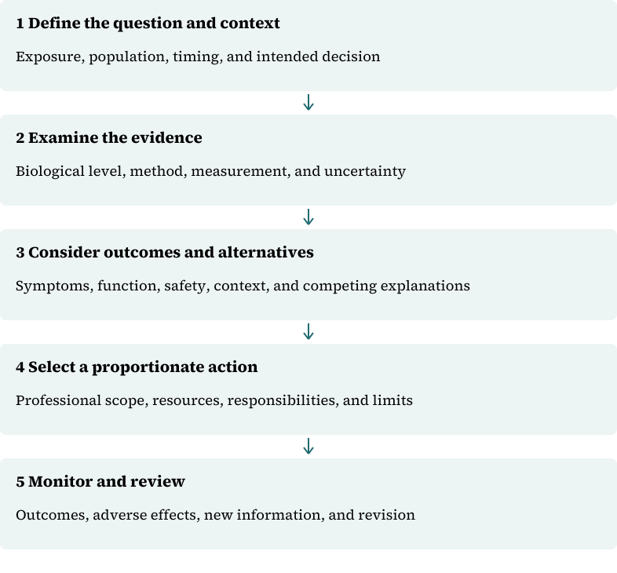
Arrows show an educational decision sequence, not biological causation or a validated clinical algorithm. Original editorial schematic derived from the supplied chapter; no empirical data are plotted.
Table 1.2. Professional applications and quality safeguards
Setting | Decision | Evidence or method | Quality safeguard
Clinical services | What action may improve safety or functioning? | Collaborative assessment; outcome monitoring | Avoid unsupported biological testing and deterministic explanations.
Education | What support may improve participation and learning? | Observation, consultation, accessible teaching | Do not infer trauma or diagnosis from behaviour alone.
Healthcare | How can care reduce avoidable threat and improve continuity? | Medical review, communication, referral, quality data | Protect consent, privacy, and appropriate professional scope.
Government | Which population-level action has evidence and resources? | Surveillance, programme evaluation, policy analysis | Examine fairness, opportunity costs, and unintended harm.
Organisations | How can exposure management and recovery support improve? | Risk assessment, confidential referral, workforce indicators | Do not substitute individual training for safer systems.
Adapted editorially from original PDF pages 131–132. These are questions for planning and appraisal, not demonstrated intervention effects.

1.8.3 Communication and professional boundaries
A useful explanation translates technical language without erasing uncertainty. Practitioners should connect the concept to the person's question, explain normal variation, identify what the evidence cannot establish, and check understanding. Technical vocabulary should not substitute for an explanation or imply that every person exposed to trauma shares the same biological pattern.
Neuroscience education does not authorise diagnosis, prescribing, imaging interpretation, brain stimulation, laboratory testing, or trauma processing without appropriate qualifications and supervision. Urgent medical or psychiatric concerns require suitable assessment and referral. The purpose of translation is to improve decisions within a professional role, not to extend that role beyond its limits.

1.9 Limits of biological reductionism

1.9.1 The person is not the measurement
A biological account becomes reductionist when a partial observation is treated as a complete explanation of a person's experience, difficulties, or prospects. A scan, assay, symptom score, or theoretical circuit should not be used to infer a personal history or a fixed condition that the evidence cannot establish. Biological findings are interpreted in relation to development, health, learning, relationships, material conditions, and access to care.
This caution does not diminish the value of neuroscience. It specifies what is required for its responsible use: a clear construct, a suitable method, an appropriate comparison, a justified inference, and a decision that benefits from the information. A technically accurate result may still have little clinical or policy value if it does not improve the decision under consideration.

1.9.2 Culture, international relevance, and fairness
Research varies across countries in sampling, instruments, diagnostic systems, language, exposure patterns, healthcare access, and research infrastructure. Findings from high-income settings should not be assumed to represent every population. Multinational studies should consider measurement equivalence, document translation, include local investigators, and examine the relevance of conflict, displacement, inequality, infectious disease, nutrition, and service access.
Cultural meaning affects how people describe distress, memory, bodily experience, family responsibility, disclosure, and help-seeking. Researchers and practitioners should ask about meaning rather than infer it from group identity. Collaboration should strengthen local research capacity and shared governance instead of extracting data from under-resourced communities without durable benefit.

1.9.3 Ethics and data governance
Ethical practice requires informed consent, privacy, welfare, fairness, professional competence, and protection from avoidable harm. Trauma research may cause distress, reveal safeguarding concerns, or generate sensitive information. Protocols should specify responses to distress, incidental findings, withdrawal, data breaches, and requests for clinical advice. Compensation should recognise participants' time without exerting undue pressure.
Brain images, genomic information, digital traces, and clinical records may be reused in ways participants did not anticipate. Collection should be proportionate to the question, access should be controlled, and the limits of use should be transparent. People affected by trauma should contribute to study design and interpretation where involvement is safe, respectful, and meaningful.
Biological evidence should not be used to justify exclusion, discrimination, compulsory testing, or intrusive surveillance without demonstrated utility and fairness. Policy requires attention to opportunity costs and unintended consequences as well as intended benefits.

1.10 Integrative contemporary models

1.10.1 Linking explanation to context
An integrative account connects biological processes to cognition, development, behaviour, relationships, and social conditions without confusing these levels. It distinguishes an exposure from its interpretation, an observed difference from a mechanism, and an explanation from an intervention. Competing accounts should remain visible when evidence does not justify choosing one with confidence.
Application begins with a real decision: who needs to decide what, which evidence is available, what uncertainty remains, and which action is proportionate? Implementation requires named responsibilities, resources, referral and escalation routes, outcome indicators, and review dates. General neuroscience cannot provide these operational details on its own; local law, service capacity, and unequal access must also be considered.
Hospitals may use this framework to improve communication, pain care, sleep protection, referral, and continuity. Schools can support participation through predictable communication, manageable cognitive demands, and clear referral routes without diagnosing trauma from behaviour. Workplaces and emergency services can review exposure management, supervision, confidential support, and return-to-work procedures. Individual resilience training must not be used in place of safer systems.

1.10.2 Research development and critical appraisal
The manuscript identifies longitudinal measurement, multimodal data, computational analysis, replication, collaborative samples, and participant involvement as areas of methodological development. Their value depends on appropriate design, harmonisation, secure computing, interpretability, and governance. Novelty is not evidence of clinical benefit.
Personalised prediction, passive sensing, wearable physiology, advanced imaging, molecular signatures, digital interventions, and adaptive treatment raise questions about overfitting, biased samples, privacy, false reassurance, unnecessary alarm, and unequal access. Evaluation should compare a proposed approach with a realistic standard of care and assess harm as carefully as benefit. These are research and evaluation priorities, not claims that the approaches are ready for routine use.
Advanced appraisal should examine the proposition, evidence, causal model, and consequences of use. Relevant questions include whether constructs are clear, samples appropriate, measures reliable and valid, analyses suitable, and findings replicated. A defensible protocol distinguishes exploratory from confirmatory analysis, justifies sample size, specifies primary questions, reports planned outcomes, and shares materials or code where lawful. Conclusions should state what the evidence supports, what remains uncertain, and which next study would reduce the most important uncertainty.

1.11 Teaching cases and worked applications
The following cases are fictional teaching composites from the supplied manuscript. They are not research findings, clinical protocols, or reports of identified people or institutions.

1.11.1 Disaster response across several communities
Severe flooding and infrastructure failure affect several communities. A multidisciplinary team encounters disrupted sleep, heightened startle, grief, pain, displacement, interrupted medication, and reduced access to care. The team considers biological responses without assuming that every reaction indicates a disorder.
Its proposed stepped response combines immediate safety, physical healthcare, practical assistance, family contact, psychological first aid, screening where referral is available, and specialist assessment or treatment for persistent impairment. Researchers propose optional longitudinal measurement with separate consent, secure data handling, community oversight, and feedback of aggregate findings.
The teaching issue is how to connect biological explanation to humane, proportionate decisions. Learners should identify which actions address immediate needs, what would justify further assessment, and how research can remain distinct from access to care.

1.11.2 Recovery after a road traffic collision in Nigeria
At a fictional Nigerian teaching hospital, an adult reports nightmares, bodily alarm, poor concentration, pain, and fear of travelling after a road traffic collision. The clinician reviews injury, medication, sleep, substance use, previous health, present safety, social support, and functional change.
The team uses traumatic stress and adaptation as possible explanatory concepts, not as proof of a diagnosis. It provides plain-language information, coordinates medical and psychological review, agrees measurable goals, and arranges follow-up. A student group considering research on the pathway first examines language validity, transport barriers, phone access, loss to follow-up, and whether biological sampling would have a clear purpose.
Learners should distinguish observed concerns from interpretation, identify the information needed for safe assessment, and consider how access barriers affect both care and research participation. No new diagnosis, outcome, or effectiveness claim is implied by the case.

1.11.3 Worked appraisal: does an association establish causation?
A report describes an association between a biological measure and trauma-related symptoms. No numerical findings are supplied in the original example. The task is to evaluate the inference, not to calculate an effect or assume an experimental result.
1. State the exposure, outcome, population, and measurement times.
2. Identify the design and whether it establishes temporal order.
3. Examine the reliability and validity of the measures.
4. Consider plausible confounding, including age, sleep, medication, physical illness, pain, previous exposure, and social adversity.
5. Inspect the reported effect size and uncertainty rather than relying on statistical significance alone.
6. Assess the comparison group and any replication evidence.
7. Restate the conclusion at the level the design and evidence support, identifying what further work would strengthen causal inference.

1.11.4 Explaining a finding to a professional audience
Begin by identifying the audience and the decision. Replace technical shorthand with accurate plain language, explain variation, and use an observable example. State what the evidence cannot establish and identify urgent concerns that require referral. Offer proportionate actions, check understanding, invite questions, and document the explanation. Review whether the communication improved understanding, safety, participation, or adherence rather than assuming that information alone was helpful.

1.12 Summary
Trauma neurobiology requires explanation across interacting levels, not a single-region or single-molecule account. A useful claim identifies the construct, method, population, timing, uncertainty, and intended use. Exposure, biological measurement, functional impairment, and diagnosis must remain distinct.
Research design determines the inference that evidence can support. Clinical and policy applications require additional attention to safety, professional competence, culture, resources, fairness, and review. Biological knowledge is most useful when it clarifies a decision without reducing a person to a measurement or presenting uncertainty as certainty.
The history of the field shows why methodological advances require conceptual discipline. Improved measurement creates opportunities for more precise questions; it does not remove uncertainty about causation, individual interpretation, or appropriate use.

Review and discussion questions
1. Why must exposure, biological response, functional impairment, and diagnosis be distinguished?
2. How do cellular, circuit, endocrine, immune, behavioural, and social levels contribute different information? Use Table 1.1 to identify a limit at each level.
3. What can cross-sectional and longitudinal studies establish, and what remains uncertain in each design?
4. Why is a statistically significant group association insufficient to determine the condition of an individual?
5. How could development, health, culture, and service access alter the interpretation or application of a finding?
6. What would justify a proposed biological test, and what additional considerations would be needed before clinical use?
7. Compare the two composite cases. Which decisions concern immediate safety, which concern longer-term care, and which concern research?
8. Explain why a single research method cannot provide a complete account of trauma-related behaviour.

Practical and research assignments
• Concepts and communication: Explain neuroscience, traumatic stress, homeostasis, allostasis, and adaptation in plain language using verified course sources. State the boundary of each term and identify one common interpretative error. Prepare a one-page handout without deterministic or stigmatising language.
• Evidence appraisal: Compare two peer-reviewed studies relevant to psychophysiology, neuroendocrinology, or trauma research. Examine sampling, measurement, analysis, conclusions, and uncertainty. Critically appraise one relevant systematic review.
• Case formulation: Prepare a 1,500-word formulation of the road traffic collision case. Include safety, alternative explanations, strengths, culture, goals, and outcome measures. Do not invent findings or diagnose from the vignette alone.
• Service application: Design a proposed pathway for a hospital, school, workplace, emergency service, or community programme. Specify responsibilities, resources, referral, escalation, outcome indicators, and review. Explain why its proposed benefits require evaluation.
• Research design: Outline a longitudinal or mixed-methods study with a defined biological measure, functional outcome, sampling plan, ethical safeguards, missing-data procedures, and analysis. State why each measure is necessary.
• Advanced research options: Develop one of the source's proposed research directions: mediation or moderation; measurement equivalence across groups; externally validated multimodal prediction with fairness and utility assessment; or implementation in under-resourced services. Replace generic labels with a specific construct, measure, population, and defensible question before proposing a study.

Literature-search activities
These activities develop the source's generic Suggested Readings into explicit search tasks. They are not bibliographic entries or claims that particular sources have been selected or verified.
1. Locate a current neuroscience textbook treatment of the scope of neuroscience and the operationalisation of trauma exposure.
2. Locate a recent systematic review relevant to psychophysiology or neuroendocrinology.
3. Identify current professional guidance for trauma assessment or treatment, research ethics, and data protection appropriate to the jurisdiction and role.
4. Find a locally relevant study on translation into practice and service access.
5. Select a methods paper that reports measurement, analysis, uncertainty, and reproducibility in sufficient detail for critical appraisal.

References
Godoy, L. D., Rossignoli, M. T., Delfino-Pereira, P., Garcia-Cairasco, N., & de Lima Umeoka, E. H. (2018). A comprehensive overview on stress neurobiology: Basic concepts and clinical implications. Frontiers in Behavioral Neuroscience, 12, Article 127. https://doi.org/10.3389/fnbeh.2018.00127
Goldstein, D. S., & Kopin, I. J. (2007). Evolution of concepts of stress. Stress, 10(2), 109–120. https://doi.org/10.1080/10253890701288935
Hinojosa, C. A., George, G. C., & Ben-Zion, Z. (2024). Neuroimaging of posttraumatic stress disorder in adults and youth: Progress over the last decade on three leading questions of the field. Molecular Psychiatry, 29(10), 3223–3244. https://doi.org/10.1038/s41380-024-02558-w
Karolinska Institutet. (1977, October). The Nobel Prize in Physiology or Medicine 1977 [Press release]. NobelPrize.org. https://www.nobelprize.org/prizes/medicine/1977/press-release/
Pitman, R. K., Rasmusson, A. M., Koenen, K. C., Shin, L. M., Orr, S. P., Gilbertson, M. W., Milad, M. R., & Liberzon, I. (2012). Biological studies of post-traumatic stress disorder. Nature Reviews Neuroscience, 13(11), 769–787. https://doi.org/10.1038/nrn3339
Scoville, W. B., & Milner, B. (1957). Loss of recent memory after bilateral hippocampal lesions. Journal of Neurology, Neurosurgery, and Psychiatry, 20(1), 11–21. https://doi.org/10.1136/jnnp.20.1.11
U.S. Food and Drug Administration. (n.d.). About biomarkers and qualification. https://www.fda.gov/drugs/biomarker-qualification-program/about-biomarkers-and-qualification

