Neuroplasticity, Learning, Memory, and Reconsolidation
Chapter 7

Chapter contents

The PDF contains generated contents and page numbers. Refresh the contents field in Word after editing.

Central question. How does the brain learn about danger, store that learning, and update it—and why does traumatic memory behave differently from ordinary memory?

Learning objectives
• distinguish the main forms of neuroplasticity;
• explain long-term potentiation and long-term depression;
• describe the memory systems involved in trauma;
• evaluate the evidence on reconsolidation and its clinical use;
• explain extinction as new learning rather than erasure.

Introduction
Trauma is a learning problem as well as an endocrine and immune one. A neutral cue—a street, a smell, a tone of voice—becomes a signal of danger through associative learning. The body responds accordingly. Avoidance then prevents the correction of the prediction, and the learning persists.
This chapter describes the mechanisms of that learning. It covers synaptic plasticity, the memory systems that support different kinds of knowledge, the stages of encoding, consolidation and retrieval, and the special case of extinction. It also examines reconsolidation, which has generated both excitement and disappointment.
A theme runs through the chapter: memory is reconstructive, not reproductive. Recalling an event alters it. This is true of ordinary memory and it is central to understanding traumatic memory, which is often vivid but incomplete, confident but inconsistent, and subject to change over time.
A note on "repression". The idea that traumatic memories are routinely pushed out of awareness and later recovered in pristine form is not supported by the memory literature. Forgetting, avoidance, dissociation and fragmented recall are real; the notion of a complete memory stored intact and inaccessible is not. This matters for clinical practice and for legal contexts.

7.1 Forms of neuroplasticity
Plasticity is the capacity of the nervous system to change with experience. It operates at several levels. Synaptic plasticity changes the strength of individual connections. Structural plasticity changes dendritic spines, axon terminals and synapse number. Intrinsic plasticity changes the excitability of a neuron. Network plasticity changes the effective connectivity of circuits. Myelin plasticity changes conduction timing.
Plasticity is not always beneficial. It is the mechanism by which both adaptive skills and maladaptive habits are acquired. Chronic pain, addiction and PTSD all involve plasticity: the system has learned something that is now costly.
Developmental plasticity is greater than adult plasticity for some functions, but adults retain substantial capacity. The practical question is not whether an adult brain can change but what conditions make change likely: attention, repetition, sleep, safety and reinforcement.

7.2 Long-term potentiation
Long-term potentiation (LTP) is a lasting increase in synaptic strength following high-frequency stimulation. At hippocampal CA1 synapses, it depends on NMDA receptor activation, calcium influx, and activation of calcium/calmodulin-dependent protein kinase II. Early LTP involves phosphorylation and receptor trafficking; late LTP requires gene transcription and protein synthesis.
LTP is the leading cellular model of learning and memory. It has properties that match memory: it is input-specific, it can last for hours or longer, and it is disrupted by the same manipulations that disrupt learning. It is not identical to memory, but it provides a mechanistic vocabulary.
In the amygdala, LTP-like processes support fear conditioning. In the prefrontal cortex, they support the maintenance of task rules and the consolidation of extinction memories. The same basic mechanism, deployed in different circuits, produces different psychological functions.

7.3 Long-term depression
Long-term depression (LTD) is a lasting decrease in synaptic strength. It can be induced by low-frequency stimulation, by spaced pairing of presynaptic and postsynaptic activity, or by metabotropic glutamate receptor activation. It depends on calcium signalling, phosphatases and receptor internalisation.
LTD is not simply the absence of LTP. It is an active process that weakens specific connections, and it contributes to learning by eliminating inaccurate predictions and refining maps. In the cerebellum, LTD is important for motor learning. In the cortex, it contributes to the pruning of unused connections.
The balance between LTP and LTD determines the net strength of a connection. Stress can shift this balance: high glucocorticoid levels impair LTP and facilitate LTD in the hippocampus, which may contribute to memory difficulties under chronic stress.

7.4 Memory systems
Memory is not a single faculty. Declarative memory—conscious recall of facts and events—depends on the medial temporal lobe, particularly the hippocampus. Non-declarative memory—skills, habits, conditioning—depends on the basal ganglia, cerebellum and amygdala. Working memory, the temporary maintenance and manipulation of information, depends on prefrontal and parietal networks.
The distinction matters for trauma. A person may have no coherent narrative of an event (impaired declarative memory) while still showing strong physiological reactions to cues (intact non-declarative learning). The body remembers what the story cannot reconstruct. This is not evidence of a "body memory" in a mystical sense; it is evidence that different memory systems encode different aspects of experience.
Scoville and Milner's (1957) study of patient H.M. established the declarative/non-declarative distinction. H.M. could learn new motor skills without recalling the practice sessions. The dissociation remains one of the most instructive findings in memory research.
Figure 7.1. Memory systems relevant to trauma
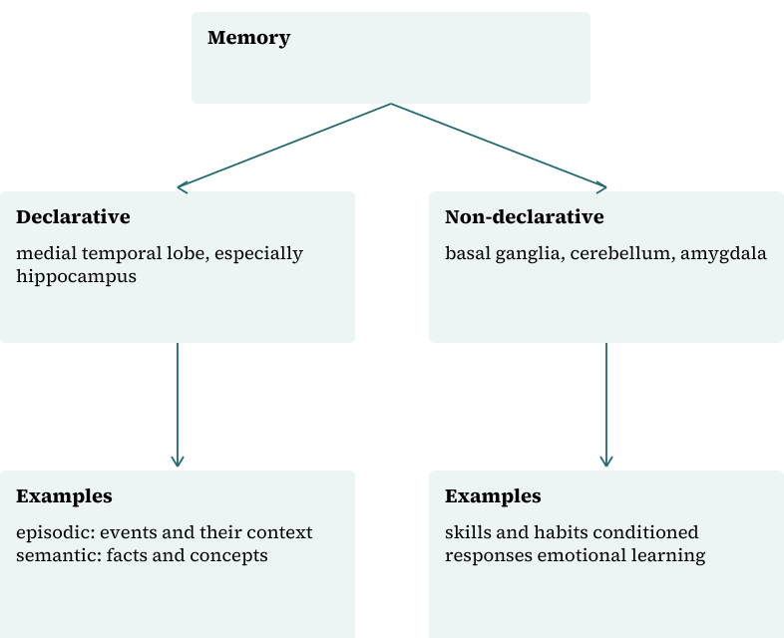
The taxonomy follows the declarative/non-declarative distinction. Real tasks usually engage more than one system, and the boundaries between systems are debated.

7.5 Encoding and consolidation
Encoding is the process by which experience is transformed into a memory trace. It depends on attention, arousal and the depth of processing. Emotionally arousing events are typically better remembered than neutral ones, an effect mediated partly by amygdala–hippocampal interactions and by stress hormones.
Consolidation is the stabilisation of the trace over time. It involves synaptic changes, gene expression and, for declarative memory, hippocampal–cortical dialogue during sleep. Sleep is not optional for memory: sleep deprivation impairs consolidation and alters emotional reactivity.
Consolidation can be modulated. Cortisol administered after learning enhances memory for emotionally arousing material in some studies; noradrenergic activity has similar effects. This is adaptive in principle—remembering danger is useful—but it means that highly stressful events may be encoded with unusual strength, which is part of why traumatic memories can be intrusive.

7.6 Retrieval and updating
Retrieval is the reactivation of a memory trace. It is reconstructive: each retrieval can incorporate new information and alter the memory. This is why eyewitness testimony is fallible and why repeated retelling can change a narrative.
Retrieval can also update memory. When a memory is retrieved, it may become temporarily labile and require re-stabilisation—the reconsolidation window described below. Alternatively, retrieval may trigger extinction if the expected outcome does not occur, producing a new inhibitory memory.
These two possibilities—reconsolidation and extinction—are not mutually exclusive. Which occurs depends on the conditions of retrieval: the strength of the prediction error, the age and strength of the memory, and the context.

7.7 Reconsolidation
Reconsolidation is the process by which a retrieved memory is restabilised. In rodents, infusing a protein synthesis inhibitor into the amygdala after retrieval produces amnesia for the memory, while the same infusion without retrieval has no effect (Nader et al., 2000). This finding revived interest in memory modification.
In humans, the evidence is more complicated. Some studies report that reactivating a fear memory followed by extinction training, or by propranolol, reduces subsequent fear responses; others find no effect. A systematic review of extinction and relapse concluded that the conditions for reliable reconsolidation-based modification are not established (Vervliet et al., 2013).
Clinically, reconsolidation has been used to justify brief interventions in which a drug or a behavioural procedure is timed to the retrieval window. The rationale is elegant; the evidence base is not yet sufficient to support routine use. Claims that a single session can "erase" a traumatic memory should be treated as marketing, not science.

7.8 Extinction learning
Extinction is the gradual reduction of a conditioned response when the conditioned stimulus is repeatedly presented without the unconditioned stimulus. It does not erase the original association. It creates a new, context-dependent inhibitory memory that competes with the original.
This is why fear can return. Renewal occurs when the extinguished cue is tested in a different context. Reinstatement occurs after an unsignalled aversive event. Spontaneous recovery occurs with the passage of time. These phenomena are not failures of treatment; they are signatures of the underlying learning.
Extinction depends on the ventromedial prefrontal cortex, the amygdala and the hippocampus (Milad & Quirk, 2012). In PTSD, extinction recall is often impaired, and vmPFC–amygdala connectivity is altered. Exposure therapy is built on extinction principles, which is why it works and why it requires within-session and between-session learning.

7.9 Habit and procedural learning
Habits are learned associations between cues and actions that become automatic with repetition. They depend on corticostriatal circuits, particularly the dorsal striatum. Habits are efficient but inflexible; they persist when the outcome changes.
Trauma-related avoidance often becomes habitual. A person may avoid a route, a conversation or a social situation without deciding to do so. The behaviour is triggered by context and executed with little deliberation, which is why insight alone rarely changes it.
Procedural learning also supports recovery: new routines, sleep habits, grounding skills and social behaviours can become automatic with practice. Rehabilitation is, in part, the deliberate construction of helpful habits.

7.10 Experience-dependent recovery
Recovery from trauma involves new learning at multiple levels: that reminders are not necessarily dangerous, that arousal can be tolerated, that the world contains safe people, and that one's own responses are understandable. Each of these is a prediction that must be tested against experience.
This is why avoidance is so costly. It prevents the prediction error that would update the threat association. It is also why safety must be real, not merely asserted: a person cannot learn that a situation is safe if it is not.
The clinical implications are consistent with the learning literature: graded exposure, context variation, sleep protection, and the gradual rebuilding of activities that matter. These principles are not new, but they are grounded in mechanisms that are now quite well understood.

Synthesis
Table 7.1 summarises memory processes and their trauma relevance.
Table 7.1. Memory processes and trauma relevance
Process | Mechanism | Trauma relevance | Clinical implication
Encoding | Attention, arousal, amygdala–hippocampal interaction | Vivid, fragmentary trauma memory | Do not assume completeness
Consolidation | Protein synthesis, sleep-dependent replay | Strong emotional memory | Protect sleep
Retrieval | Reactivation, reconstruction | Memory can change on recall | Caution in testimony
Reconsolidation | Labilisation and restabilisation | Potential treatment window | Evidence not yet sufficient
Extinction | New inhibitory learning | Exposure therapy | Context variation matters
Habit learning | Corticostriatal circuits | Automatic avoidance | Practice new routines

Composite case study
A patient avoids driving after a collision. Exposure begins with sitting in a parked car, then short drives on quiet roads, then the route of the collision. Each step is repeated in different contexts and at different times of day to reduce renewal. Sleep is treated because sleep deprivation impairs extinction consolidation. The patient is told that fear may return after a stressful week and that this is expected, not failure.

Review and discussion questions
Why is extinction described as new learning rather than forgetting?
What are the three main forms of fear relapse, and what do they imply for treatment?
How strong is the human evidence for reconsolidation-based therapy?
Why might a person have physiological reactions to a cue without a coherent memory of the event?
What is the difference between a habit and a deliberate avoidance strategy, and why does it matter?
Why is the concept of repression not supported by memory research?

Research assignments
• Design an exposure study that tests renewal, reinstatement and spontaneous recovery.
• Critically appraise one reconsolidation trial, noting blinding, sample size and outcome measurement.
• Write a protocol for a sleep intervention adjunct to exposure therapy.

Chapter summary
Learning and memory are the mechanisms by which trauma becomes persistent. Synaptic plasticity supports the acquisition of threat associations; declarative and non-declarative systems encode different aspects of experience; consolidation stabilises memory; retrieval can update it. Extinction creates new inhibitory learning rather than erasing the original, which explains relapse. Reconsolidation is a promising but unproven clinical route. Recovery depends on new learning under conditions of safety, repetition and sleep.

References
Milad, M. R., & Quirk, G. J. (2012). Fear extinction as a model for translational neuroscience: Ten years of progress. Annual Review of Psychology, 63, 129–151. https://doi.org/10.1146/annurev.psych.121208.131631
Nader, K., Schafe, G. E., & LeDoux, J. E. (2000). Fear memories require protein synthesis in the amygdala for reconsolidation after retrieval. Nature, 406(6797), 722–726. https://doi.org/10.1038/35021052
Scoville, W. B., & Milner, B. (1957). Loss of recent memory after bilateral hippocampal lesions. Journal of Neurology, Neurosurgery, and Psychiatry, 20(1), 11–21. https://doi.org/10.1136/jnnp.20.1.11
Vervliet, B., Craske, M. G., & Hermans, D. (2013). Fear extinction and relapse: State of the art. Annual Review of Clinical Psychology, 9, 215–248. https://doi.org/10.1146/annurev-clinpsy-050212-185542

