Integration, Professional Practice, and Future Directions
Chapter 20

Chapter contents

The PDF contains generated contents and page numbers. Refresh the contents field in Word after editing.

Central question. How can the neuroscience of trauma be integrated into ethical, effective professional practice, and where is the field heading?

Learning objectives
• integrate biological, psychological and social levels of explanation;
• apply ethical principles to trauma research and practice;
• identify emerging areas of trauma neuroscience;
• recognise the limits of current knowledge;
• plan continuing professional development in this field.

Introduction
This book has moved from molecules to society. It has described how stress hormones, neurotransmitter systems, memory processes, immune signalling and brain networks respond to threat, and how these responses are shaped by development, social context and clinical care.
The final chapter draws the threads together. It argues for integration: biological, psychological and social explanations are not competing accounts but different levels of description. It sets out ethical principles for practice and research, identifies emerging areas and persistent uncertainties, and proposes a stance of disciplined humility.
A note on integration. Integration does not mean that every clinical problem requires a biological explanation. Sometimes the most useful formulation is social, psychological or practical. Integration means having multiple frameworks available and choosing the one that serves the person.

20.1 Levels of explanation
Trauma can be described at molecular, cellular, circuit, cognitive, behavioural, social and political levels. Each level has its own vocabulary, methods and evidence standards.
Reductionism—explaining higher levels entirely in terms of lower ones—is tempting but incomplete. A full molecular account of fear would not tell us what the fear means, whether it is justified, or what should be done about it.
Explanatory pluralism holds that multiple levels can be valid simultaneously. This is not a licence for vagueness; it is a demand for clarity about which level is being used for which purpose.
Figure 20.1. Levels of analysis in trauma neurobiology
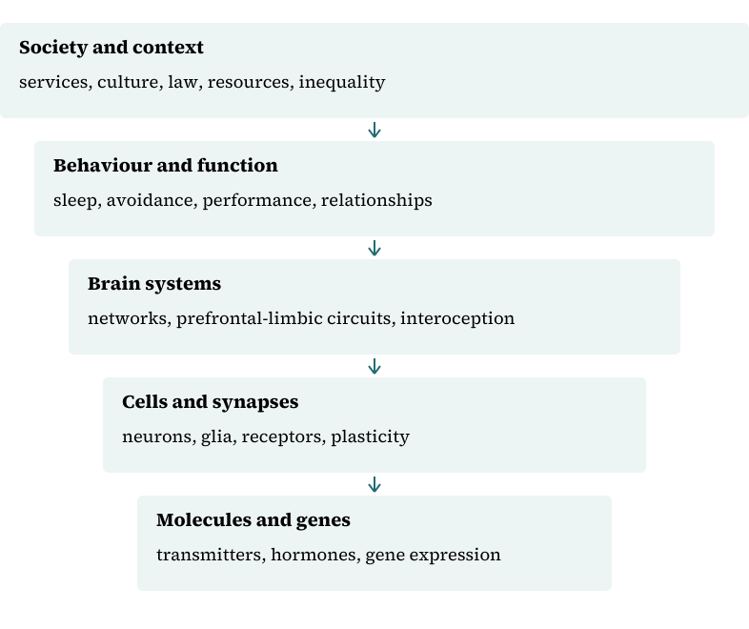
The levels interact reciprocally. Arrows indicate influence, not anatomical containment; a finding at one level cannot be substituted for a finding at another.

20.2 The biopsychosocial formulation
The biopsychosocial model integrates biological, psychological and social factors. It is often invoked but rarely applied rigorously.
A good formulation specifies which biological factors are relevant (for example, sleep disruption, thyroid disease, medication effects), which psychological factors (appraisal, avoidance, memory), and which social factors (housing, safety, discrimination, support).
The formulation should guide intervention: some problems require medication, some require therapy, some require housing, and some require all three.

20.3 Ethical practice
Ethical practice in trauma care rests on respect for persons, beneficence, non-maleficence and justice. These principles have practical implications.
Respect requires informed consent, confidentiality and attention to power. Beneficence requires effective treatment, not merely good intentions. Non-maleficence requires avoiding re-traumatisation and iatrogenic harm. Justice requires attention to access and to the distribution of resources.
Trauma survivors may be especially vulnerable to coercion, particularly in legal, immigration and child protection contexts. Clinicians should be clear about their role and its limits.
Public-facing guidance on PTSD and its treatment is available from the National Institute of Mental Health (n.d.).

20.4 Ethical research
Research with trauma survivors must be safe, respectful and useful. Risks include distress during assessment, breach of confidentiality and stigmatisation of groups.
Trauma-informed research practices include flexible protocols, trained interviewers, accessible information, referral pathways and the option to pause or withdraw.
Community participation improves relevance and acceptability. Benefit-sharing is important, particularly in low-resource settings.

20.5 Emerging areas
Several areas are developing rapidly. Biomarkers and predictive modelling may eventually support stratification, though current tools are weak. Digital therapeutics may increase access, with questions about safety and equity. Psychedelic-assisted therapy has generated substantial interest, with early trials showing promise for PTSD; larger, blinded trials are needed, and hype should be resisted.
Optogenetics and chemogenetics have transformed animal research and may inform circuit-level treatments, though translation to humans is distant. Closed-loop neuromodulation is being explored for several conditions.
Each emerging area requires the same standards of evidence as established treatments.

20.6 Persistent uncertainties
Several questions remain unresolved. Why do some people develop PTSD after trauma while others do not? Which mechanisms are causal and which are consequences? How do biological, psychological and social factors interact over time? Which treatments work for whom?
These questions are not failures of the field; they are its agenda. Honest acknowledgement of uncertainty is a mark of maturity.

20.7 Professional development
Continuing professional development should include both content and skills: new evidence, critical appraisal, communication, cultural competence and self-care.
Supervision and peer consultation are essential, particularly for clinicians working with complex trauma. Reflective practice helps clinicians notice their own reactions and biases.
Organisations have a responsibility to provide time, resources and support for development.

20.8 Communication and public understanding
Public understanding of trauma is shaped by media, social media and popular psychology. Misinformation spreads quickly, and simplistic claims about brain chemicals or single treatments can mislead.
Researchers and clinicians have a responsibility to communicate accurately, to correct misinformation and to avoid overclaiming. This does not mean avoiding engagement; it means engaging honestly.

20.9 Working with lived experience
People with lived experience of trauma bring expertise that complements clinical and scientific knowledge. Their involvement improves research questions, service design and public communication.
Involvement should be genuine, resourced and reciprocal, not tokenistic. It requires attention to power, consent and support.

20.10 Conclusion
Trauma is a whole-person and whole-society phenomenon. Neurobiology helps us understand how experience becomes biology, how memory and stress systems adapt, and why some people remain symptomatic while others recover.
That knowledge should be used with humility. It does not replace the person's account, the social context or the ethical requirement to provide safe, effective and accessible care. The field's future depends on rigorous science, honest communication and commitment to justice.

20.11 Teaching trauma neurobiology
Teaching this material well requires more than transmitting facts. Students need to understand levels of explanation, the difference between a mechanism and a treatment, and the limits of each method they encounter.
A workable curriculum moves from normal function to disruption to intervention. Students who understand the HPA axis in ordinary circumstances can grasp what changes under chronic stress; students who have never seen a conditioned response will struggle with extinction. Cases and laboratory demonstrations help, provided they are clearly identified as teaching material and do not require students to disclose their own histories.
Assessment should test reasoning rather than recall alone. Questions that ask students to interpret a finding, identify an alternative explanation or design a control are more informative than questions that ask them to name a structure. Where statistics and methodology are taught, they should be applied to real papers from the field.
Clinical and laboratory teaching require boundaries. Students should not be asked to practise assessment on each other's trauma, to disclose personal experiences, or to interpret images or samples beyond their competence. Simulation and standardised cases are safer.
Teachers should model uncertainty. Saying "we do not know" and explaining how the field might find out is more valuable than presenting a tidy account that collapses under scrutiny. Students who learn to tolerate uncertainty are better prepared for practice than those who expect certainty.

20.12 What would change practice
Several developments would materially change clinical practice if they were realised. None is guaranteed, and each should be judged by evidence rather than enthusiasm.
Reliable prediction of who will develop persistent symptoms after trauma would allow targeted early intervention. Current models perform poorly at the individual level, and the ethical risks of false positives—stigma, unnecessary treatment, insurance consequences—are considerable.
Brief, scalable treatments with durable effects would extend reach. Exposure-based and trauma-focused therapies are effective but require trained staff and time. Digital and guided self-help formats may help, but the evidence for unguided tools is weak and dropout is high.
Biologically informed stratification—matching people to treatments based on mechanism—remains speculative. The heterogeneity of PTSD suggests that subtyping may eventually help, but current biomarkers are not ready for clinical use.
Better treatment of sleep, pain, substance use and social adversity would improve outcomes without requiring new neuroscience. These are unglamorous priorities, and they are among the most likely to help.
Finally, equitable access would change more lives than any single discovery. Effective treatments that reach only a minority of those who need them are, in public-health terms, a partial solution.

Synthesis
Table 20.1 summarises the book's levels of analysis.
Table 20.1. Levels of analysis and clinical implications
Level | Focus | Example | Implication
Molecular | Signalling, gene expression | Glucocorticoid feedback | Medication targets
Cellular | Neurons, glia | Synaptic plasticity | Learning mechanisms
Circuit | Networks | Amygdala–prefrontal | Exposure, neuromodulation
Psychological | Appraisal, memory | Avoidance | Therapy
Social | Relationships, resources | Housing, discrimination | Advocacy, policy
Ethical | Rights, justice | Consent, access | Professional standards

Composite case study
A service redesigns its trauma pathway. It combines trauma-focused therapy, sleep intervention, peer support and practical advice on housing and benefits. Staff receive training in trauma-informed practice and supervision. Outcomes are monitored, including access for marginalised groups. The pathway reflects the book's argument that biological, psychological and social levels must be addressed together.

Review and discussion questions
What is explanatory pluralism, and why does it matter clinically?
How can the biopsychosocial model be applied rigorously rather than rhetorically?
What are the ethical risks of trauma research, and how can they be reduced?
How should clinicians respond to patients who request experimental treatments?
Why is lived experience important in research and service design?
What would you prioritise for your own continuing development in this field?

Research assignments
• Write a service specification for a trauma-informed pathway in a general hospital.
• Critically appraise the evidence for psychedelic-assisted therapy for PTSD.
• Develop a public communication strategy to counter misinformation about trauma neurobiology.

Chapter summary
This book has integrated molecular, cellular, circuit, psychological, social and ethical perspectives on trauma. Each level contributes to understanding, and none is sufficient alone. Ethical practice requires consent, competence, safety and justice. Emerging areas offer promise but require rigorous evaluation. Honest communication, lived-experience involvement and continued learning are professional obligations.

References
National Institute of Mental Health. (n.d.). Post-traumatic stress disorder. https://www.nimh.nih.gov/health/publications/post-traumatic-stress-disorder-ptsd

