Stress Physiology: HPA Axis, Autonomic Regulation, and Allostasis
Chapter 8

Chapter contents

The PDF contains generated contents and page numbers. Refresh the contents field in Word after editing.

Central question. What happens in the body during and after threat, and how do we distinguish a normal stress response from a system that has become stuck?

Learning objectives
• define stress, stressors, allostasis and allostatic load;
• describe the sequence of HPA-axis activation and feedback;
• explain sympathetic and parasympathetic contributions to threat responses;
• describe the physiological measures used in trauma research and their limits;
• relate sleep and circadian regulation to stress recovery.

Introduction
Stress physiology is the bridge between experience and biology. An event is appraised as threatening; neural circuits activate endocrine and autonomic outputs; the body mobilises energy, increases vigilance, and prepares for action. When the event ends, the response is normally terminated. When it does not end, or when it is repeated, the cost accumulates.
This chapter describes the major systems involved. It begins with definitions, because "stress" is used loosely in both research and everyday language. It then follows the HPA axis from hypothalamic drive to glucocorticoid feedback, describes autonomic regulation, and introduces allostasis and allostatic load. It closes with sleep and circadian rhythms, which are both affected by stress and important for recovery.
A caution is necessary at the outset. Physiological measures are often treated as biomarkers of trauma, but cortisol, heart rate and blood pressure are non-specific. They vary with time of day, posture, food, caffeine, medication, exercise, infection and anticipation of measurement. A single cortisol sample tells us very little about a person's trauma history.
A note on definitions. A stressor is an event or condition that challenges homeostasis. The stress response is the physiological and behavioural reaction to it. Allostasis is the process of achieving stability through change—adjusting set points to meet anticipated demand. Allostatic load is the cumulative cost of repeated or sustained adjustment.

8.1 Definition of stress
The concept of stress has a complicated history. Selye introduced the general adaptation syndrome, describing a non-specific response to diverse demands. Later work distinguished the stimulus (stressor), the response (stress response) and the appraisal that links them. Lazarus and Folkman emphasised that stress depends on whether an event is appraised as threatening and whether the person believes they can cope.
Contemporary definitions combine these elements. Stress is a real or anticipated challenge to homeostasis, appraised as significant, that engages physiological and behavioural responses. The appraisal is not merely cognitive; it is shaped by prior experience, current state and social context.
Goldstein and Kopin (2007) trace how the term evolved and argue for precision: stress is not a single entity but a category of processes. This matters for research, because different studies operationalise stress differently and therefore measure different things.

8.2 Acute stress response
The acute stress response has two phases. The fast phase is neural and hormonal: sympathetic activation releases noradrenaline from nerve terminals and adrenaline from the adrenal medulla within seconds. Heart rate rises, blood pressure increases, blood flow is redirected to muscles and brain, pupils dilate, digestion slows, and glucose is mobilised.
The slower phase is endocrine: the HPA axis releases glucocorticoids over minutes to hours. Glucocorticoids mobilise energy, suppress non-essential immune activity, and modulate memory and appraisal. They also help terminate the response through negative feedback.
This two-phase organisation is adaptive: the fast phase prepares for immediate action, and the slow phase sustains the response and then shuts it down. Problems arise when the fast phase is repeatedly triggered without resolution, or when the slow phase fails to terminate.

8.3 HPA axis sequence
The HPA axis begins in the paraventricular nucleus of the hypothalamus, where neurons release corticotropin-releasing hormone (CRH) into the portal circulation. CRH stimulates the anterior pituitary to release adrenocorticotropic hormone (ACTH), which travels in the blood to the adrenal cortex and stimulates glucocorticoid synthesis and release.
The axis is regulated by inputs from the brainstem, amygdala, hippocampus and prefrontal cortex. The amygdala promotes activation; the hippocampus and prefrontal cortex contribute to inhibition; the brainstem provides rapid relay of visceral and nociceptive signals. The balance of these inputs determines the magnitude and duration of the response (Ulrich-Lai & Herman, 2009).
The axis is also regulated by circadian rhythms. Cortisol peaks shortly after waking and declines through the day, reaching a nadir in the early hours of the morning. This rhythm is important for interpreting measurements and for understanding sleep disruption.
Figure 8.1. The hypothalamic–pituitary–adrenal axis and glucocorticoid feedback
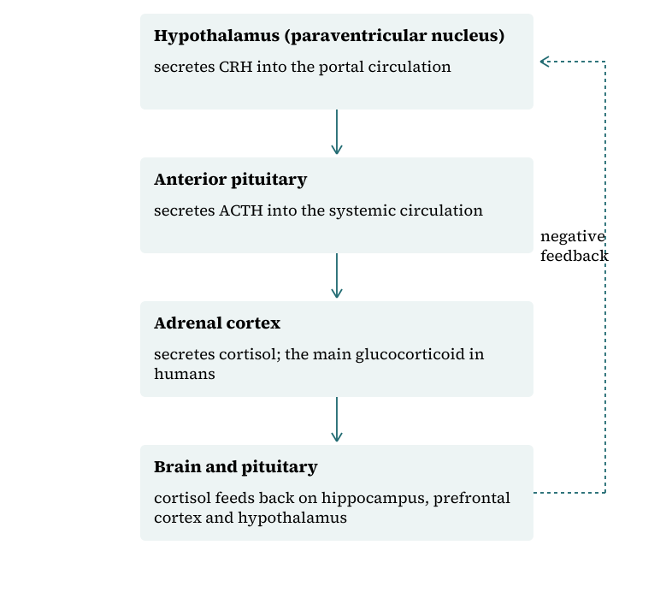
CRH, corticotrophin-releasing hormone; ACTH, adrenocorticotrophic hormone. Solid arrows indicate stimulation; the dashed arrow indicates negative feedback. The diagram is schematic and omits many inputs and timescales.

8.4 Glucocorticoid feedback
Glucocorticoids exert negative feedback at multiple levels: they inhibit CRH release in the hypothalamus, ACTH release in the pituitary, and drive from upstream regions. Feedback operates over different timescales—rapid non-genomic effects within minutes, and slower genomic effects over hours.
Feedback sensitivity is a key variable. In some people with PTSD, cortisol levels are lower than expected and feedback is enhanced; in others, particularly those with chronic stress or depression, cortisol is elevated and feedback is blunted. The heterogeneity is real, and it reflects differences in trauma type, timing, comorbidity and measurement.
Glucocorticoid receptors are expressed throughout the brain, with high density in the hippocampus, amygdala and prefrontal cortex. Their activation alters gene transcription, which is one route by which stress affects memory and mood over time.

8.5 Sympathetic activation
The sympathetic nervous system prepares the body for action. Preganglionic neurons in the spinal cord project to sympathetic ganglia, which innervate the heart, blood vessels, lungs, gut and sweat glands. The adrenal medulla releases adrenaline and noradrenaline directly into the bloodstream.
Cardiovascular effects include increased heart rate and contractility, vasoconstriction in the skin and gut, and vasodilation in skeletal muscle. Respiratory effects include bronchodilation and increased rate. Metabolic effects include glycogenolysis and lipolysis. These changes are adaptive in the short term.
Chronic sympathetic activation is associated with hypertension, cardiovascular disease, insulin resistance and immune dysregulation. For trauma survivors, this is one pathway by which psychological distress becomes physical illness—not through belief alone, but through sustained physiological load.

8.6 Parasympathetic regulation
The parasympathetic nervous system promotes rest, digestion and recovery. The vagus nerve provides the main parasympathetic supply to the heart, lungs and gut. High vagal tone is associated with efficient cardiac regulation and with better emotional regulation in some studies.
The polyvagal theory, developed by Porges, proposes that the vagus has distinct branches with different evolutionary histories and that withdrawal of vagal tone produces the immobilisation responses seen in trauma. The theory has been influential in clinical practice, but its anatomical and physiological claims have been criticised by comparative physiologists. It is best treated as a clinical metaphor with some empirical support, not as an established mechanism.
The practical point is that recovery requires parasympathetic engagement: sleep, digestion, social connection and periods of safety. Interventions that promote these—rather than only reducing sympathetic arousal—are likely to be more effective.

8.7 Cardiorespiratory responses
Heart rate variability (HRV) is the variation in the interval between heartbeats. It reflects the interplay of sympathetic and parasympathetic influences and is associated with emotional regulation, resilience and cardiovascular health. Low HRV has been reported in PTSD, but effect sizes are modest and findings are affected by medication, fitness, age and breathing rate.
Respiratory rate and depth change under stress, and hyperventilation can produce dizziness, tingling and a sense of unreality that overlap with dissociative symptoms. Breathing retraining is sometimes helpful, though the evidence for it as a stand-alone trauma treatment is limited.
Blood pressure, heart rate and respiration are useful in research and in clinical monitoring, but they are not diagnostic. A person can be highly distressed with normal vitals, and a person can be physiologically aroused for reasons unrelated to trauma.

8.8 Allostatic load
Allostatic load is the cumulative physiological cost of adapting to stress. It is indexed by a panel of measures that typically includes blood pressure, waist circumference, cortisol, cholesterol, glucose, inflammatory markers and heart rate variability. Higher scores predict functional decline and mortality in longitudinal studies.
McEwen's (1998) formulation describes four patterns of allostatic load: repeated activation, failure to habituate, failure to terminate, and inadequate response. These patterns help explain why both over- and under-activity of stress systems can be harmful.
For trauma, allostatic load provides a way to connect psychological adversity to physical health without claiming that stress directly causes a specific disease. It also supports early intervention: reducing load may have benefits beyond symptom relief.

8.9 Sleep and circadian regulation
Sleep is essential for memory consolidation, emotional regulation, immune function and metabolic health. Trauma commonly disrupts sleep: difficulty falling asleep, frequent waking, nightmares, and a fear of sleeping. These problems are not merely consequences of trauma; they maintain it, because sleep deprivation increases amygdala reactivity and impairs prefrontal function.
Circadian rhythms are regulated by the suprachiasmatic nucleus and synchronised by light, activity, meals and social cues. Trauma and displacement can disrupt these cues, particularly in refugees, shift workers and hospitalised patients. Jet lag, shift work and irregular schedules produce physiological stress even without psychological trauma.
Sleep interventions—stimulus control, sleep restriction, cognitive therapy for insomnia—are effective and can be delivered alongside trauma-focused therapy. Nightmares can be treated with imagery rehearsal therapy, which has good evidence.

8.10 Recovery and physiological flexibility
Recovery is not the absence of stress; it is the capacity to mount a response and then return to baseline. Physiological flexibility—the ability to shift between states—is a marker of health. Rigidity, whether in the direction of chronic hyperarousal or chronic shutdown, is a marker of dysfunction.
Several factors support flexibility: sleep, exercise, nutrition, social connection, predictable routines and a sense of control. These are not soft extras; they are biological requirements. Interventions that address them can improve symptoms even when trauma-specific therapy is not available.
The clinical task is to help the body relearn that arousal is survivable and that rest is possible. That relearning happens through experience, not through instruction alone.

Synthesis
Table 8.1 summarises the principal physiological systems.
Table 8.1. Stress systems and measures
System | Key mediators | Time course | Common measures | Limits
Sympathetic | Noradrenaline, adrenaline | Seconds | Heart rate, blood pressure, skin conductance | Non-specific
HPA axis | CRH, ACTH, cortisol | Minutes to hours | Salivary or serum cortisol, dexamethasone suppression | Diurnal variation
Parasympathetic | Acetylcholine, vagal tone | Seconds to minutes | HRV, respiratory sinus arrhythmia | Affected by fitness, medication
Allostatic load | Multiple | Months to years | Composite index | Indirect
Sleep | Circadian and homeostatic | Hours | Polysomnography, actigraphy, self-report | Measurement burden

Composite case study
A patient presents with palpitations, dizziness and a sense of unreality. Medical assessment excludes cardiac and neurological causes. The physiological formulation considers chronic sympathetic activation, hyperventilation, sleep deprivation and caffeine intake. The plan includes sleep regularisation, reduced caffeine, breathing retraining and trauma-focused therapy. Symptoms improve as sleep and arousal regulation improve, without any claim that the original trauma has been erased.

Review and discussion questions
Distinguish homeostasis, allostasis and allostatic load.
Why is a single cortisol measurement of limited value in assessing trauma?
What are the strengths and limitations of polyvagal theory?
How does sleep deprivation maintain trauma symptoms?
Why is physiological flexibility a better marker of health than low arousal?
What would a study need to do to show that an intervention reduced allostatic load?

Research assignments
• Design a study of cortisol rhythms in PTSD that controls for time of sampling, medication and sleep.
• Critically appraise the evidence on HRV biofeedback for trauma-related conditions.
• Write a protocol for a sleep intervention in a low-resource setting.

Chapter summary
Stress engages fast neural and slower endocrine systems that mobilise the body for action and then terminate the response. The HPA axis and autonomic nervous system are tightly regulated and highly context-dependent. Allostatic load describes the cumulative cost of repeated or sustained activation. Sleep and circadian rhythms are both affected by trauma and essential for recovery. Physiological measures are useful but non-specific, and clinical interpretation requires attention to time, context, medication and individual variation.

References
Goldstein, D. S., & Kopin, I. J. (2007). Evolution of concepts of stress. Stress, 10(2), 109–120. https://doi.org/10.1080/10253890701288935
Herman, J. P., McKlveen, J. M., Ghosal, S., Kopp, B., Wulsin, A., Makinson, R., Scheimann, J., & Myers, B. (2016). Regulation of the hypothalamic–pituitary–adrenocortical stress response. Comprehensive Physiology, 6(2), 603–621. https://doi.org/10.1002/cphy.c150015
McEwen, B. S. (1998). Protective and damaging effects of stress mediators. New England Journal of Medicine, 338(3), 171–179. https://doi.org/10.1056/NEJM199801153380307
Ulrich-Lai, Y. M., & Herman, J. P. (2009). Neural regulation of endocrine and autonomic stress responses. Nature Reviews Neuroscience, 10(6), 397–409. https://doi.org/10.1038/nrn2647

