Research Methods and Evidence Appraisal
Chapter 19

Chapter contents

The PDF contains generated contents and page numbers. Refresh the contents field in Word after editing.

Central question. How should students and practitioners evaluate trauma research, and what are the strengths and limitations of the main study designs?

Learning objectives
• describe the main study designs used in trauma research;
• explain bias, confounding and causal inference;
• interpret effect sizes and confidence intervals;
• appraise systematic reviews and guidelines;
• recognise questionable research practices.

Introduction
Trauma research spans molecular biology, clinical trials, epidemiology, qualitative inquiry and policy analysis. No single method answers all questions. The task is to match the method to the question and to interpret findings with appropriate humility.
This chapter provides a practical guide to evidence appraisal. It covers study designs, bias, effect sizes, systematic reviews and questionable practices. It is written for readers who need to make judgements about evidence, not to conduct research themselves—though it is also useful for those who do.
A note on "evidence-based". The phrase is often used to mean "supported by randomised trials". That is one kind of evidence, appropriate for questions of efficacy. Other questions—how people experience care, why implementation fails, what meanings trauma has—require other methods. Evidence-based practice involves using the best available evidence for the question at hand, not privileging one design for all questions.

19.1 Research questions and designs
The design should follow from the question. Questions about prevalence require epidemiological surveys. Questions about mechanism require laboratory or imaging studies. Questions about efficacy require randomised trials. Questions about experience require qualitative methods.
Mixing methods can be valuable: a trial can include qualitative interviews to understand acceptability, and a survey can include biological measures to examine mechanisms.
The most common error is using a design that cannot answer the question—for example, a cross-sectional study to establish causation.

19.2 Randomised trials
Randomisation balances known and unknown confounders between groups, which is why it supports causal inference. Blinding reduces bias in delivery and assessment. Intention-to-treat analysis preserves the benefits of randomisation.
Trials in trauma face challenges: heterogeneity of trauma, comorbidity, difficulty blinding psychological treatments, dropout and contamination between arms.
Reporting standards, such as CONSORT, improve transparency. Registration and prespecified analysis plans reduce selective reporting.

19.3 Observational studies
Cohort studies follow groups over time and can establish temporality. Case–control studies compare people with and without an outcome and are efficient for rare outcomes. Cross-sectional studies measure exposure and outcome at one time and cannot establish direction.
Confounding is the central challenge. Childhood adversity, for example, is correlated with poverty, family instability and genetic factors. Statistical adjustment can reduce but not eliminate confounding.
Causal inference methods—such as instrumental variables, difference-in-differences and Mendelian randomisation—can strengthen observational claims when assumptions are met.
Confounding by socioeconomic and family factors is a persistent challenge in research on childhood adversity (Teicher & Samson, 2016).

19.4 Qualitative methods
Qualitative research explores meaning, process and experience. Methods include interviews, focus groups, ethnography and participatory research. Analysis may be thematic, narrative or grounded theory.
Quality criteria differ from quantitative research: credibility, transferability, dependability and confirmability. Sample size is determined by information power rather than statistical power.
Qualitative findings cannot be generalised statistically, but they can be transferable to similar contexts and can generate hypotheses.

19.5 Bias and confounding
Bias is a systematic error that distorts results. Selection bias occurs when the sample is not representative. Measurement bias occurs when measures are inaccurate or inconsistent. Attrition bias occurs when dropout is related to outcome. Reporting bias occurs when studies or outcomes are selectively reported.
Confounding occurs when a third variable is associated with both exposure and outcome. It can be addressed by design (randomisation, restriction, matching) or analysis (stratification, regression, propensity scores).
No study is free of bias. The question is whether the bias is likely to change the conclusion.

19.6 Effect sizes and uncertainty
Statistical significance indicates whether an effect is unlikely under the null hypothesis; it does not indicate whether the effect is important. Effect sizes—such as standardised mean differences, odds ratios and numbers needed to treat—provide information about magnitude.
Confidence intervals convey uncertainty. A wide interval indicates imprecision; an interval that includes no effect indicates that the data are compatible with no effect.
Clinical significance depends on context: a small effect on a severe condition may matter more than a large effect on a trivial one.

19.7 Systematic reviews
Systematic reviews use explicit methods to identify, select and synthesise studies. Meta-analysis statistically combines results. Both can reduce bias and increase precision, but they inherit the limitations of included studies.
Heterogeneity—variation in effects across studies—should be examined, not ignored. Subgroup analyses should be prespecified, not exploratory.
Publication bias can distort reviews. Funnel plots and trim-and-fill methods can detect it, though imperfectly. Prospective registration of reviews reduces selective reporting.
Reporting standards such as PRISMA improve transparency in systematic reviews (Page et al., 2021).

19.8 Guidelines
Clinical guidelines synthesise evidence and provide recommendations. They vary in quality and in how they handle uncertainty and values.
GRADE is a widely used framework for rating evidence quality and strength of recommendations. It separates the quality of evidence from the strength of the recommendation, which depends also on values, resources and acceptability.
Guidelines should be adapted to local contexts, not applied mechanically.

19.9 Questionable research practices
Questionable practices include p-hacking, HARKing (hypothesising after results are known), selective reporting, salami slicing and inadequate outlier handling. They inflate false positive rates and undermine trust.
Preregistration, open data, open materials and registered reports reduce these practices. Journals and funders increasingly require them.
Replication is essential. A single study, however elegant, should not change practice without independent confirmation.

19.10 Appraising a paper
A practical appraisal asks: What question did the study address? What design was used, and was it appropriate? Who was studied, and how were they selected? What was measured, and how? What was the effect size and precision? Were confounders addressed? Were limitations acknowledged? Do the conclusions follow from the data?
These questions are more useful than a checklist score. They direct attention to the reasoning, not only the reporting.

19.11 Analysis, visualisation and reporting
Analysis should follow the question, not the other way round. The primary outcome, the comparison and the statistical model should be specified before the data are inspected.
Exploratory analysis is legitimate, but it should be labelled as such. A finding that emerges after examining many subgroups is a hypothesis, not a result, unless it is tested in independent data.
Statistical significance is a poor summary. Report effect sizes with confidence intervals, the number of participants contributing to each analysis, and the amount of missing data. For clinical trials, report the number needed to treat where it is meaningful.
Figures should be honest. Truncated axes exaggerate differences; cherry-picked individual traces mislead; error bars should indicate what they represent (standard deviation, standard error or confidence interval—each tells a different story). Bar charts of continuous data hide distributions; scatter plots or box plots with individual points are often better.
Selective reporting remains common. Studies that find null results are less likely to be published, and published studies often report outcomes that were not prespecified. Registration, reporting guidelines and access to protocols reduce but do not eliminate the problem.
Data sharing is increasingly expected. It allows reanalysis and replication, but it requires attention to consent, de-identification and the risk that participants in small, distinctive populations could be identified.

19.12 Writing, peer review and responding to criticism
Scientific writing should be clear, specific and proportionate. Claims should match the evidence: "associated with" is not "causes", and "in this sample" is not "in general".
Reporting guidelines exist for most designs—CONSORT for trials, STROBE for observational studies, PRISMA for systematic reviews, COREQ for qualitative research. They improve completeness and make appraisal easier.
Peer review is imperfect. Reviewers are busy, may lack methodological expertise, and may be biased toward familiar approaches. Review improves many papers but does not guarantee validity. Post-publication critique, replication and data sharing are essential complements.
Responding to criticism well is a skill. Address the substance, acknowledge limitations, provide additional analyses where appropriate, and avoid defensiveness. Reviewers can be wrong, but engagement is more productive than dismissal.
Retraction and correction are part of the system, not a sign that science has failed. What matters is that errors are identified, disclosed and corrected.
Finally, writing for different audiences is not a compromise of rigour. A plain-language summary that is accurate is more useful to participants and policymakers than a technically precise abstract that nobody reads.
Figure 19.1. Levels of analysis in trauma neurobiology
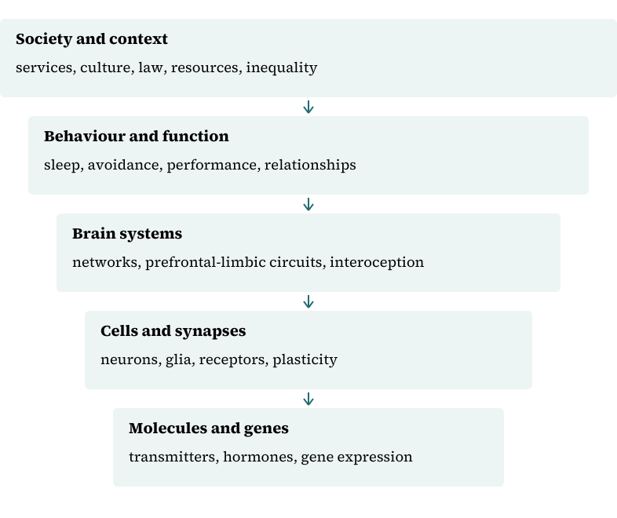
The levels interact reciprocally. Arrows indicate influence, not anatomical containment; a finding at one level cannot be substituted for a finding at another.

Synthesis
Table 19.1 summarises designs and their uses.
Table 19.1. Study designs and appropriate questions
Design | Question | Strength | Limitation
Randomised trial | Efficacy | Causal inference | Cost, generalisability
Cohort | Risk over time | Temporality | Confounding
Case–control | Rare outcomes | Efficiency | Recall bias
Cross-sectional | Prevalence | Cheap | No temporality
Qualitative | Meaning, process | Depth | Limited generalisability
Systematic review | Synthesis | Precision | Inherits bias

Composite case study
A clinician reads a study claiming that a supplement reduces PTSD symptoms. She checks the design: open-label, no control group, 30 participants, outcomes measured by the treating clinician. She concludes that the study does not support the claim and waits for better evidence. This is evidence appraisal in practice.

Review and discussion questions
Why does randomisation support causal inference?
What is the difference between statistical and clinical significance?
How can publication bias distort a meta-analysis?
Why are qualitative methods appropriate for some questions?
What are the main questionable research practices, and how can they be reduced?
What questions should you ask when appraising a paper?

Research assignments
• Appraise a trauma trial using CONSORT and GRADE.
• Design a mixed-methods study of treatment acceptability.
• Write a plain-language summary of a meta-analysis for a clinical team.

Chapter summary
Trauma research uses multiple designs, each suited to different questions. Randomised trials support causal inference about efficacy; observational studies describe risk and course; qualitative methods explore meaning and process. Bias, confounding and selective reporting threaten all designs. Effect sizes and confidence intervals matter more than p-values alone. Systematic reviews and guidelines synthesise evidence but inherit its limitations. Critical appraisal is a practical skill, not a checklist.

References
Page, M. J., McKenzie, J. E., Bossuyt, P. M., Boutron, I., Hoffmann, T. C., Mulrow, C. D., Shamseer, L., Tetzlaff, J. M., Akl, E. A., Brennan, S. E., Chou, R., Glanville, J., Grimshaw, J. M., Hróbjartsson, A., Lalu, M. M., Li, T., Loder, E. W., Mayo-Wilson, E., McDonald, S., … Moher, D. (2021). The PRISMA 2020 statement: An updated guideline for reporting systematic reviews. BMJ, 372, Article n71. https://doi.org/10.1136/bmj.n71
Teicher, M. H., & Samson, J. A. (2016). Annual research review: Enduring neurobiological effects of childhood abuse and neglect. Journal of Child Psychology and Psychiatry, 57(3), 241–266. https://doi.org/10.1111/jcpp.12507

