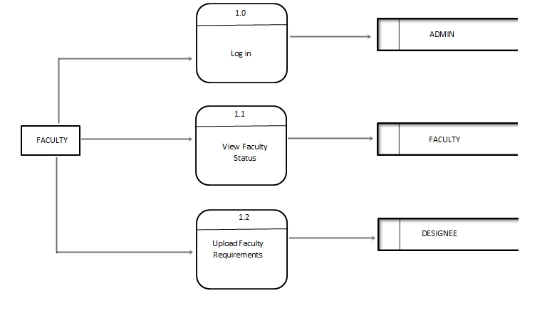

2.1

2.0

**REQUIREMENT STATUS**

**FACULTY**

Requirement Status Information Record

Faculty Information

Faculty Information Record

Faculty Data

2.3

**REQUIREMENT TABLE**

Requirement Status

Requirement Documents

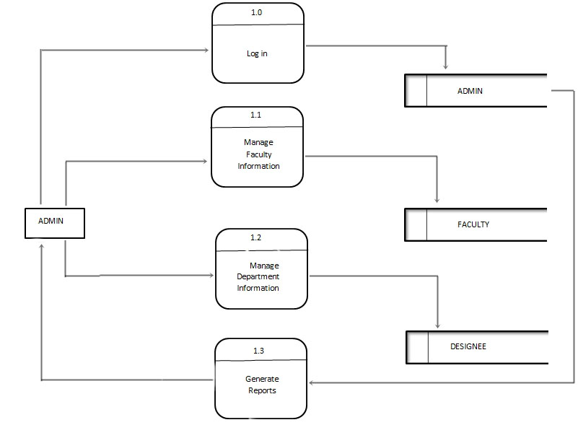

Completed Clearance

Admin Record

Designee Information Record

Faculty Information Record

Admin Information Record

Admin Data

Faculty Data

Department Data