**Clark Give Page Research Plan**

Tianci Zhang tzhang@clarku.edu

2016.8

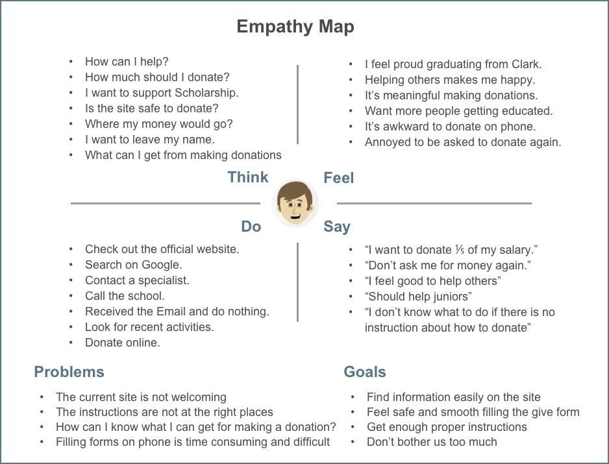

**Clark Give Page Persona 1**

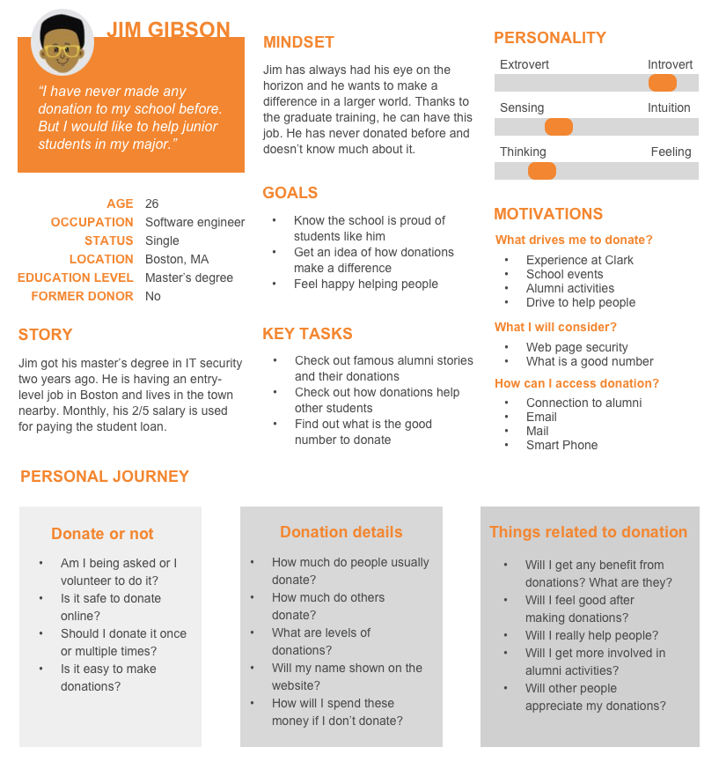

**Clark Give Page Persona 2**

