Clark Give Page Research Plan
Tianci Zhang tzhang@clarku.edu
2016.8

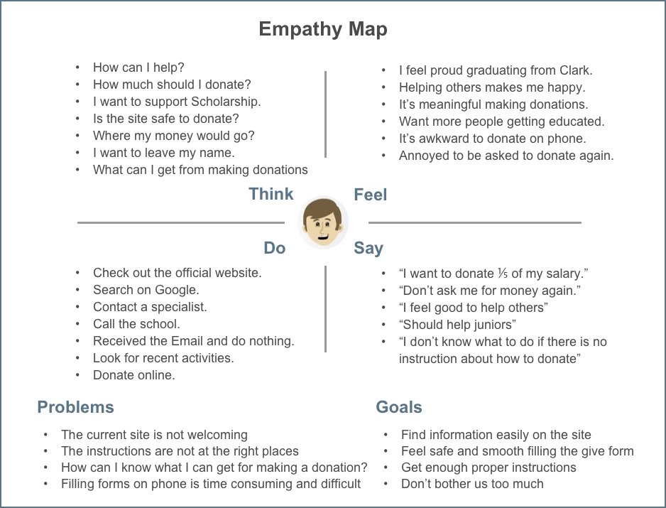

Clark Give Page Persona 1

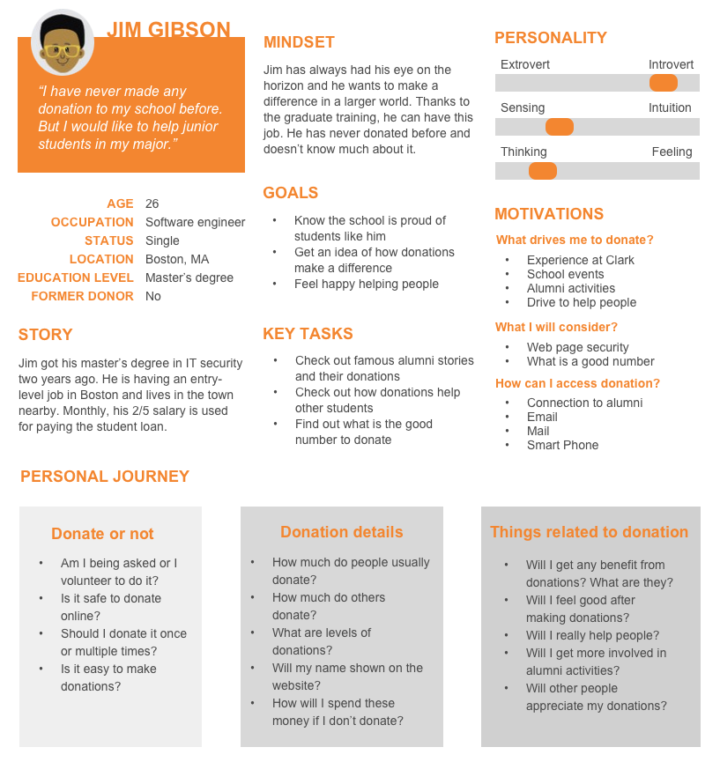

Clark Give Page Persona 2
