

Optum University

College of Emerging Technologies

Graph **Visualization** Class Requirements

(Instructor-led)

Date: January 2nd, 2019

Prepared by: Dan McCreary

**Course Title:** Graph Visualization

**Total Course Time:** 4 hours (1/2 day) instructor led training

**Prerequisites:** Introduction to Graph Databases and Basic Familiarity with JSON and JavaScript

# This Course and Optum Strategy

This course is designed to differentiate Optum in the marketplace by building teams of world-class graph visualization developers that can quickly create high-quality and extensible web-based graph visualizations. We want this course to give us a significant competitive advantage over our current competitors in the healthcare space by allowing both internal users and Optum customers (Providers, Data Analysists) the ability to visualize complex healthcare networks and healthcare terminology.

This course is part of the Emerging Technology college because the material is very new to the healthcare space. Although there are many commercial graph visualization systems and open source products we want to create high-quality visualizations and minimize expensive license fees. As a result, this course will need to break new ground and help us discover what concepts are feasible to teach in a graph visualization course.

Here is an overview of our planned Graph curriculum:

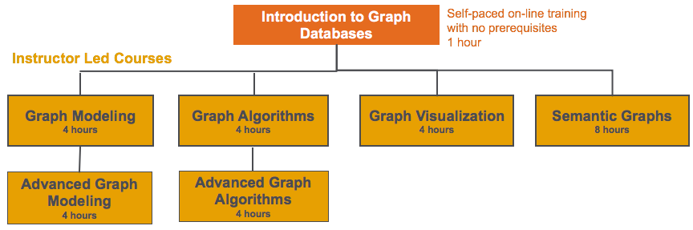

**Figure 1: The Optum Technologies Graph Curriculum**

Note that we assume everyone in the Graph Visualization class has already finished the one our Introduction to Graph Databases class and has a high-level understanding of labeled property graphs. We will briefly review this material at the beginning of the class but not spend more than around five minutes reviewing graph databases.

# Target Audience and Student Prerequisites

This course is designed for in-house development community at United Heath Group. This includes both United Health Care developers and Optum Technologies developers. Some Optum subcontractors and partners may also take this course. The goal will be to introduce them to the concepts in graph visualization and give the students a better understanding of how we build graph models.

The course will include both hands-on labs where students build a working graph visualization using a JavaScript library such as D3.js. Our goal is to assume some basic knowledge of JSON files and JavaScript and to quickly review key JavaScript concepts that are required for development.

All training will be done in as vendor neutral way as possible. There may be some demonstrations that use representative healthcare graphs, but there will be no data that includes actual Personal Healthcare Information (PHI).

The classes are designed to be taught face-to-face with a student-instructor ratio of around 10 to 1. The ratio is low because the material is very sequential. Many concepts can only be understood if the prior steps have been successfully completed. Losing a student in the first hour of the class will limit the success of the later hours. As a result the first hour should be carefully designed to no lose any students.

**Concrete-Abstract Cycles** – we will continuously cycle between concrete hands-on activities and abstract concepts. When users start the class, **they want to get started building a graph visualization**. They don’t want to listen to two hours of solid lecture on the theory of force-directed graphs. So, we will **always begin with a very simple hands-on lab**. This “simple get-started” is a core technique to get people confident they can build things on their own desktop. Each hands-on activity will reinforce the other activities. We will start slowly and gain momentum in the class.

**Key to our success: Testing** – we will continue offer this class and do assessments to see if users understand the key graph visualization concepts. If they don’t we will go back and change the class content or duration. We really don’t know if we can teach the visualization concepts in a ½ day with hands-on-labs.

We will start with a hands-on use of the D3 force directed graph. Users will view a small representative graph of a clinical setting. Sample graph verticies might be Doctors, Patients, Visits, Prescriptions, Drugs, Allergies, Conditions, Symptoms etc. This lab should last about 30 minutes. We will then break for some concepts using PowerPoint slides. We will also load sample synthetic data into the model. We then will refactor our model to add Visits between a Doctor and a Patient. We will repeat this process 4-5 times.

# The Demo Data Model

The demo database we will use is a clinical data model that describes a patient and their conditions as well as their relationship to their care providers (e.g. Physicians, Caregivers). We are doing this because Optum is strategically moving away from a batch Claims processing organization that will eventually provide point-of-care real-time clinical decision support. Our Clinical Model might include the following types:

1. Doctor (aka Provider role of Individual)
2. Patient (aka Member role of Individual)
3. Caregiver (an Individual that provides care for the elderly or sick)
4. Medical Activity (must have a StartDateTime and optional EndDateTime)
5. Doctor Visit (instance of Medical Activity)
6. Healthcare Concept (a general concept with broader and narrower concepts)
7. Prescription (instance of Medical Activity)
8. Drug (a Healthcare Concept tied to a medication or prescription)
9. Allergy (instance of Medical Activity)
10. Vaccination (instance of Medical Activity)
11. Medical Condition
12. Location (for finding nearby providers)
13. Event (single eventDateTime)
14. memberTouchpointEvent (Events linked to a Member)
15. Call Center Event (a type of customer touchpoint)
16. E-Mail (a type of customer touchpoint)

We will start out with a very simple model Doctor -> HAS_PATIENT -> Patient and then continue to add detail. All data will be completely “synthetic” and generated just for these demos. We will alternate with a model/load, model/load cycle.

**Course Objectives**

|  |
| --- |
| After completing this course, you should be able to: |
| * Understand the basic concepts and parameters of a force-directed or similar graph layout * Understand how verticies, edges and properties are displayed * Understand how filters are used to add and remove elements from a graph * Understand how interactivity is used to expand graph queries * Be able to name some graph visualization design patterns |

**Course Introduction**

**Hands-on Activity 1:** **Use D3 to display a clinical graph showing providers, visits and patients**