Project Submission # 6 - Data Visualization
Author: Matthew R. Versaggi, MS, MBA - Artificial Intelligence Engineer
Dec of 2016

PROJECT OVERVIEW

This Data Visualization project is a direct extension of my EDA (Exploratory Data Analysis) project, and takes one specific finding from the EDA and constructs an interactive tool to explore that particular phenomenon manifested in the data.

- To provide context, I have included the HTML rendering of my EDA project (from R) for perusal. That filename is: Project_4-ExploratoryDataAnalysisSubmission.html.
- I've performed ETL (Extraction, Transformation, and Loading) of the original data source to a form usable for this data visualization project. The original data source is "icb2v11.csv", whereas the data source used extracted for this project is "usa_cold_war_powdis.tsv", and additionally the JSON file "world_countries.json" is used to construct the world map.

SUMMARY

- The projects original data source is the ICB (International Crisis Behavior) dataset - a project that collates interstate (nations) crisis data from 1918 (the end of World War I) onward to a few years ago (currently until 2013).
- My EDA project submission (included) had a particular section which focused on one attribute of interest, the "Power Disparity" between the USA and it's adversaries during crises in the Cold War Period.
- This Data Visualization project focus is on the development of a (D3) Visual Tool which the user can use to explore that "Power Disparity" phenomenon on an incident by incident basis of the Cold War period.
- Full Disclosure: I'm an Artificial Intelligence Engineer in the US Defense industry, so international conflict datasets are of particular interest to me, which is why I chose the ICB dataset for both my EDA and DV projects.

DESIGN

The design elements were forged from the visual concepts manifested in iterations from these following 3 sections taken from my EDA project using the ICB dataset. Since a picture is worth 1000 words, it's easier to gleam the final design characteristics from the backdrop of the EDA projects three key sections of interest. Screen shots are included in the screen shot folder.
- Design Source #1: - Initial Visualization Design

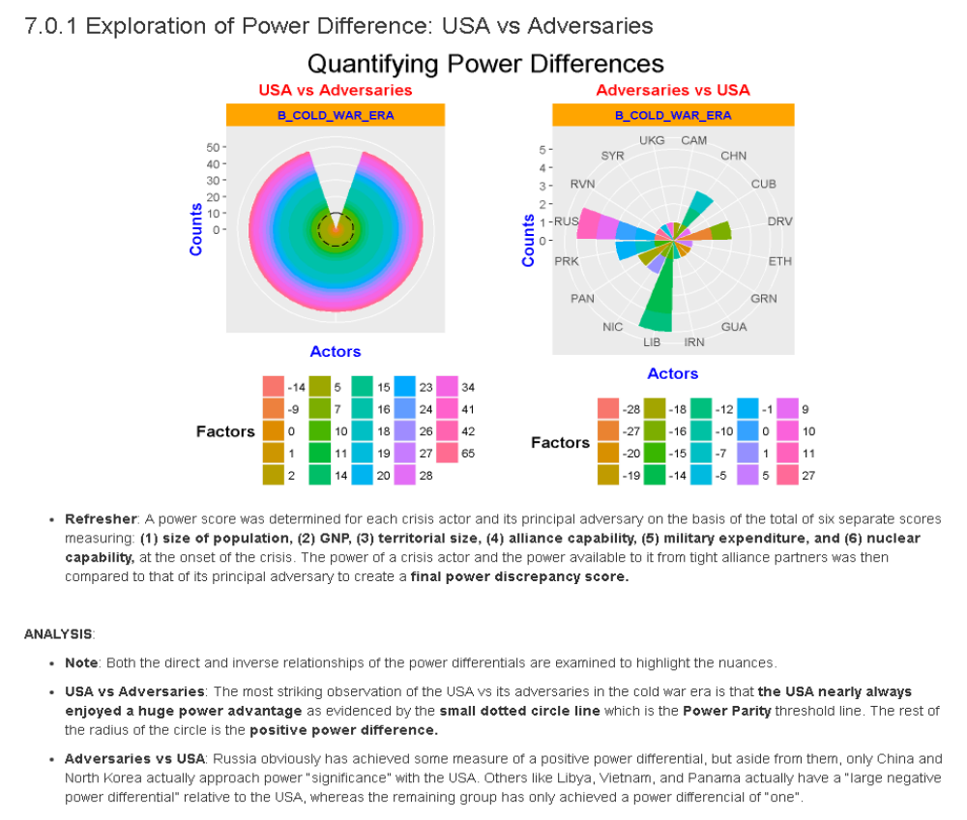
- Design Source #2: - Second Visualization Design

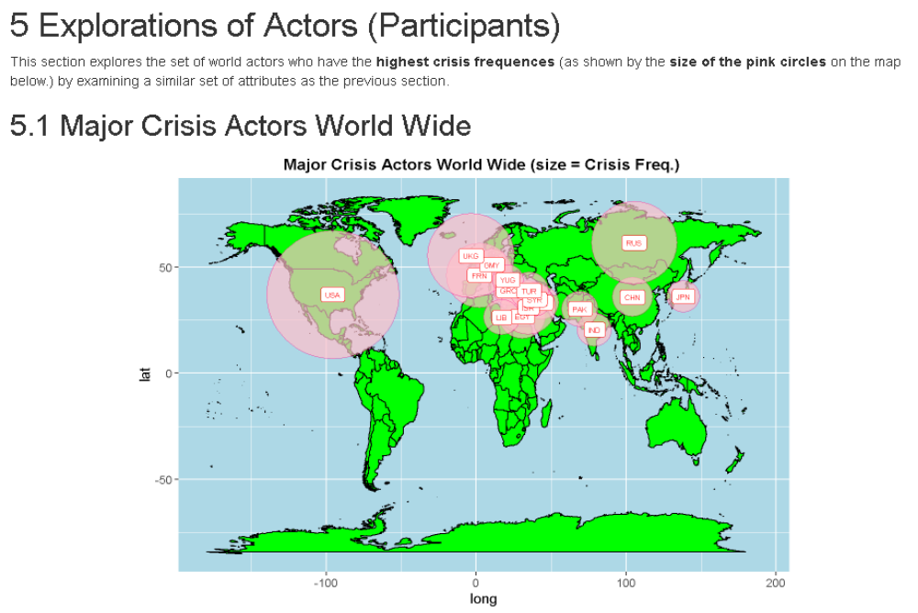

- Design Source #3: Third Visualization Design

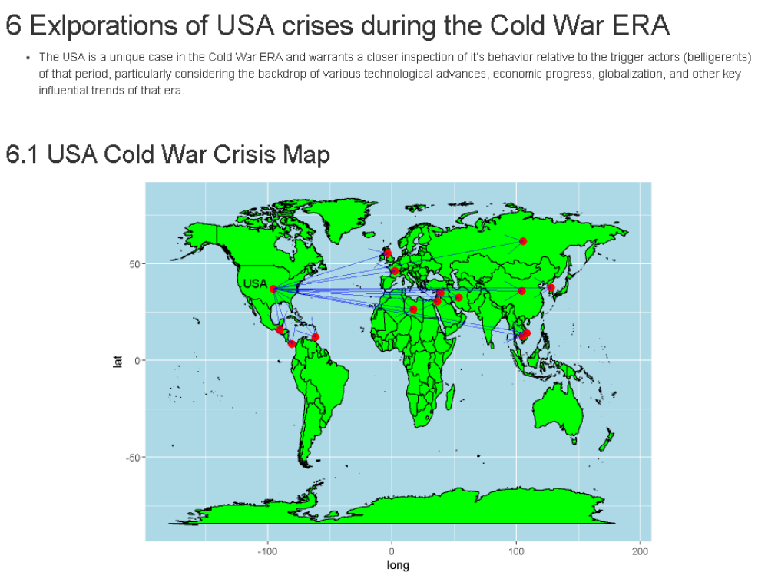

Post Feedback Design Modifications:

- The original design implementation attempt was to manifest something akin to the last visual in the above section (7.0.1). That failed miserably and actually never got very far out of the gate before being scrapped completely. However, I was determined to visually convey the power disparity on an instance by instance basis, and not just the summary disparities. The feedback of the initial design were so bad that it gave material cause for a classic fast fail scenario.

- The next two design attempts were precisely those of manifesting the first two sections (5.1 and 6.1), and although those were far better because they conveyed the Geo-Political gravity of the desired analysis, they lacked the ability to convey the power disparity visually. The feedback from these later designs were positive but the concern was focused on how to convey the power disparity attribute visually in the most effective way and iterative cycling through the cold war years.

- The final design combined all best of all the previous designs to arrive at the following (including crisis outcome):

- Final Visualization Design

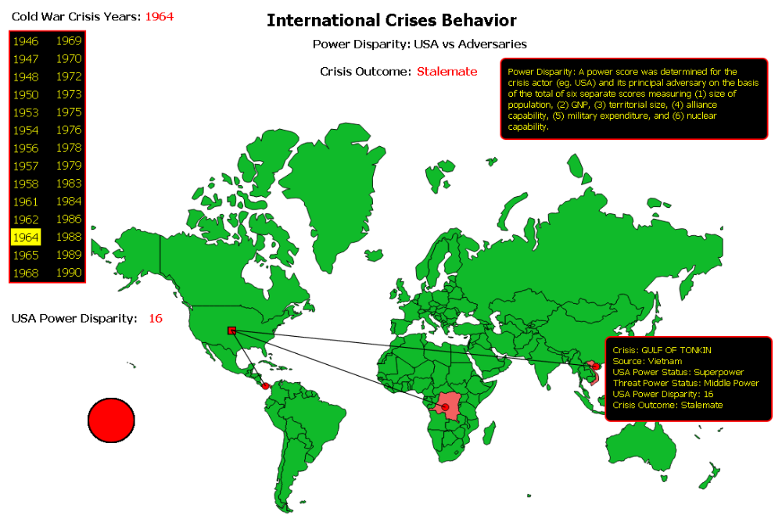

FEEDBACK

- Individuals Contributors and Feedback Summaries:

  - Initial Design - "Paul Stevens, PhD" : "There is just no way to visually convey the attribute power disparity on an instance by instance basis using a polar coordinate view of ordinal data. It places too much of a burden on the reader to discern the intricacies of the cart to get at the meaning of the data. This needs to be re-thought."
    - Modifications: The entire initial design strategy was scrapped for a more geo-political mercantor world map design.

  - Second Design Iteration - "Robert Tillman Sr." : "This iteration makes use of geo-political context and articulates magnitude differences of power disparity but does not make it easy to highlight the particular adversary in question. This must be addressed."
    - Modifications: The concept of world mapping introduced, red dot endpoints incorporated, shading of adversaries included, and inclusion of key metrics via tooltips added.

  - Third Design Iteration - "Tomas Rockman III" : "This iteration is much better but it does not allow for iterating through the years in the Cold War to implement an instance by instance comparison. Can that be added?"
    - Modifications: Lines from the US to adversaries introduced, ellipse sizing to the power disparity included, iterating through cold war years navigational system injected, and key metrics displayed onto screen.

  - Final Design - "Peter Calvanese, MD/PhD" : "Much better, the iterative construct of the years is evident, the visual conveying of the gravity of the power disparity is exists, the highlighting of the geo-political context is clear, and the overall context is further clarified / defined by the info box at the top. Color scheme could be improved."
    - Modifications: Color scheme altered to fit more cohesively.

RESOURCES

D3 WorkShop Page:
http://enjalot.github.io/intro-d3/

D3 Tutorials:
https://github.com/d3/d3/wiki/Tutorials

D3 Geo API Site
http://enjalot.github.io/intro-d3/maptime/geo/#data

GEO Projections
http://enjalot.github.io/intro-d3/maptime/geo/

ZeroViscosity
http://zeroviscosity.com/

RAW:
http://app.raw.densitydesign.org/

D3 - Variable "d"
http://stackoverflow.com/questions/24358842/use-of-d-in-function-literal-in-d3

Learn JS Data - D3
http://learnjsdata.com/group_data.html

Secret 3rd Variable in D3 Anonymous Function
http://stackoverflow.com/questions/20437116/third-variable-in-d3-anonymous-function

Exporting Data from R
http://www.statmethods.net/input/exportingdata.html

How do you set periodic timers in d3.js?
http://stackoverflow.com/questions/13390438/how-do-you-set-periodic-timers-in-d3-js

Filter data in d3 to draw either circle or square
http://stackoverflow.com/questions/20335118/filter-data-in-d3-to-draw-either-circle-or-square

D3 Docs:
https://github.com/d3/d3-3.x-api-reference/blob/master/Geo-Projections.md

use of “d” in function literal in D3?
http://stackoverflow.com/questions/24358842/use-of-d-in-function-literal-in-d3

CSS Shapes:
https://css-tricks.com/examples/ShapesOfCSS/

Straight lines on map in d3.js
https://github.com/mbostock/d3/wiki/SVG-Shapes#wiki-line

Circles and Rectangles:
https://www.dashingd3js.com/svg-group-element-and-d3js

D3 Tutorials
http://alignedleft.com/tutorials/d3

Tributary
http://tributary.io/

1000+ D3.js Examples and Demo's
http://techslides.com/over-1000-d3-js-examples-and-demos

D3.js Playground:
http://phrogz.net/js/d3-playground/#BlankDefault

GitHub: D3
https://github.com/d3/d3/wiki/Gallery

Lyra:
Open source editor for D3 data visualization
https://powertripanalytics.com/open-source-editor-for-d3-data-visualization/

UW Interactive Data Lab: Lyra
http://idl.cs.washington.edu/projects/lyra/

D3 Hello World
http://www.jeromecukier.net/blog/2012/09/04/getting-to-hello-world-with-d3/

Newbie to D3.js Expert: Complete path to create interactive visualization using D3.js
https://www.analyticsvidhya.com/learning-paths-data-science-business-analytics-business-intelligence-big-data/newbie-d3-js-expert-complete-path-create-interactive-visualization-d3-js/

Handling Chrome Stupid Stuff:
Allow Google Chrome to use XMLHttpRequest to load a URL from a local file
http://stackoverflow.com/questions/4819060/allow-google-chrome-to-use-xmlhttprequest-to-load-a-url-from-a-local-file

The BOOK:
http://ritchiesking.com/book/

Other Books on D3:
http://it-ebooks24.com/search/?q=D3&type=title

D3 Tutorials
http://alignedleft.com/tutorials/d3

Tributary
http://tributary.io/

1000+ D3.js Examples and Demo's
http://techslides.com/over-1000-d3-js-examples-and-demos

D3.js Playground:
http://phrogz.net/js/d3-playground/#BlankDefault

GitHub: D3
https://github.com/d3/d3/wiki/Gallery

GitHub Wiki
https://github.com/d3/d3/wiki

Scott Murray Tutorial:
http://alignedleft.com/tutorials/d3

Online Book: Interactive data visualization for the web
http://chimera.labs.oreilly.com/books/1230000000345/

Animating Lines in D3:
http://jaketrent.com/post/animating-d3-line/

Appendix - List of ICB Crises in the Cold War Era.

USA Cold War Crisis List: (Adversary, Crisis, Outcome)
## Cambodia
## crisname Crisis_Result
## 1 MAYAGUEZ Victory
##
## China
## crisname Crisis_Result
## 1 KOREAN WAR II Compromise
## 2 TAIWAN STRAIT I stalemate
## 3 TAIWAN STRAIT II Victory
##
## Cuba
## crisname Crisis_Result
## 1 BAY OF PIGS Defeat
##
## Vietnam
## crisname Crisis_Result
## 1 GULF OF TONKIN stalemate
## 2 VIETNAM SPRING OFF. Victory
## 3 INVASION OF CAMBODIA stalemate
## 4 VIETNAM PORTS MINING Compromise
## 5 CHRISTMAS BOMBING Compromise
##
## France
## crisname Crisis_Result
## 1 DIEN BIEN PHU Defeat
##
## Grenada
## crisname Crisis_Result
## 1 INVASION OF GRENADA Victory
##
## Guatemala
## crisname Crisis_Result
## 1 GUATEMALA Victory
##
## Iran
## crisname Crisis_Result
## 1 US HOSTAGES IN IRAN Compromise
## 2 IRAN NUCLEAR II Compromise
##
## Iraq
## crisname Crisis_Result
## 1 IRAQ/LEB. UPHEAVAL Victory
## 2 IRAQ DEPLOY./KUWAIT Victory
## 3 DESERT STRIKE Victory
## 4 UNSCOM I Victory
## 5 UNSCOM II Compromise
## 6 IRAQ REGIME CHANGE Victory
##
## Jordan
## crisname Crisis_Result
## 1 BLACK SEPTEMBER Victory
##
## Libya
## crisname Crisis_Result
## 1 LIBYAN JETS Victory
## 2 LIBYAN CIVILWAR Victory
##
## MULTI_STATE_ACTOR
## crisname Crisis_Result
## 1 KOREAN WAR III Victory
## 2 OCTOBER-YOM KIPPUR WAR Victory
## 3 GULF WAR Victory
##
## NON_STATE_ACTOR
## crisname Crisis_Result
## 1 CHINA CIVIL WAR Defeat
## 2 PATHET LAO OFFENSIVE Victory
## 3 VIET CONG ATTACK Victory
## 4 NAM THA Victory
## 5 CONGO II Victory
## 6 PLEIKU stalemate
## 7 DOMINICAN INTERVENTN. Victory
## 8 TET OFFENSIVE Defeat
## 9 WAR IN ANGOLA Defeat
## 10 SHABA II Victory
## 11 GULF OF SYRTE II Victory
## 12 HAITI MIL. REGIME Victory
## 13 US EMBASSY BOMBINGS Compromise
## 14 AFGHANISTAN/US Victory
##
## Panama
## crisname Crisis_Result
## 1 PANAMA FLAG Compromise
## 2 INVASION OF PANAMA Victory
##
## Korea
## crisname Crisis_Result
## 1 KOREAN WAR I Victory
## 2 PUEBLO Defeat
## 3 EC-121 SPY PLANE stalemate
## 4 POPLAR TREE Compromise
## 5 N. KOREA NUCLEAR I Compromise
## 6 N. KOREA NUCLEAR II Compromise
## 7 N. KOREA NUCLEAR III Compromise
## 8 N. KOREA NUCLEAR IV-SATELLITE LAUNCH stalemate
## 9 N. KOREA NUCLEAR V stalemate
##
## Russia
## crisname Crisis_Result
## 1 AZERBAIJAN Victory
## 2 TURKISH STRAITS Victory
## 3 BERLIN BLOCKADE Victory
## 4 SUEZ NATN.-WAR Victory
## 5 BERLIN DEADLINE stalemate
## 6 BERLIN WALL Compromise
## 7 CUBAN MISSILES Victory
## 8 SIX DAY WAR Victory
## 9 CIENFUEGOS SUB. BASE Victory
## 10 AFGHANISTAN INVASION stalemate
## 11 NICARAGUA MIG-21S stalemate
##
## Syria
## crisname Crisis_Result
## 1 SYRIA/TURKEY CONFRNT. Victory
## 2 SYRIA CHEMICAL WEAPONS Compromise
##
## United Kingdom
## crisname Crisis_Result
## 1 TRUMAN DOCTRINE Victory

