Apaji Institute of Mathematics and Applied Computer Technologies


Banasthali Vidyapith

Software Requirement Specification (SRS)
And Software Design Specifications (SDS)
CSD032
[Personal Finance Manager and Advisor]

Project Mentor: Submitted By:
Dr. K.F.Rahman Lavanya Singh (2316453)
(Department of Computer Science) Mansi Ruhil (2316464)

Nidhi kumari (2316485)

Poorvi Ganjiwale (2316503)
Pragati Chauhan (2316504)

Chapter 1 SRS

TABLE OF CONTENTS

1. Introduction
1.1 Purpose …………………………………………………… 4
1.2 Scope……………………………………………………… 4
1.3 Definitions, Acronyms and Abbreviations……………….. 4
1.4 Overview………………………………………………….. 5

2. General Description
2.1 Product Perspective…………………………………..……....6
2.1.1 Product Function ……………………………….........6
2.1.2 Hardware Requirements………………………….......7 2.1.3 Software Requirements ……………………………....8
2.1.4 Communication Interface……………………….…....9
2.2 User Characteristics………………………………………….10

2.2.1Use case Diagram…………………………………………..11
2.3 General Constraints……………………………………….....16
2.4 Technologies used……………………………………….......17

3. Specific Requirements
3.1 Functional Requirements…………………………………….18
3.2 Non-Functional Requirements ……………………………….19

3.2.1 AVAILABILITY……………………………………..19 3.2.2 SECURITY…………………………………………...19 3.2.3 RELIABILITY……….……………………………….19 3.2.4 PORTABILITY……………………………………….20 3.2.5 MAINTAINABILITY………………………………...20

1. Introduction
1.1 Purpose
The purpose of this Software Requirements Specification (SRS) document is to clearly and formally define the functional and non-functional requirements for the Smart Personal Finance Web Application.
This document is intended for:
- System designers and developers: To implement the system according to well-defined requirements.
- Testers: To verify the system against these requirements.
- Project stakeholders (teachers, evaluators): To review the intended system functionality, scope, and constraints without ambiguity.
1.2 Scope
The product to be produced is a Smart Personal Finance Web Application designed to help users track income, manage expenses, plan budgets and savings, estimate taxes, and get personalized investment recommendations.
The system will:
- Allow users to securely register, log in, and manage their financial profile.
- Enable income and expense tracking via manual input, OCR receipt scanning, and voice input.
- Provide visual dashboards and reports to display financial trends and insights.
- Allow users to set and track budget limits and savings goals.
- Estimate tax liability based on income, deductions, and configured tax slabs.
- Provide AI-driven personalized investment recommendations and financial tips.
The system will not:
- Execute real financial transactions (e.g., no real-time stock trading or tax filing).
- Integrate directly with banking or investment platforms.
- Handle multiple concurrent users (for this project phase, designed as single-user but scalable later).
1.3 Definitions, Acronyms, and Abbreviations.

- SRS (Software Requirements Specification)
A document that defines the system's functional and non-functional requirements to guide development.
- API (Application Programming Interface)
Set of protocols and tools for building software applications and enabling communication between different software components.
- ML (Machine Learning)
Artificial Intelligence technique that enables systems to automatically learn and improve from experience without explicit programming.
- OCR (Optical Character Recognition)
Technology that recognizes text within digital images and converts it into machineencoded text.
- PWA (Progressive Web Application)
Web application that uses modern web capabilities to deliver app-like experiences to users.
- SIP (Systematic Investment Plan)
Investment strategy where investors contribute a fixed amount regularly into mutual funds or other investment vehicles.
- JWT (JSON Web Token)
Compact, URL-safe token format for securely transmitting information between parties.
- REST (Representational State Transfer)
Architectural style for designing networked applications, particularly web services.

1.4 Overview

- Functional Requirements - Describing core features such as expense tracking, budget planning, tax calculation, investment recommendations, and AI-powered insights.
- Non-Functional Requirements - Addressing performance, security, usability, scalability, and reliability aspects.
- Technology Stack - Highlighting the use of React.js frontend, FastAPI backend, SQL Server database, and various ML libraries for intelligent financial analysis.
- Target Audience - Defining sections most relevant to users (individual finance managers), developers, testers, and project stakeholders.

By clearly defining the system requirements, this SRS ensures successful project execution and delivery of a comprehensive personal finance management solution.

2. General Description
The Personal Finance Advisor is an innovative responsive web application designed to revolutionize personal financial management through artificial intelligence and machine learning. The system offers effortless tracking of income and expenses, enabling smart budgeting and savings goal planning. Its AI-driven core provides personalized tax estimates, investment recommendations, and actionable money management tips. Through intuitive visual reports, users gain clear insights, transforming complex data into a path for achieving financial well-being and freedom. It's a comprehensive, smart guide for all personal finance needs.

2.1 Product Perspective

2.1.1 Product Function
The Personal Finance Advisor is designed as a centralized responsive web platform that enhances personal financial management through AI-powered automation and insights. It focuses on providing comprehensive financial guidance while maintaining user privacy and data security.
- User Authentication and Profile Management o Function- Secure user registration and login system with personalized profile management including financial preferences, risk tolerance assessment, and goal setting.
  - Purpose- Ensures data security while enabling personalized financial recommendations and maintaining individual user sessions across devices.
- Automated Expense Tracking o Function- Multi-modal expense logging including manual entry, OCR-powered receipt scanning, voice-to-text input.
  - Purpose- Reduces manual data entry burden while ensuring comprehensive transaction capture and accurate categorization using ML algorithms.
- Budget Planning o Function- Intelligent budget creation based on historical spending patterns, with real-time monitoring and predictive alerts for potential overspending.
  - Purpose- Helps users maintain financial discipline through proactive budget management and spending optimization recommendations.
- Savings Goals Management o Function- Users can create multiple savings goals with target amounts, deadlines, and automatic progress tracking with milestone celebrations.
  - Purpose- Motivates users toward financial objectives through visual progress tracking and intelligent savings suggestions based on spending patterns.
- Tax Estimation and Optimization o Function- Real-time tax calculation using current Indian tax slabs with personalized optimization suggestions for real legal tax savings through strategic investments and deductions.
  - Purpose- Simplifies tax planning and maximizes user tax savings through intelligent recommendations aligned with current tax laws.
- Personalized Investment Advisory o Function -ML driven investment recommendations using collaborative filtering and risk assessment to suggest suitable mutual funds, SIPs, and investment strategies.
  - Purpose- Provides professional-level investment guidance tailored to individual risk profiles and financial goals, democratizing wealth management advice.
- Interactive Financial Reporting o Function- Dynamic dashboards with customizable charts, trend analysis, and exportable PDF reports for comprehensive financial overview.
  - Purpose- Enables users to visualize their financial health and make informed decisions based on clear, actionable insights.
- AI-Powered Financial Insights o Function- Advanced analytics including anomaly detection for unusual spending, predictive modeling for future expenses, and personalized financial advice.
  - Purpose- Provides proactive financial guidance and helps users identify improvement opportunities in their financial behavior.
- Voice and OCR Integration o Function- Natural language processing for voice commands and optical character recognition for receipt processing with automatic data extraction.
  - Purpose- Streamlines data entry through modern input methods, making expense tracking effortless and accurate.
- Real-Time Data Calculation o Function- Integration with government authenticated rules (RBI, Income Tax Department) for real time financial data including interest rates, tax slabs, and inflation rates.
  - Purpose- Ensures calculations and recommendations are based on current, official financial data for maximum accuracy and relevance.
These product functions work together to create an integrated ecosystem that transforms personal financial management from a tedious task into an intelligent, automated, and insightful experience.

2.1.2 HARDWARE REQUIREMENT
Developer Perspective:
- Development machines should have:
- CPU: Minimum Quad-core; Recommended Hexa-core or better
- RAM: Minimum 8 GB; Recommended 16 GB or more (especially if working with ML model training/testing)
- Storage: Minimum 50 GB free; Recommended 100+ GB SSD for faster database and ML dataset access
- GPU: Optional; Recommended NVIDIA GPU with CUDA support for local ML training
- Multiple monitors recommended for efficient coding, testing, and documentation
- Operating systems: Windows 10/11 or Linux
- Windows 10 / Windows 11
•macOS (latest stable versions)
•Linux (Ubuntu, Fedora, etc.)
•Android (latest stable versions)
•iOS (latest stable versions)
- Reliable internet connection with 50+ Mbps for package downloads, API testing, and cloud-based ML services.
- Peripherals: Keyboard, mouse, optional external storage and webcam for meetings

User Perspective:
- Devices supported: Laptop, desktop, tablet, or smartphone.
- Minimum hardware:
- CPU: Dual-core processor
- RAM: 4 GB
- Storage: 500 MB free for browser and caching
- Display: Minimum resolution 1280×720
- Camera and microphone are optional but required for features like invoicing via receipt capture and voice inputs.
- Internet connectivity of at least 5 Mbps for API communication and uploads.
- Recommended for better experience:
- CPU: Quad-core or better
- RAM: 8 GB or more
- High-quality webcam and microphone
- Internet speed 20+ Mbps for smooth interaction
2.1.3 Software Requirements
Developer Perspective:
- Frontend: React.js with Tailwind CSS for UI styling.
- Backend: FastAPI with Python 3.12.
- Database: Microsoft SQL Server 2021 with SQL Server Management Studio.
- APIs: Interfaces to RBI Data Services API v2.1, Income Tax Department API v3.2.
- Google Cloud APIs: Vision API (OCR) and Speech-to-Text API for text extraction and voice inputs.
- Tools: Git for version control, VS Code as code editor, automated test frameworks (pytest, Jest).
- Development and deployment support frameworks such as CI/CD pipelines.
- Security libraries for authentication and encryption.
- Python SQL drivers like pyodbc or sqlalchemy for database connectivity.

User Perspective:
- Modern web browsers
•Google Chrome: v116.x, v115.x
•Mozilla Firefox: v116.x, v115.x
•Microsoft Edge: v116.x
•Apple Safari: v16.x, v15.x.
- Browser support for camera and microphone access.
- Stable internet connection to access cloud-hosted services.

2.1.4 Communications Interfaces
2.1.4.1 Client ↔ Backend Communication
- Protocol: HTTPS (HTTP over TLS) • Reason:
  - Secure encrypted communication between the user’s browser (React frontend) and the backend (FastAPI).
  - Prevents eavesdropping and data tampering.
- Message Format:
  - Request: JSON payload in standard HTTP POST/GET requests. o Response: JSON payload returned by FastAPI endpoints.
2.1.4.2. Backend ↔ Database Communication
- Protocol: TCP/IP via SQL Server Driver (ODBC or SQLAlchemy) • Reason:
  - Standard database connectivity mechanism.
  - Allows secure, efficient interaction with Microsoft SQL Server.
- Message Format:
  - SQL queries (INSERT, SELECT, UPDATE, DELETE). o Results returned as tabular data (rows/columns).
2.1.4.3 Backend ↔ AI/ML Model Communication
- Protocol: Internal function calls within FastAPI process.
- Reason:
  - Pre-trained models (saved as .pkl) are loaded in memory when the backend starts.
  - Direct Python function calls → No need for HTTP between backend and ML models.
- Message Format:
  - Python objects (e.g., pandas DataFrames or dictionaries).
2.1.4.4 Backend ↔ External APIs
- Govt APIs:
  - HTTPS REST API → JSON responses.
  - Example: Fetch tax slab data from RBI or IRS API.
- Speech-to-Text API:
  - HTTPS REST → Audio file upload → JSON transcript in response.

2.2 User Characteristics
- Students
  - Educational Level:
College/university students (mostly undergraduate level).
  - Experience & Technical Expertise:
Basic computer and internet usage skills.
Familiar with using web applications (e.g., Google Sheets, online banking portals).
  - Design Impact:
      - Simple, intuitive UI design with minimal steps.
      - Avoid jargon → Use layman-friendly terms like “Add Expense” instead of “Record Transaction”.
      - Auto-categorization helps reduce manual effort. o No need to input monthly income during initial setup (since many don’t have a fixed income).
- Working Professionals
  - Educational Level:
College-educated, employed individuals from diverse sectors.
  - Experience & Technical Expertise:
Moderate technical knowledge.
Familiar with online banking, tax filing apps, budget planning tools.
  - Design Impact:
o More advanced features unlocked (tax estimation, investment advice). o Slightly advanced forms (input of deductions, risk profile)

2.2.1 Use case

2.2.1.1Use case diagram

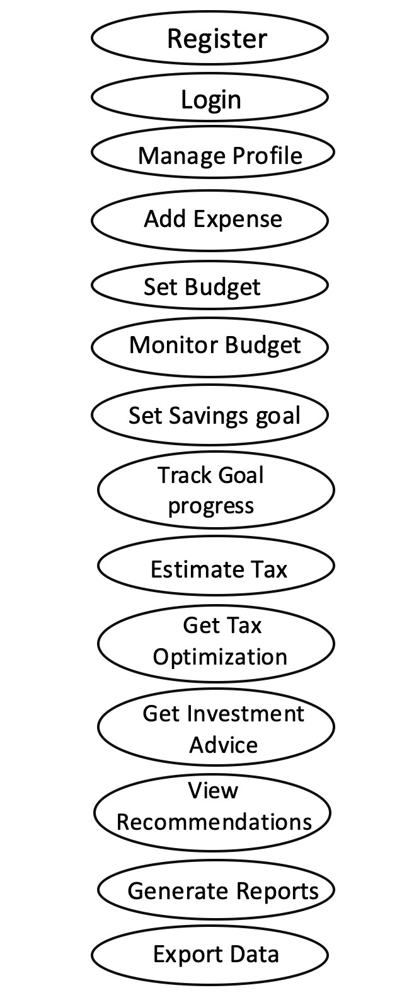

Working
Professional

Student

Personal Finance Manager

1. Register
Field | Description
Use Case Name | Register
Actor | New User (Student / Working Professionals)
Prerequisite | None
Normal Course of Action | - User provides name, email, password  - System validates inputs  - Account is created and confirmation shown
Alternative Course of Action | - Email already exists → Error shown  - Weak password → Prompt user for stronger password
Outcome | New user account created successfully

- Login
Field | Description
Use Case Name | Login
Actor | Registered User
Prerequisite | User must already be registered and have valid credentials
Normal Course of  Action | - User enters username and password  - System validates credentials  - Dashboard is displayed
Alternative Course of  Action | - Invalid credentials → System shows error and prompts retry-  Too many failed attempts → System locks account
Outcome | User is successfully logged into the system

- Manage Profile

Field | Description
Use Case Name | Manage Profile
Actor | Registered User
Prerequisite | User must be logged in
Normal Course of Action | - User navigates to profile  - Updates personal details (name, DOB, preferences)  - Updates financial info (income, risk level)  - Saves changes
Alternative Course of  Action | - Invalid inputs → System prompts correction- User cancels changes
Outcome | Profile updated successfully

- Track Expense

Field | Description
Use Case Name | Expense Tracker
Actor | Registered User (Student / Working Professionals)
Prerequisite | User must be logged in
Normal Course of  Action | - User adds expense (manual/OCR/voice)  - System validates input  - AI categorizes & checks anomalies  - Saves expense and updates dashboard
Alternative Course of  Action | - OCR fails → Prompt manual entry- AI miscategorizes → User can edit
Outcome | Expense recorded and insights updated

5.Set Budget

Field | Description
Use Case Name | Budget Setting
Actor | Registered User
Prerequisite | User must be logged in
Normal Course of Action | - User selects “Set Budget”  - Chooses category and timeperiod  - Inputs budget amount  - Confirms and saves
Alternative Course of  Action | - Negative/invalid value → Error shown- User cancels before saving
Outcome | Budget stored and activated

6.Saving goals

Field | Description
Use Case Name | Saving Goals
Actor | Registered User
Prerequisite | User must be logged in
Normal Course of Action | - User selects “Add Goal”  - Inputs goal name, target, target date  - Saves goal  - Dashboard shows progress
Alternative Course of  Action | - Invalid date/amount → System prompts correction- User cancels entry
Outcome | Goal created and tracked successfully

7.Investment Recommendation

Field | Description
Use Case Name | Investment Recommendation
Actor | Working Professionals (people earning income)
Prerequisite | User must be logged in and profile must be completed (income, risk tolerance)
Normal Course of  Action | - User requests investment recommendation  - System fetches profile data  - ML model suggests suitable options  - Recommendations displayed
Alternative Course of Action | - Missing profile data → Prompt user to complete- ML model error →  System shows default/fallback suggestions
Outcome | Personalized investment advice displayed

8.Tax Estimation

Field | Description
Use Case Name | Tax Estimation
Actor | Working Professionals (people earning income)
Prerequisite | User must be logged in and income entered
Normal Course of Action | - User requests tax estimate  - System fetches tax slabs from Gov API  - Calculates tax liability  - Shows detailed breakdown
Alternative Course of  Action | - API unavailable → Use cached tax data- Income not provided  → Prompt user
Outcome | Estimated tax liability displayed

9. Report Generation

Field | Description
Use Case Name | Report Generation
Actor | Registered User
Prerequisite | User must be logged in and have stored transactions
Normal Course of  Action | - User selects “Generate Report”  - Chooses time period (monthly/annual/custom)  - System compiles financial data  - Generates report with charts and insights5. User  downloads/export as PDF
Alternative Course of Action | - No transactions → Show “No data available”- System error → Retry or notify user
Outcome | Financial report displayed and available for export

2.3 Constraints

2.3.1 Regulatory Policies
- Tax estimation feature will follow current government tax regulations (India/IRS) for informational purposes only.
- Tax slabs will be maintained in static JSON files updated yearly.

2.3.2 Hardware Limitations
- Works on standard devices (laptops, desktops, smartphones).
- OCR and voice input run asynchronously to support lower-end devices.

2.3.3 Interface to Other Applications
- No direct integration with banking or investment platforms.
- Optional use of public APIs (e.g., Alpha Vantage) for general market data.

2.3.4 Parallel Operation
- Only single-user mode supported.
- Multi-user support planned for future versions.

2.3.5 Audit Functions
- Audit logs will track key actions (login, expenses, tax profile updates).

2.3.6 Control Functions
- Users can edit or override AI suggestions.
- No automatic financial actions (investments, tax filing).

2.3.7 Higher-Order Language Requirements
- Backend: Python 3.11+
- Frontend: React.js

2.3.8 Communication Protocols
- Standard HTTP(S) with JSON payloads only.

2.3.9 Reliability Requirements
- Regular requests respond within 2 seconds.
- OCR/speech-to-text within 6 seconds.
- Database ensures atomic transactions.

2.3.10 Application Criticality
- Informational and educational tool only.
- No real financial transactions.
- User data confidentiality prioritized.

2.3.11 Safety and Security
- All sensitive data encrypted.
- JWT-based authentication with expiry.
- HTTPS only communication.

2.4 Technologies Used

2.4.1 Frontend - React.js (19.1.1) with modern JavaScript providing a responsive, component-based user interface with Tailwind CSS (4.1.13) for styling and responsive design.
2.4.2 Backend - FastAPI (0.116.1) framework with Python 3.11+ for high-performance API development with automatic documentation and native async support.
2.4.3 Database - SQL Server Management Studio 2021 for reliable data storage with advanced querying capabilities and robust transaction management.
2.4.4 Machine Learning - Python ecosystem including scikit-learn (1.7.2) for classification, Prophet for time series forecasting, and spaCy (3.8.0) for natural language processing.
2.4.5 Authentication and Security - JWT-based authentication with bcrypt password hashing, HTTPS encryption, and role-based access control.
2.4.6 Development Tools - Git version control, automated testing frameworks, CI/CD pipelines, and comprehensive API documentation tools.

3.Specific Requirements
In this section, all software requirements are explained to provide detailed information for development and testing teams.
All requirements are divided into two groups:

3.1 Functional Requirements

3.1.1 User Authentication & Profile
- Users register with name, email, password, occupation.
- Passwords stored using bcrypt/argon2.
- JWT issued on login and required for all API requests.
- Users can view/update profile (including income).
- Access to tax/investment features restricted by occupation.

3.1.2 Expense & Income Tracking
- Users can manually input income/expenses (amount, category, date, optional merchant/notes).
- OCR and voice input supported for expense recording.
- NLP extracts amount, date, category, merchant.
- ML model provides auto-categorization, which users can override.
- Anomaly detection via Isolation Forest flags unusual expenses.
- Transactions stored with timestamp and user ID.

3.1.3 Budget & Savings Goals
- Set monthly category-wise budgets.
- Utilization = (expenses ÷ budget) × 100.
- Alerts when utilization ≥90% or exceeded.
- Savings goals with title, target amount, deadline, saved amount.
- Goal prediction with linear regression.
- Suggested monthly contribution for deadlines.

3.1.4 Tax Estimation
- Input annual income, deductions (80C, 80D, HRA), tax regime.
- System calculates taxable income and tax using JSON slabs.
- Provides textual optimization suggestions.
- Tax records stored for audit.

3.1.5 Investment Recommendations
- Input risk preference, investment horizon, monthly surplus.
- Recommendations via Decision Tree model (e.g., equity, mutual funds, debt).
- Display in dashboard cards.

3.1.6 Reports & Insights
- Charts (bar, pie, line) via Chart.js.
- Export reports in PDF/CSV.
- AI insights (e.g., spending trends).

3.1.7 Error Handling & Recovery
- Validate all inputs.
- Meaningful error messages with standard HTTP codes.
- Graceful recovery from API failures with user-friendly fallback.

3.2 Non-functional Requirements

3.2.1 Availability
- Hosted on cloud services: Vercel (Frontend), Render (Backend), Azure SQL (Database).
- Requires user login for personalized features; unauthenticated users see only the informational homepage.

3.2.2 Security
- Stateless authentication using JWT.
- Passwords stored via hashing.
- All communication uses HTTPS.
- Input validation with FastAPI Pydantic models.
- Sensitive feature access restricted by occupation.
- Public endpoints protected by rate limiting (max 10 requests/minute per IP).

3.2.3 Reliability
- Data stored in SQL Server with ACID-compliant transactions.
- Automated daily backups on Azure.
- Data recovery possible from latest backup after failures.

3.2.4 Portability
- Accessible on any modern browser: Chrome, Firefox, Edge v114.x+, Safari v15.x+.
- Responsive design for desktop and mobile.
- Backend and database are platform-independent, hosted on cloud.

3.2.5 Maintainability
- Modular architecture: separate modules for authentication, transactions, budgets, savings, tax, investments, reports, and AI insights.
- Clear folder structure, documented code (PEP-8).
- ML models stored as versioned .pkl files.
- Configuration (e.g., tax slabs) stored as external JSON.
- Comprehensive unit and API tests; follows best coding practices with documentation and CI.

Chapter 2 SDS

TABLE OF CONTENTS

- Introduction
  - Purpose ……………………………………………………23
  - Scope………………………………………………………23
  - Terms, Definitions, Acronyms and Abbreviations………..23
  - Overview …………….……..……………………………..23

- System Architectural Design
  - High Level Design Overview…………………………….. 23
  - Detailed Description of Components
    - Activity Diagram…………………………………. 24
    - Sequence Diagram…………………………………27

- Data Design
  - Database Description……………………………………….28
  - Class Diagram…………………………. ………………… 32

- User Interface Design
4.1Detailed Description of Components……………………… 33
4.2 Screen images………………………………………………34

- TYPES OF TEST ………………………….......................................36
- References ……………………………………………………37

SOFTWARE DESIGN SPECIFICATION (SDS)
- Introduction
  - Purpose
This Software Design Specification (SDS) outlines the intended design, architecture, and implementation plan for the Smart Personal Finance Web Application. It is intended for designers, developers, testers, and stakeholders to guide software realization, assure that requirements are met, and enable effective review.
  - Scope
The system is a personal finance web app that enables users to register, log in, and manage profiles; input income and expenses (manual, OCR, voice); view dashboards; plan budgets and track savings goals; estimate taxes (Indian law); and receive personalized investment recommendations. No real financial transactions are executed; the system is designed for singleuser operation with future scalability.
  - Definitions, Acronyms, Abbreviations
    - SRS: Software Requirements Specification
    - SDS: Software Design Specification
    - ML: Machine Learning
    - OCR: Optical Character Recognition
    - JWT: JSON Web Token
    - API: Application Programming Interface
    - DFD: Data Flow Diagram
  - Overview
This SDS covers functional and non-functional designs, architecture diagrams, component specifications, database design, module structure, user interface layouts, communication protocols, and quality assurance plans.

- System Architectural Design 2.1 High-Level Design Overview
The application employs a modular architecture with a React.js frontend, FastAPI backend
(Python 3.11), and a MySQL Server (Azure) database. All connections use secure HTTPS and JWT authentication. Design supports OCR for expense input, voice-to-text conversion, AIpowered budgeting, tax, and investment modules. All critical financial logic is centralized in the backend, with frontend interacting via REST APIs.

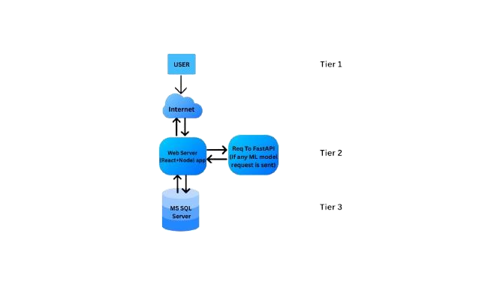

2.2 Detailed Description of Components
2.2.1 Activity Diagram
Expense, income, budget, and tax flows begin at the UI, pass via REST calls to backend, interact with SQL database, and trigger ML-based analytics for reports and recommendations. Anomaly detection and category suggestions use scikit-learn models.

1.Track expense

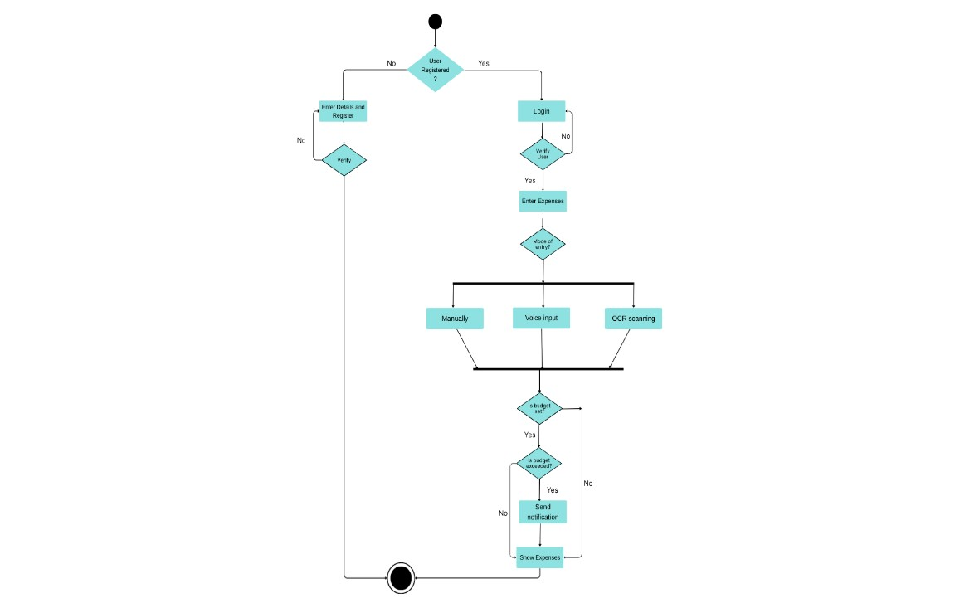
2.Set budget and saving goals
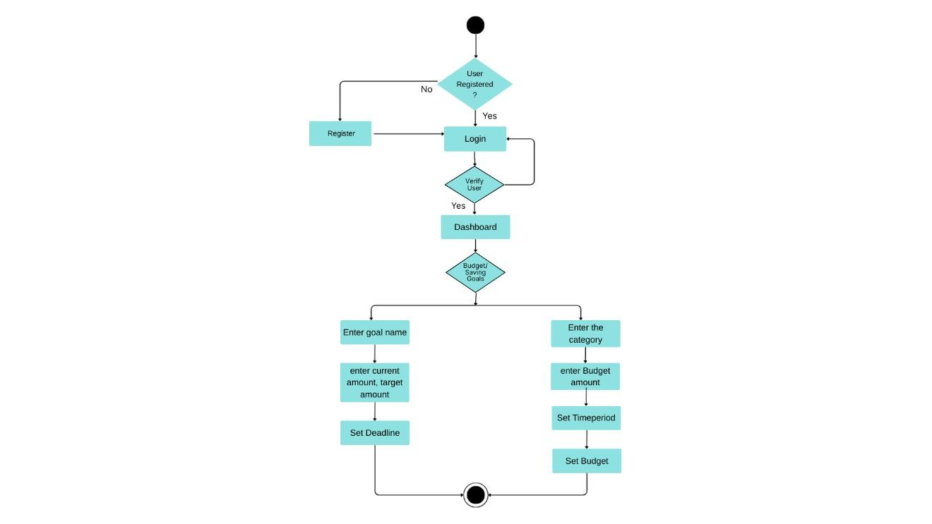

- Tax estimation and Investment recommendation

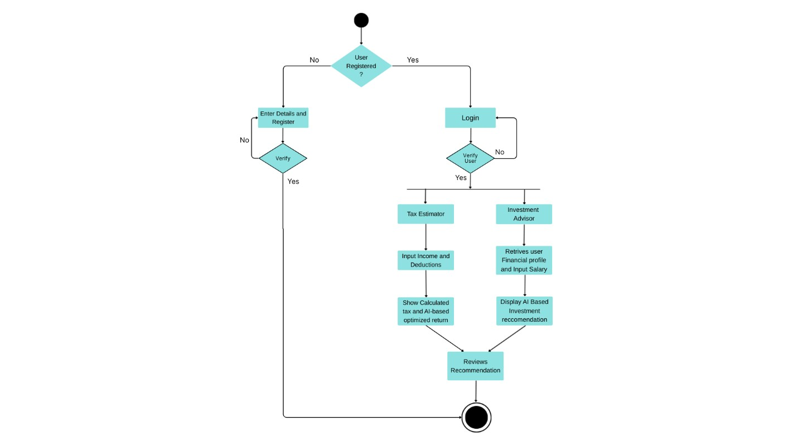
2.2.3 Sequence Diagram

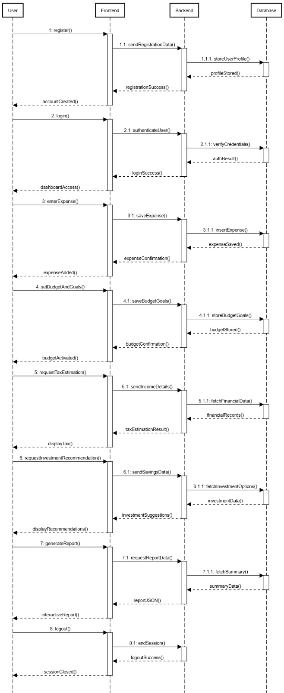
3. Data Design

3.1 Database Description
The Personal Finance Advisor uses a normalized relational database design following Third Normal Form (3NF) principles to ensure data integrity, minimize redundancy, and optimize query performance. The database schema is designed to handle comprehensive financial data while maintaining scalability and security.
Database Tables:
- Users Table
Stores core user information and authentication data.
Field Name | Description | Data Type | Constraints
UserID | Unique identifier for each user | INT IDENTITY(1,1) | Primary Key, Default  NEWID()
Username | User's chosen username | NVARCHAR(50) | Unique, Not Null
PasswordHash | Encrypted password using bcrypt | NVARCHAR(255) | Not Null
FirstName | User's first name | NVARCHAR(50) | Not Null
LastName | User's last name | NVARCHAR(50) | Not Null
DateOfBirth | User's date of birth | DATE | Not Null
CreatedDate | Account creation timestamp | DATETIME2 | Default GETDATE(), Not Null
LastLoginDate | Last login timestamp | DATETIME2 | Null
IsActive | Account status flag | BIT | Default 1, Not Null
SecurityQuestion | Security question for password reset | NVARCHAR(200) | Null
SecurityAnswerHash | Encrypted security answer | NVARCHAR(255) | Null
- User_Profiles Table
Stores detailed user profile information and preferences.
Field Name | Description | Data Type | Constraints
ProfileID | Unique profile identifier | INT IDENTITY(1,1) | Primary Key, Default  NEWID()
UserID | Reference to Users table | INT | Foreign Key (Users.UserID), Not Null
MonthlyIncome | User's monthly income | DECIMAL(15,2) | Check (>= 0)
Currency | Preferred currency | NVARCHAR(3) | Default 'INR', Not Null
RiskTolerance | Investment risk tolerance | VARCHAR(20) | Check IN ('Low', 'Medium', 'High')
FinancialGoals | Primary financial objectives | NVARCHAR(500) | Null
TaxBracket | Current tax bracket | DECIMAL(5,2) | Check (>= 0 AND <= 50)
UpdatedDate | Last profile update | DATETIME2 | Default GETDATE()
- Expenses Table
Stores all expenses.
Field Name | Description | Data Type | Constraints
ExpenseID | Unique transaction identifier | INT IDENTITY(1,1) | Primary Key, Default  NEWID()
UserID | Reference to Users table | INT | Foreign Key  (Users.UserID), Not Null
Category | Enter expense category | VARCHAR(50) | Not Null
Amount | expenditure | DECIMAL(15,2) | Not Null, Check (!= 0)
Date | Date of entry | DATE | Not Null
Description | Expense description | NVARCHAR(255) | Not Null
ReceiptImagePath | Path to receipt image | NVARCHAR(500) | Null
CreatedDate | Record creation timestamp | DATETIME2 | Default GETDATE()
UpdatedDate | Last update timestamp | DATETIME2 | Default GETDATE()
- Budgets Table
Stores user-defined budgets for different categories and time periods.
Field Name | Description | Data Type | Constraints
BudgetID | Unique budget identifier | INT IDENTITY(1,1) | Primary Key, Default NEWID()
UserID | Reference to Users table | VARCHAR(10) | Foreign Key (Users.UserID), Not Null
Category | Enter Category | VARCHAR(50) | Not Null
BudgetAmount | Allocated budget amount | DECIMAL(15,2) | Not Null, Check (> 0)
BudgetPeriod | Budget time period | NVARCHAR(20) | Check IN ('Monthly', 'Quarterly', 'Yearly'), Not Null
StartDate | Budget start date | DATE | Not Null
EndDate | Budget end date | DATE | Not Null
IsActive | Budget status flag | BIT | Default 1, Not Null
CreatedDate | Budget creation date | DATETIME2 | Default GETDATE()
- Goals Table
Stores user savings goals and financial objectives.
Field Name | Description | Data Type | Constraints
GoalID | Unique goal identifier | INT IDENTITY(1,1) | Primary Key, Default NEWID()
UserID | Reference to Users table | INT | Foreign Key (Users.UserID), Not Null
GoalName | Name of the savings goal | NVARCHAR(100) | Not Null
TargetAmount | Target amount to save | DECIMAL(15,2) | Not Null, Check (> 0)
CurrentAmount | Current saved amount | DECIMAL(15,2) | Default 0, Check (>= 0)
TargetDate | Goal completion target date | DATE | Not Null
Priority | Goal priority level | NVARCHAR(10) | Check IN ('High', 'Medium', 'Low'), Default 'Medium'
Description | Goal description | NVARCHAR(500) | Null
IsCompleted | Goal completion status | BIT | Default 0, Not Null
CreatedDate | Goal creation date | DATETIME2 | Default GETDATE()
CompletedDate | Goal completion date | DATETIME2 | Null
- Tax_Calculations Table
Stores tax calculation history and optimization suggestions.
Field Name | Description | Data Type | Constraints
TaxCalculationID | Unique calculation identifier | INT IDENTITY(1,1) | Primary Key, Default  NEWID()
UserID | Reference to Users table | INT | Foreign Key  (Users.UserID), Not Null
FinancialYear | Tax calculation year | NVARCHAR(10) | Not Null
TotalIncome | Total annual income | DECIMAL(15,2) | Not Null, Check (>= 0)
TaxableIncome | Income after deductions | DECIMAL(15,2) | Not Null, Check (>= 0)
TotalDeductions | Total claimed deductions | DECIMAL(15,2) | Default 0, Check (>= 0)
TaxLiability | Calculated tax amount | DECIMAL(15,2) | Not Null, Check (>= 0)
SuggestedSavings | AI-suggested tax savings | DECIMAL(15,2) | Default 0, Check (>= 0)
CalculationDate | When calculation was performed | DATETIME2 | Default GETDATE()
TaxRegime | Old or new tax regime | NVARCHAR(20) | Check IN ('Old', 'New'), Default 'New'
- Investment_Recommendations Table
Stores AI-generated investment recommendations for users.
Field Name | Description | Data Type | Constraints
RecommendationID | Unique recommendation  identifier | INT IDENTITY(1,1) | Primary Key, Default  NEWID()
UserID | Reference to Users table | INT | Foreign Key  (Users.UserID), Not  Null
InvestmentType | Type of investment | NVARCHAR(50) | Not Null
InvestmentName | Specific investment product name | NVARCHAR(200) | Not Null
RecommendedAmount | Suggested investment amount | DECIMAL(15,2) | Not Null, Check (> 0)
RiskLevel | Investment risk level | NVARCHAR(20) | Check IN ('Low',  'Medium', 'High'), Not  Null
ExpectedReturn | Projected annual return | DECIMAL(5,2) | Check (>= 0)
GeneratedDate | Recommendation  creation date | DATETIME2 | Default GETDATE()
ExpiryDate | Recommendation  validity date | DATETIME2 | Not Null
- Notifications Table
Manages in-app notifications and alerts for users.
Field Name | Description | Data Type | Constraints
NotificationID | Unique  notification identifier | INT IDENTITY(1,1) | Primary Key, Default NEWID()
UserID | Reference to Users table | INT | Foreign Key (Users.UserID), Not Null
Title | Notification  title | NVARCHAR(200) | Not Null
Message | Notification content | NVARCHAR(1000) | Not Null
NotificationType | Type of notification | NVARCHAR(50) | Check IN ('Budget Alert', 'Goal  Update', 'Tax Reminder',  'Investment', 'System'), Not Null
Priority | Notification priority | NVARCHAR(10) | Check IN ('High', 'Medium', 'Low'), Default 'Medium'
IsRead | Read status flag | BIT | Default 0, Not Null
CreatedDate | Notification creation date | DATETIME2 | Default GETDATE()
ReadDate | When  notification was read | DATETIME2 | Null

3.2 Class Diagram
Entities include Users, Transactions, Budgets, SavingsGoals, TaxRecords,
InvestmentRecommendations. Relationships are 1-to-many (User-Transactions), with normalized fields.
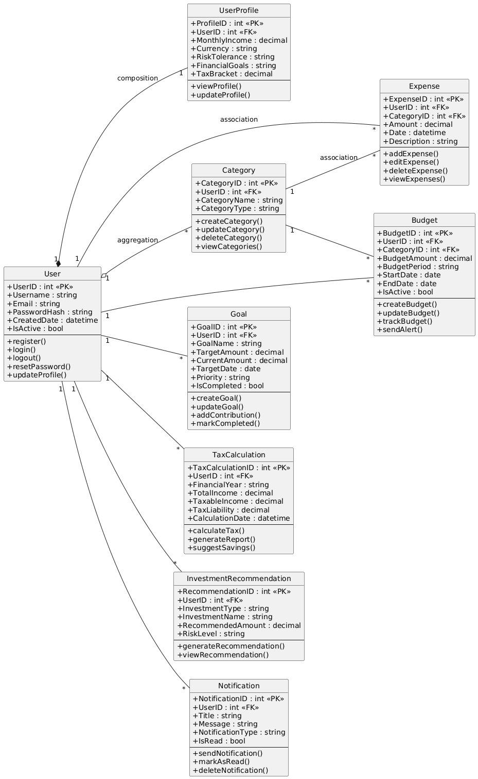

- User Interface Design
  - Detailed Description of Components
    - Login/Register
    - Profile
    - Dashboard (income/expenses graphs, insights)
    - Add Transaction (manual, OCR, voice)
    - Budget/Saving Goals
    - Tax Estimator
    - Investment Recommendation c
    - Reports (Download/Export)

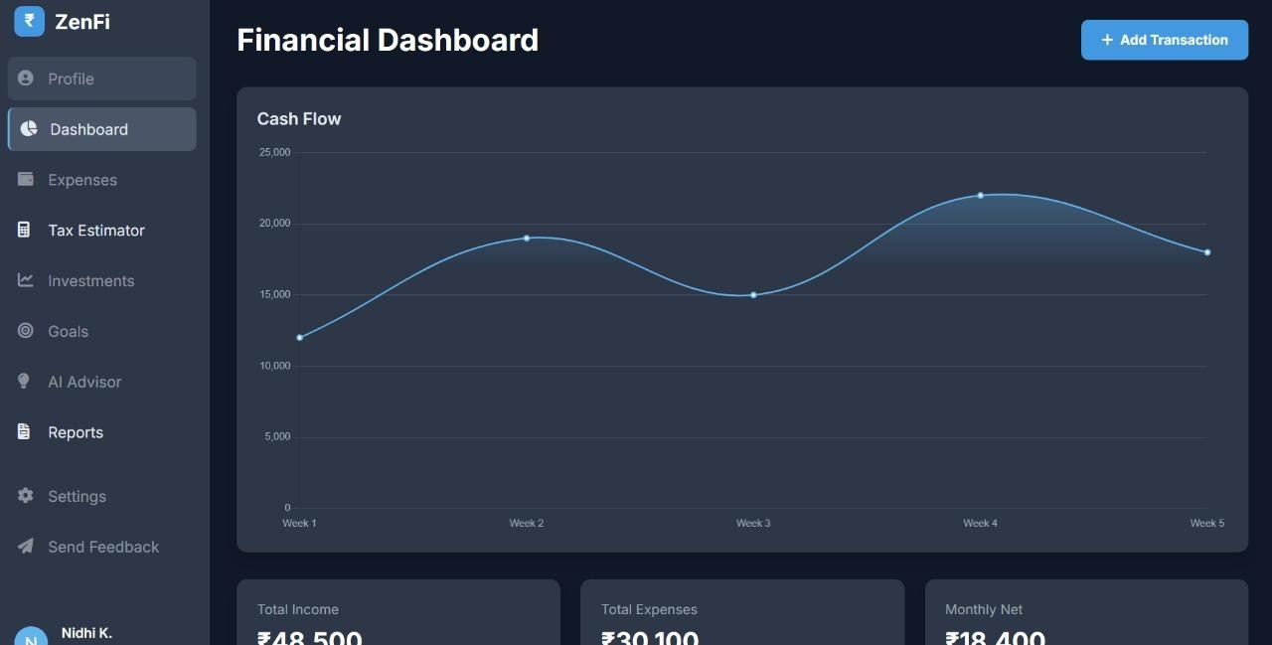

  - Screen Images
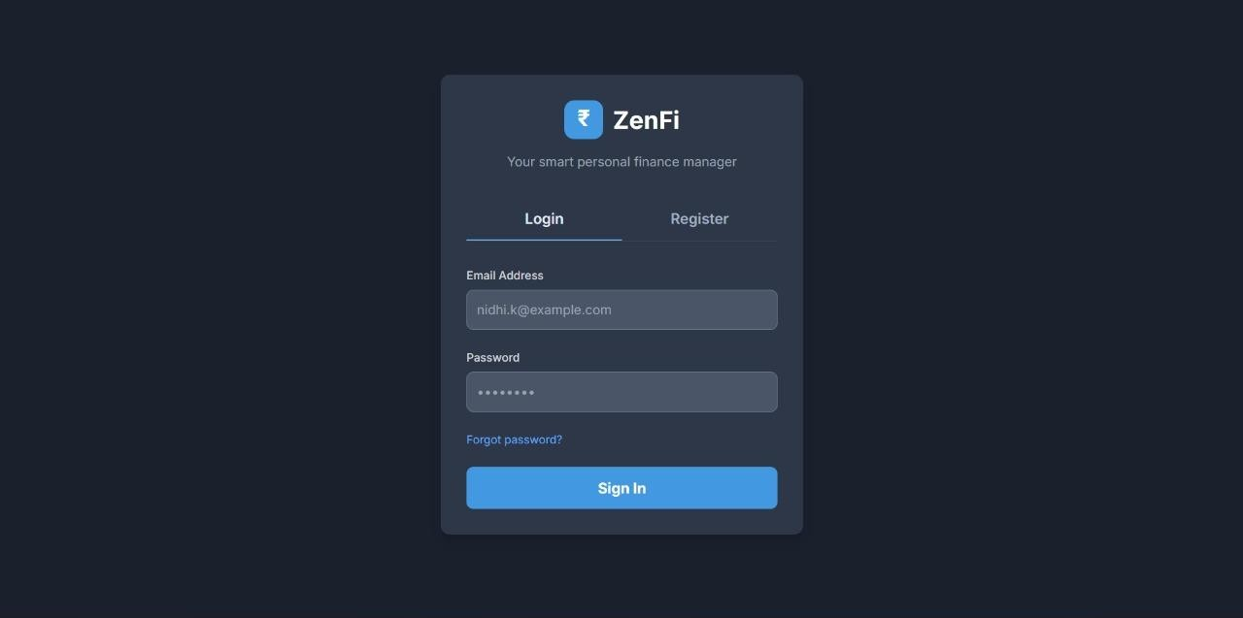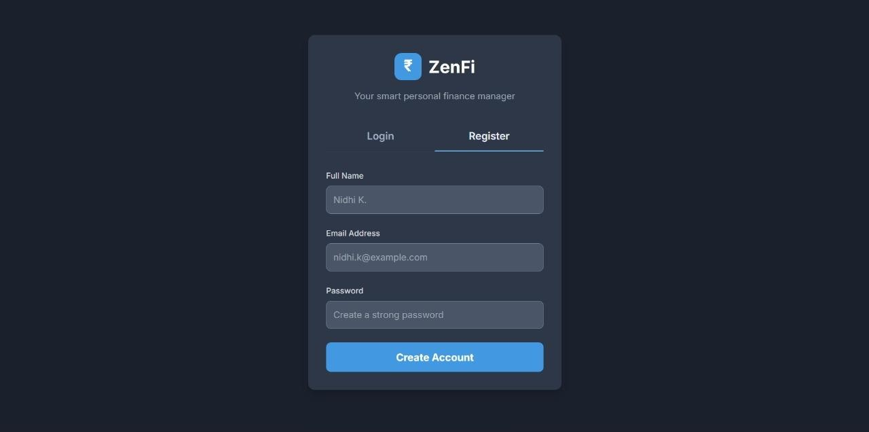
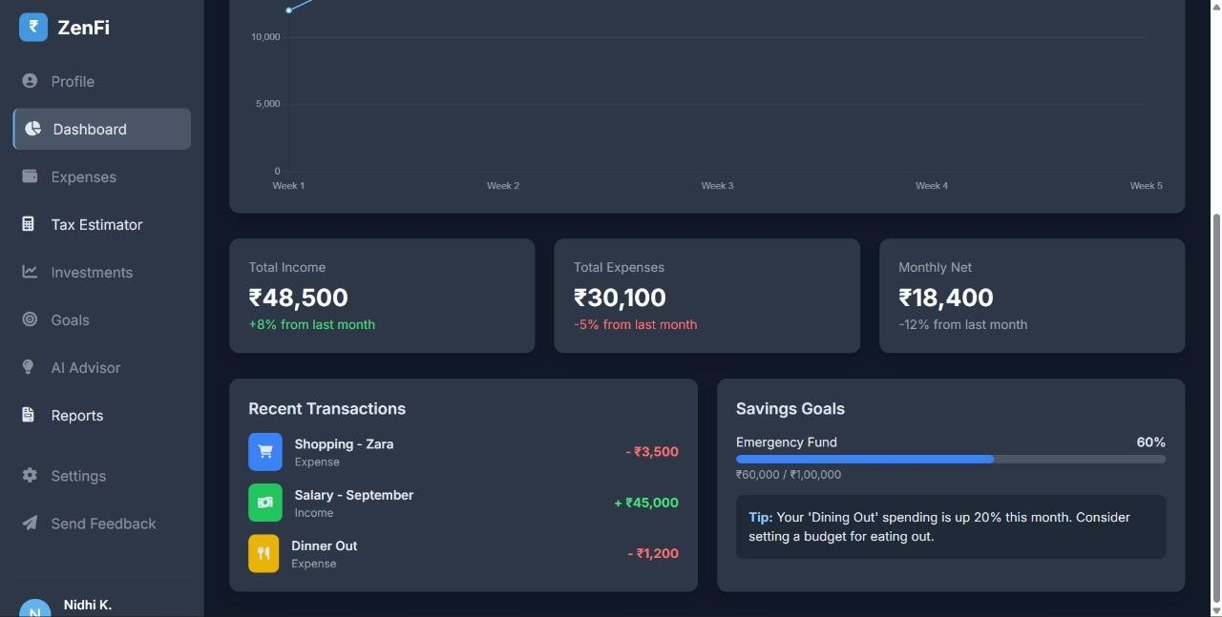

- Types of Tests (With Implementation)
    - Unit Tests: Each core module (auth, transactions, budgets, etc.) undergoes Python (pytest) and JavaScript (Jest) unit tests for correctness.
    - System Tests: End-to-end workflow from login to reporting is verified with real user flows, including error handling and recovery.
    - Integration/Regression Tests: API endpoints and database logic are tested for compatibility and stability across releases.
    - Stress Tests: Simulate multiple expense entries, file uploads, and heavy AI calculations to ensure robust performance.
    - Acceptance Tests/Staging: Finished builds are validated against functional/nonfunctional requirements; user satisfaction and usability are checked prior to deployment.

- References
Key References

Software Engineering & Design Principles
- Fowler, M. (2004). UML distilled: A brief guide to the standard object modeling language (3rd ed.). Addison-Wesley Professional.
- ISO/IEC/IEEE. (2018). ISO/IEC/IEEE 29148:2018 – Systems and software engineering — Life cycle processes — Requirements engineering. International Organization for Standardization.
- Martin, R. C. (2018). Clean architecture: A craftsman's guide to software structure and design. Prentice Hall.
- Pressman, R. S., & Maxim, B. R. (2020). Software engineering: A practitioner’s approach (9th ed.). McGraw-Hill Education.

Frontend Technologies
- React Team. (n.d.). React documentation. Retrieved September 20, 2025, from https://react.dev/
- Tailwind Labs Inc. (n.d.). Tailwind CSS documentation. Retrieved September 20, 2025, from https://tailwindcss.com/docs

Backend & Database Technologies
- Google Cloud. (n.d.-a). Cloud Speech-to-Text API documentation. Retrieved
September 20, 2025, from https://cloud.google.com/speech-to-text/docs
- Google Cloud. (n.d.-b). Cloud Vision API documentation. Retrieved September 20,
2025, from https://cloud.google.com/vision/docs
- Microsoft. (n.d.). SQL Server technical documentation. Retrieved September 20, 2025, from https://docs.microsoft.com/en-us/sql/
- Tiangolo. (n.d.). FastAPI documentation. Retrieved September 20, 2025, from https://fastapi.tiangolo.com/

Artificial Intelligence & Machine Learning
11. Pedregosa, F., Varoquaux, G., Gramfort, A., Michel, V., Thirion, B., Grisel, O., ... & Duchesnay, E. (2011). Scikit-learn: Machine learning in Python. Journal of Machine Learning Research, 12, 2825–2830.

Security & Protocols
12. Internet Engineering Task Force (IETF). (2015). RFC 7519: JSON Web Token
(JWT). Retrieved September 20, 2025, from https://tools.ietf.org/html/rfc7519 13. OWASP Foundation. (n.d.). OWASP Top Ten. Retrieved September 20, 2025, from https://owasp.org/www-project-top-ten/

