**Q1: What output is produced by the following code?**

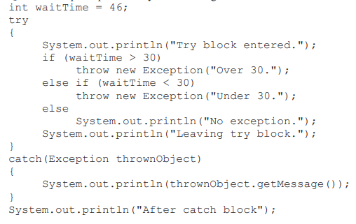

Try block entered.

Over 30

After catch block

**Q2: is the following legal?**

Exception exceptionObject = new Exception("Oops!");

Yes this is legal because we are creating an instance of the class exception and we are passing the message oops to the constructor.

**Q3: is the following legal?**

Exception exceptionObject = new Exception("Oops!");

throw exceptionObject;

it is legal only when we handle it in a try-catch block or we declare it in a method by using a throw clause next to the method

in a try-catch block

try {

Exception exceptionObject = new Exception("Oops!");

throw exceptionObject;

} catch (Exception e) {

e.printStackTrace();

}

Declared in a method

public void someMethod() throws Exception {

Exception exceptionObject = new Exception("Oops!");

throw exceptionObject;

}

**Q4 write a java statement that throws a new exception with the string: file not found**

throw new Exception (“file not found”)

**q5: use a catch block to display the exception thrown in q4**

catch(Exception e){

system.out.println(“file not found”);

throw e;

}