Intalling wxWidgets

REF:

https://wiki.codelite.org/pmwiki.php/Main/WxWidgets31Binaries#toc2

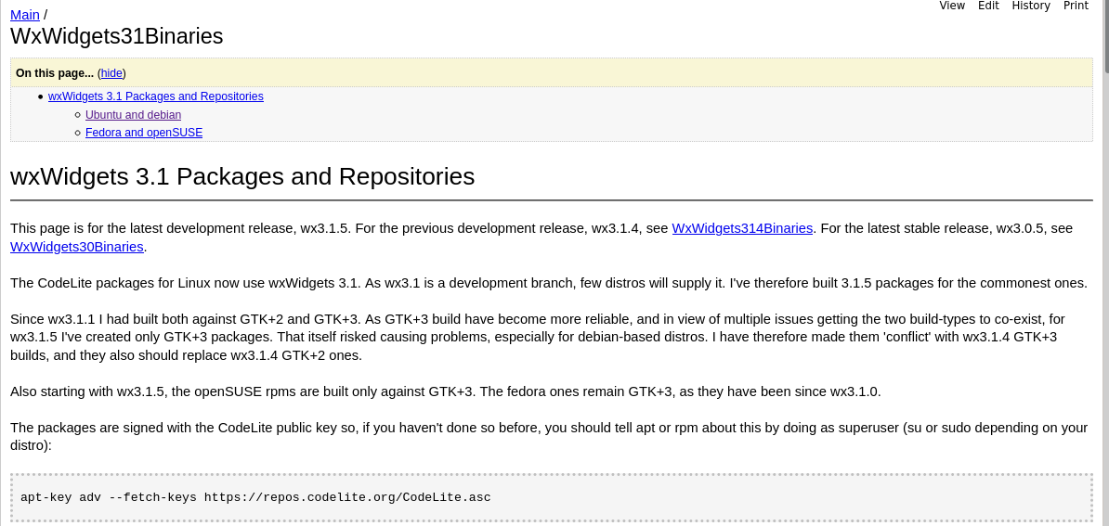

apt-key adv --fetch-keys https://repos.codelite.org/CodeLite.asc

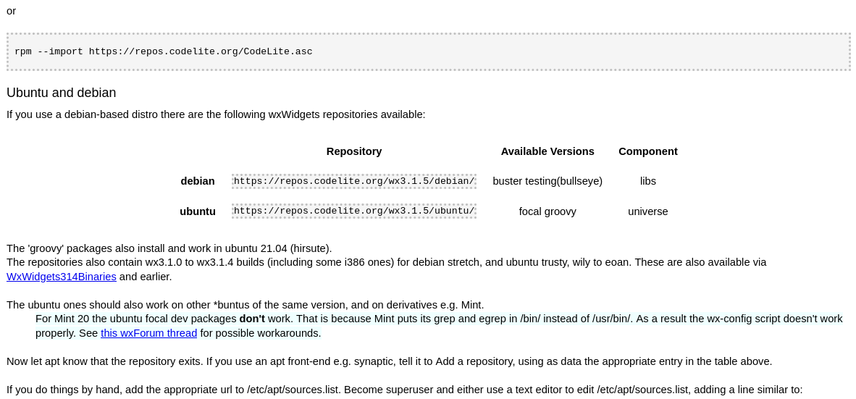

deb https://repos.codelite.org/wx3.1.5/debian/ buster libs

Cambié buster por bullseye

deb <https://repos.codelite.org/wx3.1.5/debian/> bullseye libs

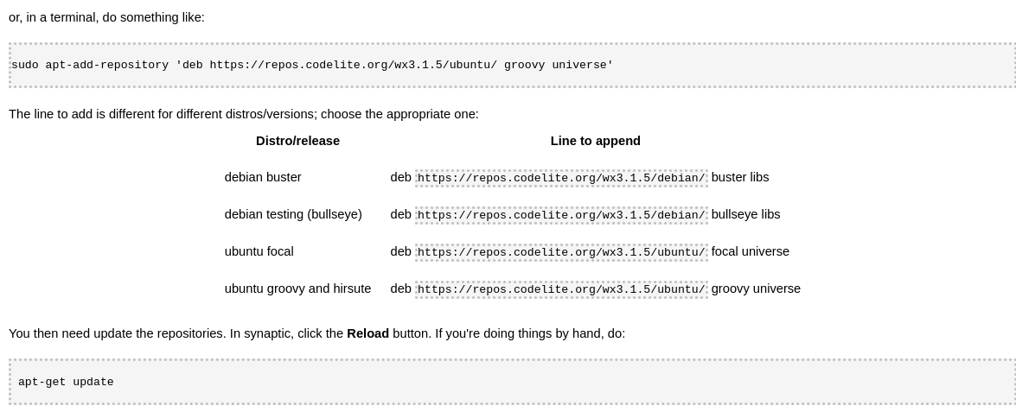

apt-get update

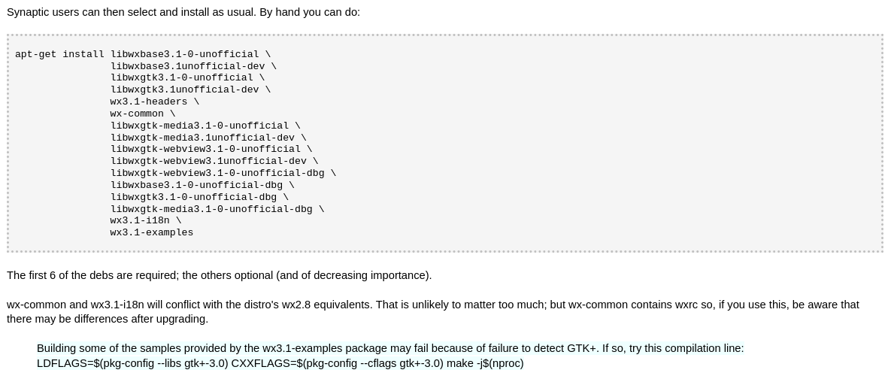

apt-get install libwxbase3.1-0-unofficial \

libwxbase3.1unofficial-dev \

libwxgtk3.1-0-unofficial \

libwxgtk3.1unofficial-dev \

wx3.1-headers \

wx-common \

libwxgtk-media3.1-0-unofficial \

libwxgtk-media3.1unofficial-dev \

libwxgtk-webview3.1-0-unofficial \

libwxgtk-webview3.1unofficial-dev \

libwxgtk-webview3.1-0-unofficial-dbg \

libwxbase3.1-0-unofficial-dbg \

libwxgtk3.1-0-unofficial-dbg \

libwxgtk-media3.1-0-unofficial-dbg \

wx3.1-i18n \

wx3.1-examples

The first 6 of the debs are required; the others optional (and of decreasing importance).

wx-common and wx3.1-i18n will conflict with the distro's wx2.8 equivalents. That is unlikely to matter too much; but wx-common contains wxrc so, if you use this, be aware that there may be differences after upgrading.

Building some of the samples provided by the wx3.1-examples package may fail because of failure to detect GTK+. If so, try this compilation line:

LDFLAGS=$(pkg-config --libs gtk+-3.0) CXXFLAGS=$(pkg-config --cflags gtk+-3.0) make -j$(nproc)

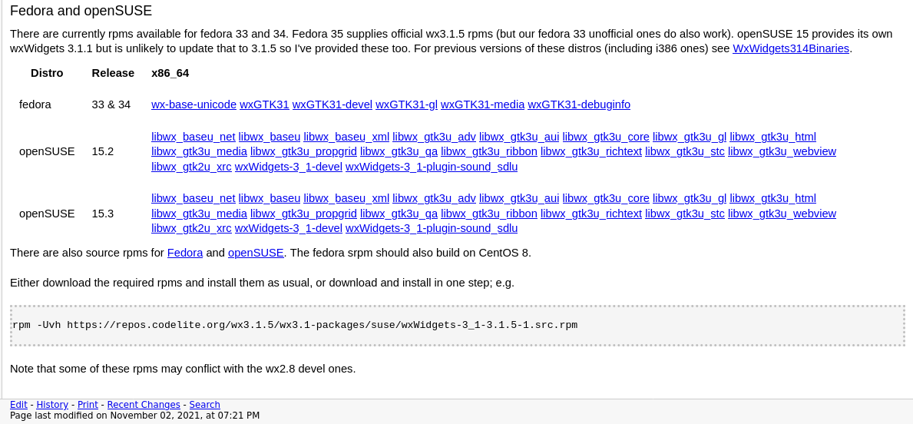



# find / -name setup.h

