

FixMyCity

Software Requirements Specification

Antonio D’Orazio, Francesco Fanali, Robert Adrian Minut | ISPW | 14/11/2019

# Introduction

## Aim of the Document

The following document contains a general description of the project developed.

## Overview of the defined system

The purpose of our system is to encourage and facilitate the collaboration of citizens and public companies, to improve management and maintenance of the city and its infrastructures.

The system allows anyone to report a problem or write a proposal for the city. These reports can be directed to the community or to public or private companies.  
If the report is aimed at the community, citizens can join an event as volunteers in order to fix the problem.  
If a report is aimed at public companies, the system will automatically notify the company involved and they can approve or reject to work on it. In case of approval, they can keep citizens informed about any progress made.

Users interact with the software through an intuitive and minimal graphical interface which makes the map of the city its main focus, showing nearby reports or events. The system will be multi-user and multi-role, allowing different kinds of actions for citizens and companies.

## Operational settings

Required:   
- S.O.: Windows 7 or greater, macOS 10.4 or greater, Android 2.3, iOS 6 or greater,   
any Linux distribution  
- Internet connection   
2GB of ram;

Optional:

- A GPS system (for automatic position detection)

## Related systems

### IoSegnalo

IoSegnalo is a web application which allows citizens to collaborate with Local Rome Police by reporting problems or discomforts in the urban area.  
Pros:   
- Local Rome Police must provide a feedback about the report  
Cons:  
- Users can only see their own reports  
- Users can’t navigate through a map  
- Users can report problems only to the Local Rome Police

### PUMS Roma

PUMS Roma is a web application which allows citizens to propose projects about sustainable mobility and public transports, and it let citizens to vote and discuss about their proposals. The most voted projects can be scheduled by the municipality for realization.  
Pros:  
- It uses an interactive map for navigating through the proposals  
- Users can comment and vote  
- Proposals  
Cons:  
- Projects are only about sustainable mobility and public transports  
- The municipality isn’t forced to provide a feedback about the proposals  
- Users can’t organize themselves as volunteers

### RomaToday Segnalazioni

RomaToday Segnalazioni is a simple section of the news website RomaToday, which allow users to send their reports about problems, car accidents, critical issues and events in the city of Rome.  
Pros:  
- Users can provide every detail about the report  
- Users can interact and comment every report  
- Every report has its own category  
Cons:  
- Users can’t navigate through a map  
- It’s only a showcase of reports, with no volunteering and no contact with public authority

### Together

Together is an app aimed to make it easier for citizens to participate in volunteering events. It allows to create and manage events, and for other people to join in.  
Pros:  
- Citizens can independently organize events to solve problems  
- Citizens can join events and share pictures after it is concluded  
- Integration with social media  
Cons:  
- The problems can only be solved by volunteers  
- Companies are not involved at all

# User Stories

#### Antonio D’Orazio

1. As a citizen, I want to join an active event, so that I can collaborate with volunteers to solve a reported problem.
2. As a citizen, I want to see the events I joined, so that I can remember where and when is the event.
3. As a citizen, I want to vote for a problem, so that I can report to the company which problem needs to be fixed as soon as possible

#### Francesco Fanali

1. As a public company, I want to see the suggested reports, so I can pick one of them.
2. As a public company, I want to approve or reject a report, so as to choose what interests me.
3. As a public company, I want to report the outcome of the work, so as to communicate it to the citizens.

#### Robert Adrian Minut

1. As a citizen, I want to see the reports in zone, so that I can be informed about any issues in my city.
2. As a citizen, I want to report a problem to the community, so that a group of volunteers can solve it.
3. As a citizen, I want to report a problem to the company involved, so that they work on it.

# Functional Requirements

#### Antonio D’Orazio

1. The system shall provide a join function for users by displaying a join button on Community Reports*.
2. The system shall provide the ability for companies to accept or refuse to work on a Company Report*.
3. The system shall show in the homepage a map with all the reports stored in the database.

#### Francesco Fanali

1. The system shall receive reports from users and store them in the database.
2. The system shall use GPS to show the position of the citizen on the map.
3. The system shall provide the ability for users to upload pictures of an event they joined in.

#### Robert Adrian Minut

1. The system shall provide Citizen users* the ability to report a problem, requiring a position on the map of where the problem is located, a category and an optional description of the problem.
2. The system shall provide an upvote* system which will showcase Company Reports*, by ordering them based on the number of upvotes*, to Company users*.
3. The system shall provide a vote function for Citizen users* by displaying a vote button for Company Reports*.

# Use Cases

# Activity Diagram

#### Antonio D’Orazio

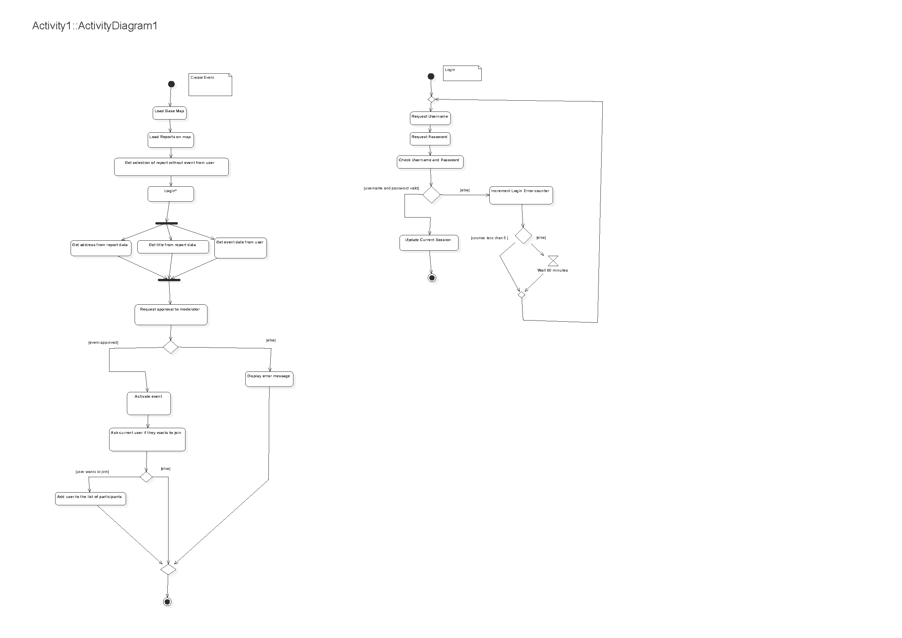

#### Francesco Fanali

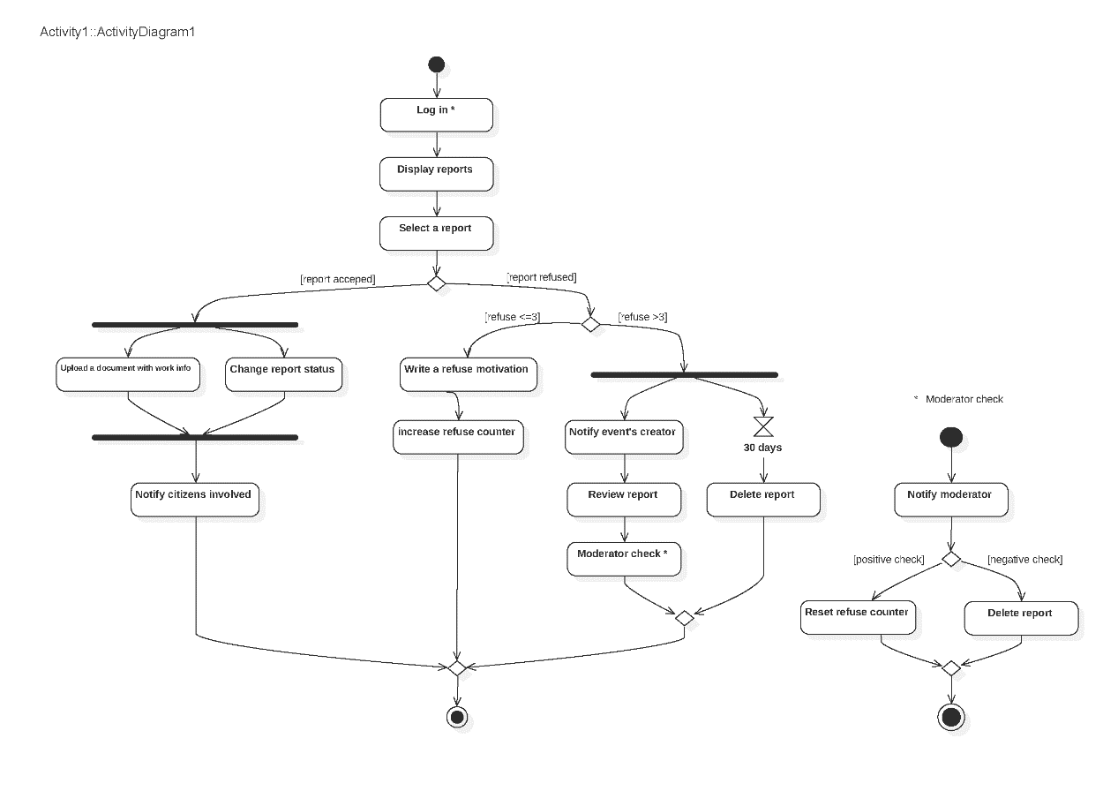

#### Robert Adrian Minut

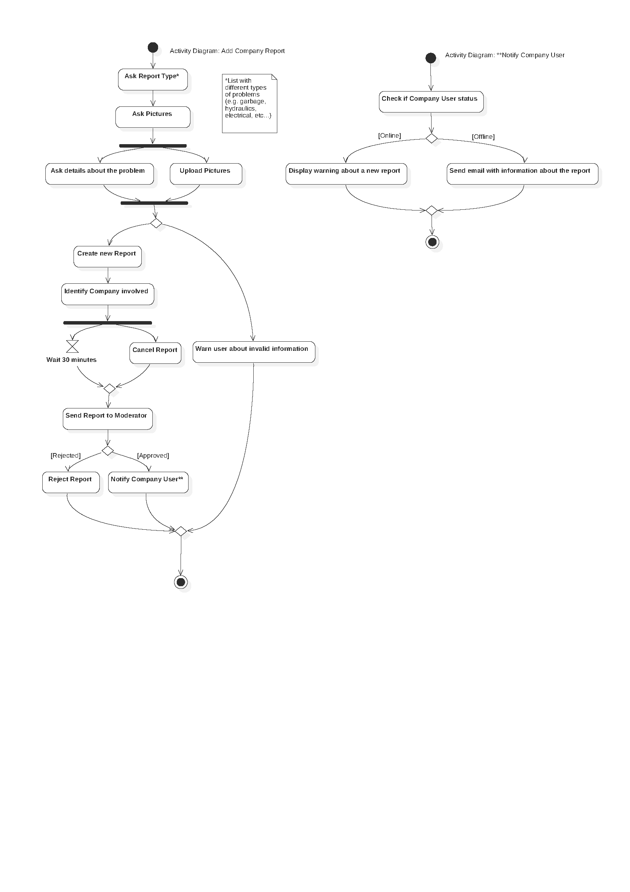

# SonarCloud

Link: <https://sonarcloud.io/dashboard?id=progettoIspw2019_ProgettoIspw2019-20> [WIP]