trends in the Dairy Sector (Aksana Chyzheuskaya, Trevor Donnellan, Patrick Gillespie, Thia Hennessy, Brian Moran, Cathal O'Donoghue)

Irish agriculture is predominantly based on livestock production systems. This is partly due to technical factors; e.g. the Irish climate is particularly well suited to grass production, and so the sector enjoys a measure of cost competitiveness in relation to feed inputs. However, with an enduring history of livestock production being present, it is also fair to say that this type of farming is engrained in the social fabric of the rural communities in which it takes place. Both facts speak to livestock production's importance within Irish agriculture, and of the various enterprises which fall under this heading none are seen in such a positive light as dairying. Indeed, even as the entire agricultural sector has been cast as an engine of an export lead recovery from the global financial crisis of 2008, it is the dairy sector that faces the most ambitious growth targets.
This optimism is not altogether unjustified. Although historically the beef sector was by some way the larger of the two sectors in Ireland, the dairy sector’s share of output value has increased more quickly since Ireland's accession to the European Union (EU). Whilst both sectors continue to account for a substantial share of agricultural output, developments in policy as well as changing consumer preferences have resulted in milk production becoming the largest contributor to the overall value of Irish agricultural output.
This plurality contribution to output is one measure of the sector's importance, but so too is its linkages with other sectors, particularly with beef and crops (i.e. feed). One such linkage is the supply of calves to the beef sector that results from increased dairy production, as only about a fifth of dairy calves are normally required for replacement of the national herd, and any excess must be sold off into beef. Furthermore, the dairy herd's consumption of feedstuffs has important ramifications for crop production.
This chapter will examine the recent history and the current state of the dairy sector in Ireland. Section 1 will put forth the policy context in which the sector has developed since the 1970's. Section 2 will review the structure of the sector, both from the indivdual farm's point of view and also through sector-wide aggregate data. Section 3 will examine the sector's profitability. Section 4 surveys the major advancements to the technical efficiency of dairying, and section 5 concludes.
  - Policy Context

The Common Market Organisation and the Common Agricultural Policy
As with all of european agriculture, EU policy is of critical importance to the Irish dairy sector. As a country with a large dairy sector relative to its population, Ireland is more than self sufficient in its dairy product requirements and is capable of producing a substantial surplus for the export market. In the period prior to entry to the European Economic Community (EEC), the only market to which Irish dairy produce had access on any meaningful scale was the United Kingdom (UK). Exports were principally in the form of butter, but the price received for these butter exports was poor due to the availability of competitively priced butter imports from New Zealand. The access to continental European markets which EEC accession provided, allowed Ireland a greater diversity of export opportunities, and also placed the Irish dairy sector under the considerable influence of the Common Market Organisation (CMO). European policy has been the dominant factor in the development of the Irish dairy sector ever since this time, and its influence will continue to be felt in the future, although recent reforms to the CAP have lead to a more market-orientated outlook.
In this section the support system operated by the Community is detailed. An understanding of the various components of this support system is a necessity, and one needs to pay particular attention to the evolution of these support structures as various rounds of World Trade Organisation (WTO) negotiations have lead to significant changes in the CAP.
1 shows the structure of the CAP system as it applies to the dairy sector. The support system of the CAP operates along two strands: these are Market Supports and Supply Constraints.
Figure -1: Representation of the Structure of the CAP Dairy System.
CAP Support System

Market support | Supply Constraints
Border protection –Import Tariffs  Export refunds  Intervention buying  Internal disposal measures | milk reference volume  butterfat reference level
Internal EU dairy prices for dairy products are maintained above world market prices. Hence the Community has required border protection in the form of variable import levies to ensure that produce from outside of the Community does not displace domestically produced dairy produce. Where the EU is more than 100% self-sufficient in a dairy product, export subsidies are also needed so that the excess can be disposed of outside the community at lower prices, while still maintaining the internal market price for the producer. The Council sets two types of prices for each milk year, which runs from July 1 to June 30: these are the Target Price and the Intervention Price.
Target Price: It is important to note that the target price is not a guarantee price as its name could suggest. The target price is merely the notional price that the Council wants farmers to receive for milk in that year. The target price is also of relevance in the formula for calculation of superlevy payments.
Intervention Price: The intervention price effectively is the price paid for surplus milk production. Public intervention schemes are operated for butter and skimmed milk powder (SMP). Intervention agencies are empowered to buy all quantities offered for intervention at the intervention price until intervention ‘buying in’ is suspended.
Minimum Import Price: A third price, the Minimum Import Price, is set above the intervention price so that domestic production cannot be displaced by cheaper imports from outside the EU. Previously, a variable levy was placed on imports into the EU so as to ensure that the minimum import price remained above the intervention price when the world price fell relative to internal EU prices. However, the latest GATT round resulted in the elimination of variable import levies and their replacement by fixed import tariffs. These changes are discussed in more detail below.
Figure -2 graphically represents these import levies and export subsidies and the associated prices.
Figure -2: The CAP Pricing System for the Dairy Sector
Butter and SMP represent respectively two components of milk, namely fat and protein. The price obtained by farmers for their milk is based on the components of the milk delivered. Historically a relationship has been observed between the intervention prices for butter and SMP and the target milk price. The market price for milk follows the path of the target price quite closely at around 90% of the target price in the case of Ireland. For other member countries, with the exception of Denmark and Italy, the producer price is also somewhat below the target price although the difference is generally not as pronounced as it is in the case of Ireland.
Differences between national prices expressed as a percentage of the target price result from several factors including: market prices, the mix of products, efficiency in production, transport and marketing costs and the seasonality of milk supply. (EU Dairy Facts and Figures 1994:70)
Following the implementation of the General Agreement on Tariffs and Trade (GATT) Uruguay Round Agreement (i.e. the predecessor of the WTO) in 1995 the system of threshold prices and variable import levies for certain milk products was replaced by fixed tariffs. Most of the tariffs were a specific rate. For some products an ad valorem rate was used and in some other cases a combination of an ad valorem duty and a specific rate was used.
In a gradual process, which took place over the period July 95 to July 2000, these import tariffs were reduced by 36% for all products - with the exception of SMP where the reduction was 20%. Some countries continue to have specific market access arrangements, allowing them market access at reduced (approximately 1/3 of normal) tariff rates. These were covered in the GATT current access and minimum access agreements. The minimum access agreements allow increased imports of products from 3% of domestic consumption to 5% of domestic consumption by 2000.
Under the terms of the agreement, by the year 2001, expenditure on export refunds were to be reduced by 36%. In addition the volume of exports were to be reduced by 21%. For butter and SMP the reductions were based on the average of the base years from 1986 to 1990. For cheese and other dairy products the base was set at the average of the 1991 and 1992 figures.
While on the face of it these export restrictions may have seemed severe at the time, closer examination shows that this was not entirely so. For example, butter exports were not constrained by these restrictions. Exports of butter from the EU were very high in the period 1986-90 with the result that in 1995 and 1996 levels of butter exports were well short of GATT allowable limits. Although butter exports are projected to increase, they are not expected to reach the export limits in the medium term. (Situation and Outlook, European Commission 1997). With SMP the export limits were almost reached in 1995 but SMP exports were much lower in 1996 and hence the GATT export restrictions have yet to be felt. In the case of cheese and other milk products the GATT commitments on export refund reductions are already a constraint.
The intervention system operates for butter, SMP and certain Italian cheeses. Intervention exists in two forms - Public storage and Private storage.
Public storage is of primary importance in that it puts a floor on the producer price of milk. Private Storage plays a secondary role in that it exists to improve market stability by balancing seasonal variations in production.
From 1987 there was a major change to the operation of butter intervention. Up to this time there had been unrestricted access to intervention for butter with a resulting stockpile of butter taking place e.g. in 1986 butter intervention reached 60% of EU production. From 1987 a limit of 180,000 tonnes was introduced beyond which it was decided that agencies would only buy in butter on a tender basis if the representative market price in the country in question fell below the level of the intervention price for two consecutive weeks. A payment delay was also introduced which reduced the effective price received by the producer. For butter the payment delay currently stands at 45 to 65 days. The private storage of butter operates from mid April to mid August to accommodate the seasonal variations in butter production.
The buying in of SMP to public intervention is limited to the months of March to August, the months of peak milk production. Buying in can be suspended at a level of 109,000 tonnes. No market price conditions and no minimum buying in prices exist. SMP private intervention is used when public intervention is suspended in the March to August intervention period.
More recently quality criteria have been introduced in relation to SMP offered for storage and, as with butter, delays have been introduced in the payment of intervention payments. These currently stand at 120 to 140 days. The practical effect of these restrictions is to reduce the effective price received by the processor and in turn the producer.
Intervention product is disposed of in a number of ways. A substantial amount is used in the manufacture of ice cream, pastry and other foods where its use is subsidised to displace otherwise cheaper ingredients such as margarine. Up until 1999, subsidised butter sales were made to social welfare recipients under the “butter voucher scheme”. The use of concentrated cooking butter is also subsidised, as is the use of SMP for incorporation in animal feed. The remainder of intervention stocks are either exported or donated as food aid.
Over the last five years EU intervention stocks have been low relative to the levels reached at times in the 1980’s and early 1990’s. EU butter storage has generally been on the decline since 1987, dropping very quickly from the enormous volumes reached in mid 1980’s. Levels of EU SMP intervention stock have been more variable - high in the mid 1980's, very low in the late 1980's, and high again briefly in 1991 and 1992. EU cheese stocks grew through the 1980's and fell somewhat in the early 1990's and have remained at that level since. Cheese stocks are almost exclusively held in private storage.
As well as being a severe burden on the CAP budget, intervention has been politically unpopular with the general public. The experience of food mountains in the 1980's has caused the community to shift its focus away from intervention and towards subsidised consumption/disposal as a means of handling excess dairy commodity supplies.
These shares were relatively stable in recent years. From 1980 to 1996 the butter subsidy amounted to a third of the market price. It was 31% in 1980, rose to 54% in 1983 and fell back to 11% by 1988. It rose sharply in the late 1980’s and early 1990’s and has been relatively stable at about 35 to 40% since 1993. The market price itself changed very little since 1980.
Subsidised use of SMP in the EU has fallen from as high as 40% of domestic consumption in the mid eighties to about 20% today. Under the CMO about 60% of the skimmed milk surplus goes for subsidised use in animal feed (making skimmed milk more attractive with respect of substitute feeds) and the remaining 40% is used for casein products. Disposal of skim milk as SMP for animal use has declined. The subsidy for skimmed milk and SMP disposal has been on the decline since the early 1980’s falling from over 50% in 1980 to about 36% in 1996.
The emergence of a substantial milk surplus within the Community in the 1970’s has already been noted. This growing surplus was initially managed through intervention buying, but it was never the purpose of the intervention system to handle the volumes of surplus output, which began to be experienced in the late 1970’s. Reacting to this, in 1977 the Council introduced the co-responsibility levy. The purpose of this levy, which was paid by producers, was to finance market development measures and some disposal measures such as the school milk scheme.
Intervention stocks continued to grow however. In 1984 the super levy or milk quota system was introduced. The alternative to the milk quota system would have been a cut in support prices for dairy products, a policy which it was felt would have had a considerable negative effect on agricultural incomes. The purpose of the milk quota system is to contain the growth in milk production so that the EU’s agriculture budget can manage the cost of the price support framework. The quota system was introduced initially for four years.
Under the quota arrangement, each member state has a reference quantity, with each producer in turn having an individual reference quantity. Milk delivered is tested against a reference milk fat level and if the milk delivered exceeds the reference milk fat level, then for quota purposes, an adjusted milk volume is calculated. If the adjusted milk volume exceeds the reference volume then this will trigger a superlevy payment. For milk produced in excess of the reference quantity, a superlevy is charged which, on a per kg basis, currently stands at 115% of the target price for milk.
When the quota system was introduced in 1984, the initial milk quotas were fixed at 1981 deliveries plus 2% for most member state, with Ireland and Italy being exceptions. Ireland was allowed to use the 1983 milk delivery volume, which was then 5.28 million tonnes, supplemented by an additional 245,000 tonne allocation from the Community reserve.
The drop in EU milk production, which occurred in 1985 and 1986, did not have the desired effect of restoring a balance to the dairy sector. In April 1986, under a programme known as the Community Cessation Scheme, the Council decided to further reduce the total guaranteed quantities in 87/88 (by 2%) and 88/89 (by 1%).
More importantly, a temporary quota cessation scheme was introduced in 1987/88. Under this scheme 4% of the quota was suspended in 87/88, 5.5% in 88/89 and 4.5% in 89/90, 90/91 and 91/92 after which time it was decided that the “temporary” cessation would continue indefinitely.
The quota system was renewed again in 1992 and extended until the end of the century. As part of the MacSharry CAP reforms in 1992, it was initially proposed to reduce the quota by a further 3%, although ultimately this policy was not contained in the reforms that were finally agreed. However, the co-responsibility levy was abolished at this time. There were no further changes to the quota system through the rest of the 1990’s. Ireland was among five EU member states which were granted quota increases in the 2000/01 and 2001/02 milk years. Ireland’s quota reference volume will increase by 2.9% over this period, with no change in the butterfat reference level. (European Commission 1999)
Quotas are generally attached to the land and cannot be freely traded but since 1992 greater flexibility has been allowed and certain exceptions to the pairing of quota with the land now exist. From an economic perspective quotas, it could be argued, have been the cause of some stagnation in the sector since they protect less efficient producers by acting as an entry barrier against new producers and hinder the expansion of output by the most efficient of existing producers. However, structural change at farm level has been helped by the creation of national reserves for the allocation of quota to special cases and also by the adoption of national and EU schemes to buy up quota from producers who wish to leave milk production. Indeed, in the case of Ireland, it must be questioned whether quotas have brought about stagnation given that the number of milk producers has fallen by half since the quota system was introduced. (Fingleton: 1998) Figure -3 shows quota volumes allocated to Ireland since the introduction of the quota system.
Figure -3: Milk Quota Volumes : Ireland 1984/85 – 2010/11
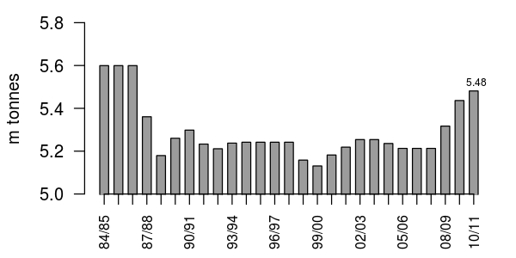
Source: EC Dairy Facts and Figures
Taking another perspective, a counter argument would be that it is good that the quota system helps to maintain dairying in less competitive areas for socio-economic and demographic reasons. Originally many farmers were strongly against the idea of quotas. However many are now in favour of the quota since for those farmers already in operation at the time of the introduction of the quota system it gave them, free of charge, a licence to produce milk which they can sell or lease.
The future of the quota system has been the subject of much debate. There has been pressure from Britain, Denmark, Sweden and Italy for its elimination on the basis that it inhibits the EU’s access to growing export markets. The system is next to be reviewed in 2003 although it is the intention to retain the system to at least 2006.
The changing stocking density on Irish dairy farms can be observed through data available in the Teagasc National Farm Survey. Stocking densities for all Irish dairy farms in the survey’s ‘Dairying System’ classification are shown in Figure -4.
Figure -4: Farm Stocking Density (System: Dairying): Ireland 1978-1999
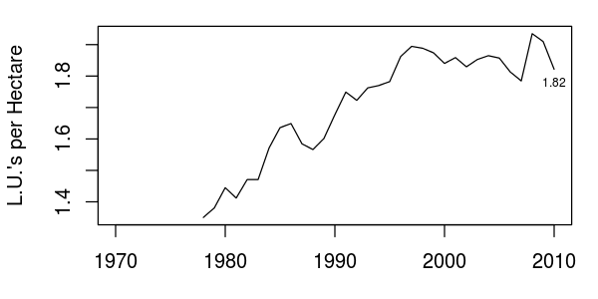
Source: Calculated using data from Teagasc National Farm Survey (various issues)
The national averages for dairy farm stocking density increased up until the end of the 1990's, although there were periods where it declined slightly. Some notable instances were in 1981 (which was due to bad weather), and in the immediate aftermath of the introduction of the milk quota system in 1984.
The overall trend levelled off at the turn of the century, but increased volatility is apparent in the tumultuous second half of the last decade. Some of this volatility may be down to changing definitions in the underlying statistical series (i.e. agricultural land), but some may be geniune reactions to market conditions. Whether real or imagined, volatility hasn't changed the overall trend over the past decade. The average stocking density currently stands at roughly the same level observed in the mid-90's. This plateau may be partially due to limits implied by the Nitrates Directive, which will be explained in further detail below.

Environmental Policy
Many of the policy mechanisms in the CAP attempt to strike a balance between supporting vulnerable rural communities on the one hand, and liberalising international trade along the lines of WTO agreements on the other. However, these are not the only two dimensions along which policies are constructed. More emphasis is progressively being given to managing the interactions between agricultural activities and the environments in which they occur.
Just as in the case of manufacturing industries, agriculture’s effects on the environment can be either acutely local or truly global in scale. An example of the former is the effect of runoff on local water quality, whereas to the latter we can ascribe the ubiquitous example of the association of greenhouse gas (GHG) emissions with global climate change. Therefore, a comprehensive policy framework is required for the reduction and mitigation of these negative externalities which result from agricultural activity, and this is reflected in the more recent reforms of the CAP. Furthermore, the examples given above constitute the main areas of environmental policy which are relevant for the dairy sector.
The need for specific climate policies stems in part from the signing of the Kyoto Protocol in 1997 . This resulted in specific limitations for Greenhouse Gas (GHG) emission levels to be achieved by the first commitment period 2008 - 2012 in countries that are signatories to the agreement. Most developed countries are obliged to reduce their GHG emissions below the 1990 level to comply with the Protocol, but Ireland received a concession that allowed an increase in its GHG emissions by a further 13 percent above this level by the first commitment period. Despite this concession, Ireland was not able to meet its target by the start of the first commitment period, causing the government to set out specific measures to control GHG emissions.
Projections in this area have changed somewhat in the recent past, due to the effects of the severe global recession. The ‘gap’ between the Kyoto target and the EPA’s latest ‘with additional measures’ projection (i.e. that which incorporates existing and planned policies) stands at -0.5 Mt per annum. This means that Ireland would more than meet its reduction target. As a consequence, the State has already obtained enough carbon credits to meet its Kyoto obligations by the end of the first commitment period in 2012.
However, the Kyoto Protocol is not the only international treaty to which Ireland is bound in this policy area. In addition, the member states of the European Union have also pledged themselves to more ambitious reduction targets under the EU 20-20-20 agreement. This agreement obligates Ireland to a 20 percent reduction in GHG emissions relative to its 2005 level, and this requirement could be strengthened to accommodate a 30 percent reduction across the entire EU in the event that a successor treaty to the Kyoto Protocol is agreed. With growth expected post-2012, and despite the impact of the recession Ireland is still projected to fall short of its current emissions reduction target under the agreement.
If Ireland is to meet its obligations under EU 20-20-20 agreement then the importance of reducing agricultural emissions is apparent, given the sector’s contribution to the national emissions total which stands at 28%.
The main policy framework for the protection of European Union (EU) water is the EU Water Framework Directive (2000/60/EC). The Directive sets goals for both the quality and sustainability of water supplies in the EU. It also puts forth common definitions pertaining to those goals, hence serving as a starting point for further specific legislation.
It is unlike other policies in that its implementation is transnational in nature. The concept of a river basin district is identified as the main management unit in Article 3(1). It's definition is rooted in the physical traits of the environment in question (i.e. ecological, hydrolgical, and hydrogeological characteristics). Therefore, a river basin district can transverse national boundaries.
The EU Nitrates Directive (91/676/EEC) predates the Water Framework Directive (WFD), but it remains the main policy framework through which the agricultural sector aims to achieve broader WFD objectives. The Nitrates Directive (ND) mandates Member States to control nitrogen and phosphorus pollution through the introduction of a suite of measures under a National Action Programme (NAP). Member States report regularly to the EU commission on progress towards the Directive's goals.
Ireland's first NAP was enacted in 2005. This was operationalised under the Good Agricultural Practice regulations as introduced under Statutory Instrument No. 378 of 2006. The plan was updated under Statutory Instrument No. 610 of 2010, Good Agricultural Practice for Protection of Waters (GAP). A third review is due in 2013.
GAP regulations address the need for managing both point and diffuse sources of nutrient transfers from agricultural land. The regulations are applied on a whole country basis, but the country is divided into three zones which affect temporal farm practices. Zone A encompasses the south-eastern counties, whist Zone B comprises the western and midland counties. Zone C is made up of the remaining border counties.
Dairy systems are more prevalent in the south-eastern counties (i.e. zone A) where both soil and climatic conditions are generally best suited for production. A recent survey of farm facilities found that 32 percent of the farms in this area were dairy farms, whereas that percentage drops to 17 percent in zone B, and further still to 15 percent in zone C (Hennessy, Buckley, et. al., 2011).
The GAP institutes tight controls on the types and quantities of fertilisers that can be applied to agricultural lands. It establishes periods of the calendar year during which no fertiliser application may take place. It introduces minimum capacity requirements for the storage of animal wastes. Furthermore, it sets regulations regarding buffer zones around water courses where fertilisers cannot be applied at all. It also prescribes certain limits to livestock stocking densities.
The regulations instigated by the Nitrates Directive have important implications for the Dairy sector. Under the Directive, herd owners must limit the amount of nitrogen from manure that is applied or deposited directly by livestock to no more than 170 kgs Nitrogen/hectare/year. The corresponding figure for any individual farm is calculated through the application of excretion co-efficients which convert the various livestock numbers to nitrogen and phosphorus totals. Dairy cows are assigned the highest nitrogen and phosphorus excretion co-efficients, so this is one of the more restrictive aspects of the regulation. It presents a real constraint on the intensification of dairy production.
Hennessy, Shalloo, et. al. (2005) assessed the implications of complying with this limit for farm profitability. Their analysis estimates that 30 percent of specialist dairy farms and 21 percent of mixed dairy farms were affected by the organic N limit. Importantly, they found that the impact of the organic N limit on farm profit depended on the farm’s stage of development; expanding farms experienced greater losses. They also found that applying the limit on a field-by-field basis reduced farm profit by a much larger amount than if the same limit were applied on a whole-farm basis.
In recognition of this burden and of the specifics of the Irish agri-environment, the EU Commission approved a derogation for Ireland which allows individual farms to operate above this limit. The upper limit under the derogation is 250 kgs Nitrogen/hectare/year (a 47 percent increase). This is subject to strict conditions, and it only takes effect after a farm specific application is approved by the Department of Agriculture, Food, and Fisheries (DAFF). The Commission approved the renewal of this derogation in November of 2010, but it is subject to review in 2013.
The structure of the GAP itself does offer some relief from the regulatory burden faced by many dairy farms. Zone A (which has the highest concentration of dairy farms) is subject to the least restrictive regulations in terms of the number of weeks of storage capacity and in terms of the length of the prohibition periods for the spreading of slurry. However, zone A still has the highest estimated slurry storage requirement in terms of volume at over 5.3 million cubic meters, which attests to the intensity and type of farming occuring in this zone.
An additional relief exists in the form of the Farm Waste Management Scheme (FWMS). The scheme was introduced alongside the new regulations in order to reduce the burden of compliance by providing grant-aid for facilities and for new equipment related to the storage and application of animal manures.

Government and Industrial Targets: Harvest 2020
The global recession hit Ireland particularly badly. The combination of global demand drying up, the bursting of a severe housing bubble, and the bank debts which resulted left the country in such a dire fiscal position that a bailout from the International Monetary Fund (IMF), the EU, and the European Central Bank (ECB) was necessary. Calamity was averted, but there has been much pain nonetheless; unemployment remains stubbornly high at above 14 percent, and a series of severely austere budgets have been passed in the years since the bailout in order to bring the government finances back in line with EU limits.
Despite these developments, the agricultural sector emerged as a rare good-news story from early on. Exports of agricultural products grew, and output prices were buoyant, although many farm incomes suffered from the loss of off-farm work. It is therefore unsurprising that the Irish government consulted with the sector to craft a strategy for an export-lead recovery. The results of this consultation was a set of ambitious targets and supporting actions to be carried out by government agencies which were collectively named the “Harvest 2020” targets (so named because of the report in which they were introduced).
Harvest 2020 is not official government policy per se, but it is a collective strategy to which the government has committed itself. The targets are ambitious; the dairy sector's goal is a 50 percent increase in volume of output by 2020. This goes well above and beyond any increase forseen as a consequence of the abolition of the Milk Quota regime in 2015.
One expects EU policy's significance in driving the sector's development to diminish as it becomes increasingly market-orientated. Both the history of the CAP's evolution over previous decades, and the continued global influence of the WTO suggest at once that policies affecting the dairy sector will proceed to increase exposure to the world market rather than shelter Irish dairy producers in any new way.
However, regulations pertaining to the protection of the environment and animal welfare will persist, thus imposing certain costs that are not faced by international competitors as of yet. Harvest 2020 and ongoing CAP reforms will likely shape the next 10 years of development in the dairy sector. Therefore, policy remains an important factor in the development of the sector in the short to medium-term.

Structure of the Dairy Sector
The dairy sector currently accounts for % of overall agricultural output in Ireland. This compares with % for beef, % for sheep, % for pigs, % and for tillage.
Themes on the sectoral side
- Intensification

- Concentration
Themes at the farm level
- Age
Dairy farmers tend to be younger; the average age of the farm holder stood at 51 for specialist dairy farms in 2006 where the same figure was 56 for all other farms. This reflects the higher incidence of older batchelor farmers in the other sectors.
Specialist dairy farm households tend to be bigger in terms of family size; dairy farm households average just over 4 people per household, whereas all other farms average about 3.5 people per households. Dairy households average more people per household for all age categories except for the above 65 age group.
- Sex
The vast majority farm holders in Ireland are men, and this is also true when considering just the dairy sector. The percentage of male farm holders for specialist dairy farms is actally slightly higher at 97 percent as compared to 95 percent for all other sectors combined. This percentage varies only slightly from year to year, and this may be due entirely to survey sampling.
- Off – farm employment

- Education/Extension
Missing!
- Debt

Profitability of the Dairy Sector

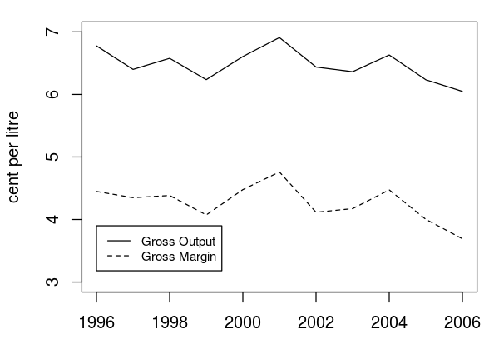
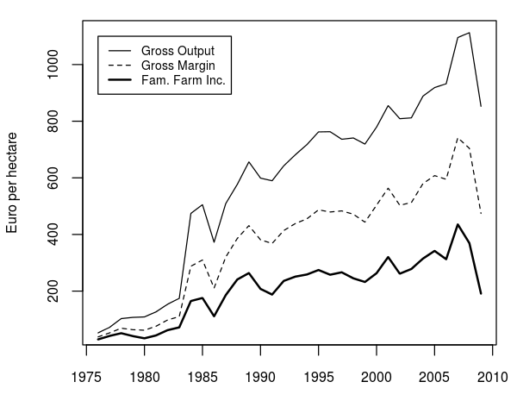Figure - Whole Farm Financial Results for Dairy Farms (Nominal)
The value of gross output is important for the profitability of the dairy sector. Figure * shows the average gross output per ha alongside average gross margin and FFI (i.e. a measure of profitability). It is obvious that the three series are highly correlated, and this alludes to the significance of output prices in determining incomes in the sector. However gross output is also determined by the volume of product, which is itself the result of technical and managerial factors.
Ireland is a small, open economy, and the Irish dairy sector is a rather diminutive part of the global dairy trade. Output prices for the dairy industry are set by the global market, and the domestic industry is necessarily a price-taker. This fact means that relatively little to be done at the sectoral level to improve the price received for dairy products. Efforts to improve profitability must therefore focus on reducing costs and improving yields, i.e. improving efficiency.
Figure * above also displays information about the cost side of production. One can see the change in direct costs in the vertical distance between gross output and gross margin. Likewise, overhead costs are represented in the vertical distance between gross margin and FFI. A situation of increasing costs appears as a “spreading” of the three series, whereas falling costs are shown as a “narrowing” of the distances between the lines.
Some facts present themselves in the figure; firstly, all three series have increased significantly over the past 35 years, as have the distances between them (i.e. costs). Much of this is due to the fact that these are nominal series, which helps to explain the rapid increases in the late 70's and early 80's as the oil shocks of that time period take effect. The very end of the time period shows increasing volatility as some of the reforms of the CAP result in reduced price protection.

The
Talk about output
Talk about costs
Talk about margins

Technical efficiency of the Dairy Sector
Talk about the yields story
Talk about recent advancements in technical efficiency (specific measures and rates of adoption). Think of supplementary survey in NFS from recent years (AI, genomic bulls, etc... grass utilisation will be a key)

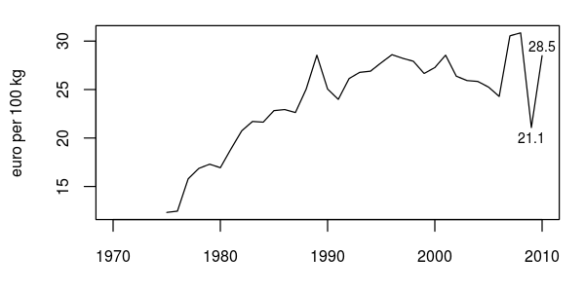
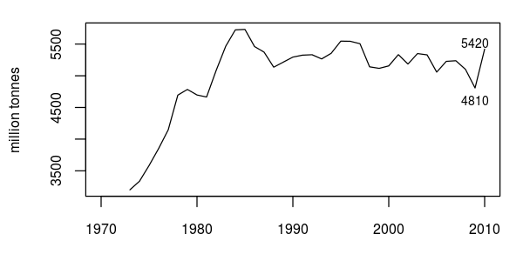
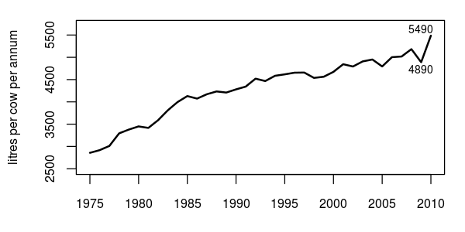
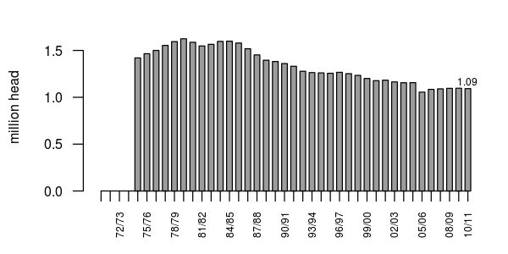
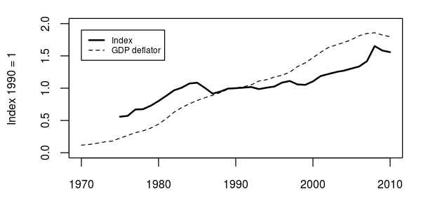
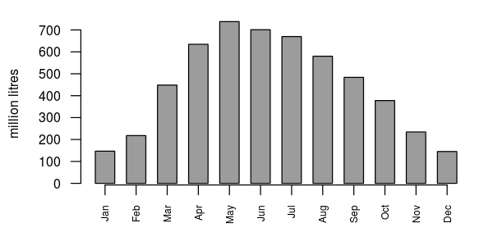

Based on domestic consumption in the base period 1986-88.
The co-responsibility levy was subsequently abolished in 1993 as part of the 1992 CAP reforms.
For each 0.1 gram deviation from the reference fat content the volume of delivered milk is adjusted by 0.18%.
However, there are some things which can be done to improve prices (e.g. improved marketing, market segmentation, altering the product mix, etc.). The point here is that these measures are not as important as efficiency improvements at the sectoral level. Furthermore, specialised marketing may be of much less consequence to the primary producer than would be to processors and retailers.

