trends in the Dairy Sector (Aksana Chyzheuskaya, Trevor Donnellan, Patrick Gillespie, Thia Hennessy, Brian Moran, Cathal O'Donoghue)

Introduction
Irish agriculture is predominantly based on livestock production systems. This is partly due to technical factors; e.g. the Irish climate is particularly well suited to grass production, and so the sector enjoys a measure of cost competitiveness in relation to feed inputs. However, with an enduring history of livestock production being present, it is also fair to say that this type of farming is engrained in the social fabric of the rural communities in which it takes place. Both facts speak to livestock production's importance within Irish agriculture, and of the various enterprises which fall under this heading none are seen in such a positive light as dairying. Indeed, even as the entire agricultural sector has been cast as an engine of an export lead recovery from the global financial crisis of 2008, it is the dairy sector that faces the most ambitious growth targets.
This optimism is not altogether unjustified. Although historically the beef sector was by some way the larger of the two sectors in Ireland, the dairy sector’s share of output value has increased more quickly since Ireland's accession to the European Union (EU). Whilst both sectors continue to account for a substantial share of agricultural output, developments in policy as well as changing consumer preferences have resulted in milk production becoming the largest contributor to the overall value of Irish agricultural output.
This plurality contribution to output is one measure of the sector's importance, but so too are its linkages with other sectors, particularly with beef and crops. One such linkage is the supply of calves to the beef sector that results from increased dairy production, as only about a fifth of dairy calves are normally required for replacement of the national herd, and any excess must be sold off into beef. Furthermore, the dairy herd's consumption of feedstuffs has important ramifications for crop production.
This chapter will examine the recent history and the current state of the dairy sector in Ireland. Section 1 will put forth the policy context in which the sector has developed since the 1970's. Section 2 will review the structure of the sector, both from the indivdual farm's point of view and also through sector-wide aggregate data. Section 3 will examine the sector's profitability. Section 4 surveys the major advancements to the technical efficiency of dairying, and section 5 concludes.

Policy Context

The Common Market Organisation and the Common Agricultural Policy
In this section the support system operated by the Community is detailed. An understanding of the various components of this support system is a necessity, and one needs to pay particular attention to the evolution of these support structures as various rounds of World Trade Organisation (WTO) negotiations have lead to significant changes in the CAP.
As with all of european agriculture, EU policy is of critical importance to the Irish dairy sector. In the period prior to entry to the European Economic Community (EEC), the only market to which Irish dairy produce had access on any meaningful scale was the United Kingdom (UK). The access to continental European markets which EEC accession provided, allowed Ireland a greater diversity of export opportunities, and also placed the Irish dairy sector under the considerable influence of the Common Market Organisation (CMO).

CAP Support System

Market support | Supply Constraints
Border protection –Import Tariffs  Export refunds  Intervention buying  Internal disposal measures | milk reference volume  butterfat reference level
Figure I 1 - Representation of the Structure of the CAP Dairy System
Internal EU dairy prices for dairy products are maintained above world market prices. This is achieved through a suite of border protections in the form of variable import levies which ensure that produce from outside of the Community does not displace domestically produced dairy produce. Where the EU is more than 100% self-sufficient in a dairy product, export subsidies are also needed so that the excess can be disposed of outside the community at lower prices, while still maintaining the internal market price for the producer. The Council sets two types of prices for each milk year, which runs from July 1 to June 30: these are the Target Price and the Intervention Price.
The target price is mainly of relevance in the formula for calculation of superlevy payments, but the intervention price effectively is the price paid for surplus milk production. Meanwhile, the Minimum Import Price is set above the intervention price so that domestic production cannot be displaced by cheaper imports from outside the EU.
The liberalising of trade can be seen in changes to these prices. Previously, a variable levy was placed on imports into the EU, but WTO negotiations eventually lead to a fixed import tariff instead. Both the import tarriffs and export refunds have been gradually reduced over time. In most cases tariffs and refunds have been reduced by 36%. For import tariffs, some countries continue to have specific market access arrangements, allowing them market access at reduced (approximately 1/3 of normal) tariff rates, and there are some products for which less liberalisation was negotiated (e.g. skim milk powder).
Figure I 2 graphically represents these import levies and export subsidies and the associated prices.
Figure I 2 - The CAP Pricing System for the Dairy Sector

Budgetary pressures have also provided an impetus for change. The previous experience of so called “butter mountains” lead the Council to introduce an intervention limit of 180,000 tonnes for butter from 1987. It was decided that agencies would only buy in butter beyond this amount on a tender basis with certain restictions. A payment delay was also introduced.
Buying in of SMP can be suspended at a level of 109,000 tonnes, and even below the limit intervention only operates though the peak production months. Quality criteria have been introduced, as have payment delays.
As well as being a severe burden on the CAP budget, intervention has been politically unpopular with the general public. The experience of food mountains in the 1980's has caused the community to shift its focus away from intervention and towards subsidised consumption/disposal as a means of handling excess dairy commodity supplies.
In 1984 the super levy or milk quota system was introduced. The purpose of the milk quota system is to contain the growth in milk production so that the EU’s agriculture budget can manage the cost of the price support framework. Under the quota arrangement, each member state has a reference quantity, with each producer in turn having an individual reference quantity. Milk delivered is tested against a reference milk fat level and if the milk delivered exceeds the reference milk fat level, then for quota purposes, an adjusted milk volume is calculated. If the adjusted milk volume exceeds the reference volume then this will trigger a superlevy payment. For milk produced in excess of the reference quantity, a superlevy is charged which, on a per kg basis, currently stands at 115% of the target price for milk.
Quotas are generally attached to the land and cannot be freely traded but since 1992 greater flexibility has been allowed and certain exceptions to the pairing of quota with the land now exist. From an economic perspective quotas, it could be argued, have been the cause of some stagnation in the sector since they protect less efficient producers by acting as an entry barrier against new producers and hinder the expansion of output by the most efficient of existing producers. However, structural change at farm level has been helped by the creation of national reserves for the allocation of quota to special cases and also by the adoption of national and EU schemes to buy up quota from producers who wish to leave milk production. Indeed, in the case of Ireland, it must be questioned whether quotas have brought about stagnation given that the number of milk producers has fallen by half since the quota system was introduced. (Fingleton: 1998) Figure I 3 shows quota volumes allocated to Ireland since the introduction of the quota system.
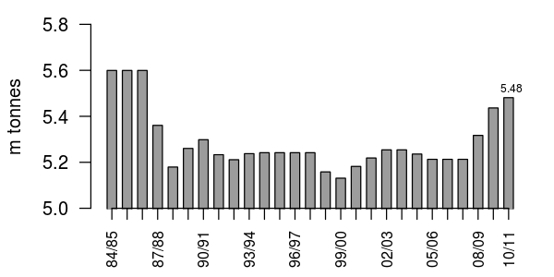Figure I 3 - Milk Quota Volumes : Ireland 1984/85 – 2010/11
Source: EC Dairy Facts and Figures

Taking another perspective, a counter argument would be that it is good that the quota system helps to maintain dairying in less competitive areas for socio-economic and demographic reasons. Originally many farmers were strongly against the idea of quotas. However many are now in favour of the quota since for those farmers already in operation at the time of the introduction of the quota system it gave them, free of charge, a licence to produce milk which they can sell or lease.
For good or for ill, the Milk Quota regime is coming to an end. The CAP reform of 2003 sets the date for the abolition of milk quotas at 2015, with incremental increases in the years running up to this date. This development presents an opportunity for countries such as Ireland which are more than self sufficient in milk production, as it will mean increased access to export markets.

Environmental Policy
Many of the policy mechanisms in the CAP attempt to strike a balance between supporting vulnerable rural communities on the one hand, and liberalising international trade along the lines of WTO agreements on the other. However, more emphasis is progressively being given to managing the interactions between agricultural activities and the environments in which they occur. The two major areas of policy pertain to climate change on the one hand and the protection of water sources on the other.
The need for specific climate policies stems in part from the signing of the Kyoto Protocol in 1997 . Most developed countries are obliged to reduce their GHG emissions below the 1990 level to comply with the Protocol, but Ireland received a concession that allowed an increase in its Greenhouse Gas (GHG) emissions by a further 13 percent above this level by the first commitment period.
In addition, the member states of the European Union have also pledged themselves to more ambitious reduction targets under the EU 20-20-20 agreement. This agreement obligates Ireland to a 20 percent reduction in GHG emissions relative to its 2005 level.
If Ireland is to meet its obligations under EU 20-20-20 agreement then the importance of reducing agricultural emissions is apparent, given the sector’s contribution to the national emissions total which stands at 28%. However, there are no binding targets for the agricultural sector as of yet.
The main policy framework for the protection of European Union (EU) water is the EU Water Framework Directive (2000/60/EC). The EU Nitrates Directive (91/676/EEC) predates the Water Framework Directive (WFD), but it remains the main policy framework through which the agricultural sector aims to achieve broader WFD objectives. The Nitrates Directive (ND) mandates Member States to control nitrogen and phosphorus pollution through the introduction of a suite of measures under a National Action Programme (NAP). In Ireland, the most recent NAP is called Statutory Instrument No. 610 of 2010, Good Agricultural Practice for Protection of Waters (GAP).
Unlike climate policy, the GAP is a set of binding regulations. Hennessy, Shalloo, et. al. (2005) assessed the implications for farm profitability of complying with the limits to nitrogen (N) implied by the GAP's regulations. Their analysis estimates that 30 percent of specialist dairy farms and 21 percent of mixed dairy farms were affected by the organic N limit. Importantly, they found that the impact of the organic N limit on farm profit depended on the farm’s stage of development; expanding farms experienced greater losses. They also found that applying the limit on a field-by-field basis reduced farm profit by a much larger amount than if the same limit were applied on a whole-farm basis.
There are a few reliefs from the regulatory burden the ND regulations impose on the dairy sector. The EU Commission approved a derogation for Ireland which allows individual farms to operate at a higher N limit. An additional relief exists in the form of the Farm Waste Management Scheme (FWMS). The scheme was introduced alongside the new regulations in order to reduce the burden of compliance by providing grant-aid for facilities and for new equipment related to the storage and application of animal manures.

Government and Industrial Targets: Harvest 2020
In the wake of the global recession of 2008 the Irish government consulted with the sector to craft a strategy for an export-lead recovery for the Irish economy. The result of this consultation was a set of ambitious targets and supporting actions to be carried out by government agencies which were collectively named the “Harvest 2020” targets (so named because of the report in which they were introduced).
Harvest 2020 is not official government policy per se, but it is a collective strategy to which the government has committed itself. The targets are ambitious; the dairy sector's goal is a 50 percent increase in volume of output by 2020. This goes well above and beyond any increase forseen as a consequence of the abolition of the Milk Quota regime in 2015.
One expects EU policy's significance in driving the sector's development to diminish as it becomes increasingly market-orientated. Both the history of the CAP's evolution over previous decades, and the continued global influence of the WTO suggest at once that policies affecting the dairy sector will proceed to increase exposure to the world market rather than shelter Irish dairy producers in any new way.
However, regulations pertaining to the protection of the environment and animal welfare will persist, thus imposing certain costs that are not faced by international competitors as of yet. Harvest 2020 and ongoing CAP reforms will likely shape the next 10 years of development in the dairy sector. Therefore, policy remains an important factor in the development of the sector in the short to medium-term.

Structure of the Dairy Sector

The Dairy Herd
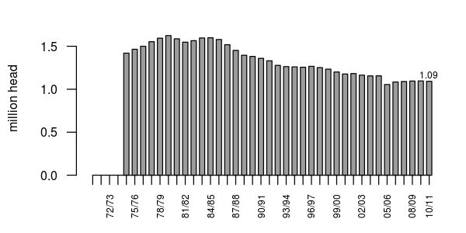Figure I 4 - Number of Dairy Cows (June Enumeration): Ireland 1974-1999
Source: Central Statistics Office
[Drystock Graph?]

Intensification of Production: Dairy Farm Stocking Density
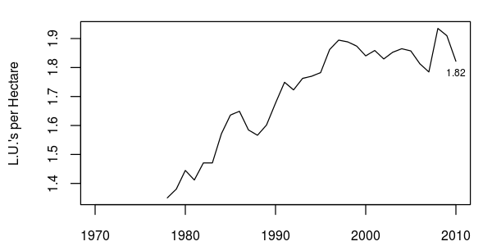Figure I 5 - Farm stocking density (System:Dairying): Ireland 1978-2010
Source: Calculated using data from Teagasc National Farm Survey (various issues)
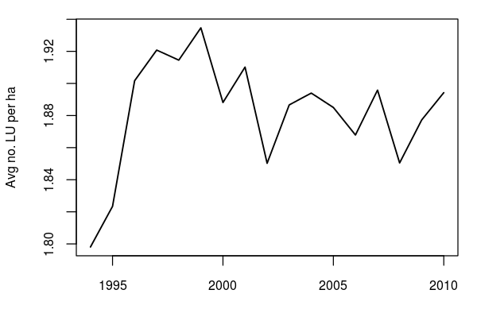

Farm Numbers and Regional Differences

Seasonality of Production
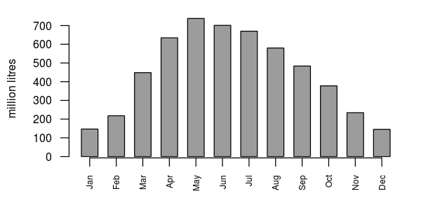
Figure I 6 - Monthly milk deliveries to creameries
Source: Central Statistics Office

Demographics

Education/Extension

Economic performance of the Dairy Sector
Output
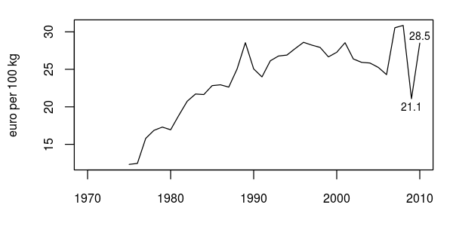Figure I 7 - Nominal Creamery Milk Prices (3.7% Fat Content): Ireland 1970-2010
Source: Central Statistics Office

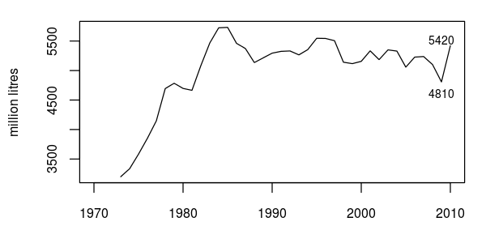Figure I 8 - Creamery Milk Deliveries (mills. litres): Ireland 1975-2010
Source: Central Statistics Office

Decomposition of output
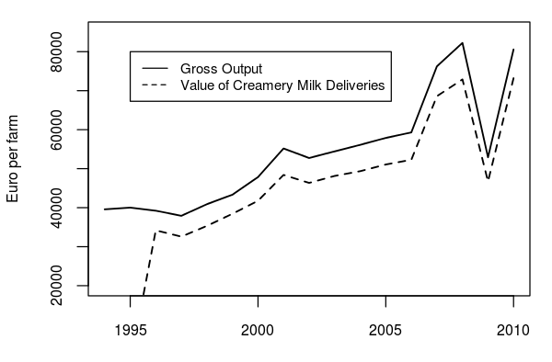
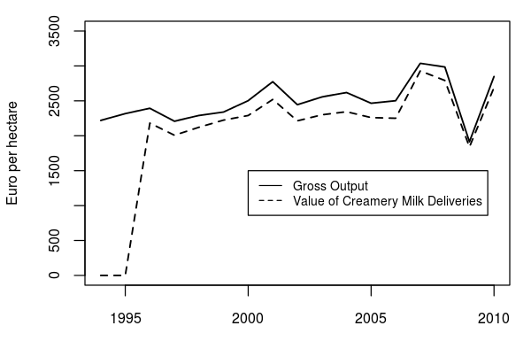

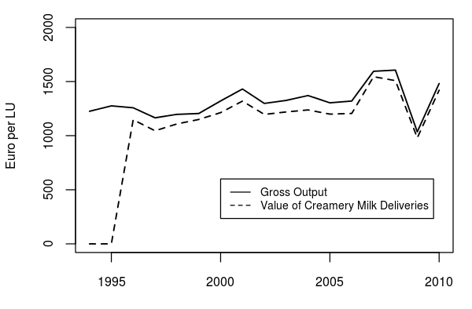

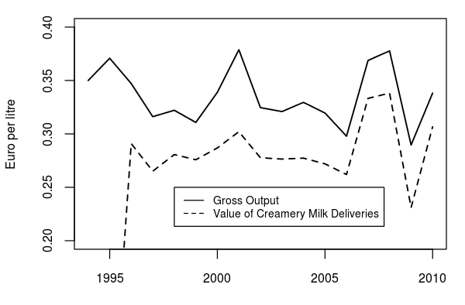

Costs

-Direct Costs

[Lo-Med-Hi of costs Here]

Cent per litre

Year | Direct Costs | Concentrates | Pasture | Winter Forage | Misc. Direct Costs | Vet. And Med. | AI and Service Fees | Transport Expense | Misc. Expenses | Casual Labour
1996 | 11.8 | 3.8 | 1.5 | 2.3 | 1.1 | 0.8 | 0.5 | 0.4 | 1.3 | 0.1
1998 | 11.2 | 3.5 | 1.2 | 2.7 | 0.9 | 0.8 | 0.5 | 0.3 | 1.2 | 0.1
2000 | 11.3 | 3.7 | 1.3 | 2.4 | 1.1 | 1.0 | 0.5 | 0.3 | 0.9 | 0.1
2002 | 12.8 | 4.7 | 1.6 | 2.7 | 1.1 | 1.1 | 0.5 | 0.2 | 0.8 | 0.1
2004 | 11.5 | 4.0 | 1.5 | 2.5 | 0.9 | 1.2 | 0.4 | 0.3 | 0.7 | 0.1
2006 | 11.9 | 4.3 | 1.6 | 2.5 | 0.7 | 1.3 | 0.5 | 0.2 | 0.8 | 0.1
2008 | 14.7 | 5.8 | 1.9 | 2.9 | 0.7 | 1.5 | 0.6 | 0.2 | 1.1 | 0.1
2010 | 13.6 | 4.8 | 1.6 | 3.1 | 0.6 | 1.6 | 0.6 | 0.2 | 1.1 | 0.0

Year | Direct Costs (€) | Concentrates | Pasture | Winter Forage | Misc. Direct Costs | Vet. And Med. | AI and Service Fees | Transport Expense | Misc. Expenses | Casual Labour | Total
1996 | 13,301 | 32% | 12% | 18% | 12% | 7% | 4% | 3% | 11% | 1% | 100%
1998 | 13,534 | 32% | 12% | 18% | 11% | 8% | 4% | 2% | 11% | 1% | 100%
2000 | 15,194 | 33% | 13% | 19% | 13% | 9% | 4% | 2% | 7% | 1% | 100%
2002 | 18,893 | 36% | 13% | 19% | 11% | 9% | 4% | 1% | 6% | 1% | 100%
2004 | 18,918 | 35% | 13% | 19% | 10% | 11% | 4% | 2% | 6% | 1% | 100%
2006 | 22,859 | 37% | 13% | 19% | 7% | 10% | 4% | 2% | 7% | 1% | 100%
2008 | 30,848 | 39% | 13% | 19% | 6% | 10% | 4% | 1% | 7% | 1% | 100%
2010 | 30,713 | 36% | 12% | 21% | 5% | 12% | 4% | 1% | 8% | 0% | 99%

Gross Margin
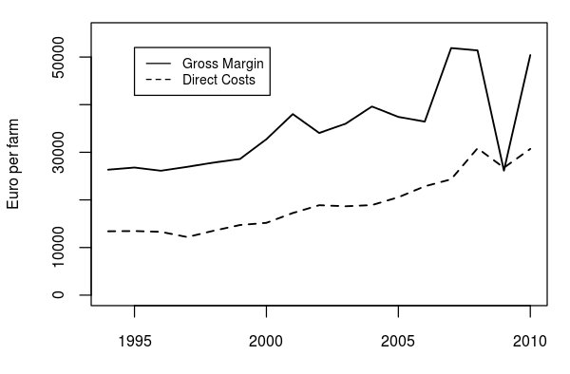
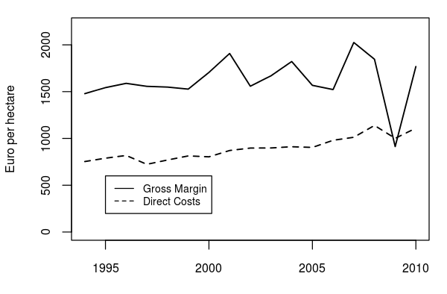
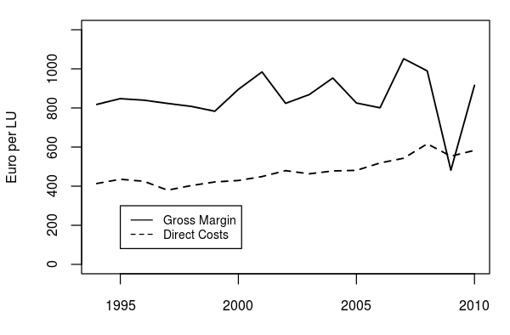

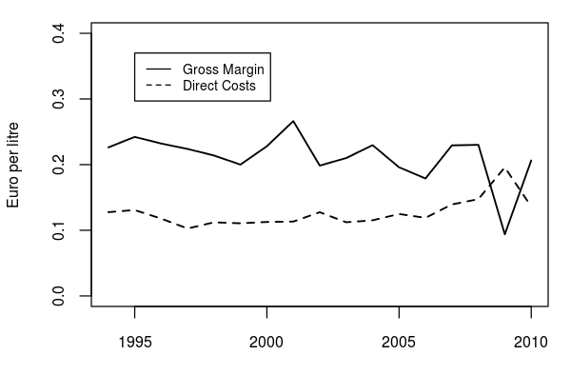
Yields
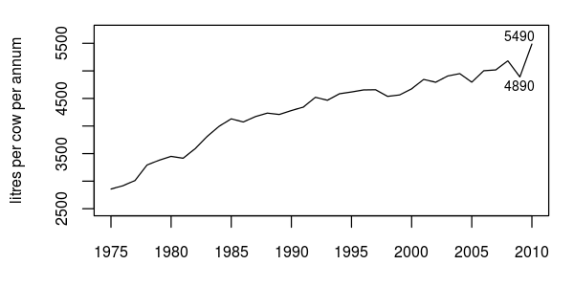Figure I 9 - Milk Output Per Cow: Ireland 1974-2010
Source: Central Statistics Office

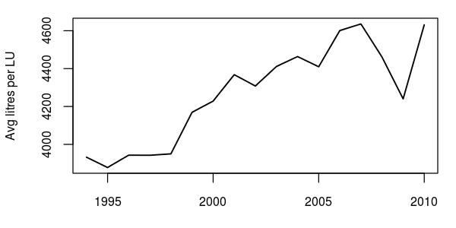

Unpaid Labour
Off – farm employment
Debt
Investment

Conclusion
Section 4 surveys the major advancements to the technical efficiency of dairying, and section 5 concludes.

For each 0.1 gram deviation from the reference fat content the volume of delivered milk is adjusted by 0.18%.

