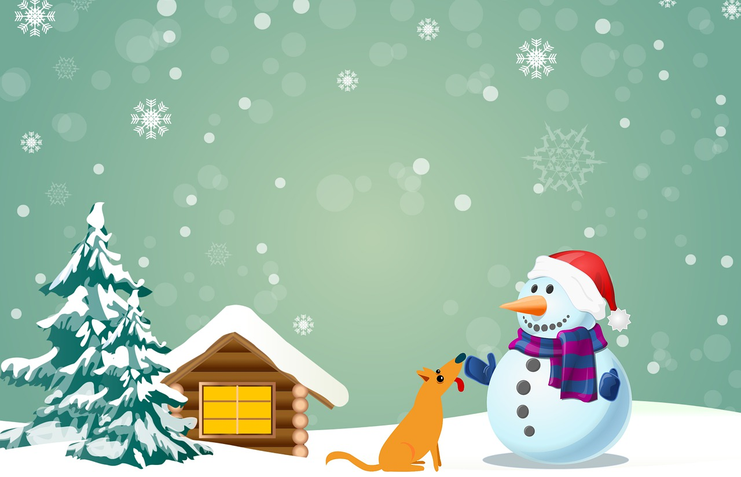

Flippy Skater

GAME OVER