Perfection is achieved, not when there is nothing more to add, but when there is nothing left to take away.
Antoine de Saint Exupéry
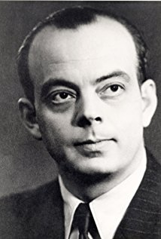
6134ab8e-4fd8-11e8-bf1d-97a8afb41480

